**(PART - B)**

(TO BE COMPLETED BY STUDENTS)

(Students must submit the soft copy as per the following segments within two hours of the practical.The soft copy must be submitted on the portal or on MS Teams before the deadline)

|  |  |
| --- | --- |
| Roll.No. : A072 | Name: Krunal Anand Sonawane |
| Sem/Year : I/2024 | Batch: B3 |
| Date of Experiment : 06/08/2024 | Date of Submission: 06/08/2024 |
| Grade -- |  |

# B.1: Procedure of performed experiment

Students can include the output/observations as per each of tasks given in Part A

**B2. Questions of Curiosity:**

* In scenarios involving simultaneous data transmissions from multiple devices, how do hubs and switches differ in their handling of network traffic, and what are the observable effects on overall network performance and latency?

# B.3: Observations and Learning’s:

(Students are expected to comment on the output obtained with clear observations and learning for each task/ sub part assigned)

# B.4: Conclusion:

(Students must write the conclusion as per the attainment of individual outcome listed above and learning/observation noted in section B.3)

**Bus Topology:-**

1. Placing the switches and pc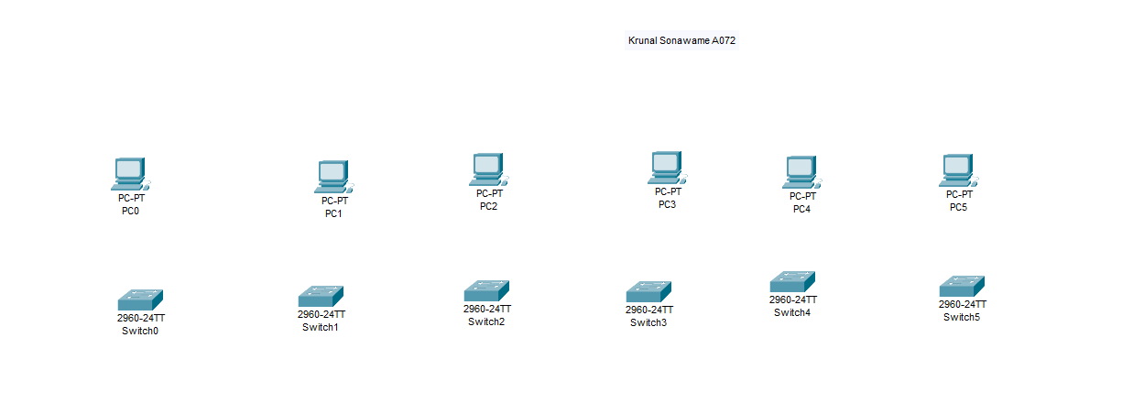
2. Connecting the switches to pc using copper straight through for switches to switches and copper cross over for switches to pc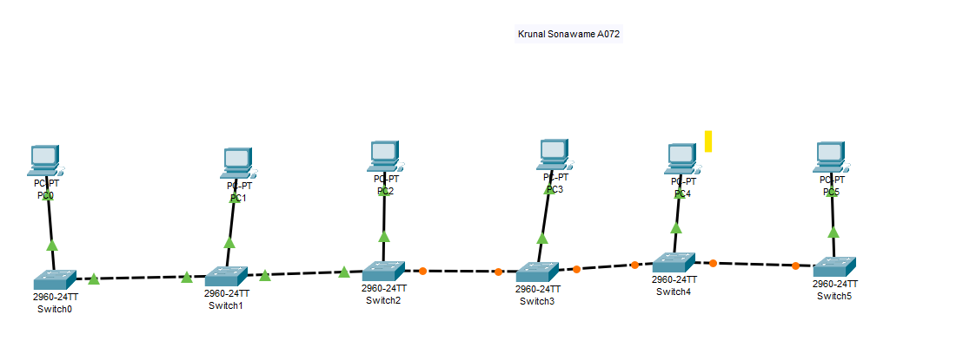
3. Configuring the pc

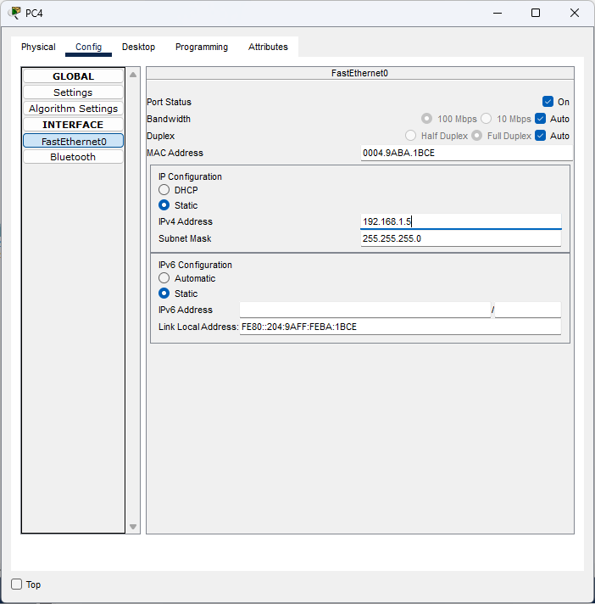

1. Checking the connection is proper by pinging the another pc

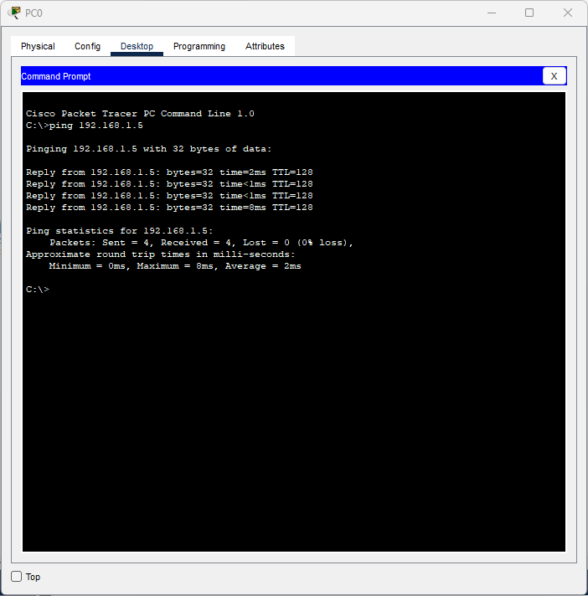

1. Verifying through simulation if the connection is running properly

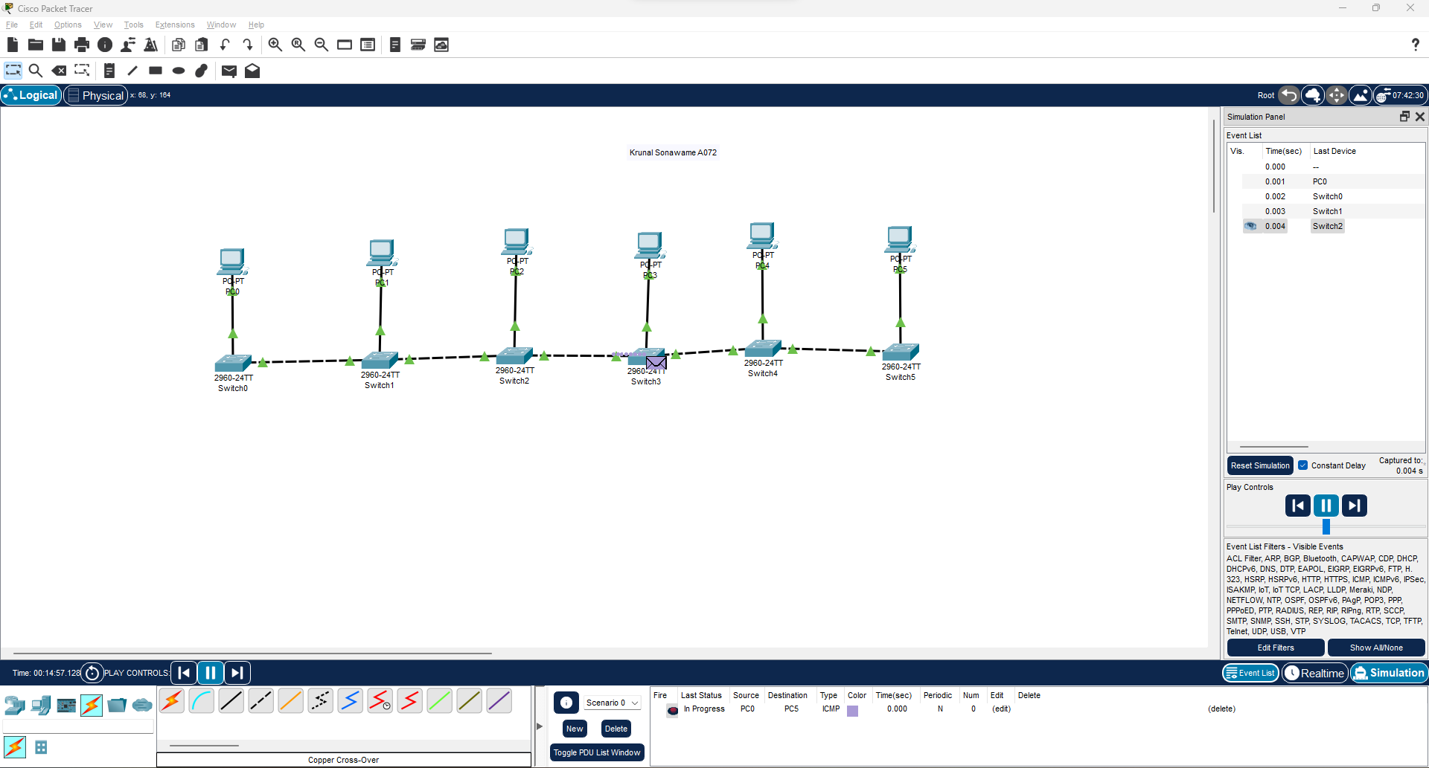

**Ring Topology**

1. Placing the pc and switches for connection

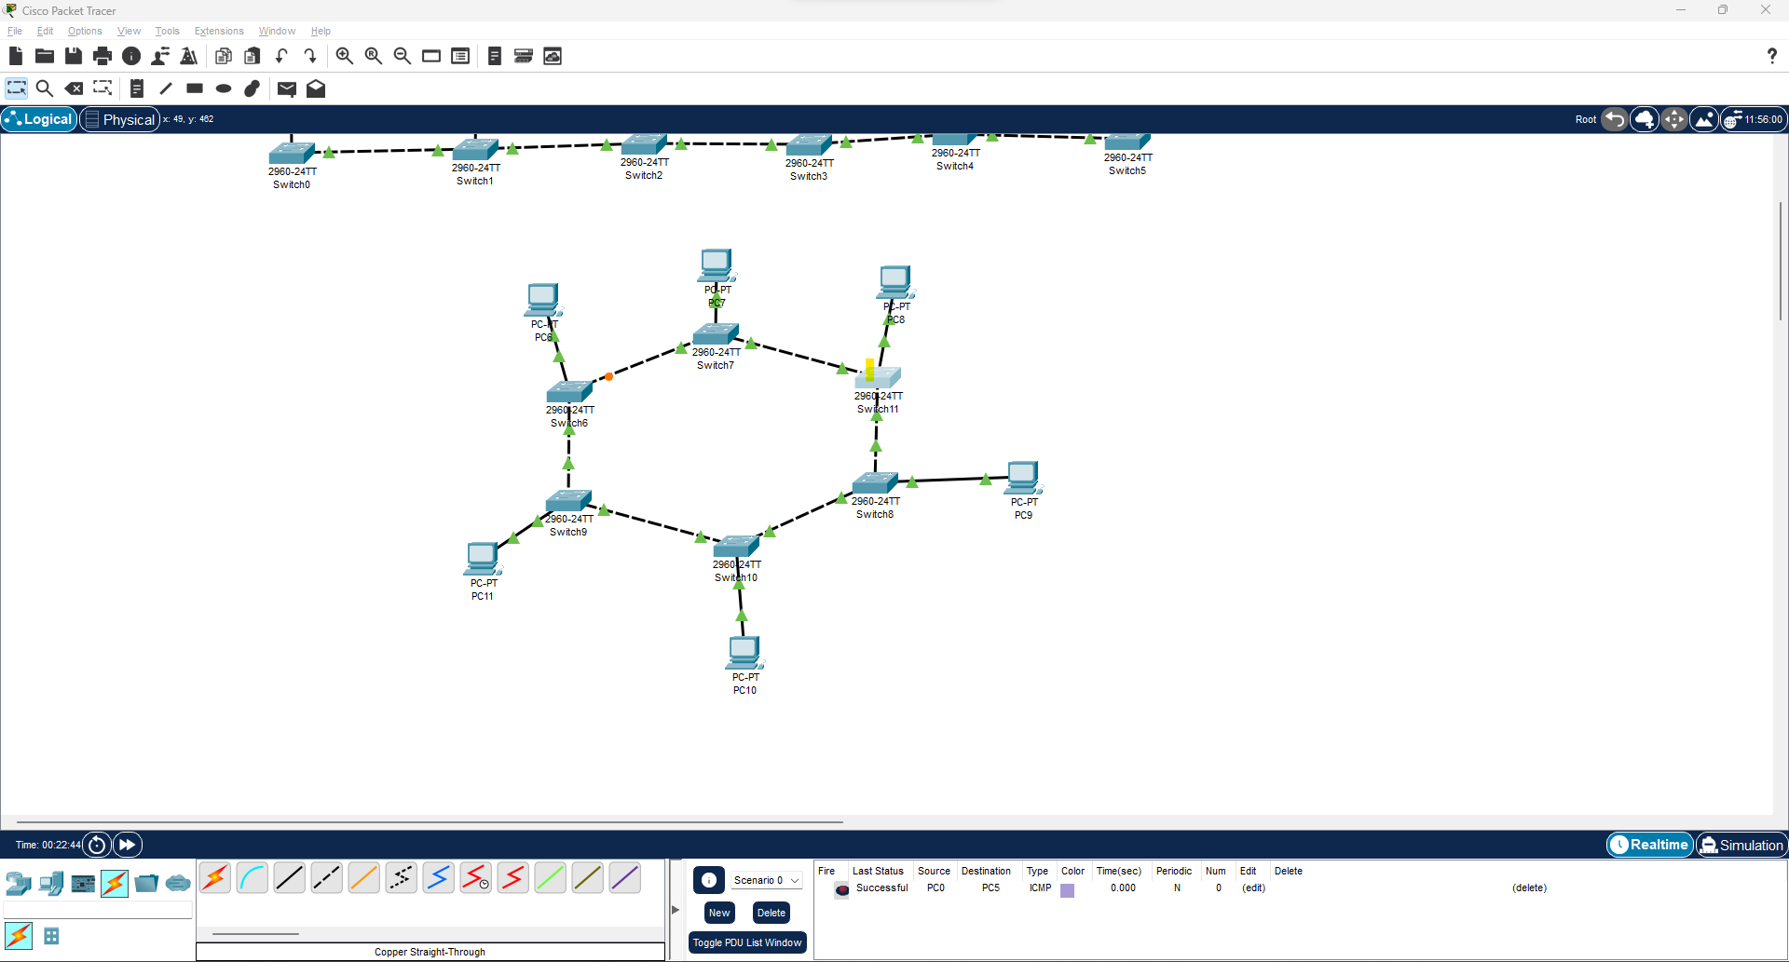

1. Configuring the pc

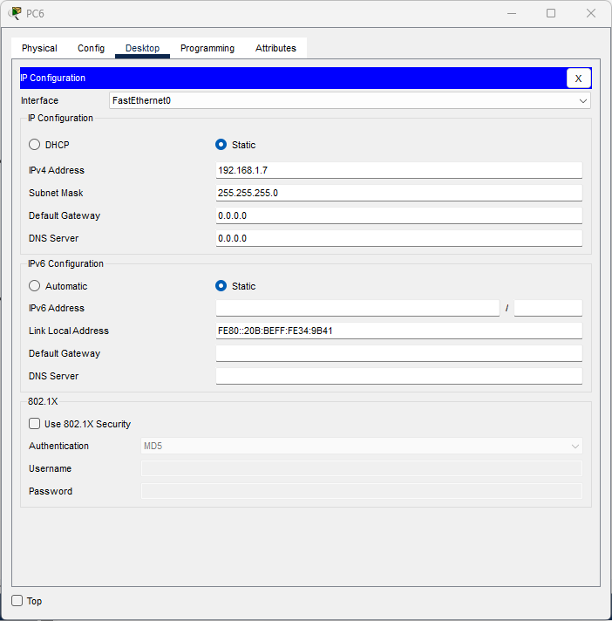

1. Pinging another pc to check if the connection is done properly

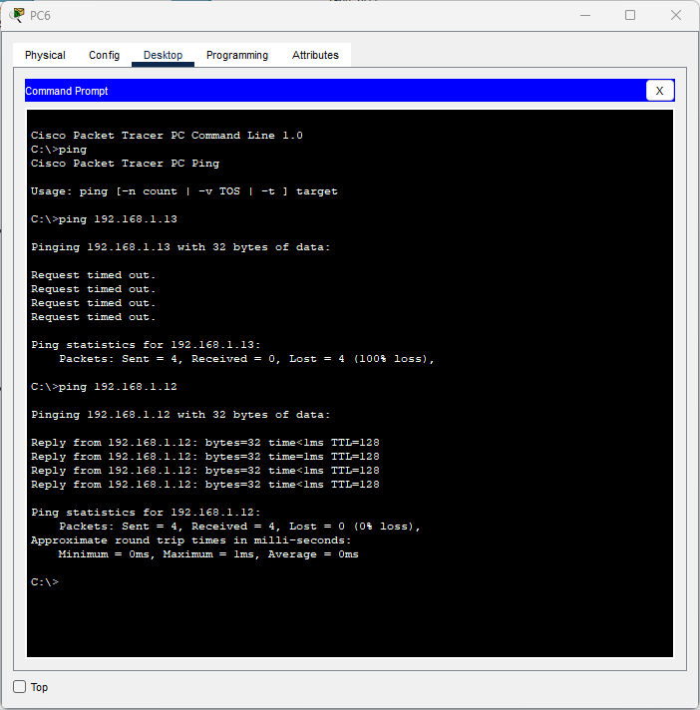

4.Using the simulation to see if the messages sending are being received properly or not

* **Hybrid topology**

1. For this topology we connect the switch of a ring topology with the switch of a bus topology.

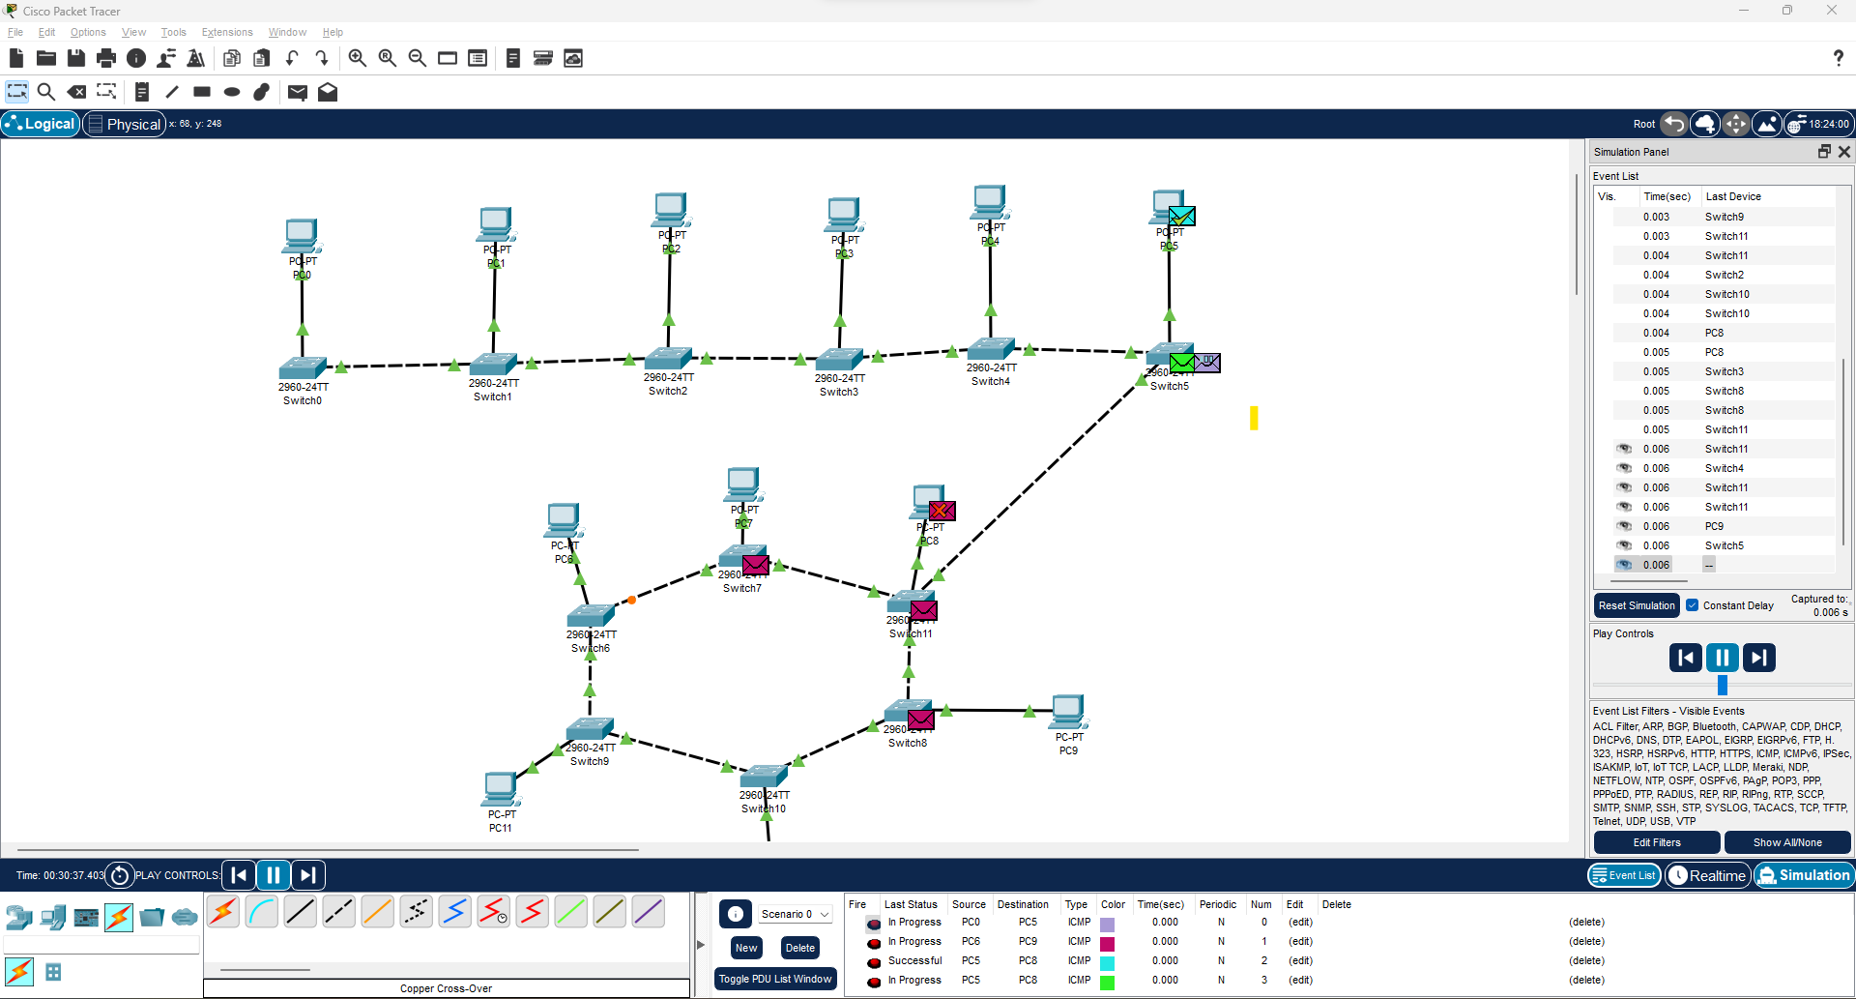

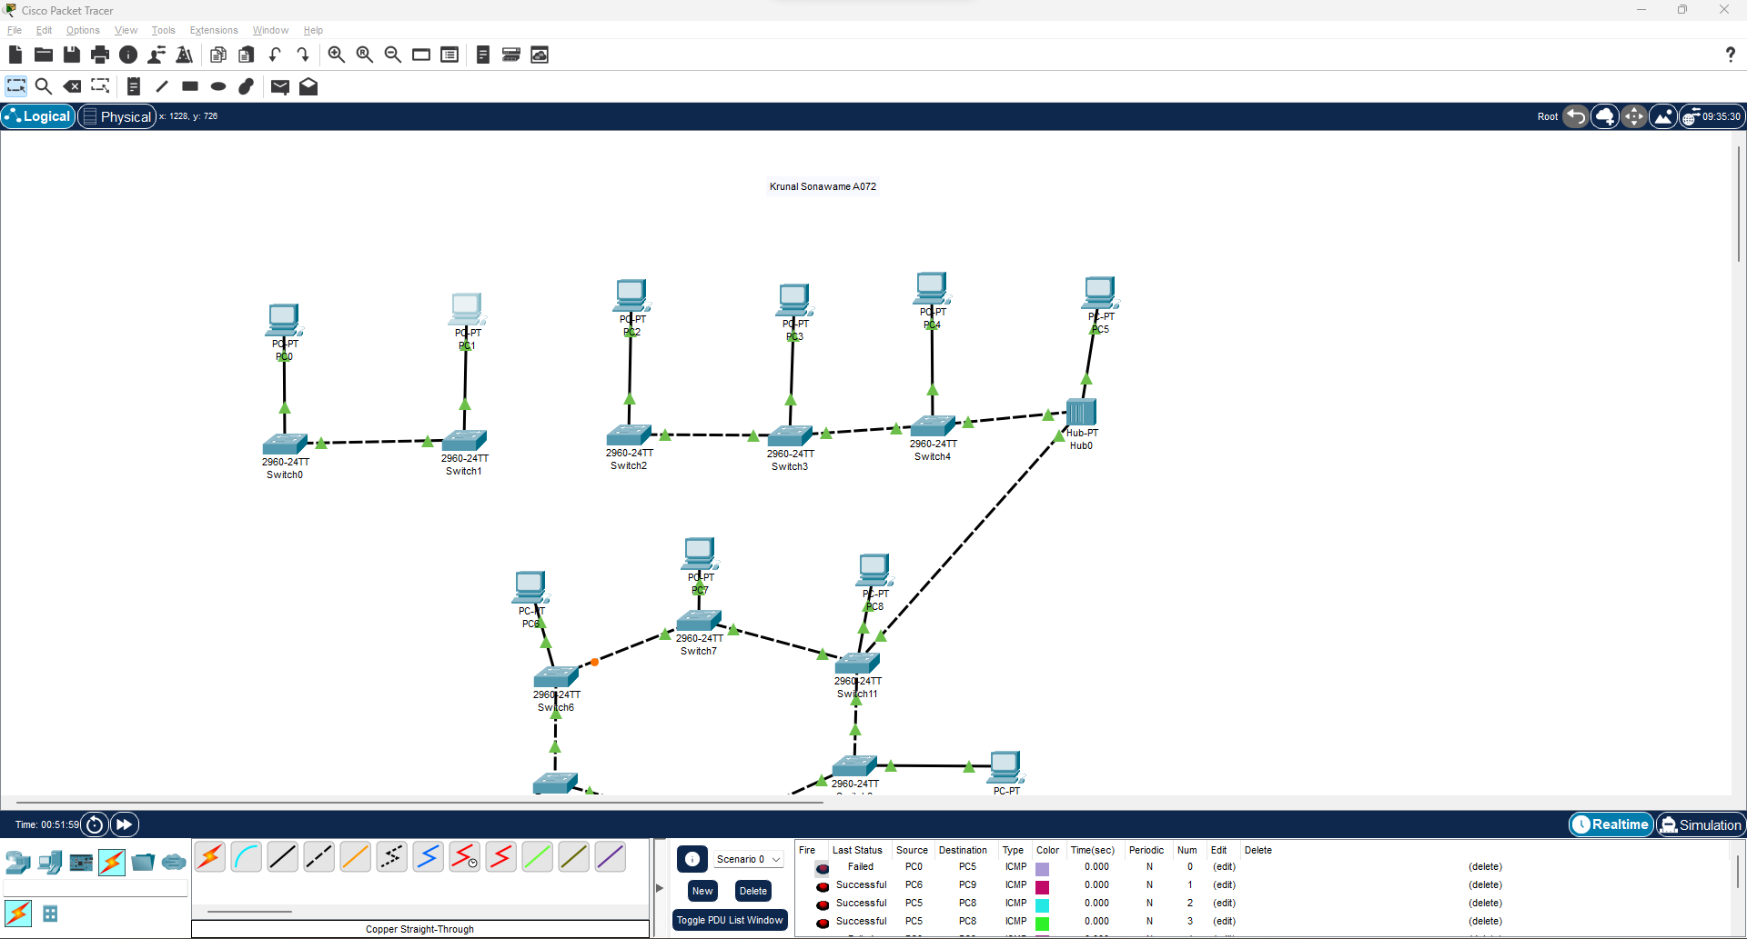

**2.** Checking the connection through simulation.

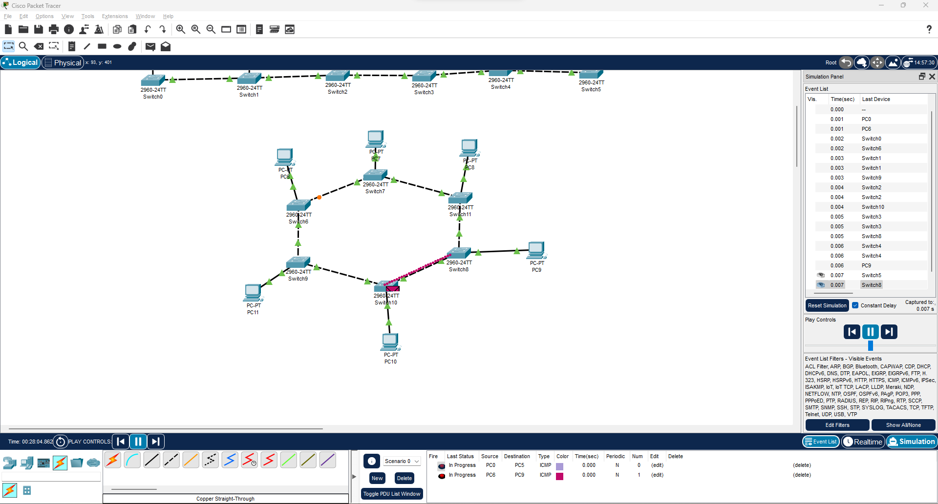

* **Using a Hub**

1. Using a hub instead of a switch.

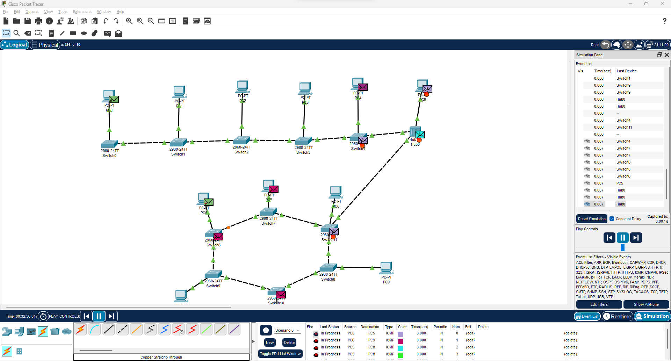

**Failure**

1. Disconnecting a connection between 2 switches

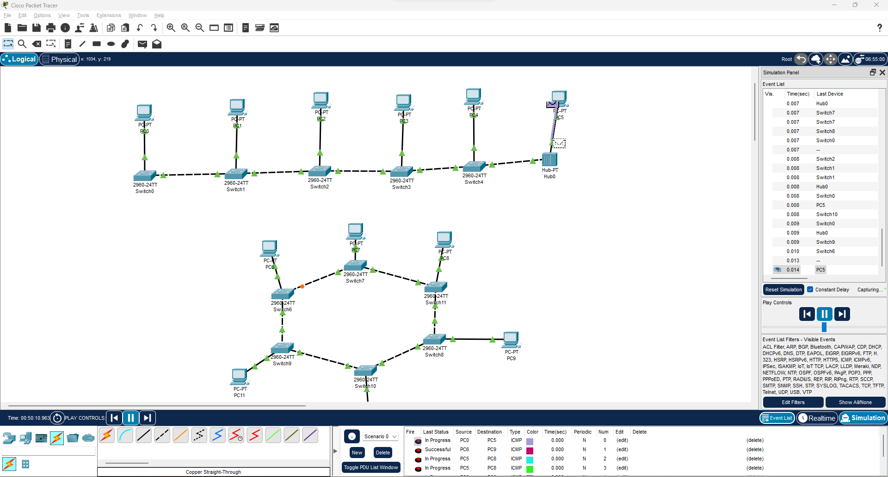

**2.** Checking the simulation

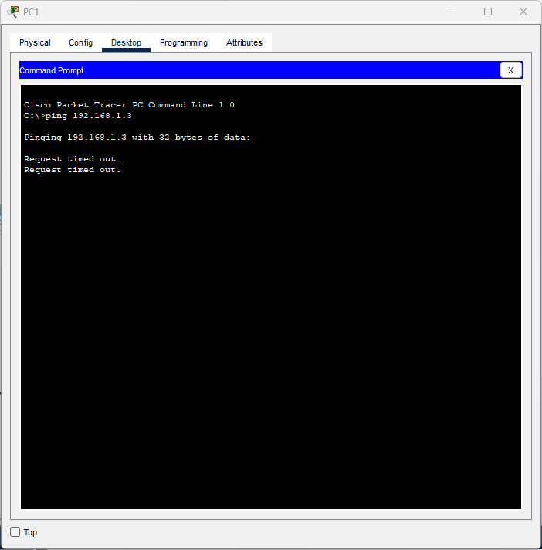

* **What is the difference between Hubs and Switches.**
* **Hub**: A hub is a basic networking device that operates at the physical layer of the OSI model. It receives data from one device and broadcasts it to all other devices connected to the hub. Hubs do not possess the intelligence to differentiate between devices or manage data traffic, which can lead to inefficient network usage.
* **Switch**: A switch operates at the data link layer of the OSI model and is more intelligent than a hub. It examines the MAC addresses of incoming data frames and selectively forwards them only to the appropriate destination device. This reduces unnecessary traffic and improves network efficiency by creating dedicated communication paths between devices.
* **What is network failure**

In network failure when the connection between two switches is severed then the message will not pass through because there is not a bridge between them to pass the message which will result in message lost.

**B2. Questions of Curiosity:**

* In scenarios involving simultaneous data transmissions from multiple devices, how do hubs and switches differ in their handling of network traffic, and what are the observable effects on overall network performance and latency?

In scenarios with simultaneous data transmissions from multiple devices:

Hubs: When multiple devices transmit data at the same time, hubs broadcast all data to every device on the network. This causes data collisions and network congestion since all devices compete for the same bandwidth. As a result, network performance degrades due to the increased number of collisions and retransmissions, leading to higher latency and slower data transfer speeds.

Switches: Switches handle simultaneous transmissions more efficiently by sending data only to the specific recipient device. They use MAC addresses to direct traffic, thus minimizing collisions and network congestion. Each port on a switch operates in its own collision domain, allowing multiple transmissions to occur simultaneously without interfering with each other. This results in improved overall network performance, lower latency, and faster data transfer speeds.

Overall, switches provide a more reliable and faster network experience compared to hubs, especially under heavy traffic conditions.

# B.3: Conclusion:

(Students must write the conclusion as per the attainment of individual outcome listed above and learning/observation noted in section B.3)

In this practical we learned 3 new topologies and how they worked. We also learned how different is hub and switch and also when do we need to use them. We also learned that the message will not be received by the receiver if the connection is severed. By using the simulation, we know how the topologies work and how can we use them. We can also get the general idea that if the message is not being received then there is a high chance of network failure.