**PART A**

**Experiment No.04**

**A1 Aim**: To analyse Media Access Control (MAC) behaviour in networks using Cisco Packet Tracer.

**A2: Pre-requisite**: Knowledge of the Address Resolution Protocol (ARP) for mapping IP addresses to MAC addresses and the Internet Control Message Protocol (ICMP) for network diagnostics.

**A3: Learning Outcomes:**

Upon completion of this experiment, students will be able to:

* **Understand and Implement CSMA/CD Protocol**: Demonstrate a clear understanding of the CSMA/CD protocol by configuring and managing Ethernet network communications, identifying collision detection and resolution processes in a shared medium environment.
* **Analyse ARP and ICMP Packet Operations:** Capture and analyse ARP and ICMP packets to understand the mechanisms of IP to MAC address resolution and network diagnostics.
* **Differentiate between Hub and Switch Operation**s:. Students will be able to observe and describe how switches build and utilize MAC address tables to improve network efficiency and reduce collisions compared to hubs.

**A4: Theory**

**Ethernet:**

Ethernet provides services on the Physical (Layers 1) and Data Link Layer (Layers 2) of OSI reference model. The Data Link Layer is further divided into two sublayers that are Logical Link Control (LLC) and Media Access Control (MAC), these sublayers can be used to establish the transmission paths and format data before transmitting on the same network segment.

Ethernet nodes also listen to the medium while they transmit to ensure that they are the only station transmitting at that time. If the stations hear their own transmission returning in a garbled form, as would happen if some other station had begun to transmit its own message at the same time, then they know that a collision occurred. A single Ethernet segment is sometimes called a collision domain because no two stations on the segment can transmit at the same time without causing a collision. When stations detect a collision, they cease transmission, wait a random amount of time, and attempt to transmit when they again detect silence on the medium.

The random pause and retry is an important part of the protocol. If two stations collide when transmitting once, then both will need to transmit again. At the next appropriate chance to transmit, both stations involved with the previous collision will have data ready to transmit. If they transmitted again at the first opportunity, they would most likely collide again and again indefinitely. Instead, the random delay makes it unlikely that any two stations will collide more than a few times in a row.

**Steps:**

1. Watch CSMA/CD protocol working: <https://www.youtube.com/watch?v=iKn0GzF5-IU>

2. Connect the hub and PCs as shown in the diagram below. Assign the IP address to PCs as

192.168.1.<roll_no>,

192.168.1.<roll_no+1>,

192.168.1.<roll_no+2>,

192.168.1.<roll_no+3>,

192.168.1.<roll_no+4>,

192.168.1.<roll_no+5 >

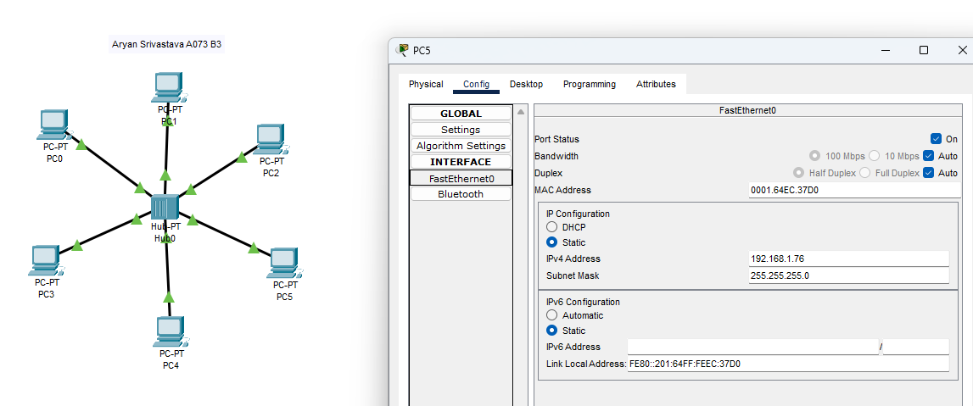

3. Go to command prompt of PC0 and type **arp –a**. Note the results.

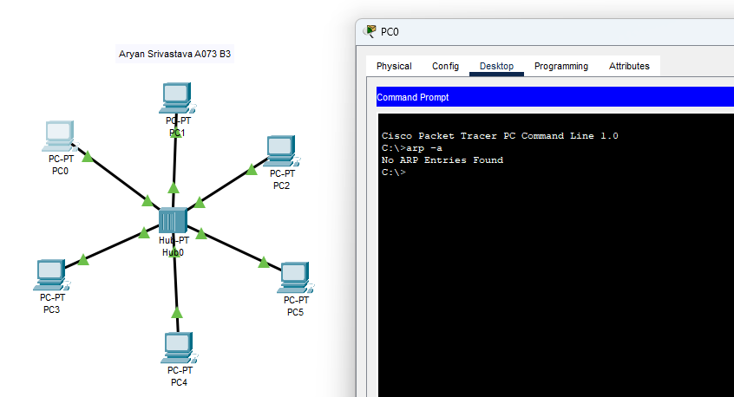

4. Go to simulation mode, in the Event List Filters section, click the Edit Filters button. Select only

ICMP and ARP packets. Select simple PDU from PC0 to PC5, click on capture/forward button.

Observe the ARP packet details – Take screen shots.

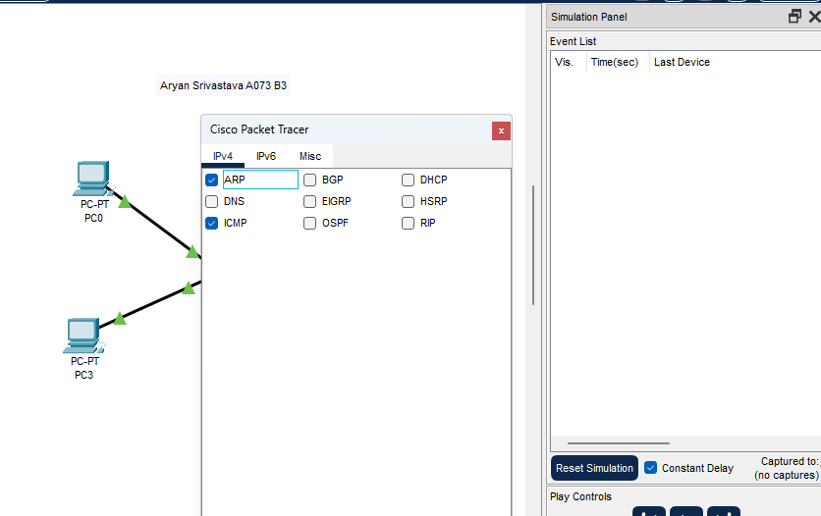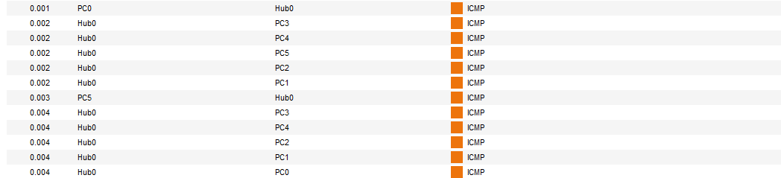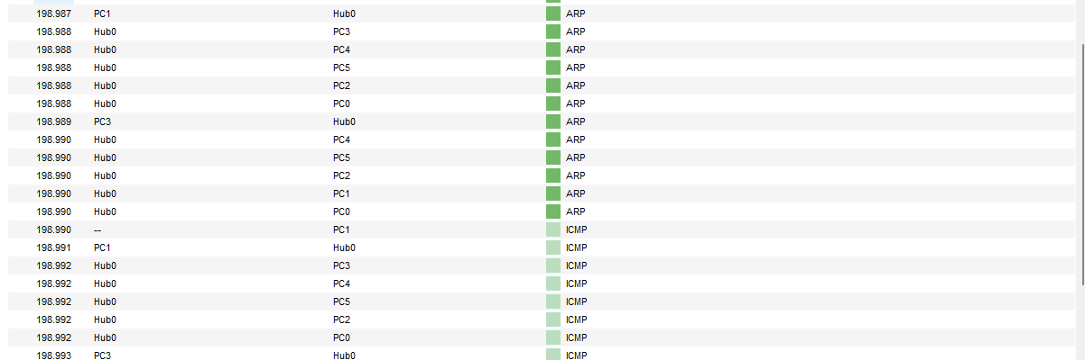

5. Repeat the step 3 again and note the results. Also check if PC5 knows the MAC address of PC0.

Take screen shots.

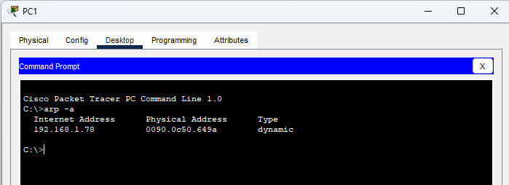

6. Clear the simulation (delete the scenario; press Delete button in the bottom pane). Then send a

simple PDU from PC0 to PC5, and from PC4 to PC0 in simulation mode at the same time. Run the

simulation and note the results. Take screen shots.

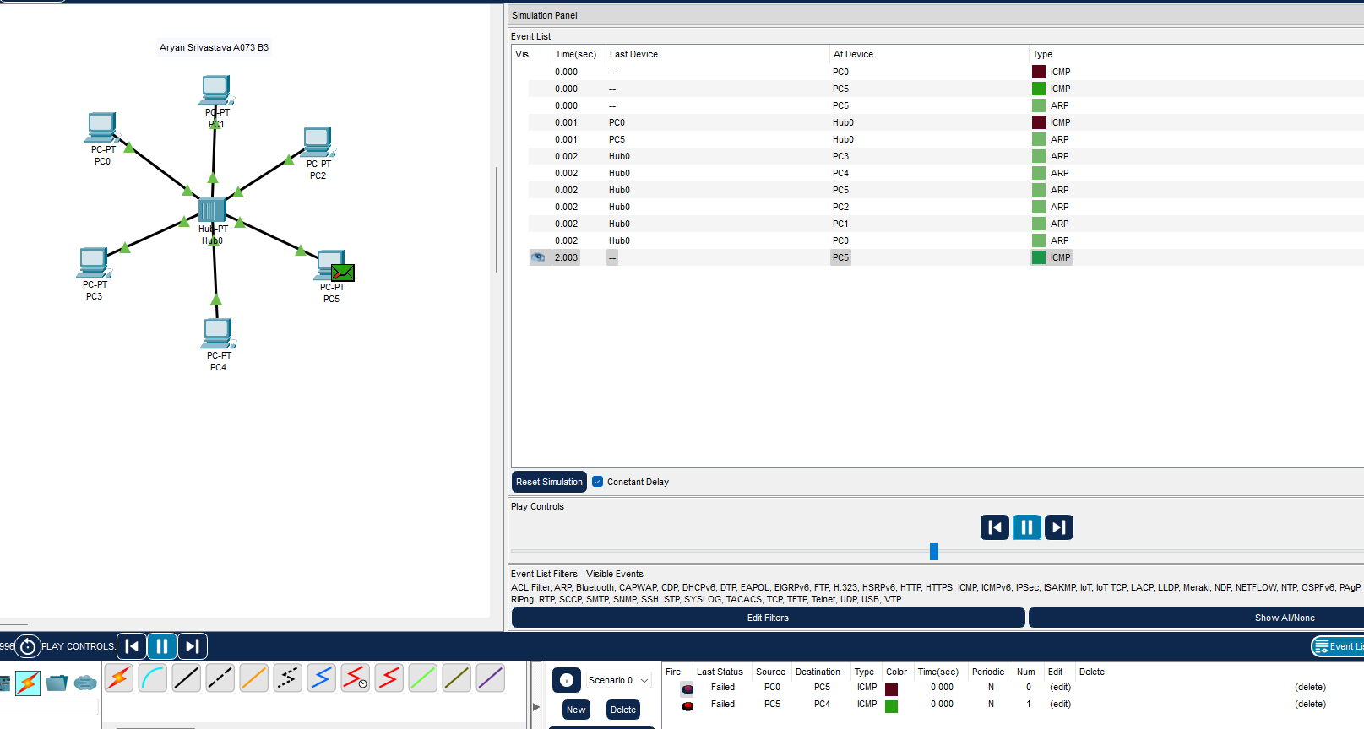

7. Switch OFF the hub and Add more port in hubs by adding interface PT-REPEATER-NM-1CE. Extend

the network as shown in the figure.

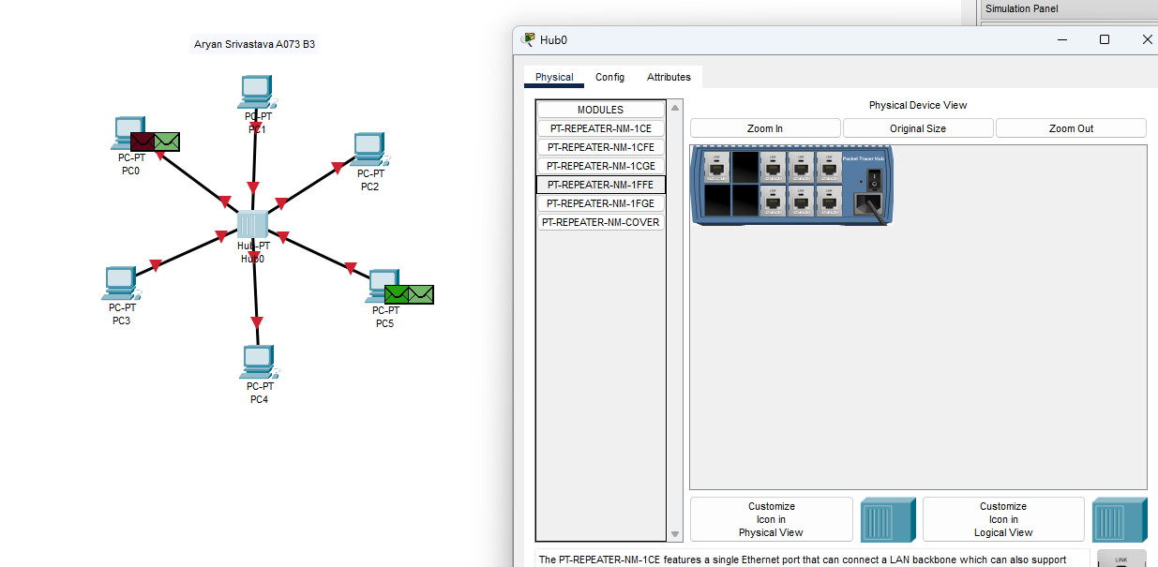

8. Send the simple PDU from PC0 to PC4, PC5 to PC4 and PC11 to PC5, in simulation mode all at the

same time. Note the results. Take screen shots

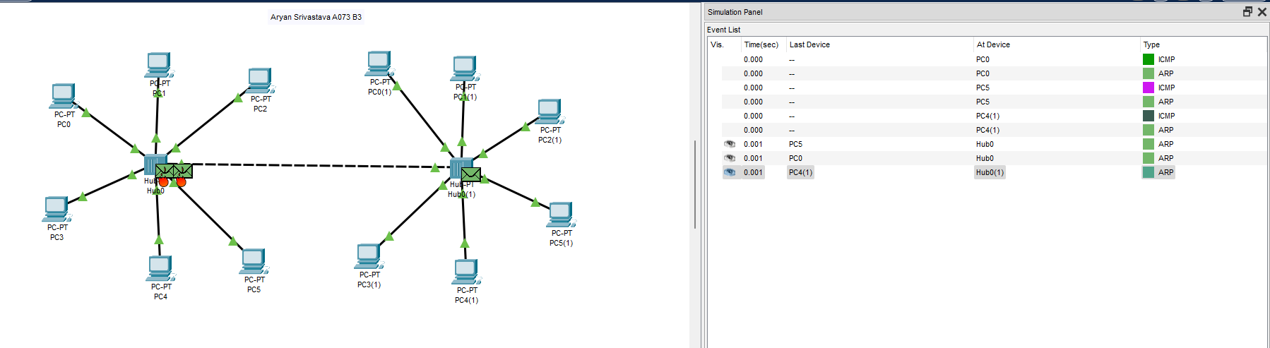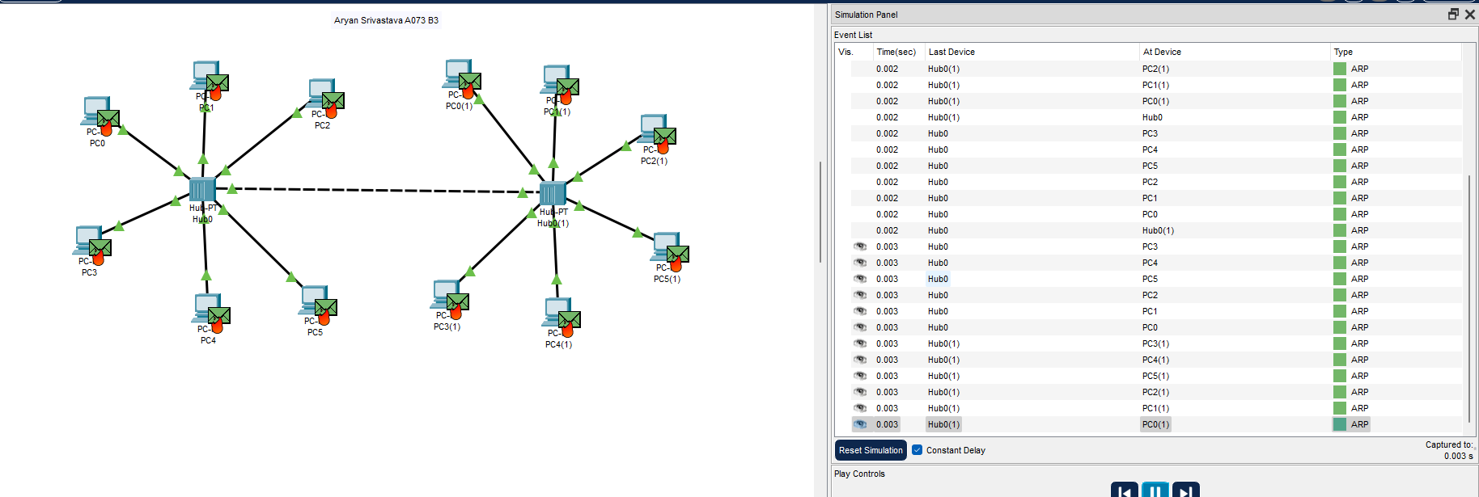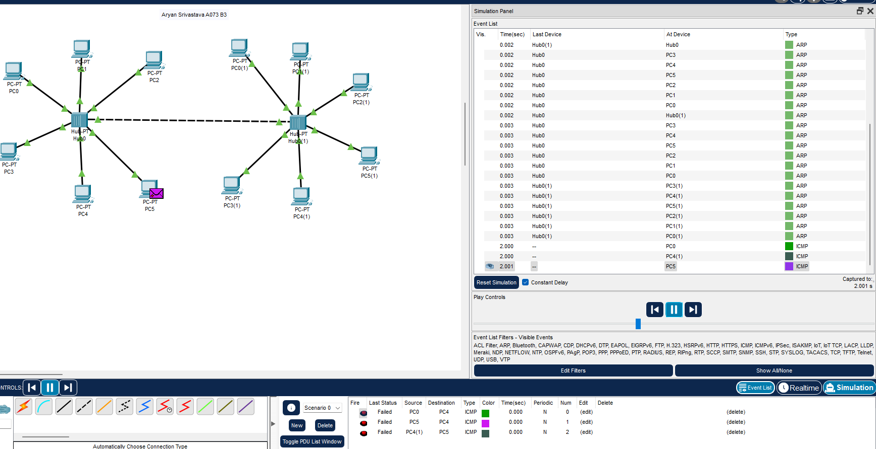

9. Replace the hub with switch in the single network figure. On the switch, go to CLI and type ***show mac address-table***. Run this command before sending the packets and after sending the packets.

Repeat steps 3 to 6. Note the

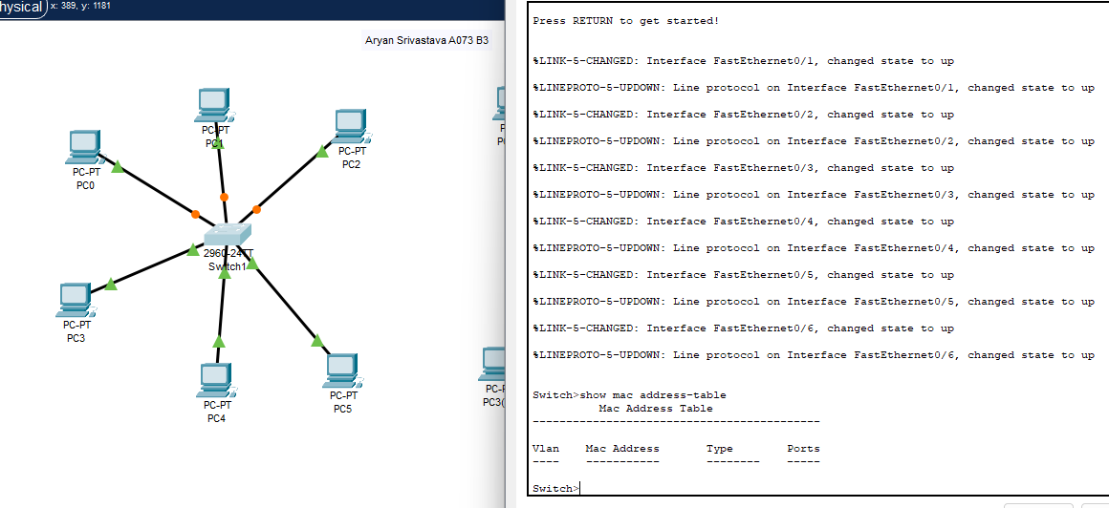 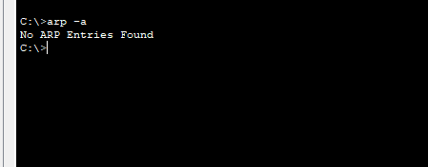 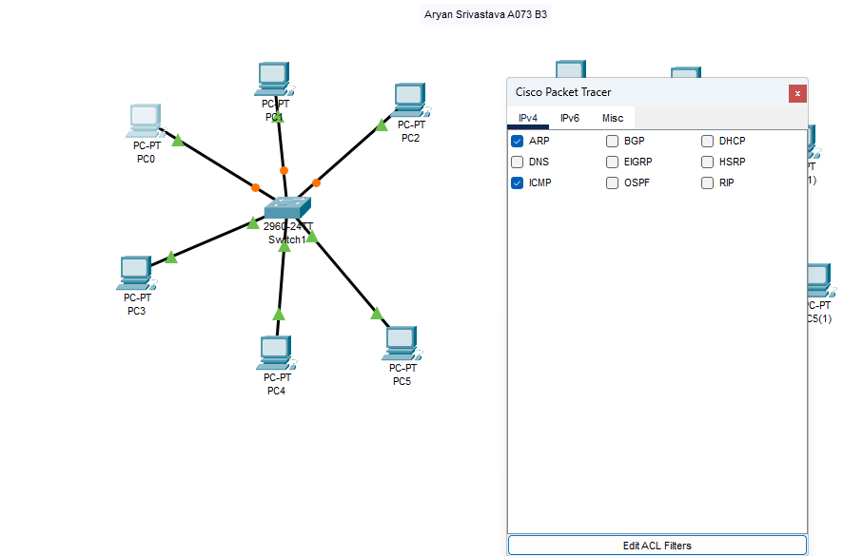 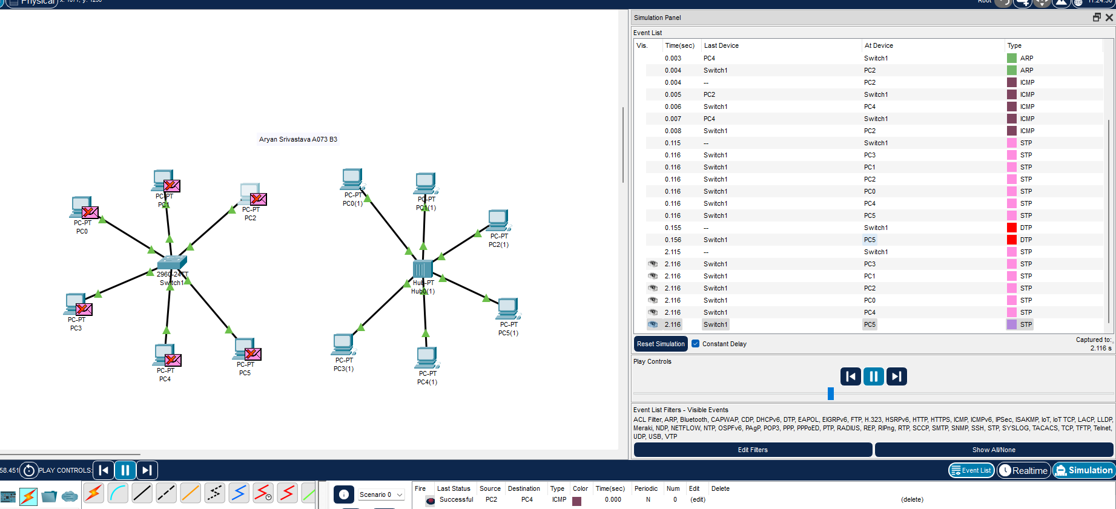 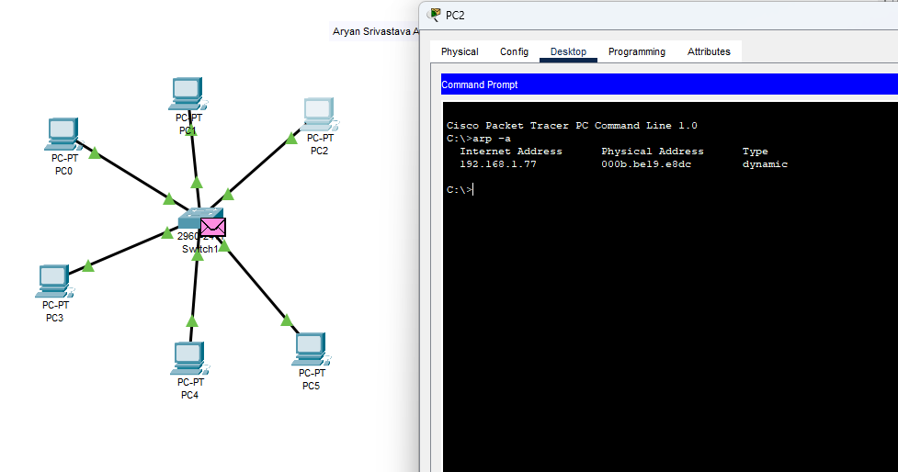 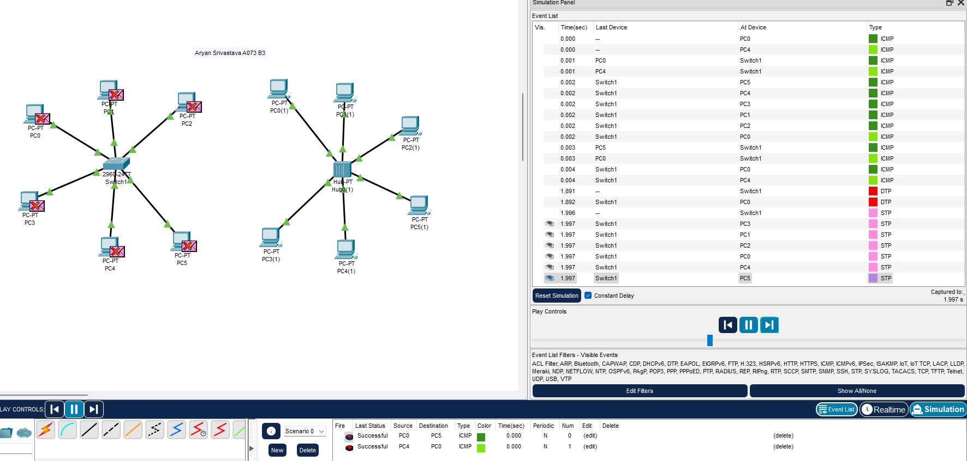 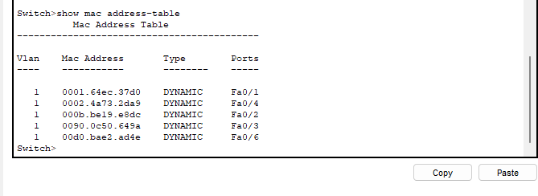

10.Similarly replace hub with switch for two networks figure. Repeat step 8 and Note the results

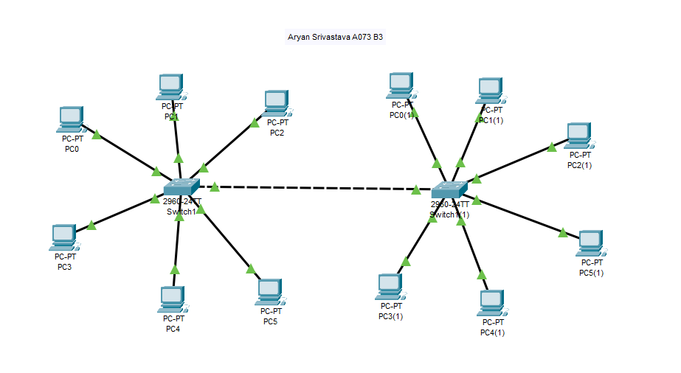 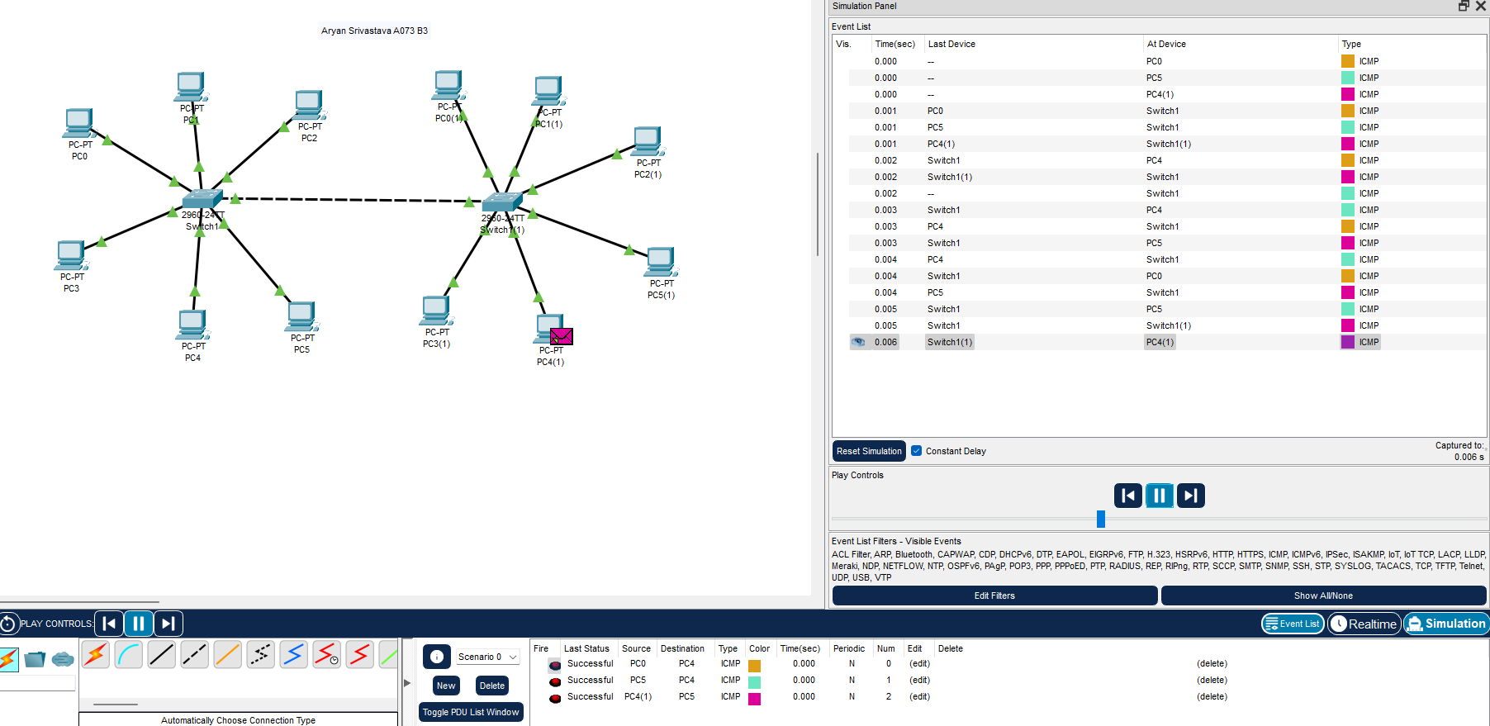

**PART - B**

(TO BE COMPLETED BY STUDENTS)

(Students must submit the soft copy as per the following segments within two hours of the practical. The soft copy must be submitted on the portal or on MS Teams before the deadline)

|  |  |
| --- | --- |
| Roll.No. : | Name: |
| Sem/Year : | Batch: |
| Date of Experiment : | Date of Submission: |
| Grade -- |  |

# B.1: Procedure of performed experiment

1. Capture and Document Steps: Provide clear and legible screenshots of all the steps showing the operation of the network with both the hub and the switch in a shared medium environment.

-Refer to part A

1. Initial ARP Table Observation: Note the output of step 3. Explain why no entries were found initially in the ARP table.
2. Analysis of ARP Packet Details: Present the ARP packet details observed in step 4. Explain the significance of the FFFF.FFFF.FFFF MAC address.
3. Discovery of MAC Address: Describe in detail how PC0 discovers the MAC address of PC5. Include a screenshot of the step 5 simulation for clarity.
4. Simulation Analysis of Step 6: Observe and describe the events that occur during the simulation in step 6. Provide a screenshot of this simulation and a detailed explanation of the outcomes.
5. Simulation Analysis of Step 8: Observe the simulation results from step 8 and include a screenshot of the output. Describe the reasoning behind the observed results.
6. Switch MAC Address Table Formation: Include screenshots of the output from step 9. Explain how the switch forms its MAC address table based on the observed data.
7. Explanation of Carrier Sense in CSMA/CD: Define and explain the concept of carrier sense within the CSMA/CD protocol, detailing its role and significance in Ethernet networking.

**B.2: Questions of Curiosity:**

a)Howdoes the presence of a switch, as opposed to a hub, impact network performance in terms of collision frequency and data throughput?

b) What are the potential consequences if multiple stations on an Ethernet network consistently collide and fail to transmit data successfully? How does the CSMA/CD protocol mitigate such scenarios?

# B.3: Observations and Learning’s:

(Students are expected to comment on the output obtained with clear observations and learning for each task/ sub part assigned)

# B.4: Conclusion

(Students must write the conclusion as per the attainment of individual outcome listed above and learning/observation noted in section B.3)