|  |  |  |  |
| --- | --- | --- | --- |
| Description: nmims-new-logo | **SVKM’s NMIMS**  **Mukesh Patel School of Technology Management & Engineering** | | |
| **Department of Computer Engineering** | | |
| **Instructor Manual** | | **Lab Manual (Part-A)** | **Academic Year- 2024-25** |
| **Year:-I** | | **Subject:- Web Technologies** | **Semester:- I** |

|  |  |  |
| --- | --- | --- |
| **Experiment # 3A** | | |
| Aryan Srivastava | A073 | **Date of Conduction:- / /2024** |
| **Class:- MCA** | | **Division:- A** |

**A.1 Aim: To implement**

1. Design of static webpage with HTML and CSS

2. Understand CSS Box Model

3. Understand CSS properties- font, text, background

**A.2 Prerequisite:**

HTML

**A.3 Outcome:**

After successful completion of this experiment students will be able to

1. Understand and implement CSS properties- font, text, border, background, box model

2. Implement CSS layouts as given below (as separate web pages)

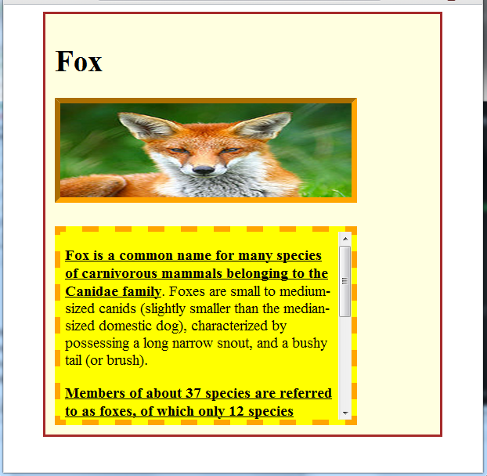

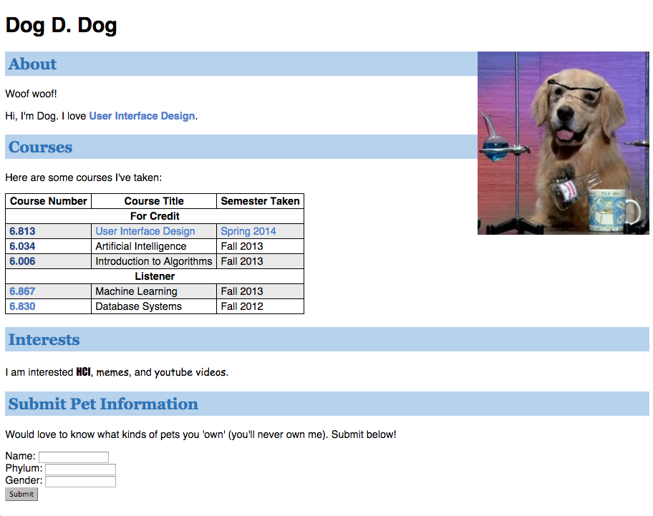

**A.4 Theory:**

* CSS is a language that describes the style of a HTML document.
* CSS describes how HTML elements should be displayed.
* CSS stands for Cascading Style Sheets
* CSS syntax

Selector , declaration

Ex: h1 Selector

{

font-size:12 Declaration

}

* 3 Types of CSS
  + Inline Style
    - CSS code written with the tag we want to apply style with
    - <h1 style="color:blue;margin-left:30px;">This is a heading</h1>
  + Internal Style
    - CSS code written in the head part of the html
    - <head>  
      <style>  
      body {  
          background-color: linen;  
      }  
        
      h1 {  
          color: maroon;  
          margin-left: 40px;  
      }   
      </style>  
      </head>
  + External Style
    - Css code written in external file and file name included in html head
    - <head>  
      <link rel="stylesheet" type="text/css" href="mystyle.css">  
      </head>

**Example of Box model properties:**

**BOX MODEL PROPERTIES**

<HTML>

<HEAD>

<TITLE>Examples of margins, padding, and borders</TITLE>

<STYLE type="text/css">

UL {

background: yellow;

margin: 0px 0px;

padding: 3px 3px 3px 3px;

/* No borders set */

}

LI {

color: white; /* text color is white */

background: blue; /* Content, padding will be blue */

margin: 12px 12px 12px 12px;

margin: 12px 12px;

margin: 12px;

margin:12px 12px 12px;

padding: 12px 0px 12px 12px; /* Note 0px padding right */

list-style: none; /* no glyphs before a list item

list-style:circle;

list-style: square;

list-style: disc;

list-style: upper-roman;

list-style-image: none;

list-style-image: url("nature.jpg"); */

list-style-image: linear-gradient(to left bottom,red,blue);

width:150px;

height:150px;

box-sizing:border-box; /*included padding and margin*/

/* box-sizing: content-box; doesnt include padding and border*/

border:1px dotted;

}

.withborder {

border-style: dashed;

border-width: medium; /* sets border width on all sides */

border-color: lime;

}

</STYLE>

</HEAD>

<BODY>

<UL>

<LI>First element of list

<LI class="withborder">Second element of list is a bit longer to illustrate wrapping.

</UL>

</BODY>

</HTML>

**PART B**

**B.1 Software Code written by student: B.2 Input and Output**

**B.2 Input and Output**

<!DOCTYPE html>

<html lang="en">

<head>

    <meta charset="UTF-8">

    <meta name="viewport" content="width=device-width, initial-scale=1.0">

    <title>Document</title>

    <style>

        body {

            background-color: rgb(255, 249, 183);

            margin: 0;

            padding: 0;

        }

        .image {

            background-image: url('silly.jpg');

            width: 400px;

            height: 300px;

            background-repeat: no-repeat;

            background-size: cover;

            background-position: center;

            border: 10px solid transparent;

            border-image: linear-gradient(to bottom right, rgb(198, 109, 0), rgb(255, 200, 0));

            border-image-slice: 1;

            margin: 40px 0px 40px 40px;

        }

        .text{

            border: 8px dashed pink;

            font-size: 20px;

            width: 400px;

            height: 300px;

            overflow-y: auto;

            padding: 10px;

            margin: 40px 0px 40px 40px;

        }

    </style>

</head>

<body>

    <h1 style=" margin: 40px 0px 40px 40px;">FoxMan</h1>

    <div class="image"></div>

    <div class="text"><b><u>Lorem ipsum dolor, sit amet consectetur adipisicing elit. Alias quasi nostrum animi sapiente.</u></b> Consequuntur excepturi illo nemo saepe doloremque! Suscipit totam ipsam, minima ipsa repudiandae expedita accusamus qui esse veritatis optio, error facere beatae provident ipsum illo! Totam esse est soluta nemo alias enim repellat veritatis harum culpa ad aperiam deleniti, ex, perspiciatis molestias! Molestias, accusantium! Quidem ducimus ad nulla. Fuga, doloribus quod, porro voluptatibus fugiat cum molestiae ipsum accusamus iusto reprehenderit a eum necessitatibus. Quam consectetur voluptatum ipsa fugiat saepe exercitationem aspernatur neque alias quis, cupiditate, reiciendis necessitatibus beatae nostrum illum expedita est quidem deleniti! Tempora porro id ipsa placeat quasi, veritatis culpa delectus incidunt nulla ratione soluta autem fuga quam! Similique minus suscipit reiciendis, in nam, perspiciatis autem nihil quis quos necessitatibus culpa repellendus illo omnis, qui deleniti! Ea illo quibusdam repellat fugiat laudantium facilis molestiae magni deserunt! Deserunt illum impedit vitae fuga eaque esse similique quod facilis vero commodi assumenda nihil voluptatem porro voluptas nobis debitis necessitatibus labore obcaecati totam, enim odit natus neque! Quisquam deserunt unde iure voluptatibus saepe sit possimus incidunt ad numquam. Perferendis assumenda maiores nesciunt ad optio quaerat eum pariatur porro aut voluptatum dolorum ullam omnis animi molestiae quis, error nulla harum repellendus.</div>

</body>

</html>

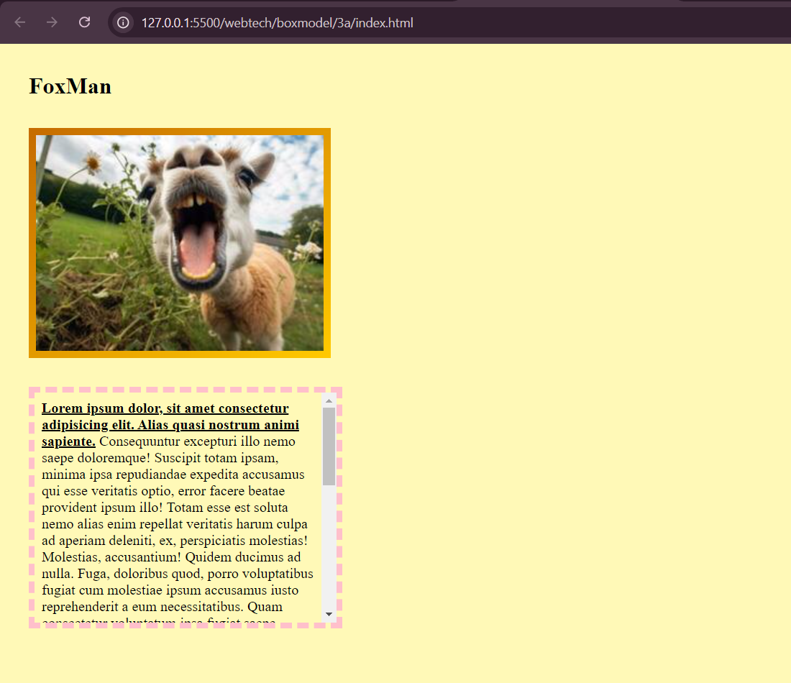

<!DOCTYPE html>

<html lang="en">

<head>

    <meta charset="UTF-8">

    <meta name="viewport" content="width=device-width, initial-scale=1.0">

    <title>Document</title>

    <style>

        body {

            padding: 0px;

            margin: 10px;

            position: relative; /* Add this to allow positioning of child elements */

        }

        .title {

            font-size: 24px;

            font-family: 'Times New Roman', Times, serif;

            font-weight: bolder;

            background-color: rgb(163, 197, 255);

            color: rgb(85, 70, 255);

        }

        .text {

            line-height: 30px;

        }

        span {

            color: rgb(85, 70, 255);

        }

        table {

            border: 2px solid gray;

            border-collapse: collapse;

        }

        th, td {

            border: 2px solid gray;

            text-align: center;

            padding: 0px;

            margin: 0px;

            width: 250px;

            height: 28px;

        }

        .label {

            font-family: Cambria, Cochin, Georgia, Times, 'Times New Roman', serif;

            font-weight: bold;

        }

        .top-right-image {

            position: absolute;

            top: 10px;

            right: 10px;

            width: 100px; /* Adjust width as needed */

            height: auto; /* Maintain aspect ratio */

        }

    </style>

</head>

<body>

    <img src="cat.png" alt="Top Right Image" class="top-right-image">

    <h2>Car Mehta</h2>

    <div class="title">About</div>

    <div class="text">Lorem ipsum dolor sit amet consectetur <br>adipisicing elit. Soluta incidunt,<span> ut error tempora laborum placeat blanditiis</span>eveniet quis accusamus nam.</div>

    <div class="title">Courses</div>

    <div class="text">Lorem, ipsum dolor sit amet consectetur adipisicing elit. Obcaecati, quae.</div>

    <table>

        <tr>

            <th>Cource number</th>

            <th>Course title</th>

            <th>Semister Exam</th>

        </tr>

        <tr>

            <td colspan="3">Full Credit</td>

        </tr>

        <tr>

            <td>9283</td>

            <td style="color: rgb(85, 70, 255);;">User Design</td>

            <td>Spring 24'</td>

        </tr>

        <tr>

            <td>9283</td>

            <td>User Design</td>

            <td>Spring 24'</td>

        </tr>

        <tr>

            <td>9283</td>

            <td>User Design</td>

            <td>Spring 24'</td>

        </tr>

        <tr>

            <td colspan="3">Listener</td>

        </tr>

        <tr>

            <td>9283</td>

            <td>User Design</td>

            <td>Spring 24'</td>

        </tr>

        <tr>

            <td>9283</td>

            <td>User Design</td>

            <td>Spring 24'</td>

        </tr>

    </table>

    <div class="title">Interests</div>

    <div class="text">Lorem, ipsum dolor sit amet

        <span style="background-color: rgb(163, 197, 255); color: rgb(249, 70, 100);

        font-family: Impact, Haettenschweiler, 'Arial Narrow Bold', sans-serif;">consectetur</span> adipisicing elit.

        Illum <span style="font-family: 'Trebuchet MS', 'Lucida Sans Unicode', 'Lucida Grande', 'Lucida Sans', Arial, sans-serif;

        color: blue;">a minus</span> voluptas placeat dolores quis soluta voluptatem fugit, fugiat aut!</div>

    <div class="title">Submit Pet Information</div>

    <div class="text">Lorem ipsum dolor sit amet consectetur adipisicing elit. Quae, consequuntur.</div>

    <div><label class="label" for="">Name: </label><input type="text"></div>

    <div><label class="label" for="">Phanum: </label><input type="text"></div>

    <div><label class="label" for="">Gender: </label><input type="text"></div>

    <input style="background-color: rgb(174, 174, 174);" type="button" value="Submit karoooo">

</body>

</html>

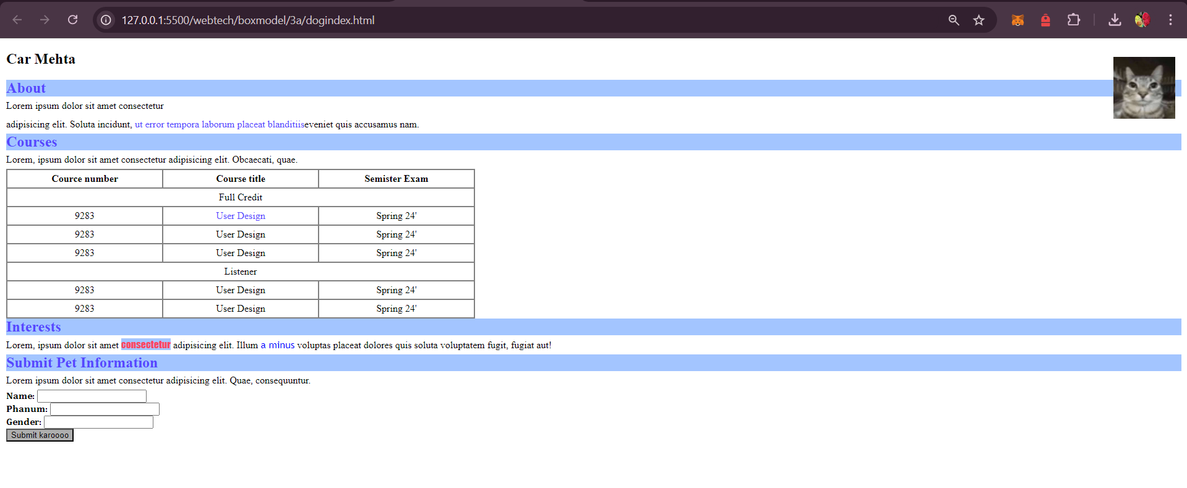

**B.3. Observations and Learning**

**Learnt about the box model of CSS**

**B.4. Conclusion**

**Successfully implemented the CSS box model**