|  |  |  |  |
| --- | --- | --- | --- |
| Description: nmims-new-logo | **SVKM’s NMIMS**  **Mukesh Patel School of Technology Management & Engineering** | | |
| **Department of Computer Engineering** | | |
| **Instructor Manual** | | **Lab Manual (Part-A)** | **Academic Year- 2024-25** |
| **Year:-I** | | **Subject:- Web Technologies** | **Semester:- I** |

|  |  |  |
| --- | --- | --- |
| **Experiment # 3B** | | |
| Aryan Srivastava | A073 | **Date of Conduction:- / /2024** |
| **Class:- MCA** | | **Division:-A** |

**A.1 Aim: To implement**

1. Design of static webpages with HTML and CSS

2. Understand and implement CSS Advanced Properties

3. Understand and implement CSS Transition, transforms and animations.

**A.2 Prerequisite:**

HTML

**A.3 Outcome:**

After successful completion of this experiment students will be able to

1. Understand and implement CSS properties- box model and certain advanced properties.

Tasks to be completed: Implement CSS layout as given below (as separate web page)

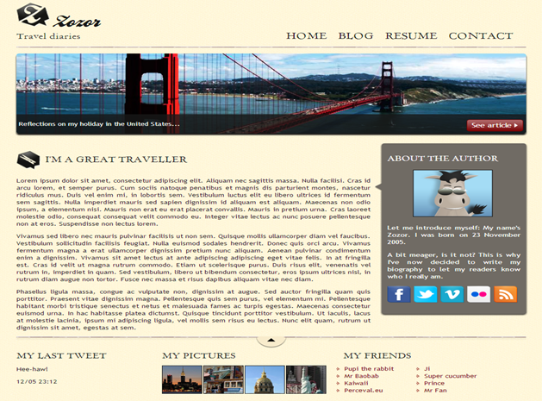

1. Implement CSS transitions- Creating a Smooth Hover Effect
   * Create an HTML file with a basic structure.
   * Add a button element to the HTML body.
   * Apply CSS to style the button, including properties like background-color, color, padding, and border.
   * Use the :hover pseudo-class to change the button’s background color and text color.
   * Apply a CSS transition to the button to make the color change smooth.
2. Implement CSS transforms: Rotating and Scaling an Image

* Create an HTML file with a basic structure.
* Add an image element to the HTML body.
* Apply CSS to style the image, including setting its width and border.
* Use the :hover pseudo-class to apply a rotation and scale transform to the image.
* Add a CSS transition to make the transform smooth.

1. CSS Animations - Creating a Bouncing Ball

* Create an HTML file with a basic structure.
* Add a div element to represent the ball.
* Apply CSS to style the div, making it look like a ball (circular shape, color, etc.).
* Use the @keyframes rule to create a bounce animation.
* Apply the animation to the ball using the animation property.

**A.4 Theory:**

* CSS is a language that describes the style of a HTML document.
* CSS describes how HTML elements should be displayed.
* CSS stands for Cascading Style Sheets
* CSS syntax

Selector , declaration

Ex: h1 Selector

{

font-size:12 Declaration

}

* 3 Types of CSS
  + Inline Style
    - CSS code written with the tag we want to apply style with
    - <h1 style="color:blue;margin-left:30px;">This is a heading</h1>
  + Internal Style
    - CSS code written in the head part of the html
    - <head>  
      <style>  
      body {  
          background-color: linen;  
      }  
        
      h1 {  
          color: maroon;  
          margin-left: 40px;  
      }   
      </style>  
      </head>
  + External Style
    - Css code written in external file and file name included in html head
    - <head>  
      <link rel="stylesheet" type="text/css" href="mystyle.css">  
      </head>

**Example of CSS Transition, transforms and animations:**

CSS Transitions allow you to change property values smoothly (over a given duration) rather than instantly, enhancing user experience.

* Transition Property: Defines which CSS properties will be transitioned (e.g., background-color, color).
* Duration: Specifies the length of time the transition takes (e.g., 0.3s for 300 milliseconds).
* Timing Function: Controls the pace of the transition (e.g., ease, linear).
* Hover Effect: When the user hovers over the button, the :hover pseudo-class triggers the transition, changing the background color and text color smoothly.

CSS Transforms enable you to apply 2D or 3D transformations to elements, like rotating, scaling, skewing, or translating.

* Transform Property: Applies transformation functions to elements (e.g., rotate(), scale()).
* Rotate: Rotates the element by a specified degree (e.g., rotate(15deg)).
* Scale: Enlarges or shrinks the element based on a scaling factor (e.g., scale(1.1)).
* Transition: Combining transforms with transitions allows for smooth changes, like a rotating and scaling effect when the image is hovered.

CSS Animations allow you to create keyframe-based animations that can make elements move, change color, grow/shrink, and more, without JavaScript.

* @keyframes: Defines the animation's keyframes, specifying the start, end, and intermediate steps of the animation (e.g., 0%, 50%, 100%).
* Animation Property: Used to apply the animation to an element. Key properties include animation-name, animation-duration, and animation-iteration-count.
* Bounce Effect: By altering the transform property within the keyframes, you can create a bouncing effect by translating the element up and down.

**Note: It is left to discretion of students to decide the topic to make website on. Also students are given freedom to learn more tags and implement it much better to improve UI of the web page.**

**PART B**

**(PART B: TO BE COMPLETED BY STUDENTS)**

**(Students must submit the soft copy as per following segments within two hours of the**

**practical. The soft copy must be uploaded on the portal at the end of the practical)**

**B.1 Software Code written by student:**

**B.2 Input and Output**

<!DOCTYPE html>

<html lang="en">

<head>

    <meta charset="UTF-8">

    <meta name="viewport" content="width=device-width, initial-scale=1.0">

    <title>Lozor - Travel Diaries</title>

    <link rel="stylesheet" href="styles.css">

    <link rel="stylesheet" href="https://cdnjs.cloudflare.com/ajax/libs/font-awesome/6.0.0-beta3/css/all.min.css">

    <style>

        body {

            font-family: Arial, sans-serif;

            background-color: #F5F5DC;

            color: #333;

            margin: 0;

            padding: 0;

            width: 100vw;

            overflow-x: hidden;

        }

        html,

        body {

            height: 100%;

            margin: 0;

            padding: 0;

        }

        .container {

            width: 100%;

            height: 100%;

            background-color: #F5F5DC;

            color: #333;

            ;

            margin: 0;

            padding: 0;

            box-sizing: border-box;

        }

        header {

            display: flex;

            justify-content: space-between;

            align-items: center;

            padding: 20px;

            background-color: #F5F5DC;

            color: #333;

            border-bottom: 2px solid #0b0b0b;

        }

        header .left-side {

            display: flex;

            flex-direction: column;

        }

        header h1 {

            font-family: 'Georgia', serif;

            font-size: 36px;

            margin: 0;

        }

        header h4 {

            font-size: 18px;

            margin: 5px 0;

        }

        header nav {

            display: flex;

            align-items: center;

            margin-left: auto;

        }

        header nav ul {

            list-style-type: none;

            padding: 0;

            margin: 0;

        }

        header nav ul li {

            display: inline;

            margin-left: 20px;

        }

        header nav ul li a {

            text-decoration: none;

            color: #333;

            font-weight: bold;

        }

        header::after {

            content: "";

            display: block;

            clear: both;

            border-bottom: 2px solid #DDD;

        }

        .main-image {

            position: relative;

            text-align: center;

            height: 23vh;

            overflow: hidden;

        }

        .bridge-image {

            width: calc(100% - 20px);

            height: auto;

            border-radius: 30px;

            display: inline-block;

        }

        .main-image p {

            position: absolute;

            bottom: 1px;

            left: 10px;

            right: 10px;

            color: #FFF;

            background-color: rgba(0, 0, 0, 0.75);

            padding: 20px;

        }

        .button {

            position: absolute;

            bottom: 20px;

            right: 20px;

            background-color: #B22222;

            color: #FFF;

            padding: 10px 15px;

            text-decoration: none;

        }

        .content {

            display: flex;

            justify-content: space-between;

            padding: 20px 0;

        }

        .intro {

            width: 65%;

        }

        .intro h2 {

            font-family: 'Georgia', serif;

            font-size: 24px;

            margin-top: 0;

        }

        .about {

            width: 20%;

            color: #FFF;

            background-color: #464848;

            padding: 15px;

            border: 1px solid #000000;

        }

        .about img {

            width: 70%;

            height: auto;

            margin-left: 30px;

        }

        .social-icons {

            margin-top: 15px;

            display: flex;

            justify-content: start;

        }

        .social-icon {

            text-decoration: none;

            margin-right: 10px;

            font-size: 24px;

            display: inline-block;

            color: #666;

            transition: color 0.3s ease;

        }

        .social-icon.facebook {

            color: #3b5998;

        }

        .social-icon.twitter {

            color: #1DA1F2;

            margin-left: 20px;

        }

        .social-icon.rss {

            color: #ff6600;

            margin-left: 20px;

        }

        footer {

            display: flex;

            justify-content: space-between;

            padding: 20px 0;

            border-top: 2px solid #DDD;

            margin-top: 20px;

        }

        footer div {

            width: 30%;

        }

        footer h4 {

            margin-top: 0;

        }

        footer img {

            width: 30%;

            margin-right: 5px;

        }

        footer .pictures img {

            height: 60px;

        }

        .friends ul {

            list-style-type: disc;

            padding-left: 0;

            margin: 0;

            display: flex;

            flex-wrap: wrap;

            gap: 10px;

        }

        .friends ul li {

            width: 45%;

            margin-bottom: 5px;

            list-style-position: inside;

            box-sizing: border-box;

        }

        li {

            color: red;

        }

    </style>

</head>

<body>

    <div class="container">

        <header>

            <h1>Lozor</h1>

            <nav>

                <ul>

                    <li><a href="#">Blog</a></li>

                    <li><a href="#">Resume</a></li>

                    <li><a href="#">Contact</a></li>

                </ul>

            </nav>

        </header>

        <br>

        <br>

        <div class="main-image">

            <img src="silly.jpg" alt="Bridge Image" class="bridge-image">

            <p>Reflections on my holiday in the United States...</p>

            <a href="#" class="button">See article »</a>

        </div>

        <section class="content">

            <article class="intro">

                <h2>I'm a Great Traveller</h2>

                <p style="font-size: 16px; "><b>Traveling is more than just visiting new places; it's a way of life, an adventure that expands the mind and enriches the soul.

                     For me, being a traveler means embracing the unknown and stepping out of my comfort zone to explore the diverse cultures,

                      landscapes, and experiences the world has to offer. It’s a journey that goes beyond the physical

                     act of moving from one place to another—it's a transformative experience that shapes who I am and how I view the world.

                    From the moment I set foot in a new destination, I am captivated by the unique tapestry of sights, sounds, and smells that define it.

                     Every corner of the globe has its own story, and I find joy in uncovering these narratives. Whether it's wandering through bustling city markets,

                      hiking up majestic mountains, or relaxing on serene beaches, each experience adds a new layer to my understanding of the world.

                    Traveling has taught me the value of adaptability and openness. It’s about more than just ticking off items on a bucket list; it’s about

                    immersing oneself in different cultures and learning from them. Every interaction with locals, every new tradition or custom I encounter,

                    and every historical site I visit contributes to a broader perspective on life. I’ve learned to appreciate the beauty of diversity and the

                     importance of cultural exchange.<br> <br>

                    One of the most rewarding aspects of travel is the connections I make along the way. Meeting people from different backgrounds and sharing

                     stories and experiences creates a sense of camaraderie that transcends geographical and cultural boundaries. These friendships often become

                      cherished memories and remind me of the shared humanity that connects us all.

                    Travel also brings with it its own set of challenges and surprises. Navigating unfamiliar places, overcoming language barriers, and adapting

                     to different environments can be daunting, but these challenges are what make the journey memorable. They test my problem-solving skills and

                      resilience, and ultimately, they contribute to personal growth.<br><br>

                    Beyond personal growth, traveling offers a chance to reflect on what truly matters. It provides moments of solitude and introspection that are often

                     hard to come by in the hustle and bustle of everyday life. It’s

                    during these quiet moments, whether while gazing at a sunset over a remote island or sipping coffee in a quaint European café, that I find clarity and inspiration.

                    Traveling also deepens my appreciation for the natural world. Experiencing the grandeur of nature, from the vastness of the Sahara Desert

                    to the tranquility of a tropical rainforest, fosters a sense of wonder and respect for our planet. It reminds me of the importance of preserving these

                     natural wonders for future generations.</b></p>

            </article>

            <aside class="about">

                <h3>About the Author</h3>

                <img src="cat.png" alt="Author Image">

                <p>Let me introduce myself! My name's Zooro...</p>

                <p>A bit meager, is it not? This is why blogging is needed... (You can add more text here)</p>

                <div class="social-icons">

                    <a href="#" class="social-icon facebook"><i class="fab fa-facebook-f"></i></a>

                    <a href="#" class="social-icon twitter"><i class="fab fa-twitter"></i></a>

                    <a href="#" class="social-icon rss"><i class="fas fa-rss"></i></a>

                </div>

            </aside>

        </section>

        <footer>

            <div class="tweet">

                <h2 style="color: darkgreen;">My Last Tweet</h2>

                <p>Hee-haw!

                    <br>

                    <br> 12/05 23:12</p>

            </div>

            <div class="pictures">

                <h4>My Pictures</h4>

                <img src="cat.png" alt="Picture 1">

                <img src="cat.png" alt="Picture 2">

                <img src="cat.png" alt="Picture 3">

            </div>

            <div class="friends">

                <h4>My Friends</h4>

                <ul>

                    <li>Pig the rabbit</li>

                    <li>Mooseee</li>

                    <li>Beaver</li>

                    <li>Super Cow</li>

                    <li>Raf</li>

                    <li>Mr. Fan</li>

                </ul>

            </div>

        </footer>

    </div>

</body>

</html>

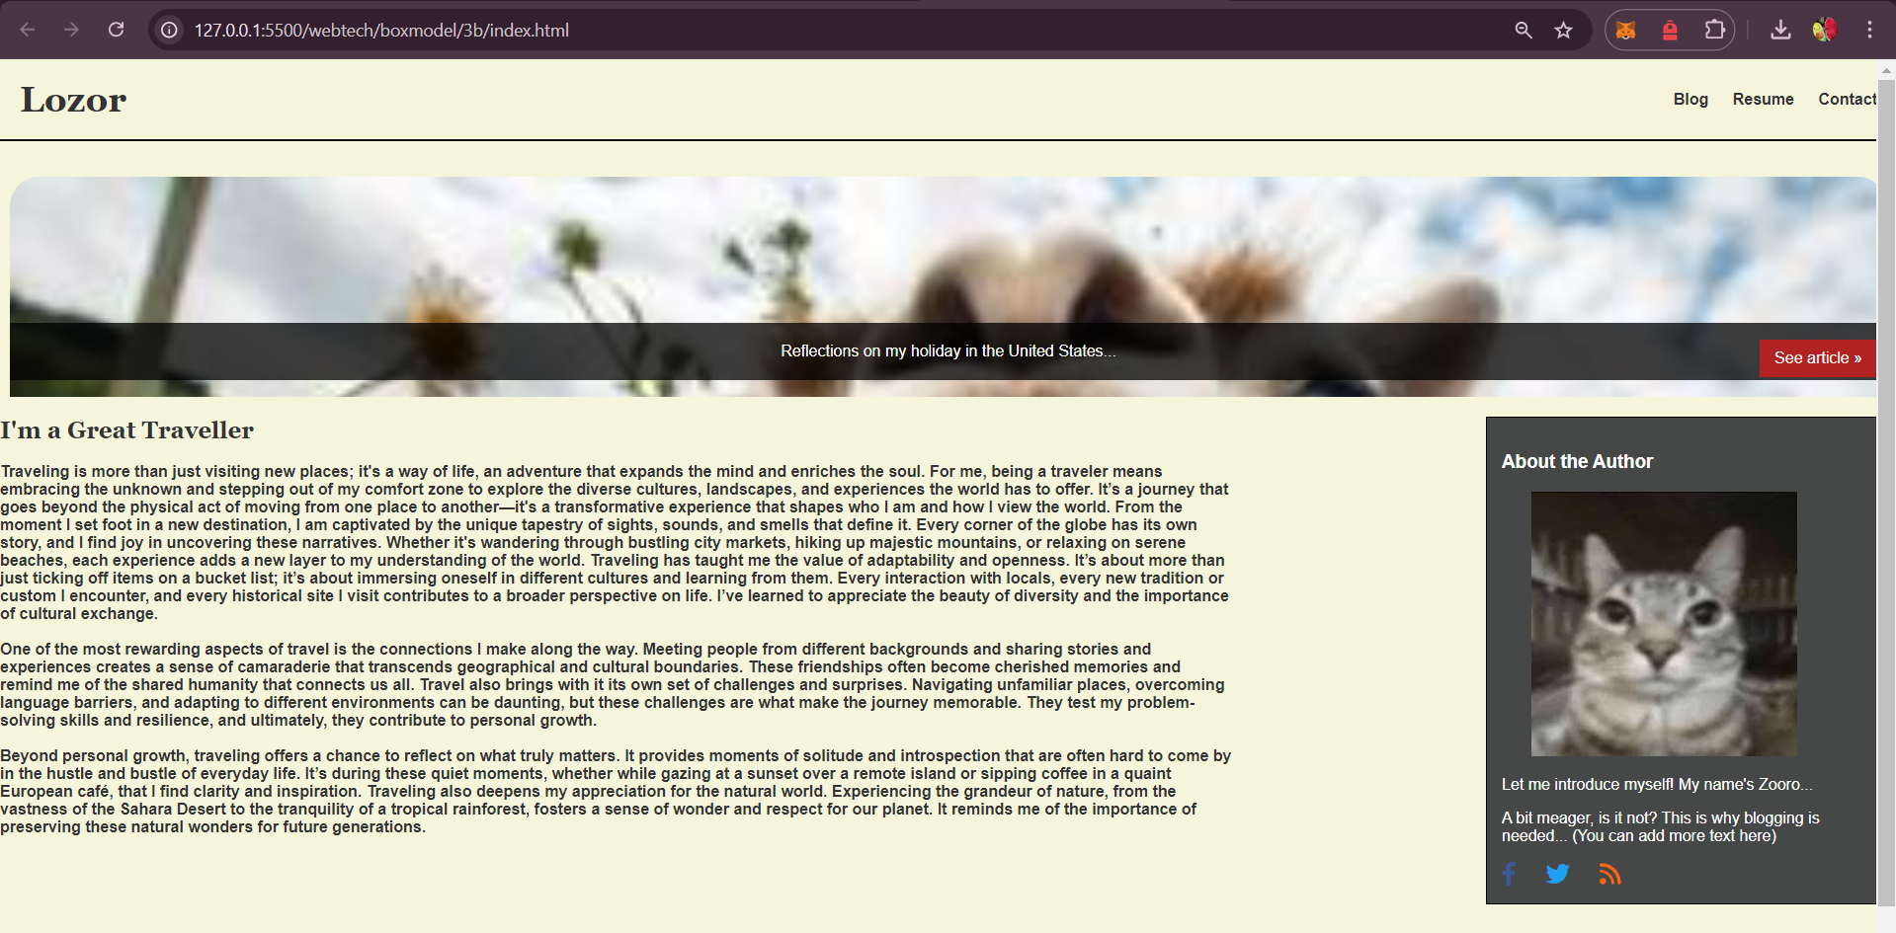

**B.3. Observations and Learning**

**Implementation and observations of CSS box model**

**B.4. Conclusion**

**Successfully implemented Box model**