**PART A**

**Experiment No. 06**

**PART B**

|  |  |
| --- | --- |
| Roll No. :A073 | Name: Aryan Srivastava |
| Class : MCA SEM 1 | Batch : B3 |
| Date of Experiment : | Date/Time of Submission : |
| Grade : |  |

**B.1 Code:**

<!DOCTYPE html>

<html lang="en">

<head>

    <meta charset="UTF-8">

    <meta name="viewport" content="width=device-width, initial-scale=1.0">

    <title>jQuery Actions</title>

    <script src="https://code.jquery.com/jquery-3.6.0.min.js"></script>

    <style>

        #myDiv {

            width: 400px;

            height: 200px;

            background-color: lightblue;

            margin: 10px;

        }

    </style>

</head>

<body>

    <p id="myParagraph">This is a paragraph.</p>

    <button id="toggleBtn">Toggle Paragraph</button>

    <button id="hideShowBtn">Hide for 3 seconds</button>

    <div id="myDiv">Hover over me!</div>

    <button id="fadeBtn">Fade Div</button>

    <button id="slideBtn">Slide Toggle</button>

    <button id="fadeToggleBtn">Fade Toggle</button>

    <button id="animateBtn">Animate Div</button>

    <script>

        $(document).ready(function() {

            $("#toggleBtn").click(function() {

                $("#myParagraph").toggle();

            });

            $("#hideShowBtn").click(function() {

                $("#myParagraph").hide(function() {

                    setTimeout(() => {

                        $(this).show();

                    }, 3000);

                });

            });

            $("#myDiv").hover(

                function() {

                    $(this).fadeOut();

                },

                function() {

                    $(this).fadeIn();

                }

            );

            $("#fadeBtn").click(function() {

                $("#myDiv").fadeOut(function() {

                    setTimeout(() => {

                        $(this).fadeIn();

                    }, 2000);

                });

            });

            $("#slideBtn").click(function() {

                $("#myDiv").slideToggle();

            });

            $("#fadeToggleBtn").click(function() {

                $("#myParagraph").fadeOut(1000, function() {

                    setTimeout(() => {

                        $(this).fadeIn(1000);

                    }, 3000);

                });

            });

            $("#animateBtn").click(function() {

                $("#myDiv").animate({

                    opacity: 0.5,

                    height: "toggle"

                }, 1000);

            });

        });

    </script>

</body>

</html>

**B.2 Output**

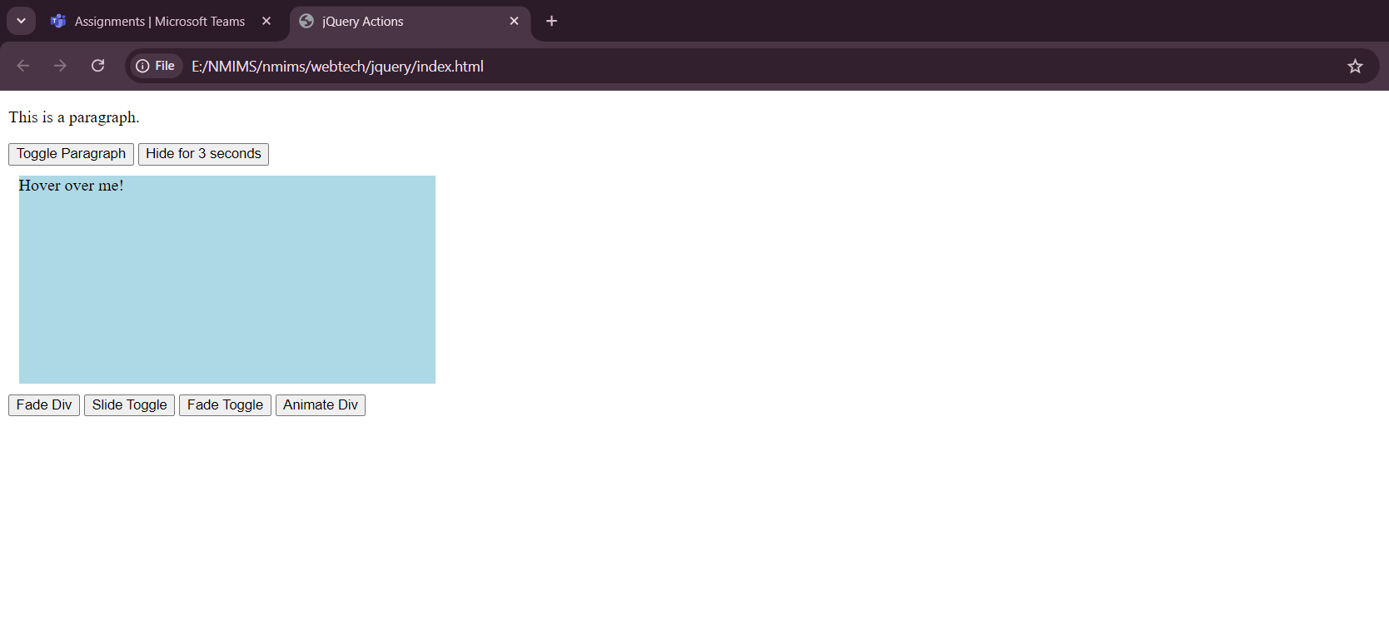

**B.3 Conclusion:**

*Successfully completed and implement JQUERY*

**B.3 Observations and Learning:**

*Successfully completed and implement JQUERY*

**B.4 Question of Curiosity**

**Q1. What is jQuery and what are its primary purposes?**

* **jQuery** is a fast, small, and feature-rich JavaScript library. Its primary purposes are:
  + Simplifying **HTML document traversal and manipulation**.
  + **Event handling**.
  + **Animation** and effects.
  + Handling **AJAX** requests.
  + Providing **cross-browser compatibility**, as it abstracts many browser-specific issues.

**Q2. What are jQuery selectors and how do they differ from CSS selectors?**

* **jQuery selectors** are used to select and manipulate HTML elements. They are based on **CSS selectors**, but jQuery also provides additional selectors and filters that are not available in CSS.
  + jQuery selectors can interact with **DOM elements** and manipulate them (e.g., hide, show, add effects).
  + They also include advanced selectors like :visible, :hidden, or selecting elements by index, which are not part of regular CSS.

**Q3. Explain the purpose of the $(document).ready() function in jQuery.**

* The **$(document).ready()** function ensures that the **DOM** is fully loaded and safe to manipulate before any jQuery code is executed. It prevents scripts from running before the page content is ready, avoiding potential errors with elements that haven't been rendered yet.

**Q4. Explain the purpose of the $(document).ready() function in jQuery.**

* This question is repeated. See the answer for **Q3**.