Environment Light Reaction Project

Part I: Introduction

My project it’s about light, especially how we can change the environments light intensity. Using sensors to measure the basic light level, we can make decisions about outputting the level of light and also how we can affect it to make it optimal for us. Using Arduino uno for basic connection of components and for the programming part we were able to achieve this project as expected.

Part II: Hardware

* Arduino Uno Board
* Small breadboard
* Connectors
* 3 leds for outputting level of light, 4 leds to affect the sensors
* 2 light sensors
* 1 LCD screen
* Rezistors

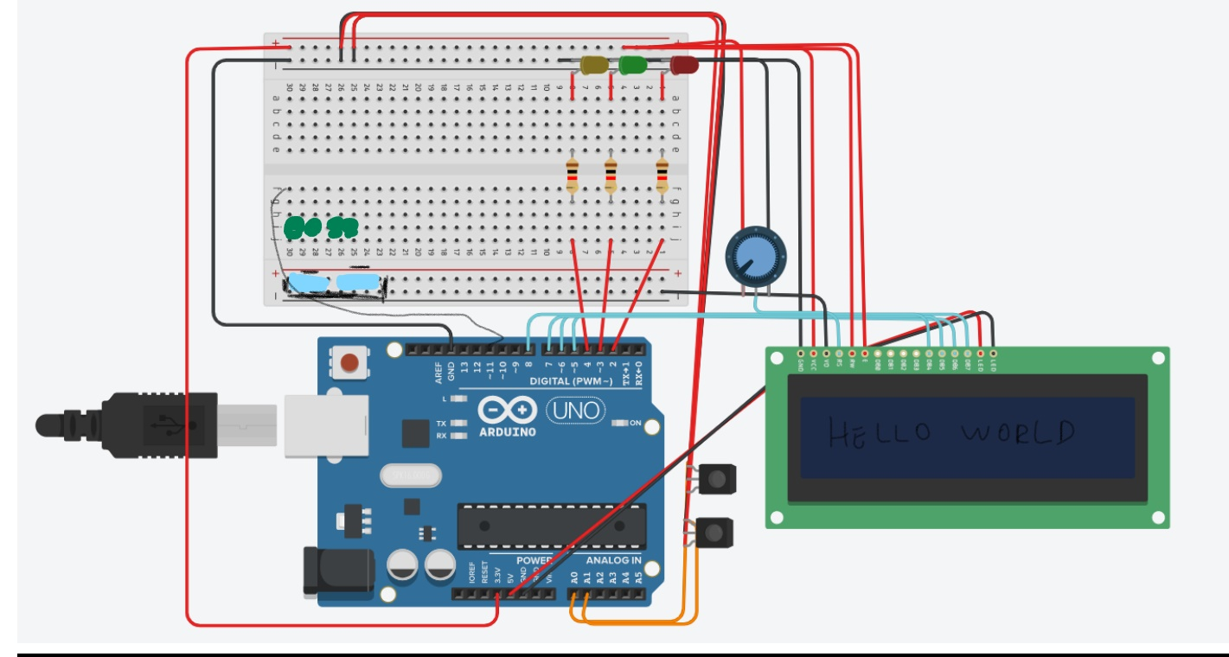

Part III: Implementation

I used Arduino software for coding the basic logic. The library LiquidCrystal.h was used for the LCD functions(print and clear). In “setup” function I set the 8,9,10 for the level of light in room and pin 11 for the leds that influence the light.

Then in function startPrint() I wrote some text to introduce the project .After that we have the variables: “*lightAdded*” which is a value between 0 and 250 because the max is 255 for outputting analog . “*lightAdded*” influences the values of the helper leds. Their propose is to help the light stabilize (in case the light is too dim we turn up these leds, in case the light is changing spontaneously from good ,or dim, to bright, we turn them down).The code is made so that the levels try to stay balanced (so the middle range is 200-400 and we try to stay in that range ,as explained later).

After that we have “*lightLevel*” which is more complex. The value of one sensor is 0 – 600.We have two of them so we can vary the positions if we want, but for easy demonstration we set them side by side. We add the two values and we multiply by three because we want a bigger range to work with.

I tested out the value of influence of the leds and come up with range 0 -150.So “*lightLevel*” is maximum around 1250,with basic lighting the mean is 1000.By multiplying it by 3 we get range 3000 -3800 (but it can go bigger sometimes this is a mean range). Subtracting 3000 we can the range 0-800 ,so optimal is 0-600.So we get some results:

0< is the yellow led (we don’t have enough light, we activate the influencer leds)

0-600 is a perfect light environment (we change the leds so we stay in range 200-400 as it can be seen)

600> is the red led (it’s too bright we try to reduce the influence but sometimes unsuccessful as for when is too dim, we can’t make it much brighter or much darker then we actually can)

Checking these levels we get a result. In the switch we decide what led to turn on, when is needed to add power to leds or to subtract from them ,and what to print on as well as the power usage by using the formula (*lightAdded*/250)*100 (250 being the max level for us and “*lightAdded*” the current value).

We calculate everything every 0.3 seconds.

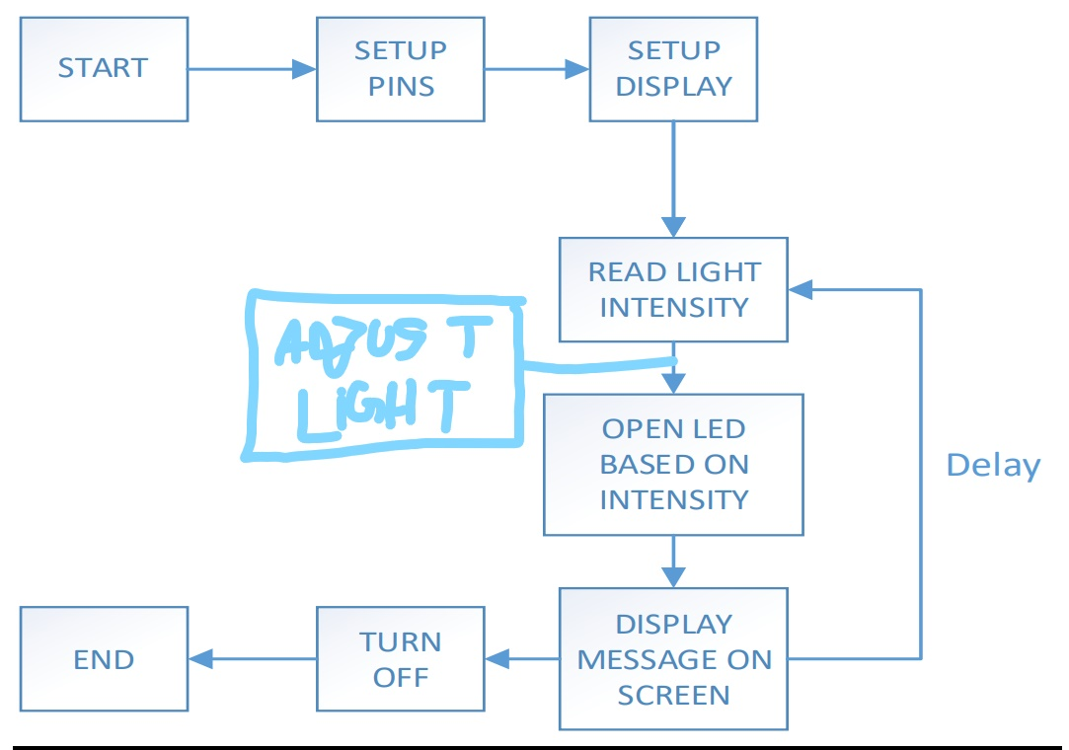

**The code:**

*#include <LiquidCrystal.h>*

*LiquidCrystal lcd(1,2,4,5,6,7);*

*int lightAdded=0;*

*void setup() {*

*lcd.begin(20,2);*

*pinMode(10, OUTPUT);//led too little*

*pinMode(9, OUTPUT);//led perfect*

*pinMode(8, OUTPUT);//led too much*

*pinMode(11,OUTPUT);//Control Light Level*

*startPrint();*

*}*

*void loop() {*

*int val1=analogRead(0);*

*int val2=analogRead(1);*

*float lightLevel=(val1+val2)*3-3000;*

*switch(ledNeeded(lightLevel)){*

*case 3:{*

*digitalWrite(8,HIGH);digitalWrite(9,LOW);digitalWrite(10,LOW);*

*if(lightAdded>0)lightAdded-=10;*

*if(lightAdded<=0) {lcd.clear();*

*lcd.print("Too much POWER! Nothing I can do!");}*

*break;*

*}//too much light*

*case 2:{*

*digitalWrite(8,LOW);digitalWrite(9,HIGH);digitalWrite(10,LOW);*

*if(lightLevel<=200 && lightAdded <=240)lightAdded+=10;*

*if(lightLevel>=400 && lightAdded >0)lightAdded-=10;*

*lcd.clear();*

*lcd.print("Levels are optimal! Power used:");*

*lcd.print((int)( ( (float)lightAdded/250.0 )*100 ) );*

*lcd.print("% :)");*

*break;*

*}//perfect*

*case 1:{*

*digitalWrite(8,LOW);digitalWrite(9,LOW);digitalWrite(10,HIGH);*

*if(lightAdded<=240)lightAdded+=10;*

*if(lightAdded>240) {lcd.clear();*

*lcd.print("I'm not POWERFUL enough!");}*

*break;*

*}//too little light*

*default:{break;}*

*}*

*analogWrite(11,lightAdded);*

*delay(300);*

*}*

*int ledNeeded(float lightLev){*

*if(lightLev<0){*

*return 1;*

*}else if(lightLev>0 && lightLev<600){*

*return 2;*

*}*

*return 3;*

*}*

*void startPrint(){*

*lcd.print("This project it's about light!");*

*delay(5000);*

*lcd.clear();*

*lcd.print("And how we affect it using just leds!");*

*delay(5000);*

*lcd.clear();*

*lcd.print("Hope you enjoy it! -Dobre Radu-Cristian");*

*delay(5000);*

*lcd.clear();*

*}*

Part IV: Conclusions

As we arrive to the end of our project we can see that it can be used in a lot of real life scenarios. It can be used for an industry where builders need light always to see what they are working, or simply in a home where you want to automate everything so that you are always comfortable in your own place. We used a lot of techniques and calculations to make it work, and the result is as expected and as amazing as we think!

# 

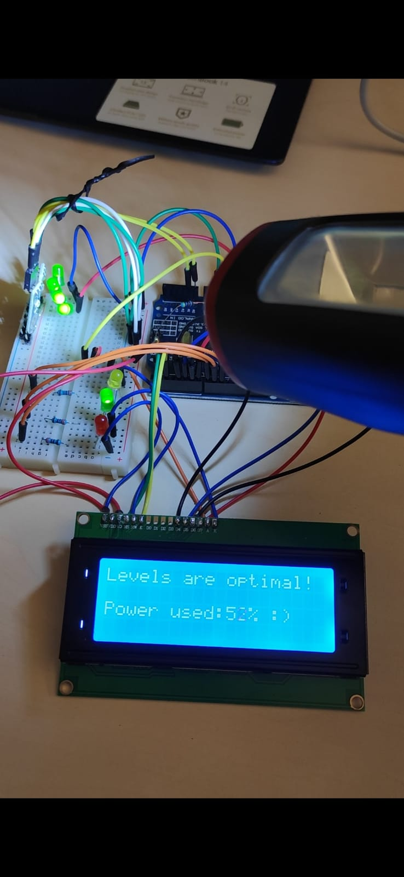

Resources

<https://www.arduino.cc/reference/en/language/functions/digital-io/digitalwrite/>

<https://www.arduino.cc/reference/en/language/functions/analog-io/analogwrite/>

<https://www.youtube.com/watch?v=dZZynJLmTn8>

<https://www.arduino.cc/reference/en/>