Problem Statement – 1: Explore, Execute and Analyse general purpose Linux commands.

1.1 Use a command to list all files, including hidden ones, in the current working directory.
1.2 Show the full path of your current working directory.
1.3 Create a new directory called MyFolder.
1.4 Change the current directory to MyFolder.
1.5 Delete the directory MyFolder.
1.6 Copy file1.txt to create file2.txt.
1.7 Rename file2.txt to file3.txt.
1.8 Delete file3.txt.
1.9 Use a command to display system information, such as kernel name and version.
1.10 Create an empty file named test.txt.
1.11 Clear the terminal screen.
1.12 List all currently running processes.
1.13 Search for the word "Linux" in the file example.txt.
1.14 Use a command to display "Welcome to Linux" on the terminal.
1.15 Display the disk usage of all mounted file systems.
1.16 Use a command to count lines, words, and characters in test.txt.
1.17 Display the current user name.
1.18 Command to sort the output of a file in reverse order.

Objective : - The objective of this lab is to explore and practice basic Linux commands used for managing files, directories, and system information. By executing these commands, students will learn how to:
- Navigate the file system and view hidden files.
- Create, rename, copy, and delete files and directories.
- Check system and user information.
- Monitor system processes and disk usage.
- Perform basic text processing like searching and sorting file content.
This exercise will help students gain hands-on experience with the Linux command-line interface (CLI), improve their understanding of file system structure, and build confidence in performing common administrative tasks efficiently.

  - Use a command to list all files, including hidden ones , in the current working directory

Command: ls -a
Explanation: ls lists files in the directory. The -a option includes hidden files (files starting with .).

Output:
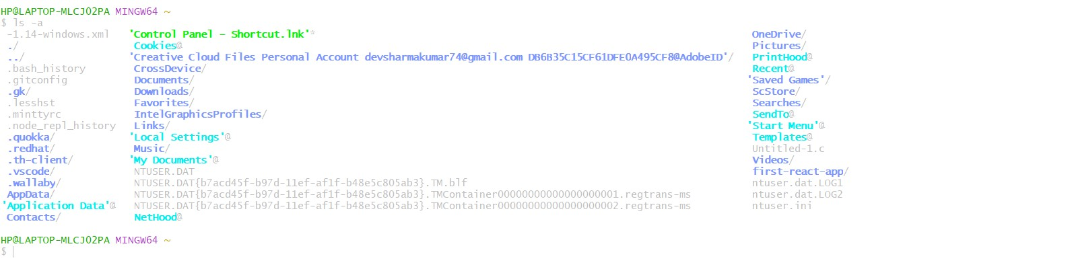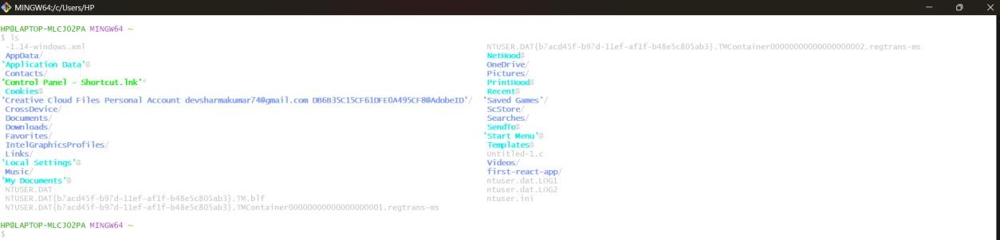

  - Show the full path of current working directory

Command: pwd
Explanation: pwd (print working directory) shows the complete path of your current working location(Directory).

Output:
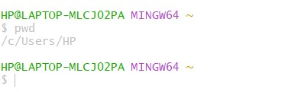

  - Create a new directory called My Folder

Command: mkdir MyFolder
Explanation: mkdir creates a directory named MyFolder.
Output:

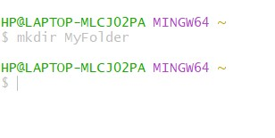

  - Change the current directory to MyFolder

Command: cd MyFolder
Explanation: Switches the current working directory to MyFolder Output:

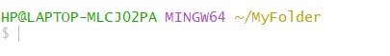

  - Delete the directory MyFolder

Command: rmdir MyFolder
Explanation: rmdir removes an empty directory named MyFolder. Output:

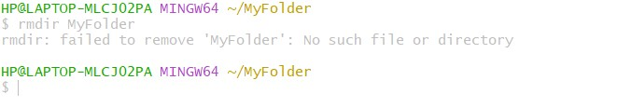

  - Copy file1.txt to create file2.txt

Command: cp file1.txt file2.txt
Explanation: Copies the contents of file1.txt into a new file named file2.txt Output:

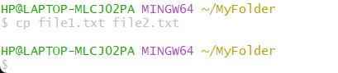

  - Rename file2.txt to file3.txt

Command: mv file2.txt file3.txt
Expalanation: Renames file2.txt to file3.txt.
Output:

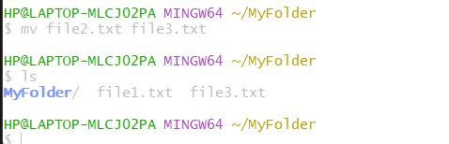

  - Delete file3.txt

Command: rm file3.txt
Expalanation: Delete the file named file3.txt Output:

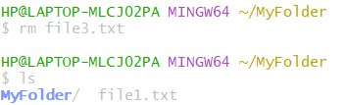

  - Use a command to display system information, such as kernel name and version

Command: uname -a
Explanation: Display detailed system information including kernel name and version Output:

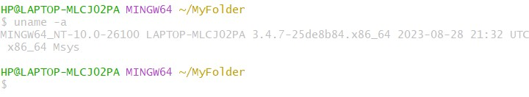

  - Create an empty file named test.txt

Command: touch text.txt
Explanation: Creates a new empty file named test.txt.
Output:

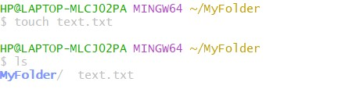

  - Clear the terminal screen

Command: clear
Explanation: Clears all text from the terminal screen Output:

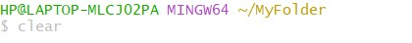

  - List all currently running processes

Command: ps -e
Explanation: Displays a list of all currently running processes. Output:

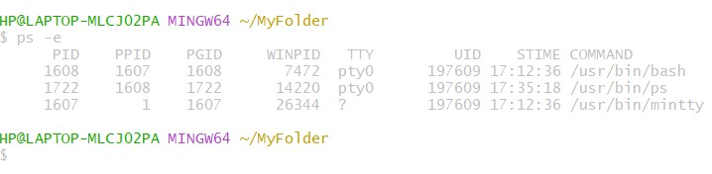

  - Search for the word “Linux” in the file example.txt

Command: grep “Linux” example.txt
Explanation: Searches for the word “Linux” inside the file example.txt and display matching line.
Output:

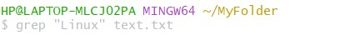

  - Use a command to display “Welcome to Linux” on the terminal

Command: echo “Welcome to Linux”
Explanation: Prints the message “Welcome to Linux” on the terminal screen. Output:

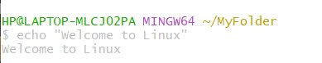

  - Display the disk usage of all mounted file systems
Command: df -h
Explanation: Shows the disk usage of all mounted file system in human-readable format. Output:

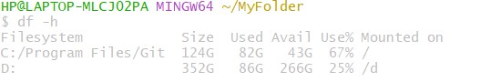

1.16Use a command to count lines, word, and characters in test.txt

Command: wc test.txt
Explanation: Displays the number of lines, word, and characters in test.txt Output:

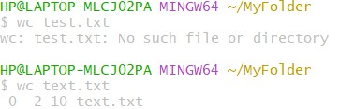

1.17Display the current user name

Command: whoami
Explanation: Displays the username of the currently logged-in user. Output:



1.18Command to sort the output of a file in reverse order

Command: sort -r text.txt
Explanation: Sorts the contents of file.txt reverse alphabetical order Output:

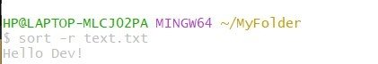

Problem Statement 2: Prepare and Verify an employee database file (EMP) that contains employee records under the following column.
EMP ID, EMP First_Name, EMP Last_Name, Location, Designation, Net Salary, Specialization, Project, Joining Month, Joining Year.
Design, Execute and Analyze AWK Script for the following problem statements.
2.1 Create and Execute AWK script to display EMP ID, EMP First_name, EMP Last_name, Location, and Designation of employees having designations as ‘Manager’.
2.2 Create and Execute AWK script to display EMP ID, EMP First_name, EMP Last_name, Location and Designation of employees who are specialized in Java Programming and are working at Delhi and Pune loactions.
2.3 Create and Execute AWK script to display EMP ID, EMP First_name, EMP Last_name, Location and Designation of employees who are specialized in Java Programming and are working at Delhi pune location.
2.4 Create and Execute AWK script to display all fields of all those employees who joined the Organization on the net salary in between 45000 to 65000, during the period January 2000 to December 2005.
2.5 Create and Execute AWK script to display all fields of all those employees whose last name is ‘Kumar’.
Objective: Create and validate a comprehensive employee database file(EMP) that accurately captures essential employee information, organized under specified columns including EMP_ID, EMP_First_Name, EMP_Last_Name, Location, Designation, Net_Salary,
Specialization, Project, Joining Month, and joying Year. This database will serve as a reliable resource for managing employee records and facelifting data analysis.

AWK Script:

BEGIN{
#header
Print “printing all employee entries\n”
}
{
Print $0
}
END{
#footer
Print “Script completed\n”
}

Output:
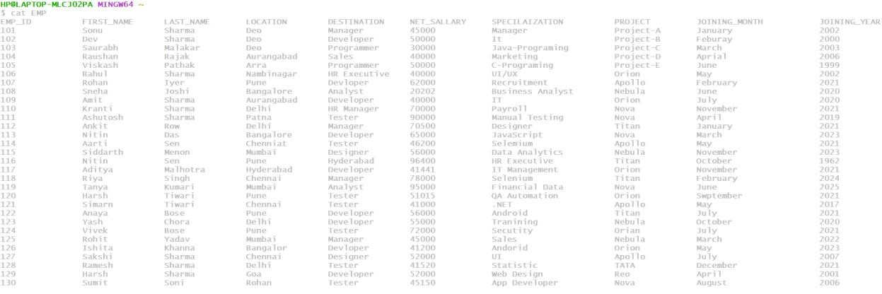

2.1 Create and Execute AWK script to display EMP ID, EMP First_Name, EMP Last_name, Location, and Designation of employees having designations as ‘Manager’.
Objective: To develop and run an AWK script that extracts and displays the employee ID (EMP_ID) 1S.J0 name (EMP_First_Name), last (EMP_Last_Name), location and designation of employees whose designation name 'Manager' from 2 SI given dataset This script will enhance data analysis and facilitate quick access to relevant employee information for management purposes

BEGIN {
 | #header
}  { | print “printing all Manager\n”
 | if ($5== “Manager”)
 | print $1, $2, $3, $4, $5
}
END {
#footer
print “script completed\n”
}
Output
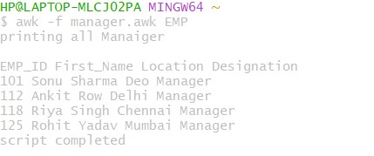

2.2 Create and Execute AWK script to display EMP ID, EMP First_Name, EMP Last_Name, Location and Designation of employees who are specialized in Java Programming and are working at Delhi and Pune location.
Objective: To create and execute an AWK script that extracts and displays the employee ID (EMP ID), first name (EMP_First_Name), last name (EMP_Last_Name), location, and designation of employees specializing in Java Programming and located in Delhi and Pune. This will enable targeted insights into the workforce's Java expertise in key locations, supporting recruitment and resource allocation strategies.
AWK Script:
BEGIN {
#header
print “All specializes in java\n”
}
{
If($7 == “java-Programing” && ($4 == “Delhi” || $4 == “Pune”)){ print $1, $2, $3, $4, $5
}
END {
#footer
Print “Script completed\n”
}
Output:
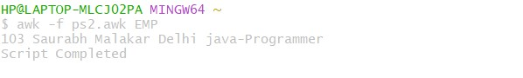

2.3 Create and Execute AWK script to display EMP ID, EMP First_Name, EMP Last_Name, Location, Designation, Joining Month and Joining Year of all those employees who joined after January 2000 but before December 2005.
Objective: To create and evecute an AWK script that retrieves and displays the employeeID (EMP_ID) first name (EMP First_Name) last name EMP_Last Name), location, designation, joining month and Joining year of all employees who joinel the organization after January 2000 but before December 2005
AWK Script:
BEGIN {
# header print "printing joining month and year\n"
} { if ( ($10 > 2000 && $10 < 2005) \
|| ($10 == 2000 && $9 != "January") \
|| ($10 == 2005 && $9 != "january") \ || ($10 == 2005 && $9 != "December") ) { print $1, $2, $3, $4, $5, $9, $10
}
}
END {
# footer print "" print "Script completed"
}
Output:
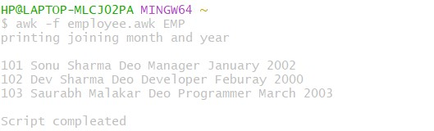
2.4 Create and Execute AWK script to display all fields of all those employees who joined the Organization on the net salary in between 45000 to 65000, during the period January 2000 to December 2005.
Objective: To create and execute an AWK script that extracts and displays all fields for employees who joined the organization with a net salary between 45,000 and 65,000 during the period from January 2000 to December 2005 This will aid in analyzing compensation trends and employee demographics within that time frame supporting strategic decisions related to salary management and recruitment practices.
AWK Script:
BEGIN { #header print “Quering the database\n”
}
{
If(($6>=45000 && $6<=65000) && ($10>=2000 && $10 <=2025)){
print $1, $2, $3, $4, $5, $6, $7, $8, $9, $10
}
}
END{
#footer
print “Script Completed\n”
}
Output:
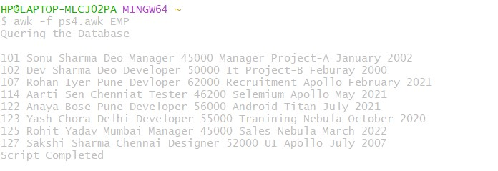

2.5 Create and Execute AWK script to display all fields of all those employees whose last name is “Kumar”.
Objective: To create and esecute an AWK script that retrieves and displays a felds for employees whose Last name is “Kumar" This will facitate targeted analysi of this specitic demographic within the organization, enabling insights into workforce composition and diversity
AWK Script:
BEGIN { #header print “employees with Last name is kumar\n”
}
{
If ($3== “Kumar”){
print $0
}
}
END{
#footer
print “Script Completed\n”
}

Output:
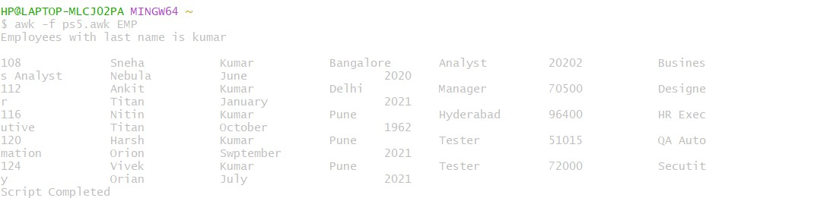

Problem Statement 3: Design, Execute and Analyze a C Program using gcc compiler to extract system information. Such as Model Name, Cache Size, Number of CPU cores, CPU clock speed, Total Memory, Free Memory, Operating system Name and Version.
Objective: To design, execute, anjd analyze a program using the GCC compiler that extracts and displays critical system information, including Model Name, Cache Size, Number of CPU Cores, CPU Clock Speed, Total Memory, Free Memory, and Operating System Name and Version. This project aims to enhance understanding of system-level programming in C utilize system calls and libraries for information retrieval, and demonstrate proficiency in compiling and executing C programs in a Unix-like environment.

For Model name, Cache size, Number of CPU Cores, CPU Clock Speed Syntax: cat /proc/cpuinfo

For Total Memory and Free Memory
Syntax: cat /proc/meminfo

For Operating System Name and Version.
Syntax: cat/etc/os-release

Code:
#include<stdio.h> #include<stdlib.h> int main(){ print(“Model name: \n”); system(“cat /proc/cpuinfo | grep -m 1 ‘model name’”);

print(“Cache Size: \n”); system(“cat /proc/cpuinfo | grep -m 1 ‘cache size’”);

print(“cpu MHz: \n”); system(“cat /proc/cpuinfo | grep -m 1 ‘cpu MHz’”);

print(“MemFree: \n”); system(“cat /proc/meminfo | grep -m 1 ‘MemFree’”);

print(“NAME: \n”);
system(“cat /etc/os-release | grep -m 1 ‘NAME’”);

print(“VERSION:\n”);
system(“cat / etc/os-release | grep -m 1 ‘VERSION’”);

return 0;
}

Output:

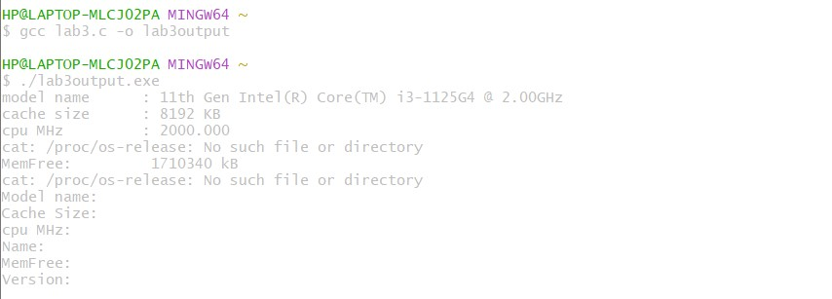

Problem Statement 4: Design, Execute and Analyze a C program using ‘gcc’ compiler to extract PID of parent process and child process. Child process is to be created using fork() system call.

Objective: To design, execute, and analyze a C program using the gcc compiler that demonstrates process creation using the fork() system call, and to extract and display the Process ID (PID) of both the parent and child processes. This helps in understanding how process management and process identification work in the UNIX/Linux operating system.

Code:- include<stdio.h>
#include<stdlib.h>
#include<sys/types.h> #include<unistd.h> int main(){
pid_t pid; for(int i =0; i<5; i++){ pid = fork(); if(pid == 0){ printf("Child PID :%d\n", getpid());
exit(0);
}else if(pid<0){ printf("fork() failed.\n");
}
}
printf("Parent Process PID: %d\n", getpid()); return 0;
}

Output: -
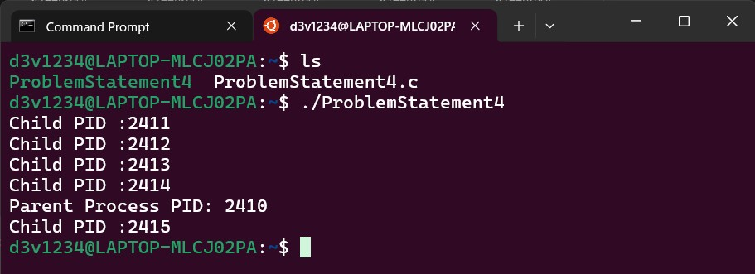

Problem Statement 5: Design, Execute and Analyze First Come First Serve (FCFS) CPU scheduling algorithm. [Algorithm can be implemented using C/gcc compiler.

Objective: To design, execute, and analyze the First Come First Serve (FCFS) CPU scheduling algorithm using the C language and gcc compiler, in order to understand how processes are scheduled based on their arrival order and to calculate Waiting Time and Turnaround Time for each process.

Algorithm :-

Code:
#include <stdio.h> int main() {
int n, i, j; int pid[20], bt[20], at[20], wt[20], tat[20], ct[20]; int twt = 0, ttat = 0; float awt, att;

printf("Enter the number of processes: "); scanf("%d", &n);

printf("Enter Process ID, Burst Time, and Arrival Time:\n"); for (i = 0; i < n; i++) { printf("Process %d:\n", i + 1); printf("Process ID: "); scanf("%d", &pid[i]); printf("Burst Time: "); scanf("%d", &bt[i]); printf("Arrival Time: "); scanf("%d", &at[i]);
}

// Sort by Arrival Time (FCFS) for (i = 0; i < n - 1; i++) { for (j = i + 1; j < n; j++) { if (at[i] > at[j]) { int temp; temp = at[i]; at[i] = at[j]; at[j] = temp; temp = bt[i]; bt[i] = bt[j]; bt[j] = temp; temp = pid[i]; pid[i] = pid[j]; pid[j] = temp;
}
}
}

// Calculate Completion, Turnaround, and Waiting Times ct[0] = at[0] + bt[0]; tat[0] = ct[0] - at[0]; wt[0] = tat[0] - bt[0];

for (i = 1; i < n; i++) { if (at[i] > ct[i - 1]) // CPU idle ct[i] = at[i] + bt[i]; else ct[i] = ct[i - 1] + bt[i];
tat[i] = ct[i] - at[i]; wt[i] = tat[i] - bt[i];
}

// Display process table
printf("\nProcess ID\tArrival Time\tBurst Time\tWaiting Time\tTurnaround Time\tCompletion Time\n");
for (i = 0; i < n; i++) { printf("%d\t\t%d\t\t%d\t\t%d\t\t%d\t\t%d\n",
pid[i], at[i], bt[i], wt[i], tat[i], ct[i]); twt += wt[i]; ttat += tat[i];
}

awt = (float)twt / n; att = (float)ttat / n;

printf("\nAverage Waiting Time: %.2f", awt); printf("\nAverage Turnaround Time: %.2f\n", att);

// ------------------- GANTT CHART ------------------- printf("\n\nGANTT CHART:\n");

// Top bar printf(" "); for (i = 0; i < n; i++) { printf("----------");
} printf("\n|");

// Process IDs for (i = 0; i < n; i++) { printf(" P%d |", pid[i]);
}

// Bottom bar printf("\n "); for (i = 0; i < n; i++) { printf("----------");
} printf("\n");

// Timeline int start_time = at[0]; printf("%d", start_time); for (i = 0; i < n; i++) { if (at[i] > ct[i - 1] && i != 0) printf(" %d", at[i]); // CPU idle time printf("\t%d", ct[i]);
}

printf("\n");

return 0;
}

Output:-
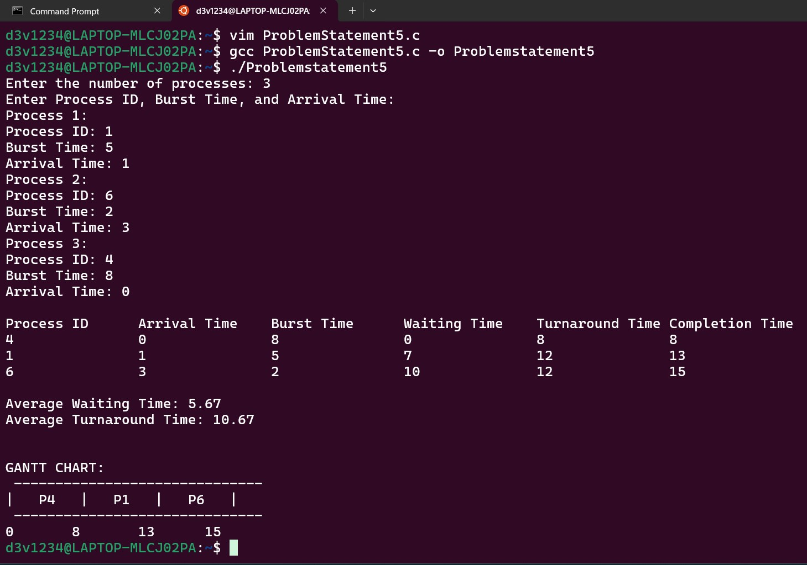

Problem statement 6: Design, Execute and Analyze Shortest Job First (SJF) CPU scheduling algorithm.

Objective: Pick the job with the smallest remaining CPU time so that, on average, processes wait as little as possible. In short: minimize average waiting/turnaround time and improve responsiveness for short jobs, while keeping the CPU busy.

Algorithm :-

Code: -
#include <stdio.h> int main() {
int n, i, j;
printf("Enter number of processes: "); scanf("%d", &n); int pid[n], bt[n], at[n], ct[n], tat[n], wt[n]; float avg_wt = 0, avg_tat = 0; // Input process details for (i = 0; i < n; i++) { pid[i] = i + 1; printf("Enter arrival time and burst time for process P%d: ", pid[i]); scanf("%d %d", &at[i], &bt[i]);
}
// Sort processes by arrival time (optional) for (i = 0; i < n - 1; i++) { for (j = i + 1; j < n; j++) { if (at[i] > at[j]) { int temp = at[i]; at[i] = at[j]; at[j] = temp; temp = bt[i]; bt[i] = bt[j]; bt[j] = temp; temp = pid[i]; pid[i] = pid[j]; pid[j] = temp;
}
}
}
int completed = 0, current_time = 0, min_bt_index; int is_completed[n]; for(i = 0; i < n; i++) is_completed[i] = 0; while (completed != n) { int min_bt = 100000; // Large number min_bt_index = -1; for (i = 0; i < n; i++) { if (at[i] <= current_time && !is_completed[i]) { if (bt[i] < min_bt) { min_bt = bt[i];
Amit Kumar Roll No-75 MCA-G1
min_bt_index = i;
}
}
}
if (min_bt_index == -1) { current_time++;
} else { current_time += bt[min_bt_index]; ct[min_bt_index] = current_time; tat[min_bt_index] = ct[min_bt_index] - at[min_bt_index]; wt[min_bt_index] = tat[min_bt_index] - bt[min_bt_index]; is_completed[min_bt_index] = 1; completed++;
}
}
printf("\nP#\tAT\tBT\tCT\tTAT\tWT\n"); for (i = 0; i < n; i++) { printf("P%d\t%d\t%d\t%d\t%d\t%d\n", pid[i], at[i], bt[i], ct[i], tat[i], wt[i]); avg_wt += wt[i]; avg_tat += tat[i];
}
printf("\nAverage Turnaround Time = %.2f\n", avg_tat / n); printf("Average Waiting Time = %.2f\n", avg_wt / n); return 0;
}

Output:-
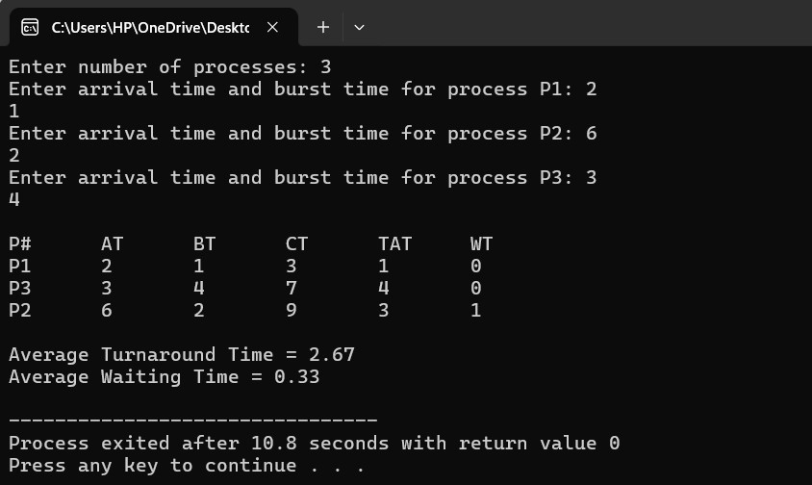

Problem statement 7: Design, Execute and Analyze First In, First Out (FIFO) page replacement algorithm.

Objective: - The objective of the FIFO Page Replacement Algorithm is to manage memory pages efficiently by replacing the oldest loaded page (the one that entered memory first) whenever a new page needs to be brought in and the memory is full.

Algorithm:-

Code:

#include <stdio.h>

int main() { int frames[10], pages[30]; int n, f, i, j, k, flag, fault = 0, front = 0;

printf("Enter number of frames: "); scanf("%d", &f);

printf("Enter number of pages: "); scanf("%d", &n);

printf("Enter page reference string:\n"); for(i = 0; i < n; i++) scanf("%d", &pages[i]);

for(i = 0; i < f; i++) frames[i] = -1;

printf("\nPage\tFrames\t\tStatus\n");

for(i = 0; i < n; i++) { flag = 0;

for(j = 0; j < f; j++) { if(frames[j] == pages[i]) { flag = 1; break;
}
}

if(flag == 0) { frames[front] = pages[i]; front = (front + 1) % f; fault++;
}

printf("%d\t", pages[i]); for(k = 0; k < f; k++) { if(frames[k] != -1) printf("%d ", frames[k]); else
printf("- ");
} if(flag == 0) printf("\tPage Fault\n"); else printf("\tPage Hit\n");
}

printf("\nTotal Page Faults = %d\n", fault); return 0;
}

Output: -
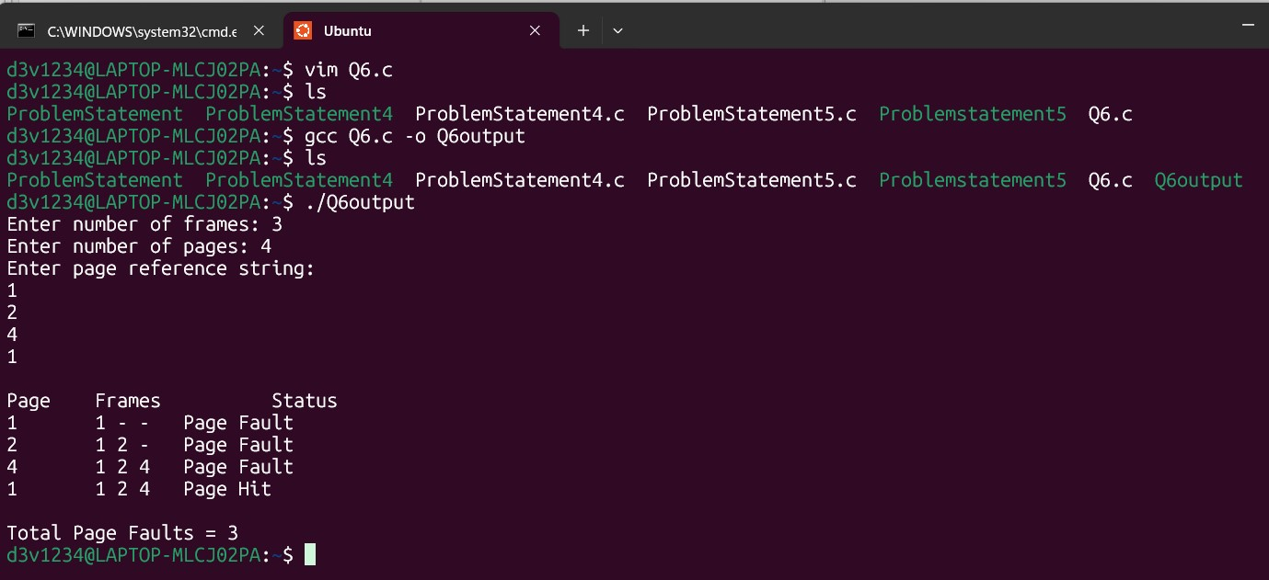

Problem Statement 8: Design, Execute and Analyze Least Recently Used (LRU) page replacement algorithm.

Objective: The main objective of the Least Recently Used (LRU) page replacement algorithm is to manage the pages in memory efficiently by replacing the page that has not been used for the longest time. This helps to reduce page faults and improve memory utilization by keeping the most recently used pages in memory and removing the least recently used ones whenever a new page needs to be loaded.

Algorithm:

Code:

#include <stdio.h>

int main() { int frames[10], pages[50]; int last_used[10]; int n, f, i, j, k, found, faults = 0; int t = 0; // time counter

printf("Enter number of frames (<=10): "); scanf("%d", &f); printf("Enter number of pages (<=50): "); scanf("%d", &n);

printf("Enter page reference string:\n"); for (i = 0; i < n; i++) scanf("%d", &pages[i]);

for (i = 0; i < f; i++) { frames[i] = -1; last_used[i] = 0;
}

printf("\nRef\tFrames\t\tStatus\n");

for (i = 0; i < n; i++) { int page = pages[i]; t++; // increment time for this reference found = 0;

// Check if page is already in frame (hit) for (j = 0; j < f; j++) { if (frames[j] == page) { found = 1; last_used[j] = t; // update last used time break;
}
}

if (!found) {
// Page fault: find empty frame or LRU frame int replaced = -1; for (j = 0; j < f; j++) { if (frames[j] == -1) { replaced = j; break; }
} if (replaced == -1) { // find LRU (smallest last_used) int min_time = last_used[0]; replaced = 0; for (j = 1; j < f; j++) { if (last_used[j] < min_time) { min_time = last_used[j]; replaced = j;
}
}
}
frames[replaced] = page; last_used[replaced] = t; faults++;
}

// print current status printf("%d\t", page); for (k = 0; k < f; k++) { if (frames[k] == -1) printf("- "); else printf("%d ", frames[k]);
}
if (found) printf("\tPage Hit\n"); else printf("\tPage Fault\n");
}

printf("\nTotal Page Faults = %d\n", faults); printf("Total Page Hits = %d\n", n - faults); return 0;
}

Output:
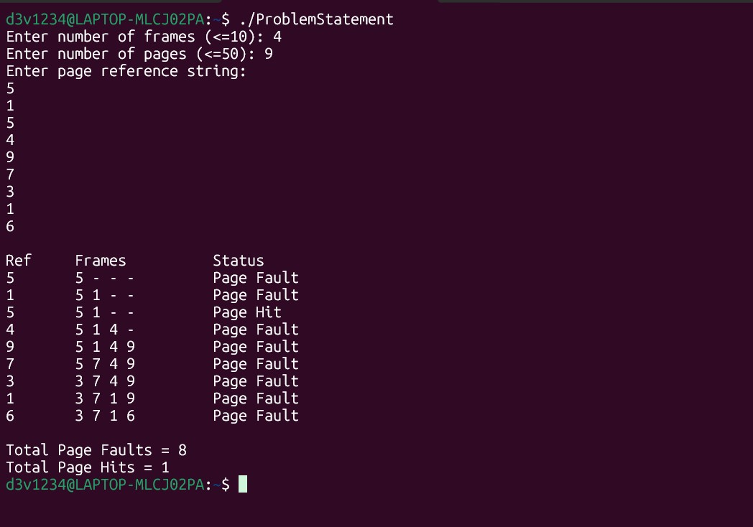

Problem statement 9: Design, Execute and Analyze First come First Serve(FCFS) Disk scheduling algorithm.

Objective: - To design, implement, and analyze the First Come First Serve (FCFS) disk scheduling algorithm in order to understand how disk I/O requests are serviced in the order of their arrival, and to measure the total head movement, average seek time, and performance characteristics of FCFS in comparison with other disk scheduling algorithms.

Algorithm:

Code: -
#include <stdio.h>
#include <stdlib.h>

int absval(int x) { return x < 0 ? -x : x; }

int main() { int n, head; printf("Enter number of requests: "); if (scanf("%d", &n) != 1 || n <= 0) { printf("Invalid number of requests.\n"); return 1;
}

int *req = (int *)malloc(n * sizeof(int)); if (!req) { printf("Memory allocation failed.\n"); return 1;
}

printf("Enter initial head position: "); if (scanf("%d", &head) != 1) { printf("Invalid head.\n"); free(req); return 1;
}

printf("Enter %d requests in arrival order (space separated):\n", n);
for (int i = 0; i < n; ++i) { if (scanf("%d", &req[i]) != 1) { printf("Invalid request input.\n"); free(req); return 1;
}
}

long long total_seek = 0; int current = head; printf("\nService order:\n"); printf("%d", current); for (int i = 0; i < n; ++i) { int dist = absval(req[i] - current); total_seek += dist; current = req[i];
printf(" -> %d", current);
}
printf("\nTotal head movement (seek): %lld\n", total_seek); printf("Average seek per request: %.2f\n", (double)total_seek / n);

free(req); return 0;
}

Output:

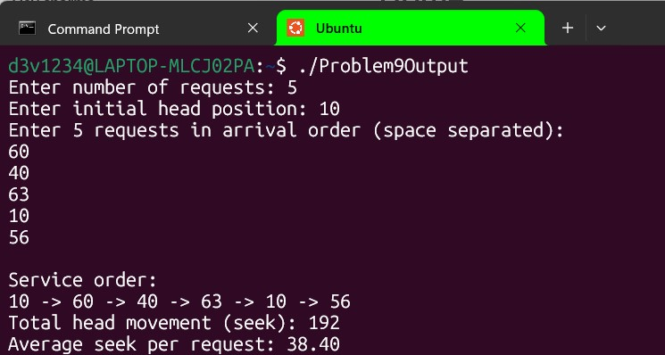

Problem Statement 10: Design, Execute and Analyze Shortest Seek Time First (SSTF) Disk scheduling algorithm.

Objective:- To design, implement, and analyze the Shortest Seek Time First (SSTF) disk scheduling algorithm in order to minimize total head movement by always selecting the disk I/O request closest to the current head position, and to compare its performance with other disk scheduling techniques.

Algorithm: -

Code: -
#include <stdio.h>
#include <stdlib.h>
#include <limits.h>

int absval(int x) { return x < 0 ? -x : x; }

int main() { int n, head; printf("Enter number of requests: "); if (scanf("%d", &n) != 1 || n <= 0) { printf("Invalid number of requests.\n"); return 1;
}

int *req = (int *)malloc(n * sizeof(int)); int *visited = (int *)calloc(n, sizeof(int)); if (!req || !visited) { printf("Memory allocation failed.\n"); free(req); free(visited); return 1;
}

printf("Enter initial head position: "); if (scanf("%d", &head) != 1) { printf("Invalid head.\n"); free(req); free(visited); return 1;
}

printf("Enter %d requests (space separated):\n", n);
for (int i = 0; i < n; ++i) { if (scanf("%d", &req[i]) != 1) { printf("Invalid request input.\n"); free(req); free(visited); return 1;
}
}

long long total_seek = 0; int current = head; int served = 0;

printf("\nService order:\n"); printf("%d", current);

while (served < n) { int min_dist = INT_MAX; int min_index = -1; for (int i = 0; i < n; ++i) { if (!visited[i]) { int dist = absval(req[i] - current); if (dist < min_dist) { min_dist = dist; min_index = i;
}
}
}
if (min_index == -1) break; /* safety check */

visited[min_index] = 1; total_seek += min_dist; current = req[min_index]; printf(" -> %d", current); served++;
}

printf("\nTotal head movement (seek): %lld\n", total_seek); printf("Average seek per request: %.2f\n", (double)total_seek / n);

free(req); free(visited); return 0;
}

Output:-

