Problem Statement 1:-
EXECUTION: IPCONFIG
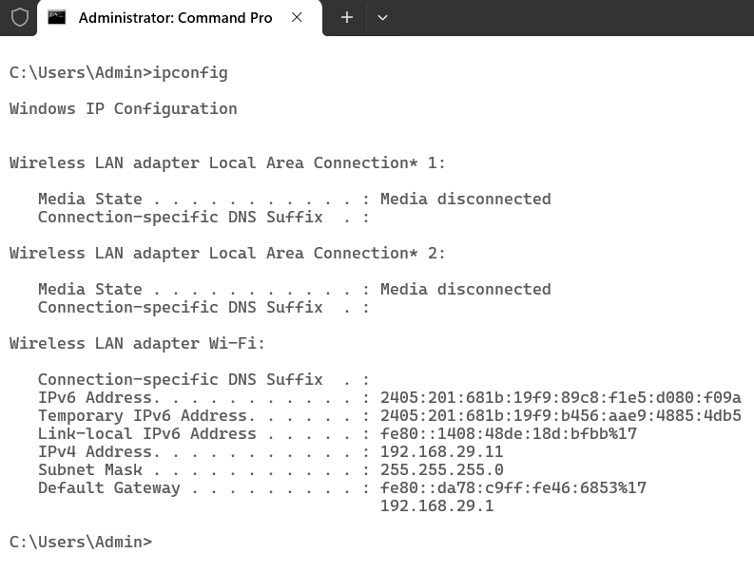

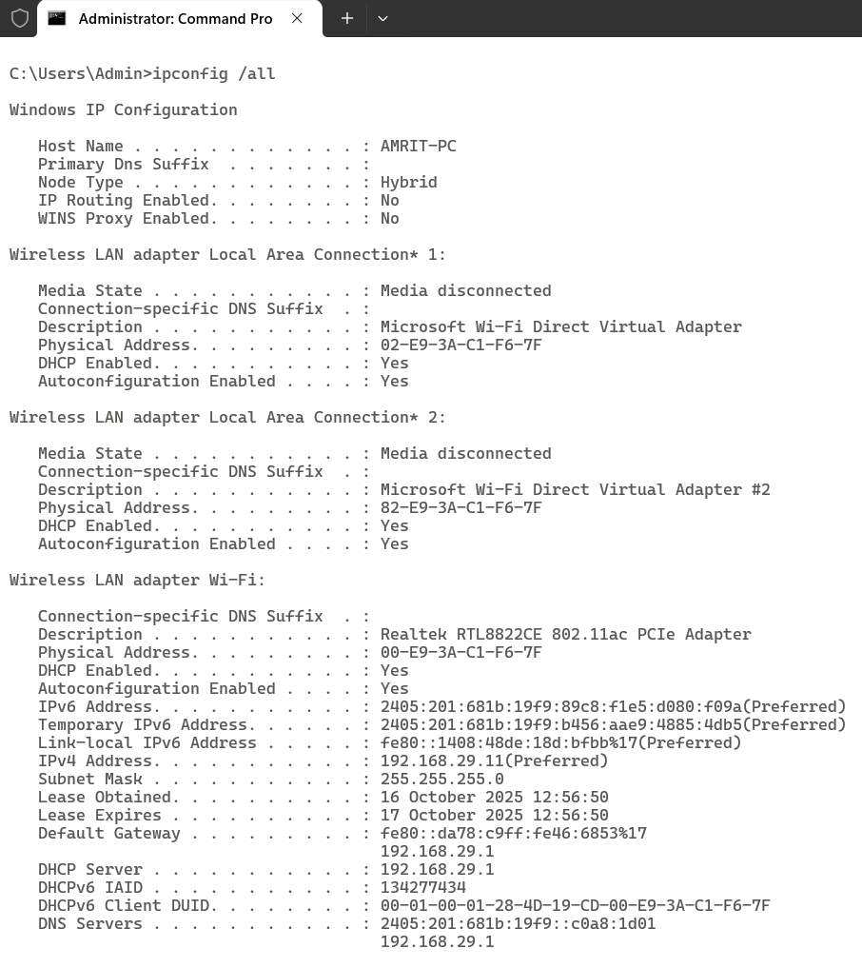

EXECUTION: PING
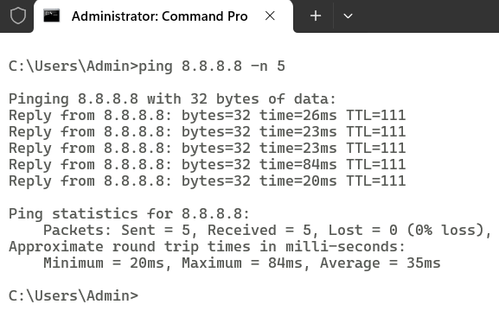

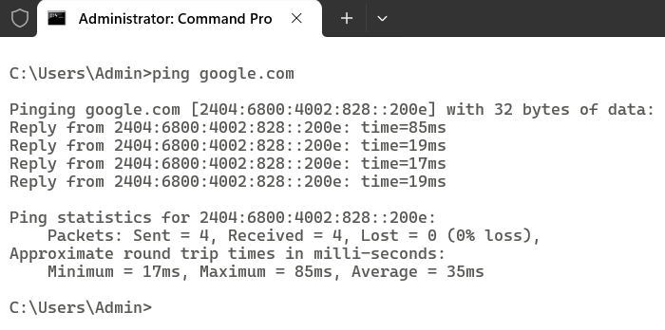

EXECUTION: TRACERT
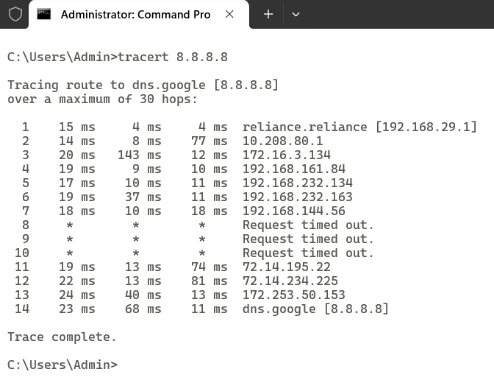

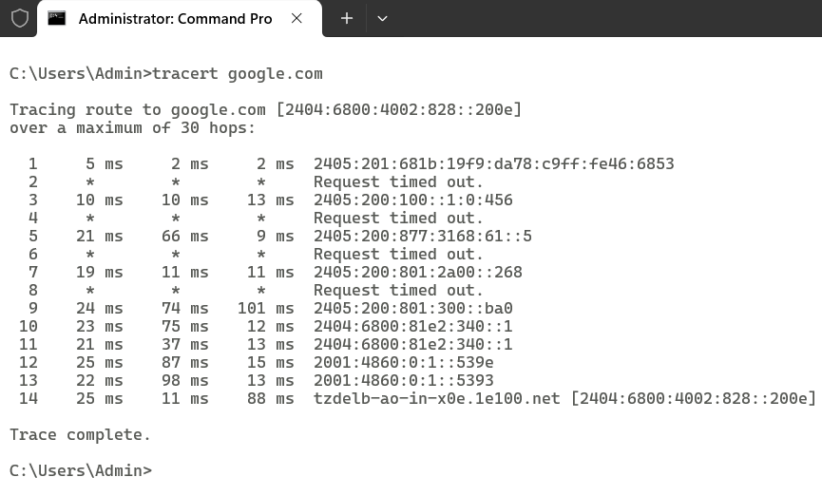

EXECUTION: ARP
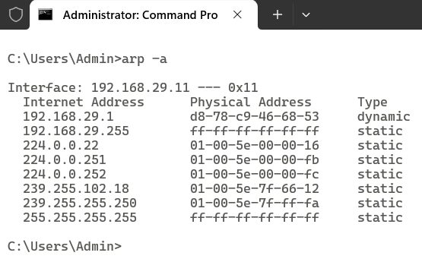

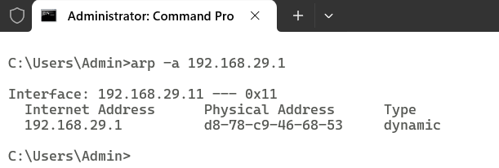

EXECUTION: NET
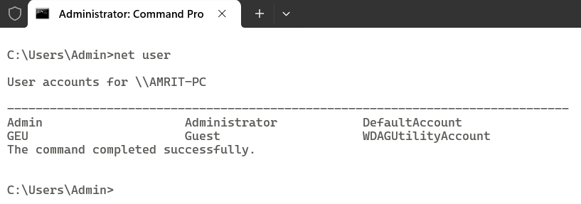

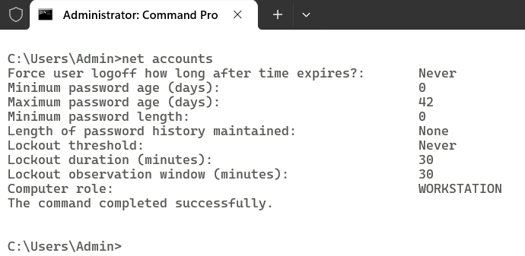

EXECUTION: NETSTAT
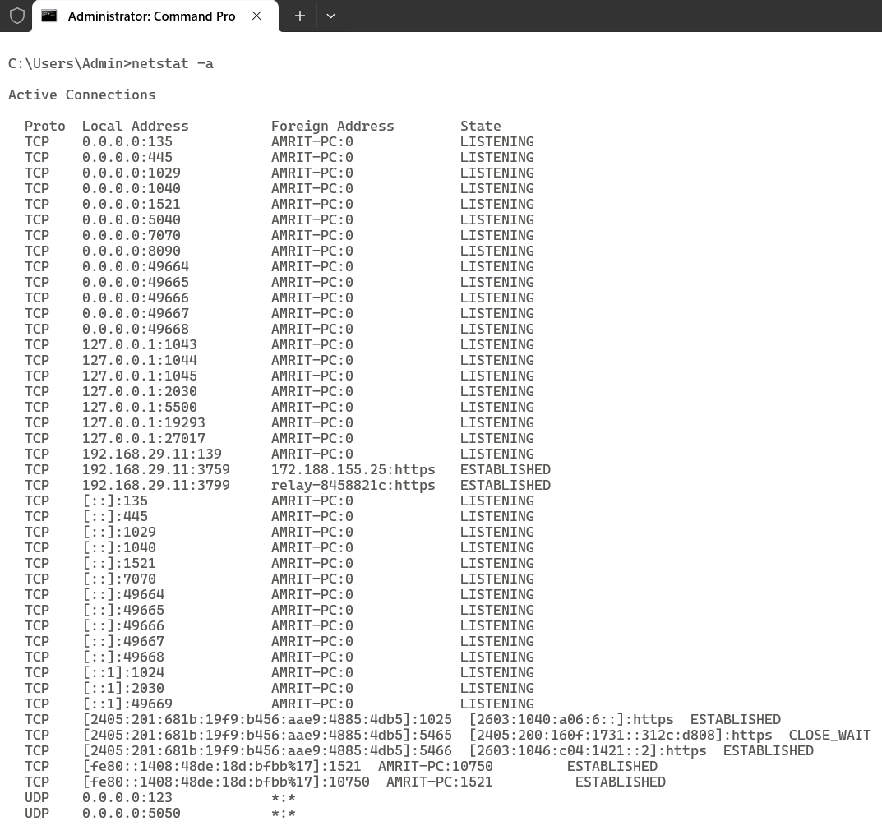

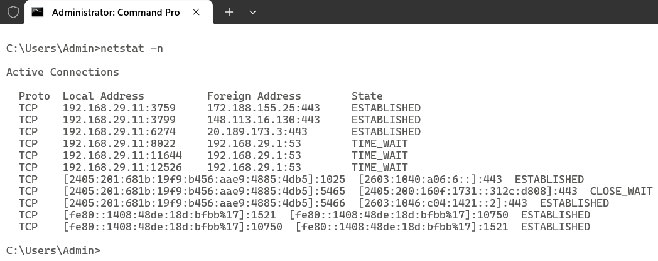

Problem Statement 2:-
Connecting PCs with Switch
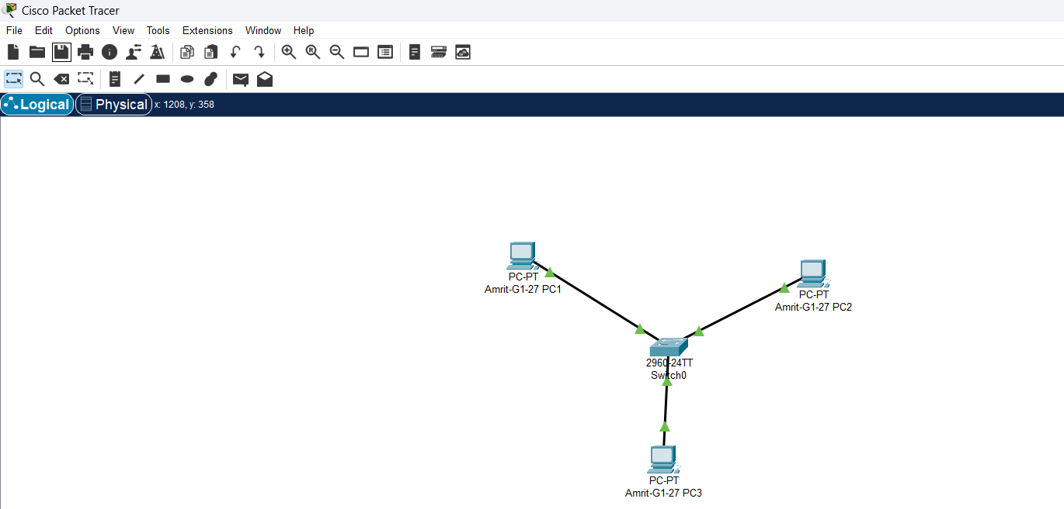

Setting IP Address of PC’s
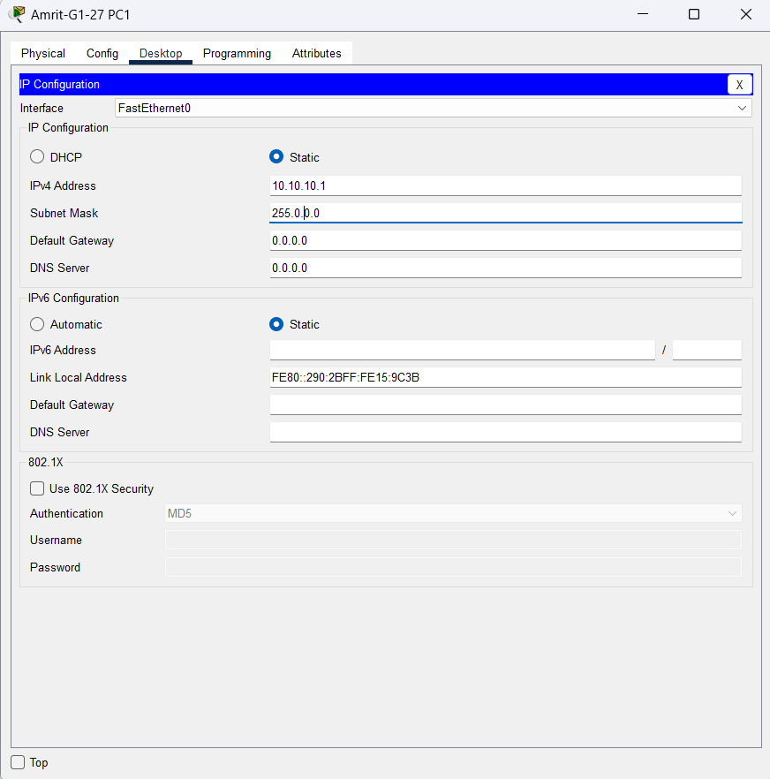

Problem Statement 3:-
Connecting 18 PCs with 3 switches
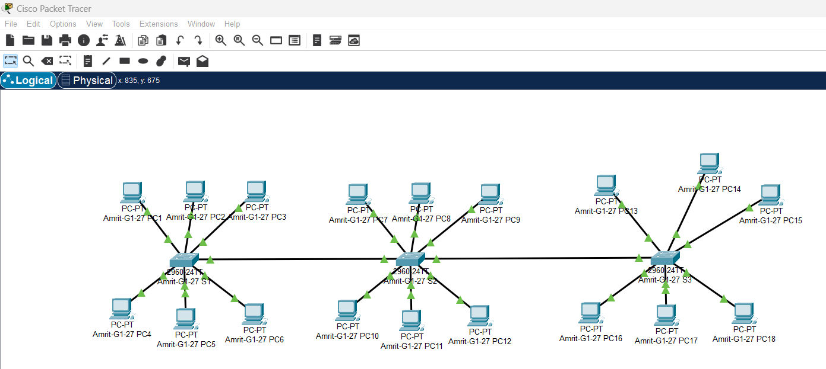

Setting IP Address of PC’s
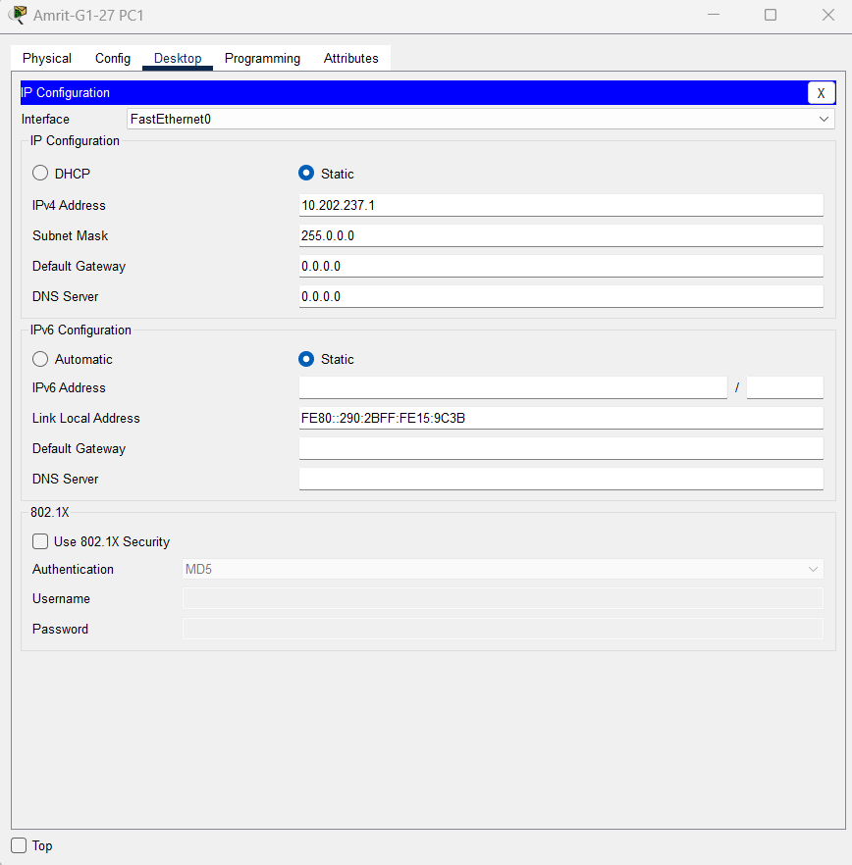

Checking connectivity using ping command
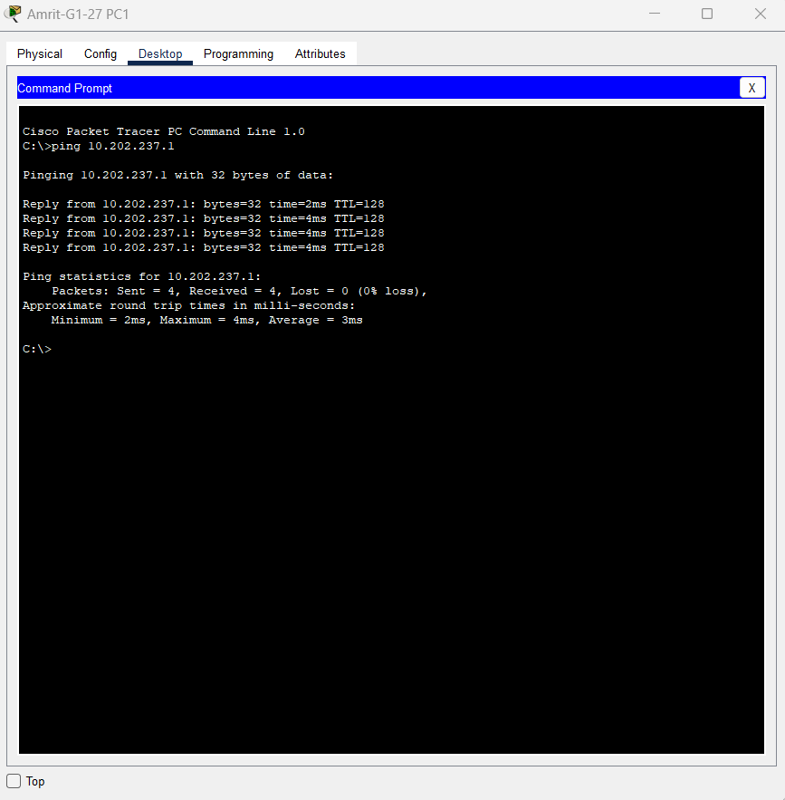

Problem Statement 4:-
Setting 15 PCs using 3 switches
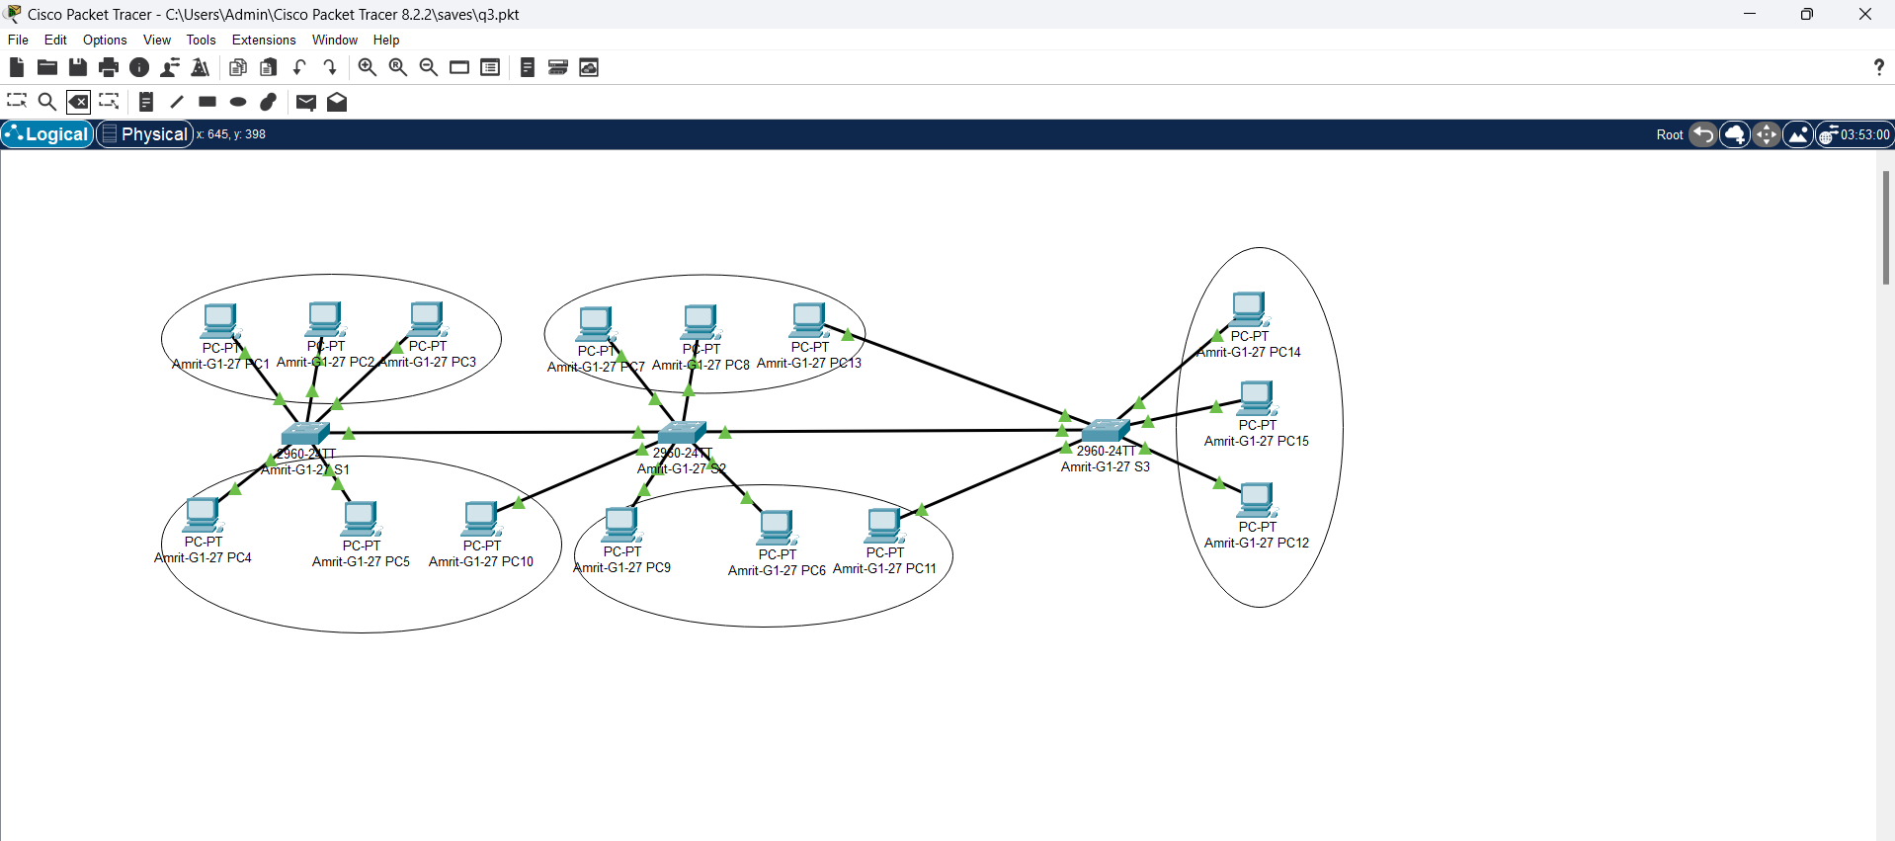

Setting IP Address of PC’s
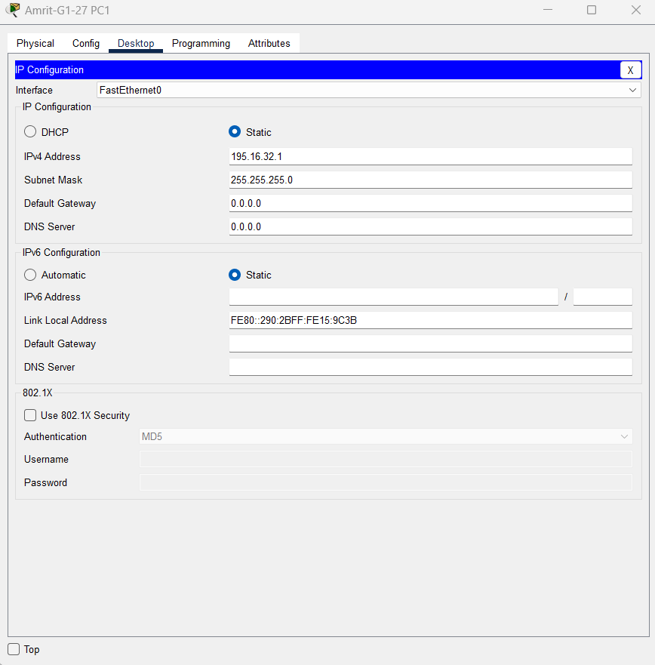

Checking connectivity using ping command
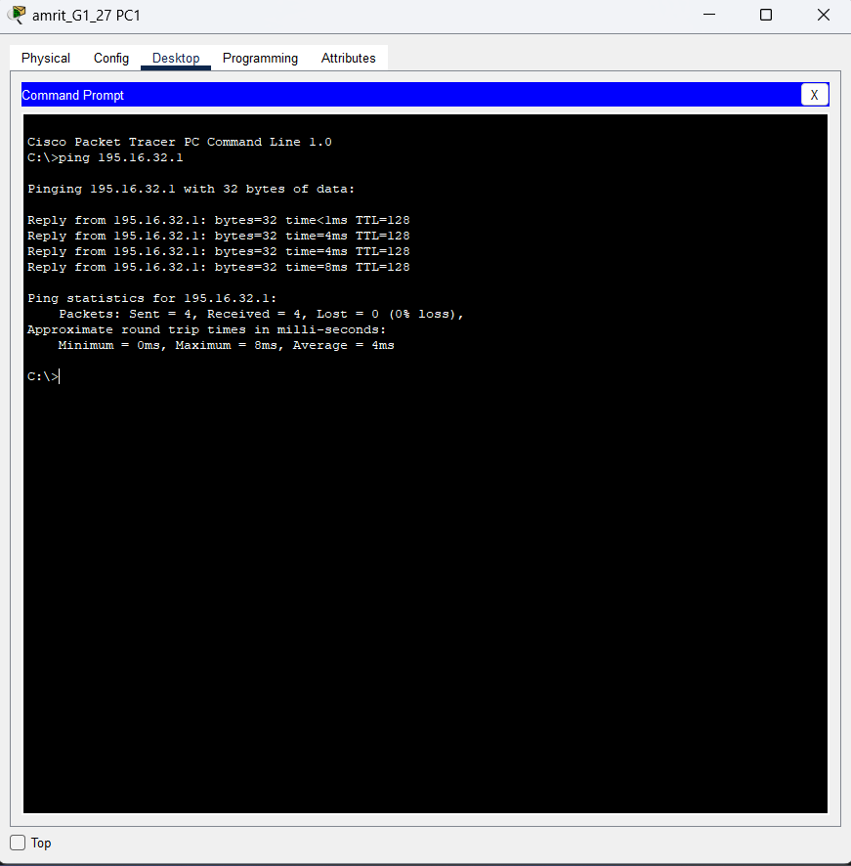

Problem Statement 5:-
Setting 15 PCs using 3 switches
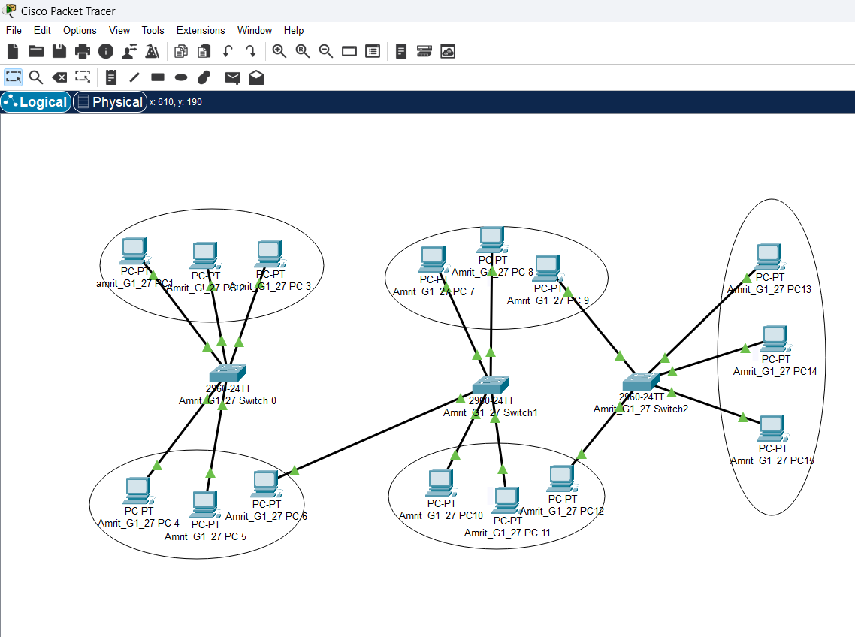

Setting IP Address of PC’s
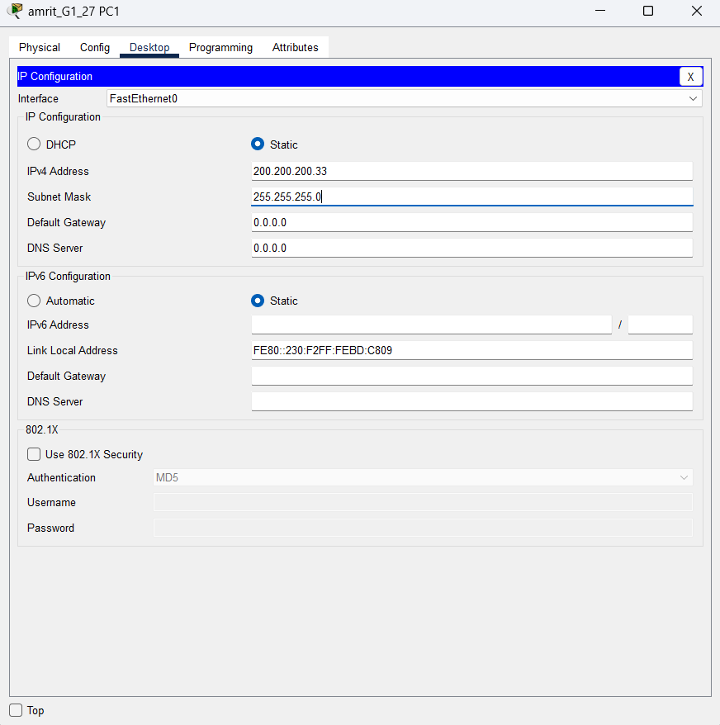

Checking connectivity using ping command
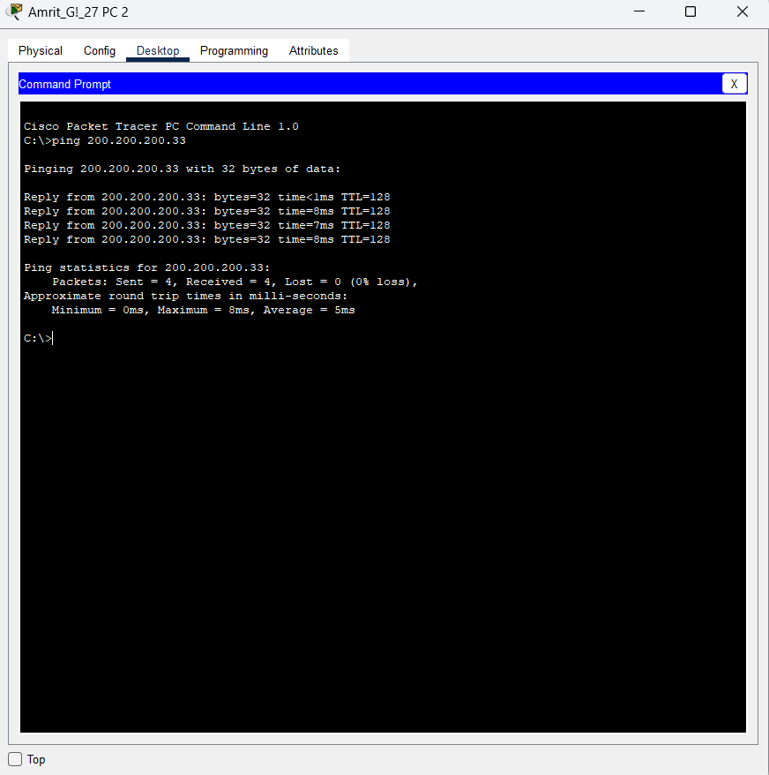

Problem Statement 6:-
Setting 15 PCs using 3 switches
Setting IP Address of PC’s
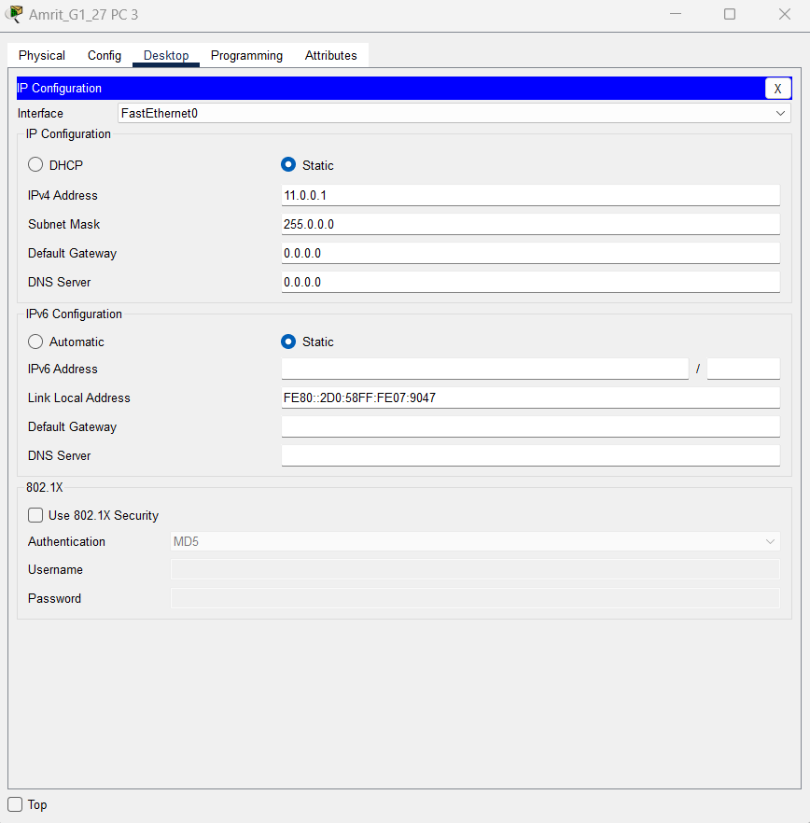

Checking connectivity using ping command
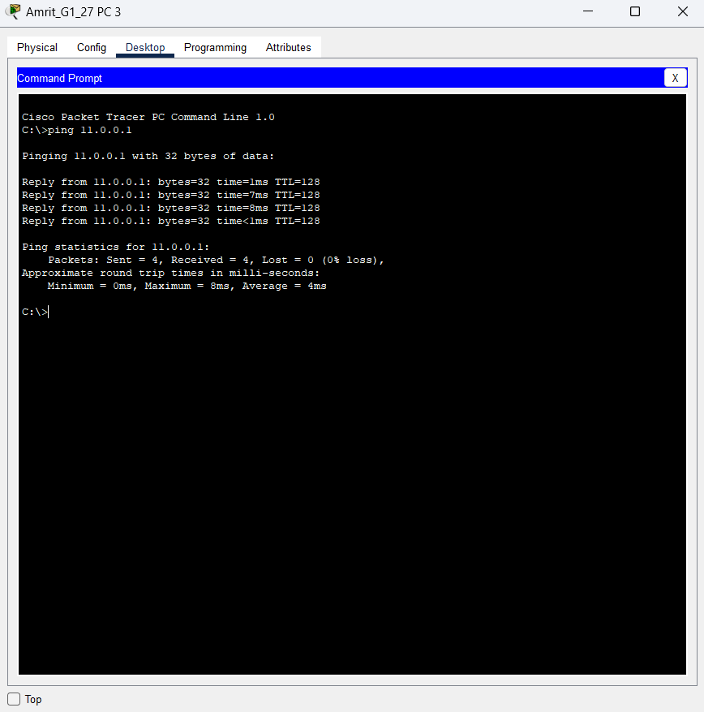

Problem Statement 7:-
Setting 15 PCs using 3 switches

Setting IP Address of PC’s
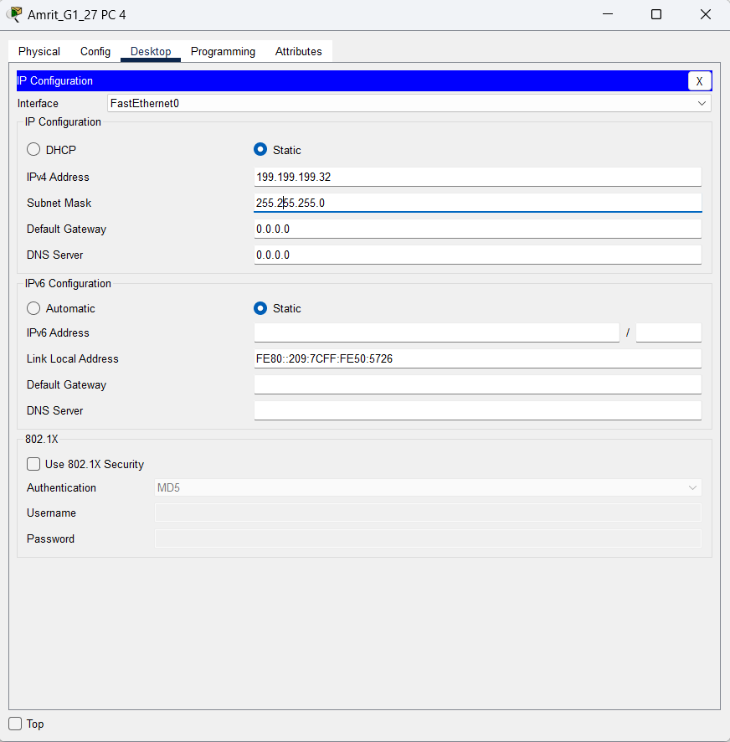

Checking connectivity using ping command
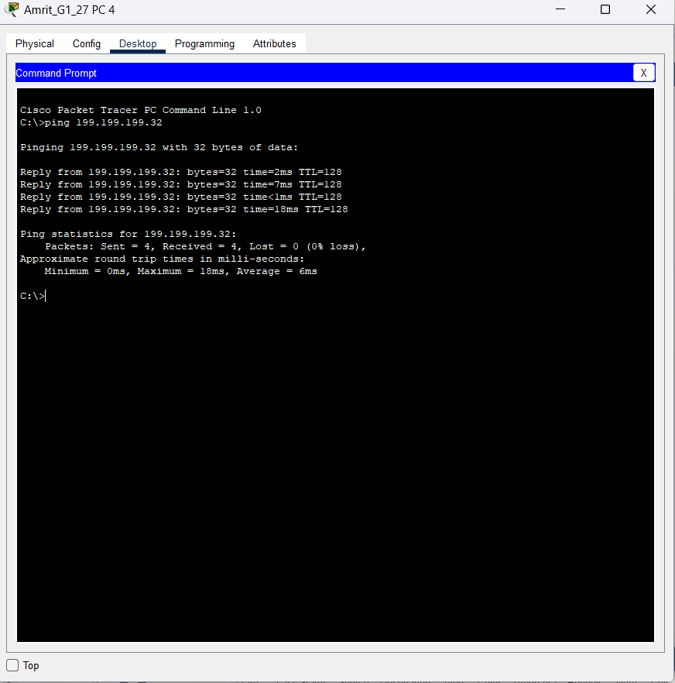

Problem Statement 8:-
Setting 15 PCs using 3 switches

Setting IP Address of PC’s
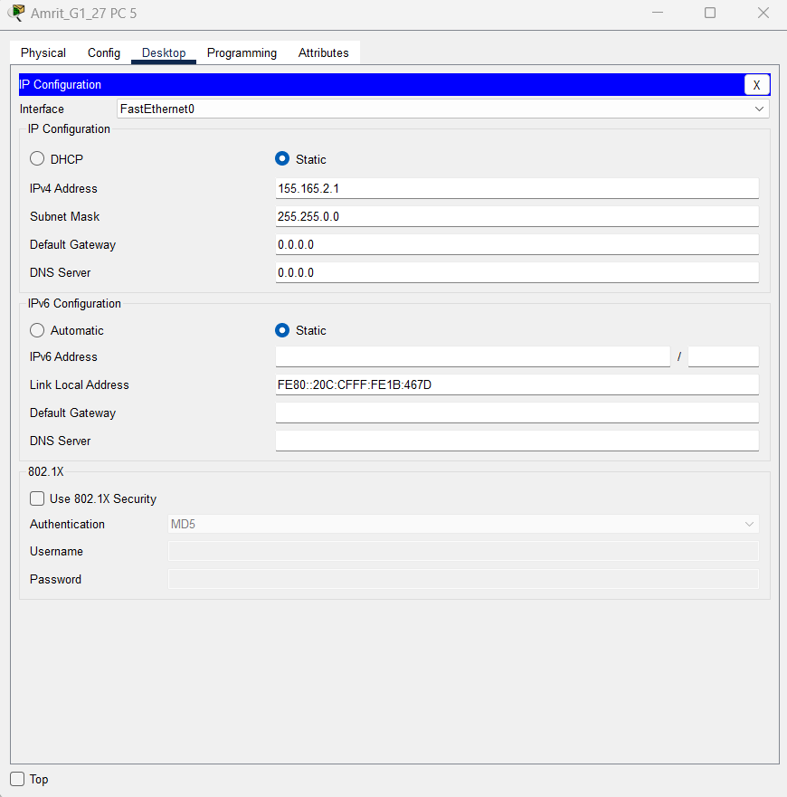

Checking connectivity using ping command
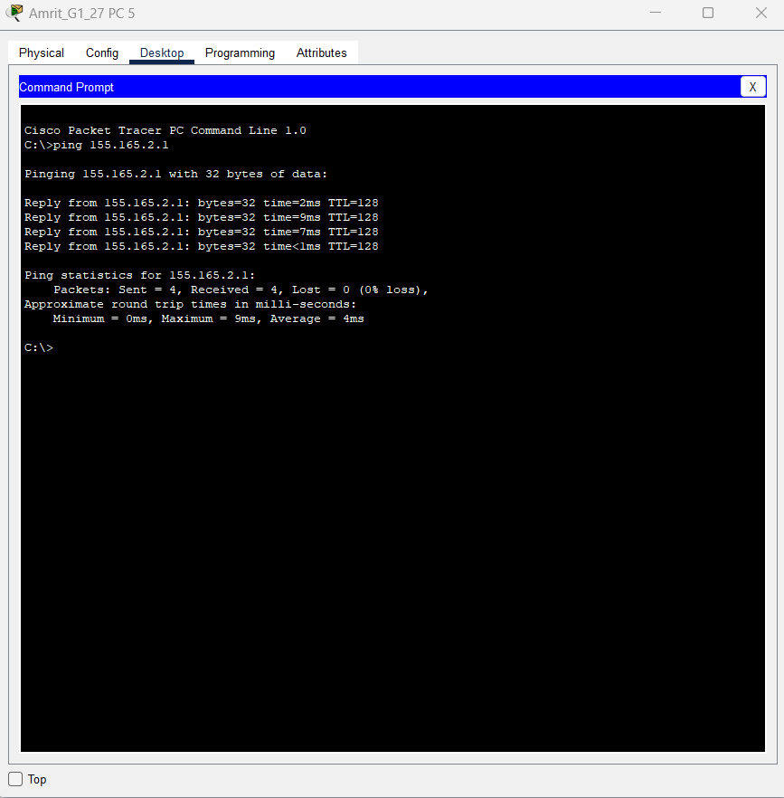

Problem Statement 9:-
Setting 15 PCs using 3 switches

Setting IP Address of PC’s
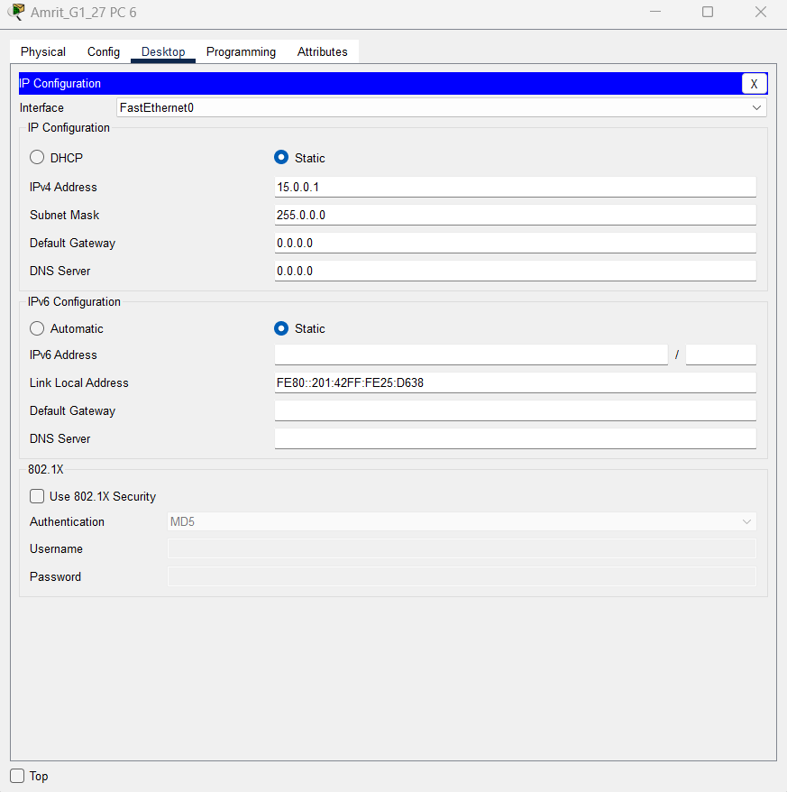

Checking connectivity using ping command
