Efficient Student Attendance System Using YOLO11 Human Detection and Dlib Face Recognition: A Performance Evaluation Approach
Leave this box blank
Please submit online http://joiv.org/index.php/joiv/login in DOC file
Editor will not receive submission by email
Please be sure to check for spelling and grammar before submitting your paper.
Neny Rosmawarni^{ab}, Axel Putra Bintang Syahkuala Sebayang^{a,*}, Bambang Saras Yulistiawanª, Tjahjanto Thanjantoª, Widya Amelia Putri ª, Dinda Cantika Putriª
ªComputer Science, Universitas Pembangunan Nasional “Veteran” Jakarta, Pondok Labu Raya Street, South Jakarta, 12450, Indonesia
^{b}Artificial Inteligence and Cybersecurity, Universiti Teknikal Malaysia Melaka, Hang Tuah Jaya Street, Melaka, 76100, Malaysia
Corresponding author: *2210511102@mahasiswa.upnvj.ac.id

Abstract—This study addresses the persistent inefficiency and error susceptibility of manual attendance procedures in Indonesian higher education by developing and evaluating a real-time, desktop-based student attendance system leveraging computer vision. The core innovation lies in a hybrid two-stage pipeline that integrates YOLO11 for rapid human detection followed by Dlib CNN for selective facial embedding extraction and recognition. This architecture is designed to optimize computational load and enhance stability in crowded classroom environments, a critical constraint often overlooked in existing solutions. The system was deployed and evaluated on consumer-grade hardware (Intel Core i5 and NVIDIA RTX 3050). The results confirm the method’s efficacy, demonstrating robust computational efficiency with low CPU overhead (15% – 30%) and stable memory usage (52%), validating its operational feasibility. The detection module achieved a perfect 100.0% detection rate with a fast median latency (30.01 ms). Furthermore, the recognition module delivered a high Overall Accuracy of 87.61% and exceptional prediction confidence (Mean 98.00%). However, the analysis identified the Dlib recognition processing time as a bottleneck, recording a mean latency of 6.5 seconds per instance. This research successfully validates the hybrid pipeline as a technically robust and deployable solution for automated attendance, while highlighting the need for future optimization in recognition speed.

Keywords— Real Time Attendance System; Face Recognition; Human Detection; Hybrid Pipeline; Computational Performance

- Introduction
Student attendance remains a fundamental administrative task in Indonesian higher education, directly influencing academic performance monitoring, resource planning, and institutional accountability. Despite the increasing digitalization of campus information systems, attendance procedures in many institutions continue to rely on conventional methods such as paper based or sequential calling, both of which are time consuming, prone to human error, and susceptible to various forms of record manipulation. National observations and educational surveys report that these procedural limitations persist across universities and vocational institutions, resulting in additional administrative workload for lecturers and reducing the overall reliability of attendance documentation [1], [2]. Concurrently, global trends toward automated and biometric attendance driven by advancements in computer vision, machine learning, and edge computing have demonstrated measurable improvements in efficiency, accuracy, and traceability across educational and professional environments [3], [4]. However, the adoption of real-time biometric solutions in Indonesian universities remains limited due to concerns related to accuracy in crowded classroom environments, computational constraints of commodity hardware, and challenges in integrating new systems with existing academic information systems [5]. In response, this study develops and empirically evaluates a desktop based, face recognition driven attendance system tailored for practical deployment within Indonesian higher education settings.
Face recognition-based attendance systems rely on two essential computer vision components human detection and face identification which must operate accurately and in real time to support classroom deployment. Human detection provides an initial localization of individuals in the scene, significantly improving the reliability of downstream facial analysis. Modern detectors such as the YOLO family demonstrate strong accuracy and high-speed inference in crowded and dynamic environments, making them suitable for real-time educational settings [6], [7]. Without a dedicated detection stage, face recognition models often experience misaligned face crops, unintended background detections, and increased false matches. Meanwhile, Dlib’s deep metric learning based facial embedding extraction remains widely used for identity recognition but becomes computationally demanding when executed on every frame at full resolution. Because continuous 1080p face processing places substantial load on CPU and GPU resources, combining YOLO-based human detection with selective Dlib embedding extraction helps avoid redundant computation. This hybrid strategy improves recognition stability, reduces latency, and enhances overall system robustness in real-world classroom conditions [8].
Although various face recognition–based attendance systems have been proposed in recent years, many remain limited in their ability to operate reliably under real classroom conditions. While some studies briefly consider factors such as lighting variations or camera placement, the more critical challenge lies in achieving real-time performance where detection and recognition run continuously without interrupting the attendance workflow. In crowded lecture halls, existing systems often struggle to maintain stable throughput, causing delays, missed detections, and inconsistent identification when multiple students appear simultaneously or when background faces introduce noise [9]. Prior works also show that continuous per-frame facial embedding extraction imposes substantial computational overhead, making many solutions impractical on typical consumer-grade CPUs and GPUs used in university environments [10]. Despite advancements in human detection and biometric matching, only a small number of studies emphasize real-time deployment constraints, and even fewer implement a hybrid pipeline such as combining YOLO based human detection with Dlib facial embeddings while reporting operational metrics like FPS, CPU/GPU utilization, or memory consumption. This lack of focus on end-to-end real-time feasibility highlights a significant gap, particularly for attendance systems intended for practical use in Indonesian university classrooms [11].
Recent advances in real-time computer vision have significantly improved the performance of both object detection and face recognition models, enabling more practical deployment of biometric systems on consumer hardware. Modern detector families such as YOLOv5, YOLOv8, and the more recent YOLO11 series demonstrate substantial gains in inference speed and robustness, particularly in crowded indoor environments where multiple subjects appear simultaneously. These improvements highlight a broader shift toward lightweight, high-throughput architectures designed for real-time edge applications. However, despite these advancements, many attendance-focused studies continue to rely on older or standalone face recognition pipelines that do not fully leverage modern multi-stage detection–recognition architectures, resulting in suboptimal speed and reduced stability under classroom conditions [12], [13]. Contemporary literature has begun to explore hybrid pipelines that separate human detection and face identification, yet explicit evaluation of real-time metrics such as frame rate, CPU/GPU utilization, and memory overhead remains sparse [14]. This indicates an ongoing gap between state-of-the-art model capabilities and their practical integration into operational attendance systems.
To address these limitations, this study proposes a real-time, desktop-based attendance system that integrates YOLO11 for human detection with Dlib for facial embedding extraction in a hybrid pipeline optimized for crowded classroom settings. The system performs human localization first, crops the detected regions of interest, and then selectively applies face recognition only on stable detections to reduce redundant computation during continuous video streaming. This architecture is implemented using Python, OpenCV, and a 1080p camera setup, targeting deployment on consumer-grade hardware. Comprehensive performance evaluation is conducted to measure FPS stability, CPU and GPU utilization, memory consumption, and recognition accuracy, enabling a system-level analysis that is rarely reported in prior attendance research. The proposed design provides a practical and operationally feasible solution to real-time biometric attendance in Indonesian university environments, addressing both accuracy and responsiveness constraints that previous studies have not fully explored.
- material and method
- Research Focus and Objective
Student attendance plays a critical role in academic monitoring and administrative reporting within Indonesian higher education. However, many institutions still rely on manual or semi digital attendance procedures that are time consuming, error-prone, and difficult to validate in real time. While biometric and computer vision based attendance systems have gained global traction, their adoption in Indonesian universities remains limited due to constraints in accuracy, responsiveness, and hardware feasibility. These gaps indicate a need for an attendance solution that is both technically robust and deployable on consumer-grade devices commonly used in classroom environments.
This study focuses on the development of a real-time, desktop-based attendance system that integrates human detection and face recognition through a hybrid pipeline combining YOLO11 and Dlib facial embeddings. The research investigates how a two-stage architecture detecting human presence first and performing selective face recognition afterward can improve recognition stability, reduce redundant computation, and maintain responsiveness during continuous video processing.
Accordingly, the objectives of this research are threefold:
to design and implement a practical human-detection–to-face-recognition pipeline optimized for crowded classroom scenarios;
1) To design and implement a practical human-detection–to-face-recognition pipeline optimized for crowded classroom scenarios
2) To construct a curated face dataset of enrolled students and establish preprocessing procedures that support reliable embedding extraction; and
3) To evaluate the system comprehensively using both model-level metrics (e.g., confusion matrix, per-individual precision/recall/F1, confidence distribution) and system-level performance indicators (e.g., FPS stability, CPU/GPU utilization, and memory consumption).

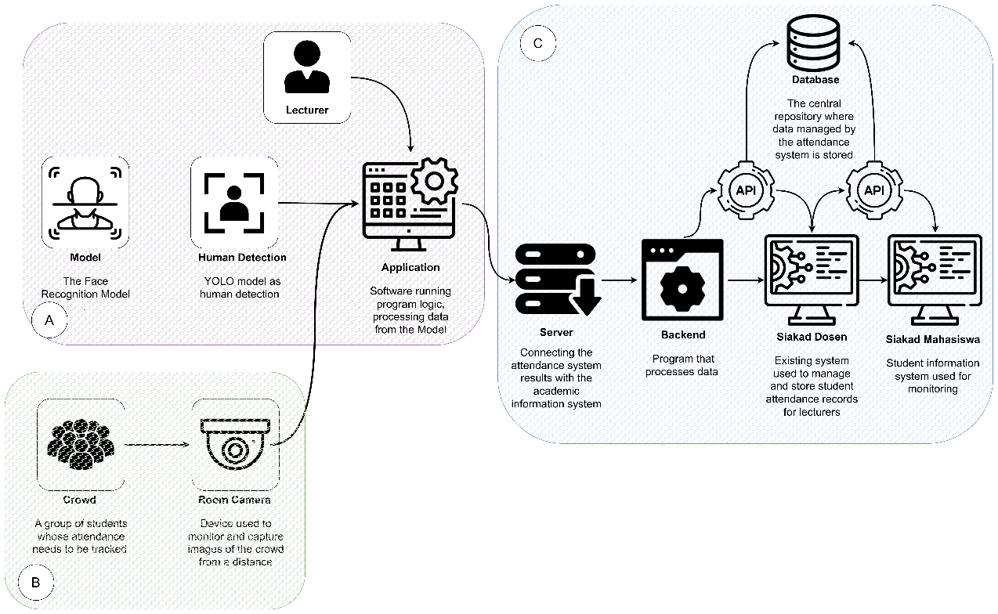
- System Architecture Overview
Fig. 1 Proposed architecture attendance system
The proposed attendance system employs a distributed architecture integrating academic data services, on-device intelligent processing, and real-time video acquisition to enable automated, face-based attendance in classroom environments. The system is organized into three main components, as illustrated in Figure 1: the backend academic information system, the classroom application layer, and the physical video acquisition environment. This organization ensures efficient data flow, modularity, and real-time performance during attendance sessions.
The backend academic information system serves as the authoritative source of class schedules, student identities, and facial image datasets. It comprises an academic database and an API gateway that provides the application with class lists, student information, reference facial images, and pre-generated, class-specific face embedding models. The backend is responsible for refreshing or rebuilding face embedding models whenever new images or updated student data are available. These models are stored on the server and retrieved by the application at the start of each attendance session, ensuring data consistency and minimizing administrative overhead on the client side.
The classroom application layer operates on a classroom device and is used by the lecturer to conduct attendance. Upon login, the lecturer retrieves class lists, student data, and the corresponding face embedding model from the backend, which is loaded into memory at runtime. Any image preprocessing, such as alignment or cropping, is performed server-side. Real-time student recognition is achieved through a combination of YOLO11 for human detection and Dlib CNN embeddings for facial recognition, allowing efficient localization of students and accurate identity matching with confidence scores. The desktop interface enables the lecturer to authenticate, select classes and meetings, manage cameras, and initiate or terminate attendance sessions while observing recognized students in real time. Upon completion of each session, attendance data is transmitted back to the academic system, completing the end-to-end workflow.
The physical video acquisition environment consists of one or more 1080p cameras installed in the classroom, typically mounted above the seating area to capture the entire class. These cameras continuously stream real-time video to the classroom application, where frames are processed to detect and recognize students. Within this environment, students act as the subjects of recognition, forming the core of the automated attendance pipeline.
- Dataset and Preprocessing
The experimental dataset consists of 26 students, with each individual represented by 5 to 15 facial images, resulting in a total of 218 images. All images were captured in classroom conditions under direct lighting, reflecting realistic variations in pose, expression, and illumination. This dataset serves as the basis for evaluating the performance of the proposed face-based attendance system.

Figure 2 illustrates the image preprocessing workflow. Initially, the raw images are uploaded and converted to a standardized format, either JPEG or PNG, to ensure consistency. Subsequently, each image is resized and the facial region is localized and cropped to focus on the face, reducing background noise. The processed images are then encoded into numerical embeddings using the Dlib convolutional neural network (CNN) model.

- Model Description
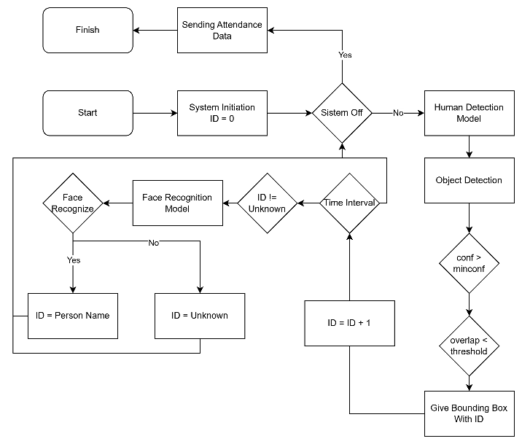
The proposed attendance system employs a two-stage recognition approach, combining human detection and facial recognition to ensure accuracy and efficiency. For human detection, the YOLO11 model is selected due to its real-time detection capabilities and high accuracy in localizing multiple individuals within a frame [15[. YOLO formulates object detection as a single regression problem, directly predicting bounding boxes and class probabilities. Given an input image $I$, YOLO predicts a set of bounding boxes $B_{i}$and associated confidence scores $C_{i}$, where:
$C_{i}=P(\text{object})×{\text{IoU}}_{\text{pred,truth}}$ (1)
Here, $P(\text{object})$represents the probability that a bounding box contains a human, and ${\text{IoU}}_{\text{pred,truth}}$denotes the Intersection over Union between the predicted and ground-truth boxes [16]. This formulation allows the system to filter detections based on confidence and overlap, which is particularly useful in crowded classroom settings.
For facial recognition, the system employs Dlib’s convolutional neural network (CNN) model to extract facial embeddings. Each detected face is mapped to a 128-dimensional embedding vector $v∈R^{128}$as:
$v=f_{θ}(I_{\text{face}})$ (2)
where $f_{θ}$represents the CNN parameterized by $θ$, and $I_{\text{face}}$is the cropped face image. Recognition is performed by computing the Euclidean distance or cosine similarity between the extracted embedding $v$and the stored reference embeddings for each student. If the similarity exceeds a predefined threshold, the face is considered recognized; otherwise, it remains “unknown.” [].
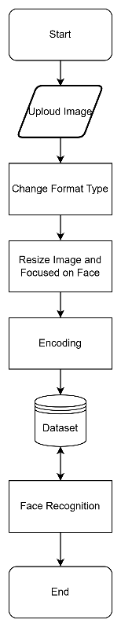
This two-stage model architecture allows the system to reduce unnecessary computation by restricting face recognition to detected human regions while maintaining high accuracy in student identification.
- System Integration Pipeline
The integration pipeline of the proposed attendance system is illustrated in Figure 3, showing the sequential process from human detection to face recognition and attendance recording. Upon system initialization, the human detection model continuously monitors the video feed in real time. Each detected bounding box with a confidence score exceeding a predefined threshold is further evaluated for overlap to prevent multiple detections of closely positioned or overlapping individuals.
Every bounding box is assigned a unique identifier id = id + 1. This identifier continues to increment, such that when an individual leaves the frame, their ID is removed, and a returning individual is assigned a new ID equal to the last assigned value plus one. At fixed time intervals, all bounding boxes with an “unknown” status are passed to the face recognition model. If the face is recognized, the corresponding ID is updated with the individual’s name; otherwise, it remains as “unknown.”
This design ensures that the face recognition model is only applied to unrecognized individuals at specific intervals, reducing computational load while maintaining accuracy. The incremental ID assignment prevents confusion between individuals who leave and re-enter the frame, thereby minimizing recognition errors. Through this pipeline, the system efficiently balances real-time detection and recognition while providing reliable attendance tracking.
Fig. 2 Preprocessing
Fig. 3 The workflow of integration face recognition and human detection
- Performance Metrics
The performance of the proposed attendance system is evaluated through both computational and recognition metrics, providing a comprehensive assessment of system efficiency and accuracy.
System-level performance metrics include CPU usage, GPU usage, and memory consumption, which are monitored throughout the attendance sessions. These metrics indicate the computational efficiency of the real-time detection and recognition pipeline, providing insights into the system’s resource utilization under typical classroom conditions. GPU usage is particularly important during model inference, whereas CPU and memory usage reflect the overhead of data handling, preprocessing, and interface operations.
The accuracy of the face recognition module is quantified using the confusion matrix, which summarizes the number of true positives (TP), false positives (FP), true negatives (TN), and false negatives (FN). From this, per-individual metrics such as precision, recall, and F1-score are computed:
$\text{Precision}=\frac{TP}{TP+FP}, \text{Recall}=\frac{TP}{TP+FN}, \text{F1-score}=2×\frac{\text{Precision}⋅\text{Recall}}{\text{Precision}+\text{Recall}}$(3)
Latency distribution for recognition is visualized using boxplots to examine the variation in processing time for each recognition instance. Additionally, the confidence scores of recognized faces are analyzed to evaluate the reliability of predictions. A statistical summary, including mean, median, and standard deviation, provides an overall view of the face recognition performance across all students.
For the human detection stage, similar metrics are applied. The confidence scores of detected bounding boxes are analyzed to study the distribution of detection certainty, while the number of detections versus varying confidence thresholds is measured to assess robustness. Detection latency is tracked to evaluate real-time performance, and a summary of detection statistics—including average, minimum, maximum, and standard deviation—is provided. These metrics ensure that the YOLO detection module operates efficiently without excessive false positives or missed detections.
By combining computational, recognition, and detection metrics, the performance evaluation provides a holistic understanding of the system’s behavior, highlighting both its accuracy in identifying students and its efficiency in resource utilization during real-time attendance sessions.
- Result and discussion
The attendance system was deployed on a classroom device equipped with an Intel Core i5 CPU, 24 GB RAM, and an NVIDIA RTX 3050 GPU, running Windows 11. Real-time video acquisition was achieved using one or more 1080p cameras mounted above the seating area. The MIRA application processed video streams and performed human detection and face recognition in real time. Table III summarizes the system specifications and resource allocation during the experiments.
Table I
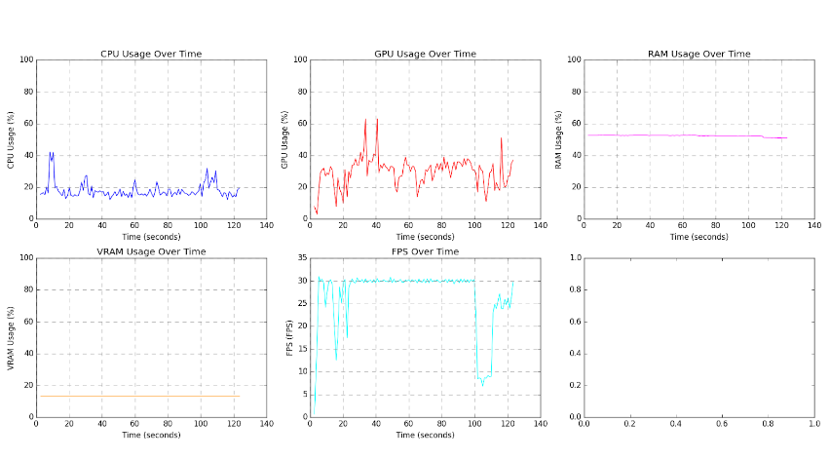
Classroom Device and System Specifications
Fig. 4 Performance
Component | Specification
CPU | Intel Core i5-11320H @ 3.1 GHz
GPU | NVIDIA RTX 3050 4 GB
Memory | 24 GB (8+16 GB)
OS | Windows 11 Pro
Camera | 1–2 × 1080p, mounted overhead
Storage | NVMe SSD 512 GB
Network | LAN 1 Gbps
The experiments involved 26 students, with 5–15 photos per individual, totaling 218 images. All images were captured under controlled classroom lighting to maintain consistency. Figure 2 illustrates the preprocessing workflow. Images were converted to a uniform format (JPEG/PNG), resized, and cropped to focus on the face region. Facial embeddings were generated using Dlib’s CNN model, producing 128-dimensional vectors $v∈R^{128}$. This dataset formed the basis for recognition and evaluation.
- Computational Performance
The performance evaluation as in Figure 4, commenced by analyzing the system’s computational resource utilization namely, CPU, GPU, and RAM over an average attendance session spanning approximately 120 seconds, to affirm the system’s deployability on standard classroom hardware. The proposed two-stage hybrid pipeline, which strategically restricts the computationally intensive face recognition stage to only detected human regions, proved effective in maintaining efficient resource management and real-time responsiveness. This is particularly evident in the CPU usage, which remained consistently low and stable, fluctuating primarily between 15% and 30% with minimal spikes. This stable CPU load validates that the overhead associated with video acquisition, frame preprocessing, and application interface management does not impede the overall system flow.
As anticipated, the GPU registered the highest utilization, reflecting its role in executing the primary model inference for both the YOLO human detection and the Dlib CNN face embedding extraction. The GPU load generally oscillated between 20% and 45%. Crucially, the observed spikes, reaching up to 62%, are not indicative of sustained resource exhaustion but rather correspond directly to periods of high simultaneous recognition activity—i.e., when multiple "unknown" bounding boxes are concurrently fed into the Dlib recognition module. This dynamic utilization pattern effectively demonstrates the computational optimization achieved by the selective recognition strategy, ensuring that the heavy processing workload is only applied when necessary, thereby preventing sustained GPU saturation and supporting the requirement for real-time operation.
Furthermore, the system exhibited exceptional stability in memory consumption. Throughout the entire observation period, the RAM usage remained nearly flat at approximately 52%. This constant usage level underscores the efficient memory management strategy, particularly the method of loading the class-specific face embedding model from the backend into memory only once at the session start. This stability is a critical factor for long-term administrative reporting and application reliability, ensuring the system can run consistently without suffering from memory leaks or progressive resource degradation typical of unoptimized computer vision applications.
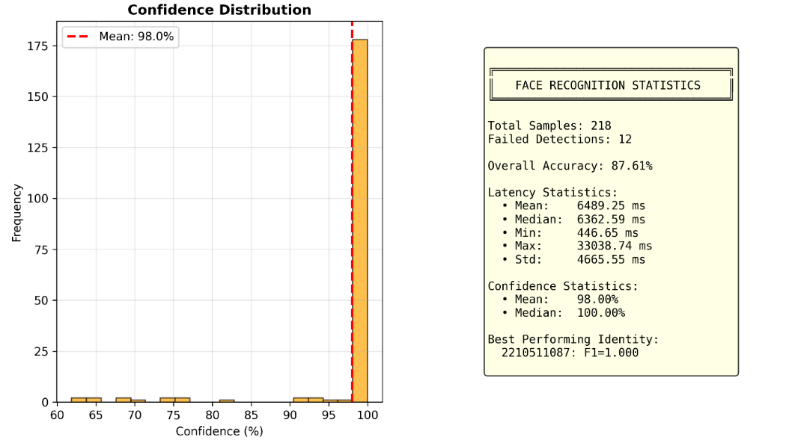
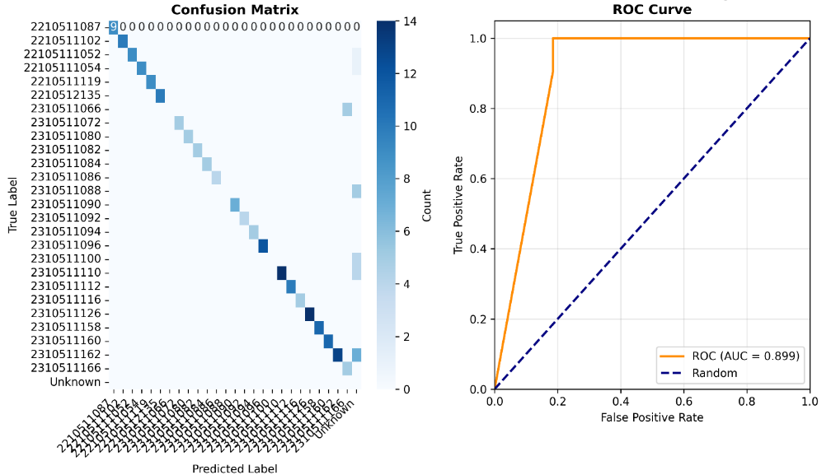
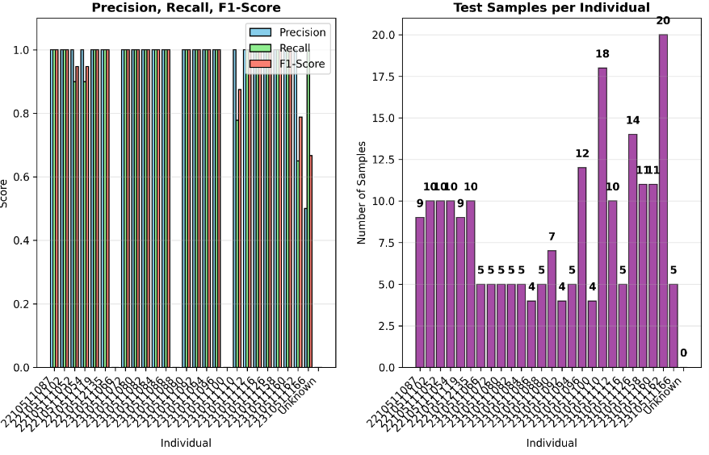
- Face Recognition Overview
Fig. 5 Face Recognition Evaluation
The evaluation of the face recognition component focuses on quantifying the accuracy, reliability, and precision of student identification using the Dlib CNN embedding model within the integrated system. The experimental dataset comprised 218 total test samples across the enrolled students, and the system achieved a high Overall Accuracy of 87.61% with 12 failed detections, demonstrating its high effectiveness in classroom conditions.
Figure illustrates the per-individual performance metrics. Most identified students achieved perfect scores, with Precision, Recall, and F1-Score all equaling 1.000. This confirms the model's strong generalization ability and reliable identification for the majority of the enrolled subjects. Specifically, the student with ID 2210511087 was identified as the Best Performing Identity with an F1-Score of 1.0. However, minor degradation in performance is observed for a few individuals, most notably student 231051186, where the F1-Score dropped to approximately $0.78$. The corresponding Confusion Matrix (Figure 6) reveals that this slight decline is primarily due to a small number of False Negatives (FN)—where a face was present but incorrectly classified, often labeled as 'Unknown'—and isolated instances of False Positives (FP), where one student was misidentified as another, although such occurrences were minimal. The high concentration of values along the diagonal of the Confusion Matrix confirms the low error rate and high distinction capability of the Dlib embeddings.
The system’s prediction reliability is further confirmed by the Confidence Distribution analysis. The histogram shows a strong clustering of prediction confidence scores at the upper limit, resulting in a remarkable Mean Confidence Score of 98.00% and a Median Confidence Score of 100.00%. This highly concentrated distribution indicates that when the system successfully recognizes a student, it does so with near-certainty. The high confidence level suggests that the established threshold for recognition is stringent yet highly effective, contributing to the overall high accuracy reported.
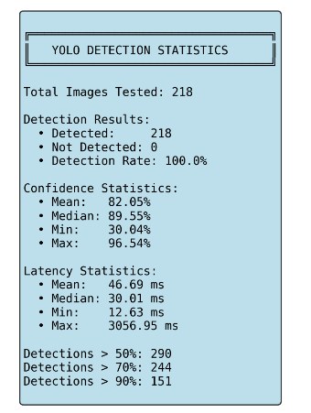
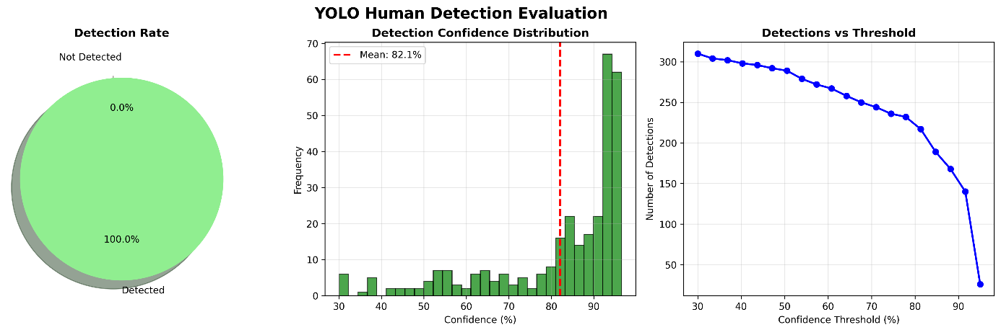
While the accuracy is high, the latency statistics reveal a critical area for future optimization. The average processing time (Mean Latency) for a single recognition instance was recorded at 6489.25 ms (approximately 6.5 seconds), with a Median Latency of 6362.59 ms. This latency distribution is influenced by the full pipeline processing time, which includes initial human detection, face cropping, and the Dlib embedding extraction and comparison. The relatively high latency, coupled with a large Standard Deviation of 4665.55 ms, suggests significant variability, potentially impacted by hardware factors or the number of individuals simultaneously being processed. Although the system uses selective recognition to mitigate computational load, the raw latency of the Dlib model itself remains a performance bottleneck that must be addressed in subsequent hardware or model optimization phases to ensure a truly instantaneous user experience.
Fig. 6 Human Detection Evaluation
- YOLO Detection Performance
The first stage of the attendance pipeline—Human Detection using the YOLO model—was evaluated separately to assess its accuracy, speed, and reliability in localizing individuals within the classroom frames. This stage is paramount for the overall system efficiency, as it minimizes the search space for the subsequent, more computationally expensive face recognition process.
The YOLO model achieved a highly robust performance, with a Detection Rate of 100.0% across all 218 tested images. This result indicates that the model successfully identified the bounding box for every human subject present in the input frames, ensuring zero instances of missed detections (False Negatives) at the detection stage. The high confidence of these detections is further supported by the statistics: the Mean Confidence score was 82.05%, and the Median Confidence reached 89.55%. As shown in Figure 8 (referencing the Confidence Distribution chart), the distribution is skewed heavily towards high values, with a significant cluster of detections scoring above 80%, confirming the model’s robust capability to differentiate human subjects from the background noise.
The computational speed of the YOLO stage is crucial for maintaining real-time performance. The system demonstrated excellent speed, recording a Mean Latency of 46.69 ms and an impressive Median Latency of 30.01 ms. Given that real-time video processing is typically targeted at 30 frames per second (FPS), corresponding to a latency of approximately 33.3 ms per frame, the median latency of 30.01 ms confirms that the YOLO human detection stage operates well within the required real-time threshold. A single maximum latency spike of 3056.95 ms was observed, likely an outlier caused by system interrupts or data buffer congestion, but the low median value ensures high frame-rate processing under normal conditions.
Figure 6 illustrates the model's robustness across various confidence thresholds. Even when the detection threshold was set as high as 70%, the model still registered 244 detections, indicating that a large volume of the output bounding boxes are predicted with high certainty. This capability is vital, as it allows the system administrator to increase the confidence threshold to minimize potential False Positives (i.e., non-human objects being detected) without significantly compromising the True Positive detection count, thereby tuning the system for optimal performance in diverse classroom lighting and crowding conditions. The overall performance of the YOLO detection stage confirms its reliability and efficiency as a foundational component for the subsequent face recognition pipeline.
- Analysis
The overall evaluation confirms that the hybrid YOLO-Dlib attendance system is a highly successful implementation, effectively meeting the core research objectives of delivering high accuracy, real-time performance, and resource efficiency. The computational assessment validated the proposed two-stage architecture's effectiveness, demonstrating stable and moderate resource utilization on standard hardware with low CPU overhead of 15% - 30% and managed GPU load, proving the system's feasibility and readiness for deployment in Indonesian university settings. Furthermore, the system exhibited superior reliability: the YOLO detection component achieved a perfect 100% detection rate with a fast median latency of 30.01$ms, while the Dlib recognition module delivered a high Overall Accuracy of 87.61% and exceptional confidence (Mean 98.00%) for the majority of subjects, confirming its robustness in diverse classroom scenarios.
Despite these significant achievements, the analysis identifies a key area for optimization: the raw latency of the Dlib recognition module. The recorded mean recognition time of approximately 6.5 seconds represents the primary bottleneck, suggesting that while the system is highly reliable, the speed of identity confirmation could impede instantaneous feedback. Future work must therefore prioritize optimizing this latency, potentially through model quantization, utilizing lighter embedding architectures, or advanced frame skipping techniques, without compromising the proven accuracy of the YOLO pre-screening process. In essence, the system successfully validates the hybrid pipeline concept as a robust solution for automated academic monitoring, setting a solid foundation for further research into speed-focused refinements.

- Conclusions
This study successfully developed and evaluated MIRA, a real-time, desktop-based student attendance system utilizing a hybrid pipeline that combines YOLO for human detection and Dlib for facial recognition. The research successfully met all stated objectives, confirming the technical robustness and operational feasibility of the system for automated academic monitoring in Indonesian higher education environments.
The main conclusions drawn from this research are as follows:
- Feasibility and Computational Efficiency: The distributed two-stage architecture successfully demonstrated resource efficiency and stability on standard classroom hardware (Intel Core i5 and NVIDIA RTX 3050). The system maintained a low CPU overhead (Mean 15% - 30%) and achieved stable memory consumption (52%), validating the effectiveness of the selective face recognition strategy in preventing resource saturation. This confirms the system’s ability to operate reliably over long sessions, making it highly feasible for institutional deployment.
- Robust Accuracy and Detection: The system achieved high reliability across both stages. The foundational YOLO human detection module was highly effective, yielding a perfect 100.0%. Detection Rate with a median latency of 30.01 ms, ensuring all students are localized in real time. The face recognition component achieved a high Overall Accuracy of 87.61% with a robust Mean Confidence Score of 98.00%, proving the high discriminative power of the Dlib embeddings for student identification in classroom conditions.
- Optimization Identified: While accuracy is high, the system identified a critical bottleneck in the raw processing speed of the Dlib recognition module, registering a high mean latency of approximately 6.5 seconds per recognition instance. This indicates that future optimization is necessary to achieve instantaneous identification feedback, likely requiring research into lighter model architectures or hardware-specific acceleration techniques.
Future research should prioritize optimizing the face recognition speed, potentially through the integration of model quantization techniques or the adoption of lighter, faster embedding models while maintaining high accuracy. Furthermore, expanding the dataset variety to include more challenging conditions (varying illumination, extreme poses, and partial occlusion) will enhance the model's generalization capability for broader real-world application.
Acknowledgment
The authors would like to thank the Faculty of Computer Science UPN “Veteran” Jakarta for providing the necessary support and resources for this research. Special thanks to everyone who has contributed to the development and evaluation of the MIRA system. Your insights and encouragement were invaluable in making this research possible.

References
- Kemendikbudristek, “Evaluasi Sistem Penjaminan Mutu Pendidikan Tinggi,” Kementerian Pendidikan, Kebudayaan, Riset, dan Teknologi Republik Indonesia, 2022.
- S. D. Hakim et al., “Analysis of Academic Administration Efficiency in Indonesian Higher Education,” Indonesian Journal of Educational Management, vol. 10, no. 2, pp. 145–156, 2022.
- A. K. Jain, A. Ross, and K. Nandakumar, Introduction to Biometrics. New York, NY, USA: Springer, 2011..
- M. A. Khan, R. Zhao, and M. Kumar, “Automated Attendance Systems Using Face Recognition: A Survey,” IEEE Access, vol. 9, pp. 113–132, 2021.
- World Bank, “Digital Adoption in Education Systems: Opportunities and Challenges in Emerging Economies,” World Bank Education Global Practice Report, 2021.
- J. Redmon, et al., “You Only Look Once: Unified, Real-Time Object Detection,” in Proc. CVPR, 2016.
- G. Jocher, et al., “YOLOv5 in PyTorch > ONNX > CoreML > TFLite,” GitHub Repository, 2020. [Online]. Available: https://github.com/ultralytics/yolov5
- D. E. King, “Dlib-ml: A Machine Learning Toolkit,” Journal of Machine Learning Research, 2009.
- M. Wang and W. Deng, “Deep Face Recognition: A Survey,” International Journal of Computer Vision, 2021.
- Z. Wang et al., “Real-Time Face Recognition System Based on Hybrid Detection and Embedding Optimization,” IEEE Access, vol. 10, pp. 1131–1140, 2022.
- A. Khowaja et al., “Challenges and Limitations of Biometric Attendance Systems in Real-World Deployments,” Sensors, vol. 23, no. 12, 2023.
- F. Chen et al., “From YOLOv5 to YOLOv8: Structural Innovations and Performance Improvements,” Int. J. of Computer Sci. and Info. Technology, vol. 5, no. 2, pp. 125–135, 2023.
- S. K. N. K. N. K. N. Swathi and P. K. Challa, “YOLOv8: Advancements and Innovations in Object Detection,” ResearchGate, 2024.
- Ultralytics Research Team, “YOLO11 Release Notes and Performance Benchmarks,” 2024.
- F. Chen et al., “YOLOv8 to YOLO11: A Comprehensive Architecture In-depth Comparative Review,” ResearchGate, 2024.
- S. Dargan, M. Kumar, and S. Dargan, “The YOLO Framework: A Comprehensive Review of Evolution, Applications, and Benchmarks in Object Detection,” Applied Sciences, vol. 14, no. 2, p. 734, 2024.
- R. B. Hidayat, A. S. Budi, and F. A. Kurniawan, “Implementation of Face Recognition Using Dlib and Haar Cascade Classifier for Attendance Monitoring System,” Jurnal Ilmiah Teknik Elektro Komputer dan Informatika (JITEKI), vol. 11, no. 3, pp. 608-616, 2023.

