
for A continous Quality Assurance

Motivation

Why should we use unit test for m-scripts?
Usually a m-script is no longer than 300 lines of code. Working hard it’s done in a day. That’s what a boss told me once starting a new job. I understood his point we worked in a research facility and most of our work had only be done once. But I worked in projects which are bigger and had a long term perspective. So the trouble started a few months later. I struggled most of my time fixing “buggy” code. I changed my view und start to understand projects handling more lines of code need other approaches to produce good and clean code. That time Kent Beck started his work on jUnit and the Test Driven Development. I’ve heard about it and worked in most of my projects with java. It was easy to apply his ideas on my work.
After many years using jUnit I started working with Matlab in product development. That time I really mist that feature. Searching the web, I found some frameworks. But none of them had the maturity I was accustomed by jUnit. So I started to contribute in the open source project mlUnit. After few weeks of work and the help of a colleague we made it and I started to use unit testing in my Matlab projects.

Benefit of Testing your m-code
In talks with colleagues and friends, reading publications and on my hands on experience testing helps to create good which can be maintained a long time.
What you gain if you applying testing, is a better understanding of:
- implemented feature
- your customer and his needs
- the code of other
Than you can improve
- confidence in your work
- quality of produced
- the kind of communication through your code, because you have to communicate your ideas
- implementation speed, because you don’t lose time bug fixing
What you have to invest:
- Learning a new method of implementing
- Patience, because you will fail some times and in the early beginning it feels like slowing down

Why open source?
I like the open source idea to exchange ideas and resources.
Most of the critique on open source projects depends on the limited resources. Most of the programmer work voluntary and are driven by their passion. We do also, but you can help us. Send us a feedback to improve our work. Funding is also welcomed to speed up the development.

A Test case (Unittest)
The easiest way to test is testing a script. Here a short example which returns a short or a long version string.
function version = fm_about(0)
version = ‘1.0 my frame work’
version = ‘1.0 my frame work’

Einführung das xUnit Testframework ?
Ein Testfall
function test = test_mxray_about

test = load_tests_from_mfile(test_loader);

%% test: argument less call of mxray_about
function test_without_arguments %#ok

sExpected = 'M-XRay Version 1.46 MES Beta - Evaluation';
assert_equals(sExpected, mxray_about);

%% test: with arguments
function test_with_arguments %#ok

sExpected = 'M-XRay V 1.46 MES Beta - Evaluation';
assert_equals(sExpected, mxray_about(0));

sExpected = 'M-XRay Version 1.46 MES Beta - Evaluation';
assert_equals(sExpected, mxray_about(1));

Ein Systemtest (Ausschnitt)

%% test: test a simulink model with library referencies
function test_info_libs %#ok
% open model
system = 'fuelsys_mod';
info = mxray_getModelInfo(system);

% check all fields
assert_equals(system,info.('Name'));
assert_equals(which(system),info.('FullName'));
assert_equals(181915,info.('Size'));
assert_equals('1.113',info.('ModelVersion'));
assert_equals(6.5,info.('Version'));
assert_equals('Tue Jun 02 16:11:43 1998',info.('Created'));
assert_equals('The MathWorks Inc.',info.('Creator'));
assert_equals('Axel',info.('LastModifiedBy'));
assert_equals('Axel',info.('ModifiedBy'));
assert_equals(10, length(fieldnames(info)));

assert_equals(3, length(info.('libs')));
assert_false(isfield(info,'refs'));

Ausführung und Testergebnisse

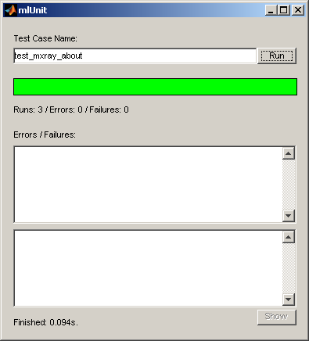
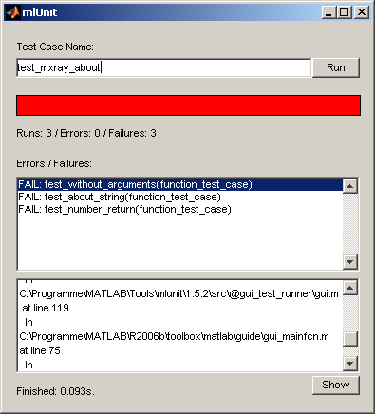
run(text_test_runner(1,2),test_mxray_about);
test_without_arguments(function_test_case) ... OK
test_with_arguments(function_test_case) ... OK

----------------------------------------------------------------------
Ran 2 tests in 0.000s
OK
run(gui_test_runner,'test_mxray_about');

Automatische Tests
Der Einsatz von automatischen Tests verbessert die Qualität des entwickelten Codes
schnelles Entdecken von Fehlern
Absicherung gegen Reintroducing
Zusammenfassen einzelner Tests zu Testsuiten
Zusammenfassen der Testergebnisse und geeignete Darstellung z.B. Ausgabe auf der Konsole oder als *.xml Datei
Erweiterung für das ant junit Format erfolgt
ML Unit hat hier Probleme ?
class based testing @folder
kein einheitliches Klassenkonzept
@folder(ab 2006a)
neues Klassenkonzept ab 2007b mit classdef
Ging nicht ab R14SP3

Testsuiten durch Erweiterung von mlUnit

Erweiterungen
suite_run() testet alle m. Files mit Präfix test_ automatisch
Script units.m führt automatisch alle Unit Tests durch und gibt die Ergebnisse auf der Konsole und als *.xml Datei aus.
Damit sind automatische Tests für m-script Projekte möglich

Nicht Teil der offiziellen Release vom mlUnit

Continuous Integration mit CruiseControl
Automatisches Build und Unit Tests in Cruise Control integriert
einfache Administration von neuen Branches, Tags
Da kein zentraler Server wurde System abgeschaltet …
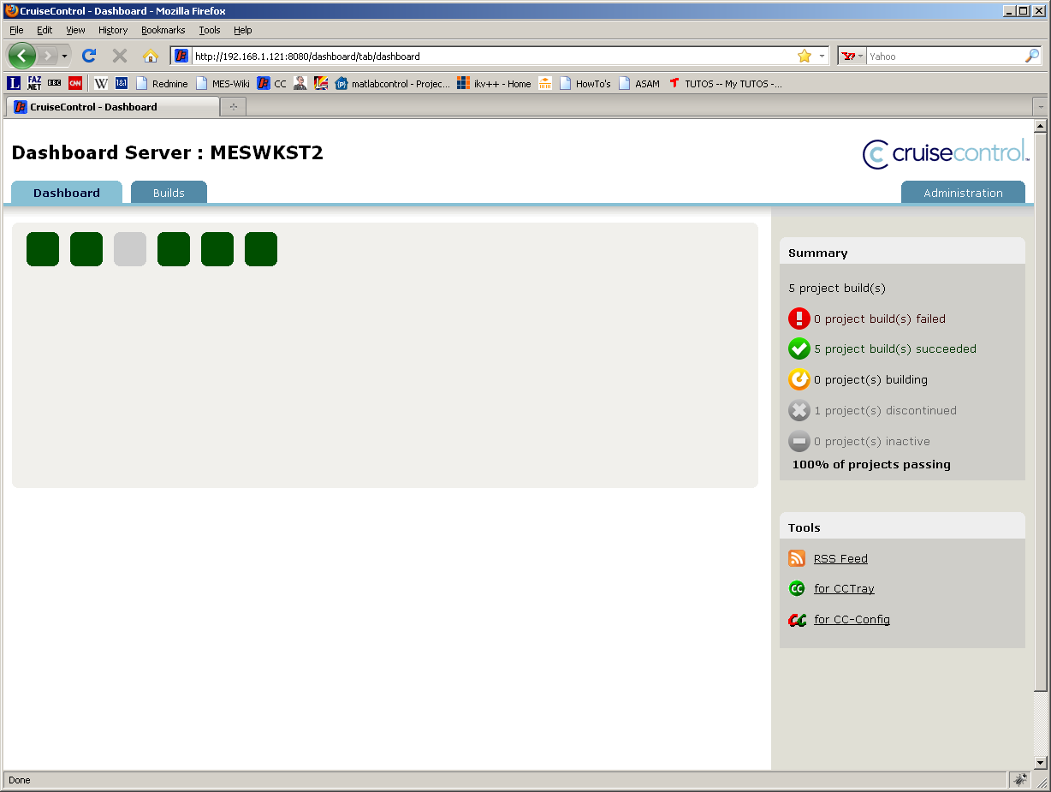

Continuous Integration mit Jenkins
Automatisches Build und Unit Tests in einer VM unseres Servers integriert
UnitTests werden in Matlab R14SP3 durchgeführt
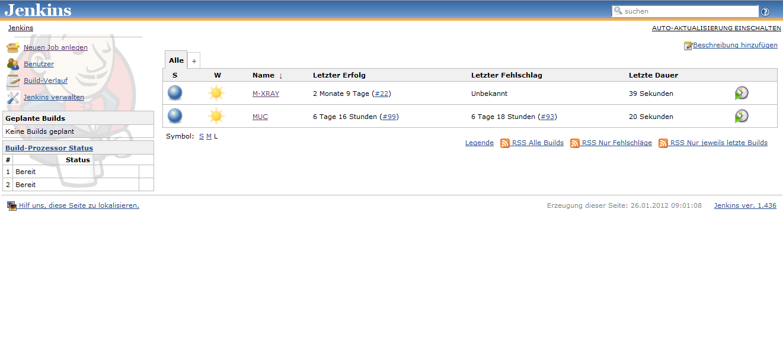
Projekte
M-XRAY
MUC

Testabdeckung – in M-XRAY
Script mxray_coverage ermittelt die Testabdeckung durch Unit Tests
Liste der mxray Funktionen wird mit Liste der Unit Tests abgeglichen
utils scripts[36] tests[4] coverage: 11 %
functions scripts[28] tests[21] coverage: 75 %
Zur Zeit keine Statement coverage !!!

Ausblick
direkter Test von Subfunktionen
Generierung von Testscripten
Script für Generation von Tests besteht bereits
Parser von Scripten erforderlich für automatische Generierung

Ermittlung der Testcoverage
Weiterentwicklung von mlUnit auf Sourgeforge vorantreiben
Unser Suitekonzept einführen
Test von Subfunktionen unterstützen
www.mlunit.de (.com) ?

