



CLIENT: DVT

Version 2.2

Department of Computer Science. University of Pretoria

Axel Ind: 12063178

Nick Robinson: 12026442

Zander Boshoff: 12035671

https://github.com/AxelInd/COS301_DriveStats

**DVT DRIVESTATS ANDROID**

**APPLICATION**

Table of Contents

1 Vision and Scope 3

1.1 Project Background 3

1.2 Project Vision 3

1.3 Project Scope 4

1.4 Architectural Diagram 5

2 Application requirements and design 6

2.1 High Level Requirements 6

2.2 Use Case Prioritisation 6

3 Use Cases 7

3.1 Critical 7

3.1.1 userRegistration 7

3.1.2 userLogin 9

3.1.3 TripMonitorState 11

3.2 Important 14

3.2.1 DisplayTripInformation 14

3.3 Nice-To-Have 16

3.3.1 viewComparedResults 16

4 Domain Model 18

4.1 Client Side Android Functionality 18

4.2 Server Side Functionality 19

4.3 Database Diagram 20

5 Access Integration Channels 21

5.1 Access Channels 21

5.1.1 Human Access Channels 21

5.1.2 System Access Channels 21

5.2 Integration Channels 21

6 Quality Requirements 22

6.1 Scalability 22

6.2 Performance Requirements 22

6.2.1 Response Time 22

6.2.2 Workload 22

6.2.3 Platform 22

6.3 Maintainability 23

6.4 Reliability and Availability 23

6.5 Security 23

Monitor-ability and Auditability 23

6.6 Testability 24

6.7 Usability 24

6.8 Integratablity 24

7 Architectural Responsibilities 25

8 Architecture Constraints 26

9 Technologies 27

9.1 Build Technologies 27

9.2 Implementation Technologies 27

Table of Figures

Figure 1 - Diagrammatic representation of the architectural layout of the DriveStats application. 5

Table 2 - Use Case Prioritisation of the DVT DriveStats Application 6

Figure 3- User Registration use case diagram 7

Figure 4- User Registration service contract 8

Figure 5 User Registration process specification 8

Figure 6 - User Login use case 9

Figure 7- User Login service contract 9

Figure 8 - User Login process specification 10

Figure 9 - Start Recording Trip use case 11

Figure 10 - Stop Recording Trip use case 11

Figure 11 - Start Trip service contract 12

Figure 12 - Start Recording Trip service contract 12

Figure 13 - Display Trip Information use case 13

Figure 14 - Display Trip Information service contract 13

Figure 15 - Display Trip Information process specification 14

Figure 16 - View Compare Results use case 15

Figure 17 - View Compare Results Service Contract 16

Figure 18 - View Compare Results Process specification 16

Figure 19- Client-Side Class Diagram 17

Figure 20- Server-side Class Diagram 18

Figure 21- Database Organisation Description 19

# Vision and Scope

All quoted information that follows represents an extract of the requirements document provided directly by the customer for the Drivestats application (DVT). These are neither modified nor abstracted and are presented directly as specified (DVT, 2015).

## Project Background

In South Africa over 10000 people die on the roads annually (Road Traffic Management Corporation, 2011). Students at the University of Pretoria (Team Antz) were approached by the company DVT with the intent of addressing this problem.

The problem of reckless driving has become so severe that, in 2011, the South African province of Limpopo has claimed that 32% of all deaths in that year were related to transport and road-safety (Department Of Statistics, 2011). With this in mind, DVT tendered a proposal to the University of Pretoria for the creation of a mobile application to increase road safety across the country.

As a team of enthusiastic and conscientious drivers, we are proud to be part of the design and implementation of the DVT DriveStats app which is designed to raise awareness for the quality of a user’s driving.

## Project Vision

The DVT DriveStats application aims to address the issue of road safety through enabling drivers to improve the quality of their driving. We intend to provide an application that will allow users to monitor and improve their driving skills. The app must have the capability of objectively measuring the level of safety of a trip taken by a driver.

The application will be used by fleet managers, car rental companies and by insurance companies to ensure that the vehicles belonging to or managed by the company are not being driven recklessly or irresponsibly.

*The app should use the sensors embedded in the mobile device, such as the GPS and accelerometer to determine different measures of driving safety, such as:*

* *Speed of the vehicle relative to the speed limit*
* *Cornering speed*
* *Braking and acceleration forces*
* *Overall smoothness of the drive, measuring the number of speedbumps and/or potholes encountered*

The app should be able to calculate an overall safety rating (“score”) for each trip measured according to a formula.

## Project Scope

The scope of this project is the design and development of a mobile application which will use the built in sensors of Android devices to monitor users driving and report on the safety level of the driving activity in a vehicle. This is achieved via the use of an Android mobile application and communication with a privately hosted Azure Server.

The algorithm designed will incorporate, as input, the data from all of the sensors identified. The output of the algorithm will be the overall driving score for an individual trip.

A driver-specific score for an individual user of the app should be calculated by taking the average of all the trip scores for that driver.

The rating should incorporate all of the above factors, weighted according to a formula which will determine an objective metric of safety of the driving session.

The deliverables for the project will be[1]:

* *Mobile Application*
* *REST service API*

## Architectural Diagram

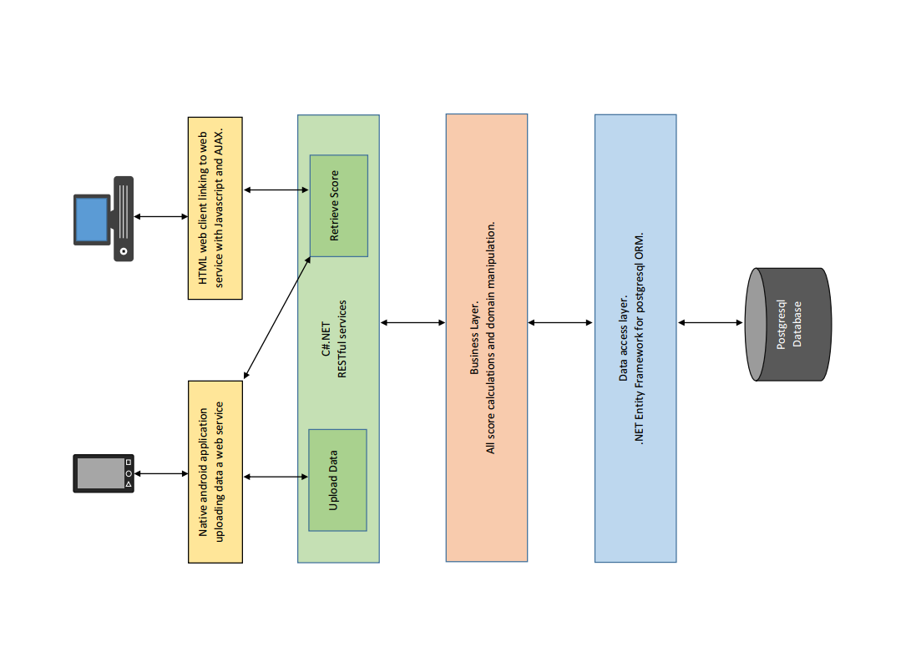

Removed from Scope

Figure - Diagrammatic representation of the architectural layout of the DriveStats application.

# Application requirements and design

This section covers the functional requirements as well as the process designs for the use cases and the domain models. The non-functional requirements are covered in the section on Quality Requirements.

## High Level Requirements

The requirements of DVT for the DriveStats application are:

1. A mobile app that has the capability of objectively measuring the level of safety of a trip taken by a driver in a motor vehicle.
2. The application should be suitable for fleet managers, car rental companies and by insurance companies to ensure that the vehicles belonging to or managed by the company are not being driven recklessly or irresponsibly.
3. The app should be able to calculate an overall safety rating (“score”) for each trip measured (as a score out of 10 with one decimal place).
4. The app should use the sensors embedded in the mobile device, such as the GPS and accelerometer to determine different measures of driving safety.
5. The safety rating should incorporate all of the available sensors, weighted according to a formula which will determine an objective metric (measure) of safety of the driving session.
6. Measures required are:

* Speed of the vehicle relative to the speed limit.
* Cornering speed.
* Braking and acceleration forces.
* Overall smoothness of the drive, measuring the number of speedbumps and/or potholes. Encountered.

## Use Case Prioritisation

|  |  |  |
| --- | --- | --- |
| Critical | Important | Nice-To-Have |
| userRegistration | DisplayTripInformation | viewComparedResults |
| userLogin |  |  |
| TripMonitorState |  |  |

Table - Use Case Prioritisation of the DVT DriveStats Application.

# Use Cases

All use cases described here-in are in direct compliance with the initial specification as released by the company, DVT (DVT, 2015). As expounded upon several meetings with the client.

## Critical

### userRegistration

#### Description

This use case will be used by the android client and the web interface to allow new users to save their information in the database.

#### Conditions

##### Preconditions

* The user has a valid google account.
* The user has the account linked to their phone
* The user grants permission to the application to access their google information
* The user has a working internet connection.

##### Post-conditions

* The user is logged in.
* The user has an account with drivestats.

#### Use Case

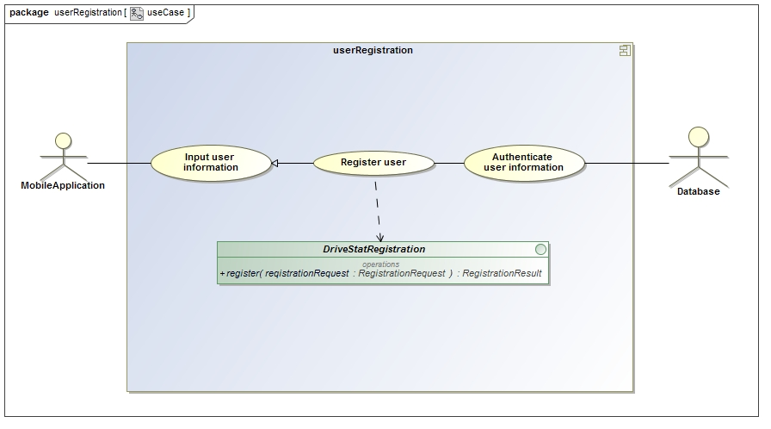

Figure - User Registration use case diagram.

#### Service Contract

The Service contract for the userRegistration service is shown in Figure 4. This is a simple database element creation service.

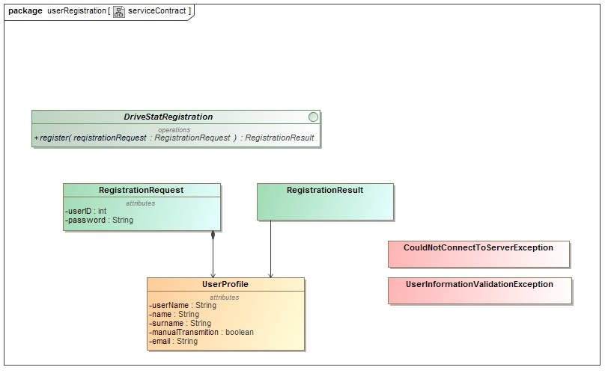

Figure - User Registration service contract.

#### Process Specification

The process specification contract for the userRegistration service is shown in Figure 5. This is a simple database element creation specification.

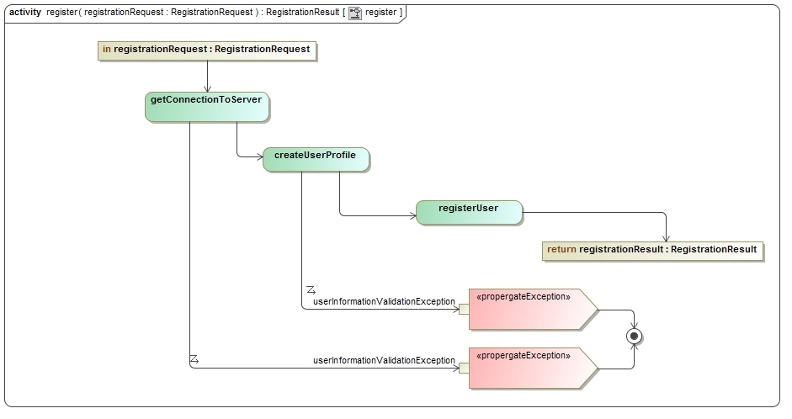

Figure User Registration process specification.

### userLogin

#### Description

This use case will be used by the android client to initiate login, via the server, for use on the client-side Android application. This use case extends to direct login of a system admin for server manipulation.

##### Preconditions

* The user is already registered with Drivestats.
* The user information is not saved on the phone already

##### Post-conditions

* The user will be logged in.
* The user remains logged in on the client.
* The user information is saved on the phone

Use case

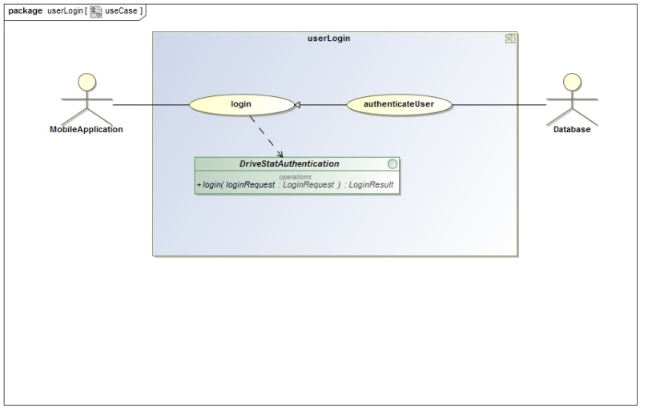

Figure - User Login use case.

#### Service Contract

This service contract outline the process used by the android client to initiate login, via the server, for use on the client-side Android application. This contract extends to description of the direct login of a system admin for server manipulation.

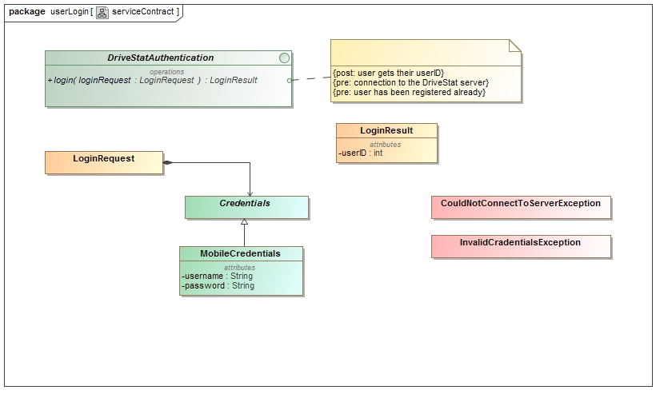

Figure - User Login service contract.

#### Process Specification

This process specification outline the process used by the Android client to initiate login, via the server, for use on the client-side Android application. This specification extends to process description of the direct login of a system admin for server manipulation.

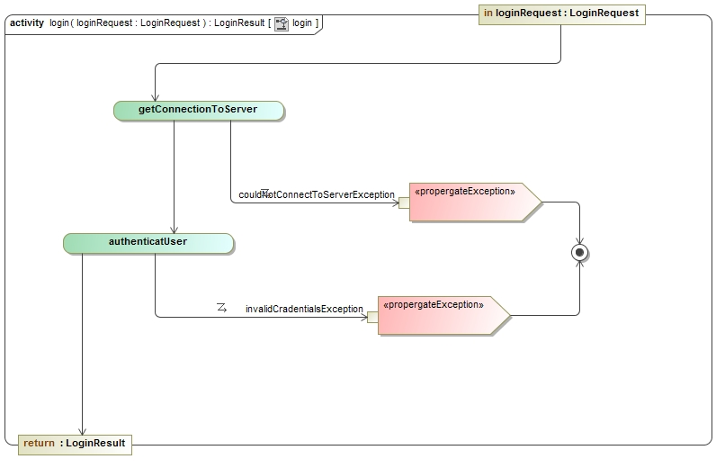

Figure - User Login process specification.

### TripMonitorState

#### Description

This use case will be used by the user to activate and deactivate the monitoring of the phones sensors.

##### Preconditions

* The user is logged in.
* The user has all the hardware installed in the phone
* The user has turned on the GPS service

##### Post-conditions

* The user’s trip data is saved with the drivestats server.
* The user is returned a score for the trip.
* All the sensor monitors are either started or stopped.

#### Use cases

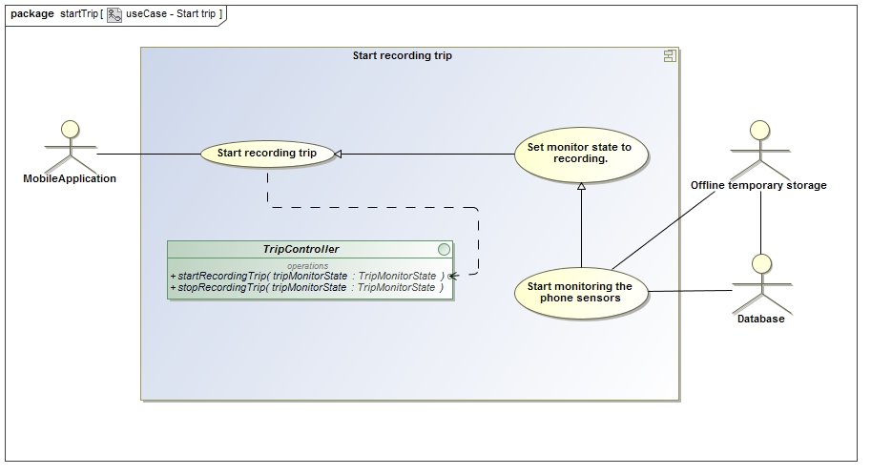

Figure - Start Recording Trip use case.

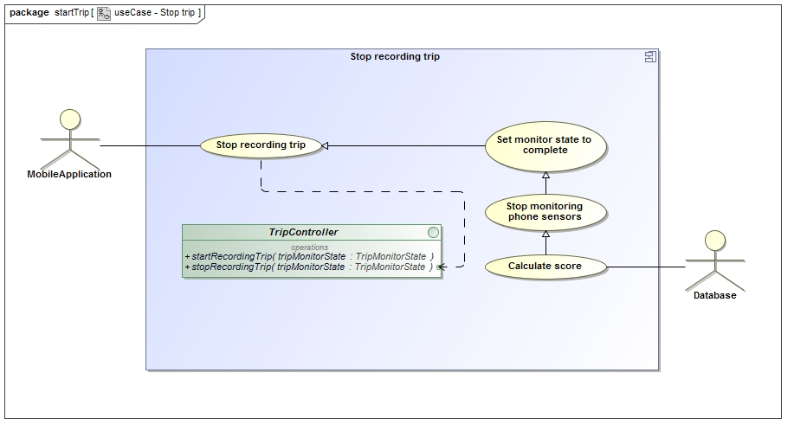

Figure - Stop Recording Trip use case.

#### Service Contract

The Service contract for the Trip Recording service is shown in Figure 11. This is a dual functioned service providing sensor monitoring and feedback to the database.

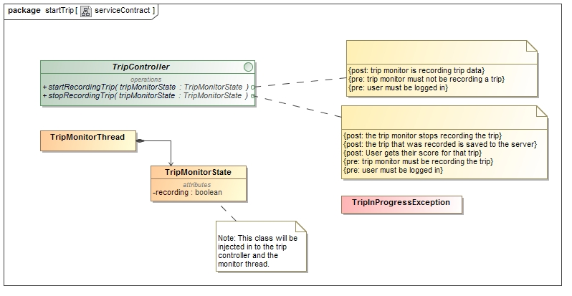

Figure - Start Trip service contract.

#### Process specification

The process specification for the Trip Recording service is shown in Figure 12. This is dual-functioned specification outlining sensor monitoring and feedback to the database.

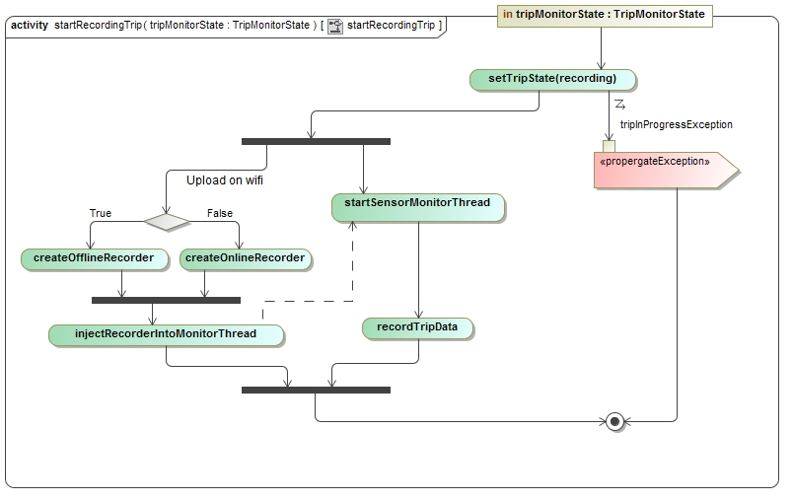

Figure - Start Recording Trip service contract.

## Important

### DisplayTripInformation

#### Description

This use case will be used by the user to receive a graphical display of the use information from their current trip.

##### Preconditions

* The user is logged in.
* The user has recorded at least 1 trip.

##### Post-conditions

* The user is returned trip information in an easy to understand manner.

#### Use case

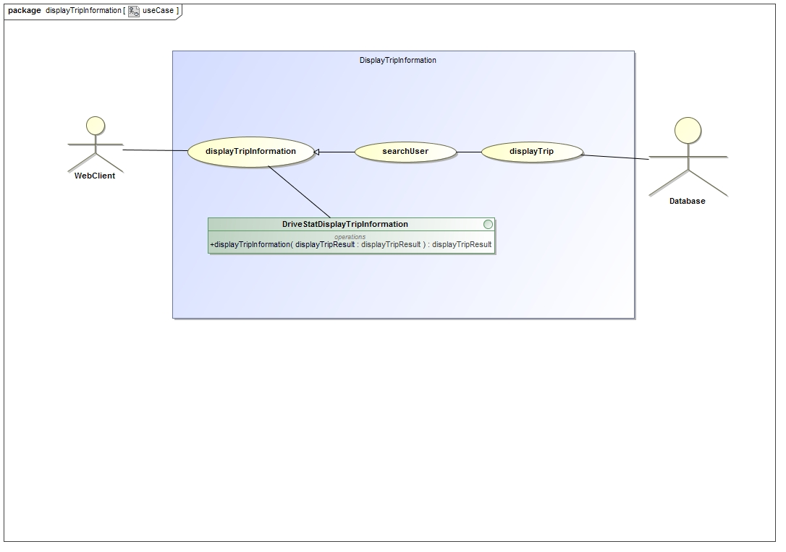

Figure - Display Trip Information use case.

#### Service Contract

This service contract describes the mechanism by which the user will receive a graphical display of the use information from their current trip.

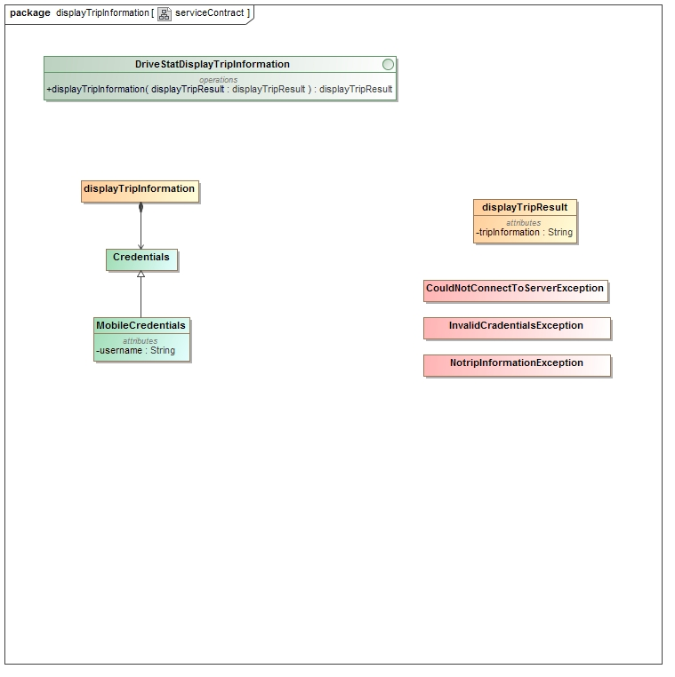

Figure - Display Trip Information service contract

#### Process Specification

This process specification describes the mechanism by which the user will receive a graphical display of the use information from their current trip.

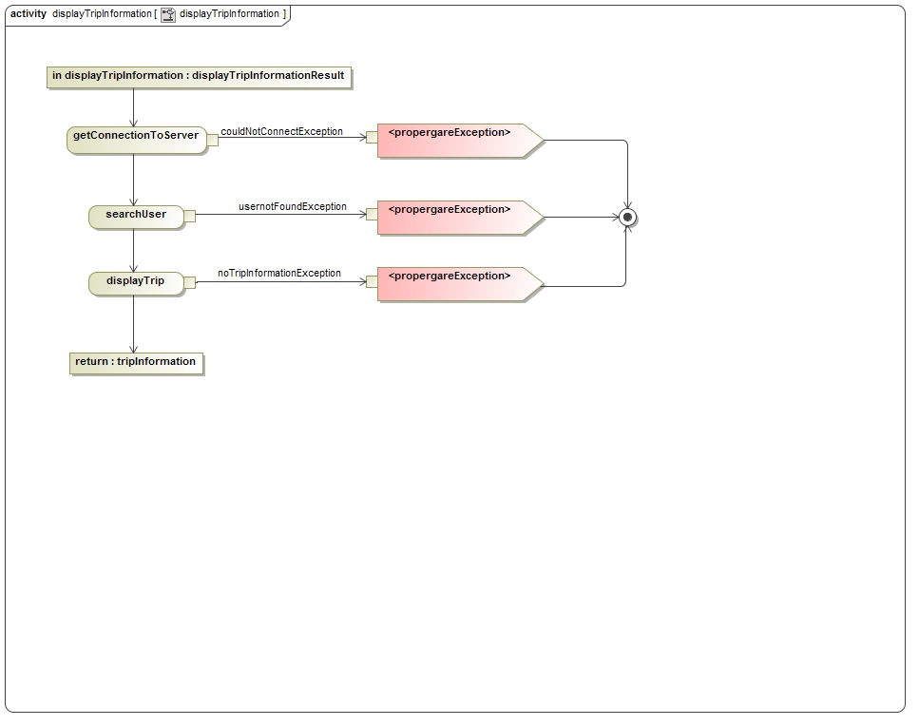

Figure - Display Trip Information process specification.

## Nice-To-Have

### viewComparedResults

#### Description

This use case describes the mechanism by which the user will be able to compare their trip information against that of their “Friends”.

##### Preconditions

* The user and the friend must have valid drivestats accounts
* Both users must have recorded at least 1 trip

##### Post-conditions

* The user will be returned comparisons to the other user

#### Use case

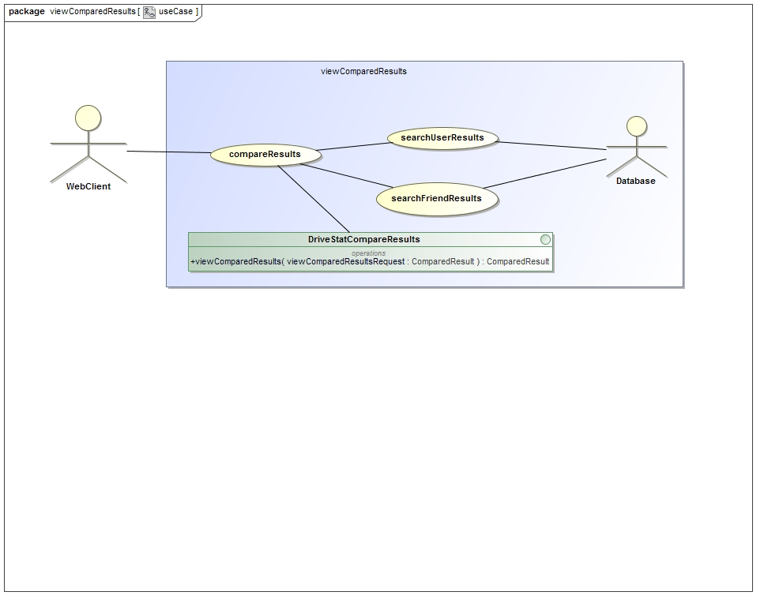

Figure - View Compare Results use case.

#### Service contract

This service contract describes the mechanism by which the user will compare their trip information against that of their “Friends”.

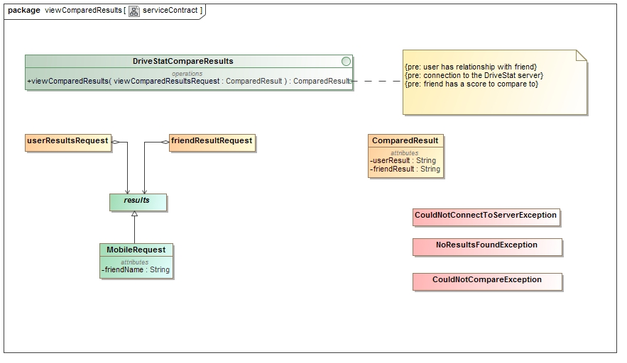

Figure - View Compare Results Service Contract.

#### Process specification

This process specification describes the mechanism by which the user will be able to compare their trip information against that of their “Friends”.

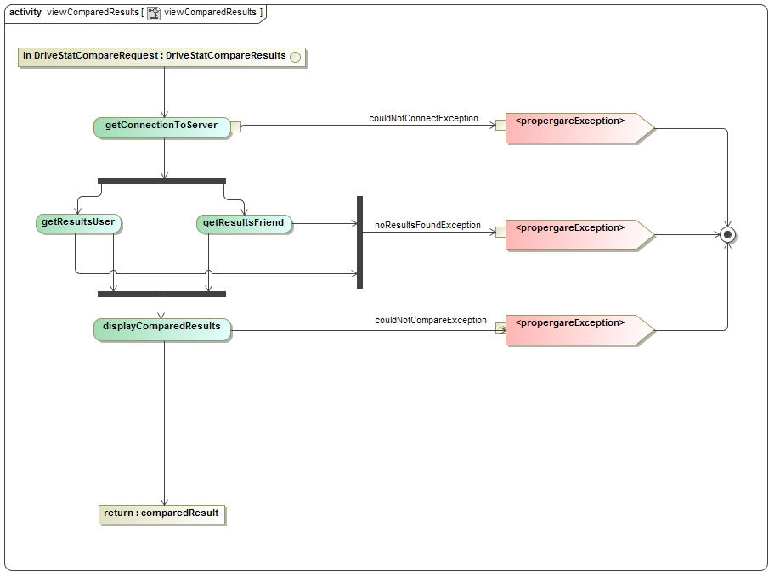

Figure - View Compare Results Process specification.

# Domain Model

The Domain for the DVT DriveStats Application Spans 2 distinct ranges of technology. For this Reason the Domain Model of the Project is divided into two distinct sections and are connected via well-described API’s.

## Client Side Android Functionality

This section refers to the mobile application aspect of the DVT DriveStats program. This details the use of activities, external application requests, sensor data aggregation, and their respective management.

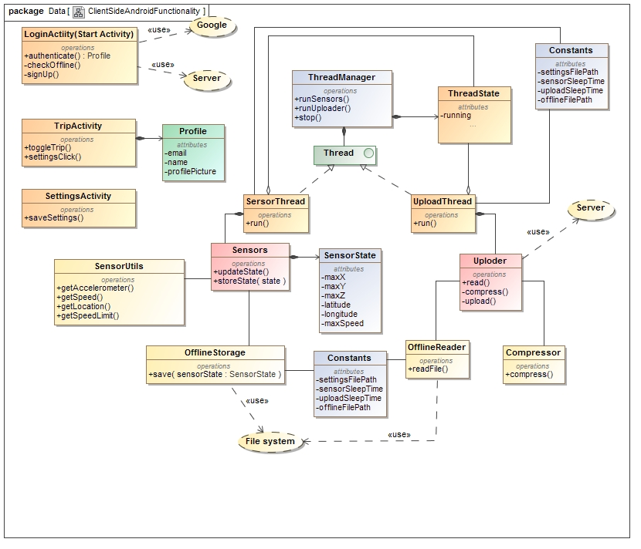

Figure - Client-Side Class Diagram.

## Server Side Functionality

This section refers to the server-side implementation of the database manager. The server is responsible for several tasks, including but not limited to, Object Relations Mapping, Equation Coefficient storage, login-authentication, user registering, and statistical and meta-statistical calculations.

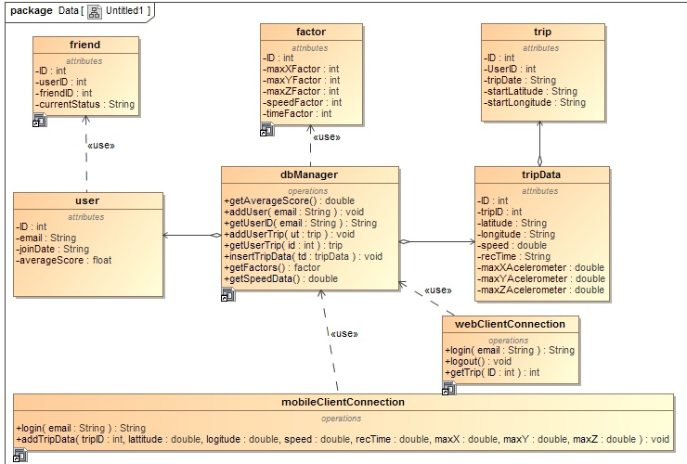

Figure - Server-side Class Diagram.

## Database Diagram

Tables relate to the storage of data, description of metadata, and algorithmic modifiers

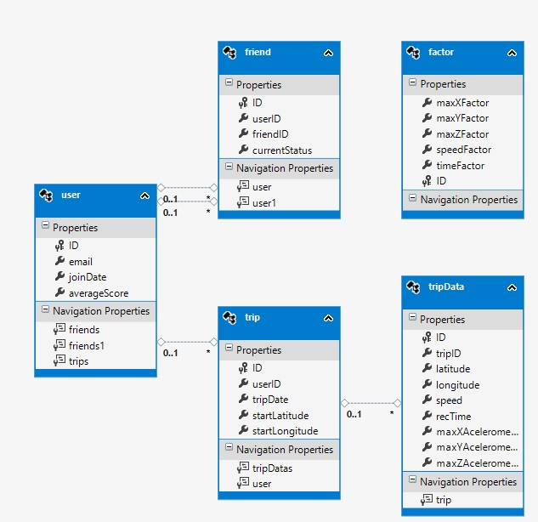

Figure - Database Organisation Description.

# Access Integration Channels

## Access Channels

### Human Access Channels

The Drivestats system user human access component must be an app for Android devices and must make use of Android sensing capabilities including but not limited to GPS and accelerometer. The Drivestats app must be made available for user download via the Android app store.

The Drivestats administrator functions must be made available via the Azure server to authorised users via a computer running Linux or Windows.

### System Access Channels

Server-side operations will be cloud based and make use of Microsoft Azure. Client side operations will be done either within the app or the public API’s relating to the accessing of sensors.

## Integration Channels

The key integration requirements for Drivestats is the ability to efficiently and effectively make use of Microsoft Azure as the cloud component of the service. Furthermore, the application should remain compliant with the Google+ API used for the login functionality of the application.

# Quality Requirements

## Scalability

The Drivestats system should be able support 300 concurrent users initially. The system has the potential to be used by over 10000 clients simultaneously and the potential for even growth both locally and internationally. While initial testing will almost certainly be done using far fewer clients, scalability is an important requirement.

It is required that, as the customer base grows, the system will need to serve more users simultaneously. This will cause an increase in networking requirements, will require extensive analytics and storage capabilities. It is envisioned that, with increasing demand, additional services from the Drivestats system will be required to accommodate an evolving business model.

It is a requirement that the Drivestats product will make use of Azure Server, Microsoft’s cloud computing platform (Microsoft, 2015), to support scalability requirements. Azure Server is currently in use by over half of Fortune 500 companies which ensures Microsoft’s continued investment in its scalability aspects.

Scalability of Azure server represents one of its main selling points. Use of this product supports scalability in terms of services, analytics, storage, networking and growth in number of subscribers. In addition, Azure is the only major cloud provider ranked as a cloud storage industry leader by Gartner (Trent, 2014): as strong indicator that all Drivestats scalability requirements will be adequately met now and in the future.

## Performance Requirements

### Response Time

All operations within the application should respond within 1 second for client-side operations. In terms of client-server interactions, data request-response operations should take fewer than 2 seconds to complete. It is understood that the speed of operations across different mobile data-transfer communication standards can differ significantly. The delays inherent in using slower communication standards cannot be circumvented by the designers in any significant manner, but must be considered in result examination.

Response time between the client and server were kept low by making the communication as minimal as possible. The login use case (Figure 6) makes use of one server call which is only used once to setup the application on the user’s phone. The recording trips use cases (Figure 9 and 10) use one call to the server to upload the trip data and wait for a response which will be the score of the trip.

### Workload

The system must be capable of handling the workload generated by 300 concurrent users without significant drop in response time. The use of multi-threading and a number of optimising algorithms for calculations must be supported. The calculations which require workload tolerance consideration include but are not limited to statistics generation and GPS co-ordinate logging.

### Platform

The Drivestats application will run on Android 4.2 or newer technology. Drivestats requires the use of several sensors available only in market certified Android enabled devices such as GPS and accelerometer features. It is required that Drivestats server side should be a cloud based application.

## Maintainability

Maintainability requirements for Drivestats include:

Defect isolation and correction supported by extensive server side logging of errors, maintainable code, the ability to provide downloadable updates to the Android devices once corrections have been made. Loose coupling of calculation methods and attributes is required to allow for dynamic, repairable and extensible code. Version control via GitHub will facilitate easy rollback and software releases as and when they become necessary. Continuous product improvement through feedback log analysis is required.

## Reliability and Availability

Dynamic error correction of identified errors should be possible, within 4 hours, in all cases where server-side faults occur.

Android app errors must notify the user in a timely and informative manner of the nature of uncorrectable errors.

It is requirement that all cases of un-correctable client side non-user errors should be appropriately logged and transmitted to the server for analysis and correction. It is an ethical consideration that permission must be given by the user for automated action logging to occur.

Correcting of app errors must be by managed update-release via the Android play-store.

The azure server keeps 3 replicas of data running on physically separate nodes. One is a primary with 2 being backups. The backups seamlessly take over if the primary data happens to go down for maintenance or disasters occur. This system is the reason Microsoft offers 99.9% availability of your data monthly. (Microsoft, 2015)

## Security

It is required that the app be password-protected on the user device. All users must be registered to access the application’s functionality. Login must occur through the app and be confirmed by the server.

The server side application will be a cloud application and thus make use of available Azure secure services. As such the assumption is that Microsoft will provide the necessary security (Kaufman & Venkatapathy, 2010). Google will provide the login security as described in their Google+ API login documentation.

## Monitor-ability and Auditability

Server-side performance must be monitored via key performance metrics for cloud services in the Azure Management Portal (Boucher, 2014). Metrics to be monitored include CPU usage, network activity, storage usage rates, user registration metrics and predictive measures. It is required that analysis of diagnostics that occur during application operations be monitored and logged.

The Android app must utilise logging and transmission of errors as previously described. App download rates will be monitored by the Google play-store and are available for developer examination as and when required for application improvement.

## Testability

It is required that application testing follow a test-plan and that testing results are recorded and monitored. All test results should be of a quantitative nature except in cases where direct usability testing of interface related components is done.

Unit testing must commence during development.

It must be possible to provide simulated testing of sensor related inputs such as GPS and accelerometer features.

Simulation of over 300 simultaneous login and calculation activities is required to ensure that the system meets its robustness and scalability requirements.

## Usability

It is required that over 90% of users should be able to achieve any task outlined in the use-cases of this application within 5 minutes of first encountering the application.

It is required that the colour and style dynamics of the application must appeal to a broad audience and must not deter more than 10% of potential customers. An in depth usability test will be performed to ensure the application meets the demand of potential customers with regards to ease of use and functionality.

## Integratablity

The Azure server is accessed through a REST web API. This allows a client to be developed for nearly anything that can provide GPS coordinates, the three accelerometer readings and the date. It can also be integrated into a whole new app that further extends the functionality of the original application.

The score calculator class from the server can also be used in situations where data over time is recorded and can then be analysed if there is no known measure of weather it is good or bad.

# Architectural Responsibilities

* Google+ API Technologies
  + This system depends heavily on its open source access to the Google API used for login and register functionality.
  + Once, registered on the server, the Google+ API also allows for downloaded of profile data.
  + The security of the login including password handling is left to the Google API.
  + The use of libraries for device calibration requires an up-to-date and effective Android-side implementation.
* Model View Controller (MVC) architecture
  + Allowing the developers of UI to focus exclusively on the UI screens without finding themselves bogged down with business logic.
  + This architecture allows for development-time parallel cooperation by separate teams.
* REST architecture
  + Providing superior security and performance to the more common SOAP API architecture.
  + This API architecture was also a core requirement of the client.
  + The simplicity of the REST API also ensured that code was more easily written, and more modifiable after implementation.
* Azure Server .NET framework
  + Although not open-source, this server was directly requested by the client.
  + Azure server combines very well with the C# implementation of the server in question.
  + Strong integrability with a number of free Microsoft products ensures extensibility of the server.

# Architecture Constraints

* The mobile application must run on Android devices (of version 4.2 or higher).
  + These devices are modern and make up the vast majority of the market share for Android devices (Bellini, 2015) and, thus, for the Drivestats Application.
* The use of MVC architecture makes continued access to a reliable mobile internet connection essential.
  + Without appropriate internet connections and permissions, it becomes impossible to upload data and properly integrate profile information.
* Integration of sensors must be accomplished in such a way to adequately function on all devices for which this application was designed.
  + These sensors are provided as standard and use a common API with a variety of modes.
* Microsoft Azure is expected to provide a stable and reliable basis for the cloud management of server-side operations and database management.
  + Azure is compliant with a number of international standards for quality assurance (Microsoft, 2015) and it is very unlikely that problems will be encountered related to its functioning or support limitations.
* Device error logging is dependent on the user’s permission to upload anonymous data on detected errors.
  + This is due both to limitations enforced by Google on Android applications and due to ethical considerations. Because the logging is dependent on user-cooperation, data gathered may not represent a representative sample of the user base and the errors it encounters.

# Technologies

## Build Technologies

* Visual Studio 2012
  + Used for C# server-side development.
  + Visual studio is the best IDE for editing and managing C# code. It also has an integrated web deployment which allows the server to be published to azure easily.
* Entity Framework 6 used as ORM.
* Entity Frame is designed for use with c# and a Microsoft sql database. This makes it very easy to implement and use with the project’s technologies while maintaining performance.
* Github
  + Provides powerful, flexible version control and allows for collocated and separately located collaboration.
* Wolfram Alpha Online
  + Normalisation and algorithm development was created in tandem with Wolfram Alpha (testing specific code exists in initial distributions). Wolfram remains one of the most powerful computational aids.
* Android Studio.
  + A powerful and fully-featured suite of products related to Android development.

## Implementation Technologies

* Azure Server for database and server-side hosting considerations.
* Android JellyBean.
* Google API’s for login.

# Bibliography

Boucher, R., 2014. [Online]   
Available at: https://azure.microsoft.com/en-gb/documentation/articles/cloud-services-how-to-monitor/  
[Accessed 28 May 2015].

Department Of Statistics, 2011. *Mortality and Causes of Death in South Africa, 2011,* s.l.: http://beta2.statssa.gov.za/publications/P03093/P030932011.pdf.

DVT, 2015. *DVT DriveStats,* s.l.: DVT.

Kaufman, C. & Venkatapathy, R., 2010. *Windows Azure Security Overview,* s.l.: Microsoft.

Microsoft, 2015. *What is Microsoft Azure?.* [Online]   
Available at: http://azure.microsoft.com/en-us/overview/what-is-azure/  
[Accessed 28 May 2015].

Road Traffic Management Corporation, 2011. *Arrive Alive.* [Online]   
Available at: https://www.arrivealive.co.za/documents/March%202011%20Road%20Traffic%20Report.pdf  
[Accessed 11 October 2015].

Trent, R., 2014. *Microsoft Sneaks into the Gartner Magic Quadrant Leader Box for IaaS.* [Online]   
Available at: http://windowsitpro.com/azure/microsoft-sneaks-gartner-magic-quadrant-leader-box-iaas  
[Accessed 28 May 2015].

1. A third part to the proposed project was initially slated to be the creation of a rich web-interface through which a user could examine their driving history. This was, however, removed from the project scope via agreement with the University of Pretoria and the DVT Company.