

DVT drivestats

User Manual



## Team: **ANTZ**

**Axel Ind**: 12063178

**Nick Robinson**: 12026442

**Zander Boshoff**: 12035671

https://github.com/AxelInd/COS301_DriveStats/

Department of Computer Science. University of Pretoria

Client: DVT

Contents

System Overview 2

System Configuration 2

Minimal Requirements 2

Graphical Illustrations 2

Installation 3

Getting Started 3

Google login 3

Using the System 5

Android Functionality 5

Login/Signup 5

Start Trip 6

End trip 7

Computer Functionality 8

Troubleshooting 8

Common Problems 8

List of Error Codes 9

Contact the Developers 10

Additional Information 10

List of countries currently supported by the DVT DriveStats application 10

Supported Languages 10

# System Overview

DriveStats is a simple road application for Android devices. Its primary purpose is to help users regulate their driving patterns by providing simple feedback on their speed, acceleration, GPS location, and several other key features.

The purpose of this guide is to aid users in their attempts to setup, navigate, and appropriately use the DriveStats Android application.

The DriveStats application provides a range of features for all motorists: from simplistic user-based scoring to tell you exactly how well you are driving, to a fully-featured graphical overview of your driving-patterns, neatly described with graphs.

Collaboration to improve general road safety is a major goal of this product, and, as such, it features a Friend system to allow drivers to share their driving information and compare their safety with friends.

# System Configuration

## Minimal Requirements

To use the DriveStats application a user should possess an Android device with the following features:

1. Android 4.2: JellyBean operating system
2. Wi-fi enabled or 3G enabled
3. GPS capabilities
4. Accelerometer capabilities
5. Google Play Certified[1]

As further requirements for using the DriveStats application a user should have the following:

1. A working Gmail account (required for the initial login)
2. Access to a wi-fi hotspot or other affordable means of internet access
3. A proper dash-mount in their car[2]

## Graphical Illustrations

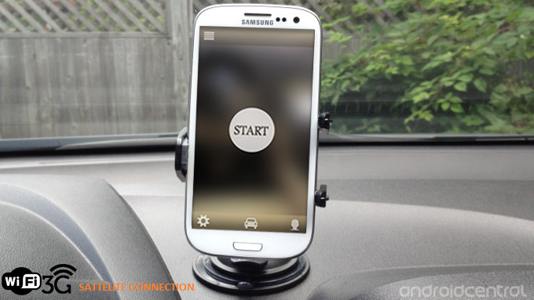

@william we also need an image of a computer with graphs on the screen. The computer should have a cable coming out of it, saying INTERNET CONNECTION

# Installation

@team at present the app is not yet on the play store this should be implemented by, Septemeber 4th

*Image showing opening app store*

*Image showing selecting our app and clicking install*

At present installation is handled via a compiled apk that is distributed.

## Getting Started

## Google login

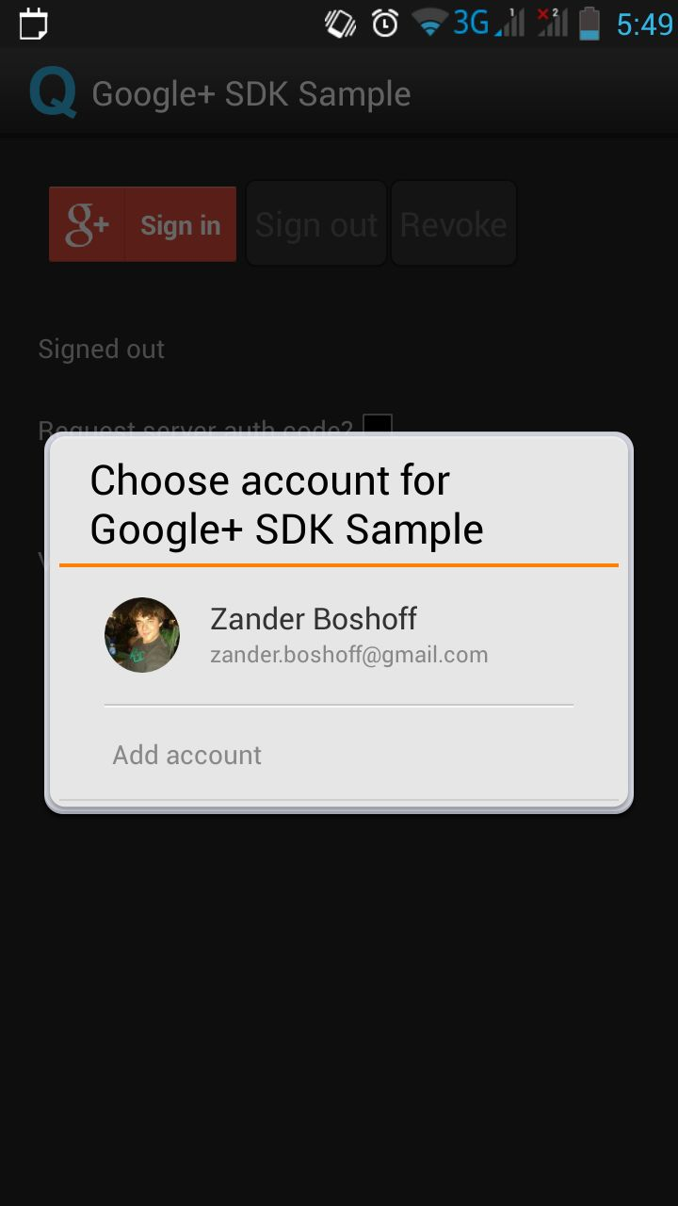

Image showing selecting desired settings (visa vi data usage, autosleep times, etc)

@todo

*Explain that user IDs do not change*

*Explain how to set display name*

*Explain no passwords required*

## Layout of system

A visual description of the screens navigation of the app.

@todo replace with more graphic solution

LOGIN

TRIP

SETTINGS

*Show how to exit system*

# Using the System

## Android Functionality

### Login/Signup

Signing up to the DriveStats service is simple. It requires a single sign-on to your Gmail account (see the Minimal Requirements section for details) and the application will remember your user ID whenever the application is opened.

The log-in details will be stored on the device. You will not be required to sign in when the application is opened in future.

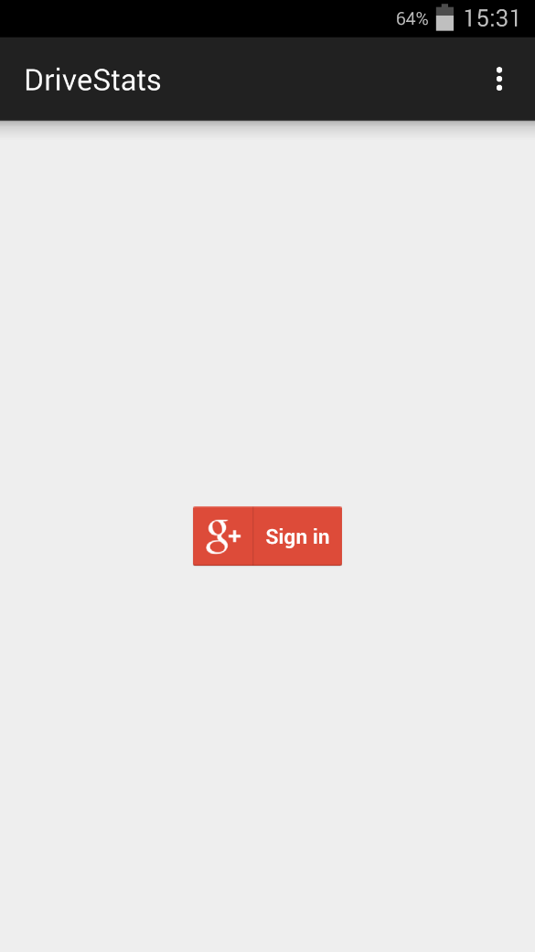

**Sign In**: When this button is pressed, the active network connection (Either a WIFI or a mobile data connection is required for this step) connects with the Google+ service. The email information linked to the phone is used to authenticate the user.

After the user’s information is verified, the email address is sent to the drive stats server to retrieve the user ID from the database of users. If this is the users first time using the application, a prompt will appear asking for permissions to register a new user.

### Start Trip

The DriveStats application requires a user to specify when a trip has started in order to begin collecting data on the driving habits on the user. Trips allow the phone to start collecting data for use in scoring.

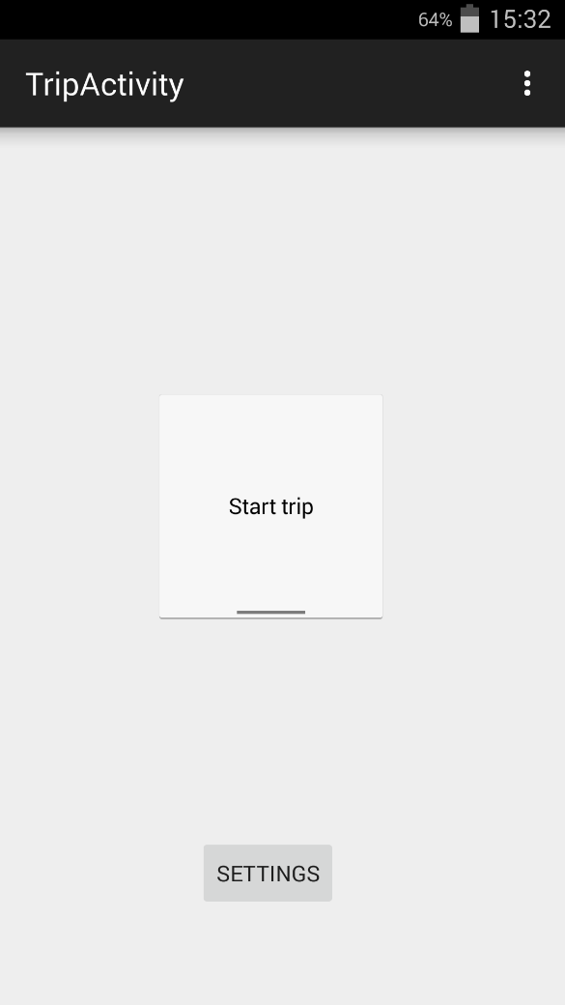

**Start Trip**: A toggle button that will cause the application to begin collecting data about the user’s movements.

End trip (sends the server all the trip information) (explain that empty trips do not get sent)

When the destination has been reached the stop trip button has to be pushed to stop the phone from gathering further data. The phone will then send the data to the DriveStats server for processing and when it’s done the user will receive a notification with the score of the trip.



Stop trip

**Stop Trip**: A toggle button that will cause the application to stop collecting data about the user’s movements.

Edit Settings

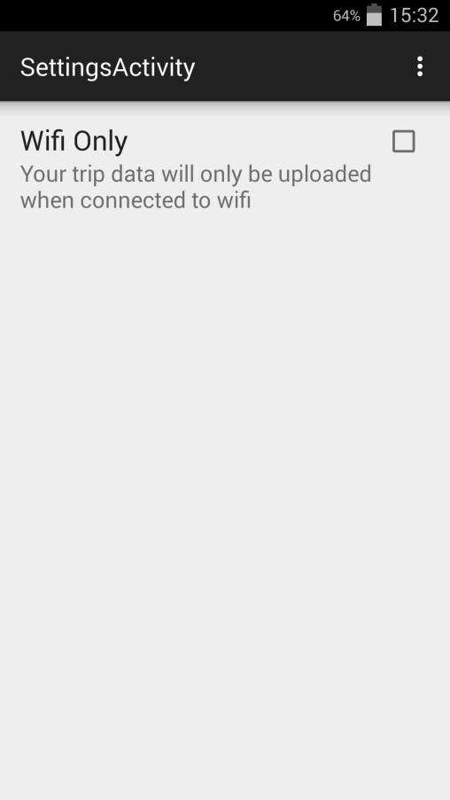

@nick implament and add screenshot

*View Profile (retrieve user information from server)*

*Add Friend (update database) (show example of how friend Bob is added)*

*Block/Remove Friend (update database) (show example of how Mike is unfriended)*

## Computer Functionality

@Tim

*View Graphs (access database)*

*Describe all graphs created*

# Troubleshooting

## Common Problems

@todo add solutions

*My data is not being uploaded*

*(Screenshot here)*

*My application will not open*

*(screenshot of failed to open screen)*

*My DriveStats application keeps crashing*

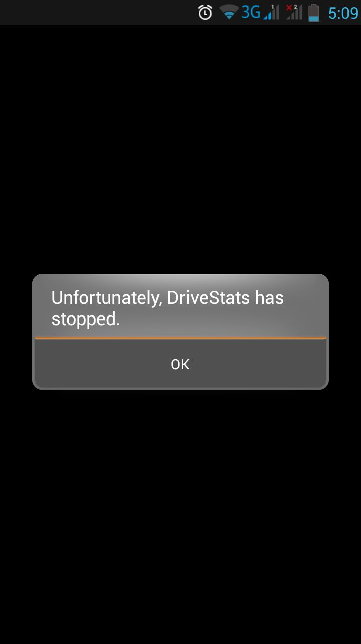

It is advisable to update the app to the latest version if the app is fully updated please contact the developers with the details of your device so the issue can be resolved.

@todo

*(screenshot)*

*I cannot log into the website to look at my graphs*

*I cannot find the application on Google play*

*(screenshot of search for DriveStats) – refer to minimum requirements. Ensure in list of supported countries*

## List of Error Codes

Error name/Cause/Solution

|  |  |  |
| --- | --- | --- |
| Code | Description | Solution |
| 501 | Cannot connect to server | Check internet connection |
| 502 | Server unresponsive | Wait several minutes, if the error persists contact the developers. |
| 503 | Server Connection refused | Please update to the latest version |
| 511 | GPS is disabled | Turn on the GPS in the phone’s settings |
| 512 | Google account Mismatch | Please log in again if error persists reinstall application |
|  |  |  |
|  |  |  |

## Contact the Developers

Zander John Boshoff u12035671@tuks.co.za

Nicholas Thomas Robinson u12026442@tuks.co.za

# Additional Information

## List of countries currently supported by the DVT DriveStats application

* South Africa

## Supported Languages

* English (European)

1. For further information on Google Play Certification please contact the list of certified devices provided by https://support.google.com/googleplay/answer/1727131?hl=en.
2. Needed to maintain accurate readings throughout the trip.