Document: Game concept. Author: Axel Lara.

**Game Profile:**

Working title: Tetris.

Genre: Puzzle.

Platforms: PC.

Game modes: single player.

Audience: 3+.

**Description:**

Tetris is a puzzle game for casual players. It is based on a board where the player has to form horizontal lines with blocks built with squares in order to win points. If the blocks reach the top of the board, the game ends.

**Core mechanics:**

Gameboard: it consists in a 10x20 grid. Each grid cell can be filled with a square. If a square gets to the top of the board, **the game ends.**

Block: this is the piece which player controls. It starts at the top of the board and start falling. It gets placed when it collides with another one. Player can control its x-axis and the velocity of falling (slow and fast).

There are 5 types of block shapes. Each of them are built with 4 squares.

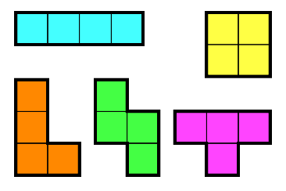

When a player fills one or more horizontal lines, the whole lines get destroyed. The above squares fall the number of line which got destroyed.

Scoreboard: reflects the score reached by the player. It gets incremented for each line formed.