Gpredict User Manual — Addendum: OGpredict

This addendum describes the new OGpredict features integrated on top of Gpredict. OGpredict (Optimize General Prediction) is a production‑oriented extension designed for second‑accurate pass planning and target selection. It introduces a dedicated Ephemeris Data window with three tabs — Ephemeris, Territory, and Points of Interest — plus deterministic CSV exports. This section complements the original Gpredict user manual and is written in English for international use.

# 1. Overview

OGpredict keeps Gpredict’s SGP4/TLE propagation and multi‑platform GTK/GLib base, while adding:

• A responsive 1 Hz ephemeris generator.  
• Country/territory filtering (ISO‑3166, including overseas territories).  
• Points of Interest (POI) selection with minimum ground‑range and bearing.  
• Deterministic, spreadsheet‑ready CSV exports (UTF‑8 with BOM).

# 2. Ephemeris Data Window

Open the Ephemeris Data window from the OGpredict menu. The window contains three tabs. Use it after updating TLEs as usual in Gpredict.

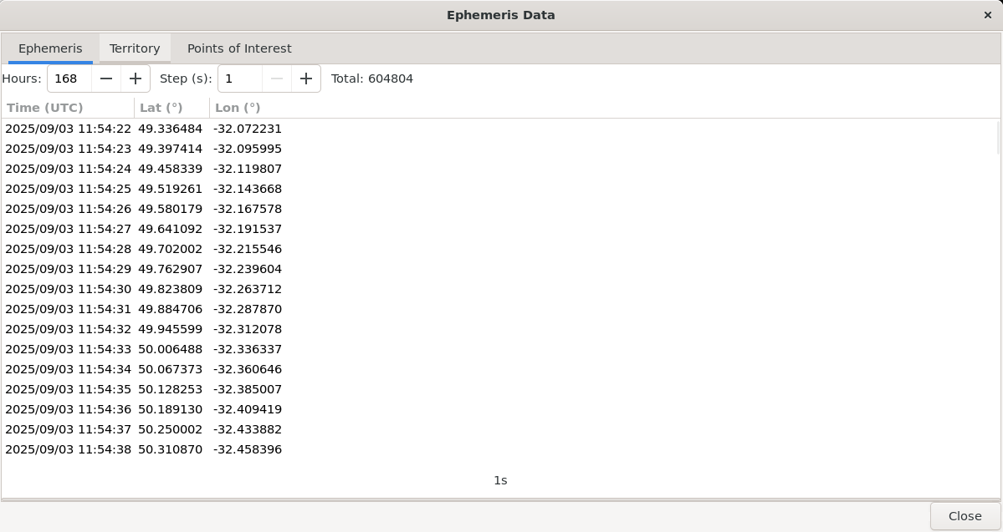

Figure 1 — Ephemeris tab streaming 1 Hz ephemerides (UTC, Lat, Lon) with a total counter and progress indicator.

## 2.1 Ephemeris Tab

• **Hours** sets the time horizon (e.g., 24 h, 168 h).

• **Step (s)** sets the sampling period; use **1 s** for second‑accurate planning.

• The table streams rows incrementally to keep the UI responsive on long computations.

• The **Total** counter shows how many samples were generated; the footer displays the step used (e.g., “1s”).

• Use **Save** to export the current result to a normalized CSV (UTF‑8 with BOM) including a metadata header (TLE source, step, horizon).

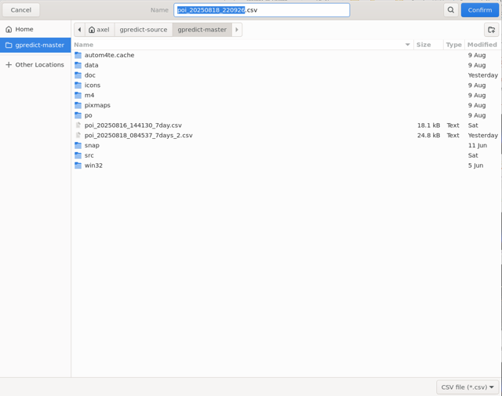

Figure 2 — Save button for deterministic CSV export.

## 2.2 Territory Tab

The Territory tab filters the ephemeris stream by ISO‑3166 country/territory, including overseas regions. Start typing a country name to filter results. The table shows Time, Latitude, Longitude, and Country for each match.

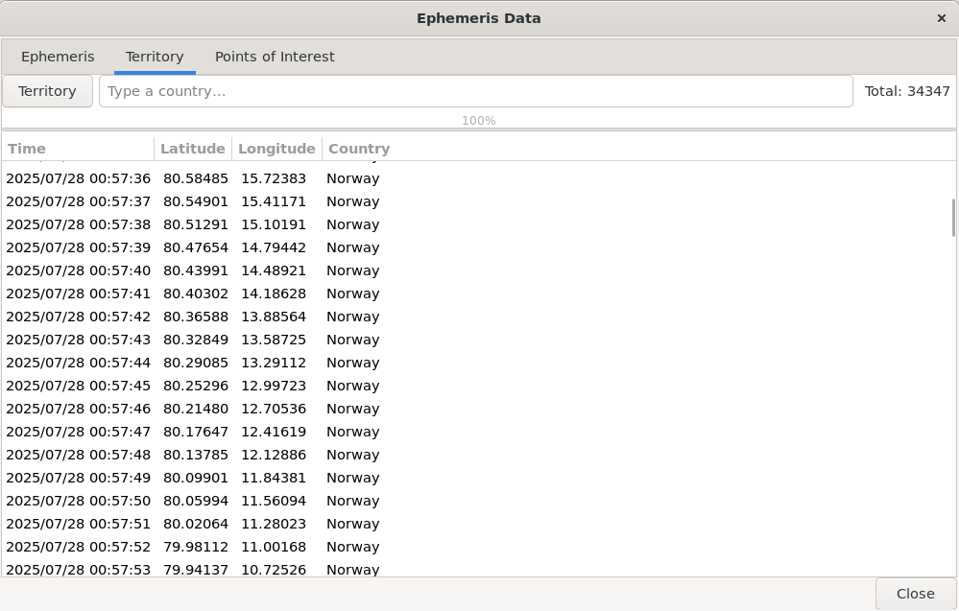

Figure 3 — Territory tab filtered on “Iceland”.

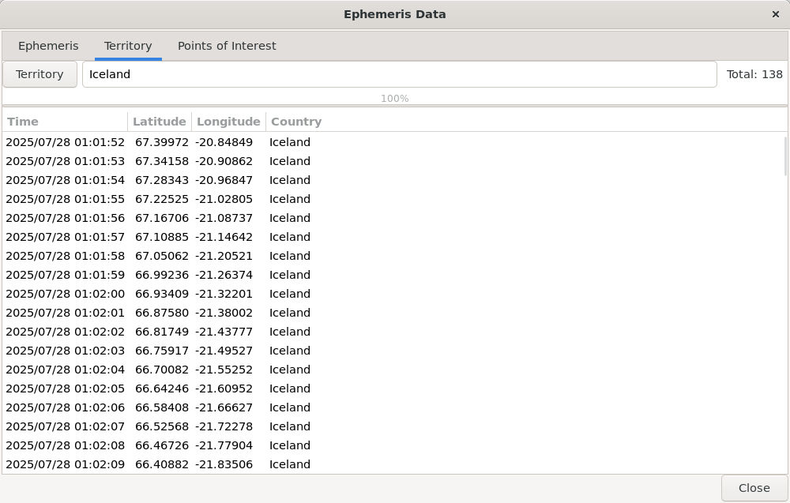

Figure 4 — Territory tab showing matches for “Norway”.

Tip: the mapping is powered by a lightweight grid built from ESA WorldCover and administrative polygons. Each tile is assigned to a country by majority surface to ensure fast, accurate lookups in the UI.

## 2.3 Points of Interest (POI) Tab

POIs let you evaluate named targets (cities, volcanoes, lookouts, spaceports, etc.). For each POI, OGpredict selects the **minimum ground‑range instant** within a configurable tile size and computes the **bearing** to the target. Results can then be exported as a normalized CSV (UTC, lat, lon, range_km, azimuth_deg, Name, Type).

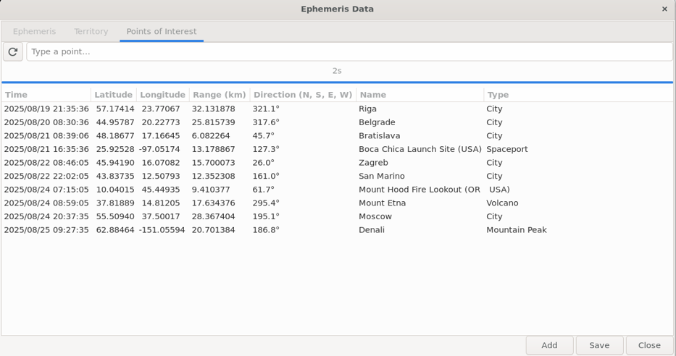

Figure 5 — Example POI results including cities, volcanoes, and mountains.

### Adding a POI

Click **Add** to create a new target. Fill in the fields:

• **Name** — The display name of the point (e.g., “Riga”).

• **Type** — Category (City, Volcano, Spaceport, Mountain Peak, etc.).

• **Center Lat / Lon** — The geographic coordinates of the POI center (WGS‑84).

• **Tile size (km)** — Effective radius/extent used to capture the closest approach within the area of interest.

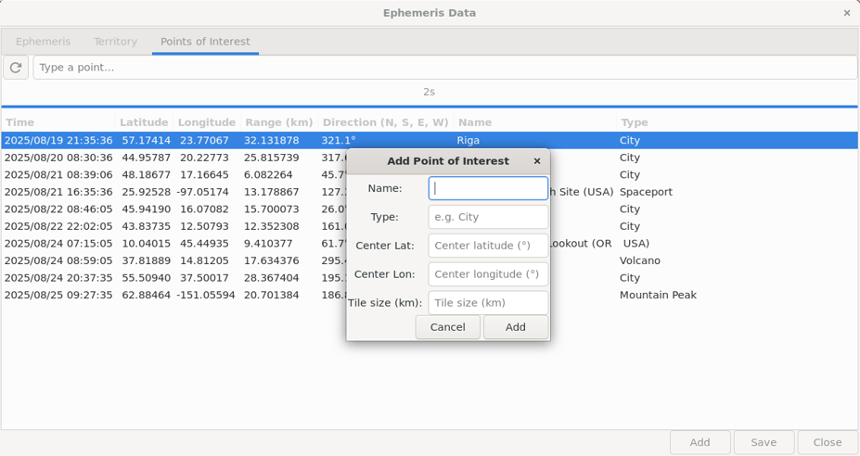

Figure 6 — “Add Point of Interest” dialog.

### Exporting POI Results

Use **Save** to export the POI table to a CSV with a UTF‑8 BOM. A metadata header is added to preserve traceability (TLE source, time step, horizon). The exported file can be opened directly in Excel, LibreOffice, or ingested by scripts.

# 3. Quick Start Checklist

1) Update TLEs in Gpredict.  
2) Open Ephemeris Data → set **Hours** and **Step = 1 s** → run.  
3) Use **Territory** to focus on countries; use **POI** to select best trigger times on targets.  
4) **Save** results to CSV for downstream planning or automation.

# 4. Notes on Licensing

OGpredict is a derivative work of Gpredict and is distributed under the GNU General Public License (GPL). If you redistribute binaries (e.g., Windows installers), you must also provide the full corresponding source code (or a valid written offer), and keep license notices intact.