Machine Learning Practical Portfolio
Student ID: [your ID]
Module: [module code and title]
Date of submission: [date]
Notebooks submitted: P1–P9 (.ipynb, with outputs) in [filename].zip

Declaration
I confirm that this portfolio and the accompanying notebooks are my own work, that all results reported were produced by my own code, and that any use of other sources or AI tools is acknowledged in Appendix A.

Student ID: ____________________ Date: ____________________

Contents
Lab Report 1 — Python for Machine Learning and the ML Workflow
Lab Report 2 — Data Construction and Data Transformation
Lab Report 3 — Linear Regression and Gradient Descent from Scratch
Lab Report 4 — Multivariate and Polynomial Regression; Underfitting vs Overfitting
Lab Report 5 — Cost Functions for Regression and Regularisation
Lab Report 6 — k-Nearest Neighbours and Classifier Evaluation
Lab Report 7 — Logistic Regression from Scratch
Lab Report 8 — Decision Trees and Ensemble Methods
Lab Report 9 — Unsupervised Learning: k-Means Clustering and PCA
Reflective summary
Appendix A — Declaration of AI tool use
Appendix B — References
(Tip: in Word, replace this list with References → Table of Contents once your headings are final.)

Lab Report 1 — Python for Machine Learning and the ML Workflow
Practical 1 · Week 2 · Notebook: P1_python_and_ml_workflow.ipynb

1. Aim

This practical aims to demonstrate the ways certain Python libraries support machine learning; this includes questions to show each of the seven steps in the machine learning workflow, using the nearest-centroid algorithm. The practical also makes sure to show comparisons in accuracy, between different models and before/after scaling.

2. Methods
I implemented the full machine learning workflow for the nearest-centroid model, which predicts the species of a penguin based on the species with the closest (using a vector norm) distance to the current penguin data, calculated from the mean value of each feature of the species.
The first task was to problem frame, where I broke down the problem into the task, typed and determined how to measure success. This is where I chose 3 key features and decided to determine a successful model from accuracy of unseen data.
The second task was to prepare the data. I removed all rows that had missing values in any of the chosen feature columns. Then I used sklearn to split up the data into 75% training and 25% testing; in order to remove bias in the accuracy calculation, I included an argument to stratify on the species which made sure that the test set had the same amount of each penguin inside. This resulted in a training set of size (256, 3) and a testing set of size (86, 3) that ensured my accuracy calculation would be less biased on the testing data.
The third step was to select the algorithm. I found a baseline accuracy of 44.2% which would be the worst case for the model made to produce. Then I continued with the nearest-centroid model as per the task set, knowing that the accuracy should improve from the basic baseline model.
The fourth step was to train the model, coding the implementation from scratch. To find the Euclidean distance in the prediction function, I used the equation
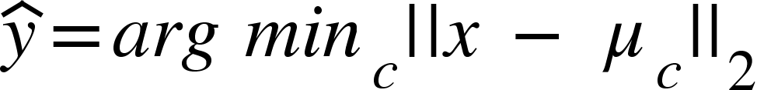
To fit the model at the start, I calculated the centroid for each class using the mean of each feature.
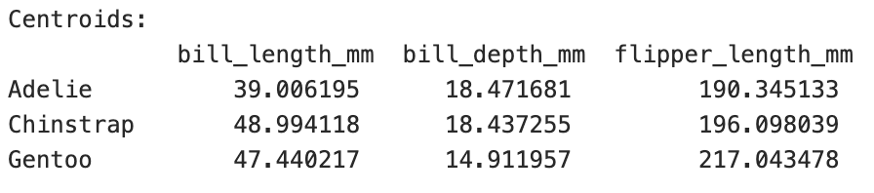
I also used the ideas of broadcasting to calculate the distance to each centroid. This fills in a new dimension which is useful in calculations where matrices are of different shapes.
The fifth step was to test the model. I used the accuracy from before and the model prediction with both the testing and training data to see the accuracy of my classifier. I also compared this to the implementation found in sklearn, where I ensured my model creates the same predictions for each penguin’s species in the testing data. I noted how the created model had a far greater accuracy compared to the baseline, 89.45% for the training data and 91.86% for the testing data.
The penultimate step was to tune the model. I used the equation x' = (x-train)/train to scale the training set in order to account for the different scales used in the features, which currently prioritises flipper length due to the greater numbers used in the data. This gave a greater accuracy of 97.27% and 96.51% respectively, which is an improvement for both sets of data.
The final step was to infer new penguins that were found in the wild. Here, an example was shown with new measurements and the model I created was used to predict which species this penguin was. This shows how once a model is trained and tuned, it can be used to make new inferences on the problem that was outlined in the first step.

3. Results
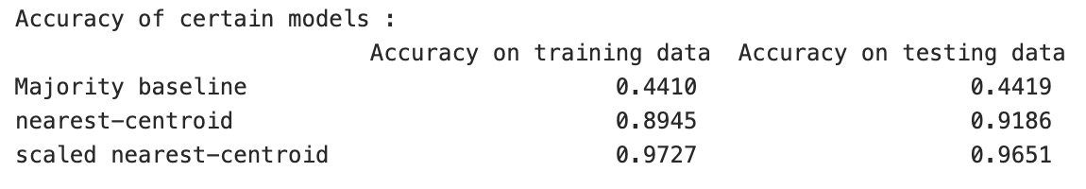
Figure 1 - accuracy table found on index [61]
Figure 1 shows a table created using pandas dataframe. It details the different accuracy scores obtained from each model created to 4 significant figures. This table shows how accuracy increased with each new model made. Interestingly, the scaled nearest-centroid has a higher accuracy on the trained data, unlike the other models. This could be because the scaling process makes the model more accurate to the data that is used in training, as it uses the mean and standard deviation from the training data (Brownlee, 2020). Therefore, it makes sense that the accuracy of the new model would be greater on the testing data that it was scaled towards and shows how this new model could include bias in the model towards the training data if refinement continued.
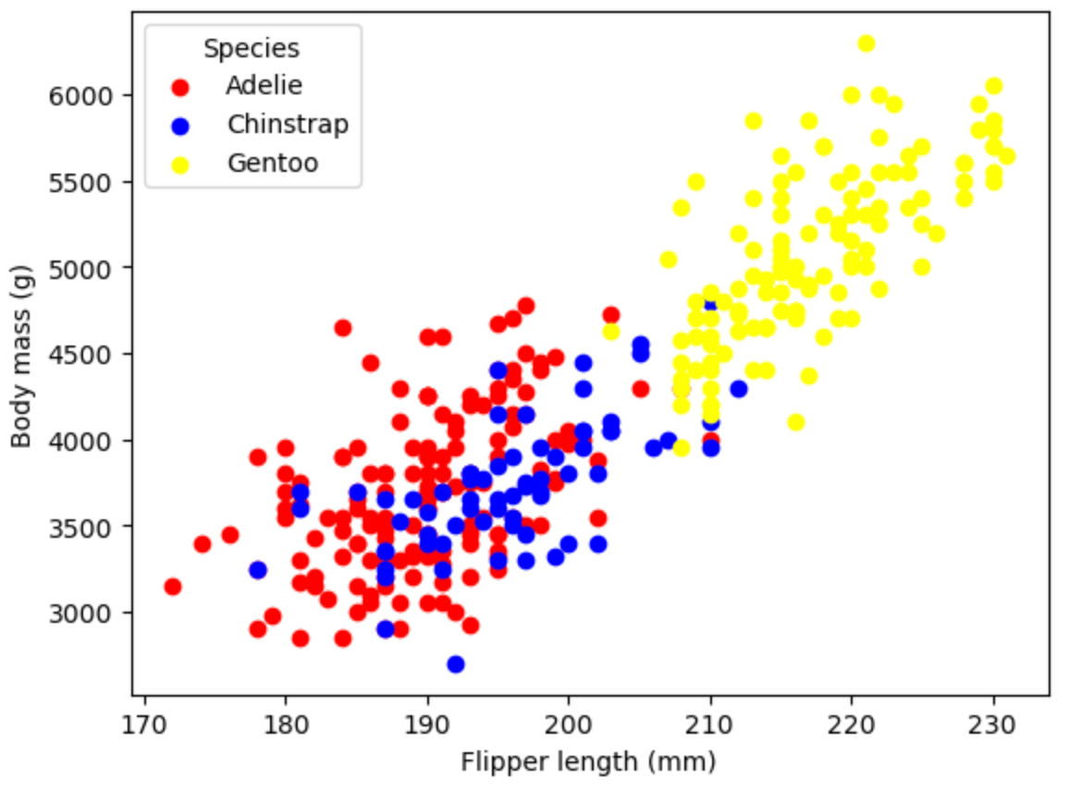
Figure 2 - scatter plot found on index [17]

Figure 2 shows a scatter plot made with matplotlib. It displays the clustering of each species of penguin, shown through chosen colours as seen in the legend, based on their spread across the features of Body mass and Flipper length. In particular, this demonstrates how Gentoo penguins can be identified as their clustering is noticeably separate compared to the other species. This was useful later in the process as 3 features were identified to be used for the created model, showing how presentations like this can influence choices in the decision making process for creating the feature matrix.

4. Discussion
The reason that scaling changed the result was the fact that the model uses Euclidean distance between each of the features. Since flipper length is a lot greater compared to bill depth, the value is more influential in finding the shortest distance, as a difference of double the flipper length would be far more impactful than double the difference of the other features.
I would say the model is good enough when the accuracy is at least 99.5%; at this level, the majority of penguins found would be correctly identified. However, this depends on how much the accuracy of the model is needed. For example, if the model needs to be super precise to find endangered penguins, then the accuracy may need to be higher compared to if the model is used for a general first categorisation or a large scale sampling project.
A notable limitation for this model is that the more it is tuned, the more accurate it is for the data provided. However, if new data is given, the model may not be accurate as the data does not necessarily follow the current data shown exactly. This means that further improvements to the model are limited and could introduce bias so the model might not work well for any data that does not group neatly based on the features chosen.
The next step would be to keep tuning, keeping in mind the limitation highlighted previously, or collect more data to increase the accuracy of the model. Otherwise, another algorithm could be chosen instead.

5. Issues and learning
What I struggled with was getting used to new libraries I had not used before and researching all the functionality that was already built into Numpy to avoid hard coding functionality that already exists. Following this, I will be able to use the features that I learnt which will speed up the process next time and I will no longer be limited by learning how to use the needed modules.

Lab Report 2 — Data Construction and Data Transformation
Practical 2 · Week 3 · Notebook: P2_data_preparation.ipynb

1. Aim
[One or two sentences stating the question(s) this practical set out to answer.]

2. Methods
[What you implemented and how: algorithm (key equation if helpful), data, preprocessing, how data were split, hyperparameters and how they were chosen.]

3. Results
[At least one figure and one table, numbered, captioned and referred to in the text, e.g. "Figure 1 shows…". State which split each number comes from.]

4. Discussion
[Interpret: why did this happen? Link to lecture theory. Answer this practical's reflection question. Limitations and next steps.]
[Reflection question for this practical: Which of today's preprocessing decisions do you think has the largest effect on a downstream model, and how could you test that?]

5. Issues and learning
[Two or three sentences: what went wrong or confused you, how you resolved it, and the main thing you learned.]
[Delete all grey guidance text before submission. Maximum two pages for this report.]

Lab Report 3 — Linear Regression and Gradient Descent from Scratch
Practical 3 · Week 4 · Notebook: P3_linear_regression.ipynb

1. Aim
[One or two sentences stating the question(s) this practical set out to answer.]

2. Methods
[What you implemented and how: algorithm (key equation if helpful), data, preprocessing, how data were split, hyperparameters and how they were chosen.]

3. Results
[At least one figure and one table, numbered, captioned and referred to in the text, e.g. "Figure 1 shows…". State which split each number comes from.]

4. Discussion
[Interpret: why did this happen? Link to lecture theory. Answer this practical's reflection question. Limitations and next steps.]
[Reflection question for this practical: Gradient descent needs a learning rate and many iterations, but the closed form does not. Why learn gradient descent at all? (Next week gives part of the answer.)]

5. Issues and learning
[Two or three sentences: what went wrong or confused you, how you resolved it, and the main thing you learned.]
[Delete all grey guidance text before submission. Maximum two pages for this report.]

Lab Report 4 — Multivariate and Polynomial Regression; Underfitting vs Overfitting
Practical 4 · Week 5 · Notebook: P4_multivariate_polynomial_regression.ipynb

1. Aim
[One or two sentences stating the question(s) this practical set out to answer.]

2. Methods
[What you implemented and how: algorithm (key equation if helpful), data, preprocessing, how data were split, hyperparameters and how they were chosen.]

3. Results
[At least one figure and one table, numbered, captioned and referred to in the text, e.g. "Figure 1 shows…". State which split each number comes from.]

4. Discussion
[Interpret: why did this happen? Link to lecture theory. Answer this practical's reflection question. Limitations and next steps.]
[Reflection question for this practical: Your validation curve chooses a degree, but the validation set was used to choose it. Is the validation error still an unbiased estimate of performance on new data?]

5. Issues and learning
[Two or three sentences: what went wrong or confused you, how you resolved it, and the main thing you learned.]
[Delete all grey guidance text before submission. Maximum two pages for this report.]

Lab Report 5 — Cost Functions for Regression and Regularisation
Practical 5 · Week 6 · Notebook: P5_cost_functions_regularisation.ipynb

1. Aim
[One or two sentences stating the question(s) this practical set out to answer.]

2. Methods
[What you implemented and how: algorithm (key equation if helpful), data, preprocessing, how data were split, hyperparameters and how they were chosen.]

3. Results
[At least one figure and one table, numbered, captioned and referred to in the text, e.g. "Figure 1 shows…". State which split each number comes from.]

4. Discussion
[Interpret: why did this happen? Link to lecture theory. Answer this practical's reflection question. Limitations and next steps.]
[Reflection question for this practical: Regularisation made almost no difference to test error on the wine data but a huge difference on the degree-15 polynomial. Why?]

5. Issues and learning
[Two or three sentences: what went wrong or confused you, how you resolved it, and the main thing you learned.]
[Delete all grey guidance text before submission. Maximum two pages for this report.]

Lab Report 6 — k-Nearest Neighbours and Classifier Evaluation
Practical 6 · Week 7 · Notebook: P6_knn_classifier_evaluation.ipynb

1. Aim
[One or two sentences stating the question(s) this practical set out to answer.]

2. Methods
[What you implemented and how: algorithm (key equation if helpful), data, preprocessing, how data were split, hyperparameters and how they were chosen.]

3. Results
[At least one figure and one table, numbered, captioned and referred to in the text, e.g. "Figure 1 shows…". State which split each number comes from.]

4. Discussion
[Interpret: why did this happen? Link to lecture theory. Answer this practical's reflection question. Limitations and next steps.]
[Reflection question for this practical: k-NN has no training phase. What does that imply about its cost at prediction time, and about its memory use, as the dataset grows?]

5. Issues and learning
[Two or three sentences: what went wrong or confused you, how you resolved it, and the main thing you learned.]
[Delete all grey guidance text before submission. Maximum two pages for this report.]

Lab Report 7 — Logistic Regression from Scratch
Practical 7 · Week 8 · Notebook: P7_logistic_regression.ipynb

1. Aim
[One or two sentences stating the question(s) this practical set out to answer.]

2. Methods
[What you implemented and how: algorithm (key equation if helpful), data, preprocessing, how data were split, hyperparameters and how they were chosen.]

3. Results
[At least one figure and one table, numbered, captioned and referred to in the text, e.g. "Figure 1 shows…". State which split each number comes from.]

4. Discussion
[Interpret: why did this happen? Link to lecture theory. Answer this practical's reflection question. Limitations and next steps.]
[Reflection question for this practical: Logistic regression and linear regression share the same form of gradient update. Why, if their cost functions are different?]

5. Issues and learning
[Two or three sentences: what went wrong or confused you, how you resolved it, and the main thing you learned.]
[Delete all grey guidance text before submission. Maximum two pages for this report.]

Lab Report 8 — Decision Trees and Ensemble Methods
Practical 8 · Week 9 · Notebook: P8_decision_trees_ensembles.ipynb

1. Aim
[One or two sentences stating the question(s) this practical set out to answer.]

2. Methods
[What you implemented and how: algorithm (key equation if helpful), data, preprocessing, how data were split, hyperparameters and how they were chosen.]

3. Results
[At least one figure and one table, numbered, captioned and referred to in the text, e.g. "Figure 1 shows…". State which split each number comes from.]

4. Discussion
[Interpret: why did this happen? Link to lecture theory. Answer this practical's reflection question. Limitations and next steps.]
[Reflection question for this practical: Random forests often beat plain bagging of the same trees. What extra source of randomness do they add, and why does it help?]

5. Issues and learning
[Two or three sentences: what went wrong or confused you, how you resolved it, and the main thing you learned.]
[Delete all grey guidance text before submission. Maximum two pages for this report.]

Lab Report 9 — Unsupervised Learning: k-Means Clustering and PCA
Practical 9 · Week 10 · Notebook: P9_kmeans_pca.ipynb

1. Aim
[One or two sentences stating the question(s) this practical set out to answer.]

2. Methods
[What you implemented and how: algorithm (key equation if helpful), data, preprocessing, how data were split, hyperparameters and how they were chosen.]

3. Results
[At least one figure and one table, numbered, captioned and referred to in the text, e.g. "Figure 1 shows…". State which split each number comes from.]

4. Discussion
[Interpret: why did this happen? Link to lecture theory. Answer this practical's reflection question. Limitations and next steps.]
[Reflection question for this practical: Looking back over all nine practicals: which algorithm did you find hardest to implement from scratch, and what did implementing it teach you that using the library version would not have?]

5. Issues and learning
[Two or three sentences: what went wrong or confused you, how you resolved it, and the main thing you learned.]
[Delete all grey guidance text before submission. Maximum two pages for this report.]

Reflective summary
[At most one page. Cover: (1) two or three ideas that recurred across the practicals and how your understanding developed; (2) what implementing algorithms from scratch taught you; (3) how you would approach a new tabular dataset, with reference to your own evidence.]

Appendix A — Declaration of AI tool use
Tool | What I used it for | Which report(s)
[e.g. none]

Appendix B — References
Brownlee, J. (2020) How to use Data Scaling Improve Deep Learning Model Stability and Performance [Online]. Available from: https://machinelearningmastery.com/how-to-improve-neural-network-stability-and-modeling-performance-with-data-scaling/ [Accessed 20 October 2026].

