Manuscript
Axel Zweistra

Meet Quarto
Quarto enables you to weave together content and executable code into a finished document. To learn more about Quarto see https://quarto.org.

Meet the penguins
The penguins data from the palmerpenguins package contains size measurements for 344 penguins from three species observed on three islands in the Palmer Archipelago, Antarctica (Horst, Hill, and Gorman 2022).
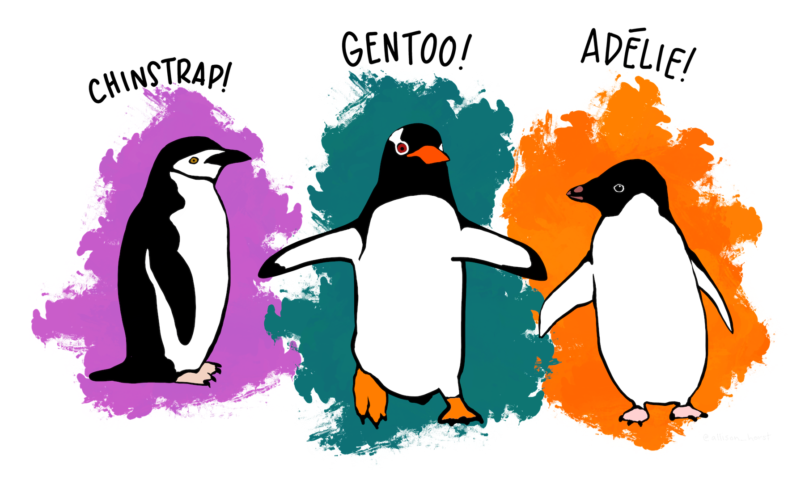
Another reference is Hamaker, Kuiper, and Grasman (2015).

Results
Warning: Removed 2 rows containing missing values or values outside the scale range
(`geom_point()`).
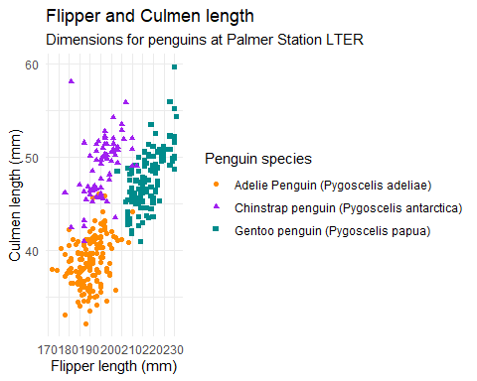

Inline code
Sanity check 1 + 1 = 2
Referring to data: there are 152 Adelie penguins and 68 Chinstrap penguins.
The average weight of a Chinstrap penguin in the dataset is 3733 grams.

Sourcing code
source("scripts/do_addition.R")
do_addition(2,2)
[1] 4
Hamaker, Ellen L., Rebecca M. Kuiper, and Raoul P. P. P. Grasman. 2015. “A Critique of the Cross-Lagged Panel Model.” Psychological Methods 20 (1): 102–16. https://doi.org/10.1037/a0038889.
Horst, Allison M., Alison Presmanes Hill, and Kristen B. Gorman. 2022. “Palmer Archipelago Penguins Data in the Palmerpenguins R Package - An Alternative to Anderson’s Irises.” R Journal 14 (1): 244–54. https://doi.org/10.1492/yres.025.

