

Mini VoIP Recorder Setup Guide

V1.00

Download Mini VoIP Recorder installation package from website, unzip it and install it:
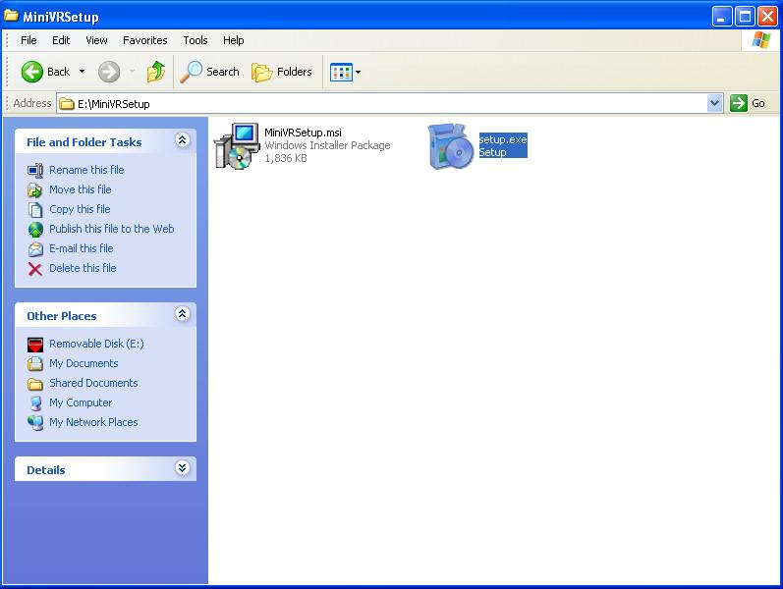

Run setup.exe
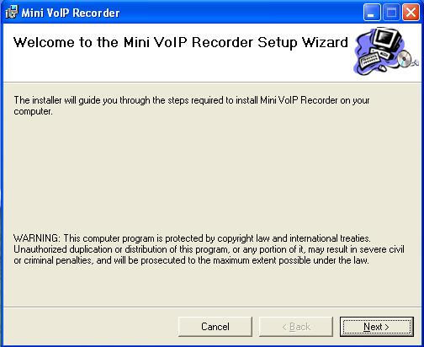

Click next.
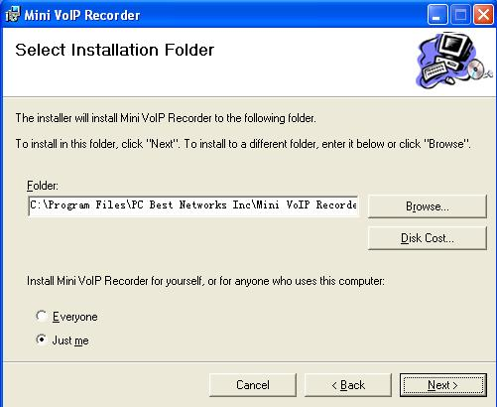
Click Next.
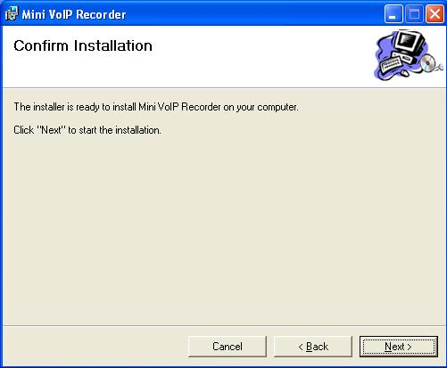
Click Next start to install.
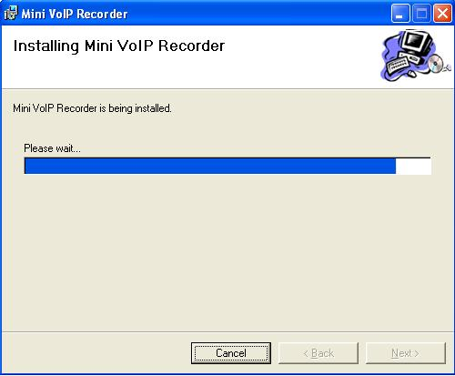
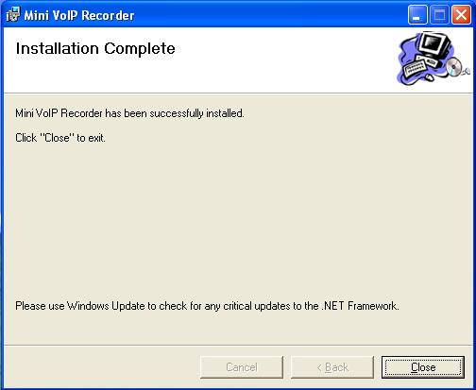
Install completed. Click Close.

Find Mini VoIP Recorder shortcut on the desktop, or in Start/All Programs/Mini VoIP Recorder.
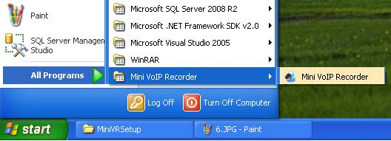

If you see the below Error dialog popup, please install WinPCap driver in your computer, otherwise please go page 8 to continue.
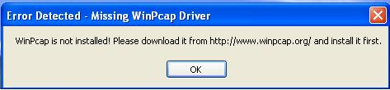

Go website www.winpcap.org and download WinPCap installation package:
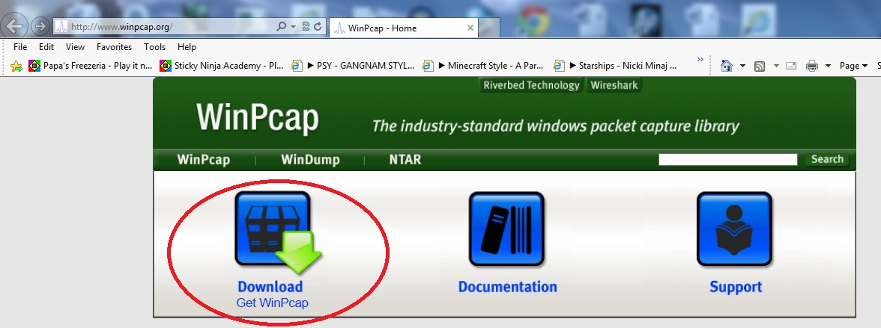

Download WinPCap and install it:
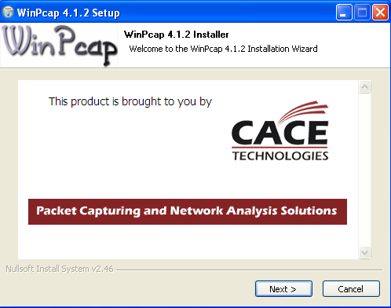

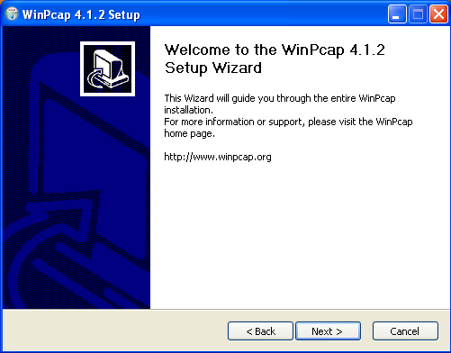

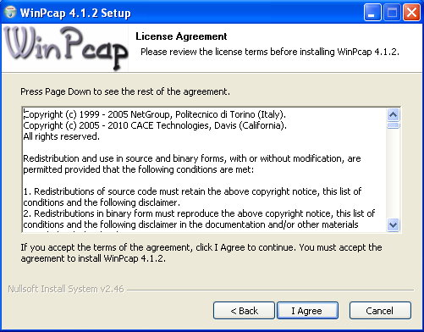

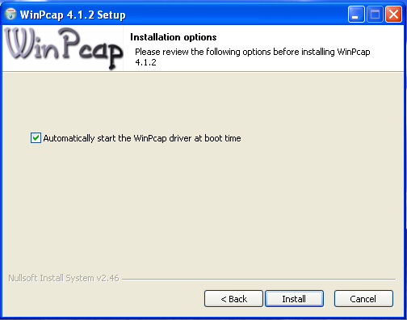

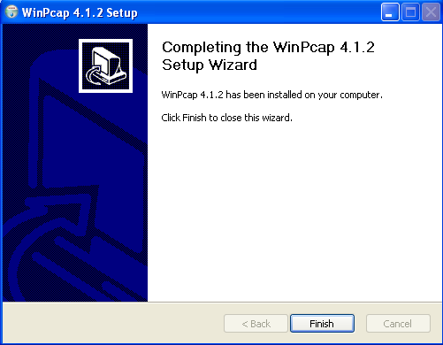

Network Requirement for Mini VoIP Recorder

You don’t need additional hardware if you only want to record calls for the local computer (using Mini VoIP Recorder to record VoIP software on the same computer).

You must have a network switch that supports bidirectional ‘port mirroring’(also called ‘port mapping’ or the existence of a ‘span port’). Most business grade switches do have this feature. Or you must have network hub to connect your SIP VoIP devices if you want to record other devices. Why? Because all Ethernet traffic passes through all hub ports, so the PC runs VoIP Recorder V2 can sniff the network and record other devices.
See articles:
http://kbserver.netgear.com/kb_web_files/n101527.asp
http://ask-leo.com/whats_the_difference_between_a_hub_a_switch_and_a_router.html
http://www.duxcw.com/faq/network/hubsw.htm
http://www.cisco.com/en/US/products/hw/switches/ps708/products_tech_note09186a008015c612.shtml#support

If you have any questions or problems about network hardware issues, please feel free to contact us by http://www.pcbest.net/contact.php

Typical Networks:

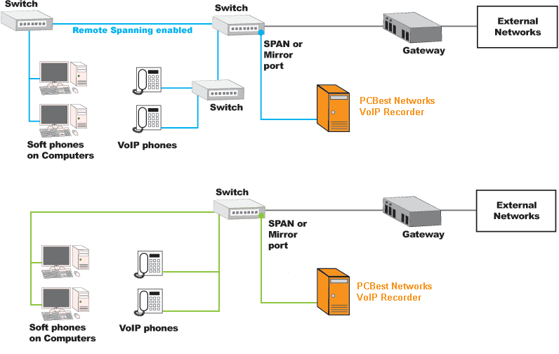

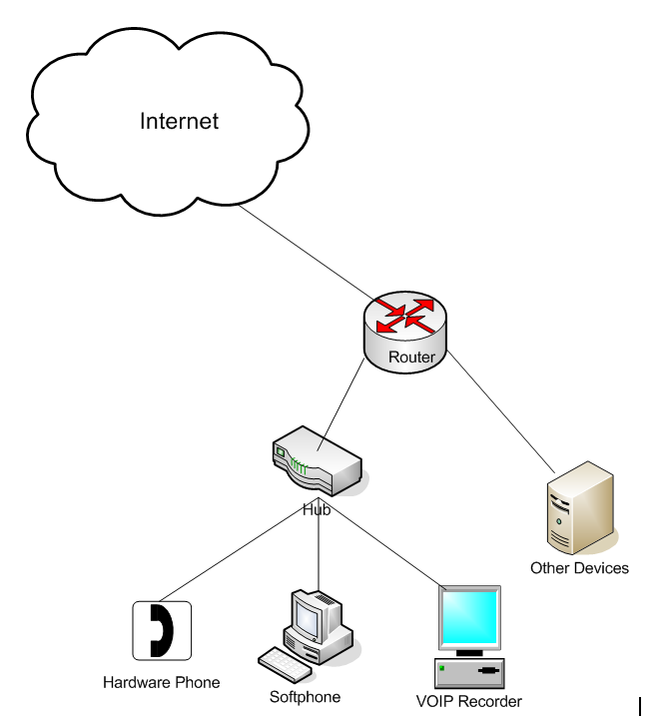

Run Mini VoIP Recorder again, and you should get this GUI:
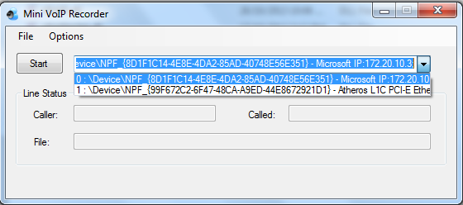

Choose the Network Interface Cards(if you have multiple network cards in computer) you want to monitor on, and click Start:
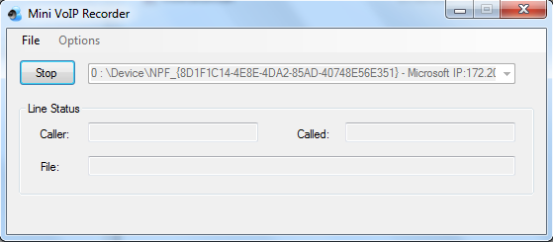

So it is monitoring, and recording.
Minimize it, it will run in background:

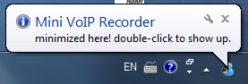

Whenever there is a VoIP call, it will show status:
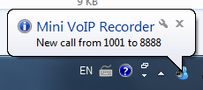

Double-Click the icon to bring up Mini VoIP Recorder main window:
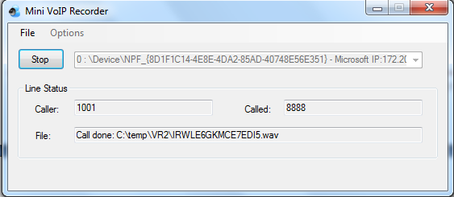

Call status is showing.

That's it. A very simple and easy software to record your VoIP calls. Please feel free to contact us if you have any question about it: support@pcbest.net

PC Best Networks Inc.
Toll Free(USA & Canada): 1-888-733-6620
Local and International: 1-613-800-2202
www.pcbest.net
www.pcbestnetworks.com

