2. Installation

The WCOP8 IDE software is provided as SHAREWARE and can be freely evaluated for a period of 30 days. After 30 days the software must be registered - otherwise it will no longer operate.

First time installation

For proper installation of the WCOP8 IDE software, insert the WCOP8 IDE installation disk into the floppy drive and run the SETUP.EXE file.

The WCOP8 IDE installation program will prompt for both drive and path before installation of program files.

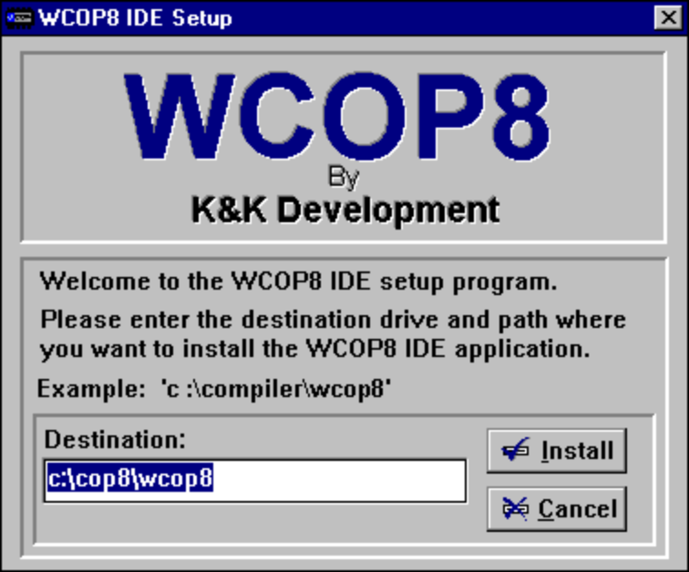
Type in the desired drive and destination path of the WCOP8 IDE program files..
…and press the Install button to begin the installation.
The WCOP8 IDE Installation Program

After successful installation, two programs have been added to the Windows program manager (Win3.x) or in the Start menu (Win95) by the WCOP8 IDE installation program: the main WCOP8 IDE program and a SETUP program. The SETUP program has different tools for supporting and easing the configuration of the WCOP8 IDE software.

Note! In order to make the link function of the WCOP8 IDE compiler interface work correctly, a path must be specified to the directory where the file PROMCOP.EXE is located (PROMCOP.EXE is normally placed in the same directory as the COP8 Assembler ASMCOP.EXE). Since PROMCOP.EXE is part of the COP8 assembler package and is not supplied with the WCOP8 IDE software, this has to be done manually by the user.
Example: If the COP8 prommer file PROMCOP.EXE is located in the directory called C:\SPROG\ASMCOP, a path to this directory has to be added to the AUTOEXEC.BAT.

Software upgrade

If the WCOP8 IDE setup program detects a previously installed version of WCOP8 IDE the setup program gives a choice between upgrading the ‘old’ software (and by that keeping the user settings) or to make a new installation with the by K&K Development defined default settings.

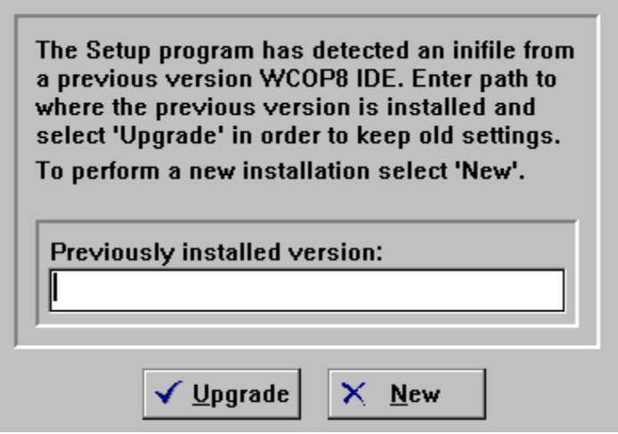
Type in the path to where the ‘old’ WCOP8 IDE version is installed and press the Upgrade button to keep your ‘old’ settings, or…
…just press the New button for a complete new installation without keeping the ‘old’ settings
WCOP8 IDE setup program upgrade prompt

When either the Upgrade or New button has been pressed the first time installation screen is showed - see previous paragraph.

Software registration

When the WCOP8 IDE software has been evaluated - and hopefully found worth to register - the following steps should be performed:

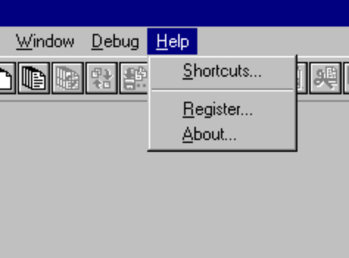
Choose this menu to register your WCOP8 IDE software

Choose Register from the Help menu and the following dialog box will appear:

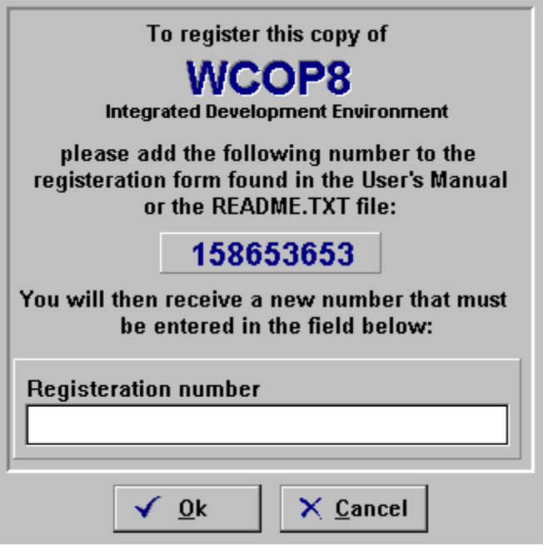
1. Type in this Personal Encryption Number on the registration form and send it to K&K Development…
2. When you receive a Reg. No. enter it in this field, press the Ok button and the software is registrated!
WCOP8 IDE registration dialog

As explained in the dialog, the 9 digits long Personal Encryption Number should be send to K&K Development for registration. After approval, K&K Development sends back a Registration Number which should be entered in the Registration Number field. By pressing the Ok button the software is registrated!

After registration the Register.. option will disappear from the Help menu.

Note! It is very important that the Personal Encryption Number is correctly specified and in a readable format in the official order form. Otherwise you may receive an invalid Registration Number and the software fails to unlock!

Note! A registration gives license for one installation of the WCOP8 IDE software on one PC. Multiple licenses requires multiple registration requests.

