3. Understanding and Using the WCOP8 IDE

WCOP8 IDE is invoked by double-clicking the WCOP8 IDE icon. When the WCOP8 IDE is activated, an initialization process begins and the user will see the following initialization screen:

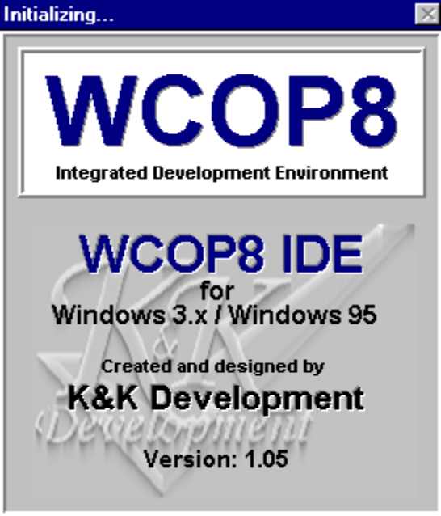
WCOP8 IDE initialization screen

When the WCOP8 IDE is invoked it automatically detects the path and directory from which it is started. This path and directory will in the following be referred to as “current directory”.

If it is the first time that the WCOP8 IDE is started after installation a system performance check is activated. The system performance check detects the relation between the CPU and harddisk speed on the current PC. The system performance value found is saved in the WCOP8 IDE initialization file and can later be changed using the WCOP8 IDE configuration program.

Before you start using the WCOP8 IDE you have to set up the editor and compilers for the WCOP8 IDE Environment. Activate the Options menu and choose Environment and the following dialog box will appear:

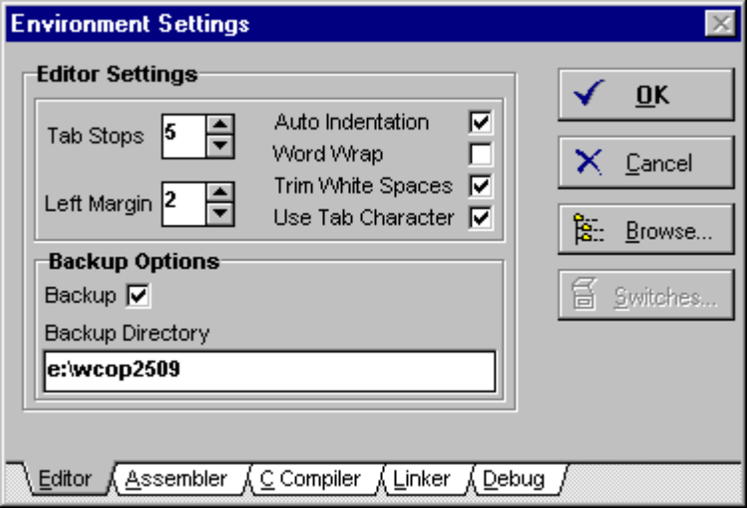
Environment Settings dialog box

Editor Settings

In the ‘Editor’ sheet of the ‘Environment Settings’ dialog box the integrated editor can be configured.

The value given in the Tab Stops field represents the number of characters between each TAB-stop. The default value is 5.

In the Left Margin field a left margin position can be given. This left margin is also presented on printout. The default value is 3.

If the Auto Indentation option is selected, the editor is in a mode where it remembers the indentation of the current line and uses this indentation on the next line when ‘Enter’ is pressed. If this option is not selected, the indentation of a new line is always the left margin. (Please note that when the editor is in overwrite mode the auto indentation feature is inactive)! The default value is not selected.

If the Word Wrap option is selected, all text lines longer than the width of the editor window, will be wrapped down to the next line. This makes the reading of files containing long lines easier. The default value is not selected.

If the Trim White Spaces option is selected, all unused spaces (if any) at the end of each line will be removed when loading a file. The default value is not selected.

If the Use Tab Character option is selected, the editor inserts a Tab character when the Tab button is pressed. If this option not is selected, the editor will convert the Tab character into spaces. The default value is not selected.

In Backup Options you can select whether a backup file should be created when a file is saved. In the Backup Directory field placement of the backup files can be selected. A backup file is given the same name and extension as that of the current file except for the first character in the name which is substituted by an underscore. (Example: PRG_MAIN.ASM backup file will be named _RG_MAIN.ASM and PRG_MAIN.C will be named _RG_MAIN.C).
If no directory is entered in the Backup Directory field, the current directory will be used!

Assembler

In the ‘Assembler’ sheet of the ‘Environment Settings’ dialog box the assembler can be configured:

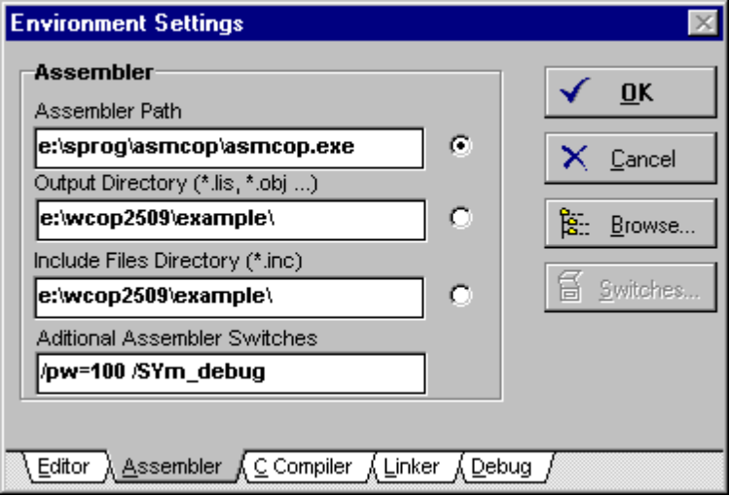
Assembler configuration

In this dialog box all relevant information as where to find the COP8 assembler and how it should behave is set up.

When the ‘dot’ is at the Assembler Path field, the Browse button will browse all valid drives on order to find the directory where the assembler is located.

When the ‘dot’ is at the Output Directory (*.lis, *.obj …) field, the Browse button will browse all valid drives in order to find the directory where output files should be placed.

Note! The directory specified in the Output directory field for the assembler will always be the input directory for the linker. If no directory is entered the current directory will be used!

When the ‘dot’ is at the Include Files Directory (*.inc) field, the Browse button will browse all valid drives in order to find the directory where include files are located (*.inc files). If no directory is entered the current directory will be used!

In the Additional Compiler Switches field all valid compiler switches can be given.

C Compiler

In the ‘C Compiler’ sheet of the ‘Environment Settings’ dialog box the C Compiler can be configured:

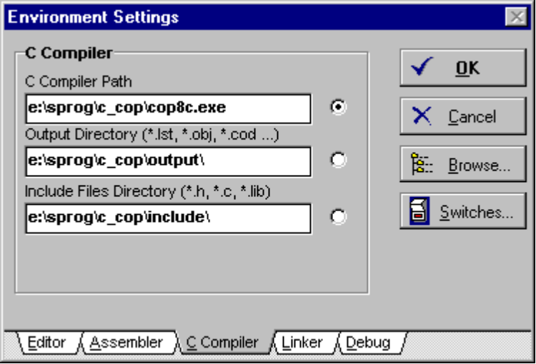
Easy access to all valid C compiler switches
C Compiler configuration

In this dialog box all relevant information as where to find the COP8 C compiler and how it should behave is set up.

When the ‘dot’ is at the C Compiler Path field, the Browse button will browse all valid drives on order to find the directory where the C compiler is located.

When the ‘dot’ is at the Output Directory (*.lst, *.obj, *.cod …) field, the Browse button will browse all valid drives in order to find the directory where output files should be placed.

When the ‘dot’ is at the Include Files Directory (*.h, *.c, *.lib) field, the Browse button will browse all valid drives in order to find the directory where include and library files are located. If no directory is entered the current directory will be used!

Note! It is mandatory to place all the *.h and *.c and library files used by the main C source file in the given Include Files Directory.

If the Switches.. button is pressed all valid compiler switches can be given:

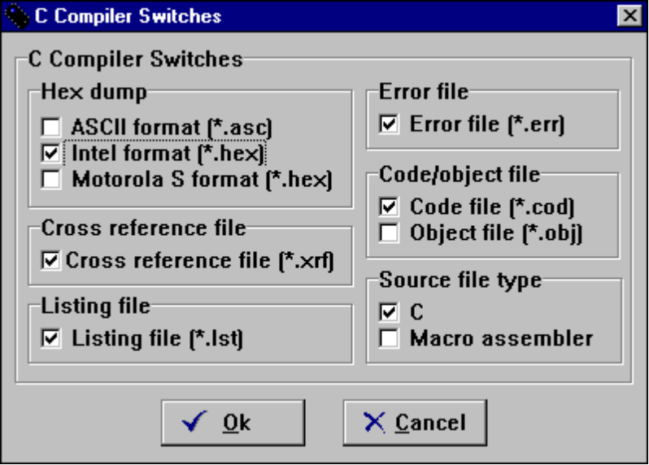
The C Compiler Switches dialog box

In this dialog box all valid C Compiler switches can be given just by clicking on the desired function. Please refer to the Bytecraft C compiler manual for the meaning of each switch.

Linker

In the ‘Linker’ sheet of the ‘Environment Settings’ dialog box the linker can be configured:

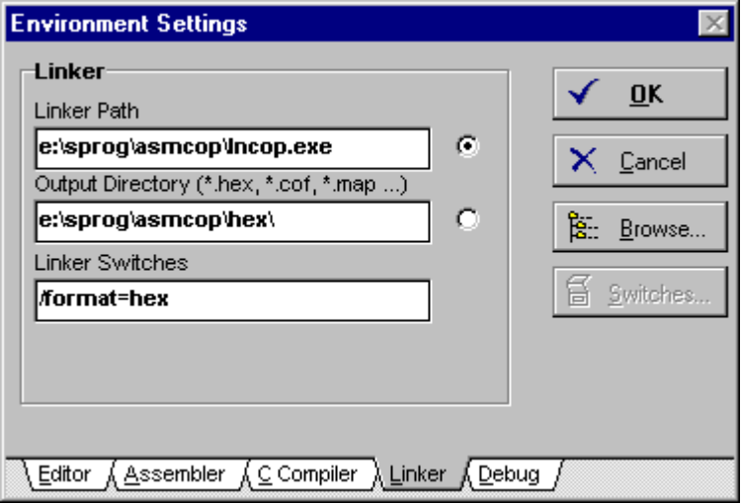
Linker configuration

When the ‘dot’ is at the Linker Path field, the Browse button will browse all valid drives in order to find the directory where the linker is located.

When the ‘dot’ is at the Output Directory (*.hex, *.cof, *map …) field, the Browse button will browse all valid drives in order to find the directory where output files should be directed. If no directory is entered the current directory will be used!

Tip! If a COP8 debug/simulation tool from Metalink are used in connection with the WCOP8 IDE, it will ease the work flow if the Output Directory (*.hex, *.cof, *.map …) is set to the directory where the Metalink tool is installed. By doing so, loading of the .COF file into the Metalink tool will require no path statement!

In the Additional Linker Switches field all valid linker switches can be given.

Note! If the switch “/Format=hex” is used, the linker will automatically start a program called PROMCOP.EXE. Since this program is not under the WCOP8 IDE control, it is mandatory to have a path in the AUTOEXEC.BAT to the directory where the file PROMCOP.EXE is sited!

When the OK button is pressed, all settings are stored in a WCOP8.INI file and will be recalled every time the WCOP8 IDE is started. The settings can always be changed by choosing Environment in the Options menu.

Debug

In the ‘Debug’ sheet of the ‘Environment Settings’ dialog box the different debug tools for the COP8 can be configured:

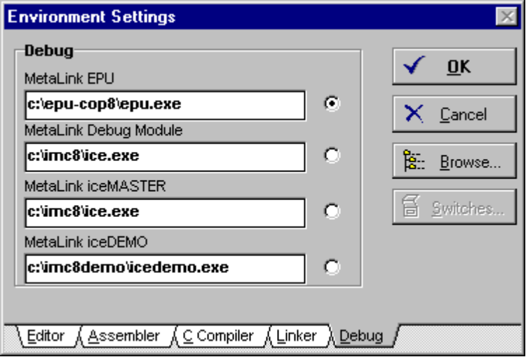
Debug configuration

In this dialog box the location of the different debug programs for debugging COP8 code is set up.

When the ‘dot’ is at the MetaLink EPU field, the Browse button will browse all valid drives on order to find the directory where the MetaLink EPU program is located.

When the ‘dot’ is at the MetaLink Debug Module field, the Browse button will browse all valid drives in order to find the directory where the MetaLink Debug Module is located.

When the ‘dot’ is at the MetaLink iceMASTER field, the Browse button will browse all valid drives in order to find the directory where the MetaLink iceMASTER is located.

When the ‘dot’ is at the MetaLink iceDEMO field, the Browse button will browse all valid drives in order to find the directory where the MetaLink iceDEMO is located.

If one or more of the above COP8 debugging programs are installed, they can be activated from within the WCOP8 IDE by selecting the desired program in the Debug menu.

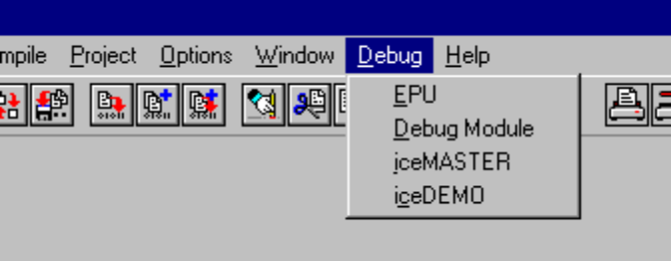
Easy access to COP8 debugging programs via the Debug menu

Note! If none of the above COP8 debugging programs are installed, the Debug menu will not appear in the WCOP8 IDE menu!

