4. Built-in Editor Functions and Other Features

The WCOP8 IDE has a built-in editor which allows the user to enter and edit text files within the WCOP8 IDE environment. This editor supports the most common windows editor functions such as Find, Find&Replace, Cut, Copy, Paste, Delete and Goto Line.

Pop-Up menu

When the cursor is located above an opened window, the right mouse button supports several fast access commands:

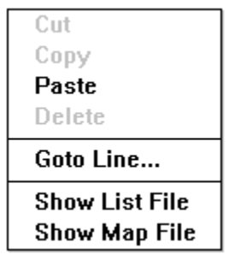
This Pop-Up menu appears when the right mouse button is clicked

The Cut, Copy, Paste and Delete fields will only be highlighted if they are accessible, ie if a block of text is marked.

If the Goto Line… function is activated a small dialog box will appear:

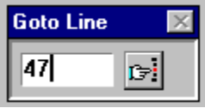
... and press this Find button or press Enter on the keyboard
Enter line number
in this field...

You are now able to enter a line number in this dialog box, press Enter or the Find button and the editor will go to the line chosen. This function is very useful when the assembler reports an error since the assembler always shows in which line(s) the error(s) occurred.

If the cursor is placed above an open file with a name such as MY_PROG.ASM, the Show List File will automatically open the list file MY_PROG.LIS in a new window. The Show Map File operates in the same way and opens the map file MY_PROG.MAP.

Note! For a group of files combined in a project, only one MAP file is generated. This MAP file will be given the same name as that of the project.

Find and Find&Replace

The Find and Find&Replace options are found in the Search menu and on the speedbar as buttons. Since the functionality of such functions is presumed to be known to all Windows users it will be described no further.


FIND selection
FIND selection and
REPLACE with...

Print and Screen functions

The Print and Printer Setup.. functions are found in the File menu and on the speedbar as buttons. Two print options are available in the Print menu: the Print All option which prints the contents of the active document and the Print Selection option which only prints a selected part of the document.

Screen arrangement of windows and icons is found in the Window menu and on the speedbar as buttons.
PRINT
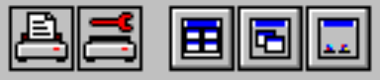
Print SETUP
TILE, CASCADE Windows
and ARRANGE icons

Fonts

Change of editor font is done in the Character menu - default font is ‘Fixedsys’ (normal, 10pt). The editor supports the use of all fixed width fonts installed in the system. No information about fonts will be saved in the files!

Status Line

At the bottom of the environment window there is (if active) a status line showing system data:
Line # : Column #
Editor in ‘Insert’ or ‘Overwrite’ mode
Name and path to file in active window

The active file/document has been modified
Name of opened project (if any). Not shown if the file in focus is not a part of the opened project.

This status line as well as the speedbar with all the icons can be toggled on and off in the Options menu.

Edit Functions and Bookmarks

The WCOP8 IDE built-in editor supports many well known editor commands and shortcuts such as Shift+Ctrl+Left arrow for ‘Mark word left’, Shift+Ctrl+PgUp for ‘Mark to top of page’ etc. A complete list of these shortcuts is listed as a appendix to this manual. The same shortcut list can also be seen as an on-line help within the WCOP8 IDE by choosing Shortcuts.. in the Help menu.
For easing the work with large files a bookmark function supports the use of up to 10 different bookmarks in a file. A bookmark is placed in a file by pressing Shift+Ctrl+0..9. When a bookmark is inserted a little bookmark number is shown in the left margin of the source file.
Jumping to a bookmark is done by pressing Ctrl+0..9. This function makes it possible to do fast jumping between code at different places in the file. Bookmarks are deleted by pressing Alt+0..9.

External Applications

If external applications should be launched from within the WCOP8 IDE environment (eg a preferred editor or similar), this can be made possible. As a matter of fact, up to 9 different external applications can be launched from within the WCOP8 IDE environment. All external applications can be assigned a specific keyboard shortcut key or they can be activated from the Files menu.

User Templates

Another useful function in the File menu is the Insert Template.. which gives fast access to up to 9 predefined templates such as user-defined procedure, function and file headers, commonly used text etc.

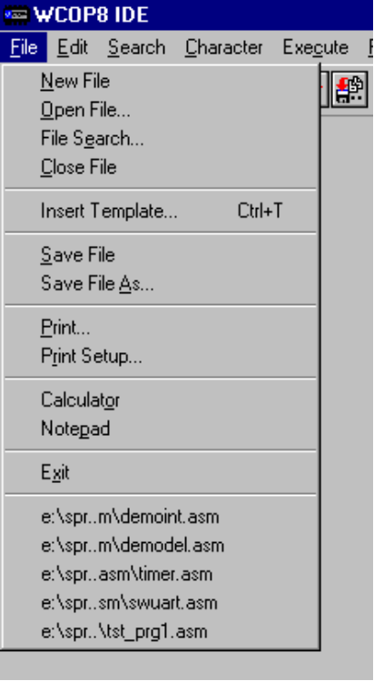
Two external applications installed: Notepad and Calculator
Insert a Template by activating this menu or by pressing Ctrl-T
A list of the last five files opened. This file list is reset at program Exit.
Search all valid drives for files or projects by activating this File search menu
The contents of the File menu with two external
applications installed

Installation of User Applications and User Templates is done by using the SETUP program which was installed separately in the Program Manager (Win3.x) or in the Start menu (Win95). See the description of the SETUP program in Chapter 7.

When Insert Template… is activated the following dialog box appears:

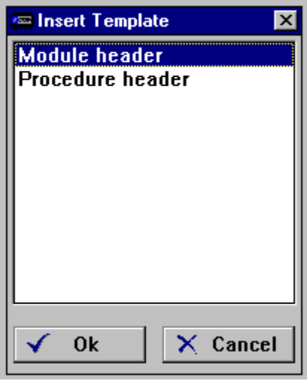
A procedure header is inserted in the active document
A module header is inserted in the active document
The Insert Template dialog box with two templates installed

The names and contents of the templates are 100% definable and this is done in the SETUP program (see Chapter 7).

Tip! After installation of the WCOP8 IDE, two ready-to-use sample templates are installed to help the user. Physically they are located in a subdirectory to the main WCOP8 IDE directory called ../TEMPLATE/

File search

The File search.. function is also found in the File menu. This function can be used to scan all the valid drives for any given mask of files. If the location of a given project, C or assembler file is forgotten this functions will quickly find it and the file can be accessed from within this function. Choose the File search.. function and the following dialog box appears:

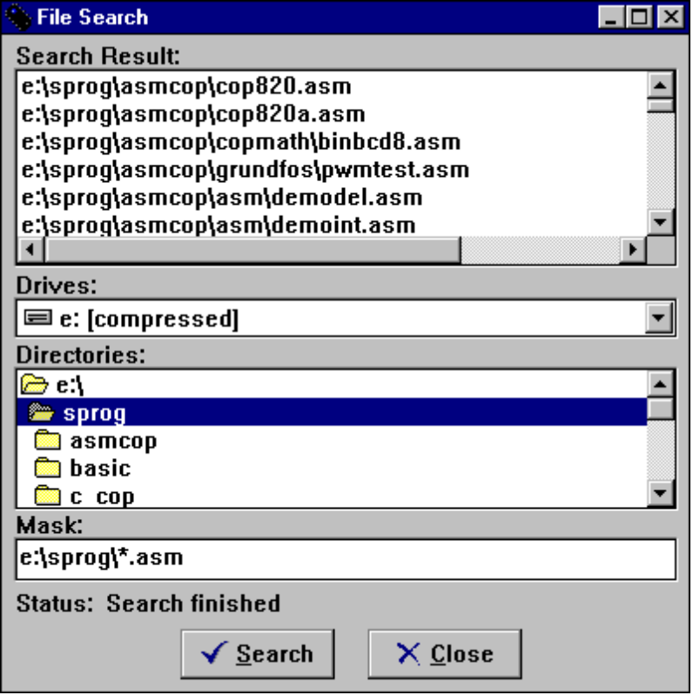
1) Type in the desired search mask…
2) and press the search button. The status will change to searching…
3) when status changes to ‘finished’ all the valid files found on the path given are listed in this box…

4) all files/projects can be opnend by double clicking on them in this window.
File search dialog box

Please note that all the sub directories to the choosen directory also will be scanned when search is activated.

