5. Using the WCOP8 IDE on Single Files

A ‘Single File’ is a file which is not opened as part of a project but as a stand-alone file which is able to be compiled and linked separately. A single file can be opened by pressing the Open File button or created by pressing the New File button on the speedbar or by choosing Open File or New File in the File menu.

Note! A single file can make use of Include files but NOT import functions from separately compiled submodules. If a file does import functions from separate submodules, correct linking can only be performed if all these modules are combined in a project. See Chapter 6.

OPEN single file
SAVE file


NEW file
SAVE file AS..

Compile and Link buttons

Compiling is done by choosing Compile from the Compile menu or by pressing the Compile button on the speedbar.

Linking is done by choosing Link from the Compile menu or by pressing the Link button on the speedbar.

Compiling and successive linking is done by choosing Build from the Compile menu or by pressing the Build button on the speedbar. Linking is only performed if the file is compiled without errors.

COMPILE file in active window



Meaning of the Compile, Link and Build buttons on
the speedbar when used on single files

Compilation

When compiling is invoked by choosing Compile from the Compile menu or by pressing the Compile button on the speedbar, the WCOP8 IDE shows its current activity in an “Action Report Window”:

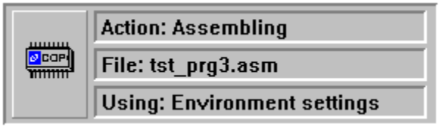
WCOP8 IDE Action Report Window when Assembling is performed

When compilation is ended a Compiler Result Window is opened with a compilation status report.

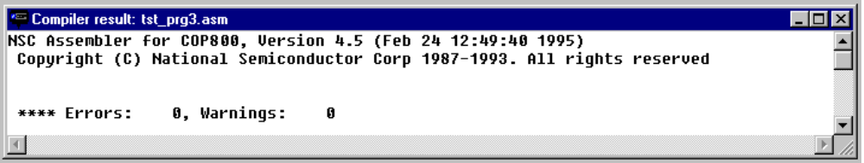Compiler Result Window after compilation has ended - no errors

If everything went OK the window can be closed, otherwise you are able to scroll through error messages from the compiler. See the paragraph Error Handling in this chapter for a guide to the WCOP8 IDE Error Handler.

When the compiler result window has been closed you now have the possibility to quickly open the list file created at compilation time by pressing the right mouse button and choose Show List File. The Show List File will always open the list file correlated to the active window.

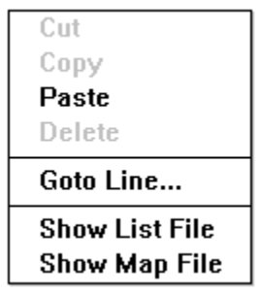
This Pop-Up menu appears when the right mouse button is activated

Linking

When linking is invoked by choosing Link from the Compile menu or by pressing the Link button on the speedbar, the WCOP8 IDE shows its current activity in an “Action Report Window”:

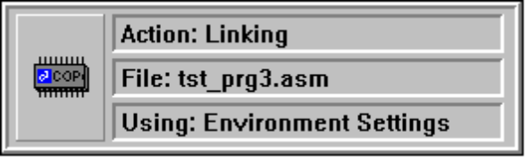
WCOP8 IDE Action Report Window

If the object file is older than the corresponding source file the WCOP8 IDE prompts for a recompilation of that specific file before linking.

When linking is ended a “Linking Result Window” is opened with a linking status report.

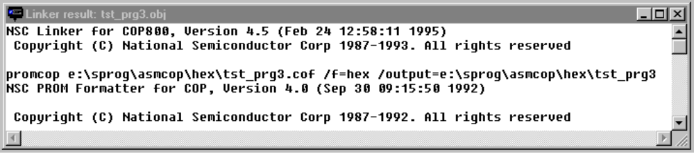Linking Result Window after linking has ended

If everything went OK the window can be closed, otherwise you are able to scroll through error messages from the linker. When you have closed the linking result window you now have the possibility to quickly open the map file created by linking. This is done by pressing the right mouse button and choose Show Map File. The Show Map File will always open the map file (*.map) correlated to the active window.

TIP! Compiler/linker result windows (only!) can be ‘fast-closed’ by pressing Ctrl + left mouse button.

Build

Pressing the Build button will perform both compilation and linking of the file in the active window. Please note that linking is only performed if compilation executes without errors.

Error Handling

If errors occur during compilation, the line numbers with bad syntax will be listed in the compiler result window after compilation:

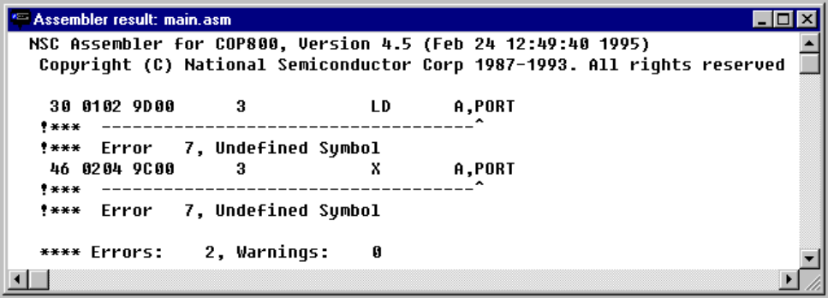
LINK file in active window
Compiler Result Window - two errors detected

For quick access to the different erroneous lines in the source file, just double click on the line numbers stated in the compiler result window and the WCOP8 IDE will automatically jump to this line in the source file. Furthermore, the WCOP8 IDE splits the editor window between the compiler result window and the source file in a way so that an overview of both is obtained.

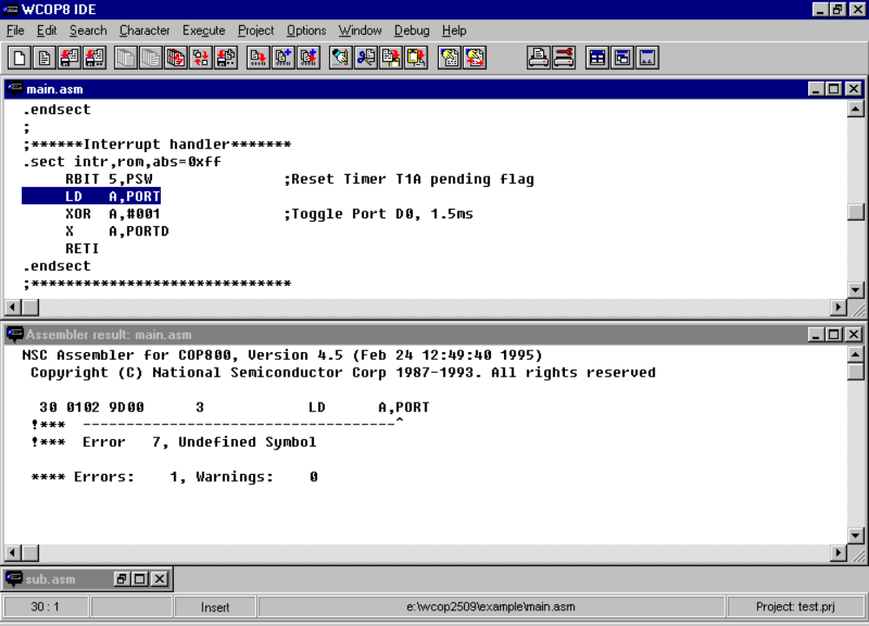
BUILD (ie Compile and Link) file in active window
Error in line 30 and 46 detected by the assembler. To edit these lines in the source file just double click on the line number!
Error editing (after automatic jump to source file)

After having edited the error, the next error line in the compiler result window can be double clicked and so on.

