6. Using the WCOP8 IDE in Project Mode

Using the WCOP8 IDE in project mode will ease the work when designing multi-module programs. When in project mode, the link feature automatically links all files in the project. The build facility will compile all files in the project using the correct compiler on .ASM and .C files and after that link them. The compile feature still only works on the active file.

Compiler/linker settings are unique to the project and are stored in a file with a .PRJ extension. This simplifies redesigns since all information about files, compilers, switches etc. is restored when the project is opened.
CLOSE project
OPEN project
SAVE project AS...

NEW project
Project FILES

Meaning of the different project buttons on the speedbar

New Project

A new project is created by selecting New Project in the Project menu or by pressing the New project button on the speedbar. When selected, several dialog boxes will guide through all the steps necessary to build a project. First the following dialog box appears:

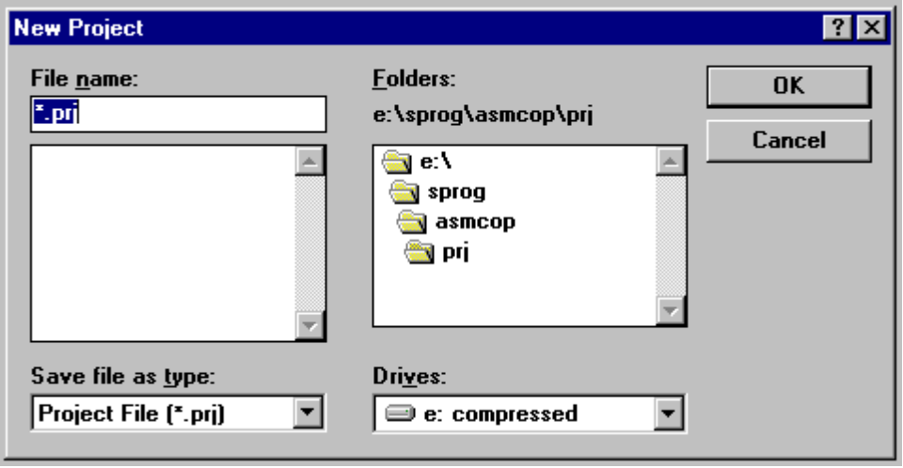
The New Project dialog box

Give the new project a name in the File name: field and select where the project file should be located.
Note! The name of the final .HEX and/or .COF file will be the same as that of the
project! For example, if a project is called MY_PROJ.PRJ the final .HEX and/or .COF file will be called MY_PROJ.HEX or MY_PROJ.COF.

When done, press the OK button. The following dialog box automatically appears:

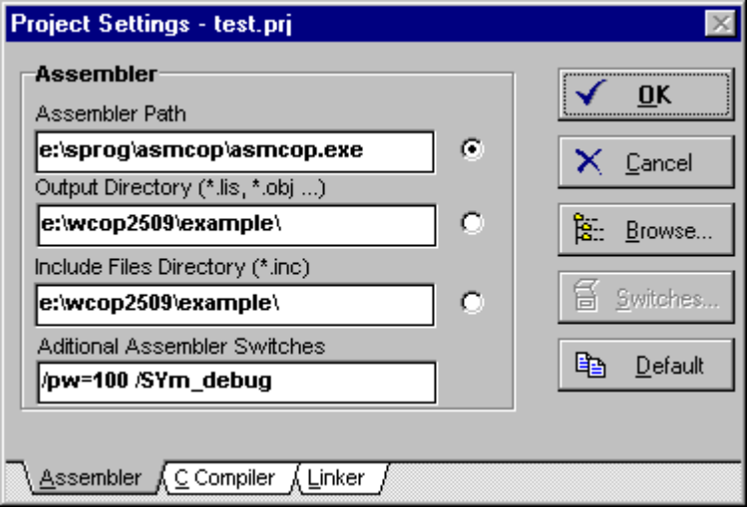
Copy compiler and linker settings from the general WCOP8 environment
The Project Settings dialog box

This dialog box is almost similar to the general WCOP8 IDE environment settings dialog box. For entering data in this dialog box please see Chapter 3.

If the Default button is pressed, the environment settings of compilers and linker are copied into the current project.

When finished, press the OK button and the following dialog box automatically appears:

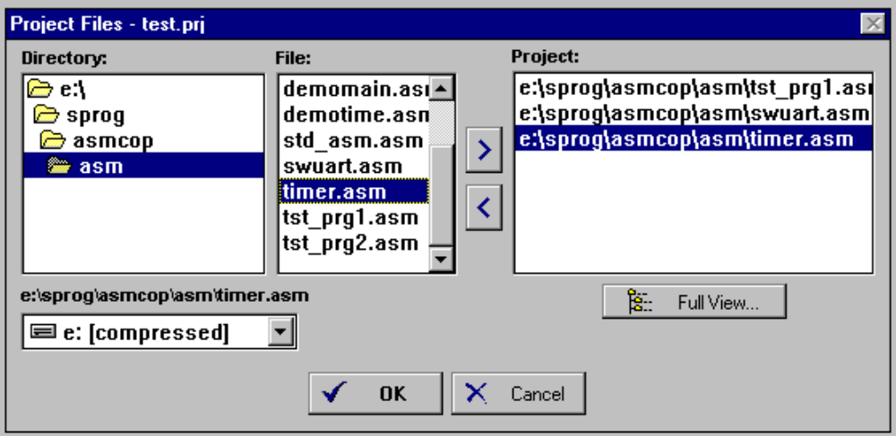
The Project Files dialog box

- Select a directory then 2) select a file and finally 3) select > to add the file or
< to remove a file
(or double click on the file)
Continue these 3 steps until all files supposed to be in your project have been selected. You can freely mix .ASM and .C files and files from different catalogs. If you later on want to change the files in your project this dialog box can be accessed by choosing Project Files in the Project menu or by pressing the Project Files button on the speedbar. When done press the OK button. Now your project file (*.PRJ) is saved on the selected drive and can be accessed with Open Project in the File menu or via the Open Project button on the speedbar.

When the OK button is pressed, the WCOP8 IDE prompts if the new project should be opened right away or not.

Working with a Project

When a project is opened, the WCOP8 IDE automatically loads the specific project settings of the compilers and linker, shows the name and the path of the project on the status line and finally opens (and iconizes) all .ASM and .C files in the project.

When a project is closed, the WCOP8 IDE automatically unloads the project settings and closes all the project files.

Note! A file opened as part of a project cannot be closed using the normal Close File command. The only way to close a project file is by closing the complete project!

Activated on files in the project, compile and link commands will use the project settings and the link and build commands are extended to work on all files in the project.

Pressing the Link button will perform a complete link of all files in the project. If an object file is older than its corresponding source file the WCOP8 IDE prompts for a recompilation of that specific file.

Pressing the Build button will perform a complete compilation and linking of all files in the project. Please note that linking is only performed if compilation executes without errors.
BUILD (ie compile and link) all files in project


COMPILE file in active window
LINK all files in project

Meaning of the same Compile, Link and Build buttons
on the speedbar when used on project files

When compiling/linking is invoked on project files, the WCOP8 IDE action report window will confirm that it is now using the project settings of the compiler/linker.

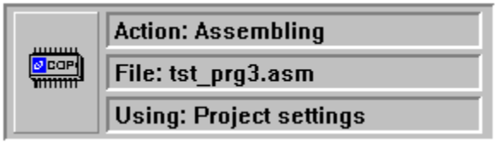

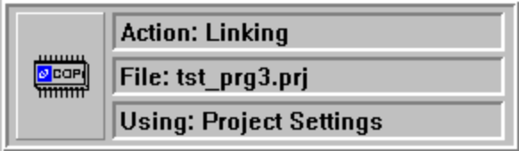

First assembling (or compilation for C files) is performed on each file in
the project and then linking is performed on the project

If a file which is not part of the current project is opened, the WCOP8 IDE will use the environment settings on this file for compilation and linking.

Tip! After installation of the WCOP8 IDE, one ready-to-use sample project is installed to help the user. Physically it is located in a subdirectory to the main WCOP8 IDE directory called ../EXAMPLE/. To access the sample project, press the Open Project button, browse to the example directory and select the project called TEST.PRJ

Full View

The Full View option of the Project Files dialog box gives a graphical view of the active project.

Press this button to get a graphical overview of the current project
The Project Files dialog box

When the Full View button is activated the following dialog box appears:

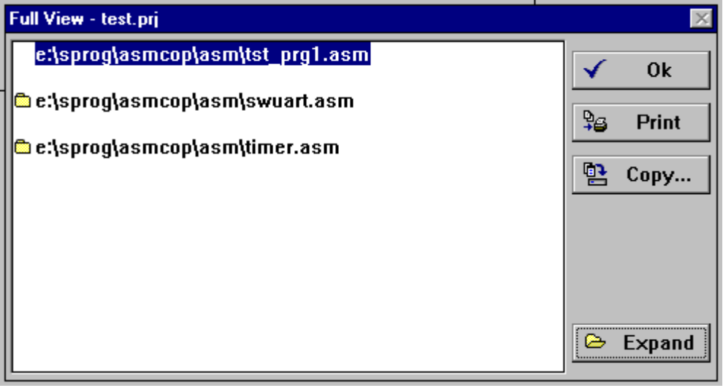
The small folder indicates that WCOP8 has detected an .INCLD statement in this file. To see the names of the files included double click on the line or press the Expand button
Copy all source, include and project files to a destination drive of the user’s choice
Printout of ‘Full View’ on the printer
Full View of the project TEST.PRJ
- collapsed mode

If there is a small folder beside the file name this file contains one or more include statements. The files included can be seen by clicking on the Expand button or by double clicking on the line with the small folder:

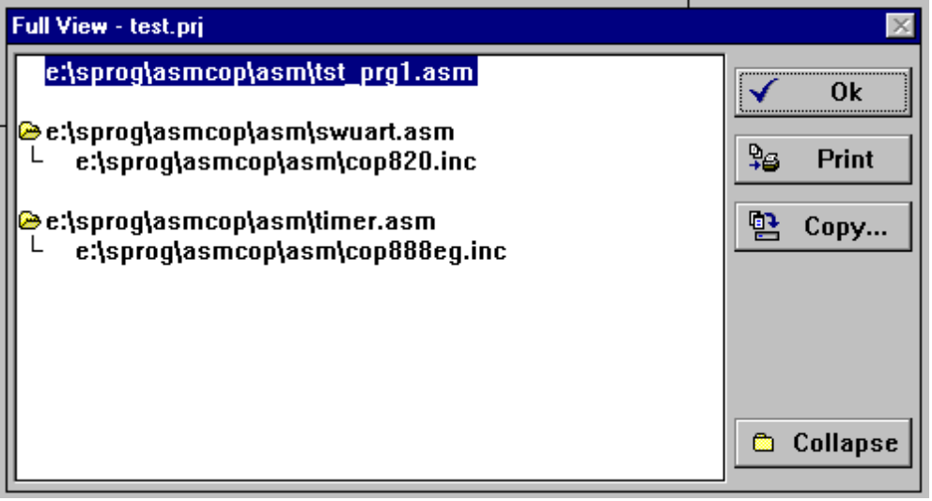
Full View of the project TEST.PRJ - expanded mode

The overview can be collapsed again by pressing the Collapse button.

If the Print button is pressed the WCOP8 IDE will generate a printout of this graphical overview of the project.

If the Copy button is pressed, the WCOP8 IDE will copy:

- all files in the project
- all include files used by files in the project
- the project file (.PRJ)

to a destination drive of the user’s choice.

