7. Using the WCOP8 IDE Configuration program

The installation of user applications and user templates is done by using the WCOP8 IDE configuration program which is supplied with the WCOP8 IDE. The WCOP8 IDE configuration program is installed separately and is invoked by double-clicking on the WCOP8 IDE configuration icon.

IDE Settings

After invoking the Setup program the following dialog box appears:

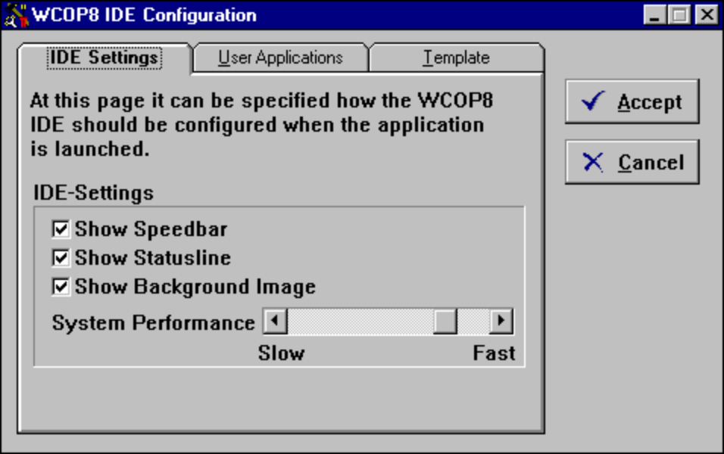
System performance of a 486DX4-120 Mhz PC with a harddisk of medium speed
The WCOP8 IDE Configuration program

In the ‘IDE Settings’ sheet of the WCOP8 IDE configuration menu the speedbar, status line and background image in the IDE can be turned on and off. The default values are on.

With the System Performance bar the relation between hardware/software performance can be fine tuned. Some notebooks and ‘old’ harddisks has a long access time for file read/write and this combined with fast CPU’s can cause problems with the handling of MS-DOS applications as the National Semiconductor Assembler.

The value shown on the System Performance bar is the result of a system performance check which is performed at the first launch of the WCOP8 IDE after installation.

By pulling the System Performance bar back and forth between Slow and Fast the open/close time for file access is changed.
Tip! If problems occurs after assembling/compiling with error messages like:
Error: No Compiler Result?
then change the value of the System Performance bar toward Slow.
If new hardware is acquired (CPU/motherboard/harddisk etc.) then change the value of the System Performance bar towards Fast.

User Applications

If the ‘User Application’ sheet of the WCOP8 IDE configuration menu is pressed, the following menu appears:

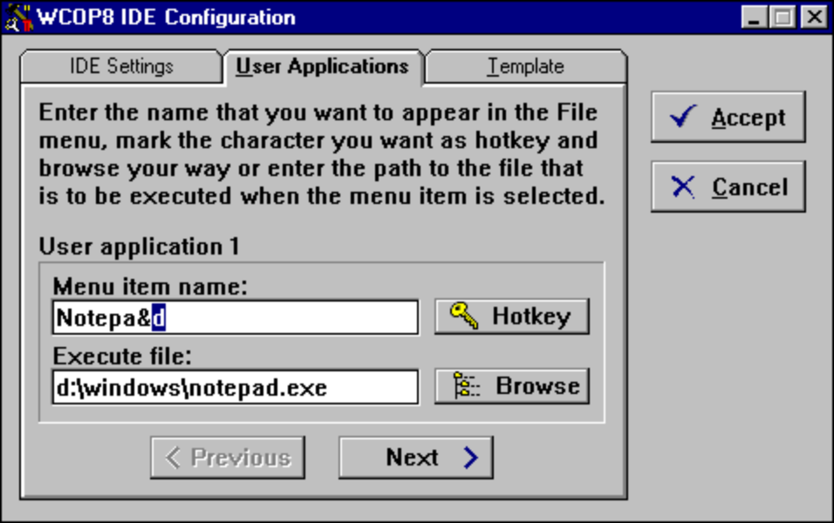
User Applications setup

In the user applications setup up to 9 different external applications can be assigned to the File menu of the WCOP8 IDE. The setup of user applications is done as follows:

- In the Menu Item Name field enter the name that should appear in the File menu
- Mark the letter that is supposed to be the keyboard shortcut
- Press the Hotkey button, and a shortcut marker sign (&) will be inserted in front of the keyboard shortcut letter
- In the Execute File field enter the name and path of (or browse to) the application which is to be launched
- If more applications are to be assigned to the File menu of the WCOP8 IDE then press the Next > button. The < Previous and Next > buttons are used to browse through all the applications installed

Templates

If the ‘Template’ sheet of the WCOP8 IDE configuration menu is pressed, the following menu appears:

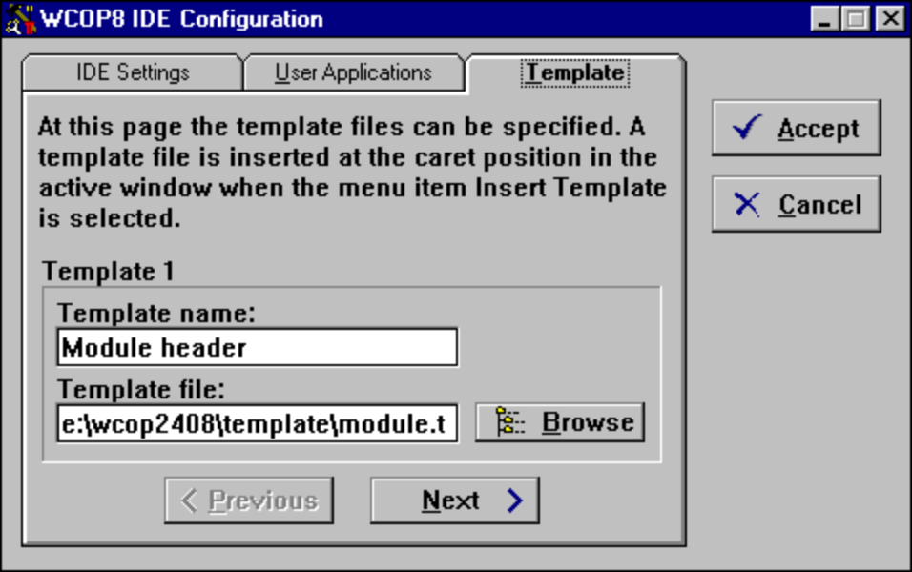
Template setup

In the user template setup up to 9 different templates can be assigned a template library which is accessible from the File menu of the WCOP8 IDE. The setup of a user template is done as follows:

- In the Template name field enter the name which should appear in the template library
- In the Template file field enter the name and path (or browse to) of the template file that contains the desired text
- If more templates are to be assigned to the template library press the Next > button. The < Previous and Next > buttons are used to browse through all the templates installed

To update the WCOP8 program with the modifications, press the Accept button or press the Cancel button to cancel.

