8. Important Notes

When running the WCOP8 IDE program please bare in mind that this software is shareware and not a x thousand dollar program - this of course gives restrictions in functionality and response time.

Due to limitations of MS-DOS command lines, the current compiler technique is to generate DOS command files (@COMMAND.CMD option in ASMCOP) and invoke the compiler with this option. Therefore, this revision is limited to compilers which can accept this format!

When using the WCOP8 IDE with the current Bytecraft C compiler please note that under certain conditions this compiler locks up in the DOS box and the WCOP8 IDE looses contact to it. This is not an error in the WCOP8 IDE since the same will be true if the compiler was invocked manually from a DOS box. If a lock up occours and errors like ‘no compiler result’ is generated do the following:
Windows 95: Exit WCOP8 IDE and answer yes to force the DOS window to close.
Win3.x: Exit and relaunch Windows.
After that, double check the C source code (maybe an invalid C compiler #pragma is used) and also check the system performance settings in the WCOP8 IDE configuration program. Try to set the system performance setting to a lower value. Relaunch the WCOP8 IDE and try again. If a problem persists then send us an email with a detailed description of the behavior.

Since the current Bytecraft C compiler and National Semiconductor ASMCOP are not (yet?) compatible, the feature of mixing .C and .ASM files is rather irrelevant even though the program will be able to support so. Therefore we have built in a blocking mechanism that excludes this mixing feature until a new version of the C compiler is released.

Updates from latest revision:
Read the WHATSNEW.TXT file in the WCOP8 IDE directory!

November 3, 1996

Morten R. Kjaer Henning Kaas
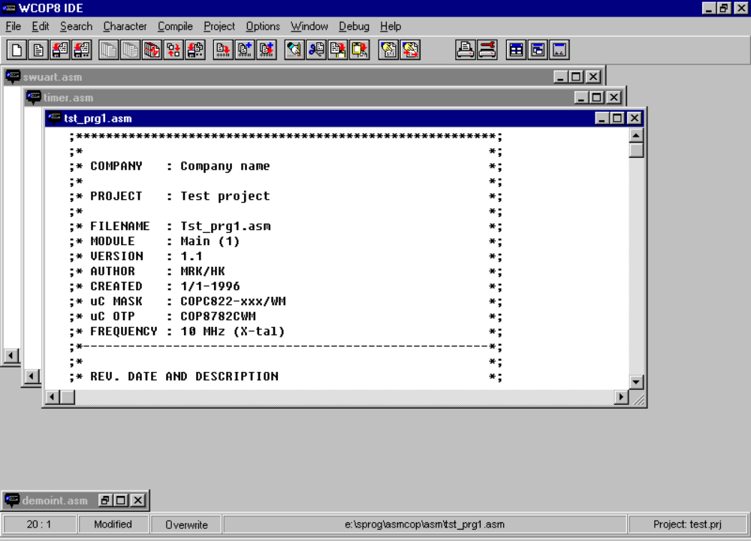

The WCOP8 IDE program in action!

