**Yanfei: Lawful Love:**



# **Profile**

Yanfei (Chinese for: “Smoky Scarlet”) is a young woman from Liyue and is the daughter of a human mother and adeptus father, which makes her a half-adeptus by blood. She was born during peaceful times and so she didn’t sign any contract with Rex Lapis, despite her father being a strong supporter of the God of Contracts. Instead she happily lives life at her own pace, which is as Liyue’s best known legal adviser, a job she’s very passionate about. Aside from that, Yanfei also likes reading books and appraising objects, and has remarkable knowledge on a plethora of subjects, not just the law. Her interests are backed up by a very big personality. Yanfei is usually very energetic, playful and as mentioned before, passionate. She’s very open towards new people and likes talking to others, especially if it’s about her interests, and if she can help someone she’ll always gladly take the opportunity. Despite being so playful she still takes her profession in the law very seriously, and she’ll take on a more fierce and serious attitude if someone dares to break any rules, to truly indicate the importance of laws. Her extreme passion is likely the reason why she ended up getting her pyro vision.

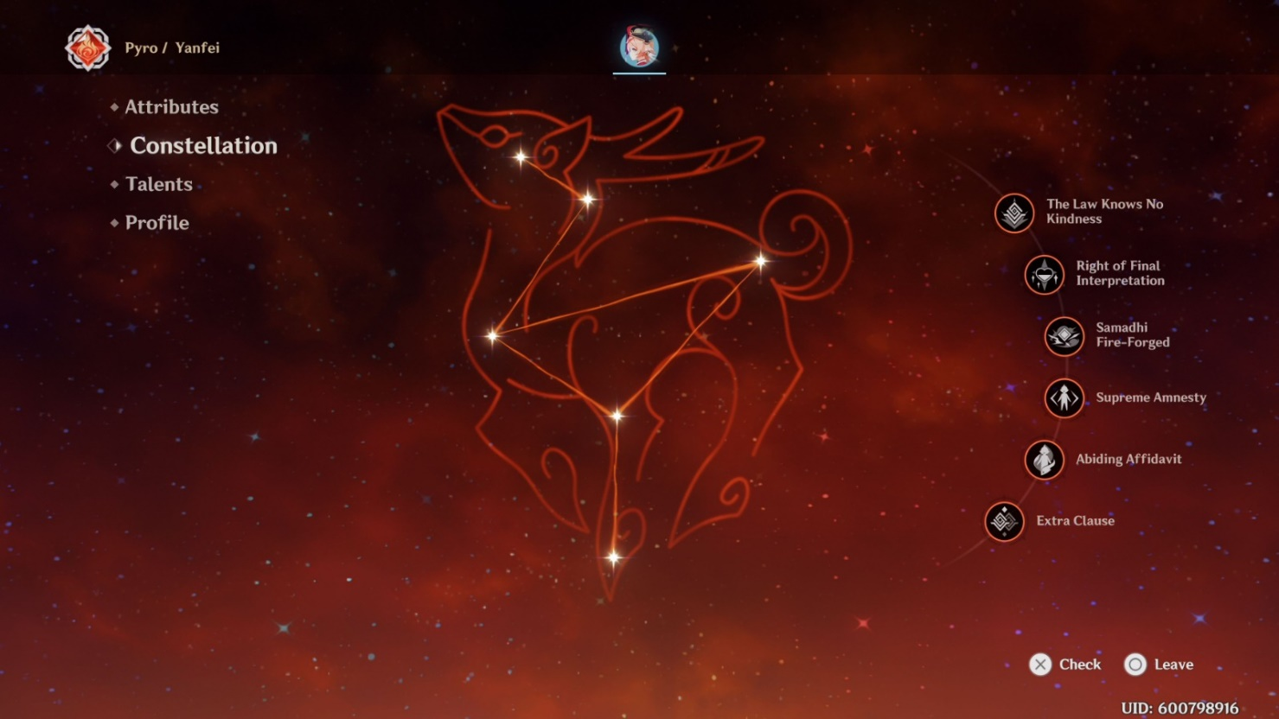

Her constellation is named “Bestia Iustitia”, which means “Beast of Justice” in Latin. Knowing this, she’s likely based off of the xiezhi, a Chinese mythical ancient creature that is known as a symbol for justice. On the battlefield she wields a catalyst, using attacks involving laws and codices like her charged attack: a stamp that drops down on enemies and leaves a mark. She even has her own self-defence measure called “Wrath of the Flame”, inspired by Rex Lapis’ “Wrath of the Rock”.

**In Game**

Yanfei is introduced in the quest where the player obtains the Sereniteapot, an item that allows them to create their own realms. During the quest, Yanfei tries to discover whether or not the Snezhnayan salesman Krosl is selling real Smaragdus Jadeite. She finds out that he does not and then she shows her aforementioned fiercer side. Yanfei also made notable appearances in the Liyue festivals such as Moonchase and Lantern Rite. Most recently she also played a role in the “Perilous Trail” event, where she and other characters fall into the Chasm’s depths, into the Chasmic Maze. The group eventually manages to escape, with Yanfei’s efforts being extremely helpful and indispensable.



-Yanfei’s “Stamp” charged attack

-Yanfei currently has 2 scarlet seals



-Art of the “Perilous Trail” event.

In battle, Yanfei is usually played as a charged attack oriented main DPS. She’s capable of quickly dishing out a lot of damage, mostly with her normal/charged attacks. Pyro remains amazing offensively and with Yanfei it’s no different. She also has a unique mechanic. Whenever she hits opponents with a normal attack, she will gain a scarlet seal, and this way she can get up to 3 of them (or 4 if you have her sixth constellation). The seals get consumed when using a charged attack, with each seal slightly increasing the attack’s power and lowering its stamina cost. Her elemental skill and burst immediately grant her the maximum amount of seals, in addition, her burst brings her in a state that increases her charged attack damage even more, and she automatically gets more scarlet seals over time even if she didn’t use any normal attacks. Another less popular build is “Tankfei”, taking advantage of her fourth constellation that gives Yanfei a shield based off of 45% of her maximum hit points after she has used her elemental burst.

**Axel’s Judgement**

Phew, finally freed from only being allowed to talk objectively about her, bias mode, activate! I guess I’ll tell my story again. Initially I didn’t expect to start liking Yanfei so much, but she was a 4* character so I was going to get her regardless. But then I played the first quest that introduced her and I was sold, she left an exceptionally big impression on me. Witnessing her work mode for the first time was an amazing experience and I also enjoyed my first battle experiences with her, enough for me to want to level her. And so I did just that, she quickly reached level 90, friendship level 10, got a decent build and I even triple crowned her eventually! I still main her to this day and I use her in Spiral Abyss. Is she the best DPS? Probably not but I fail to care, she’s strong enough for Spiral Abyss definitely, and is worth more attention than she’s currently getting, although in my personal case it’s debatable whether her smaller popularity is a bad thing or a very good thing.

-Her namecard



-Love this expression!!

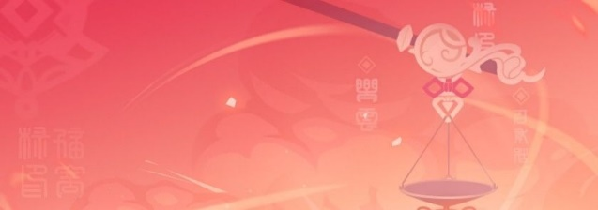 -Look at that smile

One more important thing I only really took into account way later is that I really like how energetic she is. This sounds weird coming from someone quiet and reserved like myself, but hear me out. Many people think that extremely energetic people and the opposite quiet and reserved types never combine well. Wrong! Sometimes the energetic person can spark up the energy and sociability inside of the reserved person. And this is something I could see Yanfei being able to do towards me. Of course I’ll also admit that I find her beautiful, especially because of the hair. She definitely isn’t my biggest kin of the entire cast, Raiden still takes the cake on that one, but if I could marry one of the characters, it’d definitely be Yanfei, or as I call her, ‘Fei.