11.1

a)-c)

This is for gamma=0.01

d)

gamma=0.015

Gamma=0.02:

Gamma=0.03

11.2

a)-b)

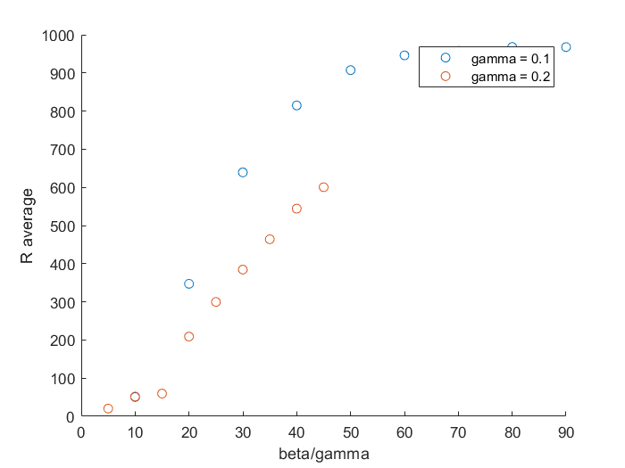

c)

11.3)

Gamma=0.01 for all

Mu=0.02

Mu=0.03

Mu=0.005

b)

11.4

a)-b)

