 +-

Play

00:00

00:00

Mute

Settings



**Assignment 2**

In this module, you learned about relational model constraints. Now let us try and apply the concepts we have learned in this module to a real world example of a database. We will be working on a relational database schema called Car dealership.The diagram below show the schema diagram for the Car Dealership relational database schema.

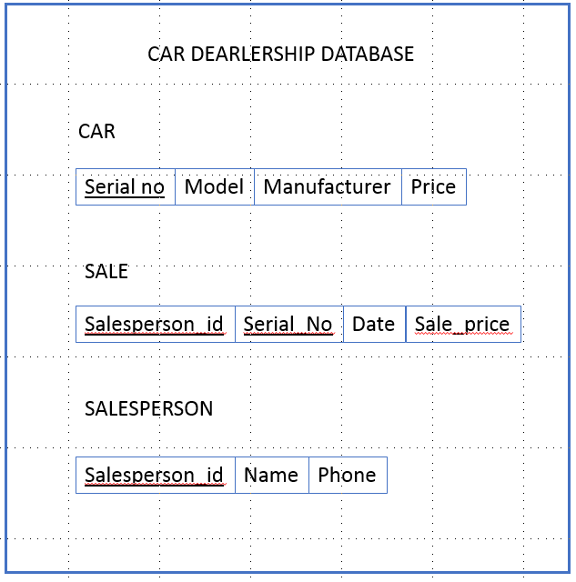

A database has to be designed to keep track of automobile sales in a car dealership.Please answer the following questions based on the above schema.

Question 1: Identify the primary key of the relation Car.

Question 2: Identify the foreign key of the relation Sale.

Question 3: How many constraint types are there in relation Sale?

Respuestas:

The solutions to the Assignment 2 are given below:

Question 1: Identify the primary key of the relation Car.

Answer: Serial no

Question 2: Identify the foreign key of the relation Sale.

Answer: Serial no

Question 3: How many constraint types are there in relation Sale?

Answer: 2 constraints : Primary Key and Foreign Key