OpenID Connect authentication
使用Java 及 Nimbus OAuth 2.0 SDK with OpenID Connect extensions
demoApp是一家前景看好,未來可能擁有數十萬客戶的網頁應用程式公司
https://coding.teliclab.info/demoApp/
本文件旨在協助建立demoApp 透過OIDC 與教育部帳號服務介接
採用模式如下:

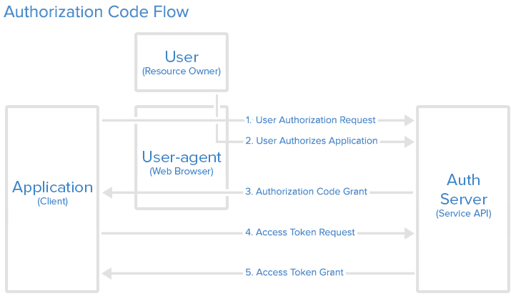
參考: http://openid.net/specs/openid-connect-core-1_0.html#CodeFlowSteps

PREPARE:
向Auth Server 申請Client ID, 並且填寫redicrect URI,
例如: demoApp 的首頁在https://coding.teliclab.info/demoApp/
而我向Auth Server 註冊的redirect URI 為
https://coding.teliclab.info/demoApp/callback
註冊申請後, 會得到Client ID及Client Secret, 依以下說明 http://n.sfs.tw/content/index/11209 為簡化日後管理及增加彈性, 建議使用Discovery Document 來取得authorization, token, userinfo 各Endpoint
但本文件為了簡化程式碼及方便說明, 各endpoint採靜態值設定

本專案使用maven 管理及需要的repository
pom.xml
<dependencies>
<dependency>
<groupId>com.nimbusds</groupId>
<artifactId>oauth2-oidc-sdk</artifactId>
<version>5.27</version>
<type>jar</type>
</dependency>

<dependency>
<groupId>ch.qos.logback</groupId>
<artifactId>logback-classic</artifactId>
<version>1.2.3</version>
</dependency>
<dependency>
<groupId>ch.qos.logback</groupId>
<artifactId>logback-core</artifactId>
<version>1.2.3</version>
</dependency>

<dependency>
<groupId>javax</groupId>
<artifactId>javaee-web-api</artifactId>
<version>7.0</version>
<scope>provided</scope>
</dependency>
<dependency>
<groupId>org.slf4j</groupId>
<artifactId>slf4j-api</artifactId>
<version>1.7.25</version>
</dependency>
</dependencies>

dempApp的首頁,畫面如下
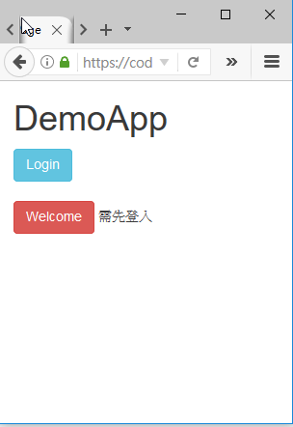

Welcome按鈕連結的網頁帶有個人重要資訊屬不公開資訊, 因此必須先透過登入程序（即本文所做的OIDC介接）,才能看到網頁內容
1. User authorization request
點擊login按鈕將頁面導向https://coding.teliclab.info/demoApp/login
此頁面的主要工作是為了在user-agent 送出以下字串, 注意 參數值必須是url encoding, 以GET Request 向Authorization Endpoint 傳送, 底下為一sample url
https://oidc.tanet.edu.tw/oidc/v1/azp?response_type=code&client_id=CLIENTID&redirect_uri=https%3A%2F%2Fcoding.teliclab.info%2FdemoApp%2Fcallback&scope=openid+profile&state=STATE&nonce=NONCE

Authorization Endpoint 為 https://oidc.tanet.edu.tw/oidc/v1/azp
參數詳見http://n.sfs.tw/content/index/11204
clientid 由op提供
scope 定義 access token可以存取的權限 openid(必要), email(選項), profile(選項)
response_type code
redirect_uri 需申請時設定
state 必要，RP需由帶回來的值驗證SESSION連續狀態
nonce 必要 ，包含在要求中的值 (由應用程式所產生)，將會包含在所得的 id_token 中來做為宣告。 應用程式接著便可確認此值，以減少權杖重新執行攻擊。
Login.java
@WebServlet(name = "Login", urlPatterns = {"/login"})
public class Login extends HttpServlet {
private final Logger logger = LoggerFactory.getLogger(Login.class);

protected void processRequest(HttpServletRequest request, HttpServletResponse response)
throws ServletException, IOException, SerializeException {
HttpSession session = request.getSession();

//The client identifier provisioned by the server
ClientID clientID = new ClientID("CLIENID");

// The client callback URI, pre-registered with the server
URI callback = new URI("https://coding.teliclab.info/demoApp/callback");

// Generate random state string for pairing the response to the request 產生state值並存入session,與回應回傳的值做比對是否一致
State state = new State();
session.setAttribute("state", state.toString());

// Generate nonce
Nonce nonce = new Nonce();
// Compose the request (in code flow) 如前面所提,組合字串並以GET request

AuthenticationRequest authzReq = new AuthenticationRequest(
new URI("https://oidc.tanet.edu.tw/oidc/v1/azp"),
new ResponseType("code"),
Scope.parse("openid profile"),
clientID,
callback,
state,
nonce);

//此為 Authrozation Code flow 的第一步
logger.info("1.User authorization request");
//觀察送出的字串
logger.info(authzReq.getEndpointURI().toString() + "?" + authzReq.toQueryString());
//送出並導向
response.sendRedirect(authzReq.getEndpointURI().toString() + "?" + authzReq.toQueryString());

}
}

2.User authorize application
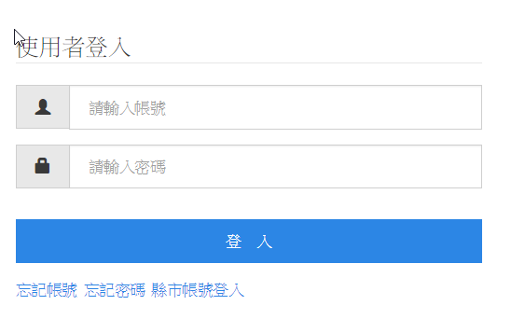

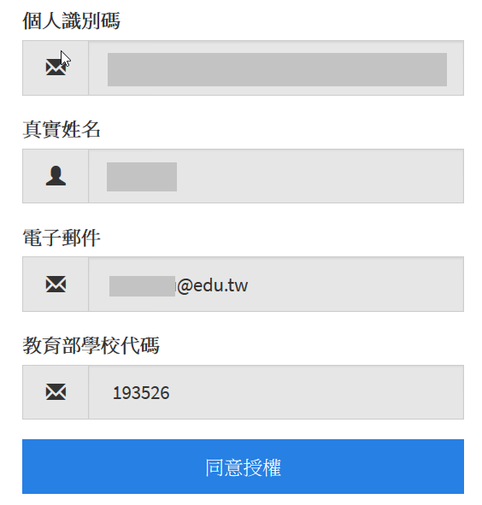

3. Authorization Code Grant
前一個步驟使用者授權並且成功驗証後, Auth Server會回傳一串參數值到我們所設定的rediect URI, 所以這裡要取出Authorization code 並且比對state值是否一致
Callback.java
String queryString = request.getQueryString();
String responseURL = "https:///path/?" + queryString;
//觀察回傳的值
logger.info(responseURL);

//取出先前建立的state 值, 稍後比對
HttpSession session = request.getSession();
String state = session.getAttribute("state").toString();

AuthenticationResponse authResponse =
AuthenticationResponseParser.parse(new URI(responseURL));
AuthenticationSuccessResponse successResponse =
(AuthenticationSuccessResponse) authResponse;

// 成功取得authorization code
AuthorizationCode code = successResponse.getAuthorizationCode();
logger.info("3. authz code grant.");
logger.info("code:" + code.toString());

logger.info("return state:" + successResponse.getState().toString());

//比對state 的值是否一致
assert successResponse.getState().toString().equals(state);

4. Access Token Request
取到Authorization Code 後, 利用此code 跟auth server 要access token,規範如下
1. POST 方式傳送
2.參數值必須以application/x-www-form-urlencoded格式
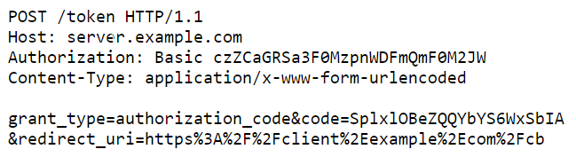

在開發階段, 為了方便除錯, 可利用curl指令觀察取得access token的結果
curl -d "client_id=CLIENTID&client_secret=CLIENTSECRET&redirect_uri=https://coding.teliclab.info/demoApp/callback&grant_type=authorization_code&code=AUTHZCODE" https://oidc.tanet.edu.tw/oidc/v1/token

-d的參數代表以POST的方式傳送
上列整令為完整一行, 因版面關係產生斷行,參數部份以" " 雙引號包圍
實際操作圖例
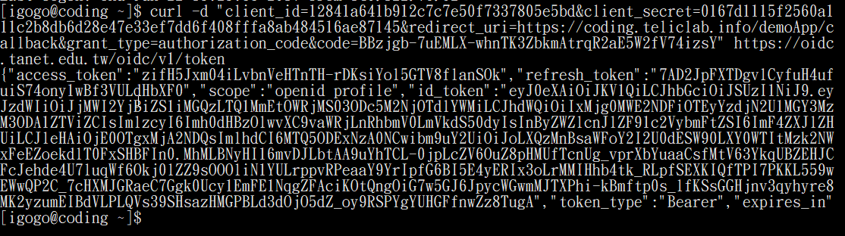

Callback.java
//此處的code是接續前面自Authz endpoint 回應的值
AuthorizationCode code = ….
URI callback = new URI("https://coding.teliclab.info/demoApp/callback");
AuthorizationGrant codeGrant = new AuthorizationCodeGrant(code, callback);

//provisioned by the server
ClientID clientID = new ClientID("CLIENTID");
Secret clientSecret = new Secret("SECRET");
ClientAuthentication clientAuth = new ClientSecretPost(clientID, clientSecret);

// The token endpoint
URI tokenEndpoint = new URI("https://oidc.tanet.edu.tw/oidc/v1/token");

// Make the token request
TokenRequest tokenRequest= new TokenRequest(tokenEndpoint, clientAuth, codeGrant);

logger.info("4. Access Token Request");
TokenResponse tokenResponse = OIDCTokenResponseParser.parse(tokenRequest.toHTTPRequest().send());

//錯誤處理
if (tokenResponse instanceof TokenErrorResponse) {
Correspondent errorResponse = (Correspondent) tokenResponse;
logger.info(errorResponse.getErrorObject().getCode());
}

//使用OIDCTokenResponse 才能取得IDToken
//如果使用AccesstokenResponse只能取得Access Token
OIDCTokenResponse accessTokenResponse = (OIDCTokenResponse) tokenResponse;
BearerAccessToken accessToken
= accessTokenResponse.getOIDCTokens().getBearerAccessToken();

SignedJWT idToken =
(SignedJWT) accessTokenResponse.getOIDCTokens().getIDToken();

RefreshToken refreshToken = (RefreshToken) accessTokenResponse.getOIDCTokens().getRefreshToken();

logger.info("5 Access Token Grant.");
logger.info("access token value:" + accessToken.getValue());
session.setAttribute("accessToken", accessToken.getValue());

//至此成功取得access token, Authorization Code flow流程跑完,將access token 存入session,網頁導向welcome
response.sendRedirect("welcome");

使用Access Token
取得合法的access token後, 我們可以利用此合法access token進行API call, 例如
取得userinfo的資訊 , 這裡我們透過三种方法中最安全也最推薦的HTTP authorization header 傳送
根據定義,詳見https://tools.ietf.org/html/rfc6750 2.1
傳送access token,我們還必須增加Authorization header 到GET request, 類似像這樣
GET /resource HTTP/1.1
Host: server.example.com
Authorization: Bearer mF_9.B5f-4.1JqM
利用curl 指令可以更改request headers 作為模擬請求
curl -H "Authorization:Bearer ACCESS TOKEN VALUE" https://oidc.tanet.edu.tw/oidc/v1/userinfo

底下程式片段並不屬於demoApp的部份, 此段旨在說明如何增加Authorization Header, 我們可使用Apache HTTP Client library,請注意如果使用nimbus library,則直接以BearerAccessToken 對API 進行request即可
package app.demo.useaccesstoken;
import java.io.BufferedReader;
import java.io.IOException;
import java.io.InputStreamReader;
import java.io.UnsupportedEncodingException;
import java.net.URI;
import java.net.URISyntaxException;
import java.util.ArrayList;
import java.util.List;
import org.apache.http.HttpResponse;
import org.apache.http.NameValuePair;
import org.apache.http.client.entity.UrlEncodedFormEntity;
import org.apache.http.client.methods.HttpPost;
import org.apache.http.impl.client.CloseableHttpClient;
import org.apache.http.impl.client.HttpClients;
import org.apache.http.message.BasicNameValuePair;

public class Main {
public static void main(String[] args) throws URISyntaxException, UnsupportedEncodingException, IOException {

if (args.length > 0) {
//取得access token後 以參數帶入的方式執行本程式
String accessToken = args[0];
URI userinfoEndpointURL = new URI("https://oidc.tanet.edu.tw/oidc/v1/userinfo");
CloseableHttpClient httpClient = HttpClients.createDefault();
HttpPost httpPost = new HttpPost(userinfoEndpointURL);
httpPost.addHeader("Authorization", "Bearer "+ accessToken);
List<NameValuePair> urlParameters = new ArrayList<>();

urlParameters.add(new BasicNameValuePair("method","get"));
httpPost.setEntity(new UrlEncodedFormEntity(urlParameters));

HttpResponse httpResponse = httpClient.execute(httpPost);

//Extract data from response
BufferedReader bufferedReader = new BufferedReader(new InputStreamReader(httpResponse.getEntity().getContent()));
System.out.println(bufferedReader.readLine());
}

}

}

執行結果
demoApp 使用nimbus library請看Welcome.java的程式碼片段
Welcome.java
HttpSession session = request.getSession();
if (session.getAttribute("accessToken") == null) {
//not allowed to visit this page
}else{
//以Bearer AccessToken 對userinfo endpoint 進行request
BearerAccessToken accessToken = new BearerAccessToken((session.getAttribute("accessToken").toString()));

URI userinfoEndpointURL = new URI("https://oidc.tanet.edu.tw/oidc/v1/userinfo");
// Append the access token to form actual request
UserInfoRequest userInfoReq = new UserInfoRequest(userinfoEndpointURL, accessToken);

//觀察送出的header
logger.info("userinfo request header:"+ userInfoReq.toHTTPRequest().getHeaders().toString());

userInfoHTTPResponse = userInfoReq.toHTTPRequest().send();
userInfoResponse = UserInfoResponse.parse(userInfoHTTPResponse);
UserInfoSuccessResponse successUserInfoResponse = (UserInfoSuccessResponse) userInfoResponse;
String msg = successUserInfoResponse.getUserInfo().toJSONObject().toString();
//處理msg 輸出到網頁...

}

驗証ID TOKEN
詳見http://n.sfs.tw/content/index/11231
// Set up a JWT processor to parse the tokens and then check their signature
// and validity time window (bounded by the "iat", "nbf" and "exp" claims) ConfigurableJWTProcessor jwtProcessor = new DefaultJWTProcessor();

// The public RSA keys to validate the signatures will be sourced from the
// OAuth 2.0 server's JWK set, published at a well-known URL. The RemoteJWKSet
// object caches the retrieved keys to speed up subsequent look-ups and can
// also gracefully handle key-rollover

JWKSource keySource = new RemoteJWKSet(new URL("https://oidc.tanet.edu.tw/oidc/v1/jwksets"));
JWKSource keySource = new RemoteJWKSet(new URL(jwksURI));

// The expected JWS algorithm of the access tokens (agreed out-of-band)
JWSAlgorithm expectedJWSAlg = JWSAlgorithm.RS256;

// Configure the JWT processor with a key selector to feed matching public
// RSA keys sourced from the JWK set URL
JWSKeySelector keySelector = new JWSVerificationKeySelector(expectedJWSAlg, keySource);
jwtProcessor.setJWSKeySelector(keySelector);
// Process the token
SecurityContext ctx = null; // optional context parameter, not required here
JWTClaimsSet claimsSet = jwtProcessor.process(idToken, ctx);

String idTokenParsed = claimsSet.toString();

完整程式碼
Index.html
<!DOCTYPE html>
<html>
<head>
<title>Start Page</title>
<meta http-equiv="Content-Type" content="text/html; charset=UTF-8">
<link rel="stylesheet" href="https://maxcdn.bootstrapcdn.com/bootstrap/3.3.7/css/bootstrap.min.css">
<script src="https://ajax.googleapis.com/ajax/libs/jquery/3.2.1/jquery.min.js"></script>
<script src="https://maxcdn.bootstrapcdn.com/bootstrap/3.3.7/js/bootstrap.min.js"></script>
</head>
<body>
<div class="container">
<h1>DemoApp</h1>

<a href="login" class="btn btn-info" role="button">MOE Login </a>

<br/>
<br/>

<a href="welcome" class="btn btn-danger" role="button">Welcome</a> 需先登入
</div>
</body>
</html>

Login.java
package app.demo.demoapp;

import com.nimbusds.oauth2.sdk.ResponseType;
import com.nimbusds.oauth2.sdk.Scope;
import com.nimbusds.oauth2.sdk.SerializeException;
import com.nimbusds.oauth2.sdk.id.ClientID;
import com.nimbusds.oauth2.sdk.id.State;
import com.nimbusds.openid.connect.sdk.AuthenticationRequest;
import com.nimbusds.openid.connect.sdk.Nonce;
import java.io.IOException;
import java.net.URI;
import java.net.URISyntaxException;
import java.util.logging.Level;
import javax.servlet.ServletException;
import javax.servlet.annotation.WebServlet;
import javax.servlet.http.HttpServlet;
import javax.servlet.http.HttpServletRequest;
import javax.servlet.http.HttpServletResponse;
import javax.servlet.http.HttpSession;
import org.slf4j.Logger;
import org.slf4j.LoggerFactory;

@WebServlet(name = "Login", urlPatterns = {"/login"})
public class Login extends HttpServlet {

private final Logger logger = LoggerFactory.getLogger(Login.class);

/**
* Processes requests for both HTTP <code>GET</code> and <code>POST</code>
* methods.
*
* @param request servlet request
* @param response servlet response
* @throws ServletException if a servlet-specific error occurs
* @throws IOException if an I/O error occurs
*/
protected void processRequest(HttpServletRequest request, HttpServletResponse response)
throws ServletException, IOException, SerializeException {
HttpSession session = request.getSession();

try {

// The client identifier provisioned by the server
//MOE clientid
ClientID clientID = new ClientID("CLIENTID");

// The client callback URI, typically pre-registered with the server
URI callback = new URI("https://coding.teliclab.info/demoApp/callback");
// Generate random state string for pairing the response to the request
State state = new State();
session.setAttribute("state", state.toString());

// Generate nonce
Nonce nonce = new Nonce();

// Compose the request (in code flow)
AuthenticationRequest authzReq = new AuthenticationRequest(
new URI("https://oidc.tanet.edu.tw/oidc/v1/azp"),
new ResponseType("code"),
Scope.parse("openid profile"),
clientID,
callback,
state,
nonce);

logger.info("1.User authorization request");

logger.info(authzReq.getEndpointURI().toString() + "?" + authzReq.toQueryString());
response.sendRedirect(authzReq.getEndpointURI().toString() + "?" + authzReq.toQueryString());

} catch (URISyntaxException ex) {
logger.info(ex.getMessage());
}

}

// <editor-fold defaultstate="collapsed" desc="HttpServlet methods. Click on the + sign on the left to edit the code.">
/**
* Handles the HTTP <code>GET</code> method.
*
* @param request servlet request
* @param response servlet response
* @throws ServletException if a servlet-specific error occurs
* @throws IOException if an I/O error occurs
*/
@Override
protected void doGet(HttpServletRequest request, HttpServletResponse response)
throws ServletException, IOException {
try {
processRequest(request, response);
} catch (SerializeException ex) {
java.util.logging.Logger.getLogger(Login.class.getName()).log(Level.SEVERE, null, ex);
}
}

/**
* Handles the HTTP <code>POST</code> method.
*
* @param request servlet request
* @param response servlet response
* @throws ServletException if a servlet-specific error occurs
* @throws IOException if an I/O error occurs
*/
@Override
protected void doPost(HttpServletRequest request, HttpServletResponse response)
throws ServletException, IOException {
try {
processRequest(request, response);
} catch (SerializeException ex) {
java.util.logging.Logger.getLogger(Login.class.getName()).log(Level.SEVERE, null, ex);
}
}

}

Welcome.java
package app.demo.demoapp;

import com.nimbusds.oauth2.sdk.ErrorObject;
import com.nimbusds.oauth2.sdk.ParseException;
import com.nimbusds.oauth2.sdk.SerializeException;
import com.nimbusds.oauth2.sdk.http.HTTPResponse;
import com.nimbusds.oauth2.sdk.token.BearerAccessToken;
import com.nimbusds.openid.connect.sdk.UserInfoErrorResponse;
import com.nimbusds.openid.connect.sdk.UserInfoRequest;
import com.nimbusds.openid.connect.sdk.UserInfoResponse;
import com.nimbusds.openid.connect.sdk.UserInfoSuccessResponse;
import java.io.IOException;
import java.net.URI;
import java.net.URISyntaxException;
import java.util.logging.Level;
import javax.servlet.RequestDispatcher;
import javax.servlet.ServletException;
import javax.servlet.annotation.WebServlet;
import javax.servlet.http.HttpServlet;
import javax.servlet.http.HttpServletRequest;
import javax.servlet.http.HttpServletResponse;
import javax.servlet.http.HttpSession;
import org.slf4j.Logger;
import org.slf4j.LoggerFactory;

@WebServlet(name = "Welcome", urlPatterns = {"/welcome"})
public class Welcome extends HttpServlet {

private final Logger logger = LoggerFactory.getLogger(Callback.class);
URI userinfoEndpointURL;

/**
* Processes requests for both HTTP <code>GET</code> and <code>POST</code>
* methods.
*
* @param request servlet request
* @param response servlet response
* @throws ServletException if a servlet-specific error occurs
* @throws IOException if an I/O error occurs
* @throws java.net.URISyntaxException
*/
protected void processRequest(HttpServletRequest request, HttpServletResponse response)
throws ServletException, IOException, URISyntaxException {
HttpSession session = request.getSession();

if (session.getAttribute("accessToken") == null) {

request.setAttribute("msg", "Not Allowed");

RequestDispatcher dispatcher = request
.getRequestDispatcher("forbidden.jsp");
dispatcher.forward(request, response);

} else {
BearerAccessToken accessToken = new BearerAccessToken((session.getAttribute("accessToken").toString()));

//https://connect2id.com/products/nimbus-oauth-openid-connect-sdk/guides/java-cookbook-for-openid-connect-public-clients

userinfoEndpointURL = new URI("https://oidc.tanet.edu.tw/oidc/v1/userinfo");

// Append the access token to form actual request
UserInfoRequest userInfoReq = new UserInfoRequest(userinfoEndpointURL, accessToken);
HTTPResponse userInfoHTTPResp = null;
try {
userInfoHTTPResp = userInfoReq.toHTTPRequest().send();
} catch (SerializeException | IOException e) {
// TODO proper error handling
}

UserInfoResponse userInfoResponse = null;
try {
userInfoResponse = UserInfoResponse.parse(userInfoHTTPResp);
} catch (ParseException e) {
// TODO proper error handling
}

if (userInfoResponse instanceof UserInfoErrorResponse) {
ErrorObject error = ((UserInfoErrorResponse) userInfoResponse).getErrorObject();
// TODO error handling
}

UserInfoSuccessResponse successUserInfoResponse = (UserInfoSuccessResponse) userInfoResponse;
String msg = successUserInfoResponse.getUserInfo().toJSONObject().toString();
request.setAttribute("msg", msg);
RequestDispatcher dispatcher = request
.getRequestDispatcher("welcome.jsp");
dispatcher.forward(request, response);

}

}

// <editor-fold defaultstate="collapsed" desc="HttpServlet methods. Click on the + sign on the left to edit the code.">
/**
* Handles the HTTP <code>GET</code> method.
*
* @param request servlet request
* @param response servlet response
* @throws ServletException if a servlet-specific error occurs
* @throws IOException if an I/O error occurs
*/
@Override
protected void doGet(HttpServletRequest request, HttpServletResponse response)
throws ServletException, IOException {
try {
processRequest(request, response);
} catch (URISyntaxException ex) {
java.util.logging.Logger.getLogger(Welcome.class.getName()).log(Level.SEVERE, null, ex);
}
}

/**
* Handles the HTTP <code>POST</code> method.
*
* @param request servlet request
* @param response servlet response
* @throws ServletException if a servlet-specific error occurs
* @throws IOException if an I/O error occurs
*/
@Override
protected void doPost(HttpServletRequest request, HttpServletResponse response)
throws ServletException, IOException {
try {
processRequest(request, response);
} catch (URISyntaxException ex) {
java.util.logging.Logger.getLogger(Welcome.class.getName()).log(Level.SEVERE, null, ex);
}
}

}

Callback.java
/*
* To change this license header, choose License Headers in Project Properties.
* To change this template file, choose Tools | Templates
* and open the template in the editor.
*/
package app.demo.demoapp;

import com.nimbusds.jwt.SignedJWT;
import com.nimbusds.oauth2.sdk.AuthorizationCode;
import com.nimbusds.oauth2.sdk.AuthorizationCodeGrant;
import com.nimbusds.oauth2.sdk.AuthorizationGrant;
import com.nimbusds.oauth2.sdk.SerializeException;
import com.nimbusds.oauth2.sdk.TokenRequest;
import com.nimbusds.oauth2.sdk.TokenResponse;
import com.nimbusds.oauth2.sdk.TokenErrorResponse;
import com.nimbusds.oauth2.sdk.auth.ClientAuthentication;
import com.nimbusds.oauth2.sdk.auth.ClientSecretPost;
import com.nimbusds.oauth2.sdk.auth.Secret;
import com.nimbusds.oauth2.sdk.id.ClientID;
import com.nimbusds.oauth2.sdk.token.BearerAccessToken;
import com.nimbusds.oauth2.sdk.token.RefreshToken;
import com.nimbusds.openid.connect.sdk.AuthenticationResponse;
import com.nimbusds.openid.connect.sdk.AuthenticationResponseParser;
import com.nimbusds.openid.connect.sdk.AuthenticationSuccessResponse;
import com.nimbusds.openid.connect.sdk.OIDCTokenResponse;
import com.nimbusds.openid.connect.sdk.OIDCTokenResponseParser;
import java.io.IOException;
import java.net.URI;
import java.util.logging.Level;
import javax.servlet.ServletException;
import javax.servlet.annotation.WebServlet;
import javax.servlet.http.HttpServlet;
import javax.servlet.http.HttpServletRequest;
import javax.servlet.http.HttpServletResponse;
import javax.servlet.http.HttpSession;
import org.slf4j.Logger;
import org.slf4j.LoggerFactory;

/**
*
* @author igogo
*/
@WebServlet(name = "Callback", urlPatterns = {"/callback"})
public class Callback extends HttpServlet {

private final Logger logger = LoggerFactory.getLogger(Callback.class);

/**
* Processes requests for both HTTP <code>GET</code> and <code>POST</code>
* methods.
*
* @param request servlet request
* @param response servlet response
* @throws ServletException if a servlet-specific error occurs
* @throws IOException if an I/O error occurs
* @throws com.nimbusds.oauth2.sdk.SerializeException
*/
protected void processRequest(HttpServletRequest request, HttpServletResponse response)
throws ServletException, IOException, SerializeException {

try {

//logger.info(request.getQueryString());
String queryString = request.getQueryString();
String responseURL = "https:///path/?" + queryString;
logger.info(responseURL);
HttpSession session = request.getSession();
logger.info("session state:" + session.getAttribute("state"));
String state = session.getAttribute("state").toString();

AuthenticationResponse authResponse = AuthenticationResponseParser.parse(new URI(responseURL));
AuthenticationSuccessResponse successResponse = (AuthenticationSuccessResponse) authResponse;
// Retrieve the authorisation code
AuthorizationCode code = successResponse.getAuthorizationCode();
logger.info("3. authz code grant.");
logger.info("code:" + code.toString());

logger.info("return state:" + successResponse.getState().toString());
assert successResponse.getState().toString().equals(state);
logger.info("the same state");

URI callback = new URI("https://coding.teliclab.info/demoApp/callback");
AuthorizationGrant codeGrant = new AuthorizationCodeGrant(code, callback);

//provisioned by the server
ClientID clientID = new ClientID("CLIENTID");
Secret clientSecret = new Secret("SECRET");

ClientAuthentication clientAuth = new ClientSecretPost(clientID, clientSecret);

// The token endpoint
URI tokenEndpoint = new URI("https://oidc.tanet.edu.tw/oidc/v1/token");
// Make the token request
TokenRequest tokenRequest
= new TokenRequest(tokenEndpoint, clientAuth, codeGrant);

// logger.info("Token Authorization Header : " + httpRequest.getAuthorization());
logger.info("4. Access Token Request");
TokenResponse tokenResponse = OIDCTokenResponseParser.parse(tokenRequest.toHTTPRequest().send());
if (tokenResponse instanceof TokenErrorResponse) {

TokenErrorResponse errorResponse = (TokenErrorResponse) tokenResponse;
logger.info(errorResponse.getErrorObject().getCode());
} else {
OIDCTokenResponse accessTokenResponse = (OIDCTokenResponse) tokenResponse;
BearerAccessToken accessToken
= accessTokenResponse.getOIDCTokens().getBearerAccessToken();

SignedJWT idToken = (SignedJWT) accessTokenResponse.getOIDCTokens().getIDToken();
RefreshToken refreshToken = (RefreshToken) accessTokenResponse.getOIDCTokens().getRefreshToken();

logger.info("5 Access Token Grant.");
logger.info("access token value:" + accessToken.getValue());
session.setAttribute("accessToken", accessToken.getValue());
response.sendRedirect("welcome");
}
} catch (Exception ex) {
logger.info(ex.getMessage());
}

}

// <editor-fold defaultstate="collapsed" desc="HttpServlet methods. Click on the + sign on the left to edit the code.">
/**
* Handles the HTTP <code>GET</code> method.
*
* @param request servlet request
* @param response servlet response
* @throws ServletException if a servlet-specific error occurs
* @throws IOException if an I/O error occurs
*/
@Override
protected void doGet(HttpServletRequest request, HttpServletResponse response)
throws ServletException, IOException {
try {
processRequest(request, response);
} catch (SerializeException ex) {
java.util.logging.Logger.getLogger(Callback.class.getName()).log(Level.SEVERE, null, ex);
}
}

/**
* Handles the HTTP <code>POST</code> method.
*
* @param request servlet request
* @param response servlet response
* @throws ServletException if a servlet-specific error occurs
* @throws IOException if an I/O error occurs
*/
@Override
protected void doPost(HttpServletRequest request, HttpServletResponse response)
throws ServletException, IOException {
try {
processRequest(request, response);
} catch (SerializeException ex) {
logger.debug(ex.getMessage());
}
}

}

Welcome.java
package app.demo.demoapp;

import com.nimbusds.jose.JOSEException;
import com.nimbusds.jose.JWSAlgorithm;
import com.nimbusds.jose.jwk.source.JWKSource;
import com.nimbusds.jose.jwk.source.RemoteJWKSet;
import com.nimbusds.jose.proc.BadJOSEException;
import com.nimbusds.jose.proc.JWSKeySelector;
import com.nimbusds.jose.proc.JWSVerificationKeySelector;
import com.nimbusds.jose.proc.SecurityContext;
import com.nimbusds.jwt.JWTClaimsSet;
import com.nimbusds.jwt.proc.ConfigurableJWTProcessor;
import com.nimbusds.jwt.proc.DefaultJWTProcessor;
import com.nimbusds.oauth2.sdk.ErrorObject;
import com.nimbusds.oauth2.sdk.ParseException;
import com.nimbusds.oauth2.sdk.SerializeException;
import com.nimbusds.oauth2.sdk.http.HTTPResponse;
import com.nimbusds.oauth2.sdk.token.BearerAccessToken;
import com.nimbusds.openid.connect.sdk.UserInfoErrorResponse;
import com.nimbusds.openid.connect.sdk.UserInfoRequest;
import com.nimbusds.openid.connect.sdk.UserInfoResponse;
import com.nimbusds.openid.connect.sdk.UserInfoSuccessResponse;
import java.io.IOException;
import java.net.URI;
import java.net.URISyntaxException;
import java.net.URL;
import java.util.logging.Level;
import javax.servlet.RequestDispatcher;
import javax.servlet.ServletException;
import javax.servlet.annotation.WebServlet;
import javax.servlet.http.HttpServlet;
import javax.servlet.http.HttpServletRequest;
import javax.servlet.http.HttpServletResponse;
import javax.servlet.http.HttpSession;
import org.slf4j.Logger;
import org.slf4j.LoggerFactory;

@WebServlet(name = "Welcome", urlPatterns = {"/welcome"})
public class Welcome extends HttpServlet {

private final Logger logger = LoggerFactory.getLogger(Callback.class);

/**
* Processes requests for both HTTP <code>GET</code> and <code>POST</code>
* methods.
*
* @param request servlet request
* @param response servlet response
* @throws ServletException if a servlet-specific error occurs
* @throws IOException if an I/O error occurs
*/
protected void processRequest(HttpServletRequest request, HttpServletResponse response)
throws ServletException, IOException, URISyntaxException {
HttpSession session = request.getSession();
if (session.getAttribute("accessToken") == null) {

request.setAttribute("msg", "Not Allowed");

RequestDispatcher dispatcher = request
.getRequestDispatcher("forbidden.jsp");
dispatcher.forward(request, response);

} else {
BearerAccessToken accessToken = new BearerAccessToken((session.getAttribute("accessToken").toString()));

// https://connect2id.com/products/nimbus-oauth-openid-connect-sdk/guides/java-cookbook-for-openid-connect-public-clients
URI userinfoEndpointURL = new URI("https://oidc.tanet.edu.tw/oidc/v1/userinfo");
// Append the access token to form actual request
UserInfoRequest userInfoReq = new UserInfoRequest(userinfoEndpointURL, accessToken);
HTTPResponse userInfoHTTPResponse = null;
try {
userInfoHTTPResponse = userInfoReq.toHTTPRequest().send();
} catch (SerializeException | IOException e) {
// TODO proper error handling
}

UserInfoResponse userInfoResponse = null;
try {
userInfoResponse = UserInfoResponse.parse(userInfoHTTPResponse);
} catch (ParseException e) {
// TODO proper error handling
}

if (userInfoResponse instanceof UserInfoErrorResponse) {
ErrorObject error = ((UserInfoErrorResponse) userInfoResponse).getErrorObject();
// TODO error handling
}

UserInfoSuccessResponse successUserInfoResponse = (UserInfoSuccessResponse) userInfoResponse;
String msg = successUserInfoResponse.getUserInfo().toJSONObject().toString();
request.setAttribute("msg", msg);

// Set up a JWT processor to parse the tokens and then check their signature
// and validity time window (bounded by the "iat", "nbf" and "exp" claims)
ConfigurableJWTProcessor jwtProcessor = new DefaultJWTProcessor();

// The public RSA keys to validate the signatures will be sourced from the
// OAuth 2.0 server's JWK set, published at a well-known URL. The RemoteJWKSet
// object caches the retrieved keys to speed up subsequent look-ups and can
// also gracefully handle key-rollover

JWKSource keySource = new RemoteJWKSet(new URL("https://oidc.tanet.edu.tw/oidc/v1/jwksets"));

// The expected JWS algorithm of the access tokens (agreed out-of-band)
JWSAlgorithm expectedJWSAlg = JWSAlgorithm.RS256;

// Configure the JWT processor with a key selector to feed matching public
// RSA keys sourced from the JWK set URL
JWSKeySelector keySelector = new JWSVerificationKeySelector(expectedJWSAlg, keySource);
jwtProcessor.setJWSKeySelector(keySelector);

// Process the token
SecurityContext ctx = null; // optional context parameter, not required here
JWTClaimsSet claimsSet = jwtProcessor.process(idToken, ctx);

logger.info(claimsSet.toString());

RequestDispatcher dispatcher = request
.getRequestDispatcher("welcome.jsp");
dispatcher.forward(request, response);

}

}

// <editor-fold defaultstate="collapsed" desc="HttpServlet methods. Click on the + sign on the left to edit the code.">
/**
* Handles the HTTP <code>GET</code> method.
*
* @param request servlet request
* @param response servlet response
* @throws ServletException if a servlet-specific error occurs
* @throws IOException if an I/O error occurs
*/
@Override
protected void doGet(HttpServletRequest request, HttpServletResponse response)
throws ServletException, IOException {
try {
processRequest(request, response);
} catch (URISyntaxException ex) {
java.util.logging.Logger.getLogger(Welcome.class.getName()).log(Level.SEVERE, null, ex);
}
}

/**
* Handles the HTTP <code>POST</code> method.
*
* @param request servlet request
* @param response servlet response
* @throws ServletException if a servlet-specific error occurs
* @throws IOException if an I/O error occurs
*/
@Override
protected void doPost(HttpServletRequest request, HttpServletResponse response)
throws ServletException, IOException {
try {
processRequest(request, response);
} catch (URISyntaxException ex) {
java.util.logging.Logger.getLogger(Welcome.class.getName()).log(Level.SEVERE, null, ex);
}
}

}

