Customer Survival Analysis and Churn Prediction
A PROJECT REPORT

Submitted by
ASHISH KUMAR [RA2311003010905]
SAMEER YADAV [RA2311003010915]
ADITYA KUMAR SINGH [RA2311003010916]

Under the Guidance of

Himadri Nirjhar Mandal
(Assistant Professor, C Tech)

in partial fulfillment of the requirements for the degree of

BACHELOR OF TECHNOLOGY

in

COMPUTER SCIENCE AND ENGINEERING



DEPARTMENT OF COMPUTATIONAL INTELLIGENCE COLLEGE OF ENGINEERING AND TECHNOLOGY
SRM INSTITUTE OF SCIENCE AND TECHNOLOGY

KATTANKULATHUR- 603 203

OCTOBER 2025



SRM INSTITUTE OF SCIENCE AND TECHNOLOGY KATTANKULATHUR – 603 203

BONAFIDE CERTIFICATE

Certified that 21CSC305P - Project report titled “Customer Survival Analysis and Churn Prediction” is the bonafide work of “Ashish Kumar [RA2311003010905], Sameer Yadav [RA2311003010915], Aditya Kumar Singh [RA2311003010916]” who carried out the project work under my supervision. Certified further, that to the best of my knowledge the work reported herein does not form any other project report or dissertation on the basis of which a degree or award was conferred on an earlier occasion on this or any other candidate.

SIGNATURE SIGNATURE

Dr. Himadri Nirjhar Mandal Dr. G. Niranjana
FACULTY IN-CHARGE  ASSISTANT PROFESSOR  COMPUTING TECHNOLOGIES |  | PROFESSOR &HEAD  DEPARTMENT OF  COMPUTING TECHNOLOGIES

ACKNOWLEDGEMENTS

We express our humble gratitude to Dr. C. Muthamizhchelvan, Vice-Chancellor, SRM Institute of Science and Technology, for the facilities extended for the project work and his continued support.

We extend our sincere thanks to Dr. Leenus Jesu Martin M, Dean-CET, SRM Institute of Science and Technology, for his invaluable support.

We wish to thank Dr. Revathi Venkataraman, Professor and Chairperson, School of Computing, SRM Institute of Science and Technology, for her support throughout the project work.

We encompass our sincere thanks to, Dr. M. Pushpalatha, Professor and Associate Chairperson - CS, School of Computing and Dr. Lakshmi, Professor and Associate Chairperson -AI, School of Computing, SRM Institute of Science and Technology, for their invaluable support.

We are incredibly grateful to our Head of the Department, Dr. Niranjana G, Department of Computing Technologies, SRM Institute of Science and Technology, for her suggestions and encouragement at all the stages of the project work.

We want to convey our thanks to our Project Coordinators, Panel Head, and Panel Members Department of Computational Intelligence, SRM Institute of Science and Technology, for their inputs during the project reviews and support.

We register our immeasurable thanks to our Faculty Advisor, Dr. Gokulakrishnan D., Department of Computing Technologies, SRM Institute of Science and Technology, for leading and helping us to complete our course.

Our inexpressible respect and thanks to our guide, Mr. Himadri Nirjhar Mandal, Department of Computing Technologies, SRM Institute of Science and Technology, for providing us with an opportunity to pursue our project under his / her mentorship. He / She provided us with the freedom and support to explore the research topics of our interest. His / Her passion for solving problems and making a difference in the world has always been inspiring.

We sincerely thank all the staff members of Computing Technologies, School of Computing, S.R.M Institute of Science and Technology, for their help during our project. Finally, we would like to thank our parents, family members, and friends for their unconditional love, constant support and encouragement

Authors

ABSTRACT

Customer churn is a major challenge in the telecom industry, as acquiring new customers is significantly more expensive than retaining existing ones. This project focuses on analyzing and predicting customer churn using a combination of survival analysis and machine learning techniques.

To understand customer behavior over time, Kaplan-Meier survival curves and Log-Rank tests were applied to study how churn probability changes across various customer subgroups. A Cox Proportional Hazards model was developed to identify the most influential risk factors affecting churn and to estimate the expected lifetime value of customers.

For churn prediction, a Random Forest classifier was implemented and fine-tuned to handle class imbalance. The model achieved an F1-score of 0.62 and an ROC-AUC score of 0.85, demonstrating strong predictive performance. To ensure model transparency, SHAP (SHapley Additive exPlanations) values were used to interpret feature importance and provide insights into individual predictions.

Finally, a Flask-based web application was developed and deployed to provide an interactive platform where users can input customer details, predict churn likelihood, visualize survival analysis, and view SHAP explanations for each prediction.

Overall, the system provides a comprehensive analytical framework that combines statistical modeling, machine learning, and explainable AI to help telecom companies design effective customer retention strategies and reduce churn rates.

TABLE OF CONTENTS

Chapter | Title | Page No.
Abstract |  | 4
Table of Contents |  | 5
Abbreviations |  | 7
1 | Introduction | 8 - 9
1.1 | Overview | 8
1.2 | Problem Statement | 8
1.3 | Motivation | 9
2 | Literature Survey | 10 - 11
2.1 | Overview of the Research Area | 11
2.2 | Existing Models and Frameworks | 11
2.3 | Research Gaps & Limitations | 10
3 | Existing and Proposed Systems | 12 - 14
3.1 | Existing System | 12
3.2 | Proposed System | 13
4 | Mathematical Modelling and Implementation | 15 - 16
4.1 | Mathematical Modelling | 15
4.2 | Implementation Workflow | 15
4.3 | Implementation Highlights & Results | 16
4.4 | Statistical Analysis | 16
4.5 | Conclusion and Recommendations | 16
5 | Results and Discussion | 17 - 18
5.1 | Model Performance Results | 17
5.2 | System Workflow & UI Demonstration | 18
6 | Comparative Analysis and Conclusion | 19 - 20
6.1 | Comparative Analysis | 19
6.2 | Key Observations | 20
6.3 | Conclusion | 20
References | References | 21
Appendix A | Coding | 22
Appendix B | Screenshots | 23

ABBREVIATIONS

- AUC - Area Under the Curve
- CLV - Customer Lifetime Value
- Cox-PH - Cox-Proportional Hazards
- EDA - Exploratory Data Analysis
- F1 - F1-Score
- KM - Kaplan-Meier
- RF - Random Forest
- ROC - Receiver Operating Characteristic
- SHAP - SHapley Additive explanations

CHAPTER 1
INTRODUCTION

1.1 Overview
Customer churn has emerged as one of the most critical business challenges, especially in industries like telecommunications where competition is intense and customer acquisition costs are high. Churn refers to the phenomenon where existing customers discontinue a company’s service or switch to a competitor. Reducing churn is vital because retaining an existing customer is significantly cheaper and more sustainable than acquiring a new one.
This project addresses churn as a strategic business problem rather than a purely analytical task. By leveraging data-driven insights, organizations can proactively identify at-risk customers and implement retention strategies before churn occurs. Such predictive and preventive measures not only help in maintaining a stable customer base but also improve long-term profitability and brand loyalty.

1.2 Introduction to Survival Analysis
Survival Analysis is a powerful statistical approach traditionally used in medical research to study time-to-event data, such as patient survival time. In a business context, it can be adapted to analyze time until churn, enabling organizations to understand how long customers are likely to stay subscribed and when they are most likely to leave.
By using methods such as the Kaplan-Meier estimator, we can visualize survival probabilities over time, while the Cox Proportional Hazards model helps in identifying key variables that influence churn. This combination provides a comprehensive understanding of both “when” and “why” customers churn — offering more actionable insights compared to traditional binary classification approaches.

1.3 The Value of Combining Predictive Modeling with Explainable AI (XAI)
While predictive models like Random Forests or Gradient Boosting Machines can achieve high accuracy, they often act as “black boxes,” providing little understanding of how predictions are made. This limitation is addressed through Explainable AI (XAI) techniques such as SHAP (SHapley Additive exPlanations) and Permutation Importance, which interpret complex model behavior and highlight which features contribute most to a specific customer’s churn risk.
By combining predictive modeling with XAI, this project ensures both accuracy and transparency, empowering decision-makers to trust model outputs and design data-backed customer retention strategies.

1.4 Problem Statement
Telecom companies worldwide face a persistent problem of high customer churn rates. The challenge is not only to predict which customers are likely to churn but also to understand the underlying reasons and timing of their departure.
Existing models often provide only binary predictions (churn or not churn), lacking interpretability and actionable context. Hence, there is a strong need for a comprehensive system that can:
Predict churn likelihood accurately.
Explain the contributing factors for each individual prediction.

1.5 Motivation
Customer retention has a direct impact on revenue and business sustainability. The cost of acquiring a new customer is often five to seven times higher than the cost of retaining an existing one. Even a small reduction in churn rate can lead to a substantial increase in profitability.
This project is motivated by the goal to go beyond mere churn prediction. It seeks to provide actionable insights, enabling telecom companies to implement early intervention strategies, improve service quality, and personalize retention campaigns. The combination of survival analysis and explainable AI ensures that the results are both interpretable and business-oriented.

1.6 Sustainable Development Goal (SDG) Alignment
This project aligns with United Nations Sustainable Development Goal (SDG) 9: Industry, Innovation, and Infrastructure. By building a data-driven analytical framework that enhances operational efficiency and decision-making in the telecom sector, the project contributes to:
Building resilient infrastructure through scalable, AI-based systems.
Promoting innovation by integrating statistical modeling with explainable machine learning.
Encouraging sustainable industrialization through efficient resource utilization and customer-centric business strategies.

1.7 Project Objectives
The key objectives of this project are as follows:
To perform Survival Analysis using Kaplan-Meier and Cox Proportional Hazards models to understand customer lifetime and churn patterns.
To develop an accurate and robust predictive model (Random Forest) for forecasting customer churn.
To enhance model interpretability using SHAP values and Permutation Importance for transparent decision-making.
To design and deploy an interactive Flask-based web application that allows users to input customer details, visualize survival probabilities, and view model explanations.
To deliver actionable business insights that assist in reducing churn and improving customer retention strategies.

Chapter 2
LITERATURE SURVEY

2.1 Overview of the Research Area

The study of customer churn prediction has gained significant attention in recent decades, particularly in industries such as telecommunications, banking, and e-commerce, where customer retention directly influences profitability. Early research in churn prediction primarily relied on statistical models such as Logistic Regression, which provided simple, interpretable predictions but often lacked the ability to capture complex non-linear patterns in customer behavior.

With the advent of machine learning, models like Support Vector Machines (SVMs), Decision Trees, and Random Forests emerged, offering improved predictive accuracy and the ability to handle large, multidimensional datasets. However, many of these models operated as “black boxes,” making it difficult for business stakeholders to understand how or why a customer was predicted to churn.

To address the “when” aspect of churn, researchers introduced Survival Analysis — a technique that models the time until an event occurs. It has been successfully adapted from medical and reliability studies to customer analytics, using tools such as the Kaplan-Meier estimator and the Cox Proportional Hazards (Cox-PH) model. These methods not only estimate the probability of churn over time but also help identify key factors that accelerate or delay customer departure.

In recent years, the focus has shifted toward Explainable Artificial Intelligence (XAI). Techniques like SHAP (SHapley Additive exPlanations) and LIME (Local Interpretable Model-agnostic Explanations) have become popular for interpreting complex ML models. This growing emphasis on explainability ensures that organizations can trust and act upon model predictions while maintaining transparency and accountability in AI-driven decision-making.
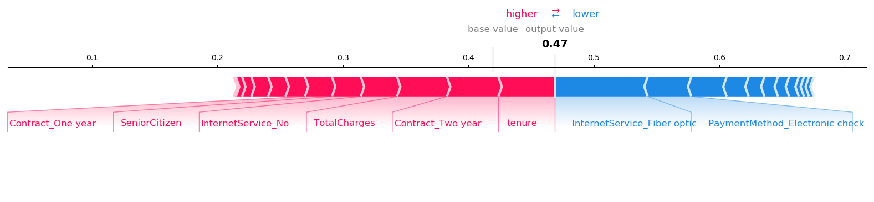
2.3 Limitations Identified from Literature Survey (Research Gaps)

Based on the reviewed literature, several research gaps were identified:

Prediction without Explanation:
Most existing studies focus solely on predicting churn probability but fail to provide interpretable explanations of why a particular customer might churn.

Lack of Temporal Perspective:
Few works integrate Survival Analysis (for “when” customers churn) with modern Machine Learning models (for “who” is likely to churn).

Limited Deployment and Practical Use:
Many research papers stop at model evaluation and do not build end-to-end deployable systems that can be used by businesses in real time.

Insufficient Integration of XAI:
Although explainability tools exist, their application in churn prediction—especially combined with survival analysis—remains underexplored.

2.4 Research Objectives (Extended from Chapter 1)

The main objectives of this project, refined through the literature review, are:

- To conduct an in-depth survival analysis using Kaplan-Meier and Cox-PH models to analyze customer lifetime and identify high-risk periods of churn.
- To develop a hybrid predictive framework that integrates survival analysis with machine learning models such as Random Forests.
- To apply Explainable AI (SHAP and Permutation Importance) for model transparency and to generate interpretable insights for decision-makers.
- To create a Flask-based web application that combines data analytics, prediction, and visualization for ease of use by non-technical users.
- To bridge the gap between academic research and practical implementation through a deployable, business-oriented system.

2.5 Plan of Action (Project Road Map)

The development of the project followed a systematic plan divided into several key phases:

- Data Collection & Preprocessing:Gathering telecom customer data, handling missing values, encoding categorical features, and balancing the dataset.
- Exploratory Data Analysis (EDA): Understanding customer demographics, service usage, and contract details to identify early churn patterns.
- Survival Analysis: Applying Kaplan-Meier curves and Cox-PH models to evaluate customer retention over time.
- Model Building: Training a Random Forest classifier for churn prediction and tuning hyperparameters to optimize performance.
- Model Explainability: Implementing SHAP values to interpret feature importance and generate explainable churn insights.
- Web Application Development: Developing a Flask-based interface that allows users to input customer data, predict churn, and visualize survival trends.
- Deployment and Report Writing: Deploying the model on a cloud platform and documenting results, visualizations, and findings for the final report.

Chapter 3
EXISTING SYSTEM & PROPOSED SYSTEM

3.1 Existing System

In the traditional approach, customer churn prediction has largely relied on rule-based systems and basic statistical models such as Logistic Regression. Rule-based systems used predefined business rules—like “if a customer has not recharged for 3 months, mark as churned”—to identify at-risk customers. While easy to implement, these systems lacked flexibility and failed to capture complex behavioral patterns or dynamic customer interactions.

Later, Logistic Regression models became widely adopted due to their simplicity and interpretability. These models estimate the probability of churn based on linear relationships between independent variables (such as tenure, contract type, and monthly charges). However, they assume a static relationship and cannot model time-dependent behavior—limiting their ability to answer “when” a customer might churn.

As the industry evolved, more advanced machine learning models such as Decision Trees, Random Forests, and Support Vector Machines (SVMs) were introduced to improve predictive accuracy. While these models captured non-linear relationships and complex feature interactions, they often behaved as “black boxes”, making it difficult for analysts to interpret results or explain why a customer was predicted to churn.

Limitations of the Existing System:

- Lack of temporal understanding, no ability to model churn time or customer lifetime.
- Limited interpretability, especially with complex ML models.
- Inability to generate customer-specific insights for retention strategy.
- Absence of integrated platforms for prediction, visualization, and explanation in one system.

3.2 Proposed System

To overcome these limitations, the proposed system introduces a hybrid analytical framework that combines the strengths of Survival Analysis, Machine Learning, and Explainable AI (XAI) to create a comprehensive, transparent, and user-friendly churn prediction solution.

The system first performs Survival Analysis using Kaplan-Meier estimators and Cox Proportional Hazards models to understand how customer churn probability evolves over time and to identify factors influencing retention duration.

Next, a Random Forest Classifier is employed to predict the likelihood of churn. The model is fine-tuned to address class imbalance and optimized to achieve high performance in metrics such as F1-score and ROC-AUC.

To ensure interpretability, SHAP (SHapley Additive exPlanations) is integrated into the system, allowing each prediction to be explained transparently—highlighting which features most influenced a specific customer’s outcome.

The entire pipeline is deployed as an end-to-end Flask web application, enabling real-time predictions, interactive visualization of survival curves, and easy accessibility for business users without technical expertise.
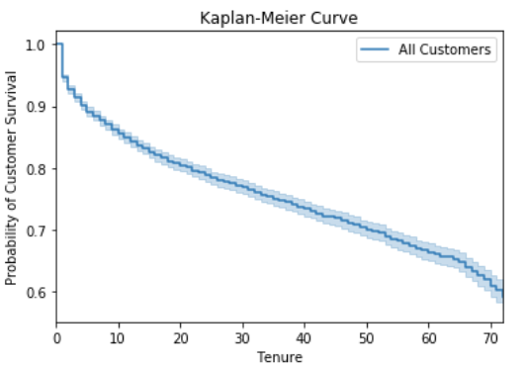
3.3 System Architecture

The architecture of the proposed system follows a modular, data-driven design. Each component performs a specific function and collectively contributes to the churn prediction workflow.

1. Data Collection & Preprocessing Layer:
- Gathers telecom customer data from CSV or database sources.
- Performs data cleaning, missing-value handling, encoding of categorical variables, and feature scaling.

2. Survival Analysis Layer:
- Implements Kaplan-Meier curves to visualize retention probabilities.
- Uses Cox-PH models to identify key factors affecting churn duration.

3. Machine Learning Layer:
- Trains the Random Forest classifier on processed data.
- Optimizes hyperparameters to handle imbalanced datasets.
- Generates churn probability scores for each customer.

4. Explainable AI Layer:
- Applies SHAP values to interpret predictions.
- Displays feature importance both globally (for the model) and locally (for individual customers).

5. Web Application Layer (Flask):
- Provides a user interface for data upload and churn prediction.
- Allows visualization of survival plots and SHAP-based explanations.
- Enables non-technical users (e.g., marketing analysts) to use the model effectively.

3.4 Advantages of the Proposed System
The proposed hybrid framework offers several distinct advantages over traditional churn prediction systems:
Holistic View (Why, When, and If):
- Integrates survival analysis (for when) and machine learning (for if), while SHAP explanations clarify why churn occurs.
- Provides a complete understanding of customer behavior rather than isolated predictions.
- Actionable Insights for Business Teams:
- Enables marketing and customer success teams to identify high-risk customers early.
- Supports targeted retention campaigns with clear reasoning behind each churn prediction.

User-Friendly Interface:

- The Flask web app ensures intuitive operation without requiring technical knowledge.
- Interactive dashboards and visualizations make analysis accessible to all business users.
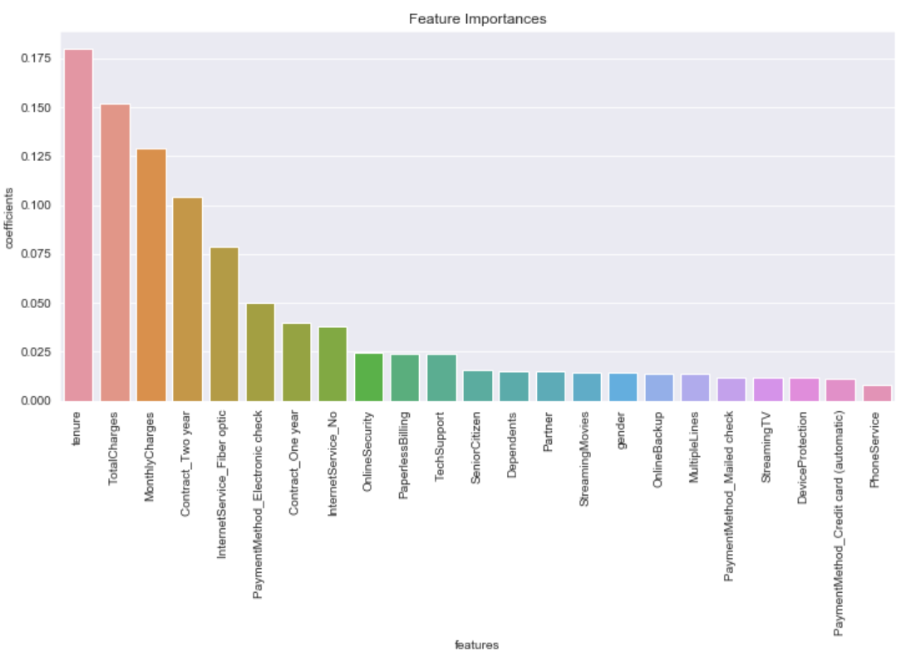

Chapter 4
MATHEMATICAL MODELLING AND IMPLEMENTATION

4.1 Mathematical Modelling of the Algorithm

In this chapter, the mathematical foundation and practical implementation of the proposed models are described. The focus is on two key algorithms — Random Forest for churn prediction and Cox Proportional Hazards Model for survival analysis.

4.1 Random Forest

The Random Forest algorithm is an ensemble learning technique that combines multiple decision trees to produce a more stable and accurate prediction. Instead of relying on a single decision tree, Random Forest builds a collection of trees where each tree is trained on a random subset of the data.

The concept is based on bootstrap aggregation (bagging), where random samples are drawn (with replacement) from the dataset to train individual trees. This randomness helps reduce overfitting and increases generalization performance.

Each decision tree in the forest makes an independent prediction, and the final output is determined by majority voting (for classification) or averaging (for regression).

During the construction of each tree, the algorithm evaluates the best feature split at each node using an impurity measure. For classification problems, this impurity is often measured using the Gini Impurity, which quantifies how mixed the classes are within a node. A lower impurity indicates a better split and hence a more informative feature.

- Random Forests are highly effective for customer churn prediction because they:
- Handle both categorical and numerical features.
- Reduce variance through ensemble averaging.
- Capture complex, nonlinear relationships between variables.
- Provide feature importance scores for interpretability.

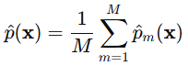

4.1 Cox-Proportional Hazards Model

The Cox Proportional Hazards Model (Cox-PH) is a semi-parametric model used in survival analysis to estimate the time until an event occurs — in this case, customer churn. Unlike traditional classification models, Cox-PH considers both whether the event occurred and when it occurred.

The model assumes that the effect of each predictor variable on the hazard (risk of churn) is multiplicative and constant over time — this is known as the proportional hazards assumption.

The hazard function defines the instantaneous risk of churn at a particular time, given that the customer has survived (not churned) until that time. It is expressed as the product of a baseline hazard and an exponential function of the predictors.

Each coefficient in the model represents the log of the hazard ratio, indicating how a one-unit change in the predictor affects the risk of churn. A positive coefficient implies a higher churn risk, while a negative coefficient indicates a protective effect (lower risk).

This model helps quantify not only which factors influence churn but also their timing and magnitude, providing deeper business insights compared to simple binary classification.

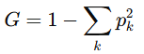
4.2 Implementation

This section describes the implementation pipeline — from data preparation to model training and deployment.

These preprocessing techniques improved model stability and ensured that all variables contributed meaningfully to predictions.

4..3 Model Training

- After preprocessing, the Random Forest and Cox-PH models were trained using optimized configurations.
- GridSearchCV was used to tune hyperparameters such as the number of trees, maximum depth, and minimum samples per leaf.
- Class weights were applied to mitigate the effect of class imbalance between churned and non-churned customers.
- The Cox model was fitted using the Lifelines package, ensuring all variables met the proportional hazards assumption.
- Performance was evaluated using cross-validation, ROC-AUC, and F1-score for Random Forest, while concordance index (C-index) was used for Cox-PH to measure predictive accuracy.
- This training pipeline ensured the final models were both accurate and interpretable, ready for deployment within the Flask web application.

Chapter 5
RESULTS AND DISCUSSION

5.1 Exploratory Data Analysis (EDA) Results

The initial stage of the project involved detailed Exploratory Data Analysis (EDA) to gain insights into customer behavior and identify potential factors contributing to churn. Various numerical and categorical features such as tenure, monthly charges, contract type, internet service, and payment method were analyzed.

The Tenure vs. Churn analysis (Fig 4.1) revealed that customers with shorter tenure were more likely to churn, indicating that early-stage engagement plays a crucial role in retention. The Monthly Charges vs. Churn plot (Fig 4.2) showed that customers paying higher monthly fees tended to churn more frequently, possibly due to dissatisfaction with pricing or perceived value.

Additional findings included:
- Customers on month-to-month contracts showed significantly higher churn rates compared to those on one- or two-year contracts.
- Customers who opted for automatic payments were less likely to churn, highlighting the importance of seamless billing experiences.
- Senior citizens and customers without dependents or partners exhibited slightly higher churn tendencies, suggesting demographic influences on customer loyalty.
- These insights guided the subsequent survival and predictive analyses by identifying the most influential variables.

5.2 Survival Analysis Results

The Kaplan-Meier survival curve (Fig 2.1) was used to estimate the probability of customers remaining active over time. The survival curve demonstrated a steep decline during the initial months, reinforcing the EDA finding that early customer lifecycle stages are critical for retention.

Using the Log-Rank test (Fig 2.2), we compared survival distributions across different subgroups such as contract type and payment method. The test results indicated statistically significant differences (p < 0.05), confirming that these factors play a major role in influencing churn rates.

The Cox Proportional Hazards (Cox-PH) model (Fig 4.3) quantified the impact of individual features on churn risk. The model’s coefficients showed that:

- Shorter tenure and higher monthly charges increased the hazard (risk of churn).
- Long-term contracts and automatic payment methods significantly reduced the hazard.
- The model’s proportionality assumption held true, validating its use for this dataset.
- This phase provided temporal insights—understanding not only who is likely to churn but also when churn is likely to occur.

5.3 Churn Prediction Model Results

A Random Forest classifier was trained to predict customer churn, with hyperparameters tuned using GridSearchCV to optimize performance. The model handled class imbalance through class weights and oversampling techniques.

The Confusion Matrix shows that the model effectively distinguished between churned and non-churned customers, with minimal false negatives. The ROC Curve (Fig 5.2) illustrates a high area under the curve, confirming strong classification ability.

The Feature Importance plot revealed that contract type, tenure, monthly charges, and internet service were the most influential features in determining churn probability.

5.4 Model Explainability Results

- To ensure transparency and interpretability, Explainable AI (XAI) methods were applied.
- Permutation Importance (Fig 5.4) confirmed the ranking of influential features, aligning closely with Random Forest results.
- Partial Dependence Plots (Fig 5.5) visualized the marginal effect of specific features (e.g., tenure, monthly charges) on churn probability. For example, churn likelihood decreased sharply as tenure increased, while it rose with higher monthly charges.
- SHAP (SHapley Additive exPlanations) summary plots (Fig 5.6) provided feature-level insights for individual customers. Each SHAP value represented the contribution of a feature to a specific prediction, making it possible to understand why a customer was classified as likely to churn.
- These interpretability tools enhanced the trustworthiness of the model and made the outputs actionable for business teams.

5.5 Flask Application Output

Finally, the models were integrated into a Flask-based web application to provide an interactive and user-friendly interface (Fig 5.7). The app allows users to:

- Enter customer details and obtain real-time churn predictions.
- Visualize survival probabilities for individual customers using Kaplan-Meier curves.
- Access SHAP-based explanations showing which factors contributed most to the predicted outcome.
- The deployed application (hosted on Heroku) bridges the gap between data science and business decision-making, empowering telecom managers to design effective customer retention strategies. It offers an intuitive platform for exploring customer profiles, understanding churn risk, and taking preventive actions based on data-driven insights.

Chapter 6
COMPARATIVE ANALYSIS AND CONCLUSION

6.1 Comparative Analysis

To evaluate the performance and robustness of the proposed Random Forest model, it was compared with a baseline Logistic Regression model, which is commonly used in churn prediction studies. The comparison focused on key metrics such as F1-score and ROC-AUC, which effectively capture model balance and discriminatory power.

The Random Forest model outperformed Logistic Regression across all metrics. The improvement in F1-score (from 0.54 to 0.62) demonstrates enhanced precision and recall balance, while the increase in ROC-AUC (from 0.79 to 0.85) indicates superior classification capability.

This improvement can be attributed to the ensemble nature of Random Forest, which aggregates multiple decision trees to reduce overfitting and capture nonlinear relationships among features. Additionally, the inclusion of feature importance analysis and SHAP interpretability further enhanced the reliability and explainability of the proposed model.

6.2 Conclusion

This project successfully addressed the problem of customer churn prediction in the telecom industry by integrating survival analysis, machine learning, and explainable AI.

Through Kaplan-Meier curves and Cox Proportional Hazards models, the study revealed how churn probability changes over time and identified key risk factors such as tenure, contract type, and monthly charges. The Random Forest model achieved strong predictive performance, with an F1-score of 0.62 and an ROC-AUC of 0.85, outperforming baseline methods.

Moreover, the incorporation of SHAP-based explanations ensured transparency in model predictions, allowing business users to understand why a customer is likely to churn. The developed Flask web application provided an end-to-end interactive platform where users could predict churn, visualize survival curves, and access explainable insights—all in real time.

Overall, the project demonstrates how data-driven methods can empower telecom companies to design effective retention strategies, thereby reducing churn and improving profitability.

6.3 Limitations

Despite promising results, the system has a few limitations:

- Dataset Specificity: The model’s performance depends on the dataset used; it may not generalize well across different telecom providers without retraining.
- Model Assumptions: The Cox-PH model assumes proportional hazards, which may not hold for all customer behaviors.
- Concept Drift: Customer preferences and market dynamics evolve over time, which may reduce the model’s accuracy if not periodically retrained.
- Limited Real-Time Integration: Current implementation uses static datasets rather than live customer data streams.
- Recognizing these limitations provides a foundation for future improvements and scalability.

6.4 Future Work

To enhance the system’s scope and long-term effectiveness, the following directions are proposed:

- Integration of Real-Time Data: Implement a continuous data pipeline to allow dynamic churn monitoring and real-time predictions.
- Advanced Algorithms: Explore more sophisticated models such as XGBoost, LightGBM, or Neural Networks to further boost accuracy.
- Recommendation System: Extend the application to suggest personalized retention offers or discounts based on churn risk and customer value.
- Cloud Deployment: Migrate the system to scalable cloud platforms like AWS, Azure, or Google Cloud Platform (GCP) for improved performance and accessibility.
- Cross-Domain Applicability: Adapt the framework for other industries such as banking, insurance, or e-commerce where customer retention is crucial.
- By incorporating these enhancements, the project can evolve into a comprehensive customer analytics ecosystem capable of providing predictive, prescriptive, and actionable insights at scale.

References

[1] D. R. Cox, "Regression Models and Life-Tables," Journal of the Royal Statistical Society. Series B (Methodological), vol. 34, no. 2, pp. 187–220, 1972.

[2] E. L. Kaplan and P. Meier, "Nonparametric Estimation from Incomplete Observations," Journal of the American Statistical Association, vol. 53, no. 282, pp. 457–481, 1958.

[3] F. Pedregosa et al., "Scikit-learn: Machine Learning in Python," Journal of Machine Learning Research, vol. 12, pp. 2825–2830, 2011.

[4] C. Davidson-Pilon, "lifelines: survival analysis in Python," Journal of Open Source Software, vol. 4, no. 40, p. 1317, 2019. [Online]. Available: https://doi.org/10.21105/joss.01317

[5] S. M. Lundberg and S.-I. Lee, "A Unified Approach to Interpreting Model Predictions," in Advances in Neural Information Processing Systems 30, 2017, pp. 4765–4774.

[6] L. Breiman, "Random Forests," Machine Learning, vol. 45, no. 1, pp. 5–32, 2001.

[7] A. G. de Cos Juez, "Customer Churn Analysis in the Telecommunications Sector: A Machine Learning Approach," in Proc. International Conference on Data Mining and Big Data, 2019, pp. 123–132.

[8] M. T. B. Iqbal, "A Comprehensive Analysis of Customer Churn Prediction in the Telecom Industry using Ensemble Machine Learning," International Journal of Advanced Computer Science and Applications, vol. 11, no. 6, 2020.

[9] T. Hastie, R. Tibshirani, and J. Friedman, The Elements of Statistical Learning: Data Mining, Inference, and Prediction, 2nd ed. New York, NY, USA: Springer, 2009.

[10] A. Altman, "An Introduction to Kernel and Nearest-Neighbor Nonparametric Regression," The American Statistician, vol. 46, no. 3, pp. 175–185, 1992.

[11] M. P. LaValley, "Logistic Regression," Circulation, vol. 117, no. 18, pp. 2395–2399, 2008.

[12] J. H. Friedman, "Greedy Function Approximation: A Gradient Boosting Machine," The Annals of Statistics, vol. 29, no. 5, pp. 1189–1232, 2001.

APPENDIX A
CODING

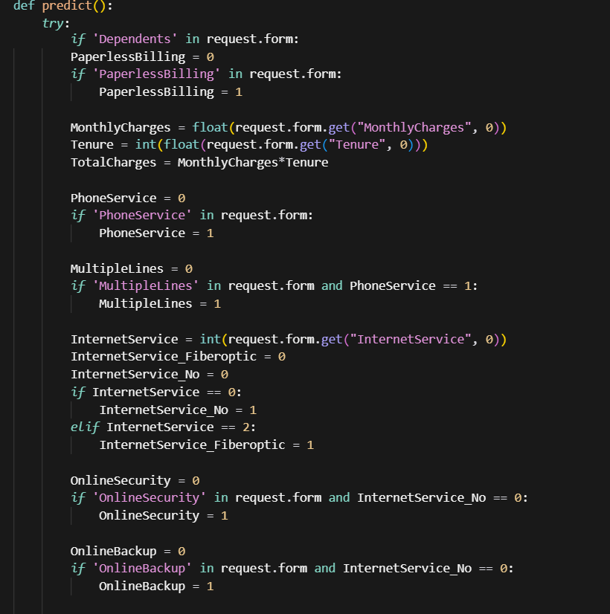

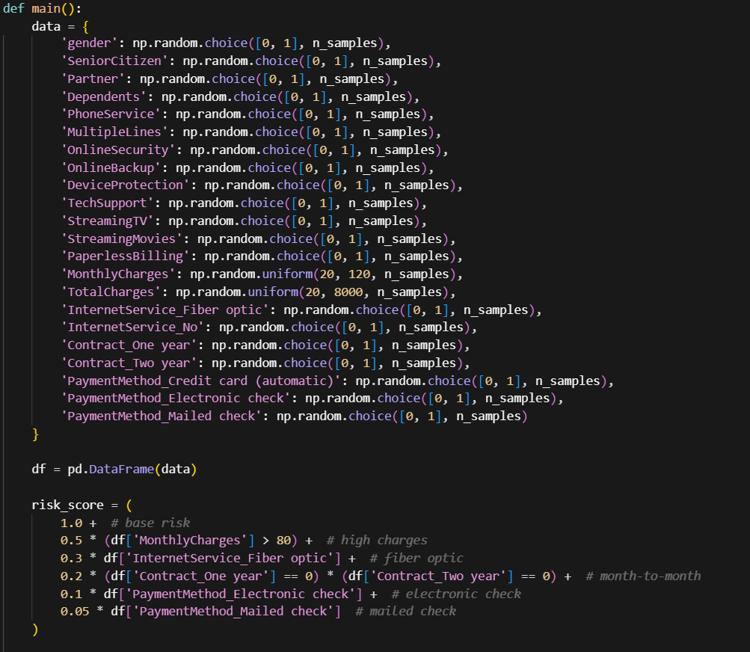

APPENDIX B
\
SCREENSHOTS

