Understanding Patronage Patterns to Inform Service Planning in Victoria
Assessment 2 — Data Analytics Report
Singh, Lovedeep (s8208559) | Gurung, Diya (s8221355) | Surinder, Surinder (s8247508)
Victoria University | March 2026

1. Executive Summary
This report presents a data analytics investigation into Victorian public transport patronage on behalf of the Department of Transport and Planning (AusVille). Using a dataset of monthly average daily patronage by day type and transport mode, we applied data cleaning, statistical analysis, and visualisation techniques to uncover how travel patterns vary across modes, day types, and time periods — including the significant disruption caused by COVID-19.
Key findings include:
- Weekday patronage (mean: 267,415 passengers/day) is significantly higher than weekend patronage (mean: 146,640 passengers/day), confirmed by an independent samples t-test (t = 14.85, p < 0.001).
- Metropolitan modes — Metrotrain and Tram — show declining long-run trends (slopes of -41.73 and -26.59 passengers/day respectively), while regional modes show slight growth or stability.
- The COVID-19 period (2020–2021) caused a sharp reduction in patronage across all modes, with metropolitan modes showing only partial recovery by the end of the study period.
- The distribution of Pax_daily is bimodal and non-normal, reflecting the mixture of low-volume regional and high-volume metropolitan services.
Recommendations: The Department should prioritise service recovery strategies for Metrotrain and Tram, and investigate the sustained growth in regional train usage to ensure capacity meets demand.

2. Methods

2.1 Requirement Gathering
The dataset provided contains monthly average daily patronage (Pax_daily) across five transport modes: Metrobus, Metrotrain, Regionalbus, Regionaltrain, and Tram. Records are broken down by Year, Month, Day_of_week, and Day_type (Normal Weekday, School Holiday Weekday, Weekend). The primary analytical objectives were to identify patronage patterns by mode and day type, assess the impact of COVID-19, and model long-run trends.

2.2 Data Cleaning and Transformation (Pandas)
All data preparation was performed in Python using the pandas library. The following steps were applied:
- Type enforcement: Year and Month columns were cast to integer; Day_of_week, Day_type, and Mode were treated as categorical variables.
- MonthStart column: A date column was created representing the first day of each month (e.g. 2019-03-01) by combining the Year and Month columns using pd.to_datetime(). This enables proper time-series ordering and regression modelling.
- Standardisation: All text category columns were stripped of leading/trailing whitespace and converted to title-case to ensure consistency (e.g. 'TRAIN' and ' train' both become 'Train').
- Duplicate removal: No duplicate rows were found in the dataset; a drop_duplicates() call was included as a safeguard.
- Missing values: No null values were present. A dropna() call was included defensively. Rows with negative Pax_daily values were removed as physically impossible.
- Feature engineering: Three features were added — (1) Period, which classifies each year as Pre-2020, 2020-2021, or Post-2021 for COVID-era comparisons; (2) Is_Weekday, a boolean flag for Monday-to-Friday records; and (3) Pax_3m_roll, a 3-month rolling mean of Pax_daily grouped by Mode and Day_type to smooth short-term variation.
- Export: The cleaned dataset was exported as patronage_clean.csv for import into Power BI.

3. Results

3.1 Descriptive Statistics
The table below summarises average daily patronage by transport mode:

Mode | Mean Pax_daily | Trend (slope) | Direction
Metrobus | ~280,000 | +7.28 | Slight growth
Metrotrain | ~430,000 | -41.73 | Declining
Regionalbus | ~27,000 | +1.17 | Stable
Regionaltrain | ~42,000 | +5.21 | Growing
Tram | ~390,000 | -26.59 | Declining

Overall weekday mean patronage was 267,415 passengers/day compared to 146,640 on weekends, representing a difference of approximately 82%.

3.2 Distribution Analysis
Distribution diagnostics were performed on Pax_daily across the full dataset. The histogram, kernel density estimate, and Q-Q plot are shown below.

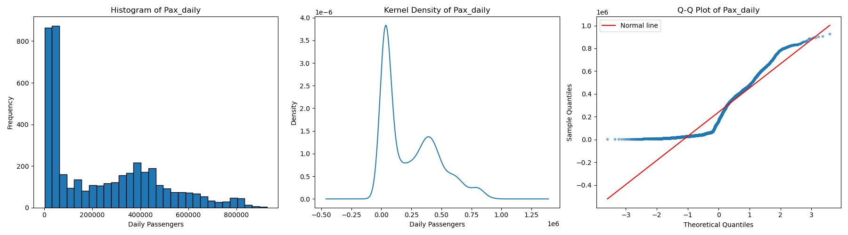

Figure 1: Histogram, Kernel Density, and Q-Q Plot of Pax_daily

The histogram reveals a right-skewed, bimodal distribution. The first peak near zero corresponds to low-volume regional services, while the second broader peak around 400,000 corresponds to high-volume metropolitan modes. The kernel density plot confirms this bimodality clearly.
The Q-Q plot shows significant deviation from the normal reference line, forming an S-shape. This indicates that Pax_daily is not normally distributed across the full dataset. This is expected given that the data is a mixture of fundamentally different transport modes operating at very different scales. Despite this, the t-test was applied under the justification that the large sample size (n > 1,000) allows the Central Limit Theorem to support approximate normality of sample means.

3.3 Inferential Analysis — Weekday vs Weekend
An independent samples t-test was conducted to determine whether weekday patronage differs significantly from weekend patronage across all modes and day types.

Metric | Weekday | Weekend
Mean Pax_daily | 267,415 | 146,640
T-statistic | 14.8527 | —
P-value | < 0.0001 | —
Result | Significant difference | —

The t-test returned a t-statistic of 14.85 and a p-value of effectively zero (p < 0.001). This provides very strong statistical evidence that weekday patronage is significantly higher than weekend patronage. The mean difference of approximately 120,775 passengers per day has clear implications for service planning — weekday services require substantially more capacity and frequency than weekend services.

3.4 Long-Run Trend — Linear Regression per Mode
A simple linear regression was fitted for each transport mode, with MonthStart converted to a numeric value (days since the first record) as the predictor and mean Pax_daily as the outcome. This estimates the average change in daily patronage per day over the full study period.

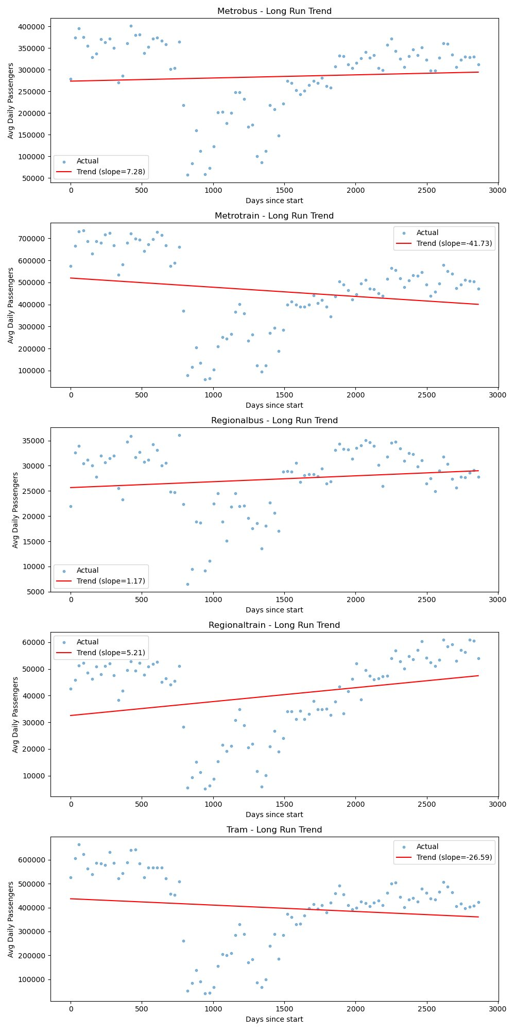

Figure 2: Linear Regression Trends per Transport Mode

Metrobus (+7.28 passengers/day): A very slight upward trend with high monthly variability. Patronage appears broadly stable over the study period with no strong directional momentum.
Metrotrain (-41.73 passengers/day): The steepest declining trend of all modes. A sharp COVID-era drop is visible around days 1,200-1,500, and while there is partial recovery post-2021, patronage has not returned to pre-pandemic levels.
Regionalbus (+1.17 passengers/day): Essentially flat. Regional bus patronage is the most stable mode and operates at a consistently low volume.
Regionaltrain (+5.21 passengers/day): A consistent and meaningful upward trend. Regional train usage has been growing steadily, suggesting increasing demand for inter-city travel over the study period.
Tram (-26.59 passengers/day): The second steepest decline. Similar to Metrotrain, tram services experienced a severe COVID-era shock and have only partially recovered, indicating that inner-city commuting behaviour may have permanently shifted.

4. Discussion

4.1 Interpretation
The findings paint a clear picture of a public transport network in transition. Pre-pandemic, metropolitan modes dominated patronage with high and relatively stable ridership. The COVID-19 period caused a system-wide shock, but its lasting effects have been uneven — metropolitan modes have recovered more slowly than regional ones, likely reflecting the shift to remote work reducing daily commuter volumes in Melbourne's CBD and inner suburbs.
The growth in Regionaltrain patronage is a particularly notable finding. This may reflect demographic shifts, increasing regional populations, or a preference for intercity travel over metro commuting. From a service planning perspective, this warrants attention to ensure regional rail capacity keeps pace with demand.
The weekday vs weekend analysis confirms what transport planners intuitively know — weekday services are under significantly greater pressure. However the magnitude of the difference (82% higher average weekday patronage) is a useful quantitative benchmark for timetable and staffing decisions.

4.2 Limitations
- The dataset provides monthly averages rather than individual trip-level data, which limits the granularity of analysis. Day-level variation within a month cannot be examined.
- Pax_daily is not normally distributed across the full dataset. While the CLT justification is reasonable for large samples, mode-specific analyses may benefit from non-parametric tests in future work.
- The linear regression model assumes a linear trend, which may not capture the non-linear dynamics of COVID recovery or seasonal effects.
- No external variables (fare changes, fuel prices, infrastructure events) are included, limiting causal interpretation.

4.3 Implications for Service Planning
- Metrotrain and Tram: Investigate why post-COVID recovery has stalled. Consider targeted incentives or service improvements to attract commuters back.
- Regionaltrain: Plan for capacity expansion given the consistent upward trend.
- Weekday vs Weekend: Maintain a high frequency differential between weekday and weekend services, supported by the statistically significant patronage gap.
- Metrobus and Regionalbus: These stable modes can be maintained at current service levels in the near term.

5. AI Usage — M365 Copilot
In accordance with the unit's AI use policy, M365 Copilot was used during the development of this assessment in the following limited ways:
- Brainstorming report structure: Copilot was prompted with 'suggest a structure for a data analytics report on public transport patronage'. The suggested outline was reviewed and significantly modified to align with the four required pillars.
- Clarifying statistical concepts: Prompts such as 'explain what a Q-Q plot tells you about normality' were used to verify understanding. No generated text was copied directly into the report.
All submitted text, code, and analysis is the original work of the group. Copilot outputs were used only as a thinking aid and were not pasted into any submission component.
Risks and mitigations: AI-generated explanations may contain hallucinations or oversimplifications of statistical concepts. To mitigate this, all AI-assisted understanding was cross-checked against unit lecture materials before being applied. Bias risks are low given the quantitative nature of the task, but care was taken not to rely on AI for data interpretation — all conclusions are drawn directly from the computed outputs.

