AXIA
Solution Overview
____________________________________________________________

Technical Buyer Reference

Audience: CISO • Head of Security Architecture • Data Protection Lead

Version 2.0 • Derived from PRD V2 and V6.30.1 demo family

"The CISO's Front-Line AI for Insider Risk"
axiasecurity.io • hello@axiasecurity.io

Executive Summary
AXIA is the judgment and engagement layer for insider risk. It sits above your existing DLP, IRM, identity, and HR stack. It does not replace any of them. It produces the thing none of them produces: a contextual decision, with explainability, ready for human review.
The problem is not detection. Your DLP detects fine. Your IRM tools surface anomalies. The problem is what happens after detection: 1,000+ alerts per day, 70-90% false positives, 86 days to contain an incident, $16.2M average cost when something gets missed. Security analysts triage by gut and burn out at 53%.
AXIA closes this gap with three architectural commitments:
• The Gatekeeper — AXIA's proprietary near-real-time vertical AI agent. A local ensemble of four ML models (ModernBERT V4, SetFit, and an embedding-based classifier with neural-network and gradient-boosted variants) that classifies every outbound communication in milliseconds, with no LLM calls. Handles all cases where the content alone determines severity, and decides which of the remaining cases gets escalated to the LLM for judgment based on AXIA's instructions and the customer's organizational context. AXIA brings the Gatekeeper. It runs locally in the customer's environment in both deployment types — no egress
• The LLM — deep contextual judgment via a frontier LLM, called only on the subset the Gatekeeper routes upward. The customer brings the LLM endpoint: the cloud-provider model (Azure OpenAI / Bedrock / Vertex AI) for Private Cloud, or the customer's IT-managed internal LLM (typically open-weights, hosted on customer GPUs) for On-Premises. Content never reaches AXIA-hosted infrastructure
• WHO / WHAT / WHO framework: every case answers who sent it, what it contains, and who received it — the dimensions traditional DLP cannot see
• Engagement first, enforcement last: coach the employee, brief the manager, escalate when warranted, block only when the case demands it
Result: alert volume reduced 80-90%, time-to-resolution reduced from days to hours, and a board-ready Risk Control Score grounded in your actual case-resolution history.
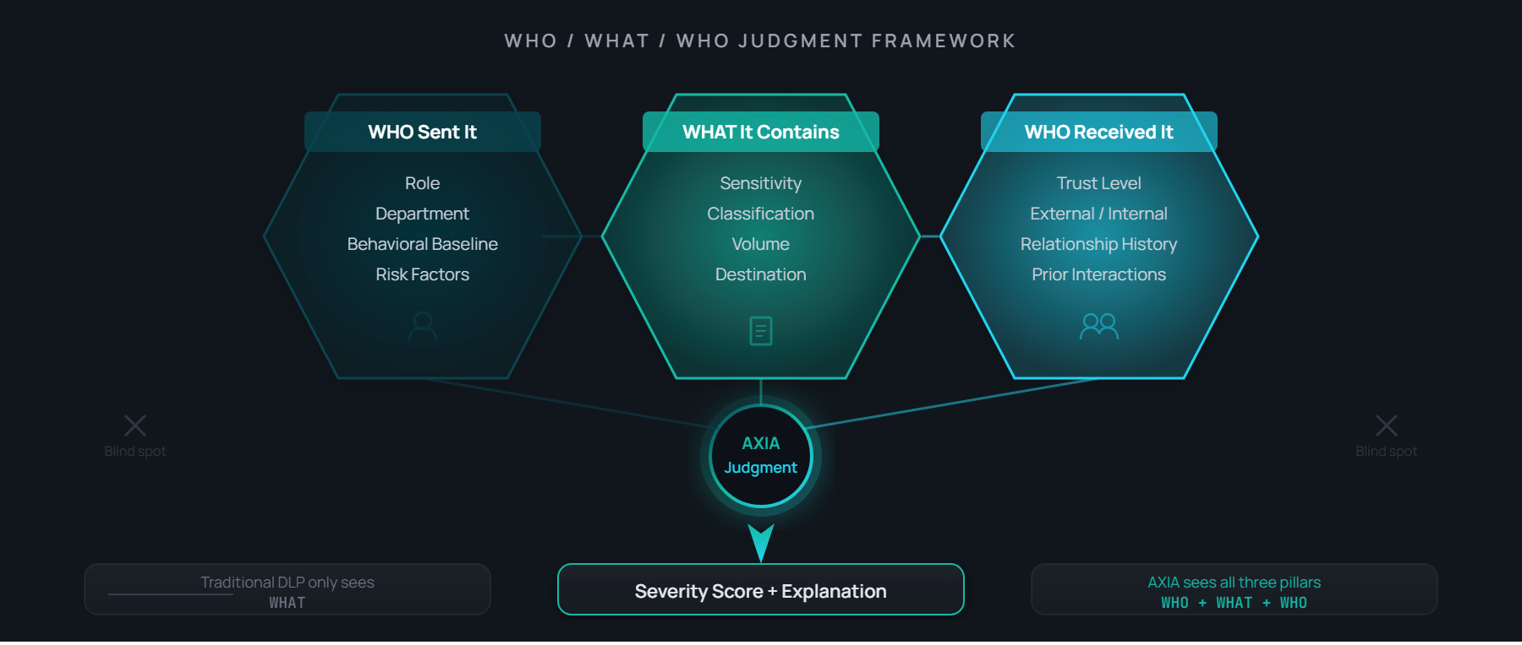
WHO / WHAT / WHO — the differentiating framework. AXIA answers all three; pattern-based DLP answers only WHAT.
________________________________________________________________________________

Platform Architecture
AXIA operates as a five-stage pipeline. Each stage is an independent service. Failure isolation, audit logging, and explainability are built in at every boundary.

Stage 1 — Ingest
API-based connectors to email (M365 / Gmail), collaboration (Teams / Slack), cloud storage (SharePoint / OneDrive / Drive), and DLP signal sources (Microsoft Purview, Netskope, Symantec, Forcepoint). Identity context flows in from Entra ID, Okta, or your IdP. Organizational context flows in from Workday, SuccessFactors, ADP, or your HR system. No agents. No SPAN ports. Standard Graph and OAuth permissions.

Stage 2 — Understand (the Gatekeeper)
The Gatekeeper is a vertical AI agent built specifically for insider-risk classification. It is an ensemble of four ML models trained on AXIA's labeled corpus using the WHO / WHAT / WHO framework (who sent it, what it contains, who received it) as the labeling rubric:
• ModernBERT V4 Gate — primary classifier, V4 production baseline at 80.4% exact-match accuracy on the five-level severity taxonomy (Critical / High / Medium / Low / Non-sensitive), Cohen's Quadratic Weighted Kappa 0.920 — meaning when the Gatekeeper is wrong, it is off by one level, never catastrophically.
• SetFit classifier — complementary model in the ensemble.
• Embedding-based classifier — neural-network and gradient-boosted (XGBoost) variants depending on deployment, evaluated against the same gold standard.
• Confidence-weighted soft voting combines the three members.
The Gatekeeper runs on every outbound communication in milliseconds, locally, with no LLM calls and no egress. It reviews metadata and content to determine whether the communication may contain sensitive information or context.

Stage 3 — Decide (the LLM Judge)
Outbound communications flagged by the Gatekeeper get sent to the LLM Judge with the right instructions based on Stage 2, as well as additional context: reply instructions and structure, severity definitions, the company's org structure, the company's policies, and the AXIA allowed actions to be suggested by the LLM.
The LLM endpoint is provisioned per engagement in one of three modes:
Mode | Endpoint | Typical Use
(a) Customer cloud | Azure OpenAI, Amazon Bedrock, or Google Vertex AI in the customer's account | Private Cloud deployments — default for Microsoft / AWS / GCP estates
(b) Customer-internal | Open-weights model hosted by the customer's IT organisation (Llama 3.3, Mistral, Qwen and equivalents) on customer GPUs | On-Premises deployments — default for finance, government, defence
(c) AXIA-provided | Llama 3.3 70B via vLLM on customer-provisioned infrastructure; alternate open-weights swap path available | Fallback when the customer has neither (a) nor (b) ready

AXIA itself never sees content under any mode. The output of this stage is a structured analysis: what the content is, what's sensitive about it, what the intent appears to be, and which behavioural and organisational signals raise or lower severity.

Stage 4 — Orchestrate
Severity drives action. P3 incidents auto-close after a teachable-moment notification to the sender. P2 routes to the employee's manager with context. P1 reaches the security analyst with a full investigation packet. P0 escalates immediately to security leadership and, where configured, to legal. Engagement messages are drafted by AXIA and approved by a human before sending.

Stage 5 — Learn
Every resolution becomes signal. Organizational baselines refine. Smart Block recommendations surface back to your DLP — tune this Purview rule, narrow this Netskope policy, convert this rule from block to coach for this department. The system gets sharper without manual retuning.
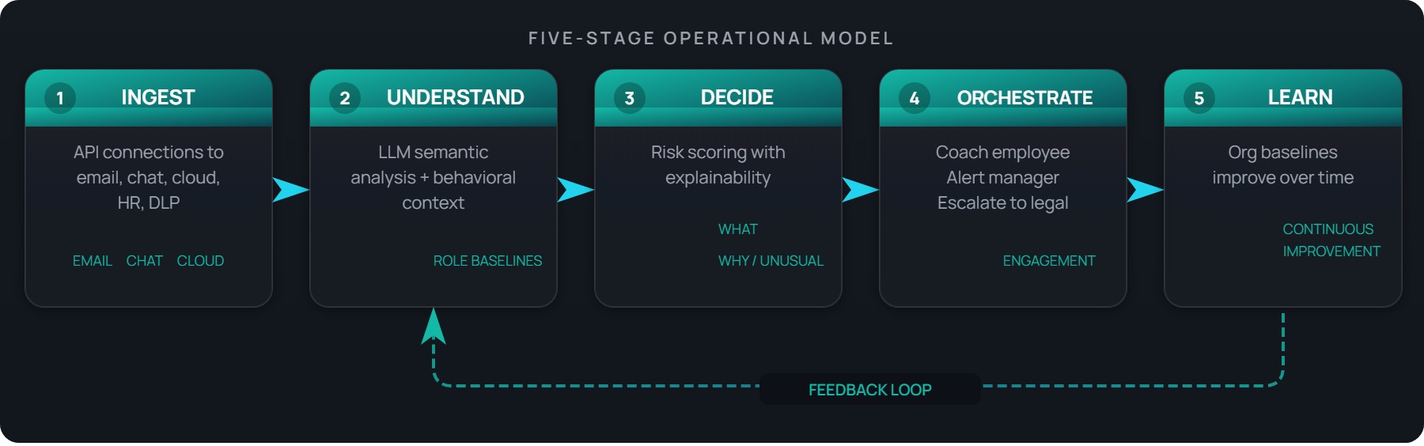
AXIA's five-stage operational model: Ingest, Understand, Decide, Orchestrate, Learn.
________________________________________________________________________________

Integrations
AXIA is a hub. It is designed to consume from the systems you already run and to push intelligence back into them. The integration model is API-first, bi-directional where it matters, and authenticated through standard OAuth and Graph permissions you already manage.

DLP Systems (signal in, intelligence out)
System | Integration | Direction
Microsoft Purview | Graph / Compliance API | Bi-directional — ingest alerts, surface Smart Block recommendations
Netskope | REST API | Bi-directional — ingest events, push recommendations
Symantec DLP | API + Syslog | Ingest incidents, classifications
Forcepoint DLP | API | Ingest policy events
Digital Guardian | API | Ingest endpoint events
Proofpoint DLP | API | Ingest email DLP events
Zscaler | API | Ingest cloud security events
Generic SIEM / Syslog | CEF / Syslog | Universal path — any DLP or SIEM that exports to Syslog

The DLP integration is the load-bearing one for many deployments. AXIA correlates DLP events with identity and HR context the DLP cannot see, then closes the loop with policy recommendations grounded in your actual case history. Purview and Netskope run bi-directionally today; the remaining systems connect through their standard APIs and the universal Syslog / CEF path.

Closed-Loop DLP Integration — the data flow
The DLP integration is bi-directional. AXIA consumes signal from your DLP and returns intelligence the DLP cannot produce on its own:
• From your DLP into AXIA — policy-match events with the matched classifier and sensitivity label; file and message metadata (sender, recipients, channel, timestamp); information-protection labels and trust-level context; endpoint DLP signals where endpoint coverage is deployed.
• What AXIA adds and returns — semantic content analysis performed against your own LLM endpoint; sender baseline (role, department, tenure, pre-departure signals); recipient-trust classification (internal, external-trusted, competitor, personal cloud); Smart Block policy recommendations that tune your DLP rules over time.
The result is a closed loop: your DLP detects, AXIA decides, your team engages, the system learns. Where AXIA consistently confirms that a given rule produces false positives in a specific context, it surfaces a Smart Block recommendation — tune the policy, narrow the rule, or convert it from block to coach for that situation — so your policies get sharper without manual digging through case history.

Content & Communication Channels
Channel | Integration
Microsoft 365 Email | Graph API
Google Gmail | Gmail API
Microsoft Teams | Graph API
Slack Enterprise | Events API
Microsoft SharePoint / OneDrive | Graph API
Google Drive | Drive API

Identity & Organizational Context
Source | Integration
Manual import (CSV / XLSX / Word) | File upload with column mapping — day one
Microsoft Entra ID | SCIM + OAuth 2.0
Okta | SCIM + OAuth 2.0
Workday | REST API
SAP SuccessFactors | OData API
ADP | REST API
Google Workspace Directory | Directory API + OAuth
Additional IdPs (Ping Identity, on-premises AD) | SCIM / SAML / LDAP

The manual-import path matters. It means AXIA can deliver value from day one, even before IT has provisioned the SCIM connection to your IdP. Upload an org chart, map the columns, get going.

SIEM / SOAR
AXIA cases export to your SIEM — Splunk, Microsoft Sentinel, IBM QRadar, Chronicle — as structured events over the standard CEF / Syslog path, so insider-risk cases land alongside the rest of your security telemetry.
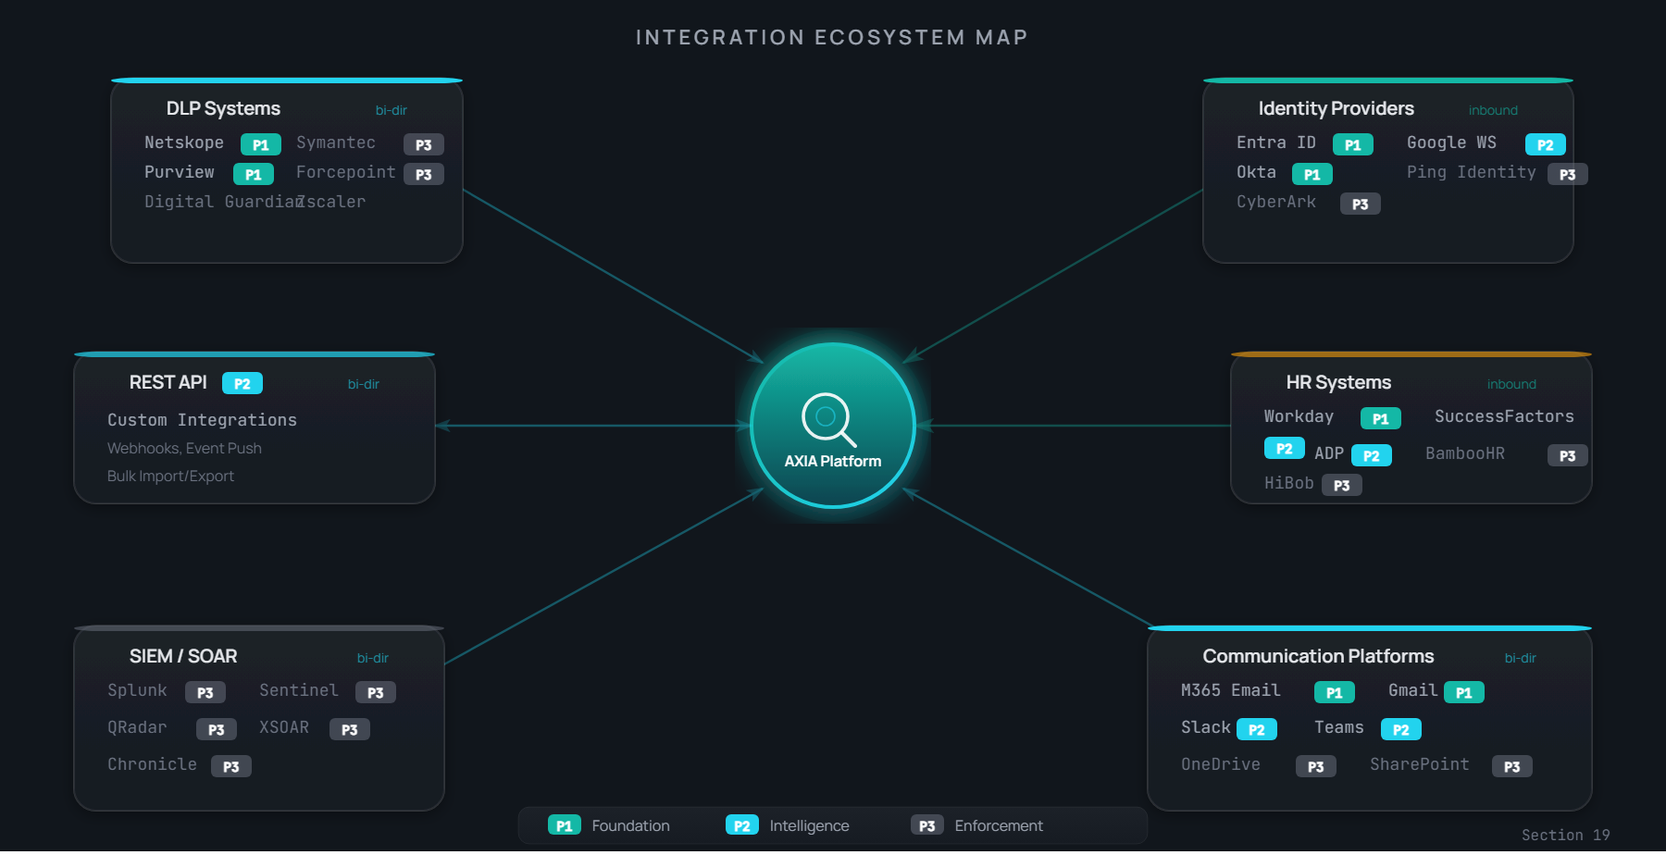
Integration ecosystem map — DLP signal sources, identity & HR context, communication channels, and SIEM/SOAR endpoints.
________________________________________________________________________________

Deployment Models
AXIA ships in two deployment models: Private Cloud and On-Premises. Both deliver the same capabilities at the same pricing. The choice is governed by data-sovereignty, regulatory, and infrastructure preferences — not feature-gating. There is no AXIA-hosted multi-tenant SaaS offering: content never reaches AXIA-controlled infrastructure under either model.

Private Cloud — recommended for most enterprises
AXIA runs in your AWS, Azure, or GCP account. Semantic analysis runs in your account's cloud LLM service: Amazon Bedrock, Azure OpenAI Service, or Google Vertex AI. Content never leaves your cloud boundary. AXIA's control plane orchestrates; content is processed under your IAM, your governance, your data-residency controls.
Your cloud | LLM service | Notes
AWS | Amazon Bedrock (Claude, Titan) | Stays in your AWS account
Azure | Azure OpenAI Service (GPT-4) | Stays in your Azure tenant — natural fit for Purview customers
GCP | Google Vertex AI (Gemini) | Stays in your GCP project

On-Premises — for regulated industries
For finance, government, healthcare, defence — environments where no data can leave the customer's data center. AXIA deploys as a virtual appliance. The Gatekeeper (Tier 1) runs locally in the customer's environment, identical to the Private Cloud build. For Tier 2 LLM judgment, the default is the customer's own IT-managed internal LLM — typically an open-weights model (Llama, Mistral, Qwen and equivalents) running on the customer's own GPU infrastructure under existing IT governance. If the customer has no internal LLM available, AXIA can provide one (Llama 3.3 70B via vLLM on customer-provisioned infrastructure) as a fallback. No cloud dependency. Same capability set as Private Cloud.

Deployment speed (either model)
Milestone | Target
API connection complete | 5 minutes
First Axia cases produced | 1 hour
Behavioral baselines learned | 24-48 hours
Full pilot value | 1 week
Ongoing model improvement | Continuous, automated

________________________________________________________________________________

Security & Data Posture
AXIA was designed by a team of insider-risk operators who understand that any system asking to read employee communications has to clear a higher bar than the systems it observes.

Data Stays in the Customer's Perimeter
No content ever reaches AXIA-hosted infrastructure. The Gatekeeper — AXIA's proprietary Tier-1 ensemble — runs locally in the customer's environment in both deployment types and makes no LLM calls; it classifies every message in milliseconds using local models and the WHO / WHAT / WHO framework, with no egress. The LLM endpoint that the Gatekeeper escalates to for Tier-2 contextual judgment is the customer's: Azure OpenAI, Amazon Bedrock, or Google Vertex AI inside the customer's cloud account under Private Cloud; the customer's IT-managed open-weights LLM on customer GPUs under On-Premises. AXIA ships the Gatekeeper, the orchestration plane, and the engagement engine. The customer owns and governs the LLM endpoint — with an AXIA-provided open-weights option (Llama 3.3 70B via vLLM on customer hardware) available only as a fallback when the customer has neither.
This is the load-bearing architectural commitment. It is not a metadata-only product. It is full semantic analysis, performed inside the customer's perimeter, against the customer's own model.

Identity, Access, and MFA
• MFA is required for all AXIA console users — non-negotiable.
• SSO via SAML 2.0 or OIDC against the customer's IdP (Entra ID, Okta, Ping, Google Workspace).
• Role-based access control with separation of duties between Security Analyst, Security Administrator, and Legal Reviewer.

Audit, Explainability, and Defensibility
Every case carries a structured reasoning trace: what AXIA saw, which classifier or signal triggered the case, which contextual factors raised or lowered severity, what action AXIA recommended, what action the human took. Cases are exportable as audit-ready PDFs.
The Risk Control Score that AXIA presents to the board is not an opinion. It is grounded in your case-resolution history, with the underlying cases retrievable per metric.

Privacy and Employee Trust
The engagement engine is designed people-first. Coaching messages are non-punitive by default. The product never sends an employee a message they wouldn't see from their own manager. Where legal jurisdictions require employee notice of monitoring, AXIA supports the notice workflow.

Compliance Posture
SOC 2 Type II framework adopted, audit in progress. ISO 27001 readiness in flight. Data-processing agreement (DPA) shipped as part of the standard EULA. GDPR, CCPA, and equivalent regulatory frameworks supported at the data-flow and consent layers.
________________________________________________________________________________

Workflow & UX — The Eight Screens
The product surfaces through eight screens, each scoped to a specific user task. The screens align to the five-stage pipeline; together they form the analyst's daily workbench and the executive's quarterly review.

Posture — the board view
A single Risk Control Score (0-100, A-F grade) with trend arrows. Severity distribution across active cases. Coverage health by channel. The screen a CISO opens before a board meeting.
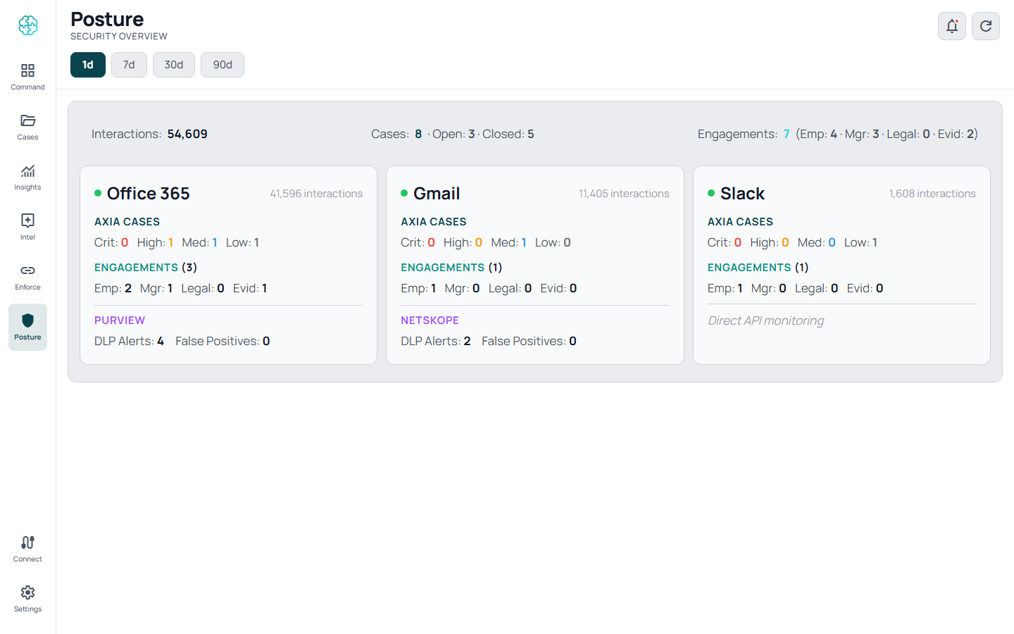
Posture — at-a-glance risk posture for the entire organization.

Command — the analyst workbench
Severity-ranked case triage. Filter by channel, DLP source, severity, status. Accordion case list. Built for small teams — 2-4 analysts handling thousands of upstream events.
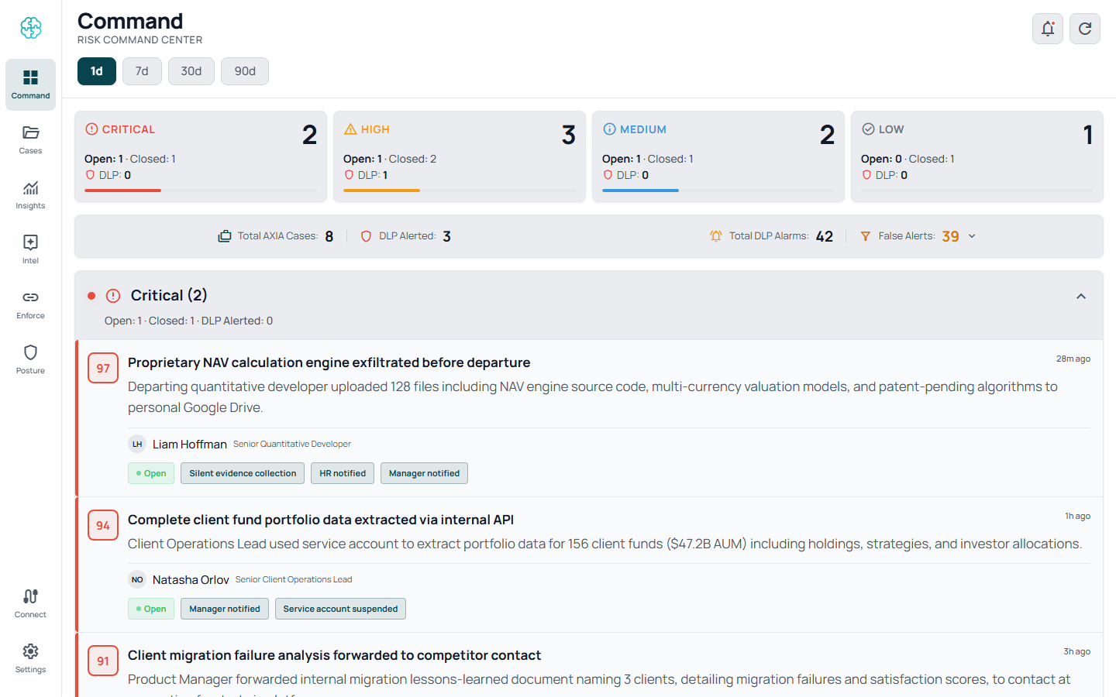
Command — the analyst's case-triage workbench.

Cases — the case list
The full case backlog with multi-select filters and AI-assisted natural-language search. Find every case involving departing engineers in the last 30 days, ranked by severity.
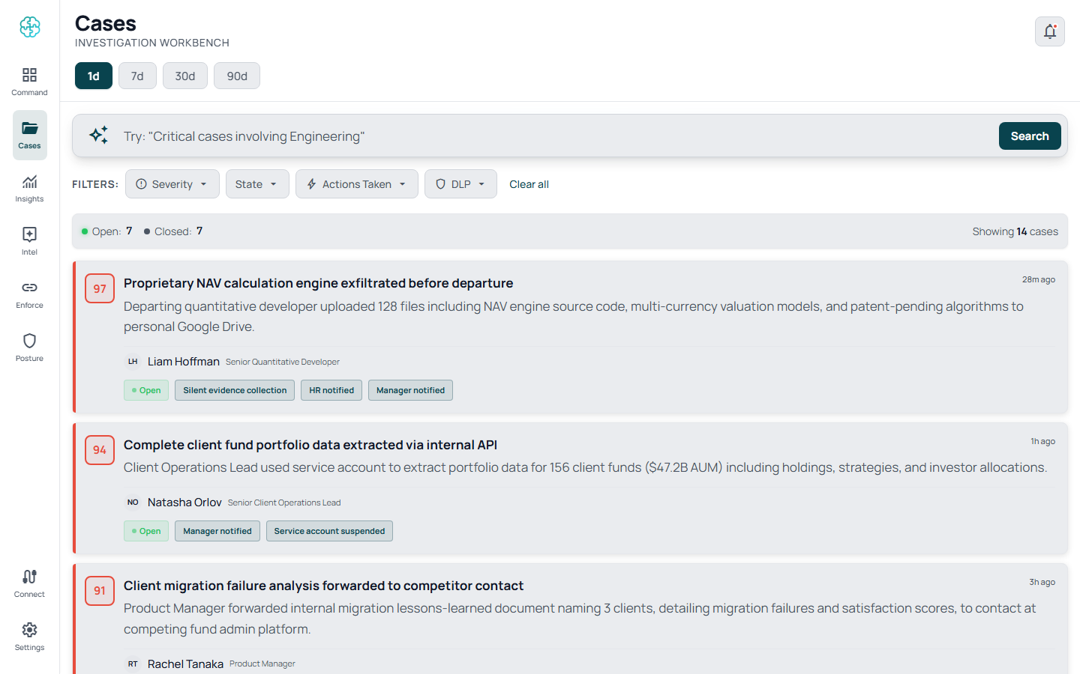
Cases — full case list with multi-select filters and AI-assisted search.

Case Details — the four-card investigation
For each case: Entity (who), AI Analysis (what happened, why it matters, why it's unusual for this person), Actions (engagement messages, escalation paths), and Timeline (the case history, including every system action and human decision).
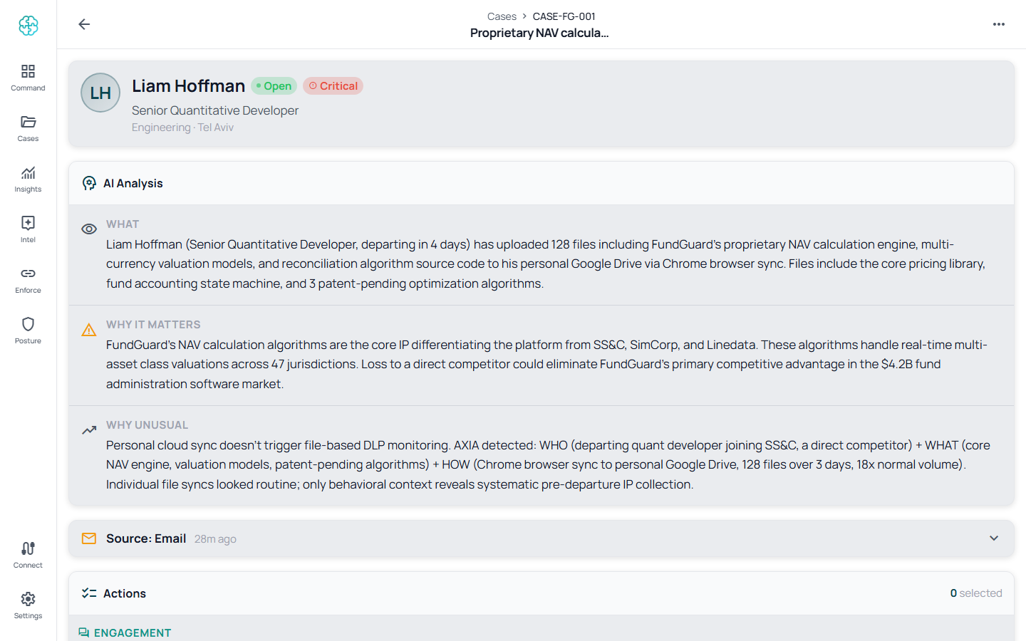
Case Details — four-card investigation view: Entity, AI Analysis, Actions, Timeline.

Insights — the analytics dashboard
RCS and MTTR over time, AXIA action breakdown, top case types, department heatmap, alerts-vs-true-cases ratio. The screen that proves AXIA is working — or surfaces where tuning is needed.
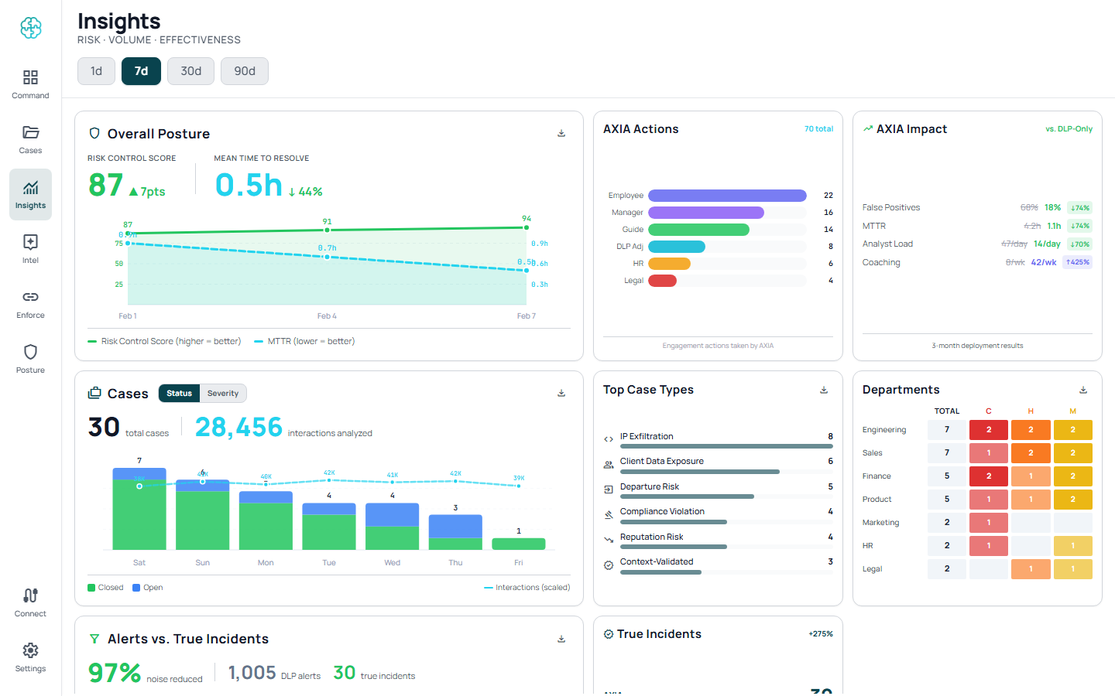
Insights — analytics dashboard with RCS/MTTR, AXIA actions, top case types, and department heatmap.

Intel — the conversational advisor
Natural-language Q&A grounded in your AXIA case history and connected data sources. "What's our risk posture in the engineering org this quarter?" Returns a narrative answer with citations to the underlying cases.
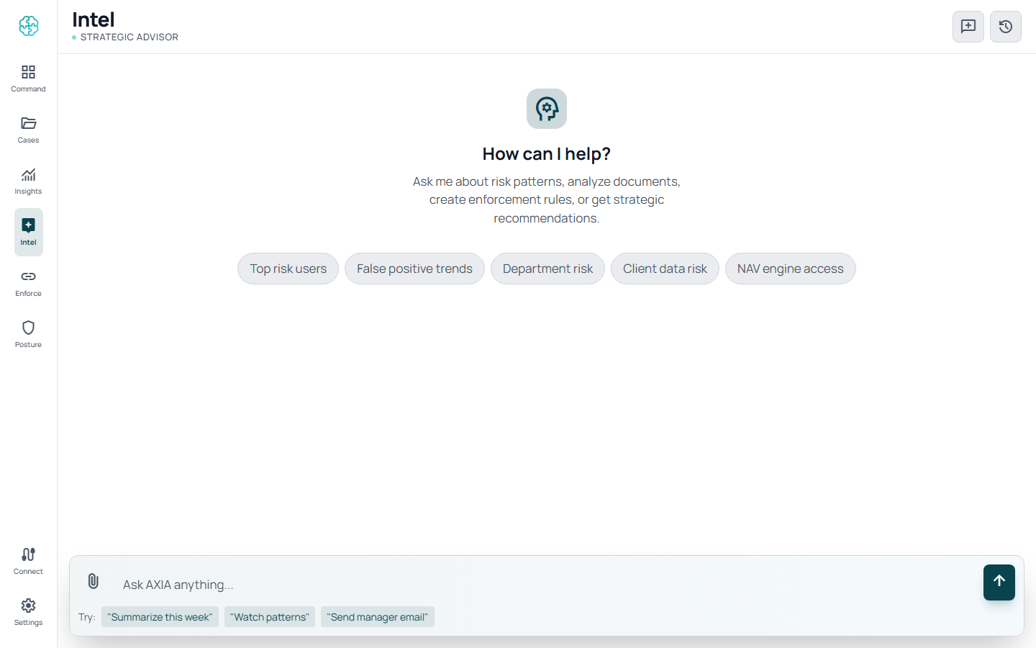
Intel — conversational AI advisor grounded in your case history.

Enforce — the DLP integration view
Connected DLP systems (Purview, Netskope) with coverage, sync status, events ingested, alerts correlated. Smart Block policies: contextual enforcement rules that close the loop back to your DLP based on resolved-case patterns.
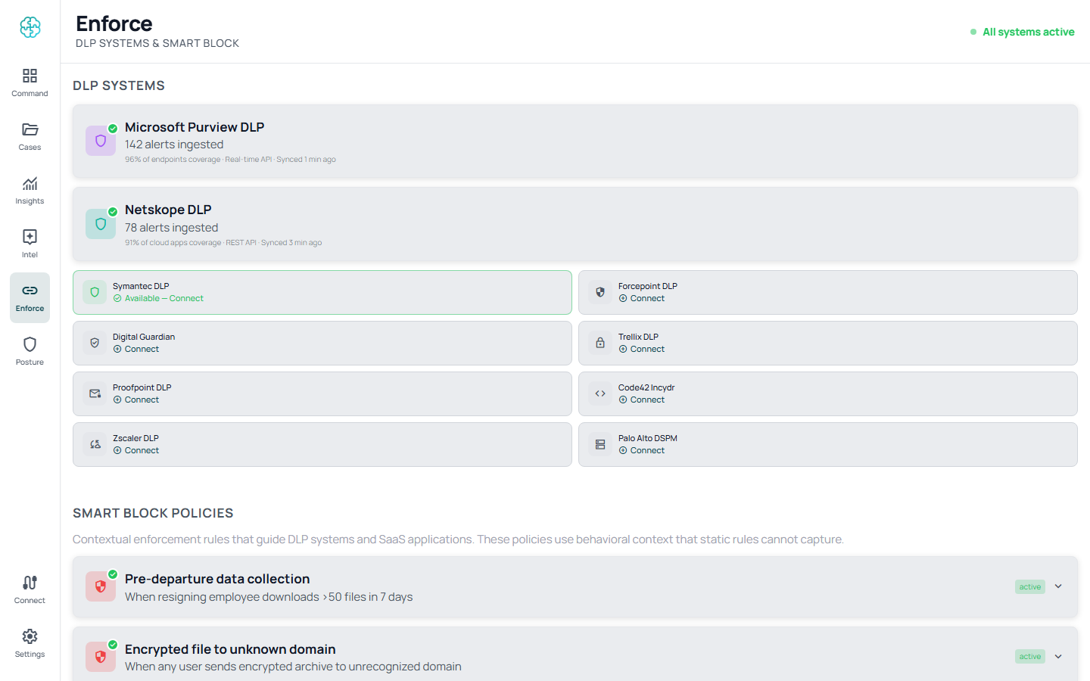
Enforce — DLP integration view showing Purview / Netskope connections and Smart Block policies.

Connect / Settings — data sources and configuration
Manage all integrations, organizational context, playbooks, and AI boundaries from one place.
________________________________________________________________________________
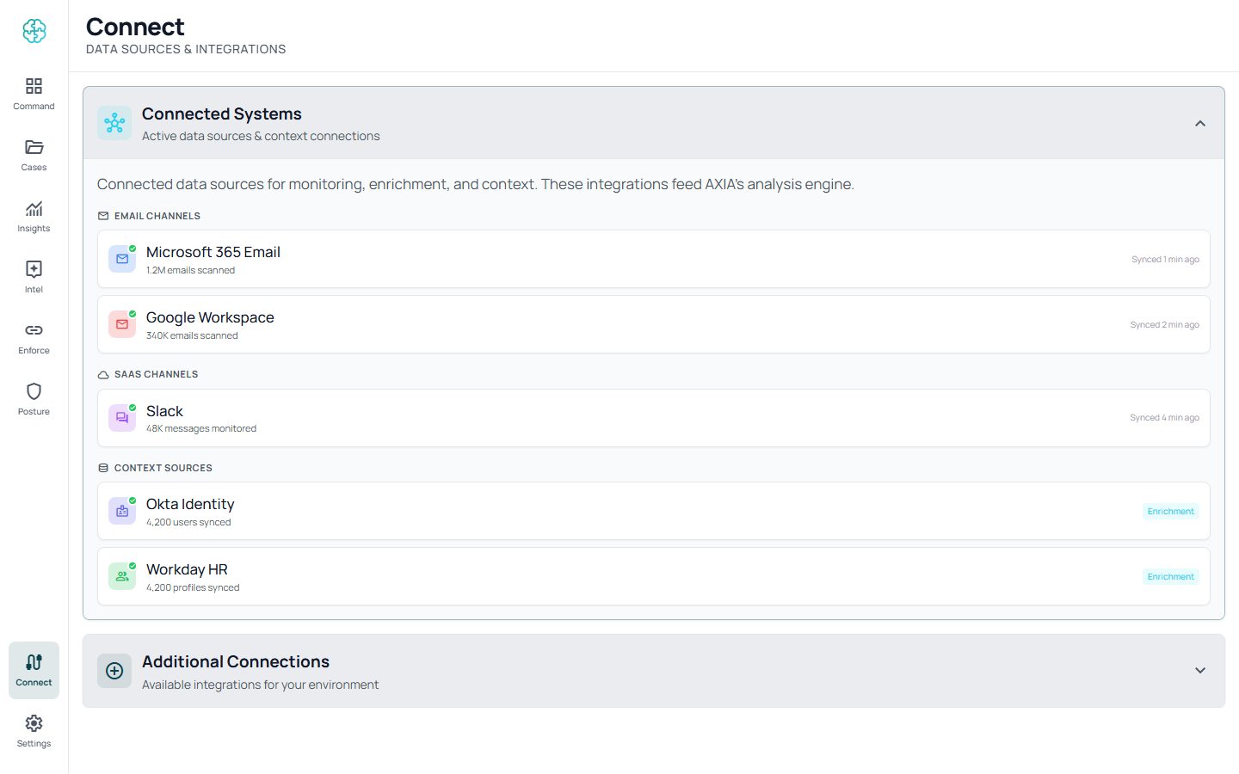
Connect — data-source management for email, SaaS, identity, and HR sources.

Why AXIA, in One Page
Dimension | Traditional DLP | IRM Platforms | AI Copilots | AXIA
Detection | Regex, keywords | Metadata analysis | General-purpose AI | Semantic AI + behavioral + intent
Context | None | Limited risk scores | Generic security context | Deep — role, HR, recipient, timing
Response | Block or alert | Alert queue | Suggestions | Judgment + engagement
Content Understanding | Pattern match | Metadata only | Generic LLM, vendor-hosted | Two-tier: AXIA's proprietary local Gatekeeper (~70% of cases, milliseconds) + customer's own LLM for deep judgment on the rest
User Engagement | None | None | Limited | Direct coaching + manager notification
Deployment | 6-12 months | Weeks-months | Depends | 48 hours, API, agentless
False Positives | 70-90% | 40-60% | n/a — not detection layer | Targeting under 10%
Existing Stack Impact | Migration | Partial overlap | n/a | Zero impact, runs alongside
Data Sovereignty | Varies | Cloud / on-prem | Vendor cloud | Your cloud or your DC — content never leaves your perimeter
Board Reporting | Alert counts | Risk dashboards | n/a | Risk Control Score, explainable

________________________________________________________________________________

Next Steps
A typical evaluation runs three weeks.
Week | Activity | Outcome
Week 1 | Graph and OAuth consent. Connect 1-2 channels, 1 DLP signal, identity context. | First Axia cases produced from your real data
Week 2 | Behavioral baselines stabilize. Smart Block recommendations begin. | Risk Control Score baseline; alert-volume reduction measurable
Week 3 | Executive walkthrough. Board-ready Posture review. | GO / NO-GO decision with concrete data on case volume, time-to-decision, FP reduction

Contact: hello@axiasecurity.io · axiasecurity.io
________________________________________________________________________________
This document derives from the AXIA PRD V2 (the definitive product specification) and the V6.30.1 demo family. For deeper technical detail on any section, refer to the PRD or request a working session with the AXIA team.

End of Document
AXIA Security • axiasecurity.io • hello@axiasecurity.io

