LUNELIS
DATA-FLOW REPORT
Lunelis Data Flow
Where every photo, setting and byte comes from, goes and stays

PRODUCT | Lunelis 0.46.0
DATE | 2026-10-09
STATUS | Draft for review (pilot of the documentation kit)
AUDIENCE | Maintainers, reviewers and anyone judging privacy
BASED ON | CLAUDE.md and src/lunelis (catalog, importers, raw, xmp, importing, edit, dupes, migrate, backups, jobs, recognize, geo, updater, gallery, darktable)

Statements in this document are read from the code and the changelog. Anything that could not be confirmed is listed under To check.
Contents
The big picture 3
Threads and trust boundaries 4
Trust boundaries 5
What Lunelis writes into photo folders 5
Scanning folders into the catalog 6
Reading metadata and sidecars 7
Thumbnails and previews to the grid 8
Ratings and tags to XMP sidecars 9
Card import 10
Edits, previews and export 11
Duplicates and quarantine 12
Migration 13
Backups and catalog snapshots 14
The darktable bridge 16
Models and recognition 18
Network use 19
Data inventory 21
Failure paths 22
To check 23
Discrepancies 24

CHAPTER 1

The big picture
Lunelis is one Python program on one PC. It indexes photos where they already sit, in folders called sources (the code calls them roots). It keeps its own records in a data folder and one SQLite catalog. This document follows the data: what is read, what is written, where it is kept, and the few places where anything leaves the PC.
44  schema migrations |  | 9  background job kinds |  | 4  internet hosts the app contacts |  | 28  file types cataloged

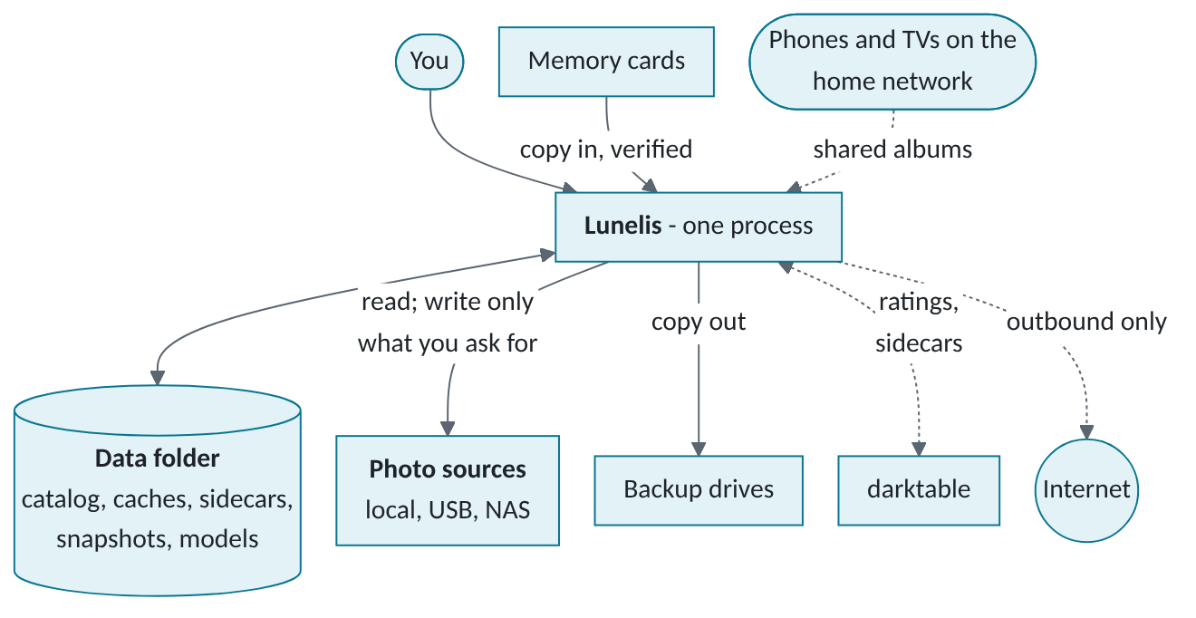
Figure 1. System context. Photos stay on their disks, Lunelis keeps its records in the data folder, and the internet is optional and outbound only.
- Originals are read, not changed. Lunelis writes into photo folders in a few cases only: an XMP sidecar next to a photo, files you import, files a migration copies, and renames into a _Lunelis Quarantine folder. Each case has its own chapter below.
- Everything else lives in the data folder. The catalog, thumbnails, edit previews, models, snapshots and the central sidecar store never go in a photo folder or the program folder (paths.py).
- No photo data is sent anywhere. The program contacts four hosts, all outbound. They see an internet address and a request, never a photo, a name or a location.

Each flow chapter that follows has the same parts: a diagram, a step table (step, from, to, data, stored in) and a box of rules that must not regress. The ends of the document hold the data inventory, the failure paths, what could not be confirmed (To check) and where the code and the project notes disagree (Discrepancies). Facts come from the code of version 0.46.0; file names are given so each one can be checked.
CHAPTER 2

Threads and trust boundaries
Lunelis is one operating-system process. Work is split across threads so the window never waits for a disk. A SQLite connection cannot cross threads, so every worker opens its own connection to the same catalog file (open_catalog: WAL mode, 20 second lock wait).
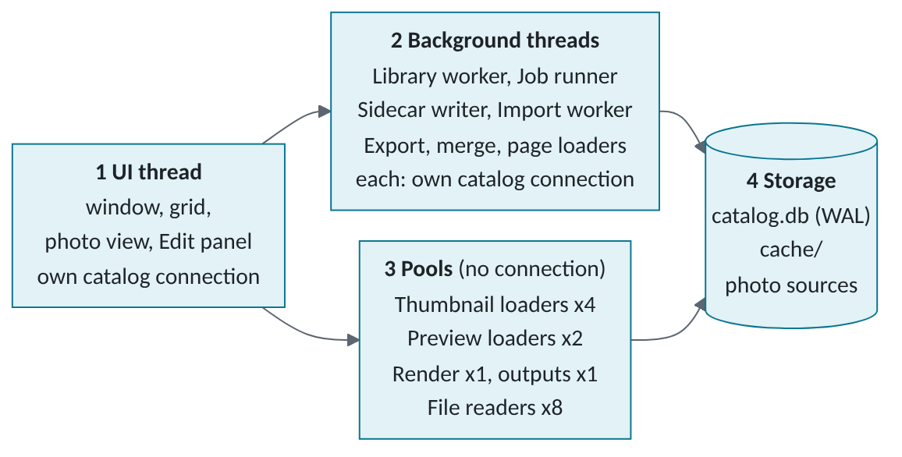
Figure 2. Four layers inside the one process. Layer 2 threads each hold a catalog connection; the pools only read files and cached images.
Worker | Runs as | What it does
Library worker | One QThread per pass | The library pass (below). Readers inside a step run 8 at a time
Job runner | One QThread per session | Takes queued jobs one at a time. 9 kinds in jobs/engine.py
Sidecar writer, import worker | A QThread per write or import | export_pending, 1.2 s after the last change; stage, verify and place card files
Thumbnail loaders | QThreadPool, 4 threads | Decode cached JPEGs for visible tiles. 1,500 pixmaps kept
Photo view, editor | Pools of 2, 1 and 1 | Preview decode, live render, edit outputs in order
Family gallery | Server thread plus request threads | Only while an album is shared. One catalog connection per request

The library pass runs on one worker, in this order: scan, find moved files, read sidecars, read metadata, Takeout dates, burst stacks and timelapses, search index, find moved files by content, thumbnails, near-duplicate fingerprints, scene tags, faces, places, suggestions, damage check. A failed step is logged and the rest still run. Every per-file worker calls pace.breathe(), which waits (at most 600 s) while a video plays, so playback is not starved.

Trust boundaries
Boundary | What crosses it | Guard in the code
You and the window | Keys, clicks, dialogs | Confirm before rating over 500 photos, downloads, emptying quarantine
App and photo sources | Reads; writes only as listed below | Read-only opens, temp name then replace, hash re-read, no rename or overwrite
App and data folder | Catalog, caches, models, snapshots | paths.py refuses a network path
App and memory cards | Reads, hashes; one delete you trigger | Clear the card re-hashes both copies
App and backup drives | Copies out, reads back | Volume serial, hashes, nothing deleted
App and other programs | XMP text, TSV files, darktable luarc, Takeout JSON | Text edits, newest change wins
App to internet | Update check, downloads, map tiles | HTTPS, SHA-256, opt-in, no photo data
Home network to app | Gallery requests | Home addresses, key per album, PIN, rate limits
Installer, updater | setup.json, release zip, swap script | .sha256, no .. in the zip, old version restored
Model files | ONNX loaded into memory | SHA-256 at download only

What Lunelis writes into photo folders
In a photo folder | When | What happens to it
name.EXT.xmp sidecar | beside mode, or one exists and the update setting is on | Stays. Edited as text, never re-serialized
.lunelis-*.xmp.tmp | While a sidecar is written | Renamed over it, or deleted on failure
.lunelis-importing-*, .lunelis-migrating-* | While a file is copied in | Renamed to the real name after the flush
Imported and migrated files | An import or a migration | Stay. Names never change
_Lunelis Quarantine/ | Copies and originals set aside (no Lunelis folder set) | Stays until you empty it
CHAPTER 3

Scanning folders into the catalog
The scan makes the files table match the disk. It reads directory listings only: names, sizes and times. It never opens a photo.
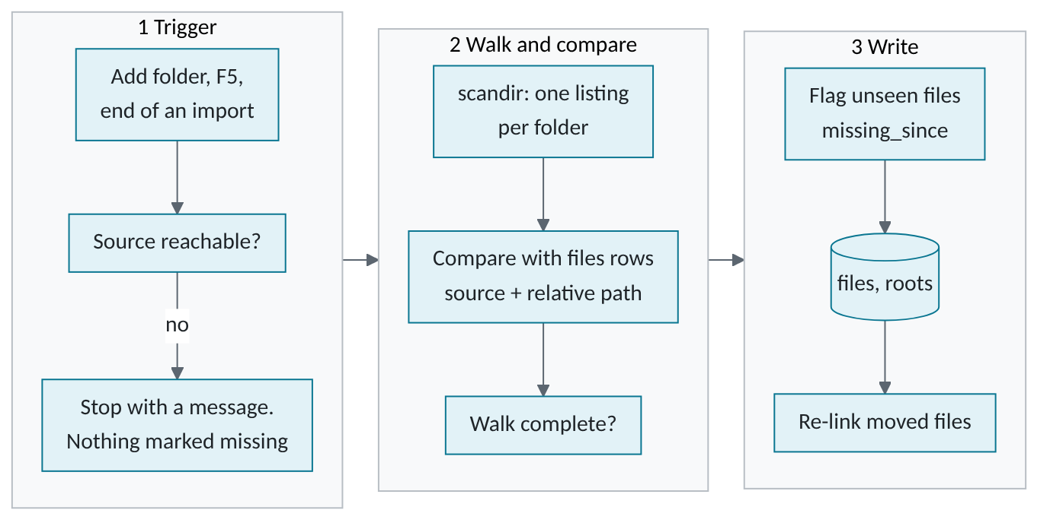
Figure 3. Scan. An offline source is refused rather than scanned as empty, and only a complete walk can flag files missing.
Step | From | To | Data | Stored in
1 | You | Library worker | Source ids from Add folder, F5 or an import. One pass at a time | Memory
2 | Library worker | Source | A folder-exists check. A missing source raises RootUnavailable, never "empty" | Nothing
3 | Source | Library worker | Per folder: name, size, time, XMP names. Hidden, system and link entries skipped | Memory
4 | Library worker | Catalog | New: insert. Size or time changed: update, clear hashes and thumbnail. Back again: clear the missing flag. Commit every 2,000 rows | files
5 | Library worker | Catalog | Complete walk only: unseen files get missing_since (not quarantined, not in unreadable or skipped folders) | files, roots
6 | Library worker | Catalog | A missing row takes over a new file with the same size and time. Rows with user data never merge | files, file_moves

WARNING · Scan rules that must not regress
- The scanner never deletes a files row. A missing file keeps its ratings, albums and faces.
- An unreachable source is never scanned as empty. A cancelled scan or an unreadable subfolder marks nothing missing under it.
CHAPTER 4

Reading metadata and sidecars
Sidecars are read first, then the files themselves. Readers run 8 files at a time and open everything read-only. Catalog writes stay on one thread, in batches.
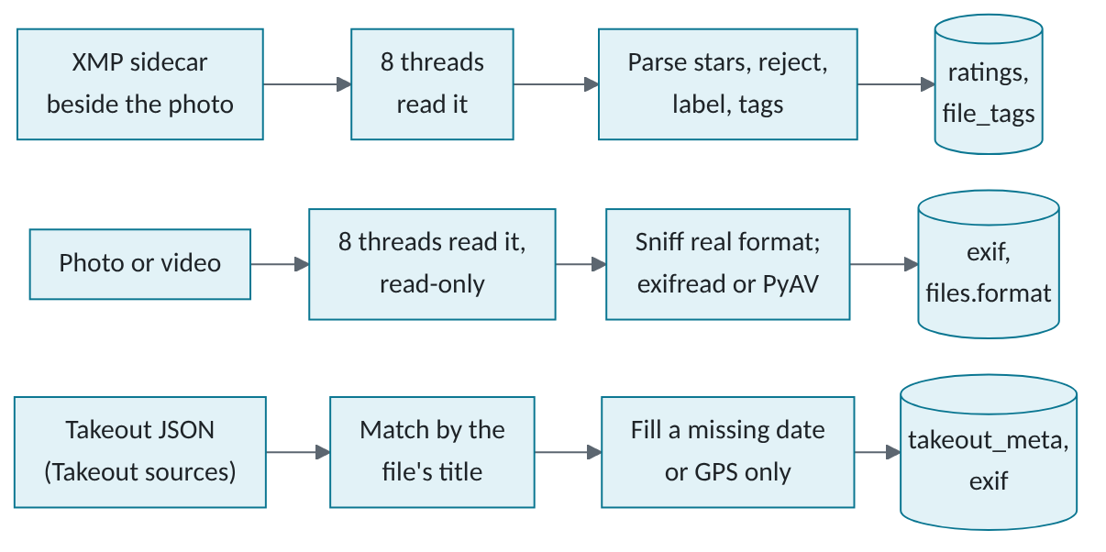
Figure 4. Three readers feed the catalog. Rows are committed in batches, so a stopped pass resumes where it left off.
Step | From | To | Data | Stored in
1 | Sidecar | Library worker | Sidecars changed since the last sync, if no Lunelis change is waiting. Rating (-1 = reject), label, tags | Memory
2 | Library worker | Catalog | A rating row only if one exists or values are not default. Tags only added. lunelis:EditStack parsed, never applied | ratings, file_tags
3 | Original | Library worker | First bytes (real format), then EXIF. Maker notes only for real camera RAW. Videos through PyAV | Memory
4 | Library worker | Catalog | Fields plus all EXIF as zlib JSON. Format and RAW flag set from the bytes. Batches of 200 | exif, files
5 | Library worker | Catalog | A failed read stores read_error, retried only when the file changes. An offline share leaves files pending | exif
6 | Takeout JSON | Catalog | Date and GPS where the file has none. Never overrides EXIF | takeout_meta, exif

WARNING · Metadata rules that must not regress
- The extension is a guess. Decoders ask files.format, which comes from the bytes (importers/formats.py).
- No pyexiv2 (it cannot open non-ASCII paths on Windows). No maker notes on non-RAW files.
CHAPTER 5

Thumbnails and previews to the grid
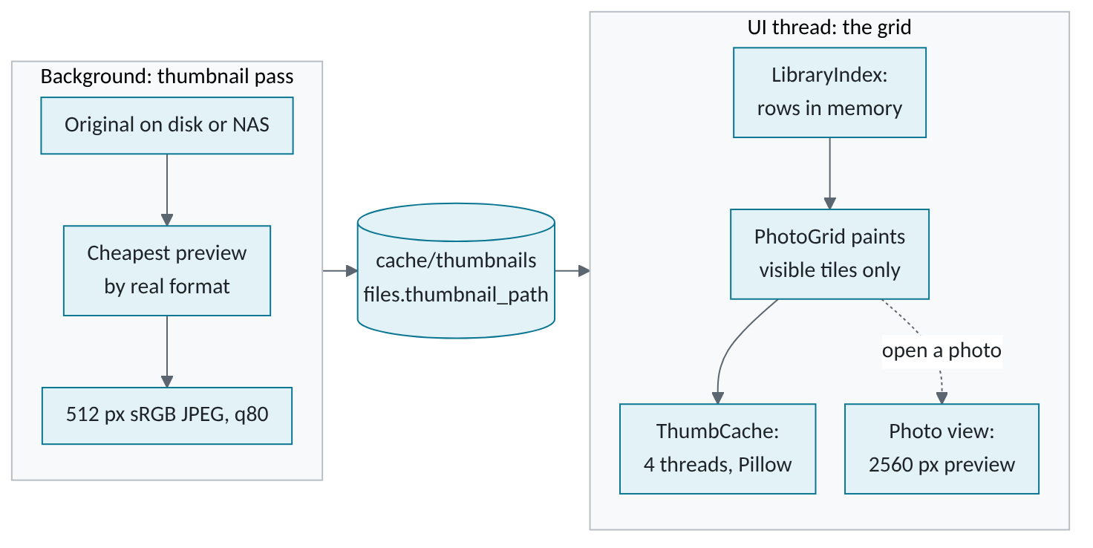
Figure 5. Thumbnails are made once, in the background. The grid only ever loads the small cached JPEGs.
Step | From | To | Data | Stored in
1 | Original | Thumbnail pass | Smallest embedded JPEG of 512 px or more (RAW), camera JPEG preview, HEIC, or a video poster frame. Decoded in 8 threads | Memory
2 | Thumbnail pass | Cache | Upright sRGB JPEG, 512 px long edge, quality 80, written to a temp name then replaced | cache/thumbnails/
3 | Thumbnail pass | Catalog | Path or error text, plus a 64-bit fingerprint (dHash) taken from the picture in memory | files
4 | Catalog | Grid | One query loads every row as plain tuples. Burst stacks collapse in Python | Memory only
5 | Cache | Grid | A visible tile with no pixmap queues a load. Pillow decodes; the UI thread converts | Memory, 1,500 pixmaps
6 | Original | Photo view | Biggest embedded preview, up to 2560 px. A full RAW decode only when you zoom past it | Memory

IMPORTANT · No RAW decode in the scroll path
The grid and the filmstrip load only cached JPEG thumbnails. Paint never touches the disk or the catalog. A RAW is decoded only on demand: in the editor, on an export, or when you zoom past the embedded preview. Deleting the thumbnail folder rebuilds it on the next pass; a file that fails keeps thumb_error until it changes.
CHAPTER 6

Ratings and tags to XMP sidecars
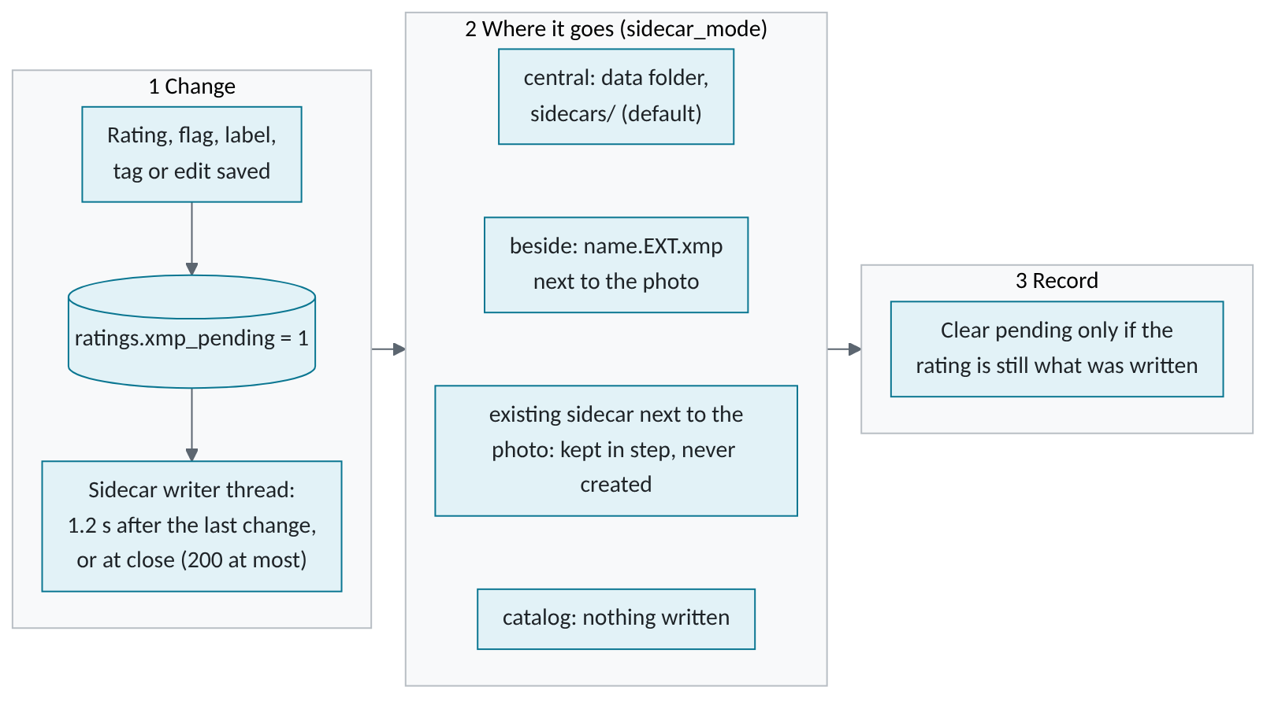
Figure 6. Sidecar export. One setting picks where the file goes, and an existing sidecar can be kept in step as well.
Step | From | To | Data | Stored in
1 | You | Catalog | Stars 0 to 5, pick or reject, colour label, tag, or edit stack | ratings, file_tags, edits
2 | Catalog | Sidecar writer | Every row with xmp_pending = 1: stars, flag, label, manual tags, edit text | Memory
3 | Sidecar writer | Central store | sidecars/<id>-<source name>/<folder>/<file>.EXT.xmp | Data folder
4 | Sidecar writer | Photo folder | Only in beside mode, or if a sidecar exists and the update setting is on (default) | Next to the photo
5 | Sidecar writer | Sidecar | Text edit of changed fields only, checked well-formed, temp file then replace. A newer unwritten Lunelis change wins over the file | XMP text
6 | Sidecar writer | Catalog | Pending cleared if stars, flag and label still match. A failure keeps it pending, with the error | ratings.xmp_error

WARNING · Sidecar rules that must not regress
- Never parse and re-serialize XMP: it renames darktable's namespace prefixes. Only changed values are edited as text.
- Reject is xmp:Rating = -1. A pick has no XMP field and never creates a sidecar. Adobe crs: settings are never written.
CHAPTER 7

Card import
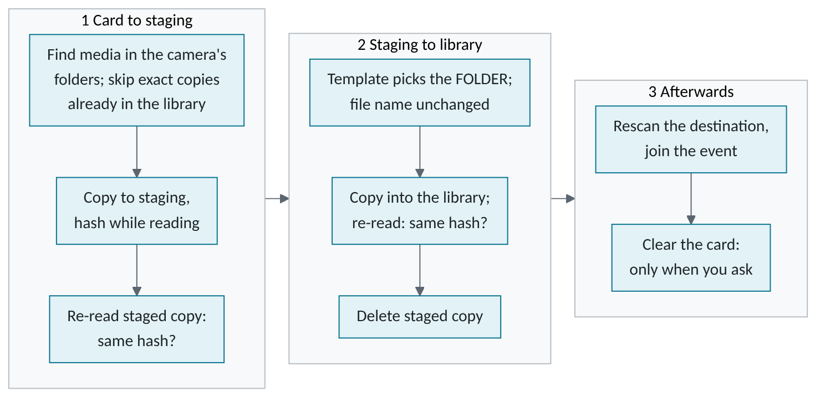
Figure 7. Card import. Two hash checks guard the copy, and the staged copy is deleted only after the library copy verifies.
Step | From | To | Data | Stored in
1 | Card | Catalog | List of media, companions (Live Photo video) and sidecars, one row each | imports, import_items
2 | Card | Staging | Copied to a .lunelis-importing-* temp name, hashed while read, flushed, renamed, re-read and compared | staging/import-<id>/
3 | Staging | Library folder | Folder from the template and capture date. A different file with the same name goes to a sibling folder, ... (2) | Your destination
4 | Library folder | Import worker | The new copy is re-read and compared with the card hash. Only then is the staged copy deleted | import_items.state
5 | You | Card | Clear the card re-checks size, time and both hashes, then deletes card files. A changed file is left | The card

Staging is local while the disk keeps import_local_reserve_gb free (50 GB by default), then spills to the network staging folder if set, else the import waits. A pulled card or sleeping share sets waiting; the import resumes from import_items.
WARNING · Import rules that must not regress
- Imported files are never renamed. The template chooses folders only.
- "Already in the library" and "Clear the card" compare the full SHA-256; a sampled hash is never proof (audit LRA-001).
CHAPTER 8

Edits, previews and export
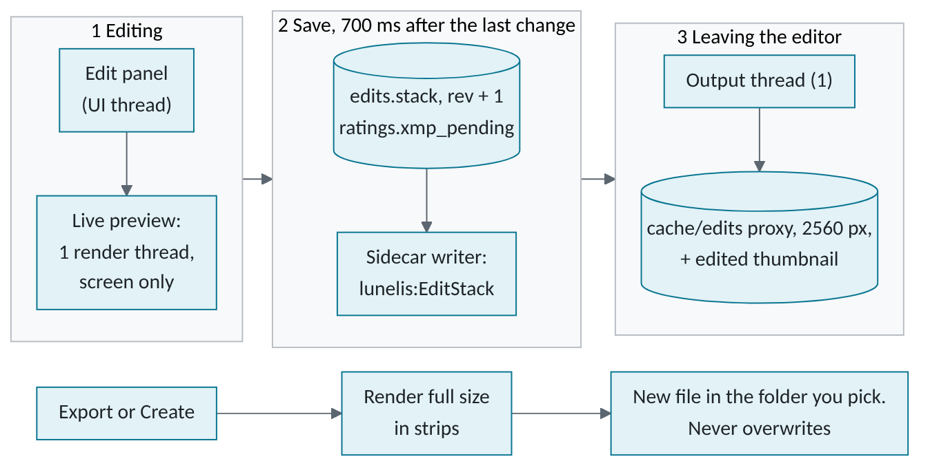
Figure 8. Edits are instructions, not pixels. Only the editor writes the cached look, through one ordered thread.
Step | From | To | Data | Stored in
1 | Original | Edit panel | RAW through rawpy (half size when enough), JPEG at its own pixels. Float RGB, upright | Memory
2 | Edit panel | Catalog | The stack as text: filter, sliders, crop, curves, masks. An identity stack deletes the row | edits, copies
3 | Catalog | Sidecar | lunelis:EditStack, when sidecars are written (previous chapter) | XMP text
4 | Edit panel | Cache | 2560 px JPEG (quality 90) and a 512 px thumbnail with the edited look | cache/edits/, cache/thumbnails/
5 | Original | Export | Full render in strips, sharpening, colour profile. EXIF rebuilt from the catalog: all, no location, or none | A new JPEG, TIFF or PNG
6 | Edit panel | Cache | AI mask maps, made from the upright source and kept as PNG | cache/masks/

WARNING · Editing rules that must not regress
- The source file is never overwritten. An export is always a new file ("name (2).jpg" if the name is taken).
- Only the edit controller writes proxies and thumbnails. A late background write once put an edited look back on a reset photo.
- Exports use apply_tiled (strips). Never apply at full size: 60 MP in one piece needs several GB.
CHAPTER 9

Duplicates and quarantine
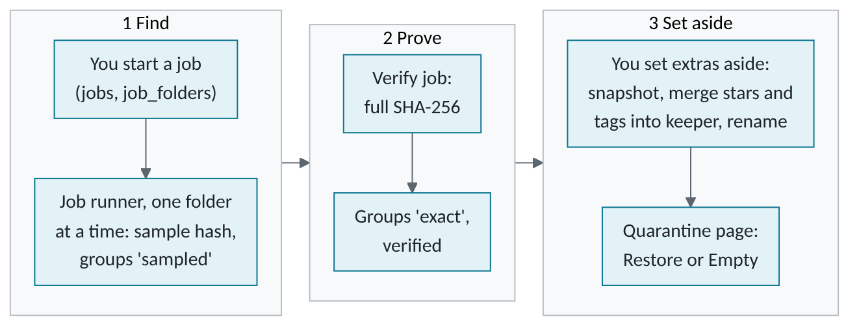
Figure 9. Duplicates. A sampled hash is a hint; only a full hash makes a group exact, and only exact groups can be set aside.
Step | From | To | Data | Stored in
1 | You | Catalog | A scope, a schedule (now, idle, night), a speed limit. A folder is marked done only after its work is committed | jobs, job_folders
2 | Original | Job runner | Sample hash: size plus 3 slices of 64 KB (about 200 KB a file), only for files sharing size and capture time | files.sample_hash
3 | Original | Job runner | Verify job: every byte, SHA-256. Identical files form an exact group | content_hash
4 | Catalog | Snapshot, catalog | Before a batch: a snapshot. Stars, tags, albums and sidecar of the extra go to the kept copy | backups/, ratings
5 | Source | _Lunelis Quarantine | A rename on the same drive (copy, compare, remove across drives), sidecar included | files.quarantined_at
6 | You | Recycle Bin | Empty: the kept copy must verify on disk. Local to the Recycle Bin; network removed after an extra tick | purged
7 | Thumbnail pass | Catalog | Near-duplicates: a dHash per photo, grouped by complete linkage (4 bits, not RAW, same moment). Method similar | perceptual_hash

WARNING · Duplicate rules that must not regress
Only verified byte-identical groups can be set aside, never down to zero live copies. A job never hard-deletes; emptying quarantine is a user action with its own snapshot.
CHAPTER 10

Migration
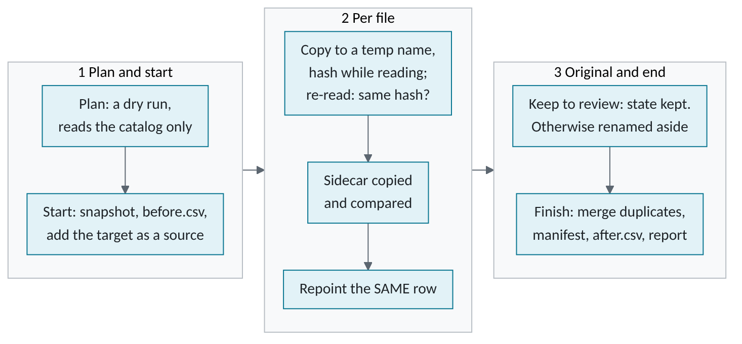
Figure 10. Migration. The same catalog row is repointed to the verified copy, so ratings, tags and thumbnails follow the file.
Step | From | To | Data | Stored in
1 | Catalog | Plan | Per file: move, skip duplicate (an exact twin moves), or skip damaged (an intact copy exists). Folder from the template | migration_items
2 | You | Logs folder | Start: snapshot, then before.csv listing every file in every source | Migration logs/
3 | Source | Target | Copy to .lunelis-migrating-*, hashed while read, re-read and compared. A name clash goes to a sibling folder | Target folder
4 | Source | Target | The sidecar is copied beside the photo and compared byte for byte | Target folder
5 | Migration | Catalog | root_id and rel_path of the same row repointed, move logged, state copied | files, file_moves
6 | Source | Set-aside | State done: renamed to the Lunelis folder's Trash, or _Lunelis Quarantine/migration-<id> on its own drive. kept in review mode, and the scanner skips it | Source drive
7 | Catalog | Logs folder | End: manifest.csv (SHA-256 of each copy), after.csv, an accounted-for report | Migration logs/

WARNING · Migration rules that must not regress
- A plan changes nothing on disk. Never delete, overwrite or rename. Originals are released only when the report finds nothing missing.
- A crash is safe: before step 5 the source is untouched; after it a resume only finishes the original.
CHAPTER 11

Backups and catalog snapshots
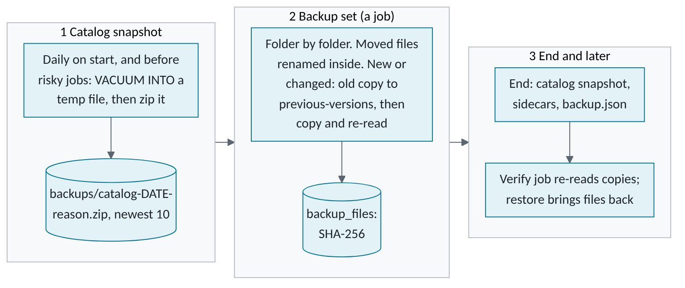
Figure 11. Two separate safety nets. Snapshots protect the catalog; backup sets protect photo files.
Step | From | To | Data | Stored in
1 | Catalog | Snapshot folder | A consistent copy made while the catalog stays open, zipped. Newest catalog_backups_keep (10) kept | backups/
2 | Library | Backup drive | New or changed files, hashed while read, re-read, compared. A mirror of each source's folders | <backup>/<id>-<name>/
3 | Backup drive | Backup drive | A changed file's old copy moves to previous-versions/<time>/ inside the backup. Nothing is deleted from a backup | Backup drive
4 | Job runner | Catalog | Size, time, SHA-256 per copy. The first backup fills files.content_hash. At the end: a snapshot (5 kept), sidecars, backup.json | backup_files, _Lunelis/
5 | Backup drive | Library | Restore: missing or damaged files come back (a damaged one is quarantined first). The catalog returns at the next start | restore-pending.json
6 | Job runner | Catalog | Verify job re-reads each copy against its hash. A missing drive makes the job wait; a full one pauses it | backup_files

WARNING · Snapshots and restores
A snapshot is taken before every job that moves or removes files, and before every schema upgrade. All snapshots share the newest 10, so an old one is deleted as newer ones arrive. Picks, events, albums, faces and edits live only in the catalog, so snapshots protect them.
CHAPTER 12

The darktable bridge
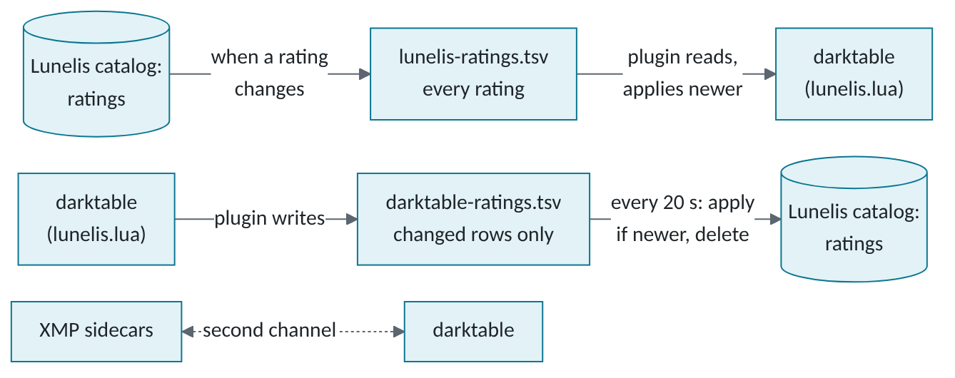
Figure 12. darktable bridge. Two TSV files in one exchange folder; the newest change wins. XMP sidecars are a second channel.
Step | From | To | Data | Stored in
1 | You | darktable | Install copies lunelis.lua into darktable's lua folder and adds one require line to luarc | %LOCALAPPDATA%\darktable\
2 | Catalog | Exchange file | Every rating: full path, stars or -1 for reject, label, UTC change time | lunelis-ratings.tsv
3 | Exchange file | darktable | At darktable start-up, on a view switch and on "Sync with Lunelis": only rows newer than its last_applied preference | darktable's library
4 | darktable | Exchange file | Same moments, and when darktable closes: rows changed since its last snapshot | darktable-ratings.tsv, darktable-snapshot.tsv
5 | Exchange file | Catalog | Matched by full path, case-insensitive. A row older than the catalog's change is skipped | ratings
6 | Catalog | Sidecar | An applied change queues a sidecar write like any rating | See the sidecar chapter

The exchange folder is darktable/ in the data folder unless you set another. The Lunelis side checks every 20 seconds on the UI thread, and is cheap when nothing changed.
WARNING · darktable rules that must not regress
- The plugin edits no photo, no darktable history and no XMP file directly. darktable writes its own sidecars as usual.
- Newest change wins. Picks never cross, because darktable has none. darktable may hold several colour labels; Lunelis keeps one and never removes the extras.
CHAPTER 13

Models and recognition
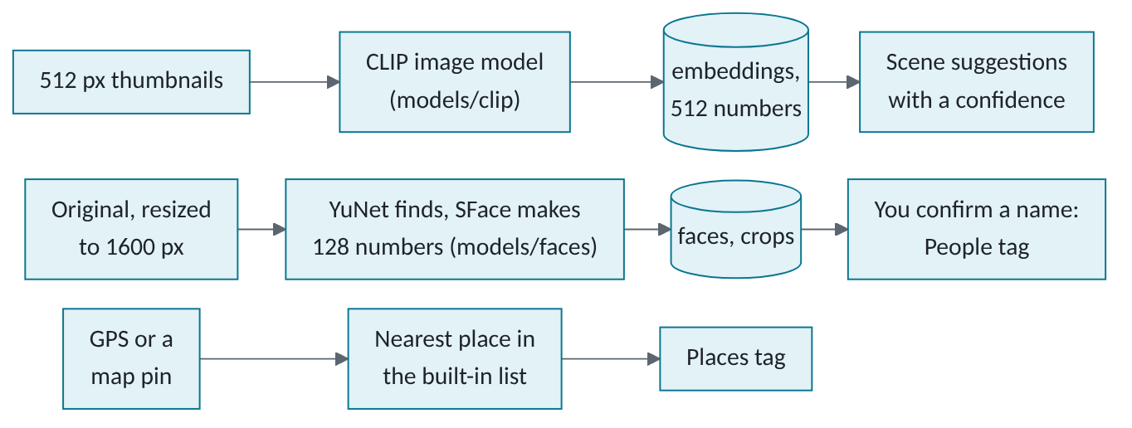
Figure 13. Recognition. Everything runs on the CPU in this process. Each path reads different pixels, and only names you confirm become tags.
Step | From | To | Data | Stored in
1 | Internet | Models folder | You confirm. Each file is checked against its SHA-256 and size, then moved into place | models/
2 | Cache | CLIP | Thumbnails only: never a RAW or the NAS. Scored against 40 labels: 25 % or more, 3 per photo at most | embeddings, file_tags
3 | Original | YuNet, SFace | Upright copy, 1600 px at most. A face needs score 0.8 and 2.5 % of the long edge. Videos skipped | Memory
4 | YuNet, SFace | Catalog | Box as fractions, 128-number fingerprint, model name, 160 px crop. Each photo once per model | faces, cache/faces/
5 | Catalog | Catalog | Suggested to a named person at cosine 0.40, grouped at 0.45. Only a face you confirm tags the photo | faces, file_tags
6 | Catalog | Catalog | Nearest of 31,735 listed towns: named within 40 km, country only within 250 km. A pin beats GPS | photo_places, locations
7 | Original | Mask maker | Subject and sky masks from the upright source, cached as PNG. Ask matches your words to stored fingerprints | cache/masks/

WARNING · Recognition rules that must not regress
Everything that understands pixels goes through the Recognizer interface, so it can move to an external service later. Suggestions carry a confidence, and every normal tag query filters confidence IS NULL.
CHAPTER 14

Network use
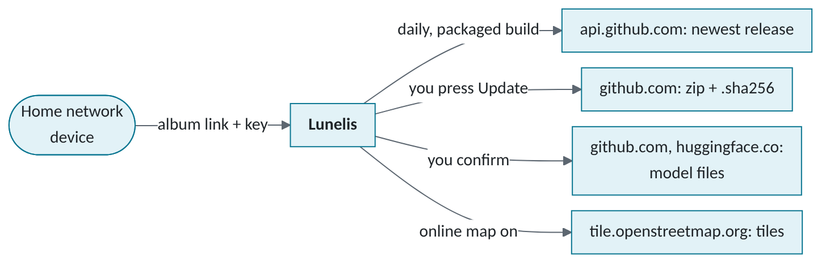
Figure 14. Network use. Four outbound hosts, each started by a setting or a click, and one inbound path that stays on the home network.
Destination | Why | When | What is sent | Default
api.github.com | Is a newer release out? | 8 s after start (packaged build, last check over 20 h ago), or the Check button. Setting update_check | GET; internet address, Lunelis-updater | On
github.com (releases) | Update zip and .sha256 | You choose Install | GET; internet address | Off
github.com (OpenCV, rembg) | Face and subject-mask models | You confirm a download | GET; Lunelis | Off
huggingface.co | CLIP and sky-mask models | You confirm a download | GET; Lunelis | Off
tile.openstreetmap.org | Map pictures | Map shows tiles (map_online); each tile fetched once | Zoom, column, row; Lunelis/x.y.z | Off
www.openstreetmap.org | Show a place in your browser | You click, and "location opens" is the browser | Coordinates, in a URL | Off
Home network, default port 8735 (in) | Family gallery | While an album is shared | 1600 px JPEGs without EXIF | Off

A search of src/lunelis for urllib, QNetworkAccessManager, socket and http finds only the files above. There is no account, no telemetry and no crash upload; Help > Report a problem shows text for you to copy. Every model download and the update check send the program name in the User-Agent header and nothing else you could identify; the host sees your internet address.
NOTE · What comes down is checked, but only so far
- Model downloads are hashed on arrival and deleted on a mismatch. Existing model files are later accepted by size only.
- An update needs a matching .sha256. It comes from the same release as the zip, so it shows the download is intact, not who made it. The build is unsigned.
- Map tiles are decoded as images before saving; they are not hashed.

WARNING · Family gallery
Plain HTTP on all addresses of the PC (0.0.0.0). A request from outside the home ranges is refused first. Then: a random key per album, an optional PIN (PBKDF2, 200,000 rounds), 5 wrong PINs lock an address for 10 minutes, 20 lock an album for an hour, at most 32 connections, 1600 px copies with no EXIF. Home-network traffic is not encrypted.

The model downloads in full. All four sets come to about 414 MB. Each file is pinned by SHA-256 and size in the code (recognize/clip.py, recognize/faces.py, edit/ai.py).
Model | Files and sizes in bytes | Source | Saved in
YuNet and SFace (faces) | Detector 232,589; recognizer 38,696,353 | github.com, OpenCV model zoo at a pinned commit | models/faces/
CLIP ViT-B/32 (scenes, Ask) | Image model 89,117,001; text model 64,504,507; two word lists 862,328 and 524,619 | huggingface.co, an ONNX copy of OpenAI CLIP | models/clip/
Silueta (subject mask) | One file, 44,173,029 | github.com, rembg release v0.0.0 | models/
Skyseg (sky mask) | One file, 175,997,079 | huggingface.co, a published skyseg model | models/
CHAPTER 15

Data inventory
Data | Where it lives | Kept for | Leaves the PC?
Photos and videos | Your source folders | Until you remove them | Only by your action: export, import, backup, shared album
Catalog: ratings, picks, tags, albums, events, faces, settings, EXIF | catalog.db in the data folder | For ever | No. In snapshots and backup sets
Edit stacks, virtual copies | edits, copies; lunelis:EditStack in sidecars | For ever | Sidecar text goes into backups
Thumbnails, edit previews, masks | cache/ | Until cleared | No
Sidecars | sidecars/ (central) or beside the photo | For ever | In backup sets
Face fingerprints, names, crops | faces, people, cache/faces | For ever | No. In snapshots, so a shared snapshot shares them
Scene fingerprints, suggestions | embeddings, file_tags | For ever | No
Place tags, pins | photo_places, locations | For ever | Tags in sidecar text; pins no
Models | models/ | Until removed | They come in only
Catalog snapshots | backups/*.zip or your folder | Newest 10 of all kinds | In backup sets (5 kept)
Set-aside files | _Lunelis Quarantine, or Lunelis folder Duplicates and Trash | Until you empty them | No
Staging, update files | staging/, updates/ | Until placed or cleaned | The update zip comes in
Map tiles | map_tiles/ | For ever | They come in only
Gallery copies | gallery_cache/ | Until cleared | Served on the home network
Log | logs/lunelis.log, 5 files of 2 MB | Rotated | No. May name folders and files
Location and set-up records | location.json, setup.json, Windows Run and Uninstall keys | Until changed | No
CHAPTER 16

Failure paths
What fails | What the program does | What the user sees
NAS or drive offline | The scan refuses the source. Metadata and thumbnail passes leave its files pending. Jobs go to waiting and retry every 60 s. An import waits | "Folder unavailable"; photos marked OFFLINE (checked every 60 s); "Waiting for ... to come back online"
Staging disk full | The import pauses; no file is half placed | "Out of staging space"
Backup drive full or removed | The job pauses or waits. Nothing is deleted from the backup | The set's status line says why
Power cut or crash | Scans keep committed batches. A job resumes at its first pending folder; an import from import_items; a migration at its last safe state | "Resuming after an interruption"
Catalog damaged or empty | Start-up will not open it, and never starts silently empty | A box: restore the newest snapshot (bad catalog kept beside it), start empty, or quit
Catalog from a newer version | Refused, untouched | A message to install the newest Lunelis
location.json unreadable | The default data folder is used for now; nothing moves | A warning naming the file
A sidecar cannot be written | The change stays pending in the catalog and is retried (60 s; 5 min after an error) | "Couldn't write N sidecar(s) - kept in the catalog"
A photo cannot be decoded | thumb_error or read_error is stored; skipped until it changes | A placeholder tile; a row in Damaged files
A model is missing | The step is skipped silently; Ask falls back to word search | A "Download and turn on" button in Settings
A download fails its hash | The partial file is deleted; nothing is installed | "Didn't match its checksum - nothing was installed"
The update cannot be swapped in | The script puts the old folder back and starts it | A warning on the next start
A card is pulled mid-copy | The import waits; it resumes when the same card (volume serial) is back. Staged files are kept | "Waiting for the card to be inserted again"
A migration copy does not match | The copy is deleted and the file fails; the original is untouched | A failed item in the Migrate page
Map tiles cannot be reached | Tiles already saved still draw. The dots always work | A one-time note on the Map page
The gallery port is busy | The server does not start | "The family gallery couldn't start on port N"
One library-pass step errors | It is logged; the other steps still run | "Finished, but these stopped on an error: ..."
REFERENCE

To check
- Start-up scan. No timer or start-up call that starts a scan was found in ui/main_window.py. Scans start from Add folder, F5, Library status, Settings, an import and the migration wizard. Confirm this is intended.
- Redirect hosts. The code names github.com and huggingface.co. The final download servers after their redirects are not in the code.
- Model files at rest. available() in recognize/clip.py and recognize/faces.py accepts a file of the right size without re-hashing it.
- Update trust. The .sha256 and the zip come from the same release. Whether signing is planned is not stated in the code.
- Gallery exposure. The server binds to all addresses and checks the client address. How Windows Firewall treats it was not examined. PIN and cookie travel unencrypted.
- Pending flag race. After a sidecar write, xmp_pending is cleared when stars, flag and label still match (xmp/sync.py). A tag or edit saved during that write is not compared. Not tested.
- RAW decode in the photo view. Preloading a neighbour that is an edited RAW with no cached proxy decodes it at half size (ui/detail_view.py). That is outside the grid and filmstrip, but it is a RAW decode while paging.
- Proxy settings. Whether QNetworkAccessManager follows the Windows proxy settings was not examined.
- darktable plugin. CLAUDE.md says the Lua script was tested only under a Lua 5.4 stand-in, never in a real darktable. Not re-checked here.
- Outside the program. The Inno Setup installer and the CI workflows are not in src/lunelis and are not covered.
- Full data disk. No code was found that handles a full data-folder drive in particular. A failed write inside a library-pass step is logged and the other steps run; other pages were not traced.
- Request headers. Qt may add default headers (such as Accept) to a tile request beyond the User-Agent set in ui/map_view.py. Not examined.
- Paths in logs. Status messages and errors go to logs/lunelis.log and can name folders and files. The problem report copies the last 200 log lines. Whether to scrub paths is not decided in the code.
- Daily snapshot. The "daily" snapshot is checked once, 3 s after start-up (_daily_backup). No timer was found, so a tray program left running for days snapshots again only at its next start, or before a risky job.
- Speeds. Rates quoted in CLAUDE.md were measured on its author's library and not re-measured.
REFERENCE

Discrepancies
Where | The documents say | The code does
docs/_tools/architecture.mmd | "SQLite schema v37". The jobs engine runs "dust maps". One box holds "Import + Autopilot, migrate, photo backups" | MIGRATIONS ends at version 44. There is no dust job kind (dust_view.py uses a page loader). Import and autopilot have their own threads; migrate and backups are job kinds
CLAUDE.md, Architecture | Edits are "an instruction stack in XMP" | The stack is written to the sidecar but never read back: import_sidecars ignores lunelis:EditStack, and nothing reads the central store. Only snapshots and backups restore edits
CLAUDE.md, thumbnail and metadata rules | Video thumbnails "not yet"; CR3 and video have no EXIF reader. Cache path <id//1000>/<id>.jpg | Videos get a poster-frame thumbnail (PyAV) and a metadata probe; only CR3 has no reader. cache_rel_path zero-pads: 0012/12819.jpg
CLAUDE.md, non-negotiables | "Lunelis's own files never go in the photo library" | Each source can hold _Lunelis Quarantine, and .lunelis-* temp files while writing. A Lunelis folder you choose can hold exports, trash and logs
CLAUDE.md, backup rule | A snapshot is taken before every job that moves or removes files | True, but Duplicates, Near-duplicates and Quarantine snapshot into data/backups, not the Settings folder that daily snapshots use. Start-up recovery also looks only in data/backups
catalog/schema.py, upgrade snapshot | The pre-upgrade snapshot "prune[s] nothing" and is "the way back" | It prunes nothing when made, but every later snapshot keeps only the newest catalog_backups_keep (10), so it is deleted after about ten more
CLAUDE.md scanner rules; geo/places.py | A change nulls three columns. About 34,000 places | The update also clears sample_hash and thumb_error. The list holds 31,735 rows
CLAUDE.md, Quarantine rules | empty() is the only hard removal | Clear the card (importing/ingest.py) also deletes, from the card, after a double hash check and your confirmation

