MediaLedger
Release and System Overview
What the software is, how it is built, and how a release is made
Version | Build date | Document date
2.1.1 | 2026-09-28 | 2026-09-29

Written for whoever maintains MediaLedger next. Every statement was checked against the repository, the git history or the GitHub release. Where something could not be checked it is marked UNVERIFIED and listed in the last section.

Contents
Contents 2
1. What MediaLedger is 3
1.1 Who it is for 3
1.2 The problem it solves 3
1.3 What it deliberately does not do 3
1.4 Size of the code 3
2. Architecture 4
2.1 Modules 4
2.2 The contract between the shells 5
2.3 Data flow of a scan 5
3. Technology 7
3.1 Outside services 7
4. How a release is made 8
4.1 Versioning 8
4.2 Branches and tags 8
4.3 The release gate (before tagging) 8
4.4 Continuous integration 8
4.5 Artifacts 8
4.6 Signing 9
4.7 How installations update 9
5. Version history 10
6. Known limitations and roadmap 13
6.1 Known limitations 13
6.2 Roadmap 13
7. Open questions and unverified items 14

Page numbers are filled in when the document is opened in Word, or when it is exported.

1. What MediaLedger is
MediaLedger is a ledger for a home media library. It reads the video files on a network share, measures each one, works out which series and movies they are, and keeps a record of what is there, what changed, what is missing and what is of poor quality. It does not play, download, transcode or serve media.

1.1 Who it is for
One household: a person who keeps a library of a few thousand to a few tens of thousands of files on a file server, usually served to the family by Plex, and who wants to know its state without opening folders. A second audience is the rest of the household, who want to see what is available and ask for more.

1.2 The problem it solves
- "What do I actually have?" Plex shows what it matched. MediaLedger shows every file, including the ones Plex ignored, with the resolution, bitrate, codecs and languages measured from the file.
- "What is missing?" It compares the episodes on disk with the episodes that exist according to TVmaze and AniList.
- "What changed?" Every scan records the files added, removed, modified and returned.
- "What is worth replacing, and what is dead weight?" It ranks titles by how much they are watched against how good the copy is, and lists large titles nobody has played.
- "Can the names be tidied safely?" It proposes names, renames in checked batches, journals each rename and can undo a batch.
- "Can the family see it and ask for things?" A separate read-only portal, by invitation.

1.3 What it deliberately does not do
- It never deletes media, and never moves or overwrites a file.
- It writes to the share only through the two rename pages, which are off until switched on.
- It sends nothing about the library to any service. Lookups carry series names only.
- It uses no paid service and no account with a third party, except the owner's optional free Tailscale account for the portal.

1.4 Size of the code
Measure | Value
Source files (src) | 50 files, 9,336 lines
Test files | 23 files, 1,197 lines, 15 suites run by npm test
Commits | 51
Tags | 31
First commit | 2026-09-05
Runtime dependencies | electron-updater
Development dependencies | docx, electron, electron-builder

2. Architecture
One core, three shells. The core is a map from an operation name to a function (src/main/service.js). The desktop shell calls it over Electron's bridge; the web shell calls it over HTTP; the family portal calls a short fixed list of its read operations and rebuilds every reply field by field. The pages are written once and run in both the desktop window and the browser.
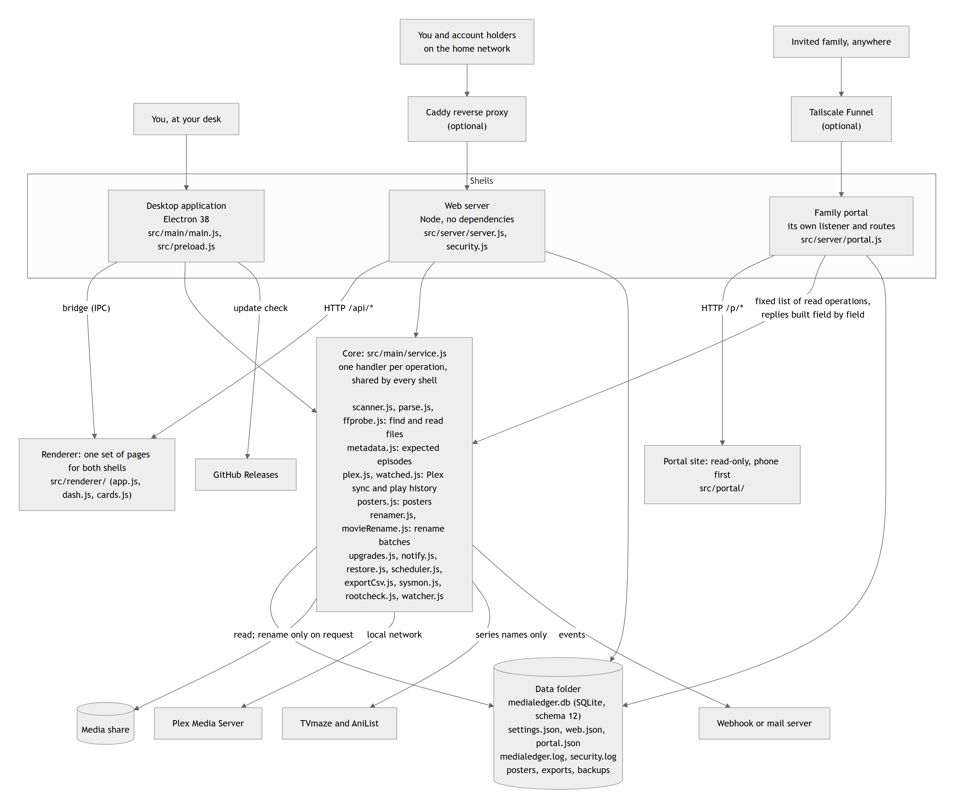
Figure 1. Modules, data flow, storage and outside services. Source: diagrams/architecture.mmd.

2.1 Modules
Module | File | Responsibility
Core | src/main/service.js | Registers every operation; owns the timers for scans, syncs, backups, snapshots and summaries; keeps the data version used to cache the dashboard.
Database | src/main/db.js | SQLite through node:sqlite. Base schema plus numbered migrations; a backup is taken before any migration.
Scanner | src/main/scanner.js, scanWorker.js | Walks the roots with worker threads, probes new and changed files with ffprobe.
Parser | src/main/parse.js, tags.js | Turns file names into series, season, episode, title and year; works out sub or dub.
Probe | src/main/ffprobe.js, ffmpegdl.js | Runs ffprobe on a file and reads the result; downloads ffmpeg on the desktop.
Roots and folders | src/main/rootcheck.js, watcher.js, paths.js | Reachability of each root with a diagnosis, folder watching, path handling.
Export | src/main/exportCsv.js, zip.js | CSV files and a dependency-free zip writer.
System monitor | src/main/sysmon.js | Processor, memory, disks, network and Raspberry Pi sensors for the System page.
Scheduler | src/main/scheduler.js | The in-app scan timer and the Windows scheduled task.
Metadata | src/main/metadata.js | Expected episodes and airing dates from TVmaze and AniList; the collecting policy.
Plex | src/main/plex.js | Library sync, path mapping, play history for every account, webhook events.
Watch reports | src/main/watched.js, upgrades.js | Who watched what, next up, reclaim candidates, upgrade ranking.
Posters | src/main/posters.js | Fetches and indexes one poster per title.
Renaming | src/main/renamer.js, movieNamer.js, movieRename.js | Proposed names, batches with pre-flight checks, journal and undo.
Notifications | src/main/notify.js | Webhook and a dependency-free mail client.
Backup and restore | src/main/restore.js | Backup sets, validation, staged restore applied at start-up.
Settings | src/main/settings.js | Defaults merged with settings.json.
Desktop shell | src/main/main.js, src/preload.js, src/main/updater.js | Window, bridge, automatic update, screenshot gate.
Web shell | src/server/server.js, security.js, totp.js, clientip.js | HTTP, roles, sessions, two-factor codes, audit log, real visitor address behind a proxy.
Family portal | src/server/portal.js, src/portal/ | Separate listener, invites, rate limits, address check, its own site.
Renderer | src/renderer/ | Pages (app.js), dashboard editor (dash.js, from the Bracket kit), charts (cards.js), QR codes (qr.js), the web bridge (webbridge.js).

2.2 The contract between the shells
src/renderer/bridge-shape.js lists every operation the pages may call. test/service.test.js fails the build when an operation exists in the core but not in the bridge, when the bridge names one that nothing serves, or when the web shell declares one that is neither a desktop-only stub nor an override of a core operation. This is what keeps the two shells from drifting apart.

2.3 Data flow of a scan
- The scanner walks every enabled root and compares size and date with the database.
- New and changed files are probed with ffprobe, several at a time.
- The parser reads each name; saved fixes are applied over the result.
- Changes are written to the change log; vanished files are flagged missing, never deleted.
- If enabled: episode lookups for new series, then a Plex sync with the play history, then posters for new titles.
- A daily snapshot is taken, CSV files are exported if configured, and the data version is bumped so cached reports refresh.

3. Technology
Part | Technology | Version | Notes
Language | JavaScript (CommonJS), no build step | ES2022 | No TypeScript, no bundler, no framework.
Desktop runtime | Electron | 38.8.6 | Declared as ^38.0.0.
Server runtime | Node.js | 22 on the Raspberry Pi (installed by the installer); 22 in the release workflow | Development machine at the time of writing: v24.18.0.
Database | SQLite through node:sqlite | Built into Node | No native add-on to compile.
Packaging | electron-builder (NSIS, x64) | 26.15.3 | One-click installer, per user.
Automatic update | electron-updater | 6.8.9 | The only runtime dependency.
Documents | docx | 9.7.1 | Development only: builds the manuals.
Media probing | ffprobe (ffmpeg) | Not pinned | Downloaded on demand on the desktop; from the system package on the Raspberry Pi.
Dashboard editor | Bracket kit dash.js | Vendored copy | Four additions marked [ML] in the file.
Reverse proxy (optional) | Caddy | Not part of the repository | Deployment choice of the owner.
Public address (optional) | Tailscale Funnel | Not part of the repository | Deployment choice of the owner.
The lock file pins 341 packages in total, nearly all of them belonging to electron-builder. The server package shipped to the Raspberry Pi contains no third-party code at all.

3.1 Outside services
Service | Used for | What is sent | Account or key
TVmaze | Expected episodes and posters for TV | Series names and identifiers | None
AniList | Expected episodes and posters for anime | Series names and identifiers | None
Plex Media Server | Titles, ratings, watched state, play history, posters | Requests on the local network | The owner's Plex token, stored in settings.json
GitHub Releases | Update check and downloads | A version request | None (public repository)
Webhook or mail server | Notifications | Event summaries | Set by the owner

4. How a release is made
This is the process as it works today, read from .github/workflows/release.yml, electron-builder.yml, tools/pack-server.js, server/install.sh and the git history.

4.1 Versioning
- Semantic versioning. The version lives in one place, package.json (mirrored in package-lock.json).
- CHANGELOG.md follows Keep a Changelog and is updated in the same commit that bumps the version.
- Commit messages are imperative, with no prefix: "Release 2.1.1: …".

4.2 Branches and tags
- One branch, main. There are no release branches and no pull requests in the history.
- A release is a tag vX.Y.Z on main, pushed by the owner by hand.
- Of the 40 versions in the changelog, 31 were tagged and built. The others were committed and superseded before being tagged; their changes shipped in the next tagged version.

4.3 The release gate (before tagging)
- npm test runs 15 suites.
- The desktop screenshot pass renders every page against a real profile and exits with code 3 if any page logged an error: npx electron . --profile=<dir> --screenshots=<dir>.
- The in-repository manual is rebuilt from those screenshots: node tools/build-manual.js <dir> docs/MediaLedger-Manual.docx, then exported to PDF with Word.
- Version and changelog are committed together.

4.4 Continuous integration
GitHub Actions, workflow "Build & Release (Windows)", on windows-latest. It runs on every pushed tag that starts with v, and can be started by hand.
Step | Command | Purpose
1 | actions/checkout@v4 | Source at the tag
2 | actions/setup-node@v4 with Node 22 | Toolchain
3 | npm ci | Exact dependencies from the lock file
4 | npm test | Quality gate: the build stops here on a failure
5 | node tools/pack-server.js | Server package and its checksum
6 | npm run build:win -- --publish never | Windows installer
7 | actions/upload-artifact@v4 | Keeps the installer with the run
8 | softprops/action-gh-release@v2 | Creates the GitHub release and attaches the files, with generated notes

4.5 Artifacts
File | What it is
medialedger-2.1.1-setup.exe | Windows installer (NSIS, x64, one click, per user).
medialedger-2.1.1-setup.exe.blockmap | Lets the updater download only what changed.
latest.yml | What the desktop updater reads to find a new version.
medialedger-server-2.1.1.tar.gz | Server package for this version.
medialedger-server.tar.gz | The same package under a fixed name, which the installer downloads.
medialedger-server.tar.gz.sha256 | Checksum the installer verifies before installing.
Published at https://github.com/AxialForge/medialedger/releases. Version 2.1.1 was published with six files; the workflow run for the tag succeeded.

4.6 Signing
The installer is not code-signed. The workflow can sign when two repository secrets are present (CSC_LINK, CSC_KEY_PASSWORD); the repository has no secrets set, and the project's policy is not to buy a certificate. Windows therefore shows an "unknown publisher" warning on first run. The server package is protected by its checksum only.

4.7 How installations update
Installation | Mechanism
Desktop | electron-updater checks GitHub at launch and every six hours, downloads in the background and applies the update on the next restart. Can be switched off in Settings or with NO_AUTO_UPDATE=1.
Raspberry Pi | sudo medialedger-update downloads the fixed-name package and its checksum, verifies, unpacks over /opt/medialedger and restarts the service. With --auto-update a systemd timer runs it every night.
Data | Never touched by either. The database upgrades itself on first start of a newer version, after taking a backup.

5. Version history
From CHANGELOG.md and the git tags. 40 versions between 2026-09-05 and 2026-09-28. "Tagged" says whether a release was built for that number.
Version | Date | Highlights | Breaking changes | Tagged
2.1.1 | 2026-09-28 | Editing the dashboard was slow; The dashboard report is answered from memory while nothing in the library has changed (for up to a minute, never during a scan), so opening the Dashboard repeatedly no longer recomputes it | None | yes
2.1.0 | 2026-09-28 | Posters; Posters folder; Sources: Plex first, through its own resizer, then AniList and TVmaze for series Plex does not have; The Plex webhook address shows https:// when the server sits behind a proxy that terminates HTTPS | None. Database upgraded to schema 12 automatically, with a backup taken first. | yes
2.0.1 | 2026-09-28 | Family portal address check; Invites can no longer be created before an address is set, which produced an invite with no link or QR code; Family portal page: the Save button and the ratings checkbox no longer stretch across the page | None | yes
2.0.0 | 2026-09-28 | Editable dashboard; Options shown; Family portal; Invites | None | yes
1.12.1 | 2026-09-26 | Turn HTTPS off; The share mount watchdog never re-mounted; Reachability check nudges an armed automount; The installer honours --port together with --update-only, rewriting just the service's port | None | yes
1.12.0 | 2026-09-18 | Reclaim space; Next up | None | yes
1.11.0 | 2026-09-18 | Collecting policy per series; Episodes filed under Movies; Plex sync breakdown per library | None. Database upgraded to schema 11 automatically, with a backup taken first. | no
1.10.0 | 2026-09-18 | Select next N; Log page; Full backups and restore; Overdue jobs | None | no
1.9.3 | 2026-09-18 | The timed Plex sync defaults to every 6 hours (it only runs when a token is set); Tables inside cards no longer overflow: on the Missing page the "N missing" badges were cut off by the neighbouring card on mid-width windows | None | no
1.9.2 | 2026-09-17 | Settings → Schedules; Timed Plex sync; The daily snapshot time is configurable (was fixed at 03:05) | None | yes
1.9.1 | 2026-09-16 | Watched tab; Upgrade candidates are ranked; The dashboard "Watched" tile opens the Watched tab | None. Database upgraded to schema 10 automatically, with a backup taken first. | yes
1.9.0 | 2026-09-16 | Readable charts; Colour rules on number tiles; Phone layout for cards | None. Database upgraded to schema 9 automatically, with a backup taken first. | yes
1.8.0 | 2026-09-16 | Dashboard and list tiles for the new data | None | no
1.7.0 | 2026-09-15 | TV and anime renames go through the movie batch engine | None | yes
1.6.0 | 2026-09-15 | Upgrades; Airing next; Notifications; Home Assistant status | None. Database upgraded to schema 8 automatically, with a backup taken first. | no
1.5.0 | 2026-09-15 | Watch tonight; Filter dropdowns; Storage forecast; Nightly backup to a folder | None | no
1.4.0 | 2026-09-15 | Tags | None. Database upgraded to schema 7 automatically, with a backup taken first. | no
1.3.1 | 2026-09-15 | Editable name pattern; Installer asked for a new web password on every rerun; The certificate download is named .crt instead of .pem, so Windows opens its certificate installer on double-click instead of asking for an app | None | no
1.3.0 | 2026-09-15 | QR codes; Turn on HTTPS; Plex token from the XML address; Colour themes | None | yes
1.2.2 | 2026-09-14 | User manual regenerated for 1.1 to 1.2.1; The Problems view's Duplicate episodes tile showed "undefined" since the 0.7.0 core split: the core returns a count while the page expected rows | None | yes
1.2.1 | 2026-09-14 | Custom internal domain | None | yes
1.2.0 | 2026-09-14 | Selectable CSV exports; Zip option; Downloads in the browser; Plex webhook | None | yes
1.1.0 | 2026-09-14 | User accounts with roles; Media requests; Issues; Account line in the sidebar with Sign in / Sign out | None | yes
1.0.4 | 2026-09-14 | Phone layout: table headers and rows stayed aligned only by luck in 1.0.3; Screenshot mode accepts --size=WxH (phone captures), waits for each web page to finish rendering, and keeps the window painting while occluded so captures are never stale | None | yes
1.0.3 | 2026-09-14 | Phone layout for the web build | None | yes
1.0.2 | 2026-09-14 | Library root status; Background root check; Folder browser on the web build; Pi mount watchdog | None | yes
1.0.1 | 2026-09-14 | Favicon in the browser tab, an Apple touch icon and a web-app manifest, so the Pi site shows the MediaLedger icon and can be added to a phone home screen as a standalone app | None | yes
1.0.0 | 2026-09-12 | User manual; Desktop app did not load in 0.7.0 through 0.8.2; docs/README.md index; Pi guide opens with a requirements table, the four commands that do everything, and a command reference | None | yes
0.8.2 | 2026-09-12 | System tab samples and refreshes every 5 s instead of 15 s (history still one hour); Pi throttling / voltage tile was missing: the installer now adds the service user to the video group so vcgencmd works | None | yes
0.8.1 | 2026-09-12 | Web server: the About page's Check for updates button was greyed out | None | yes
0.8.0 | 2026-09-12 | System tab; Security tab and hardening for the web server; Server-only release package; docs/RASPBERRY-PI.md: the complete Pi guide (hardware, OS, install, first run, daily use, updating, security, moving the desktop database, System tab, troubleshooting, f… | None | yes
0.7.0 | 2026-09-12 | Web server for the Raspberry Pi (and any Linux box); renderer/bridge-shape.js is now the single description of the window.ledger API; The application core moved out of the Electron entry point into src/main/service.js; Stored rel_path values keep \ separato… | None | yes
0.6.2 | 2026-09-12 | About page no longer flickers while an update downloads: progress updates the status line in place instead of rebuilding the page; Long values on the About page (ffprobe path, version banner) wrap inside their card instead of running off the right edge | None | yes
0.6.1 | 2026-09-12 | Check for updates; The GitHub repository is now public, so the in-app updater works with no token; Update errors are shown as a short explanation instead of the raw HTTP response (which dumped GitHub's headers and cookies into the panel) | None | yes
0.6.0 | 2026-09-12 | Plex integration (phase 2); Ratings tab gains Plex audience score, your Plex rating (shown out of 5) and a watched column; Movie naming engine gets a per-batch truth source: title and year from the file name plus fixes (default) or from the Plex match, with… | None | yes
0.5.0 | 2026-09-11 | Adult library; Web videos; Ratings; Movie names | None | yes
0.4.0 | 2026-09-06 | Movie naming engine; Batch executor with the full safety model: dry run by default, a per-tab "Allow live renames" switch plus a typed RENAME confirmation, whole-batch pre-flight (source exists, size unchanged since scan, target free, root writable, path le… | None | yes
0.3.0 | 2026-09-05 | Missing episodes; Duplicate review; Quality report; Rename tool (opt-in, off by default) | None | yes
0.2.0 | 2026-09-05 | Manual fixes: a Fix… button on every episode, movie file and Problems row opens a form to correct series, season, episode, title, year or edition, or to ignore a file; Multi-threaded directory listing (worker threads, on by default, toggle and thread count … | None | yes
0.1.0 | 2026-09-05 | Initial release: Electron desktop app that walks the TV, Anime and Movies shares, probes files with ffprobe, stores results in SQLite, exports CSVs, keeps a change log, and schedules scans via an in-app timer or Windows Task Scheduler | None | no
No version in the history required manual migration. Every database change was applied automatically on first start, with a backup taken beforehand.

6. Known limitations and roadmap

6.1 Known limitations
Limitation | Where | Effect
Binge detection is not written | src/main/watched.js, bingeSessions() (marked TODO) | The Binges card on the Watched page never appears.
The list pages are not on the dashboard editor | src/renderer/app.js, seriesView, views.movies | Only the Dashboard can be rearranged.
Desktop and web server keep separate databases | By design so far | Fixes, ratings and tags made on one do not reach the other.
"Renamed so far" can show a negative failure count | src/renderer/app.js, views.rename | Cosmetic. Seen while making the screenshots: the tile subtracts batch results from the older history count.
Some check boxes stretch across the page | Settings: Renaming, Adult content, CSV export | Cosmetic. The box is drawn the width of its field.
No light theme | src/renderer/styles.css | All eight themes are dark.
The renderer is one large file | src/renderer/app.js | Every page lives in it; changes are made by careful search.
Installer is unsigned | Release process | Windows warns on first run.
The legacy card-settings dialog is unreachable | src/renderer/app.js, openCardSettings | Dead code since 2.0.0.
"Not watched yet" on the portal is the household's | src/server/portal.js | Invites are not linked to Plex accounts.
Windows only on the desktop | electron-builder.yml | No macOS or Linux desktop build is produced.

6.2 Roadmap
Item | Source
Move-into-season-folder option for the rename tool | README, Roadmap
Synopsis from the metadata match on the series page (posters shipped in 2.1.0) | README, Roadmap
Dashboard editor on the TV, Anime and Movies pages | Planned with the owner for the 2.x line
A card builder: choose a measure, a filter and a chart | Planned with the owner
Home Assistant link through MQTT discovery | Planned with the owner
Desktop application as a client of the web server | Planned with the owner
Split the renderer into one file per page | Maintenance
Port the dashboard edit fix to the Bracket kit | Maintenance, in progress in a separate session

7. Open questions and unverified items
Item | Status
Minimum memory and processor | Never measured. The manual states this.
ffprobe version | Not pinned; whatever the download or the system package provides.
Behaviour on Node versions other than 22 and 24 | Not tested. node:sqlite requires Node 22.5 or newer.
Test coverage as a percentage | No coverage tool is configured; see the developer guide for what the suites cover.
Plex poster fetch on a real server | Tested against a stand-in server and on the owner's Raspberry Pi by the owner, not by the documentation run.

