MediaLedger
User Manual
Every page, dialog and setting, with numbered screenshots
Version | Build date | Document date
2.1.1 | 2026-09-28 | 2026-09-29

MediaLedger inventories the video files on a network share, tracks what changes between scans, finds what is missing or weak, and keeps your corrections. It runs as a Windows desktop application and as a web server on a Raspberry Pi; both show the same pages.
The screenshots in this manual show a fictional library generated for the purpose. No title, person or address in them is real.

Contents
Contents 2
1. Installing and first launch 5
1.1 System requirements 5
1.2 Installing the desktop application 5
1.3 Installing the web server on a Raspberry Pi 5
1.4 First launch 6
2. The interface 8
2.1 The sidebar in full 9
2.2 The three ways MediaLedger runs 10
2.3 Colour themes 11
3. Library 12
3.1 Dashboard 12
3.2 Dashboard, edit mode 15
3.3 Add a card dialog 16
3.4 Card options dialog 18
3.5 TV Shows 19
3.6 Poster wall view 21
3.7 Series page (episodes) 22
3.8 Movies 24
3.9 Movie page (versions) 25
3.10 Web videos 26
3.11 Adult library 27
4. Review 29
4.1 Missing episodes 29
4.2 Match dialog 32
4.3 Collect dialog 33
4.4 Issues: Problems 34
4.5 Fix dialog 36
4.6 Issues: Duplicates 37
4.7 Quality 39
4.8 Upgrade candidates 40
4.9 Reclaim space 41
4.10 Ratings 42
4.11 Watch tonight 44
4.12 Watched 45
4.13 Requests 47
4.14 Request page for phones 49
5. Maintenance 52
5.1 Change log 52
5.2 Movie names 53
5.3 Rename TV / anime 56
5.4 Rename confirmation dialog 58
5.5 CSV export 59
6. Application 62
6.1 System 62
6.2 Family portal (administration) 63
6.3 Invite created, with its QR code 65
6.4 Log 66
6.5 Security 67
6.6 Two-factor setup 69
6.7 About 70
7. Settings 72
7.1 Settings: Appearance and Library roots 72
7.2 Settings: Scanning, ffprobe, lookups and folder watch 73
7.3 Settings: Renaming, adult content, quality thresholds and CSV export 75
7.4 Settings: Schedules 76
7.5 Settings: Data, backups and posters 78
7.6 Restore from a backup dialog 79
7.7 Folder browser dialog (web server) 81
7.8 Settings: Updates and notifications 81
7.9 Settings: Plex 83
8. The family portal 86
8.1 Family portal: Library 86
8.2 Family portal: a series 87
8.3 Family portal: Tonight 89
8.4 Family portal: Requests 90
8.5 Family portal: Settings 92
9. Short dialogs 95
9.1 Confirm it is you (password again) 95
9.2 One at a time 95
9.3 Dry run result 95
9.4 Batch items 95
9.5 Undo batch 95
9.6 Rename movie files, live 96
9.7 Movie batch result 96
9.8 Set source for selected 96
9.9 Ignore the other files 96
9.10 Card settings (before version 2.0) 96
10. Common tasks from start to finish 97
10.1 Find and fill the gaps in a series 97
10.2 Tidy the names of a group of episodes 97
10.3 Arrange the Dashboard 98
10.4 Give a family member access 99
10.5 Back up, and restore 100
10.6 Find out why something did not happen 100
11. Settings reference 102
11.1 What is remembered in the browser only 105
12. Keyboard shortcuts 106
13. Troubleshooting and frequently asked questions 107
13.1 Every message in one place 107
14. Glossary 110

Page numbers are filled in when the document is opened in Word, or when it is exported.

1. Installing and first launch

1.1 System requirements
 | Desktop application | Web server
Computer | A 64-bit Windows computer. The installer is built for x64 only. | Raspberry Pi 4B or 5 recommended; a Pi 3 works on a 64-bit system but scans slowly. Any Linux computer with Node 22 also works.
Operating system | Windows 10 or 11, 64-bit. | Raspberry Pi OS Lite (64-bit), Trixie or newer. 32-bit is not supported.
Storage | About 300 MB for the application. The database for a library of 25,000 files is about 25 MB; posters about 100 MB. | 32 GB microSD (class A2) or a USB solid-state drive.
Network | Access to the share that holds the media. | Ethernet on the same network as the file server. Port 8080 by default.
Also needed | ffprobe (part of ffmpeg). The application offers to download it on first launch. | Installed by the installer: Node 22, ffmpeg, cifs-utils, curl, openssl.
Memory and processor | UNVERIFIED: no minimum has been measured. A scan uses one ffprobe process per parallel probe (8 by default). | UNVERIFIED: no minimum has been measured. Runs on a Pi 4 with 4 GB.

1.2 Installing the desktop application
- Download medialedger-2.1.1-setup.exe from the Releases page of the project on GitHub.
- Run it. The installer needs no questions answered and installs for the current user.
- Windows may warn that the publisher is unknown, because the installer is not code-signed. Choose More info, then Run anyway.
- MediaLedger starts when the installer finishes.
Data is kept apart from the program, in %APPDATA%\MediaLedger. Updating, reinstalling or uninstalling never touches it.

1.3 Installing the web server on a Raspberry Pi
- Flash Raspberry Pi OS Lite (64-bit) with SSH enabled and start the Pi.
- Connect over SSH and run the installer:
curl -fsSL https://raw.githubusercontent.com/AxialForge/medialedger/main/server/install.sh -o install.sh && sudo bash install.sh
- Answer the three questions: the user name and password of the share, and a web password of at least 8 characters.
- Open http://<address of the Pi>:8080 and sign in as admin.
The installer is safe to run again. It creates a service that starts with the Pi, mounts the share, and installs three commands:
Command | What it does
sudo medialedger-update | Downloads the newest release, checks it, installs it and restarts. Data is untouched.
sudo medialedger --set-password | Sets or resets the web password and signs everyone out.
sudo bash install.sh --update-only --port=8080 | Moves the service to another port.
sudo bash install.sh --auto-update | Adds a nightly update at about 04:30. --no-auto-update removes it.

1.4 First launch
- Open Settings. Under Library roots list each folder to scan with its type, and press Check reachability.
- Press Save settings.
- Press Scan now at the bottom of the sidebar. The first scan reads and measures every file, which takes a while; later scans only read what changed.
- Open the Dashboard.
- Optional: under Settings, Plex, connect your Plex server, then set a backup folder under Data.
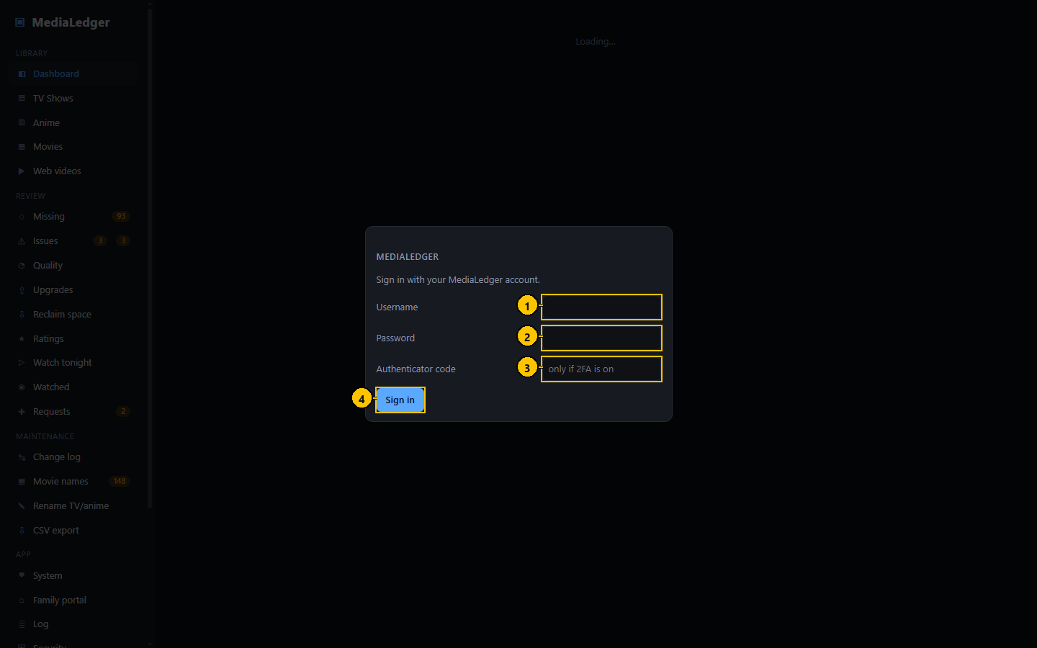
Figure 1. The sign-in dialog of the web server.
# | Control name | Type | What it does | Inputs and limits | Default | Notes
1 | User name | Text field | The account to sign in as. | Letters, digits, dot, dash and underscore; not case sensitive. | admin | The installer creates the account "admin".
2 | Password | Password field | The password of that account. | At least 8 characters. | empty | Never stored in the browser by the application.
3 | Authenticator code | Text field | The six-digit code, when two-factor codes are on. | 6 digits | empty | Leave empty when two-factor codes are off.
4 | Sign in | Button | Checks the pair and opens a session. | – | – | Pressing Enter in either field does the same.

Messages and what they mean
Message | Meaning and what to do
Wrong user name or password | The pair did not match an account. The attempt is counted towards the lockout.
Too many failed attempts; this address is locked for 15 minutes | Wait, or sign in from another address. The lockout is per address, not per account.
No account exists yet. On the server run: sudo medialedger --set-password | The server has never had a password set. Run the command on the Raspberry Pi.
Enter the 6-digit code from your authenticator | The password was right; two-factor codes are on and the code is the second step.

2. The interface
Everything happens in one window: a sidebar on the left that never changes, and the page you chose on the right. The desktop application and the web server show the same window; a few buttons that open folders exist only on the desktop.
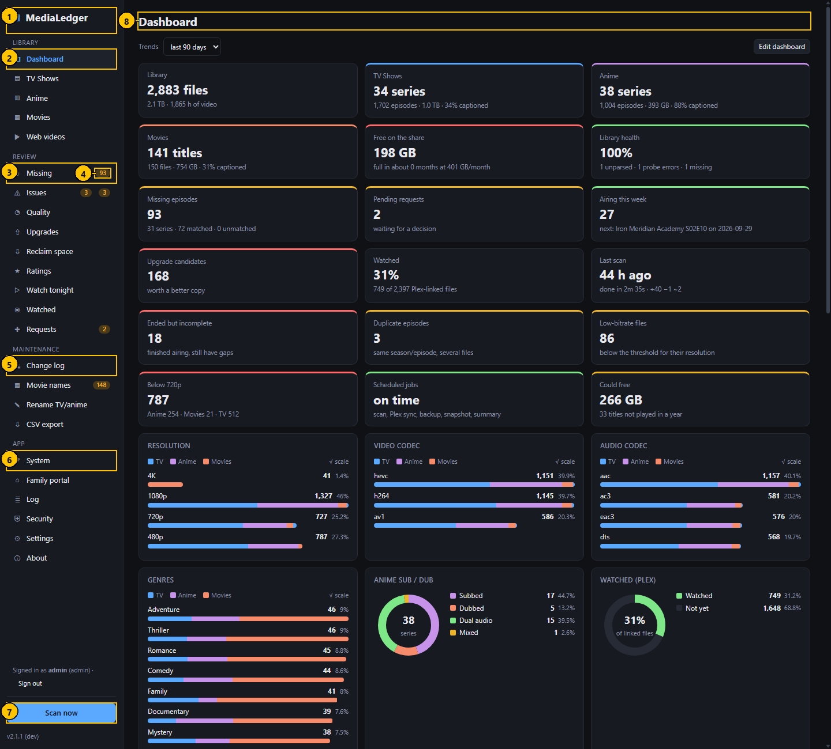
Figure 2. The main window. The numbers match the table below.
# | Control name | Type | What it does | Inputs and limits | Default | Notes
1 | Application name | Label | Shows which application this is. Not clickable. | – | – | –
2 | Library group | Navigation | Dashboard, TV Shows, Anime, Movies and Web videos: what is in the library. | – | Dashboard | The page you were last on is highlighted.
3 | Review group | Navigation | Missing, Issues, Quality, Upgrades, Reclaim space, Ratings, Watch tonight, Watched and Requests. | – | – | –
4 | Count pill | Indicator | How many items wait on that page: missing episodes, open problems, duplicates, pending requests, movie names to tidy. | – | hidden when zero | Amber for attention, red for a fault.
5 | Maintenance group | Navigation | Change log, Movie names, Rename TV/anime and CSV export. | – | – | The two rename pages are the only ones that write to the share.
6 | App group | Navigation | System, Family portal, Log, Security, Settings and About. | – | – | –
7 | Scan now | Button | Starts a scan of every enabled library root. | – | – | Turns into a progress line while a scan runs; a second scan cannot be started until the first ends.
8 | Page title | Heading | The name of the page on the right. | – | – | –

Finding your way
- Pick a page in the sidebar.
- Read the tiles at the top of the page for the summary, then the table or cards below for detail.
- Click a row to open the title or file it describes.
- Use the browser Back button, or the back link on a title page, to return.
- The sidebar is grouped: Library (what you have), Review (what needs attention), Maintenance (tools that change things), App (the application itself).
- Coloured pills beside a sidebar entry count what is waiting there.
- On a phone the sidebar is hidden behind the menu button at the top left.
- Pages that a guest or a standard user may not open are not listed in their sidebar at all.
- The Adult entry only appears when adult content is switched on for the session.

2.1 The sidebar in full
The sidebar is the application's only menu. It is present on every page.
 | Control name | Type | What it does | Inputs and limits | Default | Notes
– | Menu button | Button | Shows and hides the sidebar on a narrow screen. | – | – | Phones and narrow windows only.
– | Dashboard | Navigation link | Opens the Dashboard page. | – | – | –
– | TV Shows | Navigation link | Opens the TV Shows page. | – | – | –
– | Anime | Navigation link | Opens the Anime page. | – | – | –
– | Movies | Navigation link | Opens the Movies page. | – | – | –
– | Web videos | Navigation link | Opens the Web videos page. | – | – | –
– | Adult | Navigation link | Opens the Adult page. | – | – | Hidden until adult content is switched on.
– | Missing | Navigation link | Opens the Missing page. | – | – | –
– | Issues | Navigation link | Opens the Issues page. | – | – | –
– | Quality | Navigation link | Opens the Quality page. | – | – | –
– | Upgrades | Navigation link | Opens the Upgrades page. | – | – | –
– | Reclaim space | Navigation link | Opens the Reclaim space page. | – | – | –
– | Ratings | Navigation link | Opens the Ratings page. | – | – | –
– | Watch tonight | Navigation link | Opens the Watch tonight page. | – | – | –
– | Watched | Navigation link | Opens the Watched page. | – | – | –
– | Requests | Navigation link | Opens the Requests page. | – | – | –
– | Change log | Navigation link | Opens the Change log page. | – | – | –
– | Movie names | Navigation link | Opens the Movie names page. | – | – | –
– | Rename TV/anime | Navigation link | Opens the Rename TV/anime page. | – | – | –
– | CSV export | Navigation link | Opens the CSV export page. | – | – | –
– | System | Navigation link | Opens the System page. | – | – | –
– | Family portal | Navigation link | Opens the Family portal page. | – | – | –
– | Log | Navigation link | Opens the Log page. | – | – | –
– | Security | Navigation link | Opens the Security page. | – | – | –
– | Settings | Navigation link | Opens the Settings page. | – | – | –
– | About | Navigation link | Opens the About page. | – | – | –
– | Account line | Label with link | Who is signed in, with a link to sign out; for a guest, a link to sign in. | – | – | Web server only.
– | Show adult content | Check box | Shows adult titles for this session. | – | off | Not offered to guests.
– | Scan now | Button | Starts a scan of every enabled root. | – | – | Administrators only on the web server.
– | Cancel scan | Button | Stops the running scan. | – | – | Shown only while a scan runs.
– | Scan progress | Progress bar | How far the scan is, and the file being read. | – | – | –
– | Lookup progress | Progress bar | How far the episode lookups are. | – | – | –
– | Folder watch line | Label | Says that folders are being watched and when a change was last seen. | – | – | Shown when folder watch is on.
– | Update pill | Indicator | Appears on About when a newer version is available or downloaded. | – | – | –
– | Version | Label | The version that is running. | – | – | "(dev)" when run from source.
– | Message | Notice | Short confirmations and errors appear at the bottom of the window and fade. | – | – | Red for an error.

2.2 The three ways MediaLedger runs
 | What it is | Who uses it
Desktop application | A window on your Windows computer. Reads and writes your own data folder. | You, at your desk.
Web server | The same pages in a browser, served from a Raspberry Pi. Accounts, roles and a security log. | You and the people you give an account, on your network.
Family portal | A separate, small, read-only site with its own address. | People you invite, anywhere.

2.3 Colour themes
The application has eight colour themes, all of them dark. This is Gunmetal on the Movies poster wall. There is no light theme.
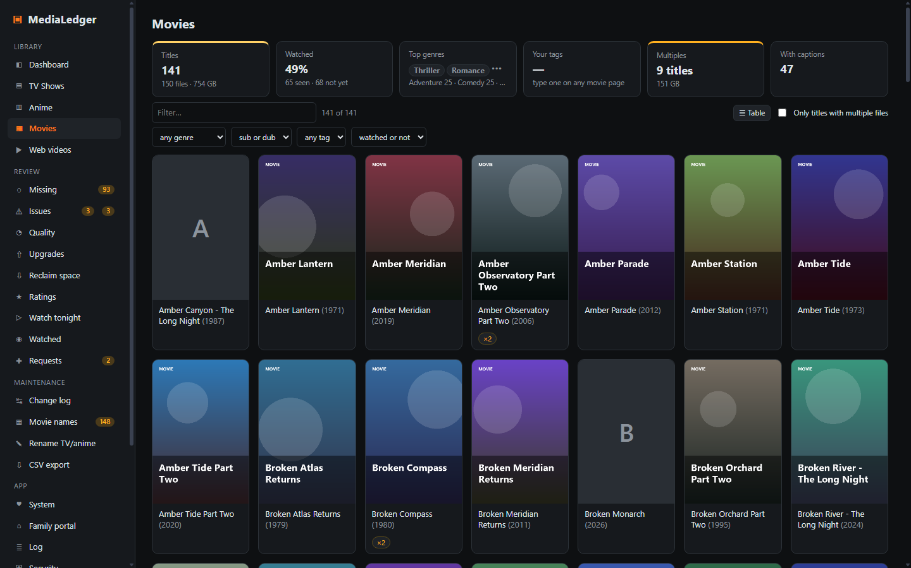
Figure 3. The Gunmetal theme.
- Graphite (the default), Midnight blue, Obsidian, Forest, Rose, Lavender, Gunmetal and Crimson.
- The choice is stored in the browser, so every device and person can have their own.

3. Library
What you have. The Dashboard summarises it; the list pages show it title by title.

3.1 Dashboard
The Dashboard answers "how is the library doing" in one look. Every element is a card; you choose which cards are shown, in what order and how wide (see Dashboard, edit mode).
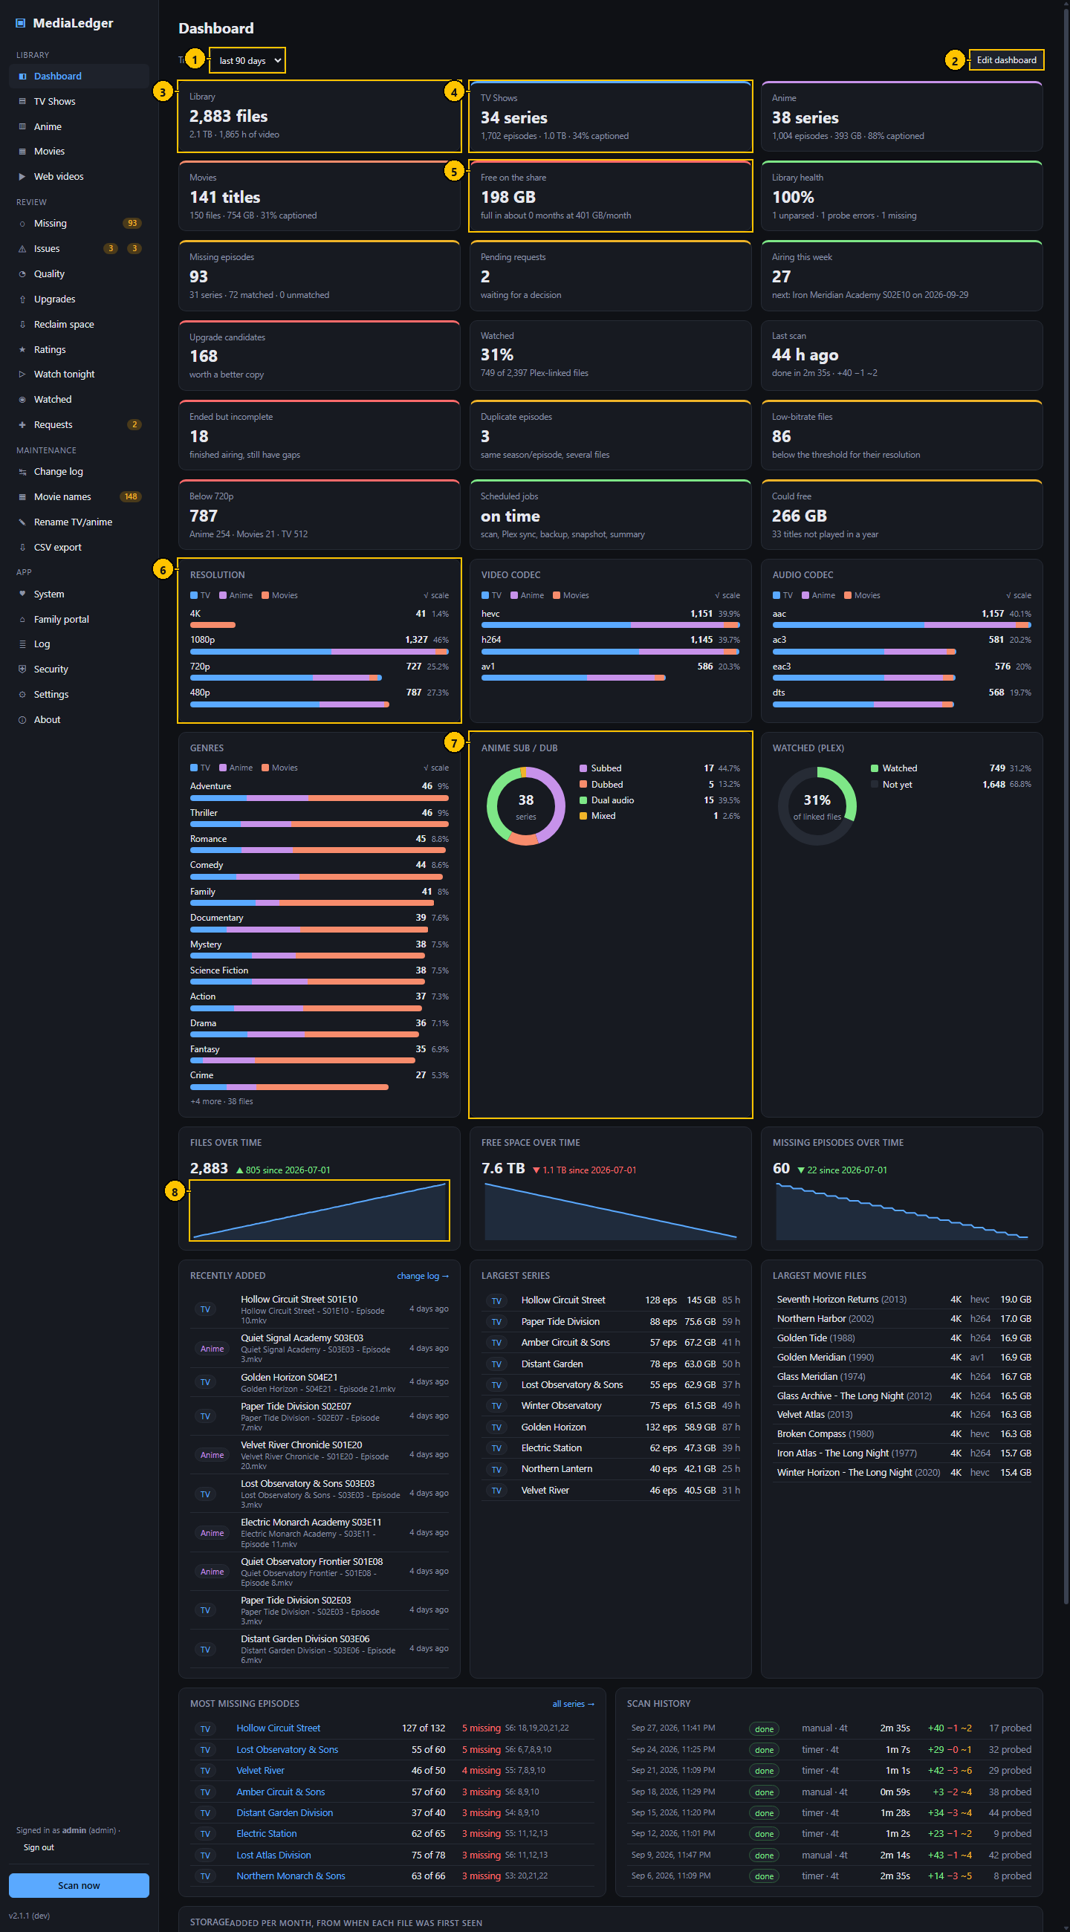
Figure 4. Dashboard. The numbers match the table below.

Controls
# | Control name | Type | What it does | Inputs and limits | Default | Notes
1 | Trend period | Drop-down list | Sets the period of every trend card that does not have its own. | last 30 days, last 90 days, last year, all time | last 90 days | Remembered in this browser.
2 | Edit dashboard | Button | Turns on edit mode. | – | – | Not shown to guests.
3 | Library tile | Tile | Files, total size and hours of video across every library. | – | – | –
4 | Linked tile | Tile (link) | A tile that opens the page behind its number: TV Shows, Anime, Movies, Missing, Requests and others. | – | – | The pointer changes to a hand over linked tiles.
5 | Coloured tile | Tile with a colour rule | The top edge is green, amber or red according to the thresholds of that card. | Thresholds per card, in the card options. | Shipped defaults, for example library health amber at 97 % and red at 90 %. | –
6 | Bar chart card | Chart | One bar per value, split by library. Count and share are printed beside each bar. | – | Ten bars | Square-root scale. Hover for details, click a segment to open the filtered list.
7 | Donut card | Chart | Shares of a whole: anime by sub or dub, watched against not yet. | – | – | Click a legend row to open the matching list where one exists.
8 | Trend card | Chart | A value over time from the daily snapshots, with the change since the start of the period. | Follows the trend period unless the card has its own. | – | Green or red says whether the change is good for that value.

Typical workflow
- Read the notices at the top, if any: an overdue job, an unreachable family portal address, or a newer version.
- Read the number tiles: green is fine, amber wants attention, red wants it now.
- Click a tile to open the page behind the number.
- Hover a bar in a chart for the exact count and the split by library; click a bar to open that list already filtered.
- Change the trend period at the top to see a month, a quarter, a year or everything.

Features
- Number tiles with colour rules; the thresholds are yours to change per card.
- Bar charts on a square-root scale, so a small value is still visible next to a large one; the numbers beside each bar are exact.
- Donut charts for shares, trend lines from the daily snapshots.
- Tables: recently added, largest series, largest movie files, most missing episodes, scan history, next up.

Edge cases
- A trend card needs two daily snapshots before it can draw a line; until then it says so.
- Cards about who watched what are left out for guests, and the overdue-jobs card is shown to administrators only.
- The numbers are held in memory for up to a minute while nothing in the library changes; any change refreshes them at once.

Messages and what they mean
Message | Meaning and what to do
<job> is overdue: last ran N h ago, expected within N h | A scheduled job has not run for twice its interval. Open Settings, Schedules.
Family portal: <address> is not reachable | The server could not open its own portal address twice in a row. Open Family portal.
MediaLedger <version> is available | Web server only. Run the update command on the Raspberry Pi.

3.2 Dashboard, edit mode
Edit mode is where you arrange the Dashboard. Each account keeps its own arrangement on the web server; guests see the administrator's; the desktop application keeps one.
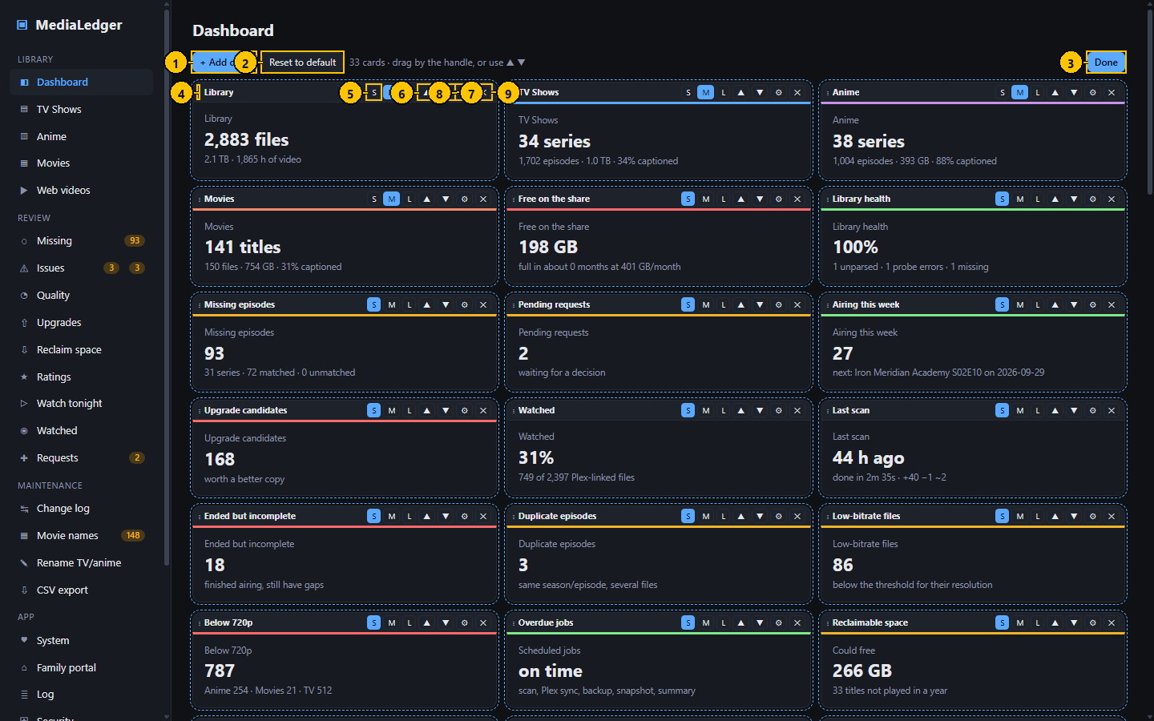
Figure 5. Dashboard, edit mode. The numbers match the table below.

Controls
# | Control name | Type | What it does | Inputs and limits | Default | Notes
1 | Add card | Button | Opens the catalog of cards. | – | – | –
2 | Reset to default | Button | Replaces your arrangement with the original one. | – | – | Asks first. Cannot be undone.
3 | Done | Button | Leaves edit mode and saves. | – | – | –
4 | Drag handle | Handle | Drag to move the card. A blue edge on another card shows where it will land. | – | – | Mouse only; use the arrows on a touch screen.
5 | Size buttons | Button group | Set the width of the card. | S, M, L, XL; a card offers only the sizes that suit it. | Per card | The current size is highlighted.
6 | Move up | Button | Moves the card one place earlier. | – | – | –
7 | Move down | Button | Moves the card one place later. | – | – | –
8 | Card options | Button | Opens the options of this card. | – | – | –
9 | Remove | Button | Takes the card off the Dashboard. | – | – | The card stays in the catalog and can be added again.

Typical workflow
- Press Edit dashboard.
- Drag a card by its handle to move it, or press the up and down arrows.
- Press S, M, L or XL on the handle to change the width.
- Press the gear to change the title, the period, the rows or the colour thresholds of that card.
- Press the cross to remove a card, and Add card to put one in.
- Press Done. The arrangement is saved.

Features
- A grid six columns wide: S is one column, M two, L three (half the width), XL all six.
- Cards can be added more than once, for example one trend over a month and the same trend over a year.
- Reset to default puts the original arrangement back.

Edge cases
- While you edit, the cards are drawn from the numbers already on screen, so moving and resizing is immediate; fresh numbers load when you press Done.
- On narrow screens cards widen by themselves; S becomes half the width and everything larger takes the full width.
- Links inside cards are switched off in edit mode so a click never navigates away by accident.

Messages and what they mean
Message | Meaning and what to do
Layout not saved: <reason> | The arrangement could not be stored on the server. It is kept in this browser and saved on the next change.

3.3 Add a card dialog
The catalog lists every card the Dashboard can show, in eight groups: Library, Health, Quality, Activity, Storage, Watching, Charts and Trends.
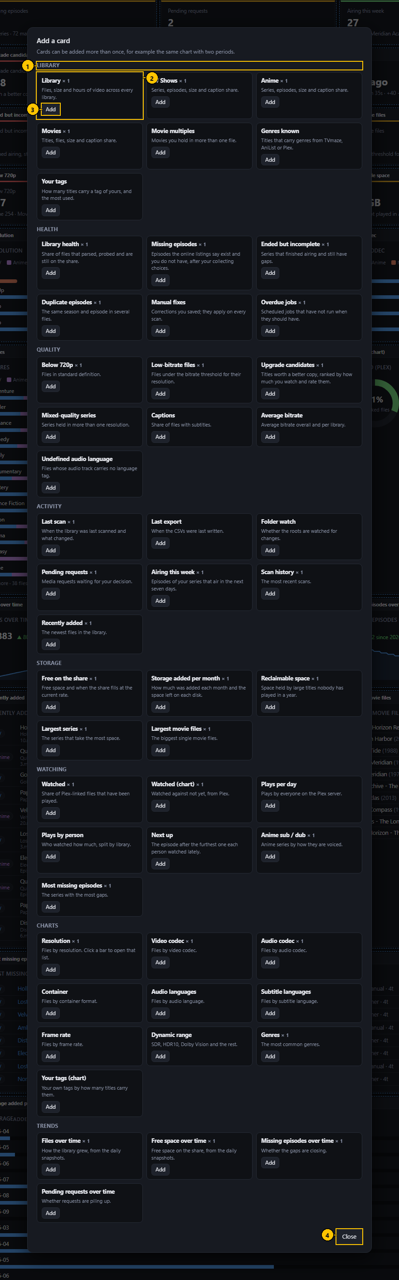
Figure 6. Add a card dialog. The numbers match the table below.

Controls
# | Control name | Type | What it does | Inputs and limits | Default | Notes
1 | Group heading | Heading | Names the group of cards below it. | – | – | –
2 | Catalog card | Entry | One card: its name and what it shows. | – | – | –
3 | Add | Button | Puts that card on the Dashboard at its usual size. | – | – | –
4 | Close | Button | Closes the catalog without adding anything. | – | – | The Escape key does the same.

Typical workflow
- In edit mode press Add card.
- Find the card; each has one line saying what it shows.
- Press Add. The card is placed last and the page scrolls to it.
- Move and size it as you like.

Features
- A small count beside a name shows how many times that card is already on the Dashboard.

Edge cases
- Guests are offered only the cards they are allowed to see.

3.4 Card options dialog
Each card has a few options. How many are shown depends on the "Options shown" level, which is remembered for your account, so a simple need stays simple.
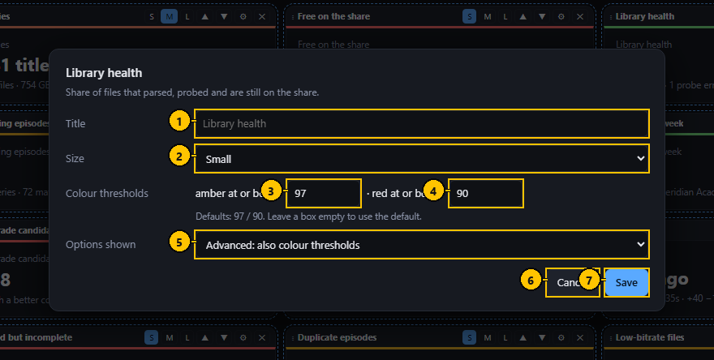
Figure 7. Card options dialog. The numbers match the table below.

Controls
# | Control name | Type | What it does | Inputs and limits | Default | Notes
1 | Title | Text field | Replaces the name printed on the card. | Free text | The name from the catalog | Leave empty to use the usual name.
2 | Size | Drop-down list | The width of the card. | Small, Medium, Half width, Full width; only the sizes that suit the card. | Per card | The same as the size buttons on the handle.
3 | Amber threshold | Number field | The value at which the tile turns amber. | Any number | Per card | Advanced level only. Whether amber means "at or above" or "at or below" is printed beside the field.
4 | Red threshold | Number field | The value at which the tile turns red. | Any number | Per card | Advanced level only.
5 | Options shown | Drop-down list | How much this dialog offers. | Simple, Standard, Advanced | Standard | Saved for your account at once; the dialog redraws.
6 | Cancel | Button | Closes without saving. | – | – | –
7 | Save | Button | Saves the options of this card. | – | – | –

Typical workflow
- In edit mode press the gear on a card.
- Change what you need.
- Press Save. The card is redrawn.

Features
- Simple shows the title and the size.
- Standard adds the period for trend cards and the number of rows for lists.
- Advanced adds the colour thresholds for number tiles.

Edge cases
- Thresholds set with the gear on a tile before version 2.0 are carried over.
- Emptying a threshold returns it to the shipped default.

3.5 TV Shows
One row per series. TV Shows and Anime are the same page over two libraries; Anime adds the sub or dub figures.
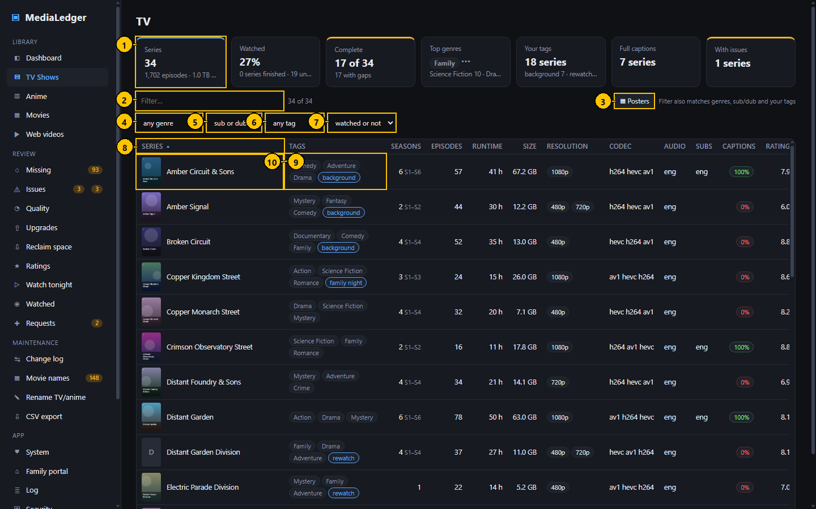
Figure 8. TV Shows. The numbers match the table below.

Controls
# | Control name | Type | What it does | Inputs and limits | Default | Notes
1 | Summary tiles | Tiles | Series, watched share, complete series, top genres, your tags, captions, series with issues. | – | – | Complete and With issues are links.
2 | Filter | Search field | Keeps the rows that contain what you type. | Any text | empty | Matches title, genres, sub or dub, tags, resolution, codec and languages.
3 | Posters / Table | Button | Switches between the table and a wall of posters. | – | Table | Remembered in this browser for every list.
4 | Genre | Drop-down list | Keeps the series with that genre. | Every genre present in this library | any genre | –
5 | Sub or dub | Drop-down list | Keeps the series voiced that way. | Subbed, Dubbed, Dual audio, Mixed | sub or dub | Mostly useful for Anime.
6 | Tag | Drop-down list | Keeps the series carrying that tag of yours. | Every tag in use | any tag | –
7 | Watched | Drop-down list | Keeps unwatched, partly watched, watched, or series Plex does not have. | – | watched or not | From Plex play counts.
8 | Column heading | Sortable heading | Sorts the table by that column. | – | Series, A to Z | A small arrow marks the sorted column.
9 | Series | Cell | Poster and name. A series with no poster shows its first letter. | – | – | –
10 | Tags | Cell | Genres in grey, sub or dub in colour, your own tags outlined. | – | – | A "+N" means more than fit.

Typical workflow
- Read the tiles for the library as a whole.
- Narrow the list with the filter box and the four drop-down lists.
- Click a column heading to sort by it; click again to reverse.
- Click a row to open the series.

Features
- A poster thumbnail beside each title.
- Genres come from the online match or from Plex; sub or dub is worked out from the audio and subtitle languages of the files; your own tags are typed on the series page.
- The Missing column counts episodes that aired and that you do not have, after your collecting choices.

Edge cases
- A series without an online match has no expected count, so Missing is empty rather than zero.
- The filter box also matches genres, sub or dub and tags.
- A link such as #tv?q=4K, which the Dashboard charts produce, opens the list already filtered.

3.6 Poster wall view
The same list as a wall of posters. It is a view of the table, not a separate page, so the filter box, the drop-down lists and the sort order all keep working.
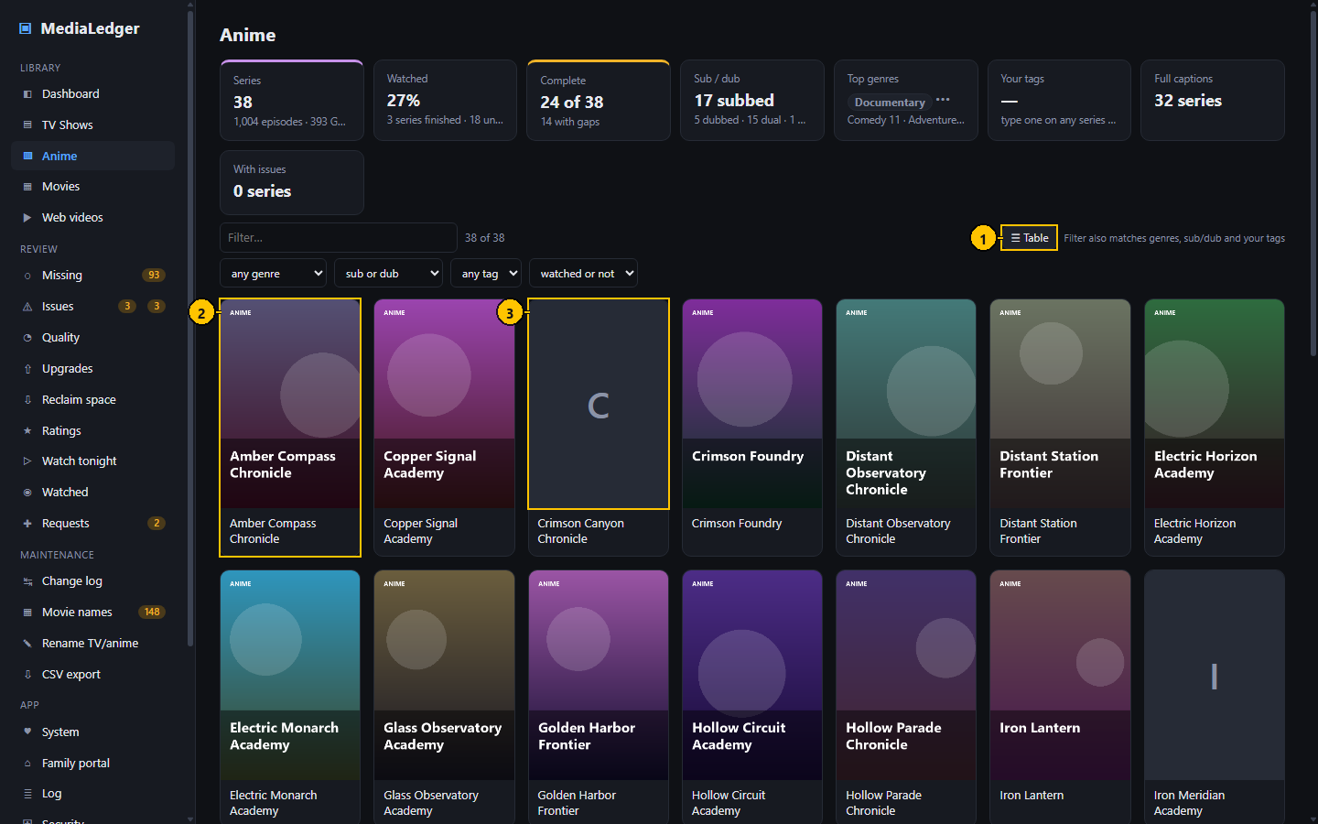
Figure 9. Poster wall view. The numbers match the table below.

Controls
# | Control name | Type | What it does | Inputs and limits | Default | Notes
1 | Table | Button | Returns to the table. | – | – | –
2 | Poster tile | Tile | One title. Click to open it. | – | – | –
3 | Title without a poster | Tile | Shown when no source had art for the title. | – | – | It is asked for again after two weeks.

Typical workflow
- Press Posters in the toolbar of a list.
- Scroll, filter or search as usual.
- Click a poster to open the title.
- Press Table to return.

Features
- Posters load as they scroll into view.
- Titles without art show their first letter on a plain tile.

Edge cases
- The column headings are hidden on the wall; choose the sort order in the table first.

3.7 Series page (episodes)
Everything about one series: what you have, what is missing, and the details of every file.
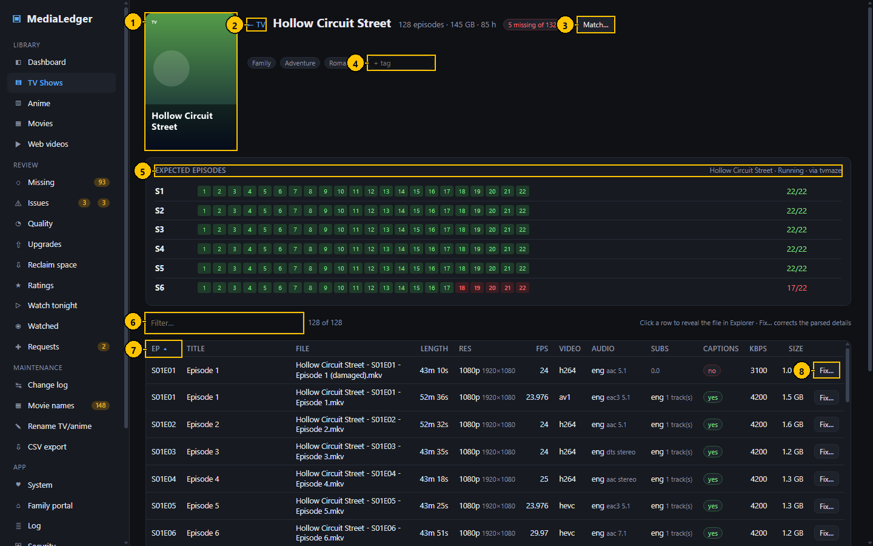
Figure 10. Series page (episodes). The numbers match the table below.

Controls
# | Control name | Type | What it does | Inputs and limits | Default | Notes
1 | Poster | Image | The poster of the series. | – | – | From Plex, AniList or TVmaze.
2 | Back link | Link | Returns to the list. | – | – | –
3 | Match | Button | Opens the Match dialog for this series. | – | – | –
4 | Add a tag | Text field | Adds a tag of your own to the series. | Up to 40 characters | empty | Press Enter to add.
5 | Expected episodes | Card | One row per season with a box per episode. | – | – | The count on the right is episodes on hand out of episodes expected.
6 | Filter | Search field | Keeps the files that contain what you type. | – | empty | –
7 | Column heading | Sortable heading | Sorts the files. | – | Episode order | –
8 | Fix | Button | Opens the Fix dialog for that file. | – | – | Administrators only on the web server.

Typical workflow
- Read the Expected episodes card: a green number is an episode you have, a red one is missing.
- Type a tag and press Enter to add it; click a tag of yours to remove it.
- Click a row to show the file in its folder (desktop), or press Fix to correct how the file was read.
- Press Match if the online listing is the wrong series.

Features
- A large poster beside the title.
- The expected episodes come from TVmaze or AniList; episodes that have not aired yet are not counted.

Edge cases
- "absolute numbering" appears when the files are numbered straight through while the listing is split into seasons; that season is skipped rather than reported as hundreds of gaps.
- A file that was present and has vanished from the share is listed last and marked missing.

3.8 Movies
One row per movie. A movie held in several files, for example two editions or two qualities, is one row with a count.
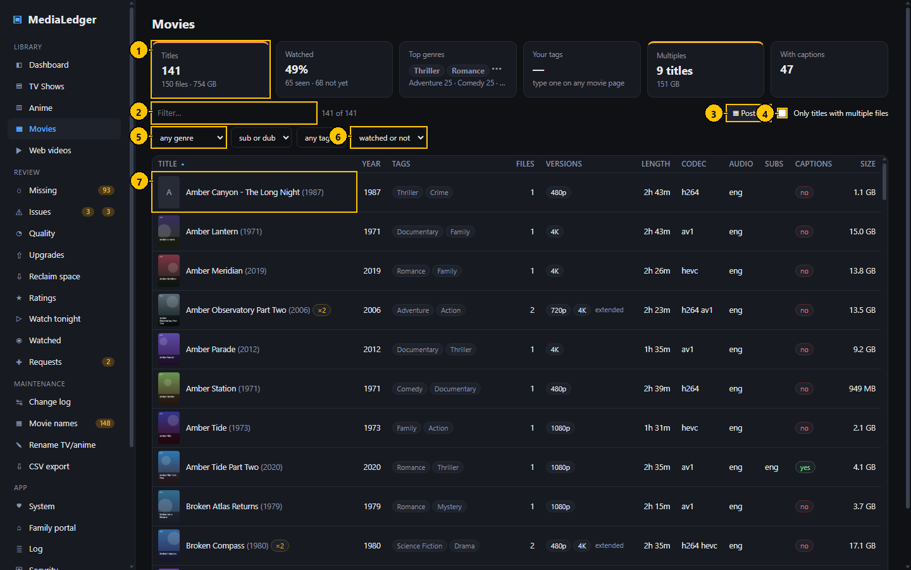
Figure 11. Movies. The numbers match the table below.

Controls
# | Control name | Type | What it does | Inputs and limits | Default | Notes
1 | Summary tiles | Tiles | Titles, watched share, top genres, your tags, multiples, captions. | – | – | Multiples is a link to the Duplicates tab.
2 | Filter | Search field | Keeps the rows that contain what you type. | – | empty | Matches title, year, genres, tags, resolution, codec and dynamic range.
3 | Posters / Table | Button | Switches between the table and the poster wall. | – | Table | –
4 | Only titles with multiple files | Check box | Keeps the movies that have more than one file. | – | off | –
5 | Genre | Drop-down list | Keeps the movies with that genre. | – | any genre | –
6 | Watched | Drop-down list | Keeps unwatched or watched movies, or the ones Plex does not have. | – | watched or not | –
7 | Title | Cell | Poster, name and year; an amber "×2" when there are several files. | – | – | –

Typical workflow
- Narrow the list with the filter box and the drop-down lists.
- Tick "Only titles with multiple files" to review duplicates and editions.
- Click a row to open the movie.

Features
- Versions lists every resolution on hand and the edition names.
- Genres come from Plex.

Edge cases
- A file in a movie folder whose name carries a season and episode marker is reported on the Issues page, not silently shown as a movie.

3.9 Movie page (versions)
The files that make up one movie, side by side, so you can see which copy is the better one.
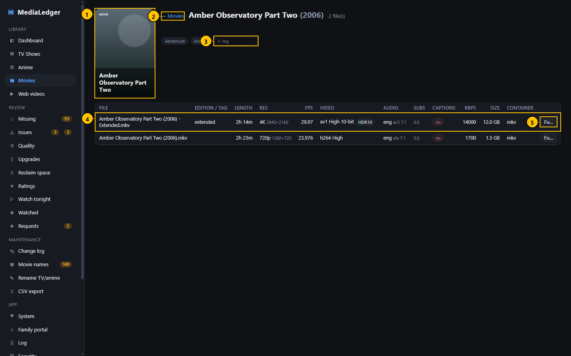
Figure 12. Movie page (versions). The numbers match the table below.

Controls
# | Control name | Type | What it does | Inputs and limits | Default | Notes
1 | Poster | Image | The poster of the movie. | – | – | –
2 | Back link | Link | Returns to Movies. | – | – | –
3 | Add a tag | Text field | Adds a tag of your own. | Up to 40 characters | empty | Press Enter to add.
4 | File row | Row | One file of this movie with its measured details. | – | – | Click to show the file in its folder (desktop).
5 | Fix | Button | Opens the Fix dialog for that file. | – | – | –

Typical workflow
- Compare resolution, bitrate, size, audio and subtitles.
- Press Fix on a file that was read wrongly, for example to give it an edition name.

Features
- Tags work as on a series page.

3.10 Web videos
Downloaded web videos, grouped by channel. The channel is the folder name and the video identifier is read from the square brackets in the file name.
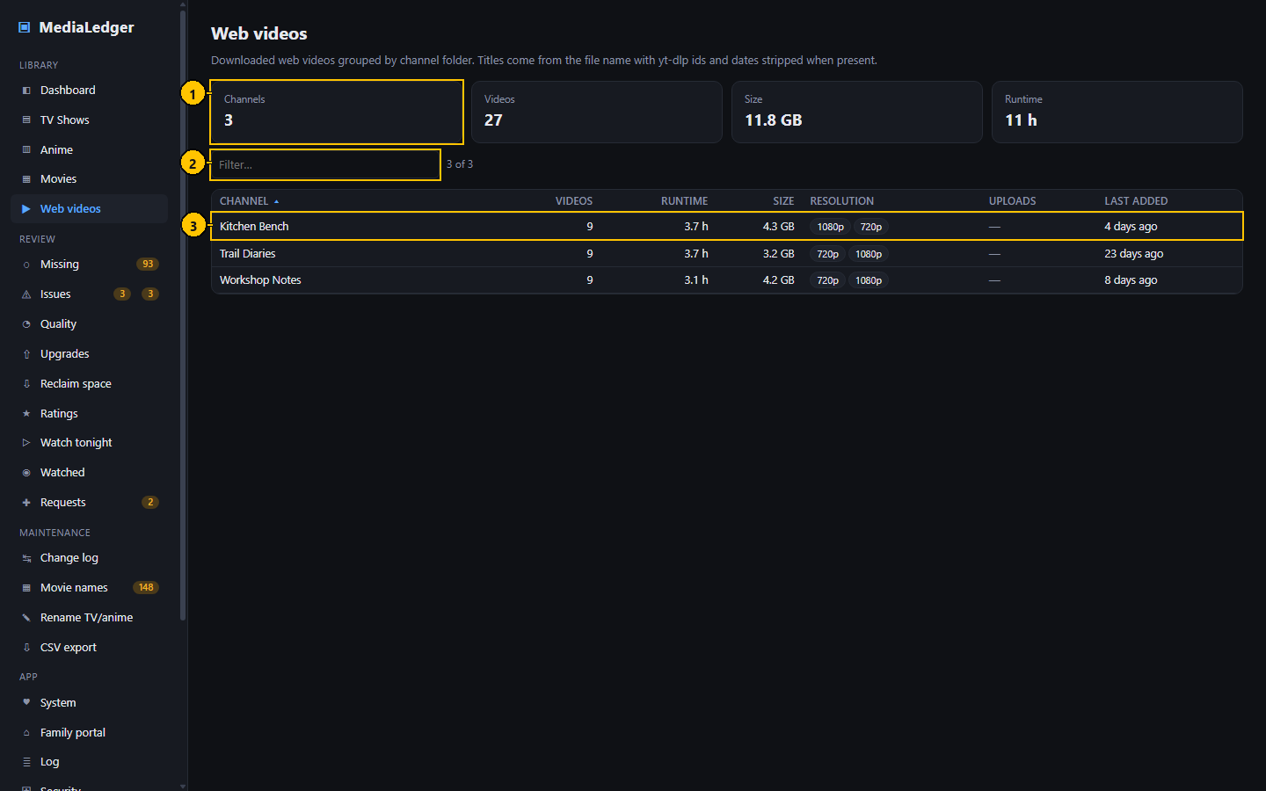
Figure 13. Web videos. The numbers match the table below.

Controls
# | Control name | Type | What it does | Inputs and limits | Default | Notes
1 | Summary tiles | Tiles | Channels, videos, total size and hours. | – | – | –
2 | Filter | Search field | Keeps the channels that contain what you type. | – | empty | –
3 | Channel row | Row | One channel with its count, size and the resolutions present. | – | – | Click to open the channel.

Typical workflow
- Click a channel to list its videos.
- Use the filter box to find a channel.

Features
- Videos are kept out of the missing-episode and movie logic; they are listed and measured, nothing more.

3.11 Adult library
Roots of the type Adult are scanned like any other but kept apart: hidden by default, out of the CSV files unless you allow it, never given a poster, and never shown on the family portal.
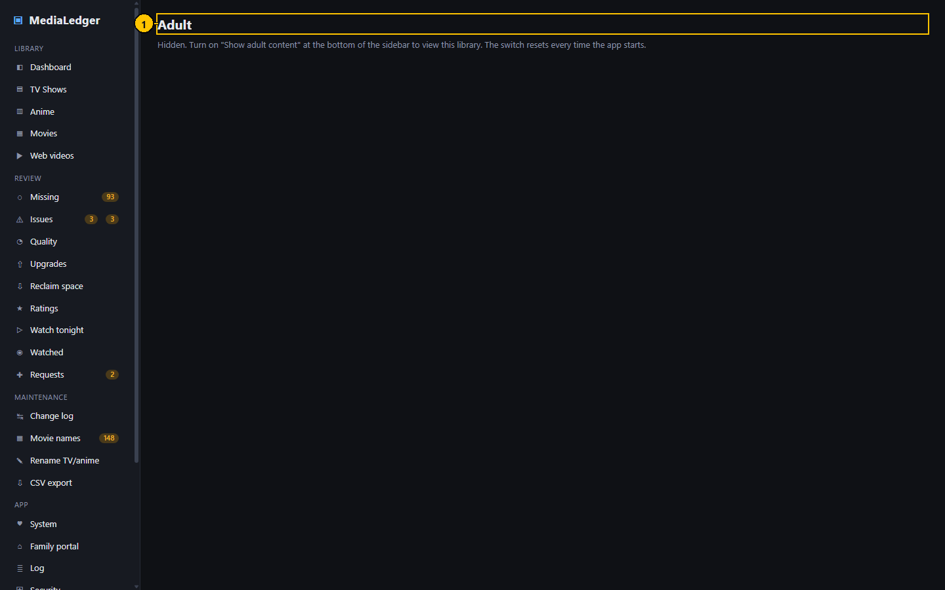
Figure 14. Adult library. The numbers match the table below.

Controls
# | Control name | Type | What it does | Inputs and limits | Default | Notes
1 | Page title | Heading | Adult. With the switch off the page only explains how to turn it on. | – | – | –

Typical workflow
- Switch "Show adult content" on at the bottom of the sidebar; on the web server this applies to your session only.
- The Adult entry appears in the sidebar and adult titles join the other pages.

Edge cases
- Guests cannot switch adult content on.
- With the switch off this page says so and lists nothing.

4. Review
What needs attention, and what to do next.

4.1 Missing episodes
Compares the episodes you have with the episodes that exist according to TVmaze (TV) and AniList (anime), and lists the gaps.
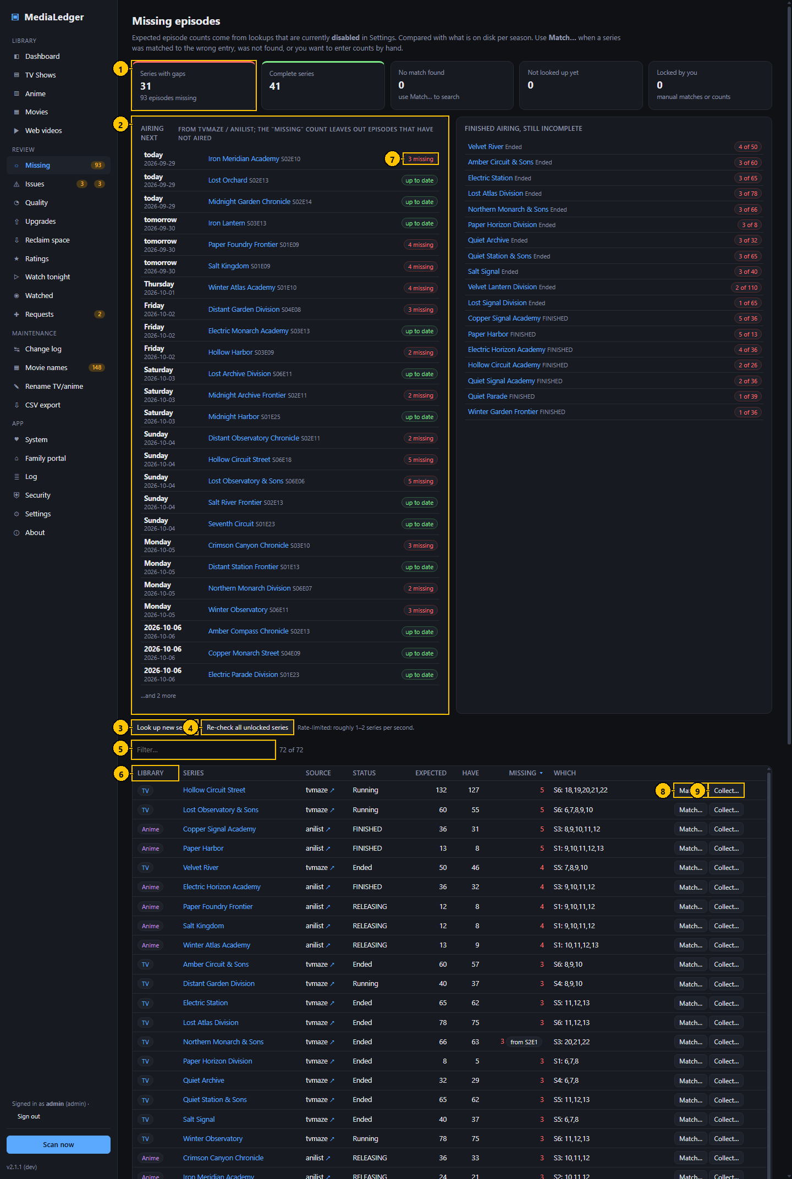
Figure 15. Missing episodes. The numbers match the table below.

Controls
# | Control name | Type | What it does | Inputs and limits | Default | Notes
1 | Summary tiles | Tiles | Series with gaps, complete series, no match found, lookups pending, locked by you. | – | – | –
2 | Airing next | Card | The next episode of each running series with its date; this week first. | – | 25 rows | Dates come with the episode lookup.
3 | Look up new series | Button | Looks up the series that have never been matched. | – | – | Runs in the background.
4 | Re-check all unlocked series | Button | Looks every series up again except the locked ones. | – | – | Slow by design: about one series a second.
5 | Filter | Search field | Keeps the series that contain what you type. | – | empty | –
6 | Column heading | Sortable heading | Sorts the table. | – | Missing, most first | –
7 | Policy badge | Badge | "muted" or "from S2E1" when a collecting choice applies; the tooltip gives the full count. | – | – | –
8 | Match | Button | Opens the Match dialog. | – | – | –
9 | Collect | Button | Opens the Collect dialog. | – | – | –

Typical workflow
- Read the tiles: series with gaps, complete series, series without a match.
- Read "Airing next" for what is coming this week.
- Sort the table by Missing to work from the biggest gap.
- Press Match when the listing is the wrong series or no listing was found.
- Press Collect to say what you are collecting of a long-running series.

Features
- Episodes that have not aired yet are never counted as missing.
- A collecting choice (from an episode onward, or muted) changes the count everywhere: Dashboard, sidebar, daily summary and the status address.
- A locked match is never replaced by an automatic lookup.

Edge cases
- The online services allow about one request a second, so "Re-check all" takes a while on a large library.
- "absolute numbering" marks a season that was skipped because the files are numbered straight through.

Messages and what they mean
Message | Meaning and what to do
HTTP 403 from graphql.anilist.co | AniList refused the request, usually because too many were sent. It is tried again on the next lookup.
no match | Neither service had a series with a close enough name. Use Match.

4.2 Match dialog
Chooses which online listing a series is compared with, or lets you type the episode counts yourself.
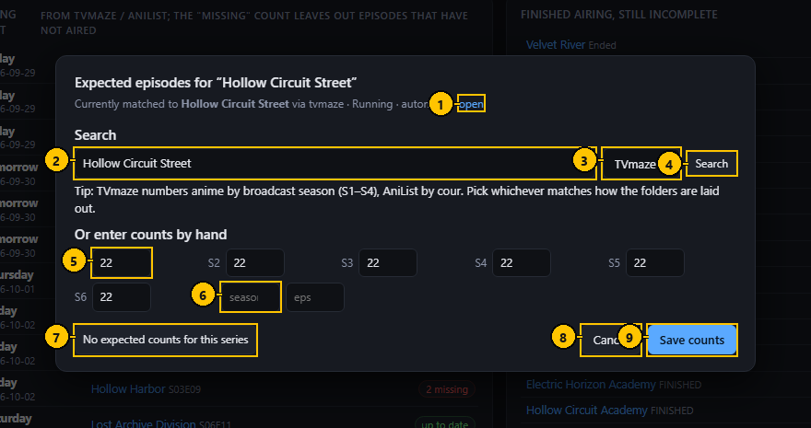
Figure 16. Match dialog. The numbers match the table below.

Controls
# | Control name | Type | What it does | Inputs and limits | Default | Notes
1 | Open | Link | Opens the current listing on the service's own site. | – | – | Desktop: in your browser.
2 | Search words | Text field | What to search the service for. | Any text | The series name | Enter starts the search.
3 | Service | Drop-down list | Which service to search. | TVmaze, AniList | TVmaze for TV, AniList for Anime | –
4 | Search | Button | Searches and lists the results. | – | – | –
5 | Episodes per season | Number fields | The counts to compare against when you enter them by hand. | Whole numbers | The current counts | One field per season.
6 | Add a season | Number fields | A season number and its episode count, to add one that is not listed. | – | empty | –
7 | No expected counts for this series | Button | Records that the series has no listing, so it is not reported as unmatched. | – | – | –
8 | Cancel | Button | Closes without saving. | – | – | –
9 | Save counts | Button | Saves the counts you typed and locks them. | – | – | –

Typical workflow
- Change the search words if the folder name is unusual, pick the service, press Search.
- Pick the right result from the list. The match is saved and locked.
- If no listing fits, type the number of episodes per season and press Save counts.
- Press "No expected counts" for a series that should never be compared.

Features
- A locked match survives every later lookup until you unlock it.

Edge cases
- TVmaze numbers anime by broadcast season while AniList lists each cour separately; pick whichever matches how your folders are laid out.

Messages and what they mean
Message | Meaning and what to do
Nothing found | The service had no series for those words. Shorten them or try the other service.

4.3 Collect dialog
Says what you are collecting of one series, so a long runner you joined late does not fill the Missing page with episodes you never meant to keep. No file is touched.
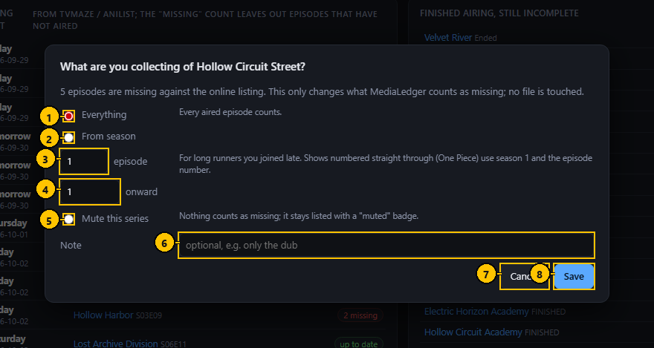
Figure 17. Collect dialog. The numbers match the table below.

Controls
# | Control name | Type | What it does | Inputs and limits | Default | Notes
1 | Everything | Option | Every aired episode counts. | – | selected | –
2 | From a season and episode onward | Option | Earlier seasons, and earlier episodes of that season, are not counted. | – | – | –
3 | Season | Number field | The first season you collect. | 0 or more | 1 | –
4 | Episode | Number field | The first episode you collect in that season. | 1 or more | 1 | –
5 | Mute this series | Option | Nothing counts as missing. | – | – | The series stays listed.
6 | Note | Text field | A reminder for yourself. | Up to 200 characters | empty | –
7 | Cancel | Button | Closes without saving. | – | – | –
8 | Save | Button | Saves the choice. | – | – | –

Typical workflow
- Choose Everything, From a season and episode onward, or Mute.
- Optionally type a note to remind yourself why.
- Press Save.

Features
- The row on the Missing page keeps a badge with the full count in its tooltip.

Edge cases
- For series numbered straight through, use season 1 and the episode number.
- Choosing Everything removes the choice.

4.4 Issues: Problems
Everything the scan could not make sense of, in one place: names it could not read, files ffprobe could not open, files that vanished, episodes filed under Movies, and the fixes you have saved.
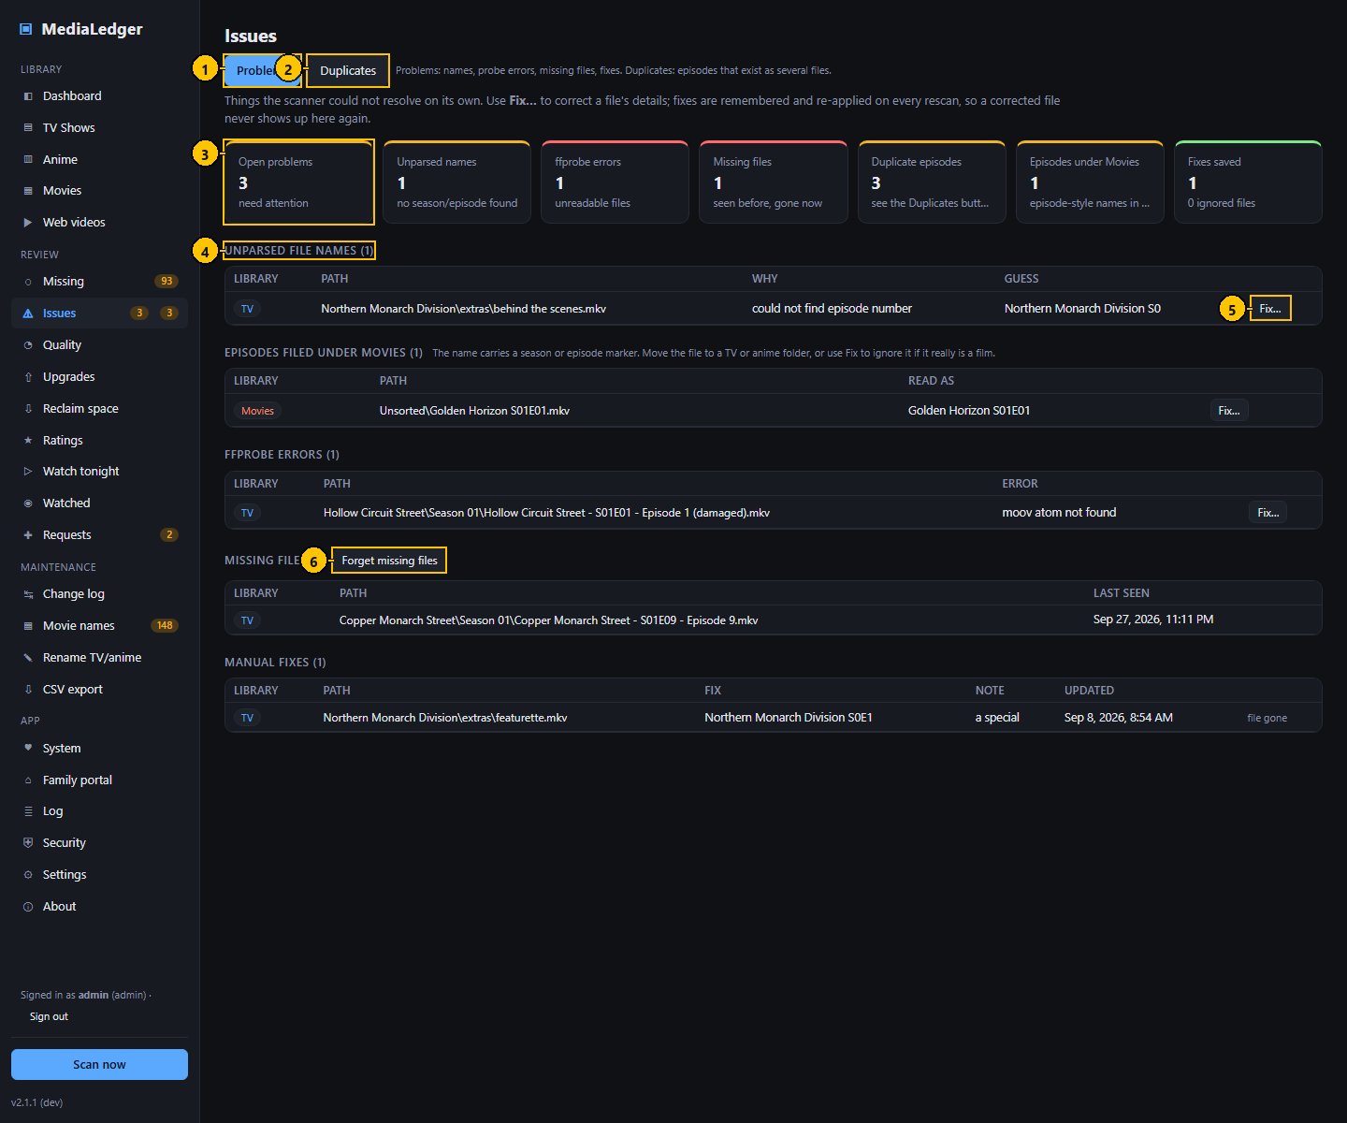
Figure 18. Issues: Problems. The numbers match the table below.

Controls
# | Control name | Type | What it does | Inputs and limits | Default | Notes
1 | Problems tab | Tab | This page. | – | selected | –
2 | Duplicates tab | Tab | Opens the Duplicates tab. | – | – | –
3 | Summary tiles | Tiles | Open problems, unparsed names, ffprobe errors, missing files, duplicate episodes, episodes under Movies, fixes saved. | – | – | –
4 | Section heading | Heading | Names the kind of problem and counts the rows. | – | – | –
5 | Fix | Button | Opens the Fix dialog for that file. | – | – | –
6 | Forget missing files | Button | Removes the rows of files that are no longer on the share. | – | – | Only the records are removed; nothing on disk changes.

Typical workflow
- Start with the tiles to see which kind of problem there is.
- Press Fix on a row to correct how the file is read, or to ignore it.
- Move an episode that sits in a movie folder to the right library.
- Press "Forget missing files" once you are sure the vanished files are gone for good.

Features
- Fixes are stored in the database and applied on every scan, so they survive a rescan and a rename.

Edge cases
- A bare "Episode 1" in a movie name is not flagged, so numbered film series are safe.

Messages and what they mean
Message | Meaning and what to do
moov atom not found | ffprobe could not read the file: it is incomplete or damaged.
no season or episode found in the name | The name has no recognisable marker. Use Fix.

4.5 Fix dialog
Tells MediaLedger how a file should be read when its name does not say. The fix is a record in the database; the file itself is not changed.
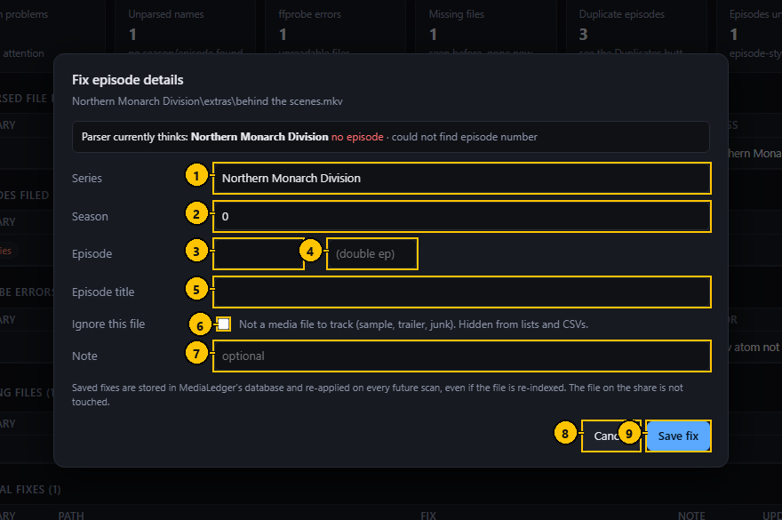
Figure 19. Fix dialog. The numbers match the table below.

Controls
# | Control name | Type | What it does | Inputs and limits | Default | Notes
1 | Series | Text field | The series the file belongs to. | Text | The current reading | For a movie this field is the title.
2 | Season | Number field | The season number. | 0 for specials | The current reading | –
3 | Episode | Number field | The episode number. | 1 or more | The current reading | –
4 | Last episode | Number field | For a file that holds two episodes: the number of the second. | – | empty | –
5 | Episode title | Text field | The name of the episode. | – | empty | Used by the rename pages.
6 | Ignore this file | Check box | Hides the file from every list and count. | – | off | It is listed under Manual fixes.
7 | Note | Text field | Why the fix was made. | – | empty | –
8 | Cancel | Button | Closes without saving. | – | – | –
9 | Save fix | Button | Saves the fix and applies it at once. | – | – | –

Typical workflow
- Correct the series, season and episode, or the title and year of a movie.
- Tick "Ignore this file" for a sample, trailer or junk file.
- Press Save fix. The file is read that way from now on.

Features
- The dialog shows what the parser currently thinks and why it gave up.

Edge cases
- A fix follows the file by its path; renaming through MediaLedger keeps the fix attached.

4.6 Issues: Duplicates
Episodes that exist in more than one file, shown side by side so you can decide which to keep.
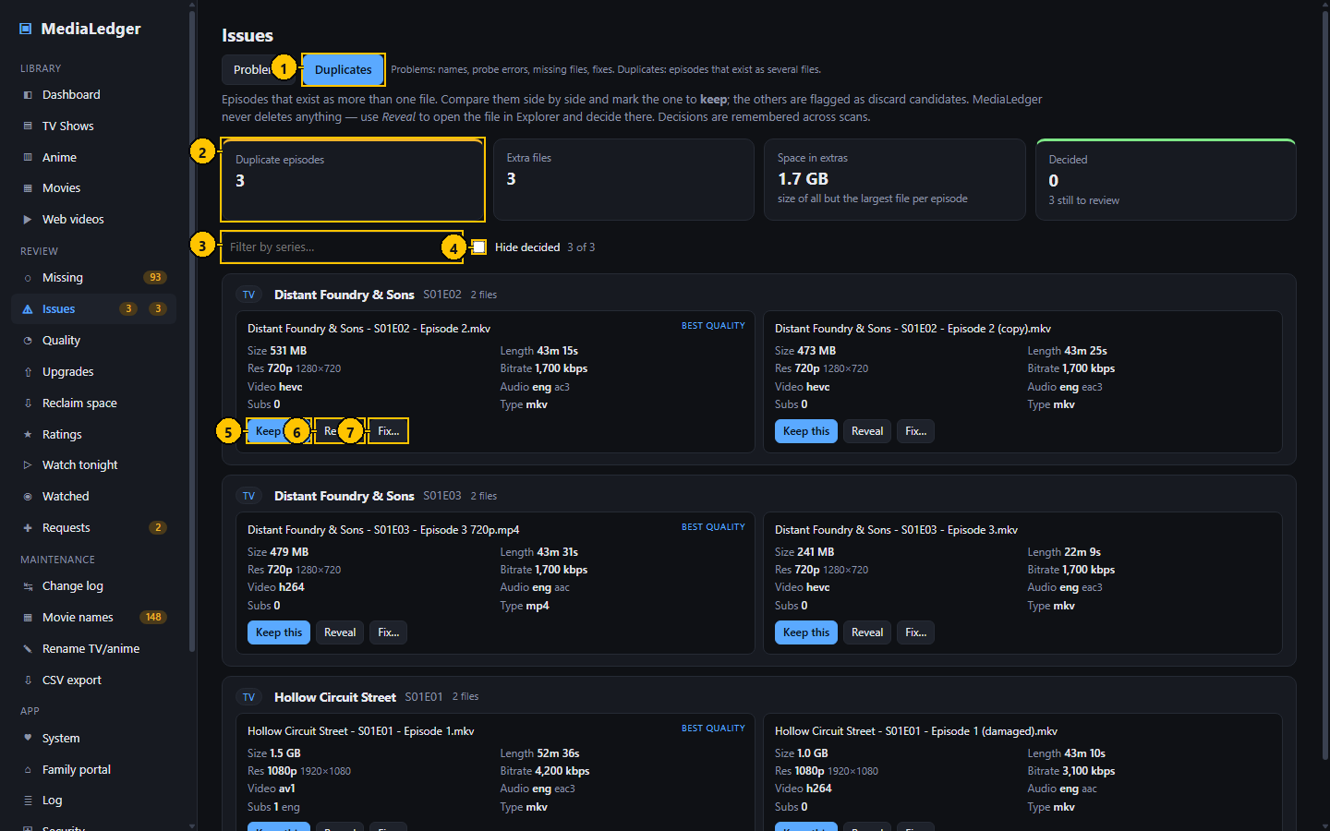
Figure 20. Issues: Duplicates. The numbers match the table below.

Controls
# | Control name | Type | What it does | Inputs and limits | Default | Notes
1 | Duplicates tab | Tab | This page. | – | – | –
2 | Summary tiles | Tiles | Duplicate episodes, extra files and the space they take, decided and still to review. | – | – | –
3 | Filter by series | Search field | Keeps the groups of that series. | – | empty | –
4 | Hide decided | Check box | Hides the groups you have decided on. | – | off | –
5 | Keep this | Button | Marks this copy as the one to keep. | – | – | –
6 | Reveal | Button | Shows the file in its folder. | – | – | Desktop only; does nothing in a browser.
7 | Fix | Button | Opens the Fix dialog, for a copy that is really a different episode. | – | – | –

Typical workflow
- Compare the copies: resolution, bitrate, size, languages.
- Press "Keep this" on the copy you want. The others are marked as the ones to remove.
- Remove the others yourself; MediaLedger never deletes media.

Features
- "Hide decided" keeps the list to the ones still to review.

Edge cases
- A decision is a note, not an action. Nothing on the share changes.

4.7 Quality
Finds the weak copies: series in mixed resolutions, files with a low bitrate for their resolution, audio without a language, files with no audio, and very short files.
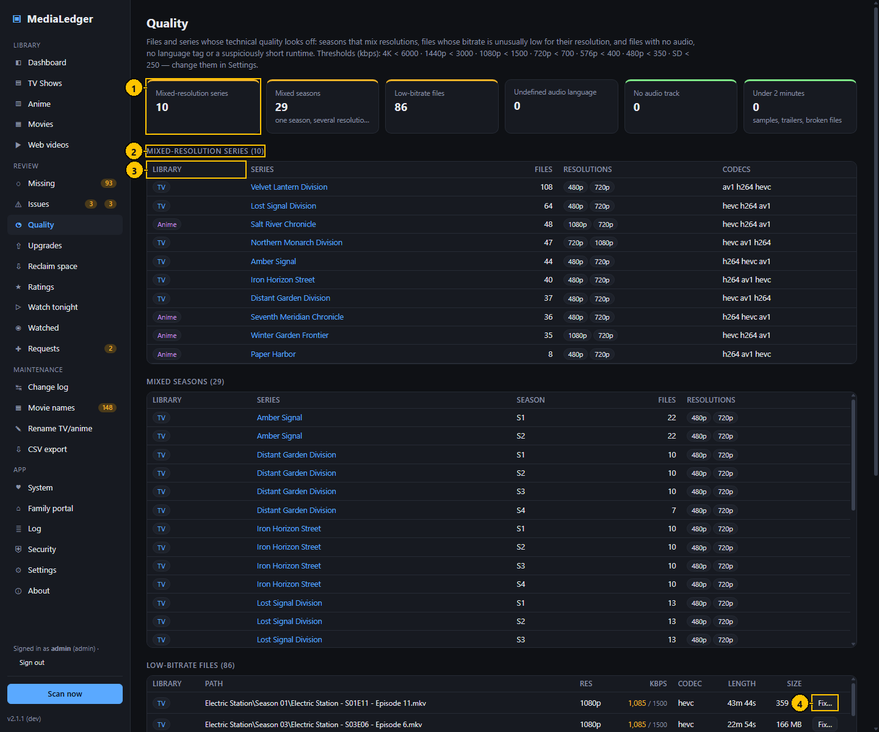
Figure 21. Quality. The numbers match the table below.

Controls
# | Control name | Type | What it does | Inputs and limits | Default | Notes
1 | Summary tiles | Tiles | Mixed-resolution series, low-bitrate files, undefined audio language, no audio track, under two minutes. | – | – | –
2 | Section heading | Heading | Names the kind of finding and counts the rows. | – | – | –
3 | Column heading | Sortable heading | Sorts that section. | – | – | –
4 | Fix | Button | Opens the Fix dialog for that file. | – | – | –

Typical workflow
- Read the tiles.
- Open a section and sort by the column that matters.
- Click a row to open the title.

Features
- The bitrate thresholds per resolution are set under Settings, Quality thresholds.

Edge cases
- "Undefined audio language" means the track has no language tag, not that the audio is missing.

4.8 Upgrade candidates
Ranks the titles most worth replacing with a better copy: those you watch and rate highly but hold in a low resolution or bitrate.
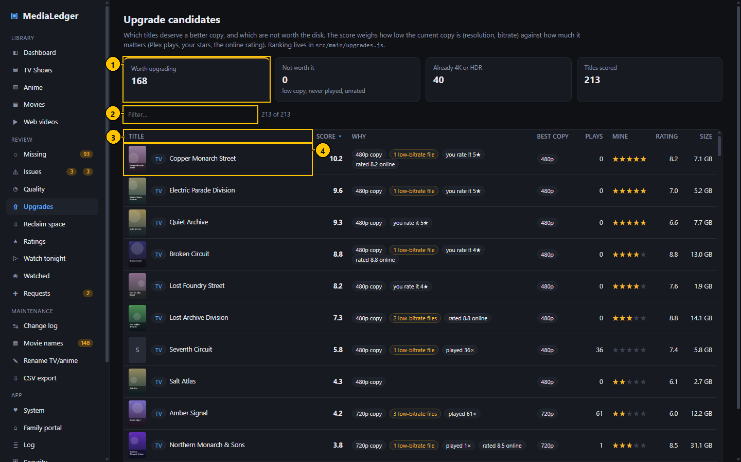
Figure 22. Upgrade candidates. The numbers match the table below.

Controls
# | Control name | Type | What it does | Inputs and limits | Default | Notes
1 | Summary tiles | Tiles | Worth upgrading, not worth it, and the totals behind them. | – | – | –
2 | Filter | Search field | Keeps the titles that contain what you type. | – | empty | –
3 | Column heading | Sortable heading | Sorts the table. | – | Score, highest first | –
4 | Title | Cell | The title and its library. | – | – | –

Typical workflow
- Work from the top of the list.
- Read the reasons beside each score.
- Click a row to open the title.

Features
- The score multiplies how far the copy falls short of 1080p (plus a low bitrate) by how much you care: plays, your stars, and the online rating.
- 4K and HDR copies score zero, and so does a title that was never played, is unrated and has a fine bitrate.

Edge cases
- Without a Plex sync there are no plays, so only your stars and the online rating count.

4.9 Reclaim space
The mirror image of Upgrades: large titles nobody on the Plex server has played for a long time, or ever. It is a list to think about; MediaLedger never deletes media.
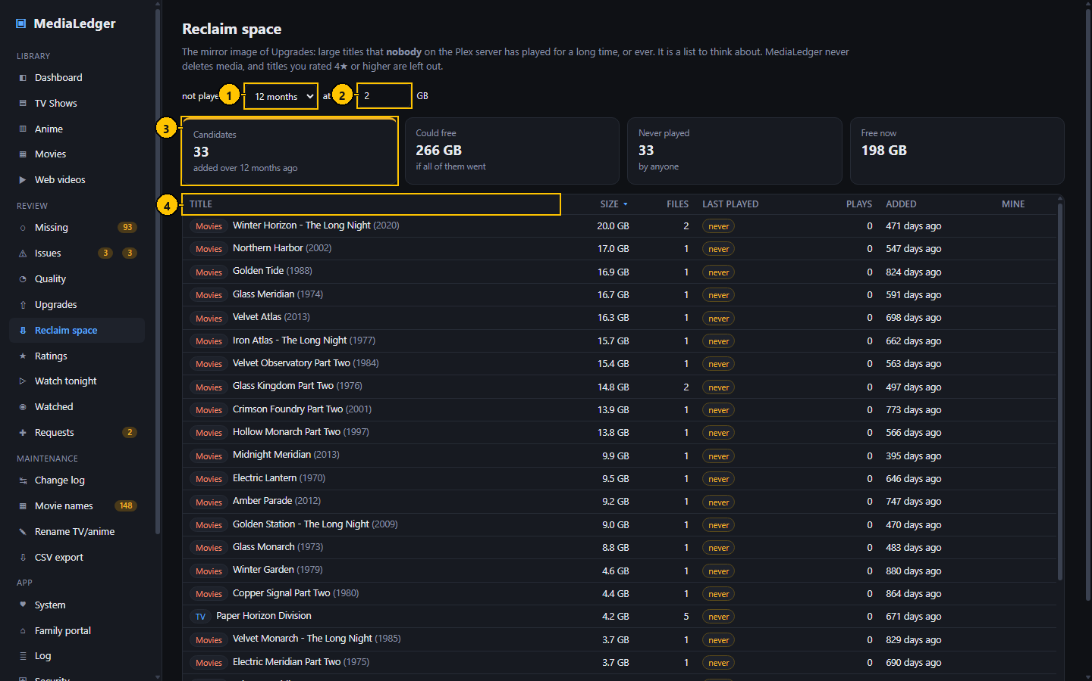
Figure 23. Reclaim space. The numbers match the table below.

Controls
# | Control name | Type | What it does | Inputs and limits | Default | Notes
1 | Not played for | Drop-down list | How long a title must have gone unplayed, and how long it must have been in the library. | 6, 12, 24 or 36 months | 12 months | Remembered in this browser.
2 | At least | Number field | The smallest total size of a title worth listing, in gigabytes. | 0 or more | 2 | –
3 | Summary tiles | Tiles | Candidates, the space they hold together, how many were never played, free space now. | – | – | –
4 | Column heading | Sortable heading | Sorts the table. | – | Size, largest first | –

Typical workflow
- Choose the period and the smallest size worth listing.
- Sort by size and work from the top.
- Click a row to open the title.

Features
- "Played" covers every Plex account, from the play history.
- Titles you rated four stars or higher are left out.

Edge cases
- "Added" is the older of the file's own date and the day MediaLedger first saw it, so a young ledger does not make everything look new.
- On a machine with no Plex sync every title reads as unplayed; the page says so rather than imply the whole library is dead weight.

Messages and what they mean
Message | Meaning and what to do
None of these titles is linked to Plex on this machine | There is no play data behind the list. Sync Plex here, or open the page on the server that does.

4.10 Ratings
Your own rating and note for every title, next to the online rating and your Plex rating.
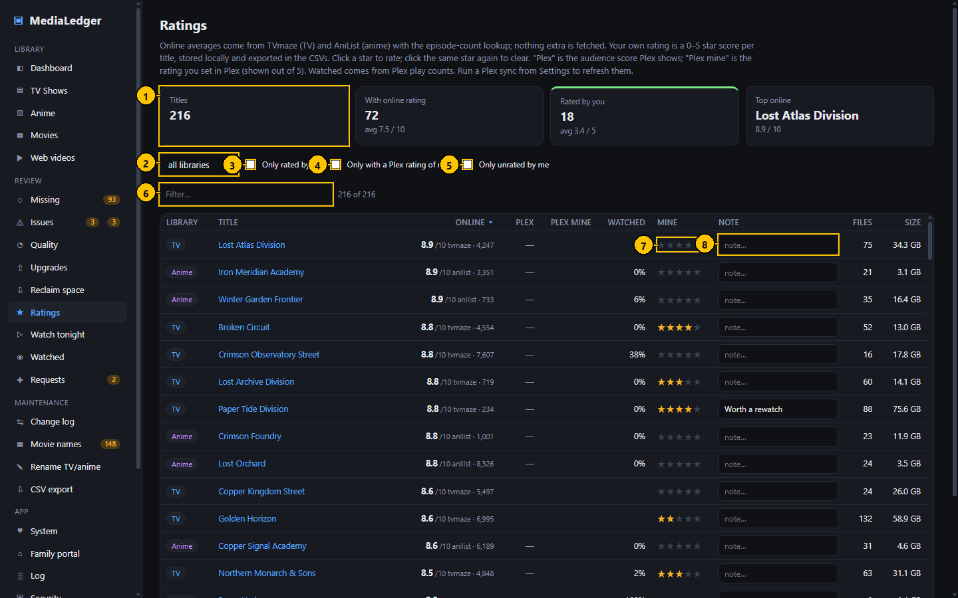
Figure 24. Ratings. The numbers match the table below.

Controls
# | Control name | Type | What it does | Inputs and limits | Default | Notes
1 | Summary tiles | Tiles | Titles, rated by you with the average, rated in Plex, online ratings known. | – | – | –
2 | Library | Drop-down list | Keeps one library. | all libraries, TV, Anime, Movies, Web channels | all libraries | –
3 | Rated by me | Check box | Keeps the titles you have rated. | – | off | –
4 | With my Plex rating | Check box | Keeps the titles you rated in Plex. | – | off | –
5 | Not rated yet | Check box | Keeps the titles you have not rated. | – | off | –
6 | Filter | Search field | Keeps the titles that contain what you type. | – | empty | –
7 | Stars | Rating control | Your rating of the title. | 1 to 5 stars | none | Click the same star again to clear.
8 | Note | Text field | A note of your own. | Free text | empty | Saved when you leave the field.

Typical workflow
- Click a star to rate; click the same star again to clear.
- Type a note and leave the field to save it.
- Use the check boxes to list only what you rated, or only what you have not.

Features
- Your stars and notes are exported in the series and movie CSV files.
- Stars feed the Upgrades ranking and protect titles on the Reclaim page.

Edge cases
- Your notes are never shown on the family portal; your stars are, unless you switch that off there.

4.11 Watch tonight
One list across every series and movie, made for the "what shall we watch" moment.
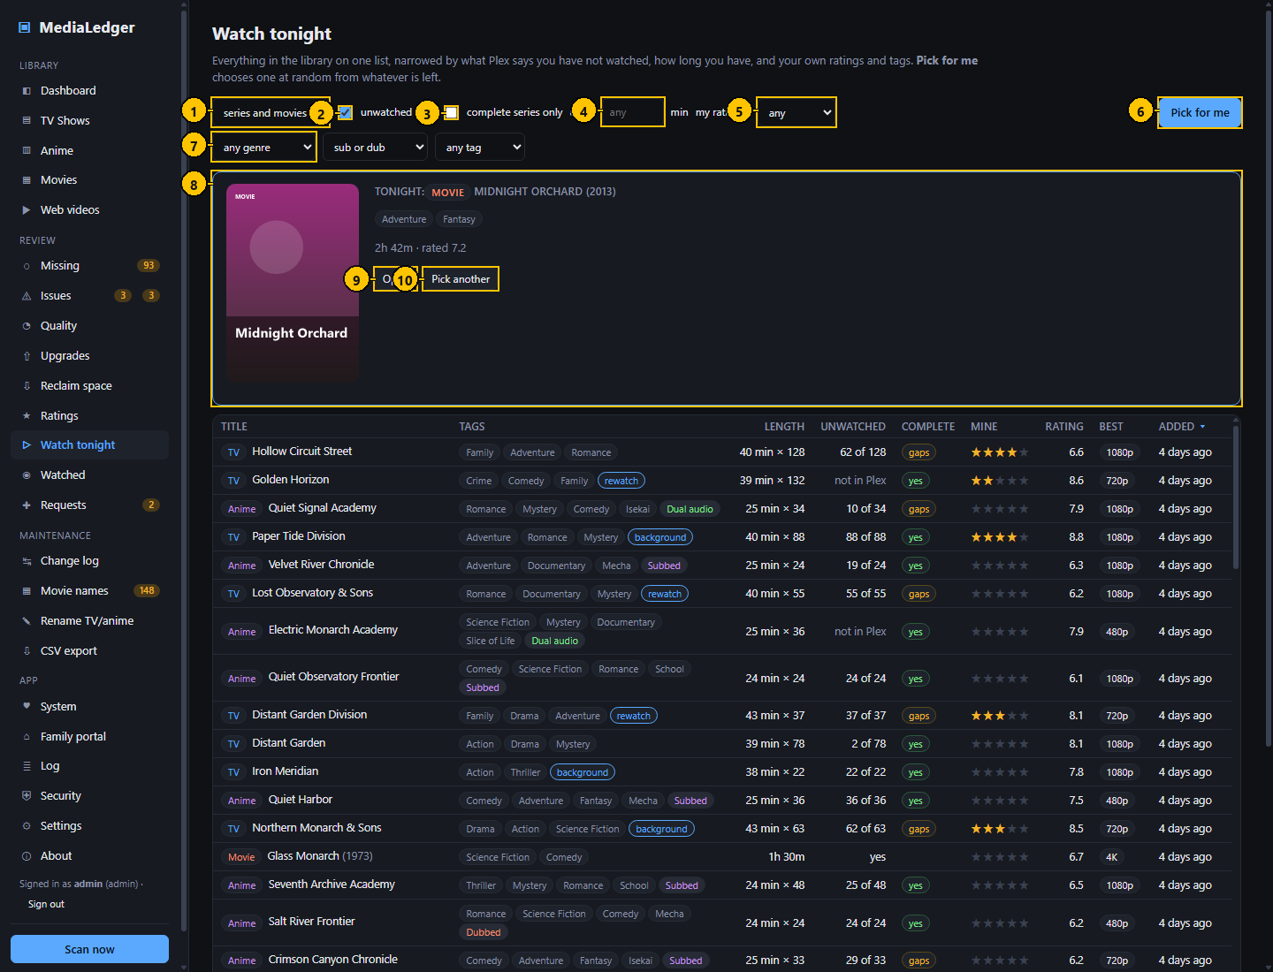
Figure 25. Watch tonight. The numbers match the table below.

Controls
# | Control name | Type | What it does | Inputs and limits | Default | Notes
1 | Kind | Drop-down list | Series, movies or both. | – | series and movies | –
2 | Unwatched only | Check box | Keeps the titles with something left to watch. | – | on | From Plex play counts.
3 | Complete series only | Check box | Keeps the series with no missing episodes. | – | off | –
4 | Up to … minutes | Number field | The longest length you have time for. | Minutes, in steps of 5 | any | –
5 | My rating at least | Drop-down list | Keeps the titles you rated that high or higher. | any, 1 to 5 stars | any | –
6 | Pick for me | Button | Chooses one title at random from the filtered list. | – | – | –
7 | Genre | Drop-down list | Keeps the titles with that genre. | – | any genre | –
8 | Tonight | Card | The title that was picked, with its poster, length and rating. | – | – | –
9 | Open | Button | Opens the picked title. | – | – | –
10 | Pick another | Button | Picks again. | – | – | –

Typical workflow
- Choose series, movies or both.
- Leave "unwatched only" ticked, set how long you have, and pick a genre or tag.
- Press "Pick for me" to have one chosen at random from what is left.
- Press Open to go to the title, or Pick another.

Features
- The choices are remembered in this browser.
- Length is the episode length for a series and the running time for a movie.

Edge cases
- Titles Plex does not have stay in the list when "unwatched only" is ticked, because nothing says they were watched.
- "Complete series only" needs an online match; unmatched series are left out.

Messages and what they mean
Message | Meaning and what to do
Nothing matches; loosen the filters | No title passes every filter.

4.12 Watched
The play history of the whole Plex server: who watched what, when, and on which device.
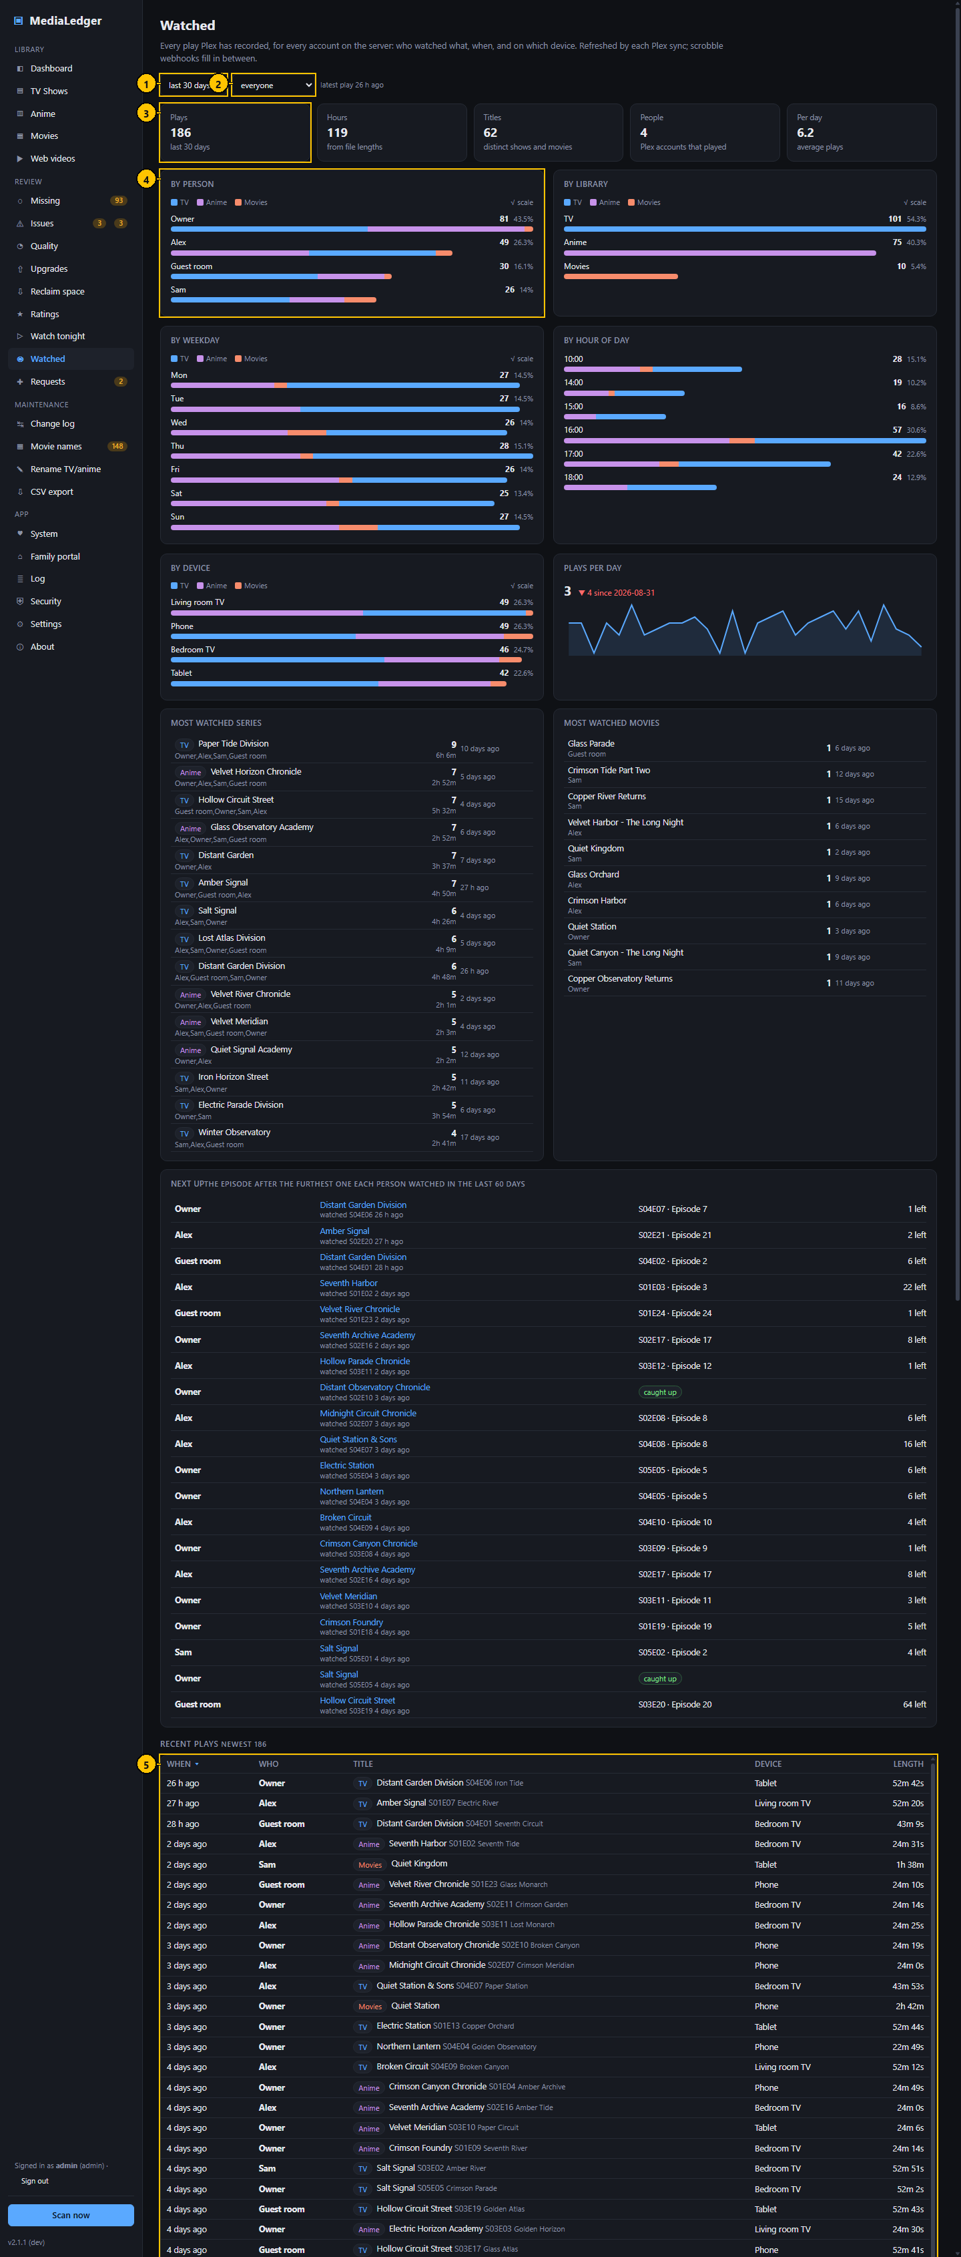
Figure 26. Watched. The numbers match the table below.

Controls
# | Control name | Type | What it does | Inputs and limits | Default | Notes
1 | Period | Drop-down list | The period the page covers. | last 7, 30 or 90 days, last year, all time | last 30 days | Remembered in this browser.
2 | Person | Drop-down list | Keeps the plays of one Plex account. | Every account, with its play count | everyone | –
3 | Summary tiles | Tiles | Plays, hours (from the lengths of the files), distinct titles, people, average plays per day. | – | – | –
4 | Charts | Charts | By person, by library, by weekday, by hour of day, by device, and plays per day. | – | – | Weekday and hour use a linear scale.
5 | Recent plays | Table | The newest plays: when, who, title, device, length. | – | 500 rows | Searchable and sortable.

Typical workflow
- Choose the period and, if you like, one person.
- Read the tiles and the charts.
- Scroll to Recent plays and search it; click a row to open the title.

Features
- Charts by person, library, weekday, hour of day and device, and plays per day.
- Most watched series and movies with who watched them.
- Next up: for each person and show, the episode after the furthest one they watched in the last 60 days.
- Binges: sittings of three or more episodes of one show.

Edge cases
- Plays are attributed by Plex account; a shared account shows as one person.
- Plex keeps history only as far back as its own setting allows.
- Each Plex sync pulls new history; the webhook adds plays in between and the next sync replaces those rows with Plex's own, so nothing is counted twice.

Messages and what they mean
Message | Meaning and what to do
Nothing here yet | No history has been pulled. Run a Plex sync.

4.13 Requests
A wish list for the library. Anyone who can open the application may ask for a title; only an administrator decides.
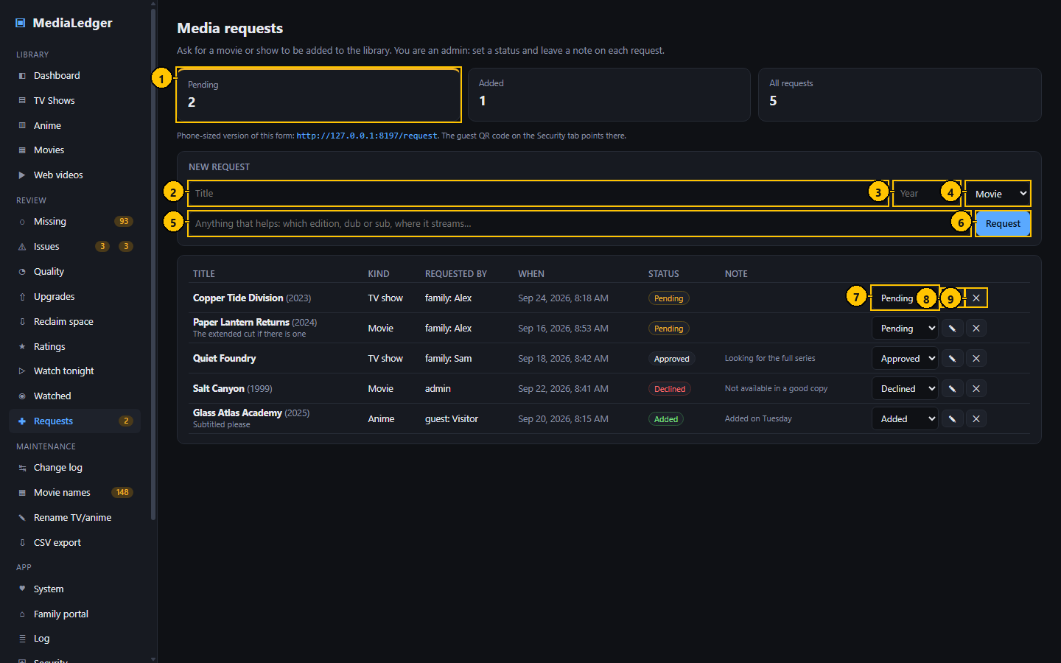
Figure 27. Requests. The numbers match the table below.

Controls
# | Control name | Type | What it does | Inputs and limits | Default | Notes
1 | Summary tiles | Tiles | Pending, added and all requests. | – | – | –
2 | Title | Text field | What is being asked for. | Up to 120 characters | empty | –
3 | Year | Number field | The year of release, to tell remakes apart. | 1900 to 2100 | empty | Optional.
4 | Kind | Drop-down list | Movie, TV show, Anime or Other. | – | Movie | –
5 | Note | Text field | Edition, dub or sub, where it streams. | Free text | empty | Optional.
6 | Request | Button | Files the request. | – | – | –
7 | Status | Drop-down list | Sets the status of that request. | Pending, Approved, Added, Declined | Pending | Administrators only.
8 | Note to the requester | Button | Writes a note the requester can read. | – | – | Administrators only.
9 | Delete | Button | Deletes the request. | – | – | Administrators only. Asks first.

Typical workflow
- Type the title, the year if you know it, the kind, and anything that helps.
- Press Request.
- As an administrator: set the status, leave a note for the person who asked, or delete the request.

Features
- Statuses: Pending, Approved, Added, Declined.
- Requests from the family portal arrive marked "family:" and the name on the invite; guests type their own name.
- A notification is sent for every new request when notifications are set up.

Edge cases
- Requests do not download anything and do not talk to Plex.

4.14 Request page for phones
A page with nothing on it but the request form, sized for a phone. The guest QR code on the Security page points here.
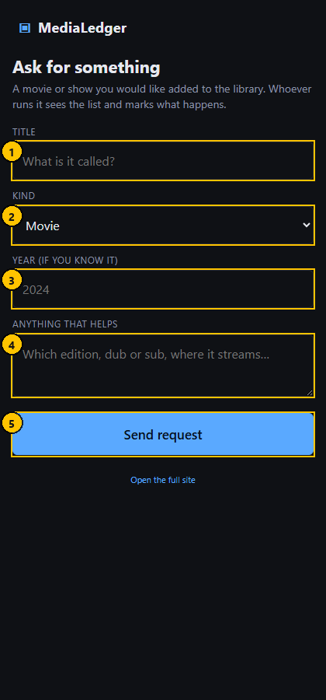
Figure 28. Request page for phones. The numbers match the table below.

Controls
# | Control name | Type | What it does | Inputs and limits | Default | Notes
1 | Title | Text field | What should be added. | Up to 120 characters | empty | –
2 | Kind | Drop-down list | Movie, TV show, Anime or Other. | – | Movie | –
3 | Year | Number field | The year of release. | – | empty | Optional.
4 | Note | Text area | Anything that helps. | – | empty | Optional.
5 | Send request | Button | Files the request. | – | – | –

Typical workflow
- Scan the QR code or open the address ending in /request.
- Type your name once; the phone remembers it.
- Type the title and press Send request.

Edge cases
- Guest access must be enabled on the Security page, otherwise the page asks the visitor to sign in.

5. Maintenance
The tools that change things. The two rename pages are the only part of MediaLedger that writes to your share.

5.1 Change log
What each scan found: files added, removed, modified and returned. It is how you notice that a folder emptied or a batch of files was replaced.
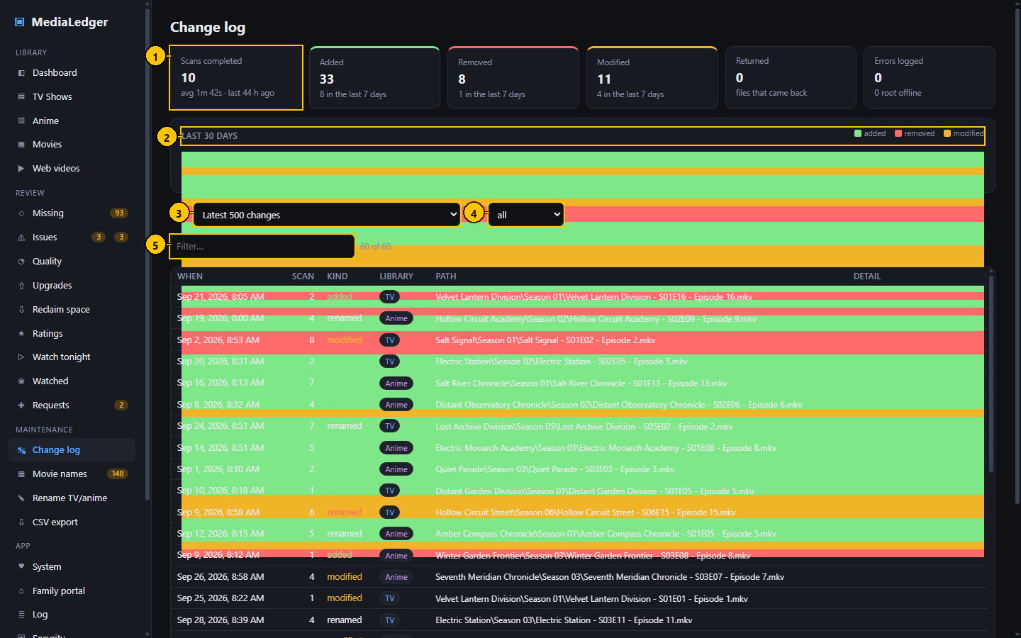
Figure 29. Change log. The numbers match the table below.

Controls
# | Control name | Type | What it does | Inputs and limits | Default | Notes
1 | Summary tiles | Tiles | Scans completed with their average length, and files added, removed and modified. | – | – | –
2 | 30-day chart | Chart | Changes per day by kind. | – | – | –
3 | Scan | Drop-down list | Shows the changes of one scan. | The latest 500 changes, or any recent scan | Latest 500 changes | –
4 | Kind | Drop-down list | Keeps one kind of change. | added, removed, modified, returned, probe error, renamed | all | –
5 | Filter | Search field | Keeps the paths that contain what you type. | – | empty | –

Typical workflow
- Read the tiles and the 30-day chart.
- Pick one scan, or leave it on the latest 500 changes.
- Pick a kind and type in the filter box to narrow the list.

Features
- "returned" marks a file that had vanished and came back.
- Renames made through MediaLedger are recorded as renames, not as a removal and an addition.

Edge cases
- "modified" means the size or the date of the file changed; the file is probed again.

5.2 Movie names
Proposes tidy names for movie files and renames them in batches. With Rename TV / anime it is the only part of MediaLedger that writes to your share.
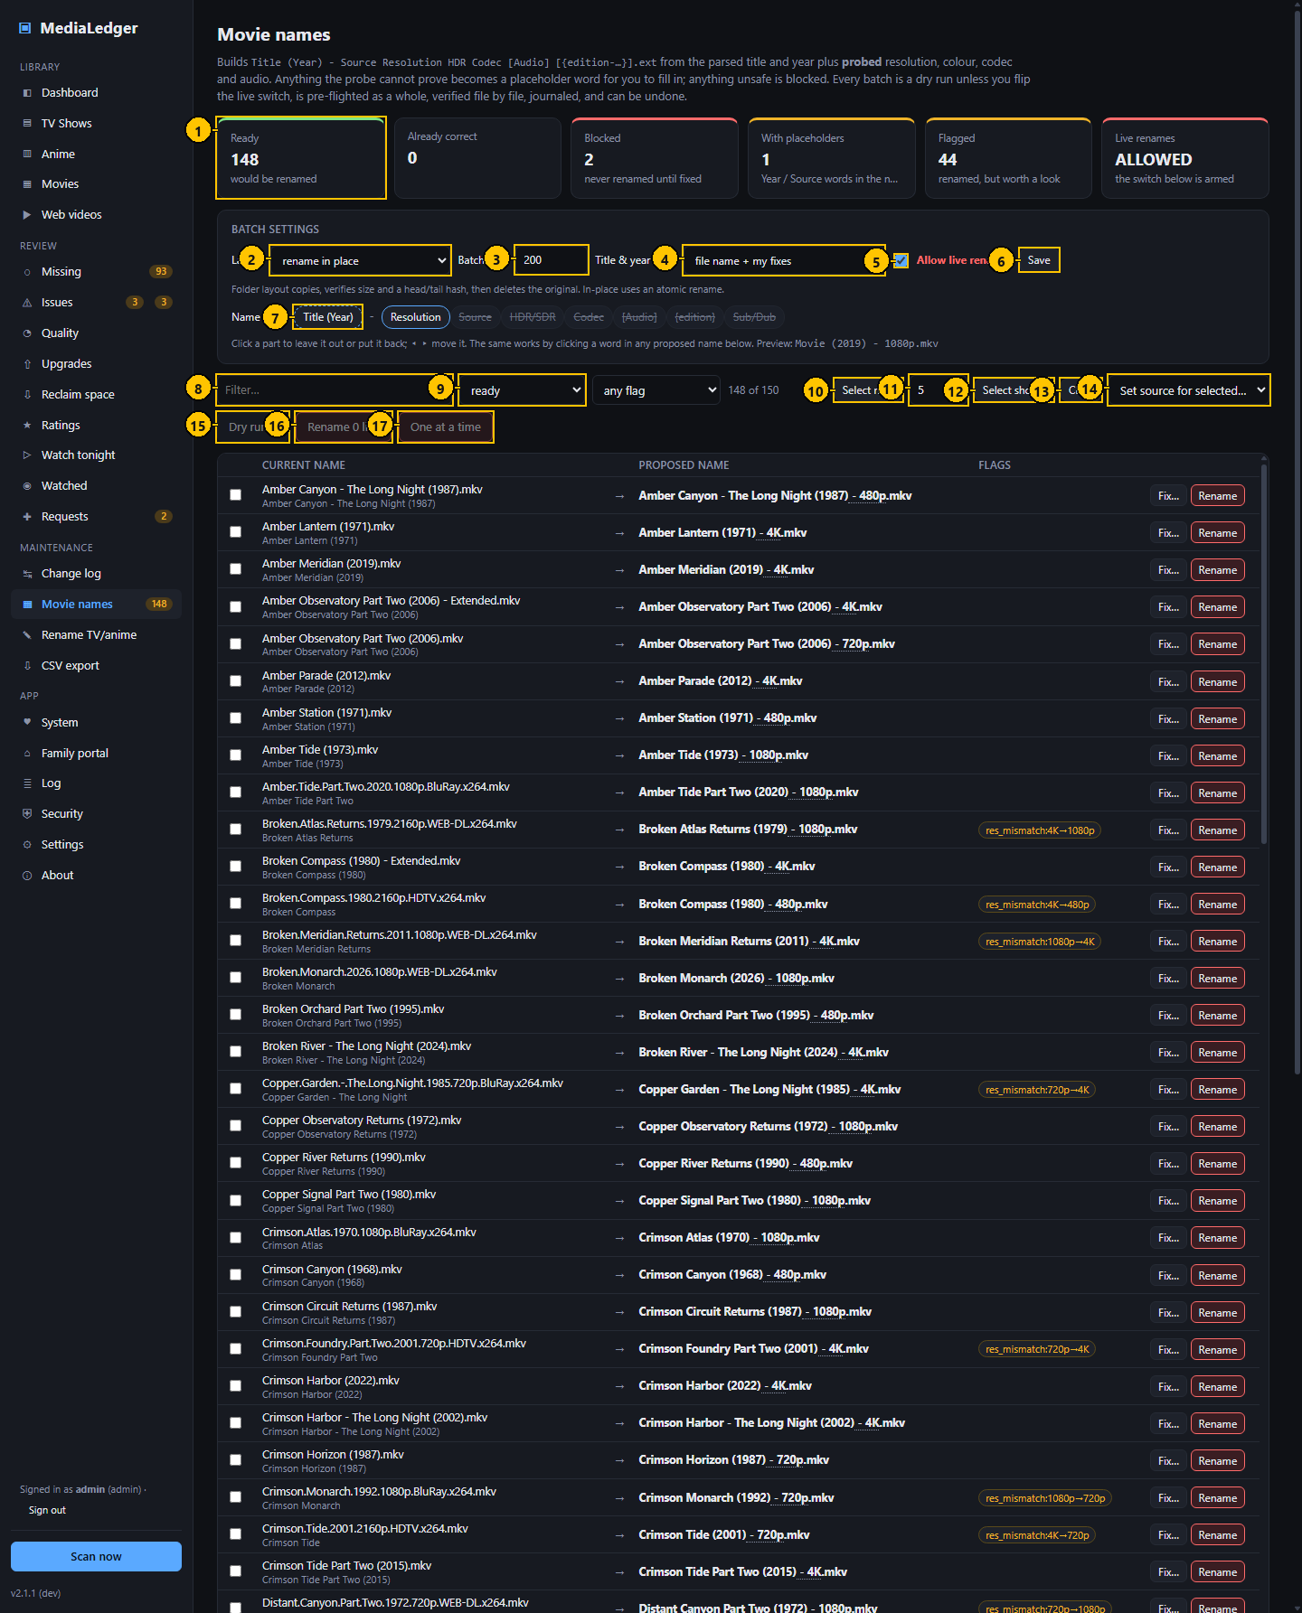
Figure 30. Movie names. The numbers match the table below.

Controls
# | Control name | Type | What it does | Inputs and limits | Default | Notes
1 | Summary tiles | Tiles | Ready, flagged, blocked, already tidy, and renamed so far. | – | – | –
2 | Layout | Drop-down list | Rename in place, or also move each movie into a folder named "Title (Year)". | – | rename in place | –
3 | Batch limit | Number field | The most files one batch may rename. | 1 to 5000 | 200 | A safety stop, enforced by the server as well.
4 | Source of the title | Drop-down list | Whether the name is built from the file name and your fixes, or from the Plex match. | – | file name + my fixes | –
5 | Live renaming allowed | Check box | Arms the live button. While it is off only dry runs are possible. | – | off | –
6 | Save | Button | Saves the batch settings. | – | – | –
7 | Name parts | Chips | Click a part to leave it out of the name or put it back. | Title (Year) is fixed; Source, Resolution, Dynamic range, Codec, Audio, Edition and Sub/Dub are optional | Source, Resolution, Dynamic range, Codec, Audio, Edition | The proposed names update at once.
8 | Filter | Search field | Keeps the files that contain what you type. | – | empty | –
9 | Status | Drop-down list | Keeps ready, flagged, placeholder or blocked files. | – | ready | –
10 | Select next | Button | Clears the selection and ticks only the next group of listed files. | – | – | After the batch those files leave the list, so pressing it again takes the following group.
11 | How many | Number field | The size of the group "Select next" ticks. | 1 to 200 | 10 | Remembered in this browser.
12 | Select shown | Button | Ticks every ready file in the list. | – | – | Asks first above 50.
13 | Clear | Button | Unticks everything. | – | – | –
14 | Set source for selected | Drop-down list | Records where the ticked copies came from, for the Source part of the name. | Web, Rip, Broadcast and others | – | –
15 | Dry run | Button | Runs the batch without touching any file and records the result. | – | – | –
16 | Rename live | Button | Renames the ticked files. | – | – | Disabled until live renaming is allowed.
17 | One at a time | Button | Walks through the ticked files, asking before each. | – | – | –

Typical workflow
- Choose the parts of the name by clicking the chips; the preview shows the result.
- Set the layout and the batch limit and press Save.
- Press "Select next" to tick a small group, check the proposed names.
- Press "Dry run" first: it records what would happen and changes nothing.
- Press "Rename live" when the dry run looks right.
- Use Undo in the Batches table if you change your mind.

Features
- Every file is Ready, Flagged or Blocked. Blocked files are never renamed until the cause is fixed.
- A batch is checked as a whole before anything is renamed: the file is still there, its size is unchanged, the new name is free, the folder is writable.
- Each rename is verified and written to a journal. The Batches table at the bottom of the page lists every batch with its mode, status and counts; Items lists its files and Undo renames them back after checking each one.

Edge cases
- "Select shown" asks first when more than 50 files would be ticked.
- Two files that would end up with the same name are listed under Name collisions and neither is renamed.
- Renaming is off until you switch it on under Settings, Renaming.

Messages and what they mean
Message | Meaning and what to do
Renaming is off | Switch it on under Settings, Renaming.
target exists | A file with the proposed name is already there. Nothing is overwritten.
size changed since the scan | The file was altered after it was scanned. Scan again.

5.3 Rename TV / anime
The same batch engine for episodes: proposes "Show - S01E02 - Title" and renames in place.
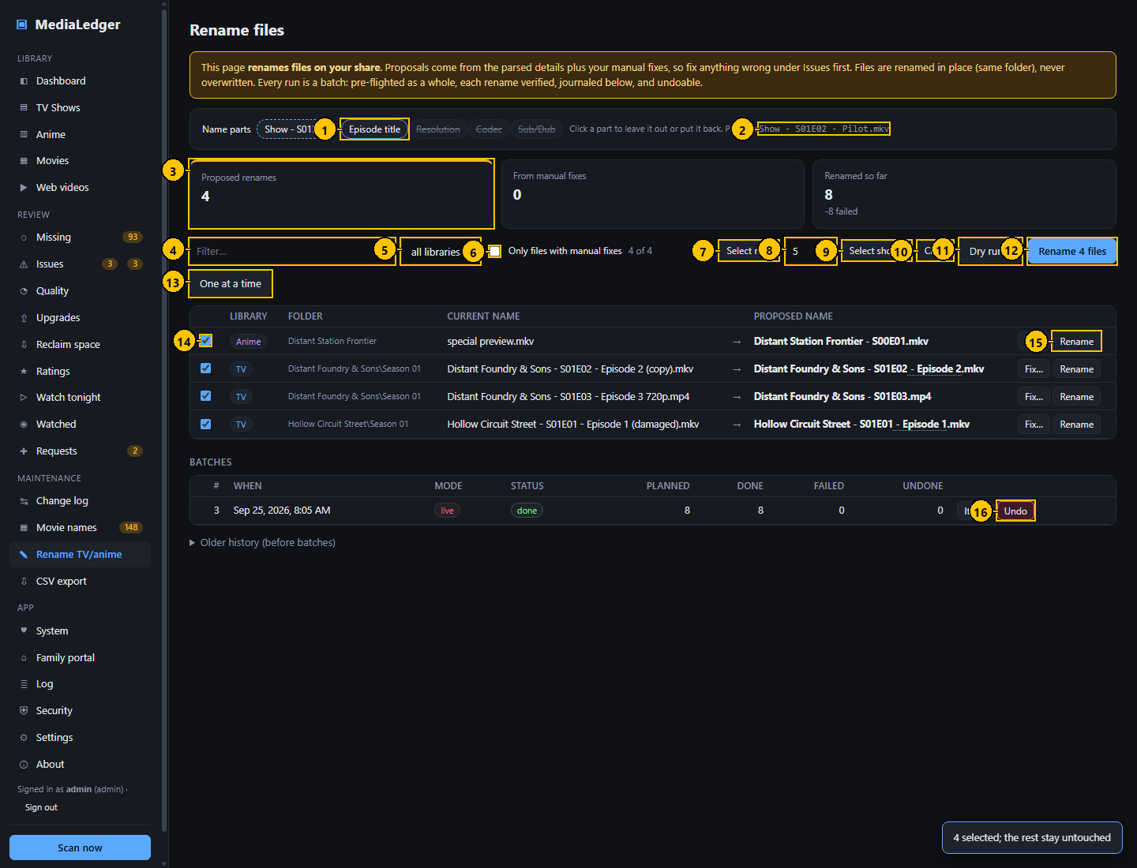
Figure 31. Rename TV / anime. The numbers match the table below.

Controls
# | Control name | Type | What it does | Inputs and limits | Default | Notes
1 | Name parts | Chips | Click a part to leave it out or put it back. | Episode title, Resolution, Codec, Sub/Dub | Episode title | "Show - S01E02" is fixed, because Plex matches on it.
2 | Preview | Label | An example of the name the chosen parts produce. | – | – | –
3 | Summary tiles | Tiles | Proposed renames, how many come from your fixes, renamed so far. | – | – | –
4 | Filter | Search field | Keeps the files that contain what you type. | – | empty | –
5 | Library | Drop-down list | Keeps one library. | – | all libraries | –
6 | Only files with manual fixes | Check box | Keeps the files whose proposal comes from a fix of yours. | – | off | –
7 | Select next | Button | Clears the selection and ticks only the next group. | – | – | –
8 | How many | Number field | The size of that group. | 1 to 200 | 10 | Remembered in this browser.
9 | Select shown | Button | Ticks every file in the list. | – | – | Asks first above 50.
10 | Clear | Button | Unticks everything. | – | – | –
11 | Dry run | Button | Shows what would happen to the ticked files. | – | – | –
12 | Rename | Button | Opens the confirmation for the ticked files. | – | – | –
13 | One at a time | Button | Walks through the ticked files, asking before each. | – | – | –
14 | Tick box | Check box | Includes that file in the batch. | – | off | –
15 | Rename this file | Button | Renames that one file after a confirmation. | – | – | –
16 | Undo | Button | Renames the files of that batch back. | – | – | –

Typical workflow
- Choose the name parts with the chips.
- Set the number beside "Select next" and press it.
- Check the ticked rows: current name on the left, proposed name on the right.
- Press "Dry run", then "Rename".
- Repeat for the next group.

Features
- Files are renamed in their folder, never moved and never overwritten.
- A rename button on each row renames just that file.

Edge cases
- Proposals come from the parsed details plus your fixes, so correct anything wrong under Issues first.
- While a batch runs, scans are held back.

Messages and what they mean
Message | Meaning and what to do
scan skipped: rename batch in progress | A scan was due while a batch was running. It runs at the next opportunity.

5.4 Rename confirmation dialog
The last stop before files are renamed: it lists every file and its new name.
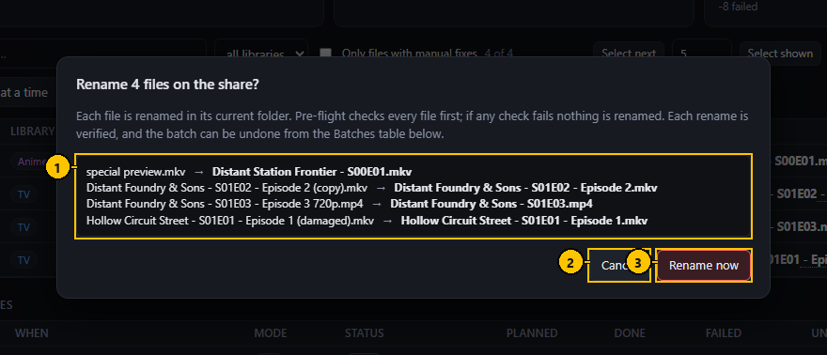
Figure 32. Rename confirmation dialog. The numbers match the table below.

Controls
# | Control name | Type | What it does | Inputs and limits | Default | Notes
1 | What will be renamed | List | Each current name and the name it will get. | – | – | –
2 | Cancel | Button | Closes without renaming. | – | – | –
3 | Rename now | Button | Runs the batch. | – | – | –

Typical workflow
- Read the list.
- Press "Rename now", or Cancel.

Features
- If any check fails, nothing is renamed.

5.5 CSV export
Writes the library to CSV files for a spreadsheet or another tool.
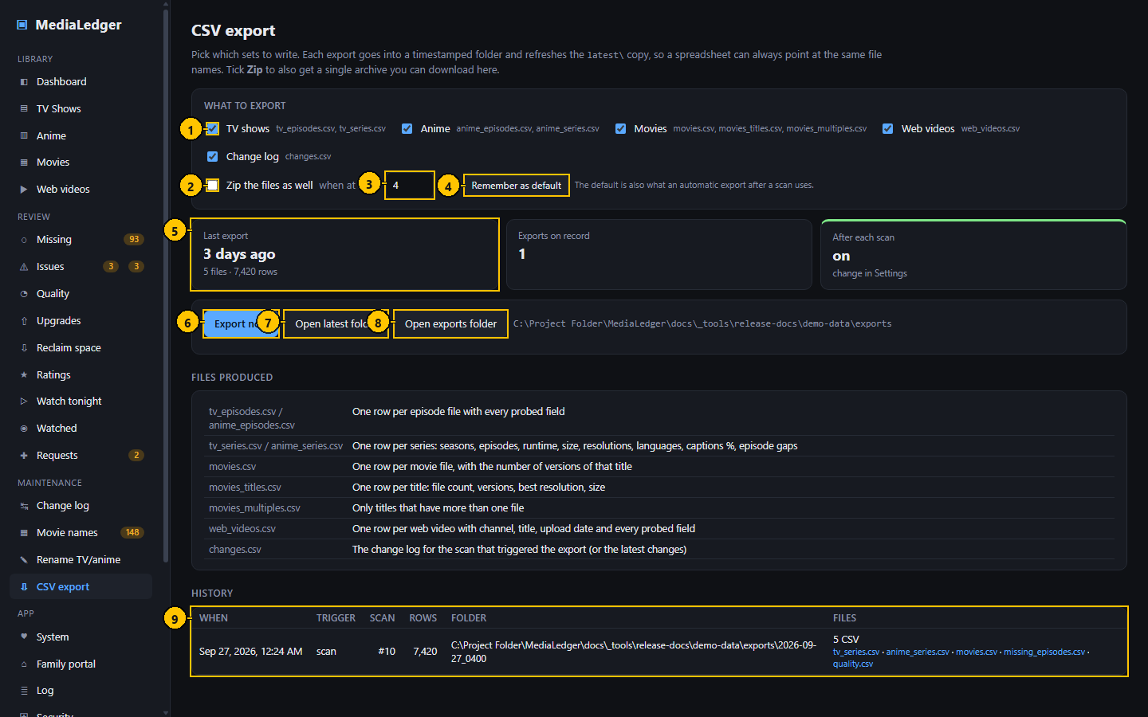
Figure 33. CSV export. The numbers match the table below.

Controls
# | Control name | Type | What it does | Inputs and limits | Default | Notes
1 | Sets to export | Check boxes | Which files to write. | – | TV, Anime, Movies, Web videos, Changes | –
2 | Zip the files | Check box | Puts the files of one export in a single zip file. | – | off | –
3 | Zip when more than | Number field | The number of files above which a zip file is made. | 1 or more | 4 | –
4 | Remember as default | Button | Saves the ticks for the automatic export. | – | – | –
5 | Summary tiles | Tiles | The last export, and whether exports run after each scan. | – | – | –
6 | Export now | Button | Writes the ticked sets. | – | – | –
7 | Open latest folder | Button | Opens the folder of the newest export. | – | – | Desktop only.
8 | Open exports folder | Button | Opens the folder that holds every export. | – | – | Desktop only.
9 | History | Table | Past exports with their files; on the web server each file is a download link. | – | – | –

Typical workflow
- Tick the sets you want.
- Choose whether to put them in one zip file.
- Press "Export now".
- Download the files from History, or open the folder on the desktop.

Features
- Sets: TV series, anime series, movies, episodes, missing episodes, quality, changes, requests and web videos.
- An export can run by itself after every scan.

Edge cases
- A zip file is made only when more files are exported than the number beside the check box.
- Adult titles are left out unless you allow them under Settings, Adult content.

6. Application
The application itself: the machine it runs on, who may use it, and what it has been doing.

6.1 System
Watches the machine MediaLedger runs on. On the Raspberry Pi that is the board itself, where temperature and power matter.
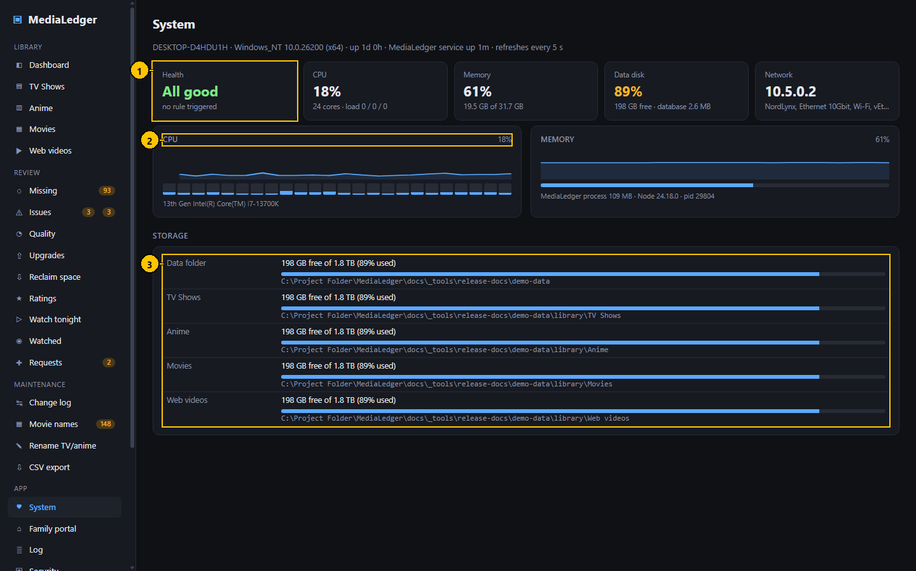
Figure 34. System. The numbers match the table below.

Controls
# | Control name | Type | What it does | Inputs and limits | Default | Notes
1 | Summary tiles | Tiles | Health, processor, memory, data disk, and on a Raspberry Pi the chip temperature. | – | – | –
2 | Charts | Charts | Processor per core, memory, temperature, network. | – | – | –
3 | Storage | Table | Free space of every root with a bar. | – | – | –

Typical workflow
- Read the Health tile: All good, Attention or Problem, with the rules that triggered.
- Read the charts for the last few minutes.
- Read Storage for the free space on every root.

Features
- Sampled every five seconds while the page is open.
- On a Raspberry Pi: chip temperature, clock speed, core voltage, throttling and under-voltage.

Edge cases
- The figures in this manual come from the computer the screenshots were made on.

Messages and what they mean
Message | Meaning and what to do
not reachable | A root or disk could not be read. Check the mount.

6.2 Family portal (administration)
Runs the family portal: a second, separate site for people you invite, where they can browse the libraries, pick something for tonight and send requests, and nothing else.
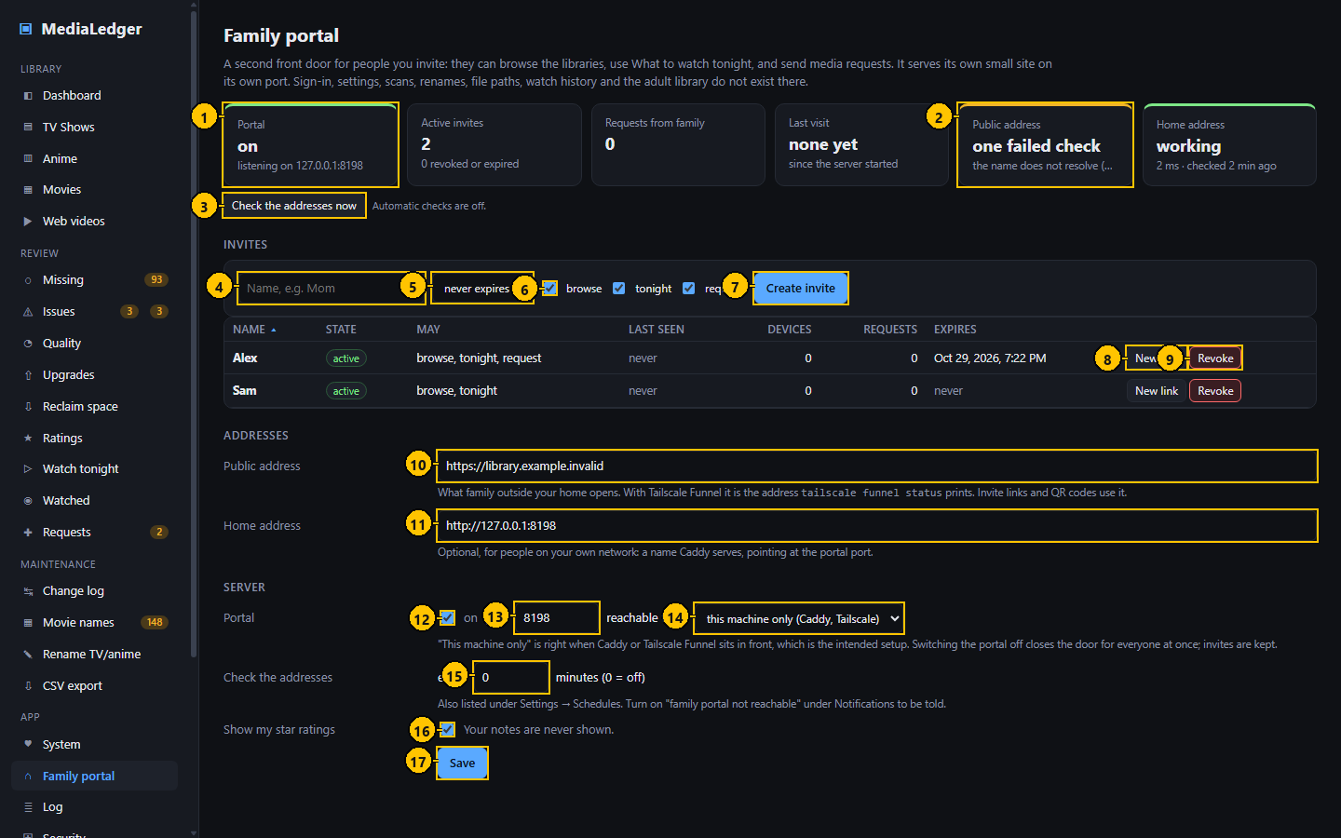
Figure 35. Family portal (administration). The numbers match the table below.

Controls
# | Control name | Type | What it does | Inputs and limits | Default | Notes
1 | Portal | Tile | Whether the portal is on and listening. | – | – | –
2 | Public address | Tile | Whether the public address works, the response time, when it was checked, and the days left on its certificate. | – | – | Amber after one failed check, red after two.
3 | Check the addresses now | Button | Tests both addresses at once. | – | – | –
4 | Name | Text field | Who the invite is for. Requests arrive under this name. | Up to 40 characters | empty | –
5 | Expires | Drop-down list | How long the invite works. | never, 7 days, 30 days, 1 year | never expires | –
6 | May browse, use tonight, request | Check boxes | What the person may do. | – | All three | –
7 | Create invite | Button | Creates the invite and shows its link and QR code once. | – | – | Asks for your password again on the web server.
8 | New link | Button | Makes a new link; the old link and every device using it stop working. | – | – | –
9 | Revoke | Button | Ends that person's access at once. | – | – | –
10 | Public address | Text field | What people away from home open. | https://name | empty | With Tailscale Funnel, the address the funnel command prints.
11 | Home address | Text field | A name served on your own network. | http:// or https://name | empty | Optional.
12 | Portal on | Check box | Starts or stops the portal. | – | off | –
13 | Port | Number field | The port the portal listens on. | 1024 to 65535 | 8090 | –
14 | Reachable from | Drop-down list | This machine only, or the whole network. | – | this machine only | Keep "this machine only" when Caddy or Tailscale is in front.
15 | Check the addresses every | Number field | Minutes between automatic checks. | 0 (off) or 1 to 1440 | 15 | –
16 | Show my star ratings | Check box | Whether the portal shows your stars. | – | on | Your notes are never shown.
17 | Save | Button | Saves the addresses and the server settings. | – | – | –

Typical workflow
- Set the public address (and a home address if you serve one) and press Save.
- Tick "on" and press Save.
- Type a name, choose an expiry and what the person may do, press "Create invite".
- Send the link or let them scan the QR code. It is shown once.
- Use "New link" or "Revoke" in the table when needed.

Features
- The portal is its own listener on its own port with its own short list of operations; sign-in, settings, scans, renames and logs do not exist there.
- Replies are built from a fixed list of fields, so paths, Plex keys, watch history and notes never leave the server; adult titles are never included.
- The server tests its own addresses on a timer and tells you when one stops working.

Edge cases
- "Create invite" is disabled until an address is set, because the link is built from it.
- Only a fingerprint of each link is stored; a lost link cannot be shown again, only replaced.
- Switching the portal off closes it for everyone at once and keeps the invites.

Messages and what they mean
Message | Meaning and what to do
Set a public or home address first | An invite needs an address to build its link.
<name> already has an active invite; use New link on it | One active invite per name.
port N is already in use | Another program listens on that port. Choose another.
the name does not resolve (DNS) | The address check could not look the name up. A new Tailscale address takes about fifteen minutes to appear.
a different MediaLedger portal answers on this address | The name points at another server.

6.3 Invite created, with its QR code
What appears after "Create invite" or "New link": the link and its QR code, once.
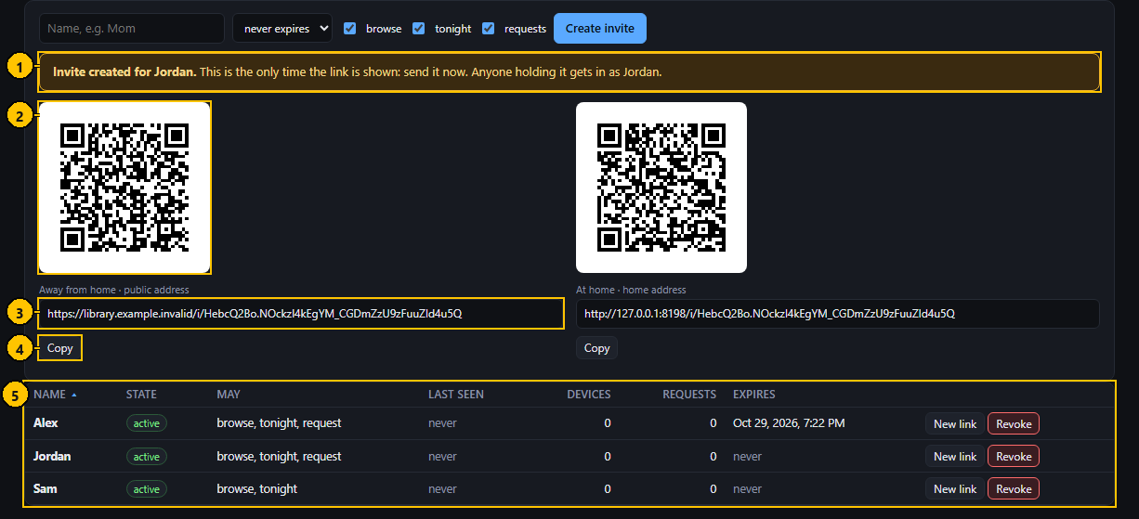
Figure 36. Invite created, with its QR code. The numbers match the table below.

Controls
# | Control name | Type | What it does | Inputs and limits | Default | Notes
1 | Notice | Notice | Says who the invite is for and that the link is shown only now. | – | – | –
2 | QR code | Image | The link as a code for a phone camera. | – | – | –
3 | Link | Text field | The link as text. Click to select it. | – | – | Read-only.
4 | Copy | Button | Copies the link. | – | – | –
5 | Invites | Table | Every invite: state, permissions, last seen, devices, requests, expiry. | – | – | –

Typical workflow
- Scan the code with the phone that should get access, or copy the link and send it.
- The phone opens the portal and is remembered for six months.

Features
- "Away from home" uses the public address; "At home" uses the home address.

Edge cases
- Leaving the page discards the link. Use "New link" to get another.

6.4 Log
The tail of the log file: scans, Plex syncs, backups, database upgrades, restores and every failure. It means diagnosing the server does not need a terminal.
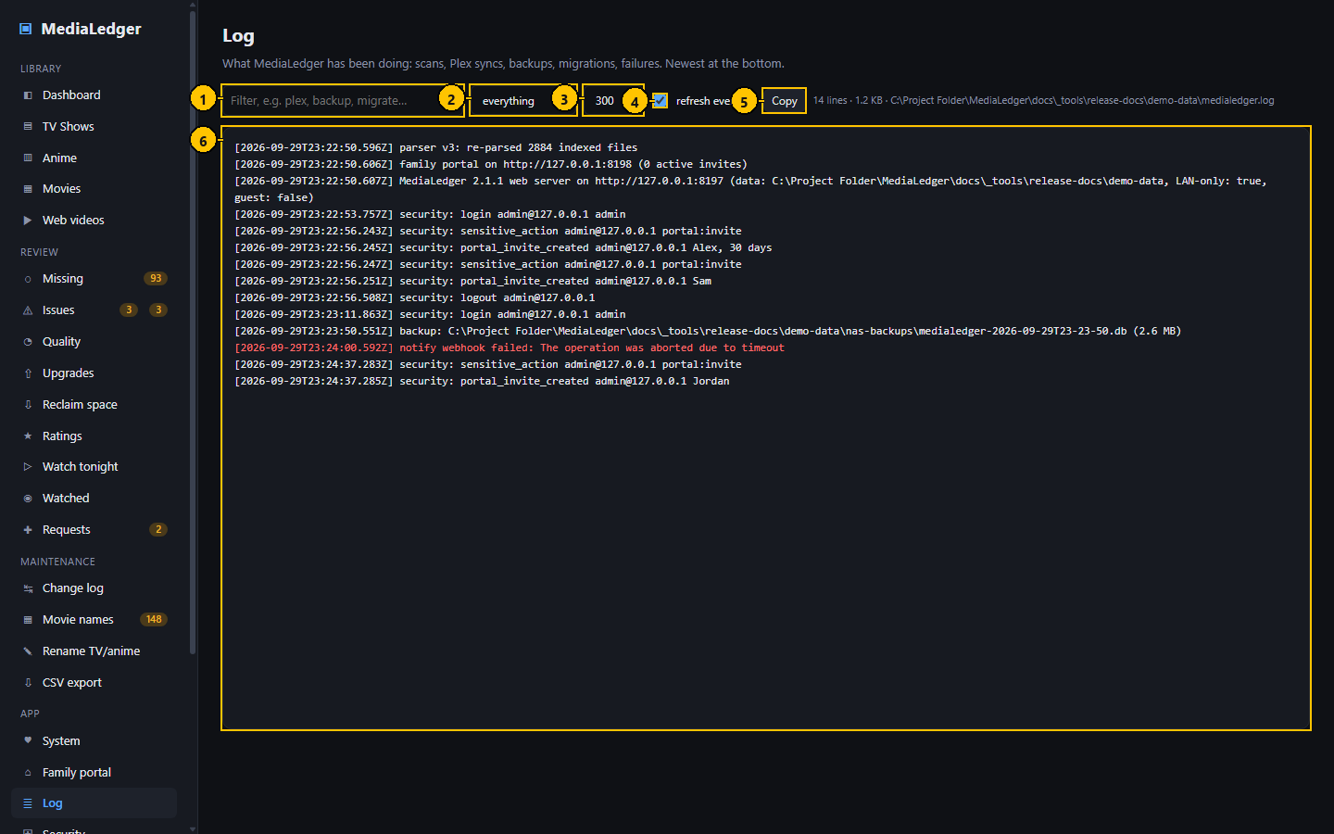
Figure 37. Log. The numbers match the table below.

Controls
# | Control name | Type | What it does | Inputs and limits | Default | Notes
1 | Filter | Search field | Keeps the lines that contain what you type. | – | empty | –
2 | Level | Drop-down list | Everything, or problems only. | – | everything | –
3 | Lines | Drop-down list | How many lines to show. | 300, 1000, 2000 | 300 | –
4 | Refresh every 5 s | Check box | Keeps the view current. | – | on | –
5 | Copy | Button | Copies the lines shown. | – | – | –
6 | Log lines | Text | The lines, newest at the bottom. | – | – | –

Typical workflow
- Type a word in the filter, for example plex or backup.
- Switch to "problems only" to see failures.
- Press Copy to take the lines elsewhere.

Features
- Refreshes every five seconds while the box is ticked.
- Failures are red, warnings amber.

Edge cases
- Only the last two megabytes of the file are read.
- Administrators only on the web server.

6.5 Security
Accounts, sessions and the protections of the web server. The desktop application shows this page only to explain that it applies to the server.
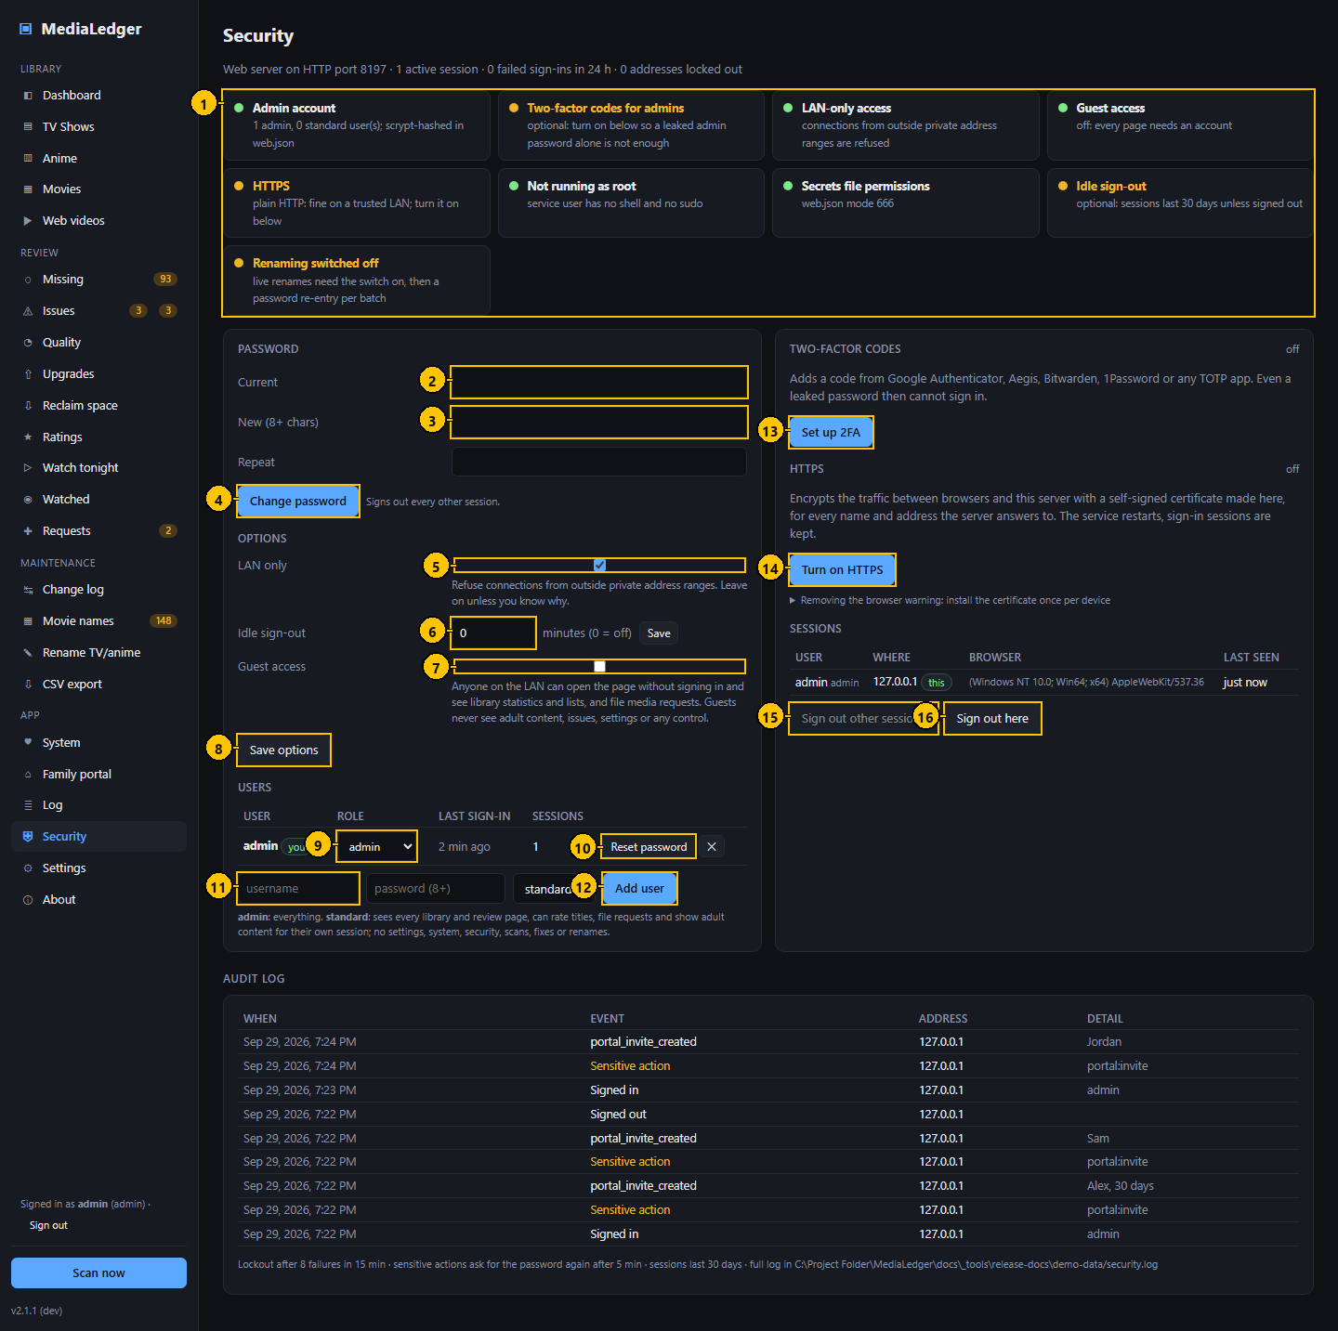
Figure 38. Security. The numbers match the table below.

Controls
# | Control name | Type | What it does | Inputs and limits | Default | Notes
1 | Checklist | Card | Each protection with a tick or a warning. | – | – | –
2 | Current password | Password field | Your password now. | – | empty | –
3 | New password | Password field | The password to change to. | At least 8 characters | empty | –
4 | Change password | Button | Changes your password and signs out your other sessions. | – | – | –
5 | LAN only | Check box | Refuses every address outside your network. | – | on | –
6 | Sign out when idle | Number field | Minutes without activity after which a session ends. | 0 (never) or more | 0 | –
7 | Guest access | Check box | Lets people look without signing in, read-only. | – | off | Guests can also file requests.
8 | Save options | Button | Saves the three options above. | – | – | –
9 | Role | Drop-down list | The role of that user. | admin, standard | – | –
10 | Reset password | Button | Sets a new password for that user. | – | – | –
11 | New user | Text field | The name of the account to add. | – | empty | –
12 | Add user | Button | Creates the account. | – | – | –
13 | Set up 2FA | Button | Starts two-factor setup. | – | – | –
14 | Turn on HTTPS | Button | Creates a self-signed certificate and restarts on HTTPS. | – | – | Use "Turn HTTPS off" instead when a reverse proxy holds the certificate.
15 | Sign out other sessions | Button | Ends every session but this one. | – | – | –
16 | Sign out here | Button | Ends this session. | – | – | –

Typical workflow
- Read the checklist at the top: each line is a protection and whether it is in place.
- Change your password, add users, set their roles.
- Switch on two-factor codes.
- Decide whether guests may look without signing in.
- Sign out other sessions if a device was lost.

Features
- Three roles: administrator (everything), standard (read, plus requests and ratings) and guest (read-only, no account).
- LAN only refuses every address outside your network.
- Sensitive actions ask for your password again when your last confirmation is more than five minutes old.
- Every sign-in, refusal and sensitive action is written to a security log, shown at the bottom.

Edge cases
- The last administrator cannot be deleted or demoted.
- Behind a reverse proxy the visitor's real address is read from the proxy, and only when the connection comes from this machine.

Messages and what they mean
Message | Meaning and what to do
Password must be at least 8 characters | Choose a longer password.
Please re-enter your password for this action | The action is sensitive and your last confirmation is too old.
LAN only | The request came from outside your network and was refused.

6.6 Two-factor setup
Adds a six-digit code from an authenticator application to the sign-in, so a leaked password alone is not enough.
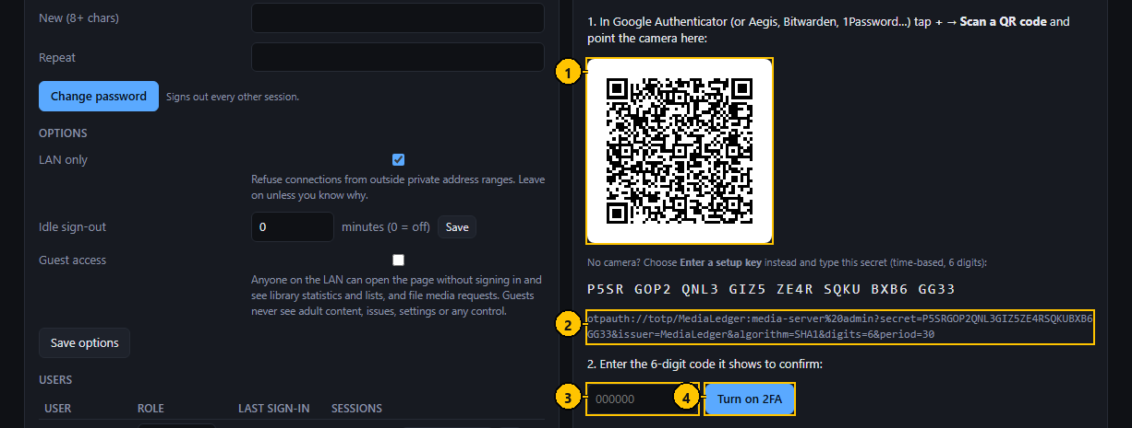
Figure 39. Two-factor setup. The numbers match the table below.

Controls
# | Control name | Type | What it does | Inputs and limits | Default | Notes
1 | QR code | Image | The setup key as a code for the authenticator application. | – | – | –
2 | Setup key | Text | The same key as text, for typing by hand. | – | – | –
3 | Code | Text field | The six digits the application shows. | 6 digits | empty | –
4 | Turn on 2FA | Button | Confirms the code and switches two-factor codes on. | – | – | –

Typical workflow
- In the authenticator application choose "Scan a QR code" and point the camera at the code.
- Or type the key shown under the code.
- Type the six digits the application shows and press "Turn on 2FA".

Features
- Works with Google Authenticator, Aegis, Bitwarden, 1Password and any application that follows the same standard.

Edge cases
- Setup is not finished until a code has been confirmed.
- Turning two-factor codes off asks for your password.

Messages and what they mean
Message | Meaning and what to do
That code is not right | The six digits did not match. Check the clock of the phone and try the next code.

6.7 About
Which version is running, where its data lives, and how to update.
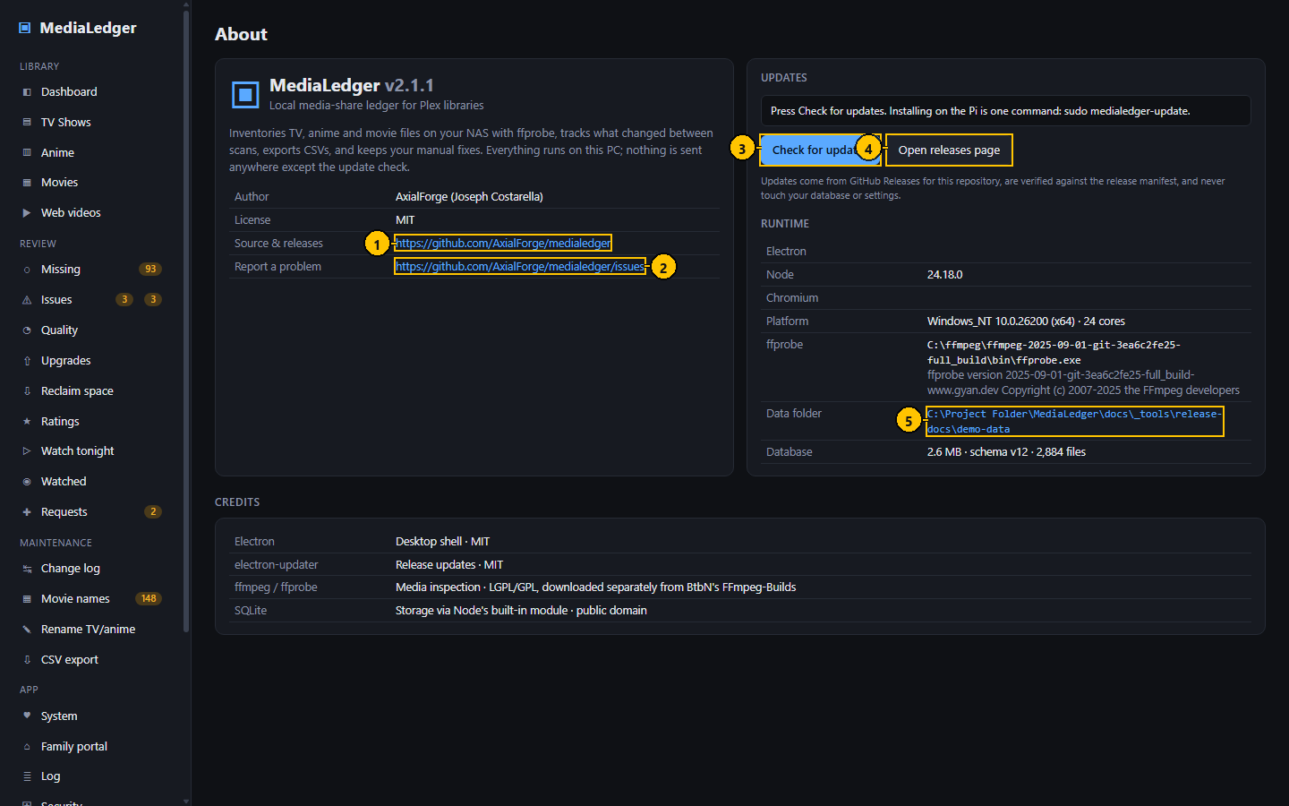
Figure 40. About. The numbers match the table below.

Controls
# | Control name | Type | What it does | Inputs and limits | Default | Notes
1 | Repository | Link | Opens the project on GitHub. | – | – | –
2 | Report a problem | Link | Opens the issue list. | – | – | –
3 | Check for updates | Button | Asks GitHub for the newest release. | – | – | –
4 | Open releases page | Button | Opens the list of releases. | – | – | –
5 | Data folder | Link | The folder that holds the database, the settings and the log. | – | – | Desktop: opens the folder.

Typical workflow
- Press "Check for updates".
- On the desktop, a newer version downloads by itself and is applied on the next restart.
- On the web server the page names the command to run.

Features
- Lists the versions of the parts it is built on and the path of the database.

Edge cases
- The desktop application checks at launch and every six hours when automatic updates are on.

Messages and what they mean
Message | Meaning and what to do
Could not reach GitHub | No connection, or GitHub is limiting requests. Try later.

7. Settings
Everything on the Settings page, section by section. Nothing on the page takes effect until Save settings at the bottom is pressed. The values are stored in settings.json in the data folder; section 10 lists every one.

7.1 Settings: Appearance and Library roots
The colour theme, and the folders MediaLedger scans. Nothing is scanned until a root is listed here and enabled.
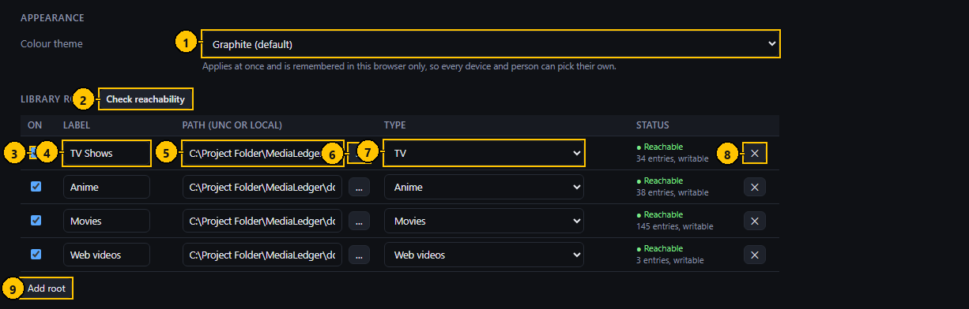
Figure 41. Settings: Appearance and Library roots. The numbers match the table below.

Controls
# | Control name | Type | What it does | Inputs and limits | Default | Notes
1 | Colour theme | Drop-down list | Changes the colours of the application. | Graphite, Midnight blue, Obsidian, Forest, Rose, Lavender, Gunmetal, Crimson | Graphite | Stored in the browser, per device.
2 | Check reachability | Button | Tests every root now and shows the result beside it. | – | – | –
3 | On | Check box | Whether this root is scanned. | – | on | –
4 | Label | Text field | The name shown for the root. | Free text | – | –
5 | Path | Text field | The folder to scan. | A network path or a local folder | – | Windows: \\server\share\folder. Raspberry Pi: /mnt/media/folder.
6 | Browse | Button | Chooses the folder. | – | – | Desktop: the system dialog. Web server: the folder browser.
7 | Type | Drop-down list | How the files in this root are read. | TV, Anime, Movies, Web videos, Adult | – | –
8 | Remove root | Button | Removes the root from the list. | – | – | –
9 | Add root | Button | Adds an empty row. | – | – | –

Typical workflow
- Pick a theme; it applies at once.
- For each library folder add a root: a label, the path, and the type.
- Press "Check reachability" to confirm every root can be read.
- Press "Save settings" at the bottom of the page.

Features
- Types: TV, Anime, Movies, Web videos, Adult.
- When a root cannot be reached the page says why: the file server does not answer, the share is not mounted, or the folder is missing.

Edge cases
- On the web server the path is typed or chosen with the folder browser, which lists folders only.
- On the Raspberry Pi an armed automount is nudged before a share is reported as not mounted.
- Removing a root does not delete its records until the next scan marks the files missing.

Messages and what they mean
Message | Meaning and what to do
Share not mounted | The file server answers but the share is not mounted. On the Raspberry Pi: sudo mount, or wait a minute for the watchdog.
does not answer on port 445 | The file server is off or unreachable.

7.2 Settings: Scanning, ffprobe, lookups and folder watch
How a scan walks the folders and measures the files, where ffprobe is, whether episode counts are looked up online, and whether folders are watched for changes.
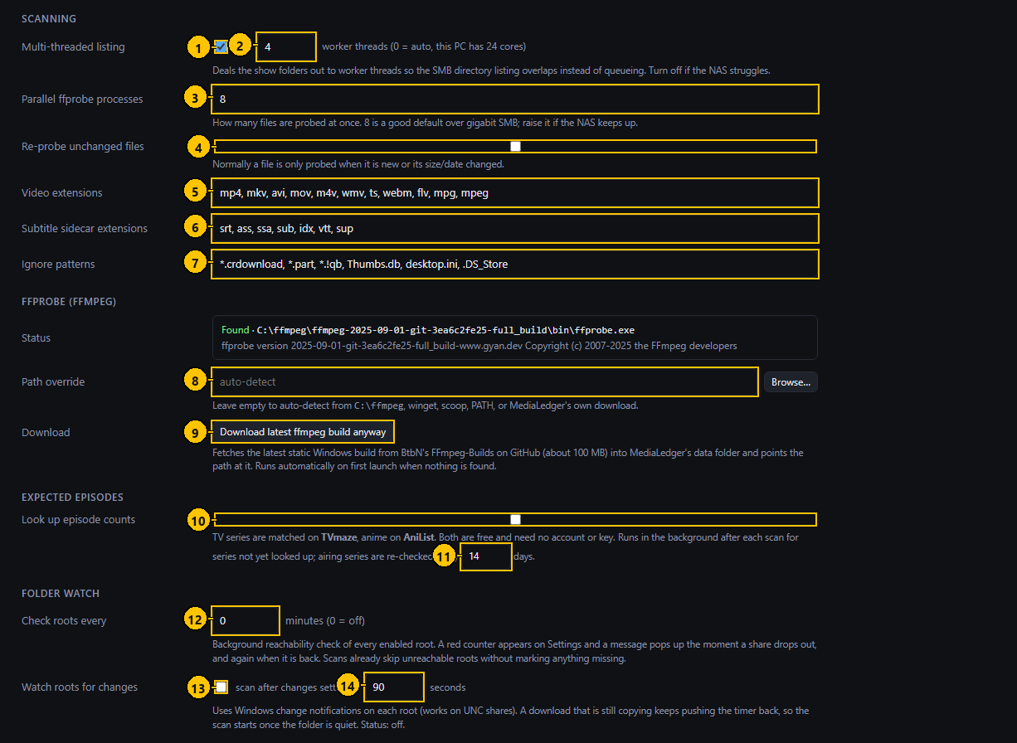
Figure 42. Settings: Scanning, ffprobe, lookups and folder watch. The numbers match the table below.

Controls
# | Control name | Type | What it does | Inputs and limits | Default | Notes
1 | Multi-threaded scan | Check box | Walks the roots with several threads. | – | on | –
2 | Threads | Number field | How many threads walk the folders. | 0 to 32; 0 chooses by itself | 0 | –
3 | Parallel probes | Number field | How many ffprobe processes run at once. | 1 or more | 8 | –
4 | Probe unchanged files again | Check box | Measures every file again, even when its size and date are unchanged. | – | off | Makes a scan much slower.
5 | Video extensions | Text field | Which file types count as video. | Comma separated | mp4, mkv, avi, mov, m4v, wmv, ts, webm, flv, mpg, mpeg | –
6 | Subtitle extensions | Text field | Which file types count as subtitles beside a video. | Comma separated | srt, ass, ssa, sub, idx, vtt, sup | –
7 | Ignore patterns | Text field | Files to skip. | Comma separated, * as wildcard | *.crdownload, *.part, *.!qb, Thumbs.db, desktop.ini, .DS_Store | –
8 | ffprobe path | Text field | Where ffprobe is. | A file path | empty (found automatically) | –
9 | Download ffmpeg | Button | Downloads a current ffmpeg build, which includes ffprobe. | – | – | Desktop only.
10 | Look up expected episodes | Check box | Asks TVmaze and AniList how many episodes each series has. | – | on | –
11 | Check running series again after | Number field | Days before a series that is still airing is looked up again. | 1 or more | 14 | –
12 | Check the roots every | Number field | Minutes between reachability checks. | 0 (off) or more | 5 | –
13 | Watch the folders | Check box | Starts a scan when files change. | – | off | –
14 | Wait for changes to settle | Number field | Seconds of quiet before that scan starts. | – | 90 | –

Typical workflow
- Leave the defaults unless scans are slow or something is missed.
- Press "Save settings".

Features
- A scan walks the roots with several threads, then probes new and changed files with ffprobe.
- Episode lookups use TVmaze and AniList; both are free and need no account.

Edge cases
- Probing is limited by the network share more than by the processor; raising the number of parallel probes beyond 8 rarely helps.
- Folder watch does not work on every network share; the daily scan is the safety net.

Messages and what they mean
Message | Meaning and what to do
ffprobe not found | Press the download button, or point the path at an existing ffprobe.

7.3 Settings: Renaming, adult content, quality thresholds and CSV export
The switches for the rename tools, how adult content is treated, the bitrate below which a file counts as low quality, and where CSV files go.
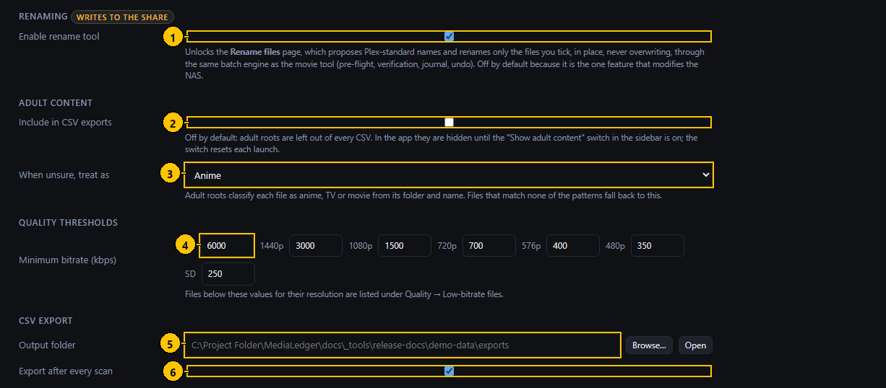
Figure 43. Settings: Renaming, adult content, quality thresholds and CSV export. The numbers match the table below.

Controls
# | Control name | Type | What it does | Inputs and limits | Default | Notes
1 | Renaming | Check box | Enables the Rename TV / anime page. | – | off | Marked "writes to the share".
2 | Adult titles in CSV files | Check box | Includes adult titles in exports. | – | off | –
3 | Read adult files as | Drop-down list | Whether files in an Adult root are read as anime or as TV. | Anime, TV | Anime | –
4 | Minimum bitrate | Number fields | Below this bitrate a file of that resolution counts as low quality. | Kilobits per second, per resolution | 4K 6000, 1440p 3000, 1080p 1500, 720p 700, 576p 400, 480p 350, SD 250 | Feeds the Quality page and the Upgrades ranking.
5 | CSV folder | Text field | Where exports are written. | A folder | empty (the exports folder beside the database) | –
6 | Export after each scan | Check box | Writes the CSV files whenever a scan finishes. | – | on | –

Typical workflow
- Switch renaming on only when you intend to use the rename pages.
- Adjust the thresholds to your own idea of acceptable quality.
- Press "Save settings".

Edge cases
- Renaming writes to your share. It is off until you switch it on.

7.4 Settings: Schedules
Every job MediaLedger runs by itself, in one table, with when it last ran and when it runs next.
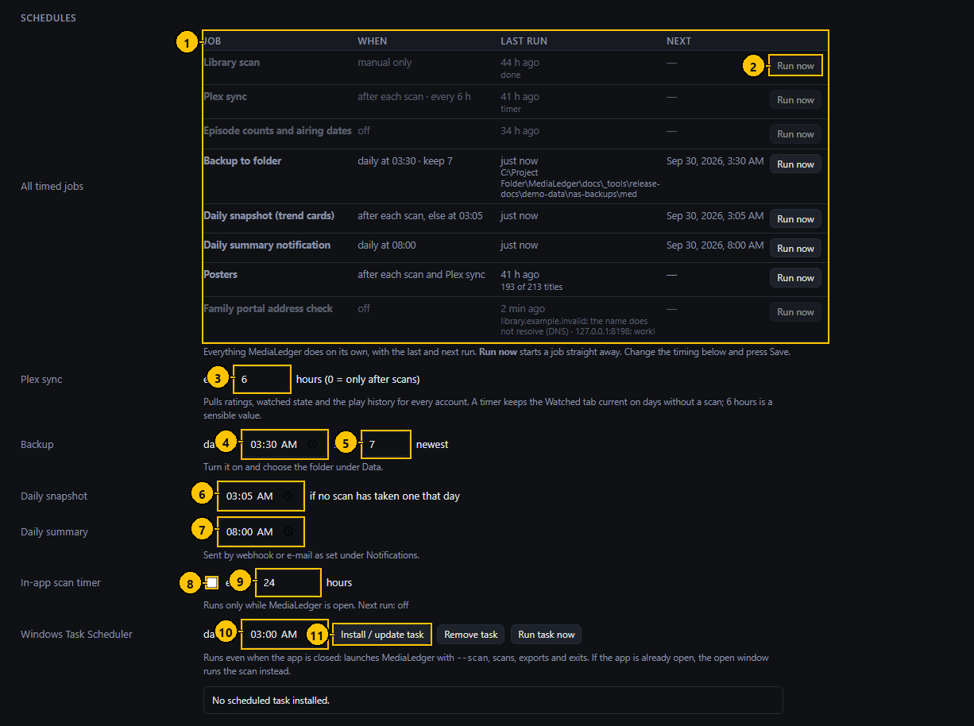
Figure 44. Settings: Schedules. The numbers match the table below.

Controls
# | Control name | Type | What it does | Inputs and limits | Default | Notes
1 | Jobs table | Table | Each job, when it runs, the last run and its result, and the next run. | – | – | –
2 | Run now | Button | Starts that job. | – | – | –
3 | Plex sync every | Number field | Hours between syncs that do not wait for a scan. | 0 (only after scans) or more | 6 | –
4 | Backup at | Time field | When the daily backup runs. | Time of day | 03:30 | –
5 | Keep | Number field | How many backup sets to keep. | 1 to 60 | 7 | –
6 | Daily snapshot at | Time field | When the snapshot is taken if no scan has taken one that day. | Time of day | 03:05 | –
7 | Daily summary at | Time field | When the summary notification goes out. | Time of day | 08:00 | –
8 | In-app scan timer | Check box | Scans on a timer while the application is open. | – | off | –
9 | Every | Number field | Hours between those scans. | 0.25 or more | 24 | –
10 | Windows scheduled task at | Time field | When the task runs each day. | Time of day | 03:00 | Desktop only.
11 | Install or update task | Button | Creates the scheduled task. | – | – | Desktop only.

Typical workflow
- Read the table: a red "overdue" badge marks a job that has not run when it should have.
- Press "Run now" to start a job at once.
- Change the timing below and press "Save settings".

Features
- Jobs: library scan, Plex sync, episode counts and airing dates, backup, daily snapshot, daily summary, posters, and on the web server the family portal address check.
- A job is overdue when it has not run for twice its interval, 48 hours for the daily ones, or when the last backup failed.

Edge cases
- The in-app scan timer runs only while the application is open; the Windows scheduled task runs even when it is closed.
- On the Raspberry Pi the application is always running, so the in-app timer is the one to use.

7.5 Settings: Data, backups and posters
Where the database is, how it is backed up and restored, and where posters are kept.
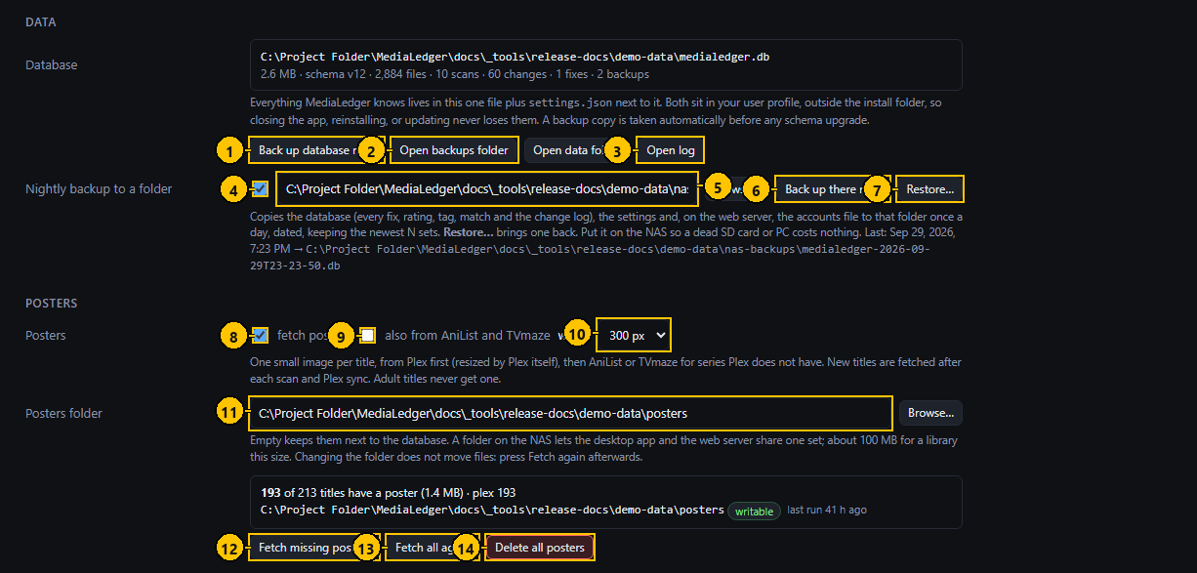
Figure 45. Settings: Data, backups and posters. The numbers match the table below.

Controls
# | Control name | Type | What it does | Inputs and limits | Default | Notes
1 | Back up database now | Button | Copies the database into the backups folder beside it. | – | – | –
2 | Open backups folder | Button | Opens that folder. | – | – | Desktop only.
3 | Open log | Button | Opens the log file. | – | – | Desktop only. The Log page works everywhere.
4 | Daily backup to a folder | Check box | Copies a backup set to the folder once a day. | – | off | –
5 | Backup folder | Text field | Where the sets go. | A folder | empty | –
6 | Back up there now | Button | Writes a set at once, which also tests the folder. | – | – | –
7 | Restore | Button | Opens the Restore dialog. | – | – | –
8 | Fetch posters | Check box | Fetches posters after each scan and Plex sync. | – | on | –
9 | Also from AniList and TVmaze | Check box | Uses the online services for series Plex does not have. | – | on | –
10 | Width | Drop-down list | The width posters are fetched at. | 200, 300 or 400 pixels | 300 | –
11 | Posters folder | Text field | Where posters are kept. | A folder | empty (the posters folder beside the database) | –
12 | Fetch missing posters | Button | Fetches posters for titles that have none. | – | – | –
13 | Fetch all again | Button | Fetches every poster again. | – | – | Asks first.
14 | Delete all posters | Button | Deletes the poster files. | – | – | Asks first. They can be fetched again.

Typical workflow
- Tick the backup box, set the folder (the NAS is the right place) and press "Back up there now" to test it.
- Set the posters folder and press "Fetch missing posters".
- Press "Save settings".

Features
- A backup is a set with one date stamp: the database, the settings and, on the web server, the accounts and portal files.
- A backup is also taken automatically before every database upgrade.
- Posters come from Plex first, then AniList and TVmaze; adult titles never get one.

Edge cases
- The accounts file holds password fingerprints and two-factor keys; keep the backup folder private.
- Changing the posters folder does not move files; fetch again afterwards.
- A title with no art anywhere is asked for again after two weeks.

Messages and what they mean
Message | Meaning and what to do
No backup folder set | Type a folder before backing up.
The posters folder is not writable | The folder does not exist or the application may not write there. On the Raspberry Pi, mount the share for the medialedger user.
Copied backup is empty | The copy failed; the folder may be full or read-only.

7.6 Restore from a backup dialog
Brings the database back from a backup set.
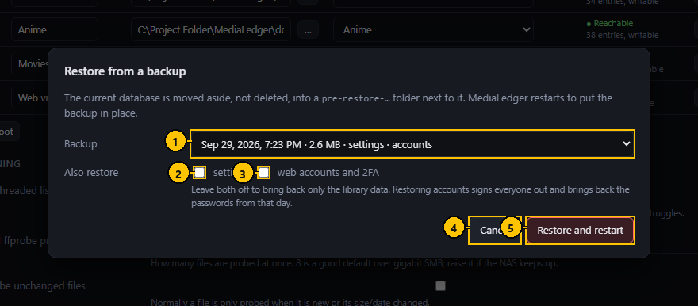
Figure 46. Restore from a backup dialog. The numbers match the table below.

Controls
# | Control name | Type | What it does | Inputs and limits | Default | Notes
1 | Backup | Drop-down list | The set to restore: its date, size and what it contains. | – | The newest | –
2 | Also restore settings | Check box | Brings the settings back too. | – | off | –
3 | Also restore web accounts and 2FA | Check box | Brings the accounts, two-factor keys and portal invites back too. | – | off | –
4 | Cancel | Button | Closes without restoring. | – | – | –
5 | Restore and restart | Button | Checks the backup, restarts, and puts it in place. | – | – | Asks for your password again on the web server.

Typical workflow
- Pick the set by its date.
- Tick whether the settings and the accounts should come back as well.
- Press "Restore and restart" and confirm.

Features
- The backup is opened read-only and checked before anything happens.
- The files it replaces are moved into a folder named pre-restore with the date, beside the database. Nothing is deleted.

Edge cases
- A backup from a newer version is refused; update first.
- Restoring accounts signs everyone out and brings back the passwords of that day.

Messages and what they mean
Message | Meaning and what to do
The backup failed its integrity check | The file is damaged. Choose another set.
The backup is schema vN; this build understands up to vM | The backup is from a newer version.
A scan is running; restore when it has finished | Wait for the scan.

7.7 Folder browser dialog (web server)
Chooses a folder on the server when the application runs in a browser, where the system folder dialog is not available.
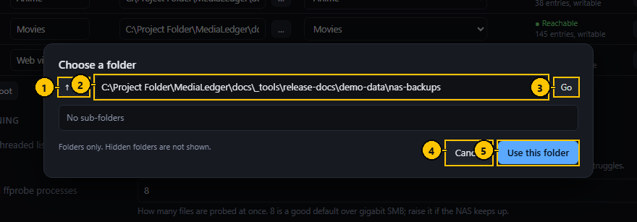
Figure 47. Folder browser dialog (web server). The numbers match the table below.

Controls
# | Control name | Type | What it does | Inputs and limits | Default | Notes
1 | Up | Button | Goes to the folder above. | – | – | –
2 | Path | Text field | The folder being shown. | – | – | Enter does the same as Go.
3 | Go | Button | Opens the typed path. | – | – | –
4 | Cancel | Button | Closes without choosing. | – | – | –
5 | Use this folder | Button | Puts the path into the field you came from. | – | – | –

Typical workflow
- Type a path and press Go, or click a folder in the list.
- Press "Use this folder".

Edge cases
- Folders only; files and hidden folders are not listed.

7.8 Settings: Updates and notifications
Whether the desktop application updates itself, and how MediaLedger tells you that something happened.
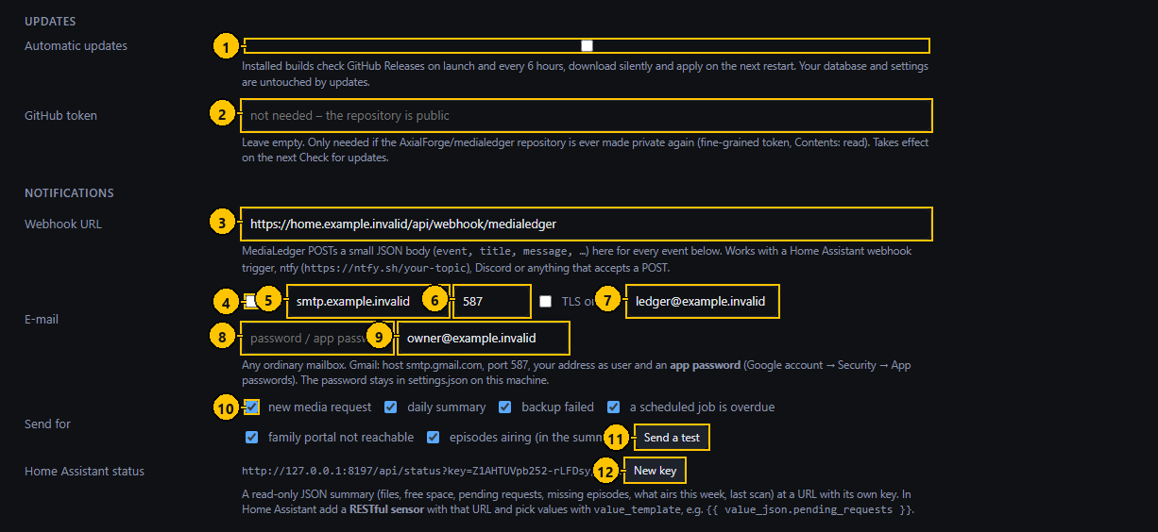
Figure 48. Settings: Updates and notifications. The numbers match the table below.

Controls
# | Control name | Type | What it does | Inputs and limits | Default | Notes
1 | Automatic updates | Check box | Checks GitHub at launch and every six hours. | – | on | Desktop only.
2 | GitHub token | Password field | Only needed if the repository is made private. | – | empty | Leave empty.
3 | Webhook address | Text field | Where event messages are sent. | An https or http address | empty | –
4 | E-mail on | Check box | Sends events by e-mail. | – | off | –
5 | Mail server | Text field | The outgoing mail server. | – | empty | –
6 | Port | Number field | The port of the mail server. | – | 587 | –
7 | Account | Text field | The account to send from. | – | empty | –
8 | Password | Password field | The password of that account. | – | empty | –
9 | Recipient | Text field | Who receives the e-mail. | – | empty | –
10 | Events | Check boxes | Which events are sent: new request, daily summary, backup failed, scheduled job overdue, family portal not reachable, episodes airing. | – | All ticked | –
11 | Send a test | Button | Sends a test message through everything that is set up. | – | – | –
12 | New key | Button | Replaces the key of the status address. | – | – | The old address stops working.

Typical workflow
- For a webhook, paste the address and press "Send a test".
- For e-mail, fill in the server, the account and the recipient, then test.
- Tick the events you want.
- Press "Save settings".

Features
- A webhook receives a small JSON message per event; Home Assistant, ntfy and Discord all accept it.
- The status address gives a read-only summary for Home Assistant, protected by its own key.

Edge cases
- For Gmail use an application password, not the account password.
- The update switch applies to the desktop application; the web server is updated with a command.

Messages and what they mean
Message | Meaning and what to do
No webhook or e-mail configured | Set one before testing.

7.9 Settings: Plex
Connects MediaLedger to your Plex Media Server on the local network, to read titles, ratings, watched state and the play history.
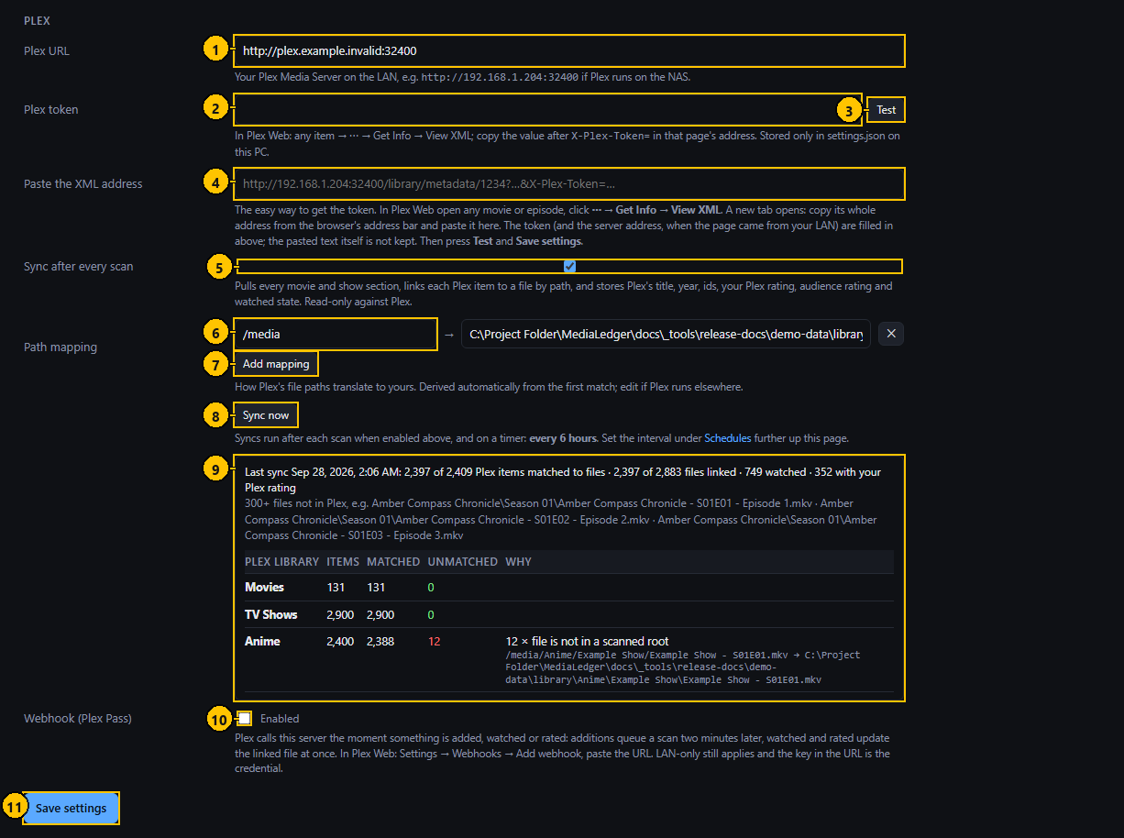
Figure 49. Settings: Plex. The numbers match the table below.

Controls
# | Control name | Type | What it does | Inputs and limits | Default | Notes
1 | Plex address | Text field | The address of the Plex server. | http://address:32400 | http://192.168.1.204:32400 | –
2 | Plex token | Password field | The token that lets MediaLedger read from Plex. | – | empty | Shown as dots; never sent anywhere but your Plex server.
3 | Test | Button | Connects and lists the libraries found. | – | – | –
4 | Paste the XML address | Text field | Takes the token out of an address copied from Plex. | – | empty | In Plex: an item, the three dots, Get Info, View XML, then copy the address.
5 | Sync after each scan | Check box | Runs a sync whenever a scan finishes. | – | off | –
6 | Path mapping | Text fields | How a path as Plex reports it translates to the path MediaLedger knows. | – | Worked out on the first sync | –
7 | Add mapping | Button | Adds a mapping row. | – | – | –
8 | Sync now | Button | Starts a sync. | – | – | –
9 | Last sync | Status | The result of the last sync and the table per library. | – | – | –
10 | Webhook enabled | Check box | Accepts reports from Plex. | – | off | Web server only.
11 | Save settings | Button | Saves everything on the Settings page. | – | – | Nothing on this page is saved until it is pressed.

Typical workflow
- Type the address of the Plex server.
- Paste the XML address from Plex into the box below; the token is taken from it.
- Press Test.
- Tick "Sync after each scan" and press "Sync now".
- Read the table under the last sync for anything unmatched.

Features
- Files are matched by their path; the path mapping translates how Plex sees a file into how MediaLedger sees it, and is worked out by itself on the first sync.
- The table breaks the sync down per Plex library, with the reason for anything unmatched.
- The webhook lets Plex report plays and ratings the moment they happen (Plex Pass).

Edge cases
- "file is not in a scanned root" means Plex has a library MediaLedger does not scan; add the root or ignore the row.
- "no path mapping covers this folder" means that library lives under a path no mapping translates; add a mapping.

Messages and what they mean
Message | Meaning and what to do
Plex rejected the token (401) | The token is wrong or has been revoked. Take a new one.
Could not reach Plex | The address is wrong or the server is off.

8. The family portal
A separate site for the people you invite. It is set up from the Family portal page (section 6) and reached at its own address. These are the pages a visitor sees, shown at the size of a phone.

8.1 Family portal: Library
The family portal is a separate small site for invited people. Library lists what is in the three libraries.
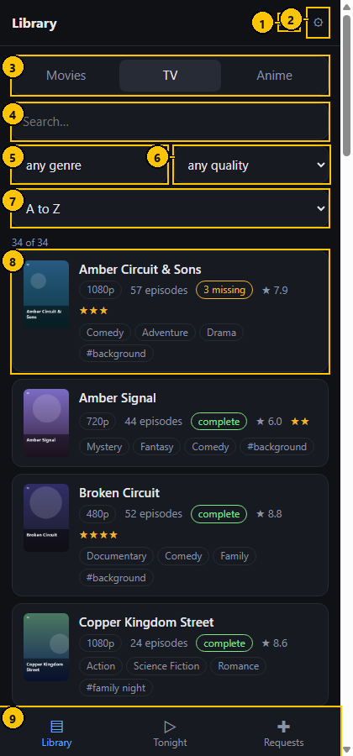
Figure 50. Family portal: Library. The numbers match the table below.

Controls
# | Control name | Type | What it does | Inputs and limits | Default | Notes
1 | Your name | Label | The name on the invite. | – | – | –
2 | Settings | Button | Opens the theme and sign-out page. | – | – | –
3 | Library | Tabs | Movies, TV or Anime. | – | Movies | Remembered on this device.
4 | Search | Search field | Keeps the titles that contain what you type. | – | empty | Also matches tags.
5 | Genre | Drop-down list | Keeps the titles with that genre. | – | any genre | –
6 | Quality | Drop-down list | Keeps the titles whose best copy has that resolution. | 4K, 1080p, 720p | any quality | –
7 | Sort | Drop-down list | Alphabetical, best rated, or newest first. | – | A to Z | –
8 | Title | Row | Poster, name, quality, length or episode count, rating, genres. | – | – | Tap to open.
9 | Tabs | Navigation | Library, Tonight and Requests, as far as the invite allows. | – | – | –

Typical workflow
- Tap Movies, TV or Anime.
- Type in the search box, or choose a genre, a quality or a sort order.
- Tap a title to open it.

Features
- Posters throughout.
- Series show whether they are complete or how many episodes are missing.

Edge cases
- Adult titles are never listed.
- Without an invite on this device the page only says that an invite is needed.

Messages and what they mean
Message | Meaning and what to do
Invite needed | Open the invite link on this device.
Too many requests; wait a minute | The portal limits how fast one device may ask.

8.2 Family portal: a series
What is on hand of one title.
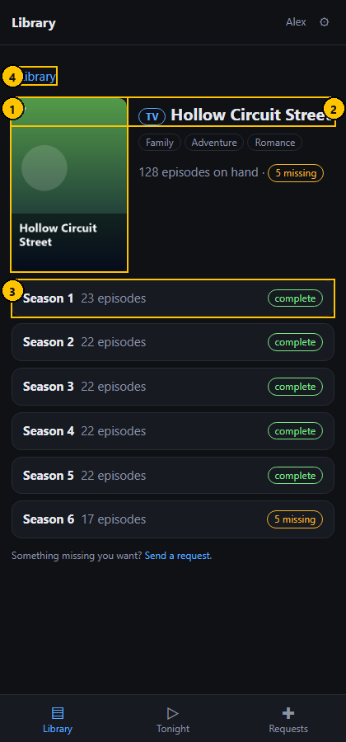
Figure 51. Family portal: a series. The numbers match the table below.

Controls
# | Control name | Type | What it does | Inputs and limits | Default | Notes
1 | Poster | Image | The poster of the title. | – | – | –
2 | Title | Heading | The name and its library. | – | – | –
3 | Season | Expandable row | A season with its episode count and whether it is complete. | – | Closed | Tap to open.
4 | Back | Link | Returns to the Library. | – | – | –

Typical workflow
- Tap a season to open it.
- Red lines are episodes that are not in the library.

Features
- A long run of missing episodes is shown as ranges, for example 1 to 60.

Messages and what they mean
Message | Meaning and what to do
Not in the library | The title was removed since the list was loaded.

8.3 Family portal: Tonight
Helps a family member choose something to watch.
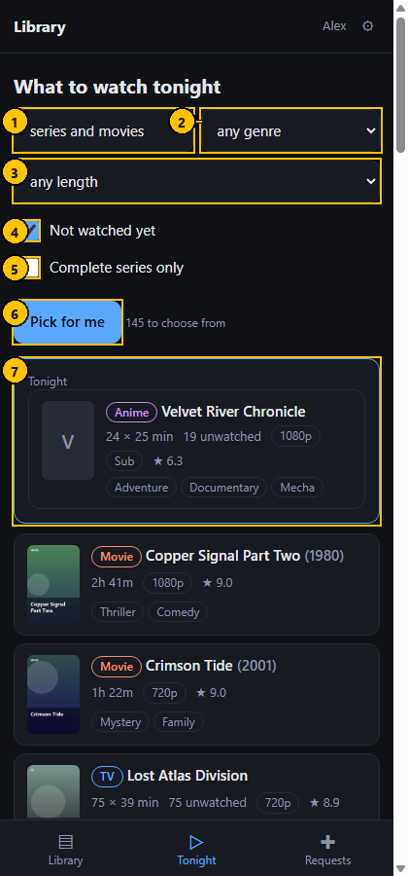
Figure 52. Family portal: Tonight. The numbers match the table below.

Controls
# | Control name | Type | What it does | Inputs and limits | Default | Notes
1 | Kind | Drop-down list | Series, movies or both. | – | series and movies | –
2 | Genre | Drop-down list | Keeps the titles with that genre. | – | any genre | –
3 | Length | Drop-down list | The longest length you have time for. | 30 minutes to 2 hours 10 minutes | any length | –
4 | Not watched yet | Check box | Keeps the titles with something left to watch. | – | on | –
5 | Complete series only | Check box | Keeps the series with no missing episodes. | – | off | –
6 | Pick for me | Button | Chooses one at random. | – | – | –
7 | Tonight | Card | The title that was picked. | – | – | –

Typical workflow
- Choose the kind, a genre and how long you have.
- Tap "Pick for me".

Edge cases
- "Not watched yet" follows the Plex account of the household, not the visitor's.

8.4 Family portal: Requests
Lets a family member ask for a title and follow what became of it.
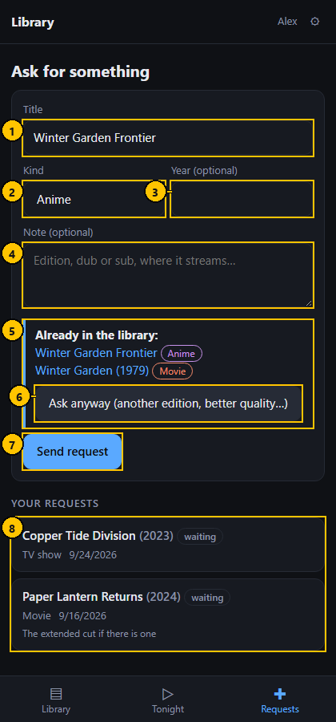
Figure 53. Family portal: Requests. The numbers match the table below.

Controls
# | Control name | Type | What it does | Inputs and limits | Default | Notes
1 | Title | Text field | What should be added. | Up to 120 characters | empty | –
2 | Kind | Drop-down list | Movie, TV show, Anime or Other. | – | Movie | –
3 | Year | Number field | The year of release. | 1900 to 2100 | empty | Optional.
4 | Note | Text area | Edition, dub or sub, where it streams. | Up to 400 characters | empty | Optional.
5 | Already in the library | Notice | Lists the matching titles, each a link. | – | – | –
6 | Ask anyway | Button | Sends the request although the title exists. | – | – | –
7 | Send request | Button | Sends the request. | – | – | –
8 | Your requests | List | Each request with its status and the reply, if any. | – | – | –

Typical workflow
- Type the title and choose the kind.
- Tap "Send request".
- If the title is already in the library the page says so; tap "Ask anyway" for another edition or a better copy.
- Read "Your requests" for the status and any reply.

Features
- The request arrives in the administrator's Requests page under the name on the invite.

Edge cases
- Six requests an hour and twenty-five a day per invite.
- Only your own requests are listed.

Messages and what they mean
Message | Meaning and what to do
That is a lot of requests; try again in an hour | The hourly or daily limit was reached.
Type the title | The title is missing or too short.
Your invite does not include this | The invite was made without permission to request.

8.5 Family portal: Settings
The visitor's own settings: the colour theme of this device, and forgetting the device.
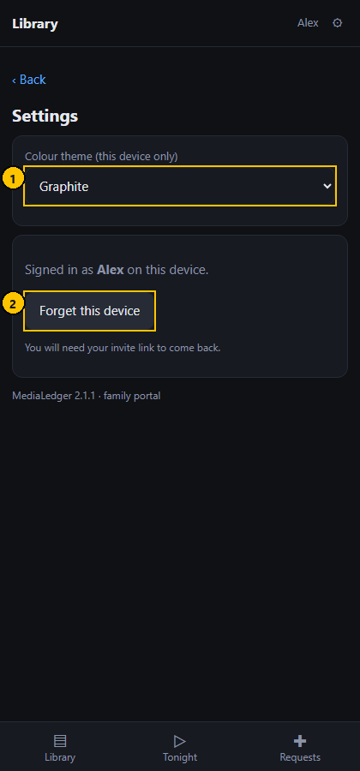
Figure 54. Family portal: Settings. The numbers match the table below.

Controls
# | Control name | Type | What it does | Inputs and limits | Default | Notes
1 | Colour theme | Drop-down list | Changes the colours on this device. | Eight themes | Graphite | –
2 | Forget this device | Button | Signs this device out of the portal. | – | – | Asks first.

Typical workflow
- Pick a theme.
- Tap "Forget this device" to sign this device out.

Edge cases
- After forgetting the device, the invite link is needed to come back.

9. Short dialogs
These dialogs have one or two buttons and appear in the middle of a task. They have no screenshot of their own.

9.1 Confirm it is you (password again)
Web server only. Before an action that changes files or security settings, the server asks for your password again unless you confirmed within the last five minutes.
 | Control name | Type | What it does | Inputs and limits | Default | Notes
– | Password | Password field | Your password. | – | empty | –
– | Confirm | Button | Confirms and carries on with the action. | – | – | –

9.2 One at a time
Walks through the ticked files, showing the current and the proposed name of each and asking before every rename. Used by both rename pages.
 | Control name | Type | What it does | Inputs and limits | Default | Notes
– | Rename this file | Button | Renames the file shown and moves to the next. | – | – | –
– | Skip | Button | Leaves this file as it is and moves to the next. | – | – | –
– | Stop | Button | Ends the walk; files already renamed stay renamed. | – | – | –

9.3 Dry run result
Lists what a rename would do to each ticked file, with a tick or a cross and the reason for a cross. Nothing on the share changes.
 | Control name | Type | What it does | Inputs and limits | Default | Notes
– | Close | Button | Closes the result. | – | – | –

9.4 Batch items
Lists the files of one batch with the status of each: done, failed, aborted or undone.
 | Control name | Type | What it does | Inputs and limits | Default | Notes
– | Close | Button | Closes the list. | – | – | –

9.5 Undo batch
Confirms renaming the files of a batch back. Each file is checked first: still present, same size, original name free.
 | Control name | Type | What it does | Inputs and limits | Default | Notes
– | Cancel | Button | Closes without undoing. | – | – | –
– | Undo now | Button | Renames the files back. | – | – | –

9.6 Rename movie files, live
The confirmation before a live movie batch. It lists the files (the first sixty) and asks you to type RENAME, so a live run cannot be started by a stray click.
 | Control name | Type | What it does | Inputs and limits | Default | Notes
– | Type RENAME to confirm | Text field | Type the word RENAME. | Exactly RENAME | empty | The rename button stays disabled until it matches.
– | Cancel | Button | Closes without renaming. | – | – | –
– | Rename now | Button | Runs the live batch. | – | disabled | Enabled once RENAME is typed.

9.7 Movie batch result
Shows the outcome of a movie batch, dry or live: how many files were renamed, skipped and failed.
 | Control name | Type | What it does | Inputs and limits | Default | Notes
– | Close | Button | Closes the result. | – | – | –

9.8 Set source for selected
Confirms recording where the ticked copies came from, which the Source part of the name uses.
 | Control name | Type | What it does | Inputs and limits | Default | Notes
– | Cancel | Button | Closes without changing. | – | – | –
– | Apply | Button | Saves the source as a fix on each ticked file. | – | – | –

9.9 Ignore the other files
When several files would get the same name, keeps one and marks the others as ignored. The ignored files stay on disk.
 | Control name | Type | What it does | Inputs and limits | Default | Notes
– | Cancel | Button | Closes without changing. | – | – | –
– | Ignore them | Button | Marks the other files as ignored. | – | – | –

9.10 Card settings (before version 2.0)
The colour-rule dialog of versions 1.9 to 1.12, opened by a gear on a tile. Version 2.0 replaced it with the card options dialog; the code remains but no gear opens it.
This dialog is not reachable from the interface in version 2.1.1.
 | Control name | Type | What it does | Inputs and limits | Default | Notes
– | Editor level | Drop-down list | Simple, Standard or Advanced. | – | Standard | –
– | Colour rule | Group | Amber and red thresholds. | – | – | Advanced only.

10. Common tasks from start to finish

10.1 Find and fill the gaps in a series
- Open Missing and sort by Missing.
- If the series is listed against the wrong title, press Match, search, and pick the right one.
- If you joined the series late, press Collect and choose the first episode you want.
- Open the series page to see exactly which episodes are red.
- Add the files to the share, then press Scan now. The gaps close by themselves.
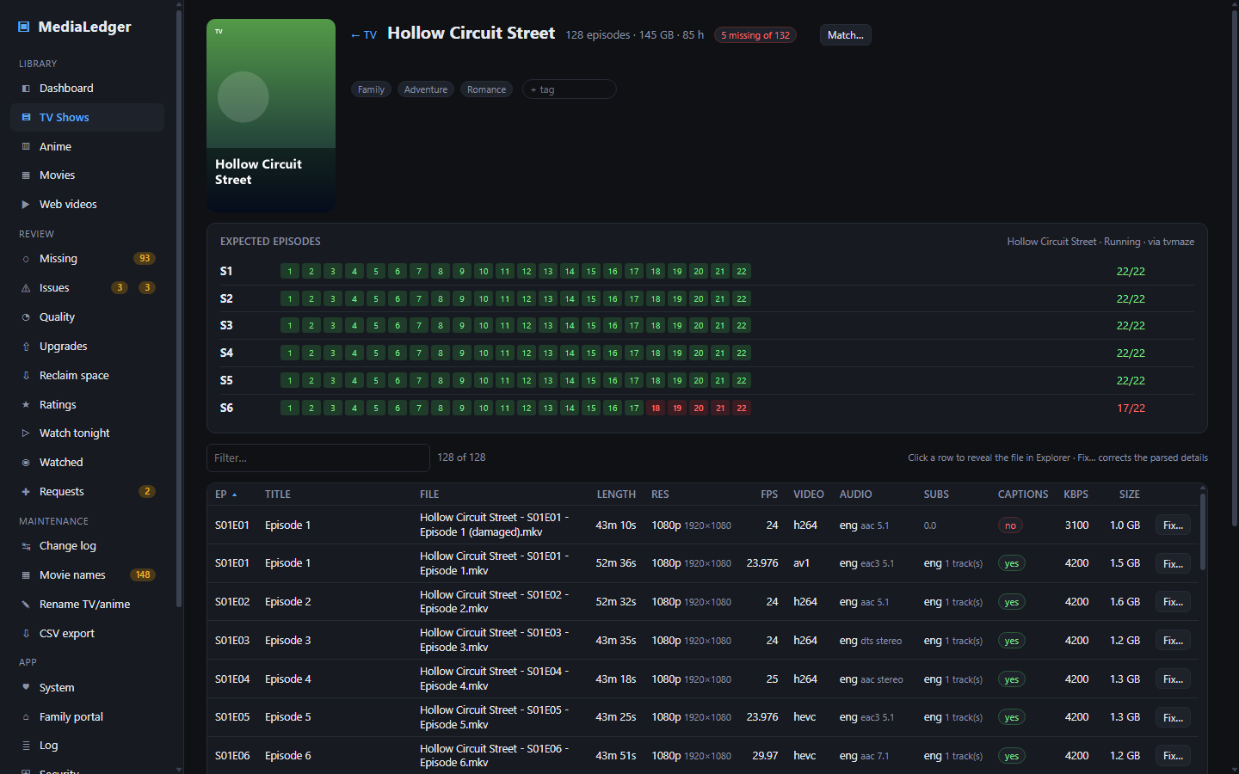
Figure 55. A series page: green is on hand, red is missing.

10.2 Tidy the names of a group of episodes
- Open Settings, Renaming, switch renaming on, and save.
- Open Rename TV/anime. Choose the name parts with the chips.
- Set the number beside Select next to a small group, for example 5, and press it.
- Press Dry run and read the result.
- Press Rename, read the list in the confirmation, and press Rename now.
- Press Select next again for the following group.
- If something went wrong, press Undo on the batch in the Batches table.
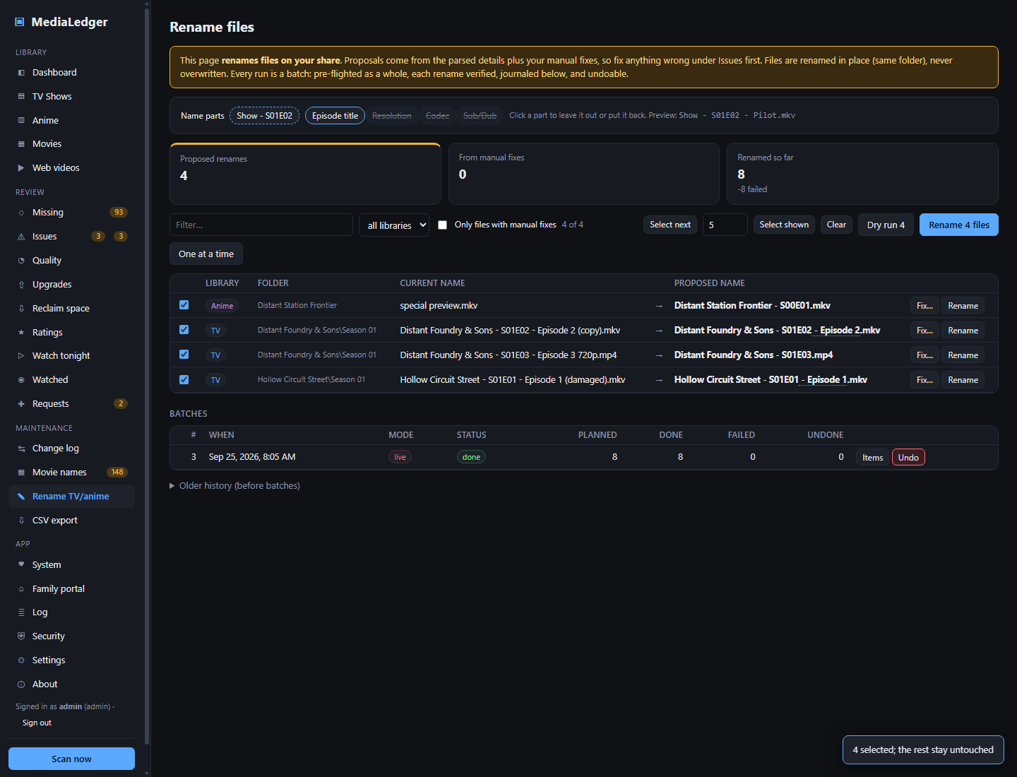
Figure 56. Five files ticked with Select next.

10.3 Arrange the Dashboard
- Press Edit dashboard.
- Remove the cards you never read with the cross on their handle.
- Press Add card and add the ones you want.
- Drag cards into order and set their width with S, M, L and XL.
- Press the gear on a number tile to set when it turns amber and red (choose Advanced under "Options shown" first).
- Press Done.
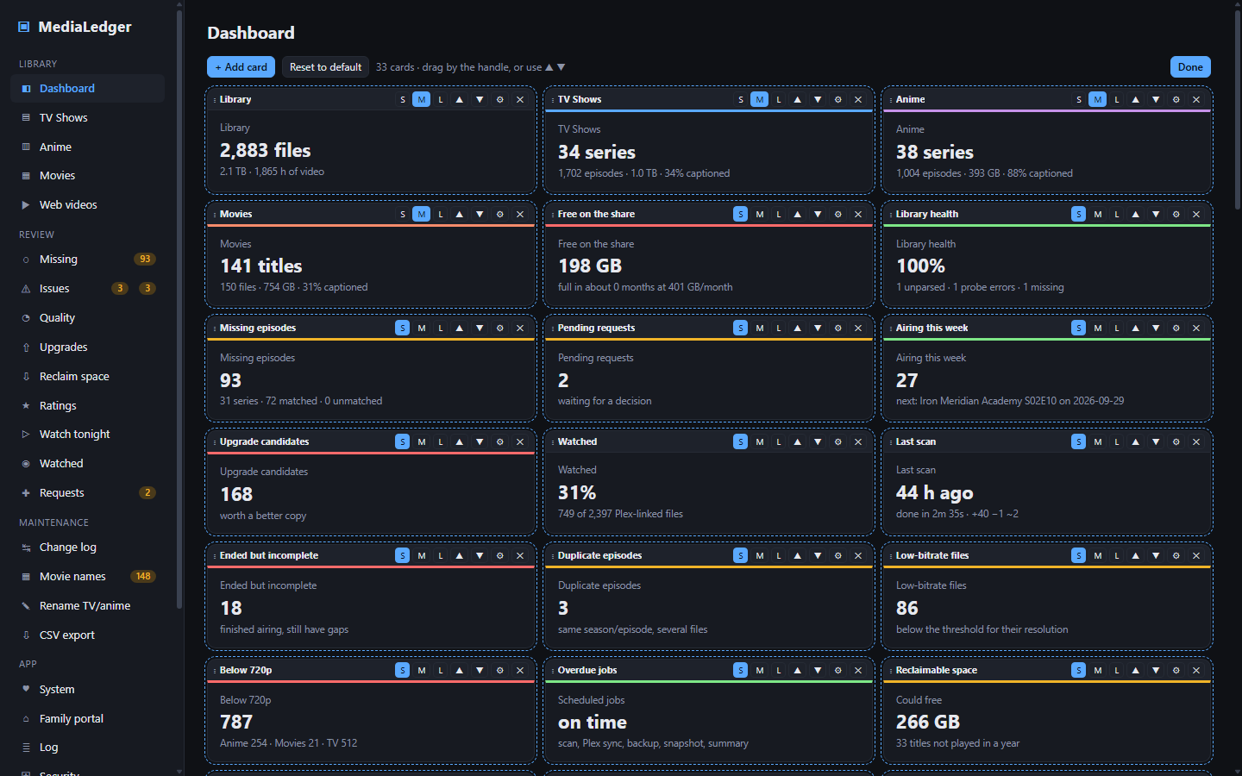
Figure 57. The Dashboard in edit mode.

10.4 Give a family member access
- Open Family portal. Set the public address and press Save.
- Tick on and press Save.
- Type the name, choose an expiry, press Create invite.
- Have them scan the QR code with their phone, or send them the link.
- Their requests appear under Requests, marked with their name.
- To end their access, press Revoke on their row.
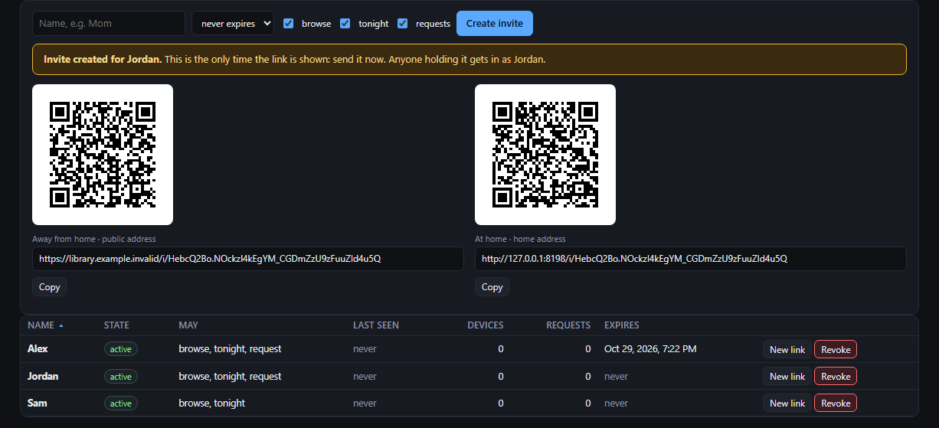
Figure 58. The invite with its QR code, shown once.

10.5 Back up, and restore
- Open Settings, Data. Tick the daily backup, type the folder, press Back up there now.
- Save the settings. A set is written every day at the time under Schedules.
- To restore: press Restore, pick the set by date, choose whether settings and accounts should come back too.
- Press Restore and restart. The application restarts on the restored data; the replaced files are kept in a pre-restore folder.
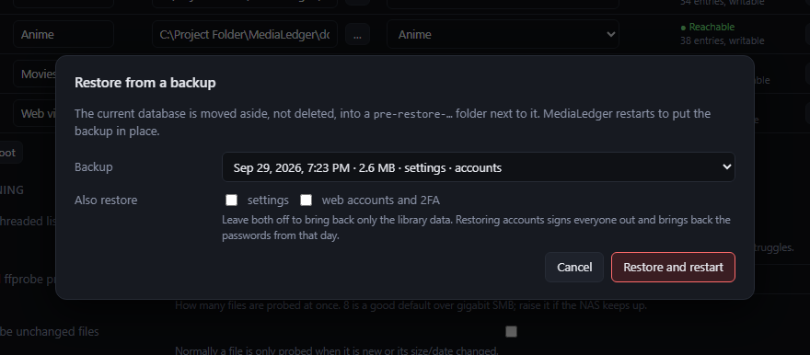
Figure 59. The Restore dialog.

10.6 Find out why something did not happen
- Open Settings, Schedules and look for a red "overdue" badge and the result of the last run.
- Open Log, type a word such as plex or backup, and switch to problems only.
- Press Run now on the job and watch the log.
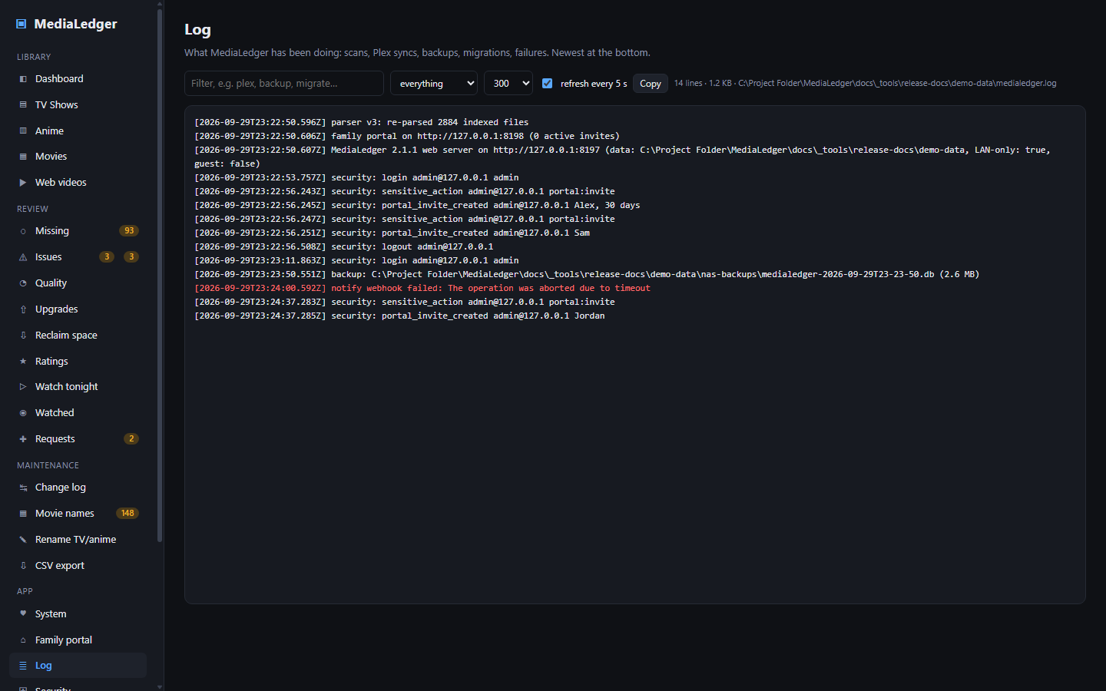
Figure 60. The Log page.

11. Settings reference
Every option on the Settings page and the pages that keep their own settings. "Stored in" says which file holds the value; all of them are in the data folder (%APPDATA%\MediaLedger on the desktop, /var/lib/medialedger on the Raspberry Pi) unless the browser is named.
Section | Option | What it does | Default | Stored in
Appearance and Library roots | Colour theme | Changes the colours of the application. | Graphite | The browser (local storage)
Appearance and Library roots | On | Whether this root is scanned. | on | settings.json
Appearance and Library roots | Label | The name shown for the root. | – | settings.json
Appearance and Library roots | Path | The folder to scan. | – | settings.json
Appearance and Library roots | Type | How the files in this root are read. | – | settings.json
Scanning, ffprobe, lookups and folder watch | Multi-threaded scan | Walks the roots with several threads. | on | settings.json
Scanning, ffprobe, lookups and folder watch | Threads | How many threads walk the folders. | 0 | settings.json
Scanning, ffprobe, lookups and folder watch | Parallel probes | How many ffprobe processes run at once. | 8 | settings.json
Scanning, ffprobe, lookups and folder watch | Probe unchanged files again | Measures every file again, even when its size and date are unchanged. | off | settings.json
Scanning, ffprobe, lookups and folder watch | Video extensions | Which file types count as video. | mp4, mkv, avi, mov, m4v, wmv, ts, webm, flv, mpg, mpeg | settings.json
Scanning, ffprobe, lookups and folder watch | Subtitle extensions | Which file types count as subtitles beside a video. | srt, ass, ssa, sub, idx, vtt, sup | settings.json
Scanning, ffprobe, lookups and folder watch | Ignore patterns | Files to skip. | *.crdownload, *.part, *.!qb, Thumbs.db, desktop.ini, .DS_Store | settings.json
Scanning, ffprobe, lookups and folder watch | ffprobe path | Where ffprobe is. | empty (found automatically) | settings.json
Scanning, ffprobe, lookups and folder watch | Look up expected episodes | Asks TVmaze and AniList how many episodes each series has. | on | settings.json
Scanning, ffprobe, lookups and folder watch | Check running series again after | Days before a series that is still airing is looked up again. | 14 | settings.json
Scanning, ffprobe, lookups and folder watch | Check the roots every | Minutes between reachability checks. | 5 | settings.json
Scanning, ffprobe, lookups and folder watch | Watch the folders | Starts a scan when files change. | off | settings.json
Scanning, ffprobe, lookups and folder watch | Wait for changes to settle | Seconds of quiet before that scan starts. | 90 | settings.json
Renaming, adult content, quality thresholds and CSV export | Renaming | Enables the Rename TV / anime page. | off | settings.json
Renaming, adult content, quality thresholds and CSV export | Adult titles in CSV files | Includes adult titles in exports. | off | settings.json
Renaming, adult content, quality thresholds and CSV export | Read adult files as | Whether files in an Adult root are read as anime or as TV. | Anime | settings.json
Renaming, adult content, quality thresholds and CSV export | Minimum bitrate | Below this bitrate a file of that resolution counts as low quality. | 4K 6000, 1440p 3000, 1080p 1500, 720p 700, 576p 400, 480p 350, SD 250 | settings.json
Renaming, adult content, quality thresholds and CSV export | CSV folder | Where exports are written. | empty (the exports folder beside the database) | settings.json
Renaming, adult content, quality thresholds and CSV export | Export after each scan | Writes the CSV files whenever a scan finishes. | on | settings.json
Schedules | Plex sync every | Hours between syncs that do not wait for a scan. | 6 | settings.json
Schedules | Backup at | When the daily backup runs. | 03:30 | settings.json
Schedules | Keep | How many backup sets to keep. | 7 | settings.json
Schedules | Daily snapshot at | When the snapshot is taken if no scan has taken one that day. | 03:05 | settings.json
Schedules | Daily summary at | When the summary notification goes out. | 08:00 | settings.json
Schedules | In-app scan timer | Scans on a timer while the application is open. | off | settings.json
Schedules | Every | Hours between those scans. | 24 | settings.json
Schedules | Windows scheduled task at | When the task runs each day. | 03:00 | settings.json
Data, backups and posters | Daily backup to a folder | Copies a backup set to the folder once a day. | off | settings.json
Data, backups and posters | Backup folder | Where the sets go. | empty | settings.json
Data, backups and posters | Fetch posters | Fetches posters after each scan and Plex sync. | on | settings.json
Data, backups and posters | Also from AniList and TVmaze | Uses the online services for series Plex does not have. | on | settings.json
Data, backups and posters | Width | The width posters are fetched at. | 300 | settings.json
Data, backups and posters | Posters folder | Where posters are kept. | empty (the posters folder beside the database) | settings.json
Updates and notifications | Automatic updates | Checks GitHub at launch and every six hours. | on | settings.json
Updates and notifications | GitHub token | Only needed if the repository is made private. | empty | settings.json
Updates and notifications | Webhook address | Where event messages are sent. | empty | settings.json
Updates and notifications | E-mail on | Sends events by e-mail. | off | settings.json
Updates and notifications | Mail server | The outgoing mail server. | empty | settings.json
Updates and notifications | Port | The port of the mail server. | 587 | settings.json
Updates and notifications | Account | The account to send from. | empty | settings.json
Updates and notifications | Password | The password of that account. | empty | settings.json
Updates and notifications | Recipient | Who receives the e-mail. | empty | settings.json
Updates and notifications | Events | Which events are sent: new request, daily summary, backup failed, scheduled job overdue, family portal not reachable, episodes airing. | All ticked | settings.json
Plex | Plex address | The address of the Plex server. | http://192.168.1.204:32400 | settings.json
Plex | Plex token | The token that lets MediaLedger read from Plex. | empty | settings.json
Plex | Paste the XML address | Takes the token out of an address copied from Plex. | empty | settings.json
Plex | Sync after each scan | Runs a sync whenever a scan finishes. | off | settings.json
Plex | Path mapping | How a path as Plex reports it translates to the path MediaLedger knows. | Worked out on the first sync | settings.json
Plex | Webhook enabled | Accepts reports from Plex. | off | settings.json
Family portal (administration) | Name | Who the invite is for. Requests arrive under this name. | empty | portal.json
Family portal (administration) | Expires | How long the invite works. | never expires | portal.json
Family portal (administration) | May browse, use tonight, request | What the person may do. | All three | portal.json
Family portal (administration) | Public address | What people away from home open. | empty | portal.json
Family portal (administration) | Home address | A name served on your own network. | empty | portal.json
Family portal (administration) | Portal on | Starts or stops the portal. | off | portal.json
Family portal (administration) | Port | The port the portal listens on. | 8090 | portal.json
Family portal (administration) | Reachable from | This machine only, or the whole network. | this machine only | portal.json
Family portal (administration) | Check the addresses every | Minutes between automatic checks. | 15 | portal.json
Family portal (administration) | Show my star ratings | Whether the portal shows your stars. | on | portal.json
Security | Current password | Your password now. | empty | web.json
Security | New password | The password to change to. | empty | web.json
Security | LAN only | Refuses every address outside your network. | on | web.json
Security | Sign out when idle | Minutes without activity after which a session ends. | 0 | web.json
Security | Guest access | Lets people look without signing in, read-only. | off | web.json
Security | Role | The role of that user. | – | web.json
Security | New user | The name of the account to add. | empty | web.json
Card options dialog | Title | Replaces the name printed on the card. | The name from the catalog | Account preferences: web.json (web server) or settings.json (desktop)
Card options dialog | Size | The width of the card. | Per card | Account preferences: web.json (web server) or settings.json (desktop)
Card options dialog | Amber threshold | The value at which the tile turns amber. | Per card | Account preferences: web.json (web server) or settings.json (desktop)
Card options dialog | Red threshold | The value at which the tile turns red. | Per card | Account preferences: web.json (web server) or settings.json (desktop)
Card options dialog | Options shown | How much this dialog offers. | Standard | Account preferences: web.json (web server) or settings.json (desktop)

11.1 What is remembered in the browser only
What | Where it is set
Colour theme | Settings, Appearance (and the portal's Settings page)
Table or poster wall | The Posters button of any list
Trend period of the Dashboard | The period list above the cards
Filters of Watch tonight, Watched and Reclaim space | On those pages
The number beside "Select next" | The rename pages

12. Keyboard shortcuts
MediaLedger is operated with the mouse or by touch. It defines no application-wide shortcuts and no menu of its own; the keys below work inside fields and dialogs.
Key | Where | What it does
Escape | Any dialog | Closes the dialog without saving.
Enter | Tag field on a series or movie page | Adds the typed tag.
Enter | Search words in the Match dialog | Starts the search.
Enter | Path in the folder browser | Opens the typed path.
Enter | Sign-in and confirmation dialogs | Submits the dialog.
Alt | Desktop application | Shows the standard Electron menu bar, which is hidden by default. MediaLedger defines no menu of its own and no application-wide shortcuts.
Standard browser and Windows keys apply as usual: Tab moves between fields, Space ticks a box, and in the desktop application F11 and the window keys behave as in any window.
Not present | Note
Context menus | None. No right-click menu is defined anywhere in the renderer.
Toolbars | No application toolbar. Pages carry their own filter row, listed with each page.
Application menu | None defined. The desktop window hides the default Electron menu bar.
Light theme | None. All eight colour themes are dark.

13. Troubleshooting and frequently asked questions
Question or symptom | Answer
The roots show "Share not mounted" on the Raspberry Pi. | The file server answers but the share is not mounted, usually after a restart. From version 1.12.1 the application nudges the mount itself and a watchdog mounts it within a minute. If it stays red, run sudo mount /mnt/media on the Pi and read the message.
The site cannot be reached by its name, but works by address. | The name is not being resolved. A virtual private network on your computer often sends lookups to its own servers, which do not know names on your network. Add the name to the hosts file of the computer, or point the network at your router for lookups.
The Watched page is empty. | Play history is pulled during a Plex sync. Run one under Settings, Plex, and set the sync timer under Schedules.
The Missing page is dominated by one very long series. | Press Collect on that series and choose "from an episode onward", or mute it.
A movie shows up that is really an episode. | It is listed under Issues, Problems, "Episodes filed under Movies". Move the file to a TV or anime folder.
Plex reports hundreds of unmatched files. | Read the table under the last sync. "File is not in a scanned root" means a Plex library MediaLedger does not scan; "no path mapping covers this folder" means a mapping is missing.
Create invite is greyed out. | Set a public or home address on the Family portal page and save first.
The invite link says the site cannot be found. | A new Tailscale address takes about fifteen minutes to appear on the internet. The tiles on the Family portal page tell you when it works.
Windows warns about the installer. | The installer is not code-signed. Choose More info, then Run anyway.
Editing the Dashboard is slow. | Update to version 2.1.1 or newer, which no longer reloads the data on every edit.
I forgot the web password. | On the Raspberry Pi run sudo medialedger --set-password.
How do I move to a new computer or a new card? | Install MediaLedger, then use Restore with your latest backup set and tick settings and accounts.
Does MediaLedger ever delete or move my media? | No. It renames files only on the two rename pages, only when you switch renaming on, and every rename can be undone. It never deletes media.
Does anything leave my network? | Episode lookups go to TVmaze and AniList, poster lookups to the same two, and the update check to GitHub. Nothing about your library is sent; the lookups contain only series names.

13.1 Every message in one place
Message | Where | Meaning and what to do
Wrong user name or password | Sign-in dialog (web server) | The pair did not match an account. The attempt is counted towards the lockout.
Too many failed attempts; this address is locked for 15 minutes | Sign-in dialog (web server) | Wait, or sign in from another address. The lockout is per address, not per account.
No account exists yet. On the server run: sudo medialedger --set-password | Sign-in dialog (web server) | The server has never had a password set. Run the command on the Raspberry Pi.
Enter the 6-digit code from your authenticator | Sign-in dialog (web server) | The password was right; two-factor codes are on and the code is the second step.
<job> is overdue: last ran N h ago, expected within N h | Dashboard | A scheduled job has not run for twice its interval. Open Settings, Schedules.
Family portal: <address> is not reachable | Dashboard | The server could not open its own portal address twice in a row. Open Family portal.
MediaLedger <version> is available | Dashboard | Web server only. Run the update command on the Raspberry Pi.
Layout not saved: <reason> | Dashboard, edit mode | The arrangement could not be stored on the server. It is kept in this browser and saved on the next change.
HTTP 403 from graphql.anilist.co | Missing episodes | AniList refused the request, usually because too many were sent. It is tried again on the next lookup.
no match | Missing episodes | Neither service had a series with a close enough name. Use Match.
Nothing found | Match dialog | The service had no series for those words. Shorten them or try the other service.
moov atom not found | Issues: Problems | ffprobe could not read the file: it is incomplete or damaged.
no season or episode found in the name | Issues: Problems | The name has no recognisable marker. Use Fix.
None of these titles is linked to Plex on this machine | Reclaim space | There is no play data behind the list. Sync Plex here, or open the page on the server that does.
Nothing matches; loosen the filters | Watch tonight | No title passes every filter.
Nothing here yet | Watched | No history has been pulled. Run a Plex sync.
Renaming is off | Movie names | Switch it on under Settings, Renaming.
target exists | Movie names | A file with the proposed name is already there. Nothing is overwritten.
size changed since the scan | Movie names | The file was altered after it was scanned. Scan again.
scan skipped: rename batch in progress | Rename TV / anime | A scan was due while a batch was running. It runs at the next opportunity.
not reachable | System | A root or disk could not be read. Check the mount.
Set a public or home address first | Family portal (administration) | An invite needs an address to build its link.
<name> already has an active invite; use New link on it | Family portal (administration) | One active invite per name.
port N is already in use | Family portal (administration) | Another program listens on that port. Choose another.
the name does not resolve (DNS) | Family portal (administration) | The address check could not look the name up. A new Tailscale address takes about fifteen minutes to appear.
a different MediaLedger portal answers on this address | Family portal (administration) | The name points at another server.
Password must be at least 8 characters | Security | Choose a longer password.
Please re-enter your password for this action | Security | The action is sensitive and your last confirmation is too old.
LAN only | Security | The request came from outside your network and was refused.
That code is not right | Two-factor setup | The six digits did not match. Check the clock of the phone and try the next code.
Share not mounted | Settings: Appearance and Library roots | The file server answers but the share is not mounted. On the Raspberry Pi: sudo mount, or wait a minute for the watchdog.
does not answer on port 445 | Settings: Appearance and Library roots | The file server is off or unreachable.
ffprobe not found | Settings: Scanning, ffprobe, lookups and folder watch | Press the download button, or point the path at an existing ffprobe.
No backup folder set | Settings: Data, backups and posters | Type a folder before backing up.
The posters folder is not writable | Settings: Data, backups and posters | The folder does not exist or the application may not write there. On the Raspberry Pi, mount the share for the medialedger user.
Copied backup is empty | Settings: Data, backups and posters | The copy failed; the folder may be full or read-only.
No webhook or e-mail configured | Settings: Updates and notifications | Set one before testing.
Plex rejected the token (401) | Settings: Plex | The token is wrong or has been revoked. Take a new one.
Could not reach Plex | Settings: Plex | The address is wrong or the server is off.
The backup failed its integrity check | Restore from a backup dialog | The file is damaged. Choose another set.
The backup is schema vN; this build understands up to vM | Restore from a backup dialog | The backup is from a newer version.
A scan is running; restore when it has finished | Restore from a backup dialog | Wait for the scan.
Could not reach GitHub | About | No connection, or GitHub is limiting requests. Try later.
Invite needed | Family portal: Library | Open the invite link on this device.
Too many requests; wait a minute | Family portal: Library | The portal limits how fast one device may ask.
Not in the library | Family portal: a series | The title was removed since the list was loaded.
That is a lot of requests; try again in an hour | Family portal: Requests | The hourly or daily limit was reached.
Type the title | Family portal: Requests | The title is missing or too short.
Your invite does not include this | Family portal: Requests | The invite was made without permission to request.

14. Glossary
Term | Meaning
Root | A folder MediaLedger scans, with a type: TV, Anime, Movies, Web videos or Adult.
Scan | Walking the roots to find files, then measuring new and changed files with ffprobe.
Probe | Reading the technical details of one file with ffprobe: length, resolution, codecs, languages.
Match | The online listing a series is compared with.
Locked match | A match you chose; automatic lookups leave it alone.
Collecting policy | What counts as missing for one series: everything, from an episode onward, or nothing.
Fix | A correction of how a file is read, stored in the database and applied on every scan.
Batch | One run of the rename tool over a group of files, checked as a whole, recorded and undoable.
Dry run | A batch that records what would happen and changes nothing.
Snapshot | One row a day describing the library, from which the trend cards are drawn.
Card | One element of the Dashboard.
Backup set | The files of one backup, sharing a date stamp: database, settings, and on the web server the accounts and portal files.
Invite | Permission for one person to use the family portal, given as a link.
Family portal | The separate read-only site for invited people.
Role | What an account on the web server may do: administrator, standard or guest.
Two-factor codes | Six-digit codes from an authenticator application, asked for after the password.
Webhook | An address another program calls when something happens.
Reverse proxy | A program such as Caddy that receives requests for several names on one machine and hands each to the right service.
Sub, dub, dual | Original audio with subtitles; audio in your language; both audio tracks present.
Square-root scale | A chart scale on which a small value is still visible beside a large one. The printed numbers are exact.

