MediaLedger
Installing on a Raspberry Pi
From a blank card to the first scan, with every question the installer asks
Version | Build date | Document date
2.4.0 | 2026-09-30 | 2026-10-01

This guide covers the web server edition of MediaLedger, which runs on a Raspberry Pi and is used from any browser on the home network.
The Windows desktop application is installed from its own setup file and needs none of this.

Contents
Contents 2
1. Before you start 3
1.1 What you need 3
1.2 What the installer puts on the Pi 3
2. Prepare the Raspberry Pi 4
2.1 Write the card 4
2.2 Connect to the Pi 4
3. Run the installer 5
3.1 The file server questions 5
3.2 The web password 6
3.3 The end of the installation 6
4. First sign-in and the welcome guide 7
4.1 The welcome guide 7
4.2 Choosing a folder 9
4.3 Connecting a share from the browser 10
4.4 The first scan 11
5. Living with it 12
5.1 What you see when you sign in over SSH 12
5.2 Commands 12
5.3 Updating 12
5.4 Adding or changing shares later 12
6. Optional extras 14
6.1 A name instead of an address 14
6.2 The family portal from outside the home 14
6.3 Bringing the database from the desktop application 14
7. When something goes wrong 16
7.1 Removing MediaLedger 16
7.2 What has and has not been tested 16

Page numbers are filled in when the document is opened in Word, or when it is exported.

1. Before you start
MediaLedger on a Pi does everything the desktop application does: it lists the media on your file server, measures every file, and shows what is missing, duplicated or worth upgrading. It runs all day on a few watts and every device in the house can open it.

1.1 What you need
Item | What to have
Raspberry Pi | A Pi 4B or Pi 5. A Pi 3 works on the 64-bit system but scans slowly.
Storage for the Pi | A 32 GB microSD card (class A2) or a USB solid-state drive.
Network | An Ethernet cable to the same network as the file server. Wi-Fi works but scans are slower.
A computer | To prepare the card and to type the commands. Windows, macOS or Linux.
The file server | Its address (for example 192.168.1.50) and a user name and password that may read the media. A NAS, or a PC that shares folders.
A password | For the MediaLedger site itself. At least 8 characters. You choose it during the installation.
Time | About fifteen minutes, most of it waiting for the card to be written.

1.2 What the installer puts on the Pi
What | Where | Purpose
The application | /opt/medialedger | The server and its web pages. Replaced by every update.
Your data | /var/lib/medialedger | The database, settings, accounts, backups and log. Never touched by an update.
The shares | /mnt/medialedger/<share> | Each share you connect appears here as a folder.
Share sign-ins | /etc/medialedger-shares/ | One file per share, readable by root only.
The service | medialedger.service | Starts MediaLedger with the Pi, as a user with no shell and no administrator rights.
The share helper | medialedger-share.path | Lets the web application connect a share without the service being an administrator.
The watchdog | medialedger-mount.timer | Reconnects a share within a minute when the file server comes back.
Programs | Node 22, ffmpeg, cifs-utils, smbclient, curl, openssl | Installed from the system package source.
Nothing on the file server is changed by the installation. MediaLedger only reads, unless you later switch on its renaming tools.

2. Prepare the Raspberry Pi

2.1 Write the card
- Download Raspberry Pi Imager from raspberrypi.com and start it.
- Choose device: your board.
- Choose OS: Raspberry Pi OS (other), then Raspberry Pi OS Lite (64-bit). The 64-bit version is required. Lite has no desktop, which is never needed.
- Choose storage: the card or drive.
- Press Next, then Edit settings. On General set a hostname (for example medialedger), a user name and password for the Pi, and the time zone. Set Wi-Fi only if no cable is used.
- On Services tick Enable SSH with password authentication.
- Save, write the card, put it in the Pi, connect the network cable and the power.

2.2 Connect to the Pi
Wait about a minute after power-on. On Windows open Terminal (or PowerShell) and type, with the hostname and user name you chose:
ssh joe@medialedger.local
Answer yes to the question about the host key the first time, then type the password of the Pi. Nothing is shown while a password is typed.
If this happens | Do this
Could not resolve hostname medialedger.local | Use the address instead. Find it in the router's list of devices and type ssh joe@192.168.1.60 with that address.
Connection refused | SSH was not enabled when the card was written. Write the card again with Enable SSH ticked.
You prefer PuTTY | Type the hostname or address in Host Name, leave the port at 22, press Open.
Check that the system is 64-bit and note the address of the Pi:
uname -m; hostname -I
The first line must say aarch64. The second is the address you will open in a browser.

3. Run the installer
One command downloads the installer and starts it:
curl -fsSL https://raw.githubusercontent.com/AxialForge/medialedger/main/server/install.sh -o install.sh && sudo bash install.sh
It begins by saying what it will ask:
MediaLedger for Raspberry Pi: installation
------------------------------------------
This takes about five minutes and asks three things:
1. where your media lives (the file server's address, a username and a password),
2. which of its shares to use,
3. a password for the MediaLedger site.
Then it works through five stages. Each stage prints a line starting with ==>.
Stage | What happens | What you do
==> Packages | Installs Node 22, ffmpeg and the tools for network shares. The slowest stage on a new card. | Wait.
==> Service user and data folder | Creates the user medialedger and the folder for your data. | Nothing.
==> Application at /opt/medialedger | Downloads the newest release, checks its checksum and unpacks it. | Nothing.
==> Network shares | Asks for the file server and connects the shares you pick. | Answer the questions in 3.1.
==> Web password | Asks for the password of the MediaLedger site. | Answer the question in 3.2.

3.1 The file server questions
Address of the file server, for example 192.168.1.50 (Enter to skip and do it later in the browser): 192.168.1.50
Username on 192.168.1.50: media
Password:

Shares on 192.168.1.50:
1) Media
2) Backups
3) Photos
Which ones hold your media? Numbers separated by spaces, or 'all': 1
connected: Media -> /mnt/medialedger/Media (Anime Movies TV Shows )
Connect shares from another server too? [y/N] n
Question | What to type | Notes
Address of the file server | The IP address or name of the NAS or PC, for example 192.168.1.50. | No slashes and no share name: only the server. Press Enter with nothing typed to skip this stage and connect shares later in the browser.
Username | An account on the file server. | It needs permission to read the media. Renaming later also needs permission to write.
Password | The password of that account. | Nothing is shown while you type.
Which ones hold your media? | The numbers from the list, separated by spaces, or all. | Pick only the shares with media. More can be added later.
Connect shares from another server too? | y to repeat the questions for another server, Enter for no.
Each share is connected under /mnt/medialedger/ in a folder named after it, and the line connected: shows the first few things found inside, which is a quick check that it is the right share.
The installer says | Meaning and what to do
gave no shares back. Check the address, the username and the password, and that file sharing (SMB) is on. | The server did not answer, refused the sign-in, or does not share files. The questions are asked again.
could not connect <share> | The share was listed but could not be connected, with the reason on the line above: usually the account may list the share but not open it.
Skipped. | You pressed Enter at the address. Nothing is connected; do it later from the welcome guide or with sudo medialedger-setup.
The sign-in for each share is stored in /etc/medialedger-shares/, readable by root only, so the share reconnects after a restart. It is not stored in MediaLedger's settings and is not shown anywhere again.

3.2 The web password
==> Web password
This is the password for the account 'admin' on the MediaLedger site (at least 8 characters).
New password for user "admin":
This is the password you will type in the browser, with the user name admin. It has nothing to do with the password of the Pi or of the file server.

3.3 The end of the installation
==> MediaLedger is running
Open it in a browser: http://medialedger.local:8080 or http://192.168.1.60:8080
Sign in as: admin (the password you just chose)

Shares connected:
/mnt/medialedger/Media <- //192.168.1.50/Media
Useful commands:
sudo medialedger-setup this guide again (more shares, password)
sudo medialedger-update install the latest release
sudo medialedger --set-password reset the admin password
journalctl -u medialedger -f watch the log
Leave the terminal open or close it; MediaLedger keeps running either way and starts by itself whenever the Pi starts.

4. First sign-in and the welcome guide
On any computer or phone on the same network, open the address the installer printed, for example http://medialedger.local:8080. If the name does not open, use the address with numbers.
The pictures in this chapter were taken on a test system with a fictional library. Where a picture shows a path beginning with C:\, a Raspberry Pi shows one beginning with /mnt/medialedger/.
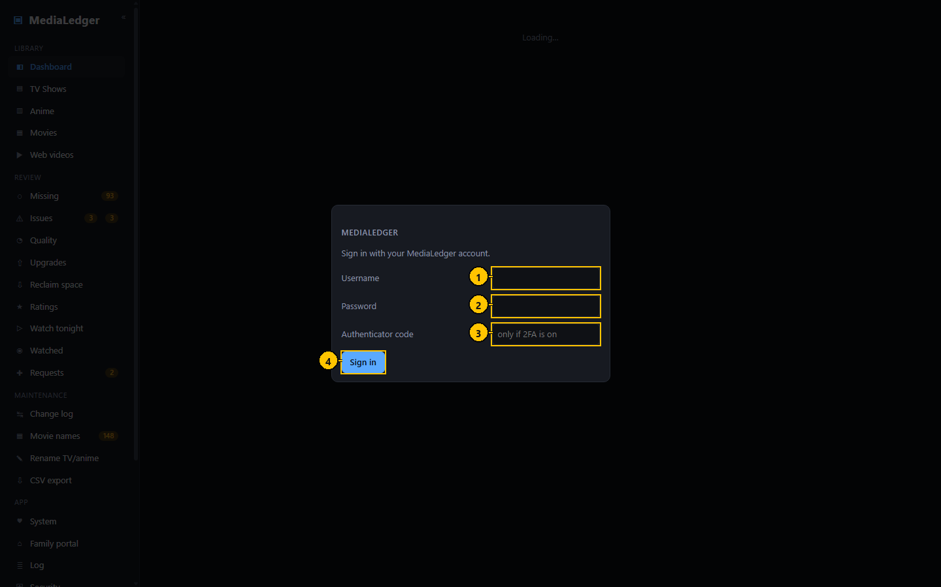
Figure 1. The sign-in dialog. User name admin, and the web password from step 3.2.
# | Control name | Type | What it does | Inputs and limits | Default | Notes
1 | User name | Text field | The account to sign in as. | Letters, digits, dot, dash and underscore; not case sensitive. | admin | The installer creates the account "admin".
2 | Password | Password field | The password of that account. | At least 8 characters. | empty | Never stored in the browser by the application.
3 | Authenticator code | Text field | The six-digit code, when two-factor codes are on. | 6 digits | empty | Leave empty when two-factor codes are off.
4 | Sign in | Button | Checks the pair and opens a session. | – | – | Pressing Enter in either field does the same.

4.1 The welcome guide
A new installation opens the welcome guide instead of an empty Dashboard. The share you connected during the installation is already listed in step 1.
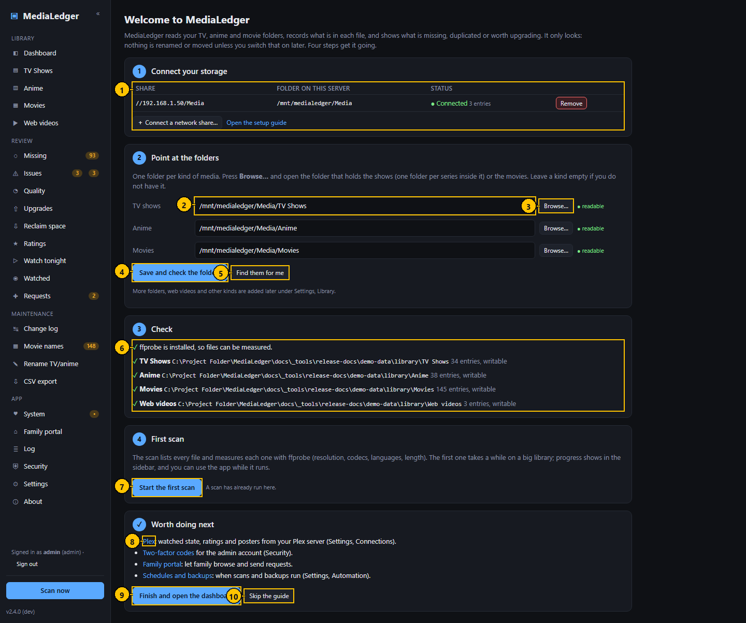
Figure 2. The welcome guide, with one share connected and the three folders filled in.
# | Control name | Type | What it does | Inputs and limits | Default | Notes
1 | Connected shares | Table | The same list and buttons as Settings, Network shares. | – | – | On the desktop application this step is an explanation only.
2 | Folder | Text field | The folder that holds that kind of media: one folder per series, or the movies. | A path on the server. | the saved root of that kind | One field each for TV shows, Anime and Movies.
3 | Browse | Button | Opens the folder browser. | – | – | –
4 | Save and check the folders | Button | Saves the three folders as library roots and checks each can be read. | – | – | Roots of other kinds are kept.
5 | Find them for me | Button | Fills the fields from folders named like TV, Shows, Series, Anime, Movies or Films inside the connected shares. | – | – | Check the result before saving.
6 | Check | Status | Whether ffprobe is installed and whether each folder can be read, with the number of entries. | – | – | –
7 | Start the first scan | Button | Starts a scan. Progress shows in the sidebar. | – | – | –
8 | Worth doing next | Link | Shortcuts to Plex, two-factor codes, the family portal and the schedules. | – | – | –
9 | Finish and open the dashboard | Button | Marks the guide as done and opens the Dashboard. | – | – | –
10 | Skip the guide | Button | Marks the guide as done without doing the steps. | – | – | –

What to do on this page
- Step 1: connect the file server (Raspberry Pi server only).
- Step 2: pick the folder for TV shows, for Anime and for Movies, or press Find them for me. Press Save and check the folders.
- Step 3: read the check. Every line should have a tick.
- Step 4: press Start the first scan.
- Press Finish and open the dashboard.

Good to know
- Opens by itself while no scan has ever run and the guide has not been finished or skipped.
- Find them for me looks one and two levels into each connected share for folders with the usual names.
- A kind you do not have is simply left empty.
- Only an administrator sees the guide.
- Skip the guide and Finish do the same thing: they stop it opening by itself. Nothing else is lost by skipping.
- More folders, web videos and other kinds are added afterwards on the Settings page.

4.2 Choosing a folder
Browse opens the folder browser. It shows the folders on the Pi, starting inside the first connected share. Click a folder to open it; press Use this folder when the folder that holds the series (or the movies) is the one named at the top.
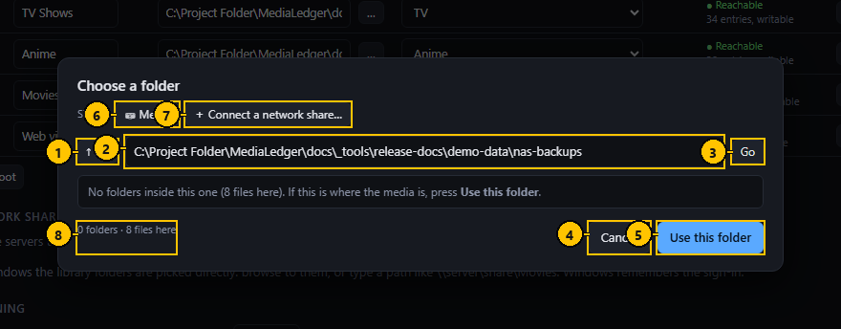
Figure 3. The folder browser, with a button for the connected share.
# | Control name | Type | What it does | Inputs and limits | Default | Notes
1 | Up | Button | Goes to the folder above. | – | – | –
2 | Path | Text field | The folder being shown. | – | – | Enter does the same as Go.
3 | Go | Button | Opens the typed path. | – | – | –
4 | Cancel | Button | Closes without choosing. | – | – | –
5 | Use this folder | Button | Puts the path into the field you came from. | – | – | –
6 | Connected share | Button | Jumps to the folder of that share. | – | – | One button per connected share. Raspberry Pi server only.
7 | Connect a network share | Button | Opens the dialog that signs in to a file server, then returns here inside the new share. | – | – | Raspberry Pi server only.
8 | Count | Label | How many folders are listed and how many files this folder holds. | – | – | Up to 2,000 folders are listed.
Pick the folder that *contains* the series folders, not one series. For TV that is the folder whose contents are one folder per show.

4.3 Connecting a share from the browser
If you skipped the file server questions, or want another share, Connect a network share in step 1 of the guide (and under Settings, Library, and in the folder browser) does the same thing as the installer.
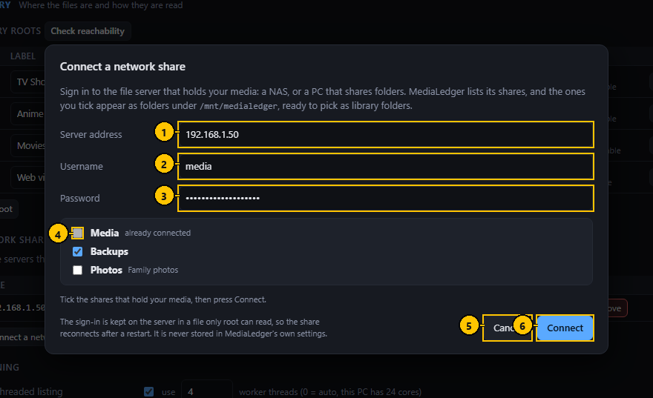
Figure 4. The connect dialog after Find shares: one share already connected, one ticked.
# | Control name | Type | What it does | Inputs and limits | Default | Notes
1 | Server address | Text field | The file server to sign in to. | An IP address or a name. No slashes. | the server of the first connected share | –
2 | Username | Text field | An account on the file server. | No % or = sign. | empty | –
3 | Password | Password field | The password of that account. | One line. | empty | Stored on the Pi in a file only root can read.
4 | Share | Checkbox | Tick each share to connect. | – | unticked | Greyed out when already connected.
5 | Cancel | Button | Closes the dialog. Shares already connected stay connected. | – | – | –
6 | Find shares, then Connect, then Done | Button | First lists the shares, then connects the ticked ones, then closes. | – | Find shares | The label changes with the step.

Messages and what they mean
Message | Meaning and what to do
The server refused the username or password | Wrong sign-in, or the account may not use that share.
The server has no share with that name | Typed by hand and misspelt, or removed on the file server.
The server did not answer. Check the address and that it is switched on | Nothing answered at that address.
The server address must be an IP address or a name, like 192.168.1.204 or nas.home | The address field holds something else, for example a path with slashes.

4.4 The first scan
Start the first scan in step 4 of the guide lists every file and measures each with ffprobe. A bar in the sidebar shows progress and the file being read. The first scan of a large library can take hours (UNVERIFIED: the time depends on the file server and has not been measured for this release); later scans only read what changed and take minutes.

5. Living with it

5.1 What you see when you sign in over SSH
Every sign-in to the Pi shows a few lines about MediaLedger:
MediaLedger 2.4.0: active http://192.168.1.60:8080
share /mnt/medialedger/Media connected
Setup guide: sudo medialedger-setup Update: sudo medialedger-update Log: journalctl -u medialedger -f
It says | Meaning
active | The service is running.
inactive or failed | It is not. Run systemctl status medialedger to see why.
connected | That share is mounted and readable.
NOT CONNECTED | The file server is off or unreachable. The watchdog retries every minute.
No network share is connected yet | No share was ever connected. Run sudo medialedger-setup.
To silence these lines, delete /etc/profile.d/medialedger-welcome.sh.

5.2 Commands
Command | What it does
sudo medialedger-setup | The installer's questions again: connect more shares, set the password if none is set, show the addresses.
sudo medialedger-update | Downloads the newest release, checks it, installs it and restarts. Data is untouched.
sudo medialedger --set-password | Sets or resets the password of admin and signs everyone out.
systemctl status medialedger | Is it running, since when, and its last log lines.
journalctl -u medialedger -f | Follow the log. Ctrl+C stops following.
sudo systemctl restart medialedger | Restart the service.
ls /mnt/medialedger | The connected shares.
sudo bash install.sh | Run the installer again: repairs the service and the commands, upgrades, keeps data.
sudo bash install.sh --auto-update | Add a nightly update at about 04:30. --no-auto-update removes it.
sudo bash install.sh --update-only --port=9000 | Move the site to another port.

5.3 Updating
The About page shows when a newer release exists. On the Pi, run sudo medialedger-update. An update replaces /opt/medialedger only; the database, settings, accounts and shares are kept.
Updating a server installed before version 2.4: after sudo medialedger-update, run sudo bash /opt/medialedger/server/install.sh once. That adds the share helper, which the update alone cannot install. An existing share at /mnt/media is kept exactly as it is.

5.4 Adding or changing shares later
- In the browser: Settings, Library, Network shares, Connect a network share. Remove a share with Remove beside it.
- Over SSH: sudo medialedger-setup.
- A changed password on the file server: remove the share and connect it again with the new password.

6. Optional extras

6.1 A name instead of an address
http://medialedger.local:8080 works on most networks without any setup. For a name of your own with no port number, such as https://medialedger.home, put the reverse proxy Caddy in front. Caddy answers on the normal web ports for every service on the Pi and hands each name to the right one.
- Install Caddy: sudo apt-get install -y caddy.
- Edit /etc/caddy/Caddyfile and add a block for the name:
medialedger.home {
tls internal
reverse_proxy localhost:8080
}
- Reload Caddy: sudo systemctl reload caddy.
- In the router's local DNS, add a record pointing medialedger.home at the address of the Pi. On a UniFi gateway: Settings, Routing, DNS, Create Entry, type A.
- Open https://medialedger.home. The browser warns once about the certificate, because Caddy made it itself; accept it, or install Caddy's root certificate on the device.
MediaLedger notices that Caddy serves HTTPS in front of it. On the Security page the HTTPS line turns green and the button for the built-in certificate is not offered.

6.2 The family portal from outside the home
The family portal is a second, read-only site for people you invite. It listens on port 8090 on the Pi itself. Tailscale Funnel gives it a public address without opening a port on the router:
- Install Tailscale on the Pi and sign in: curl -fsSL https://tailscale.com/install.sh | sh then sudo tailscale up.
- In the Tailscale admin console, switch on HTTPS certificates and allow Funnel for the Pi.
- In MediaLedger open Family portal, tick Portal on, and press Save.
- On the Pi: sudo tailscale funnel --bg 8090. It prints the public address.
- Paste that address into Public address on the Family portal page and press Save. Invites made after that carry it.
The User Manual, chapters 6 and 8, describes the portal pages and the owner's sign-in at /admin.

6.3 Bringing the database from the desktop application
The database is the same on both. Copying it carries over every fix, match, rating and the change log, and skips the first long scan.
- On the Windows PC close MediaLedger and copy the database to the Pi:
scp "%APPDATA%\MediaLedger\medialedger.db" joe@medialedger.local:/tmp/medialedger.db
- On the Pi, put it in place:
sudo systemctl stop medialedger && sudo mv /tmp/medialedger.db /var/lib/medialedger/medialedger.db && sudo chown medialedger:medialedger /var/lib/medialedger/medialedger.db && sudo systemctl start medialedger
- Open Settings, Library. Give each root the same type as on the desktop and its folder under /mnt/medialedger/, save, and run a scan. Files are matched by their path inside each root, so nothing is measured again.
Do not copy settings.json: it holds Windows paths.

7. When something goes wrong
What you see | What to check
The page does not open | systemctl status medialedger on the Pi. Is the computer on the same network? With LAN only on, other networks are refused.
The name does not open but the address does | The computer uses a DNS server that does not know local names, which a VPN often causes. Use the address, or add the name to the computer's hosts file.
A library folder shows "not reachable" | Settings, Library shows a status for each root and each share. The watchdog reconnects a dropped share within a minute once the file server answers. To force it: sudo mount /mnt/medialedger/<share>.
"The share helper did not answer" | sudo systemctl status medialedger-share.path. If it does not exist, run sudo bash /opt/medialedger/server/install.sh.
"The server refused the username or password" | The account or password is wrong for that file server, or the account may not use that share.
The folder browser shows no folders | The line under the list says how many files the folder holds. A folder with files and no sub-folders may be the right one: press Use this folder.
The scan is slow | Use a cable. The System page shows network speed during a scan.
"Too many failed attempts" | That address is locked out for fifteen minutes. Wait, or restart the service.
Forgot the web password | sudo medialedger --set-password
Lost the two-factor device | Stop the service, set "totp": {"enabled": false} in /var/lib/medialedger/web.json, start it again.
The Pi runs hot during scans | Add a heatsink or a fan, or lower Parallel ffprobe processes in Settings.

7.1 Removing MediaLedger
sudo systemctl disable --now medialedger medialedger-share.path medialedger-mount.timer && sudo rm -f /etc/systemd/system/medialedger*.service /etc/systemd/system/medialedger*.timer /etc/systemd/system/medialedger-share.path /usr/local/bin/medialedger* /usr/local/sbin/medialedger-mount-check /etc/profile.d/medialedger-welcome.sh && sudo rm -rf /opt/medialedger && sudo systemctl daemon-reload
That leaves your data and the shares. To remove those too, delete the lines for /mnt/medialedger/ from /etc/fstab, then:
sudo rm -rf /var/lib/medialedger /etc/medialedger-shares

7.2 What has and has not been tested
Part | Status
The installer's questions, the sign-in lines and the watchdog script | Run on a Linux test system with a stand-in for the file server.
The share helper's checks and what it writes | Covered by automated tests with a stand-in for the system.
Connecting a real share on a Raspberry Pi with version 2.4.0 | UNVERIFIED at the time of writing. The first installation on a Pi is the test.
The web pages in this guide | Captured from the running application, with fictional data.

