

American International University-Bangladesh (AIUB)
Department of Computer Science Faculty of Science & Technology (FST)
PROJECT TITLE
Society Problem Reporter and Analyzer
Submitted By Group 7
Semester-->Summer-25-26 |  | Section:T
SL | Student Name | Student ID
29 | 24-58655-2 | Sheikh Ahnaful Islam
31 | 24-58796-2 | Ayon Chowdhury
22 | 24-58220-2 | MD. Mezbah-Ul-Hossain Rahat
4 | 23-53306-3 | Md Rashed Musharof
3 | 23-52565-2 | Sabit Haan

2 . Timeline Chart / Gant
MD RASHED MUSHAROF: https://trello.com/invite/b/6a9038564629504848073a28/ATTI0211e... | Chat | Microsoft Teams

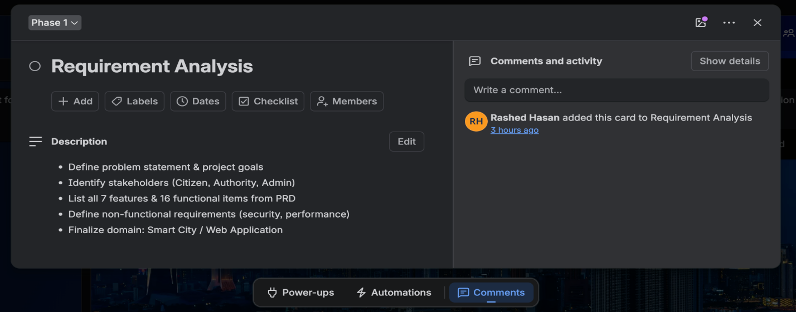
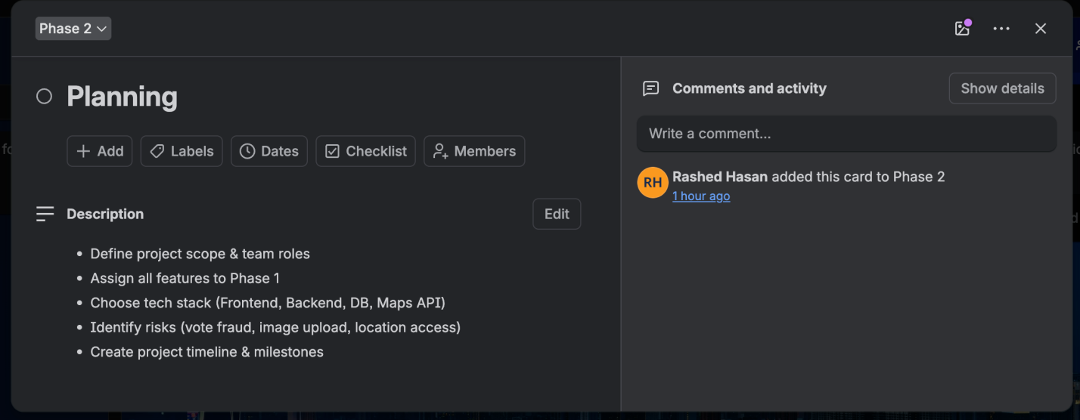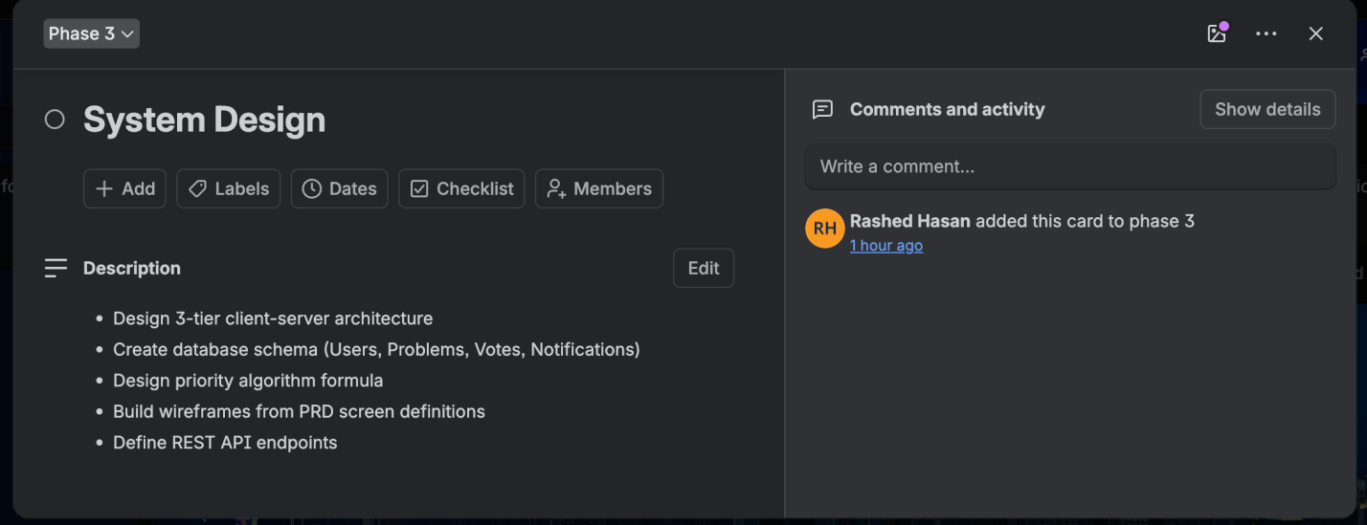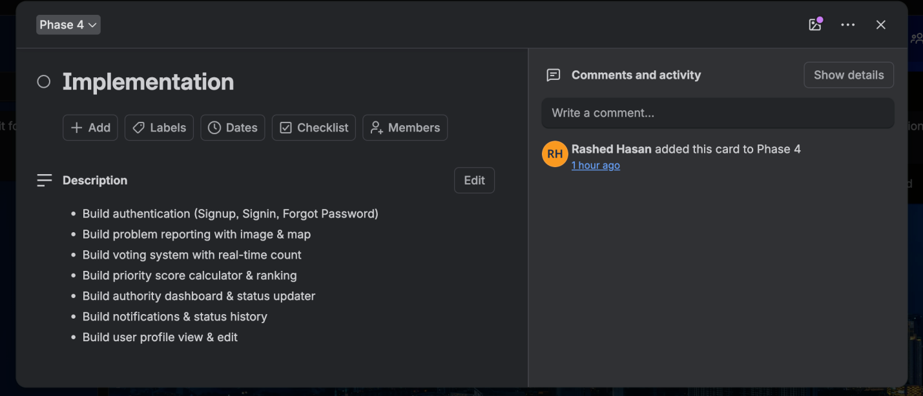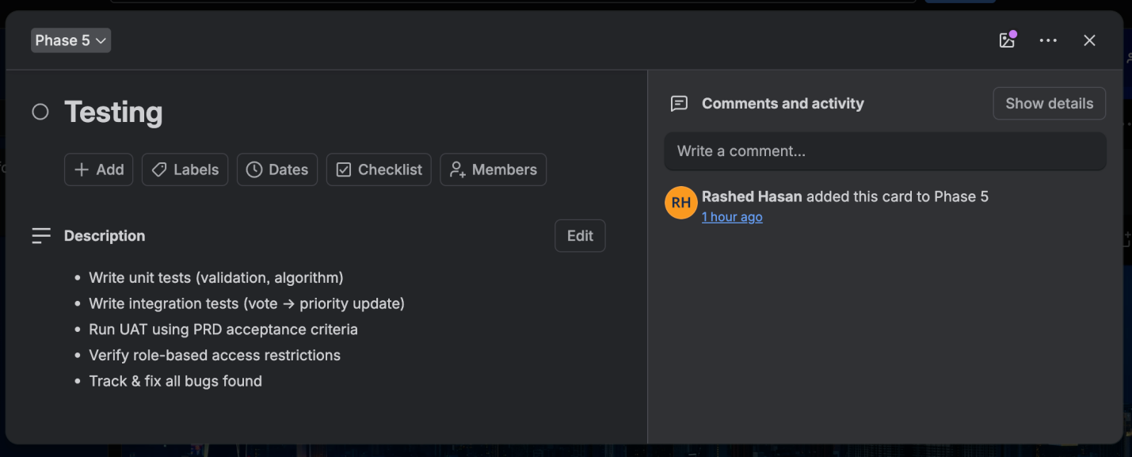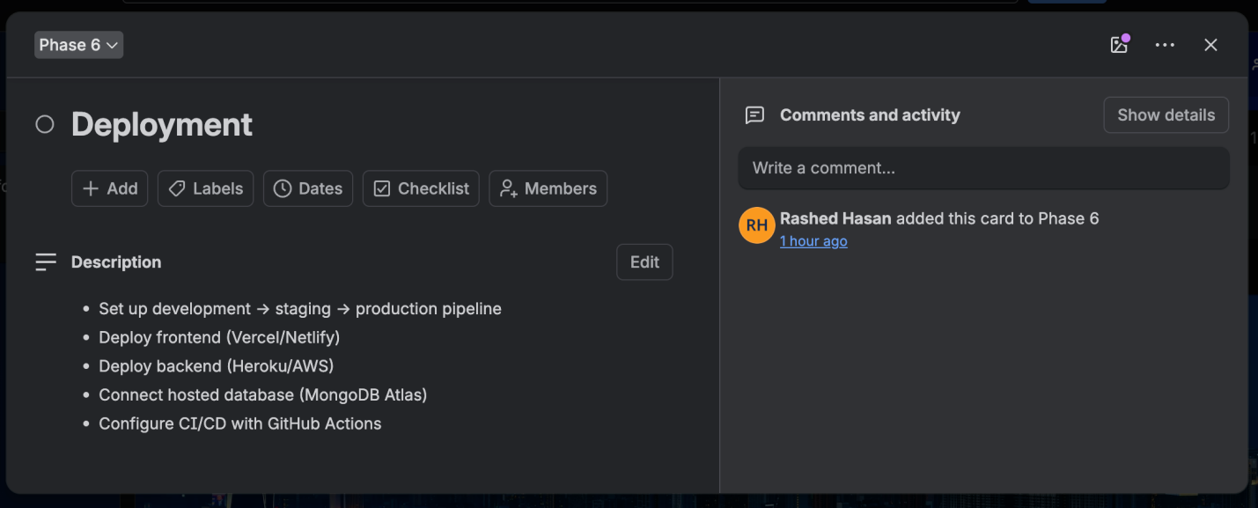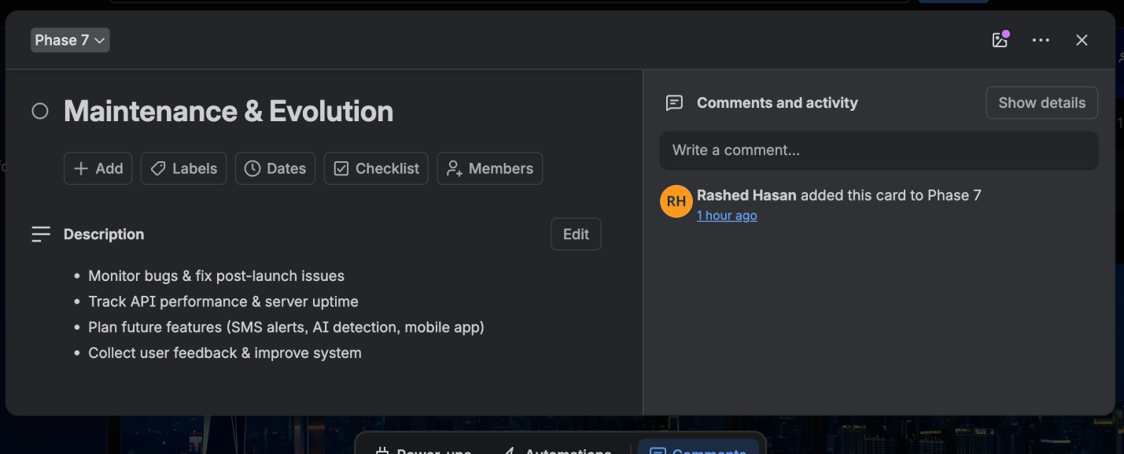

Figma
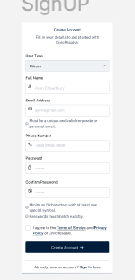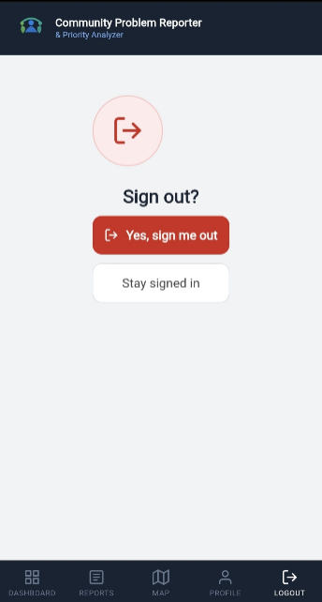
Figure : Sign UP Figure: Logout

