

American International University-Bangladesh (AIUB)
Department of Computer Science Faculty of Science & Technology (FST)
PROJECT TITLE
Society Problem Reporter and Analyzer
Submitted By Group 7
Semester-->Summer-25-26 |  | Section:T
SL | Student Name | Student ID
29 | 24-58655-2 | Sheikh Ahnaful Islam
31 | 24-58796-2 | Ayon Chowdhury
22 | 24-58220-2 | MD. Mezbah-Ul-Hossain Rahat
4 | 23-53306-3 | Md Rashed Musharof
3 | 23-52565-2 | Sabit Haan

1.3 Selection of Process Model

Selected Process Model: Dynamic Systems Development Method (DSDM)

Overview of the DSDM Model
The Dynamic Systems Development Method (DSDM) is an Agile software development framework that focuses on rapid delivery, active user involvement, and iterative development. It ensures that high-priority features are delivered first while maintaining quality and meeting deadlines.
DSDM follows a structured lifecycle where the system is developed incrementally. Each iteration produces a functional part of the system, allowing continuous feedback and improvement.
The model is particularly suitable for projects that require flexibility, user interaction, and privatization of features

DSDM Process Visualization
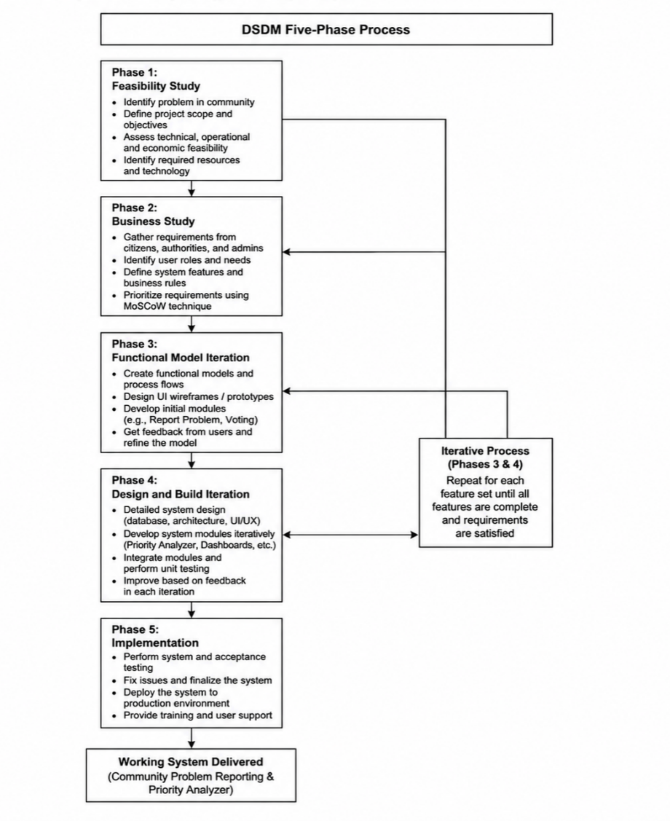

Explanation of DSDM Phasese

1. Feasibility Study
In this phase, the overall feasibility of the project is analyzed.
- Identify the problem of inefficient complaint systems
- Define project scope
- Check technical feasibility (web system, database, UI)

2. Business Study
This phase focuses on understanding user requirements and business needs.
- Identify user roles (Citizen, Authority, Admin)
- Define system features (report problem, vote, priority system)
- Understand how users interact with the system

3. Functional Model Iteration
In this phase, prototypes and initial models are developed.
- Design UI wireframes
- Create basic reporting system
- Collect feedback and improve design
4. Design and Build Iteration
This is the core development phase.
- Develop frontend (UI pages)
- Implement backend logic (Priority Analyzer)
- Integrate database and system modules

5. Implementation
Final system is deployed and tested.
- System deployment
- Final testing
- User access and usage

Why We Chose DSDM for This Project
The DSDM model is selected for the Community Problem Reporting and Priority Analyzer system due to the following reasons:

1. Supports Priority-Based System
The system includes a Priority Analyzer that ranks problems based on importance.
DSDM uses the MoSCoW prioritization technique, which perfectly aligns with this concept. It allows the development team to focus on the most critical features first.

2. Iterative Development of Features
The project contains multiple modules such as:
- Problem Reporting
- Voting System
- Priority Analyzer
- Dashboard Systems
- DSDM allows these features to be developed step by step, ensuring better control and quality.
3. Strong User Involvement
- The system depends heavily on user interaction:
- Citizens report and vote
- Authorities manage problems
- Admin controls the system
4. Timeboxing Ensures Timely Delivery
- Each phase in DSDM is time-limited, which helps:
- Maintain deadlines
- Avoid delays
- Deliver features on time

5. Continuous Testing and Quality Assurance
Each iteration includes testing, which helps:
- Identify errors early
- Improve system reliability
- Ensure accurate priority calculation

6. Reduced Risk
Since development is incremental:
- Problems in one feature do not affect the whole system
- Core features can be delivered even if advanced features are delayed

7. Future Scalability
The system can be expanded with new features such as:
- Mobile application
- Advanced analytics
- AI-based solutions
DSDM supports easy integration of future features.
The DSDM process model is the most suitable choice for this project because it supports prioritization, iterative development, and user involvement. It ensures timely delivery, high-quality output, and a flexible development approach, making it ideal for building the Community Problem Reporting and Priority Analyzer system.

- Software Design

  - System Design

Use Case Diagram
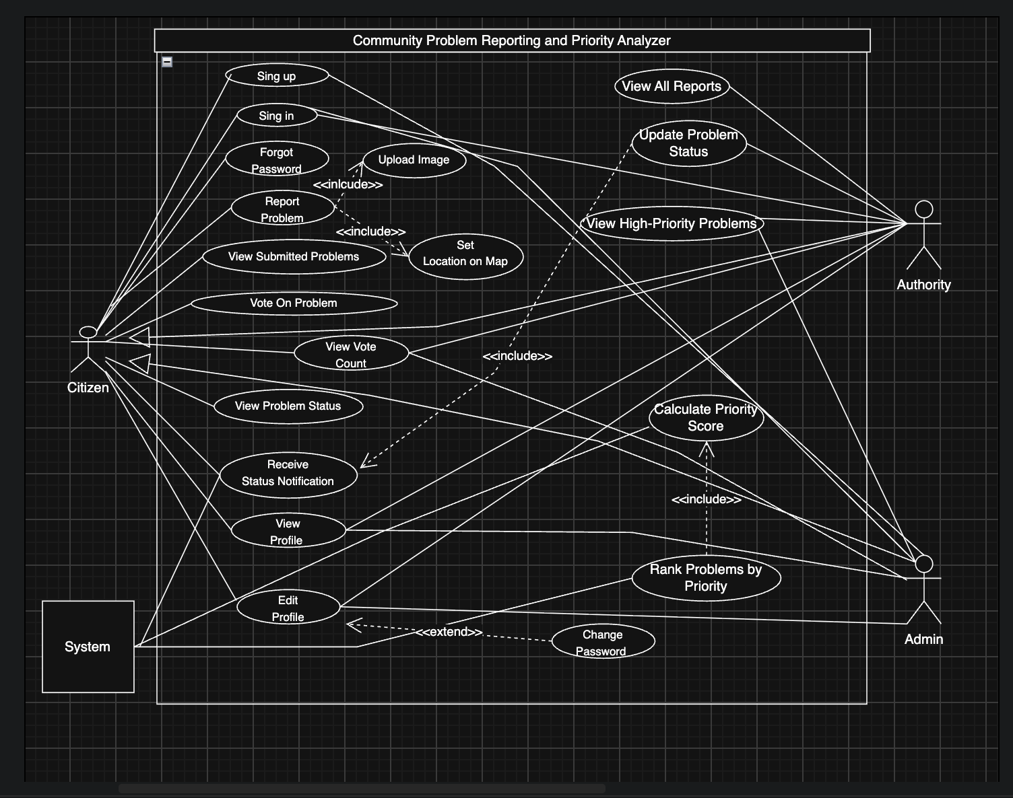

Class Diagram
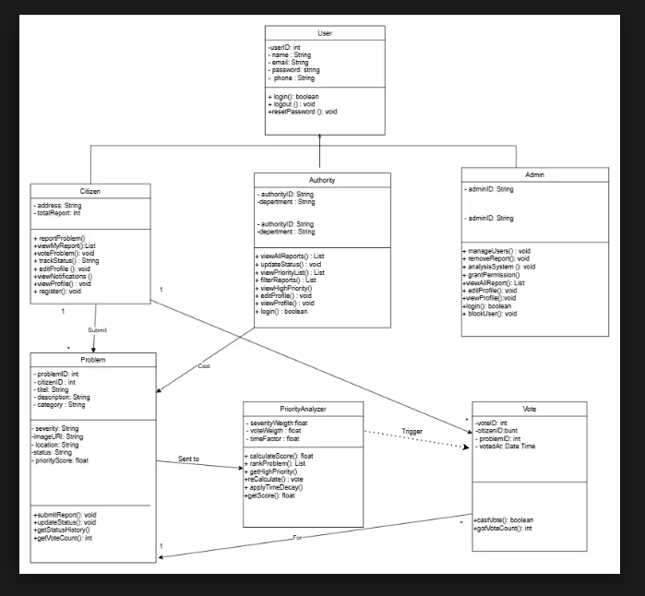

Figma design
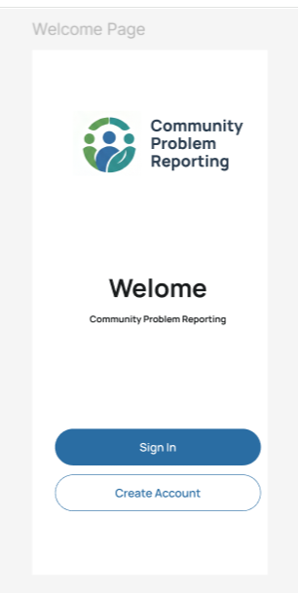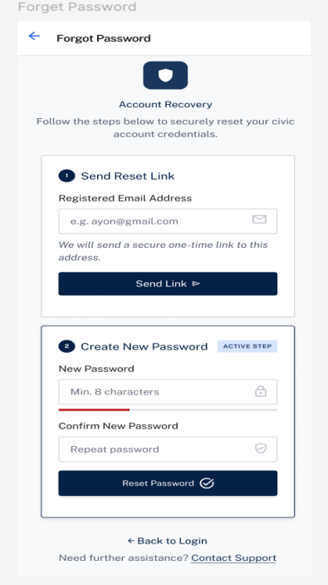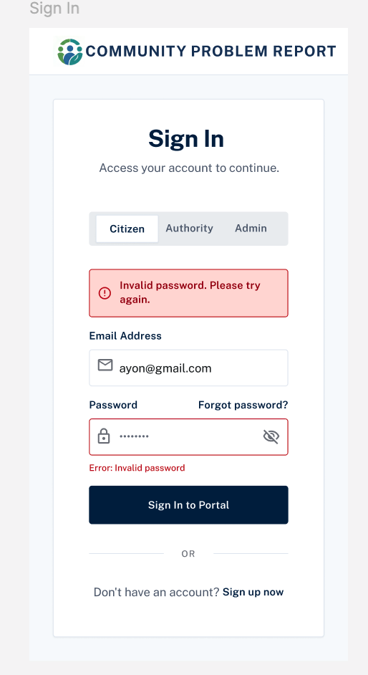
Figure: Welcome page Figure: Sign In & Role Detection Figure: Forgot Password

