LAB 0
MY FIRST FPGA – BLOCK DESIGN

Objective
- The objective of this Lab is to provides comprehensive information that will help you understand how to create a FPGA design and run it on your DE10-Standard development board. The following sections provide a quick overview of the design flow, explain what you need to get started, and describe what you will learn.
- Create a design that causes LEDs on the development board to blink at a speed that is controlled by an input key—This design is easy to create and gives you visual feedback that the design works. Of course, you can use your DE10-Standard board to run other designs as well. For the LED design, you will write Verilog HDL code for a simple 32-bit counter, add a phase-locked loop (PLL) megafunction as the clock source, and add a 2-input multiplexer megafunction. When the design is running on the board, you can press an input switch to multiplex the counter bits that drive the output LEDs.
- Becoming familiar with Quartus II design tools—This lab will not make you an expert, but at the end, you will understand basic concepts about Quartus II projects, such as entering a design using a schematic editor and HDL, compiling your design, and downloading it into the FPGA on your DE10-Standard development board.
Reference:
DE10-Standard_My_First_Fpga.pdf

Procedure
- Design flow
Figure 1-1 shows the FPGA design flow block diagram.
The standard FPGA design flow starts with design entry using schematics or a hardware description language (HDL), such as Verilog HDL or VHDL. In this step, you can create a digital circuit that is implemented inside the FPGA. The flow then proceeds through compilation, simulation, programming, and verification in the FPGA hardware.
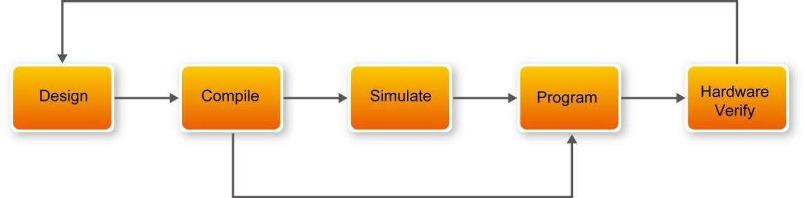

Figure 1-1 Design Flow

This tutorial guides you through all of the steps except for simulation. Although it is not covered in this document, simulation is very important to learn, and there are entire applications devoted to simulating hardware designs. There are two types of simulation, Functional and Timing Functional simulation allows you to verify that your code is manipulating the inputs and outputs appropriately. Timing (or post place-and- route) simulation verifies that the design meets timing and functions appropriately in the device.
- Before you begin
This tutorial assumes the following prerequisites
- You generally know what a FPGA is. This tutorial does not explain the basic concepts of programmable logic.
- You are somewhat familiar with digital circuit design and electronic design automation (EDA) tools.
- You have installed the Altera Quartus II 18.1 software on your computer. If you do not have the Quartus II software, you can download it from https://bitly.com.vn/lct3c6
- You have a DE10-Standard Development Board on which you will test your project. Using a development board helps you to verify whether your design is really working.
- You have gone through the quick start guide and/or the getting started user guide for your development kit. These documents ensure that you have:
- Installed the required software.
- Determined that the development board functions properly and is connected to your computer.

Next step you should installed the USB-BlasterII driver, Plug in the 12-volt adapter to provide power to the board. Use the USB cable to connect the leftmost USB connector on the DE10-Standard board to a USB port on a computer that runs the Quartus II software. Turn on the power switch on the DE10-Standard board.
The computer will recognize the new hardware connected to its USB port and Power on the board as shown in Figure 1-2, but it will be unable to proceed if it does not have the required driver already installed. The DE10-Standard board is programmed by using Altera USB-Blaster II mechanism. If the USB-Blaster II driver is not already installed, the Driver Software Installation in Figure 1-3 will appear.Click close.

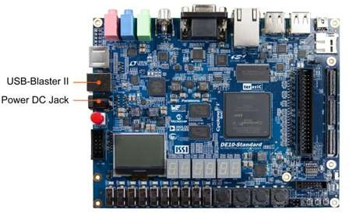

Figure 1-2 Connection Setup
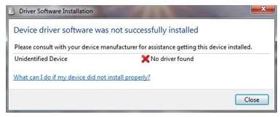
Figure 1-3 Driver Software Installation
Since the desired driver is not available on the Windows Update Web site, open the Computer Management and select the Device Manager. This leads to the window in Figure 1-4.
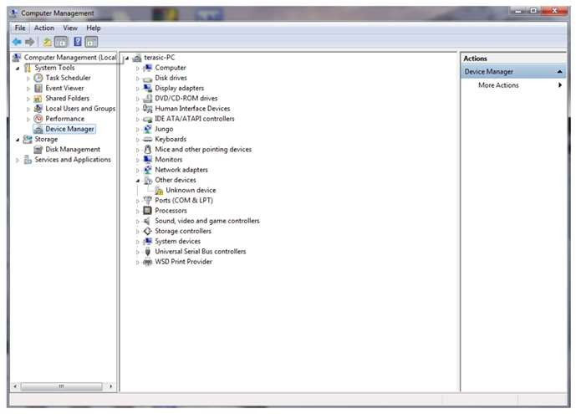

Figure 1-4 Device Manager
Right click Other devices>Unknown device and select Update Driver Software…This leads to the window in Figure 1-5.

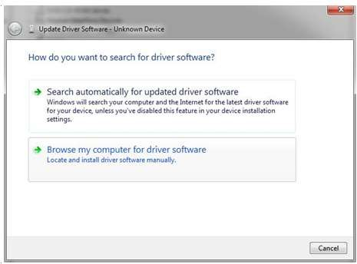
Figure 1-5 Update Driver Software
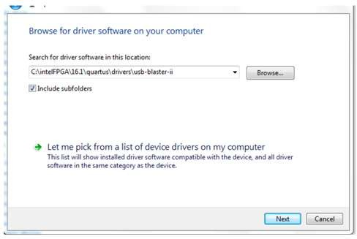
The driver is available within the Quartus II software. Hence, click Browse my computer for device software to get to

Figure 1-6 Specify the location of the driver

Now, click Browse to get to the pop-up box in Figure 1-7 Find the desired driver, which is at location C:\intelFPGA\16.1\quartus\drivers\usb-blaster-ii. Click OK and then upon returning to Figure 1-6. Click Next.
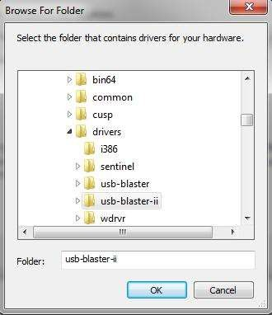

Figure 1-7 Browse to find the location
The driver will now be installed as indicated in Figure 1-8 Click close and you can start using the DE10-Standard board
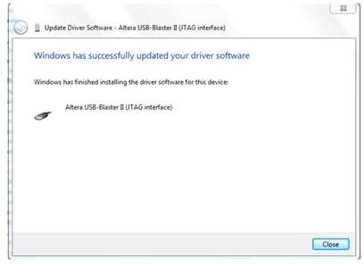

Figure 1-8 The driver is installed

- Assign the device
You begin this tutorial by creating a new Quartus II project. A project is a set of files that maintain information about your FPGA design. The Quartus II Settings File (.qsf) and Quartus II Project File (.qpf) files are the primary files in a Quartus II project. To compile a design or make pin assignments, you must first create a project.
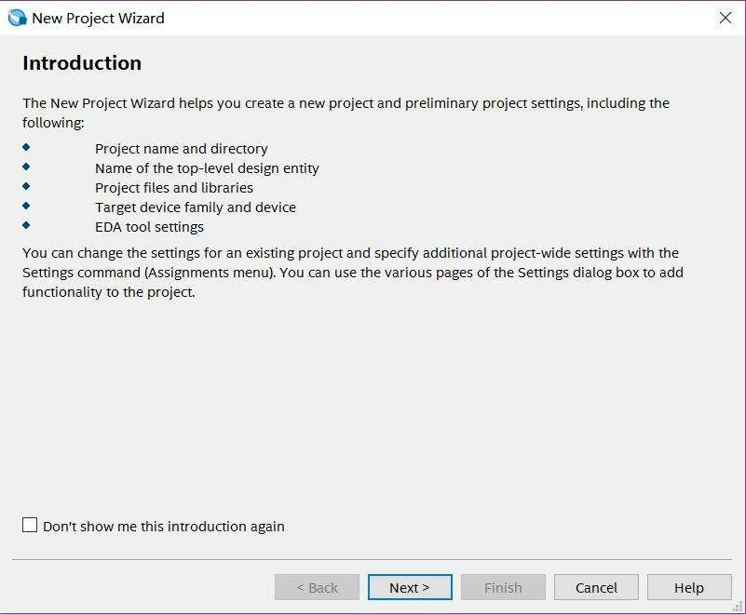
- In the Quartus II software, select File > New Project Wizard. The Introduction page opens. See Figure 2-1.
Figure 2-1 New Project Wizard introduction
- Click Next.
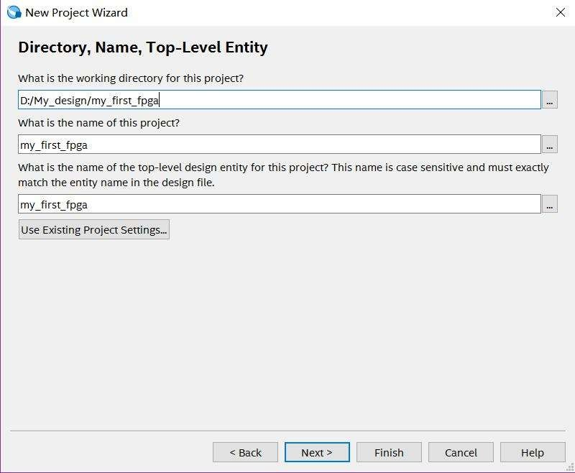

Figure 2-2 Project information
- Enter the following information about your project:
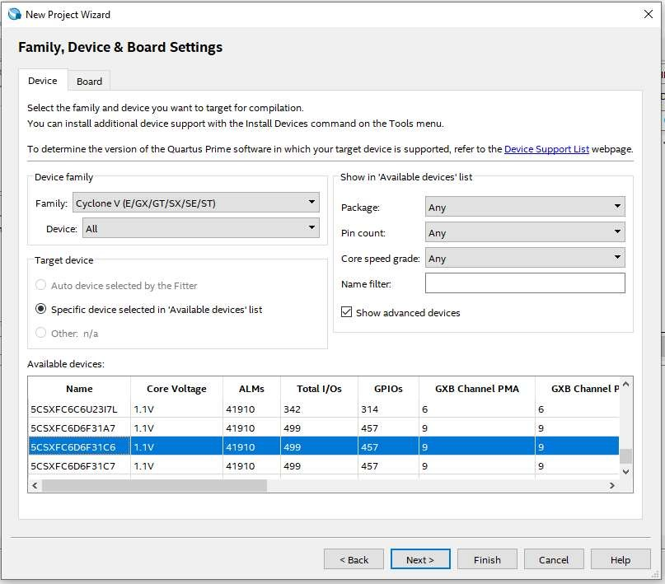
Figure 2-3 Specify the Device Example

- When prompted, choose Yes to create the my_first_fpga project directory. You just created your first Quartus II FPGA project. See Figure 2-4.
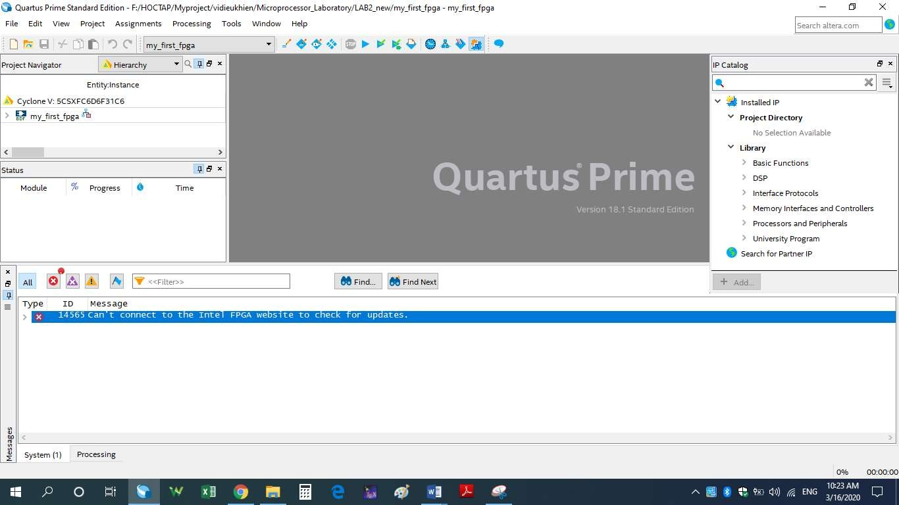

Figure 2-4 my_first_fpga project

- Design Entry
- Add a PLL Megafunction
In the design entry step you create a schematic or Block Design File (.bdf) that is the top-level design. You will add library of parameterized modules (LPM) functions and use Verilog HDL code to add a logic block. When creating your own designs, you can choose any of these methods or a combination of them.
- Choose File > New > Block Diagram/Schematic File (see Figure 4-1 to create a new file, Block1.bdf, which you will save as the top
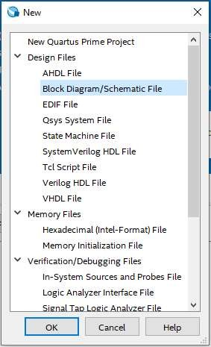
Figure 4-1 New BDF
- Click OK
- Choose File > Save As and enter the following information.
- File name: my_first_fpga
- Save as type: Block Diagram/Schematic File (*.bdf)
- Click Save. The new design file appears in the Block Editor (see Figure 4-2).

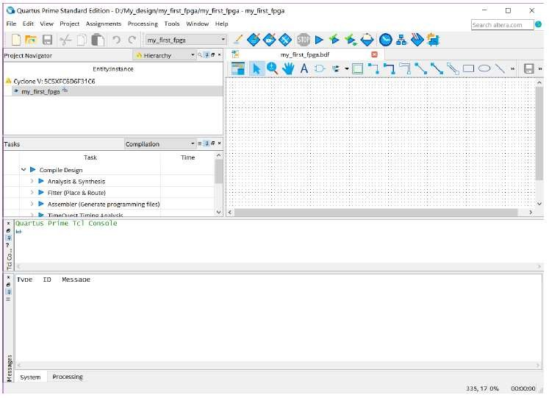

Figure 4-2 Bank BDF
- Add HDL code to the blank block diagram by choosing File > New > Verilog HDL File.
- Click OK to create a new file Verilog1.v, which you will save as simple_counter.v.
- Select File > Save As and enter the following information (see Figure 4-3).
- File name: simple_counter.v
- Save as type: Verilog HDL File (*.v, *.vlg, *.verilog)

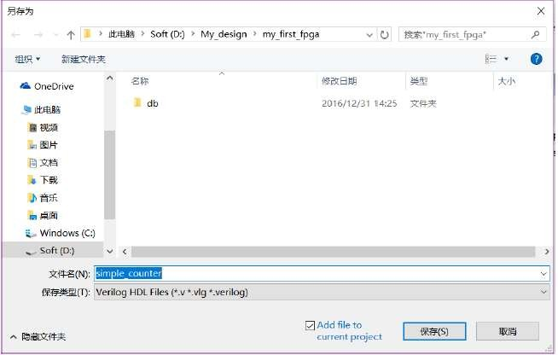

Figure 4-3 Saving the Verilog HDL file
- Type the following Verilog HDL code into the blank simple_counter.v file (see Figure 4-4 The Verilog File of simple_counter.v).

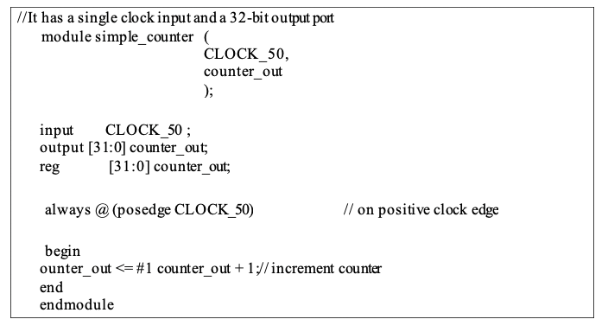

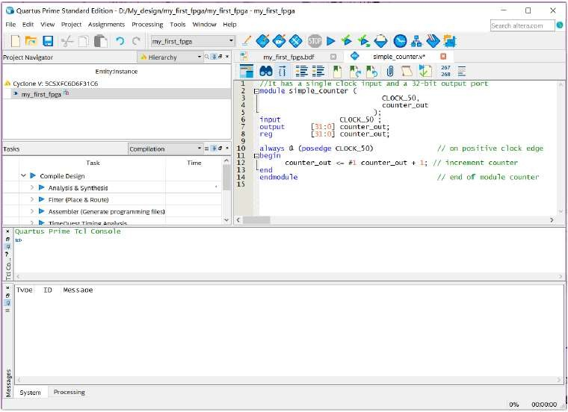

Figure 4-4 The Verilog File of simple_counter.v
- Save the file by choosing File > Save, pressing Ctrl + s, or by clicking the floppy disk icon.
- Choose File > Create/Update > Create Symbol Files for Current File to convert the simple_counter.v file to a Symbol File (.sym).You use this Symbol File to add the HDL code to your BDF schematic.
- The Quartus II software creates a Symbol File and displays a message (see Figure 4-5).
Figure 4-5 Create Symbol File was Successful
- Right click > Open Symble file to see the simple_counter.v symbol
- To add the simple_counter.v symbol to the top-level design, click the my_first_fpga.bdf tab.
- Insert Symbol or click Add Symbol on the toolbar.
- Double-click the Project directory to expand it.
- Select the newly created simple_counter symbol by clicking it’s icon.
(You can also double-click in a blank area of the BDF to open the Symbol dialog box)
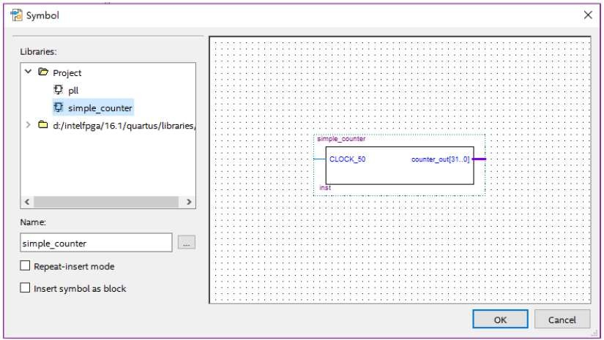

Figure 4-6 Adding the Symbol to the BDF
- Click OK
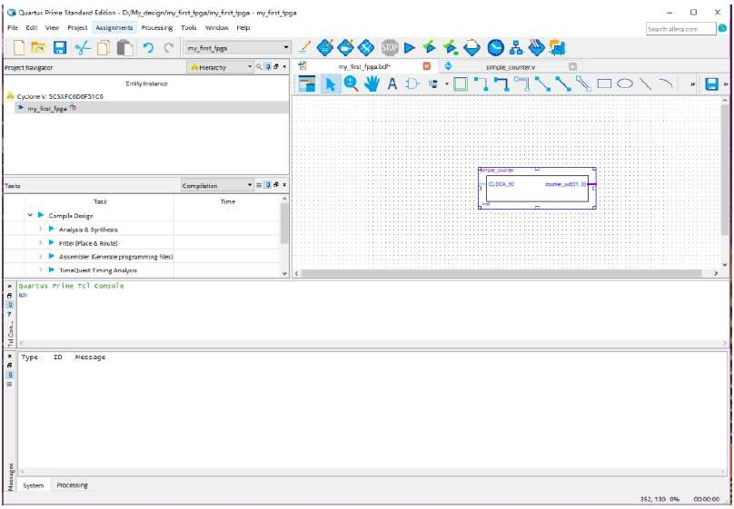
- Move the cursor to the BDF grid; the symbol image moves with the cursor. Click to place the simple_counter symbol onto the BDF. You can move the block after placing it by simply clicking and dragging it to where you want it and releasing the mouse button to place it. See Figure 4-7.

Figure 4-7 Placing the simple_counter symbol
- Press the Esc key or click an empty place on the schematic grid to cancel placing further instances of this symbol.
- Save your project regularly.
- Using IP Catalog to Add a PLL IP
There is a IP catalog which can easily customize and integrate IP cores into your project. Use the IP Catalog and parameter editor GUIs to select, customize, and generate files representing your custom IP variation. You can increase efficiency by using a megafunction instead of writing the function yourself. Altera also provides more complex functions, called MegaCore functions, which you can evaluate for free but require a license file for use in production designs. This tutorial design uses a PLL clock source to drive a simple counter. A PLL uses the on-board oscillator (DE10- Standard Board is 50 MHz) to create a constant clock frequency as the input to the counter. To create the clock source, you will add a pre-built IP core named Altera PLL.
- Choose Tools > IP Catalog to automatically displays the IP cores available for your target device. Double-click any IP core name to launch the parameter editor and generate files representing your IP variation (see Figure 4-8).
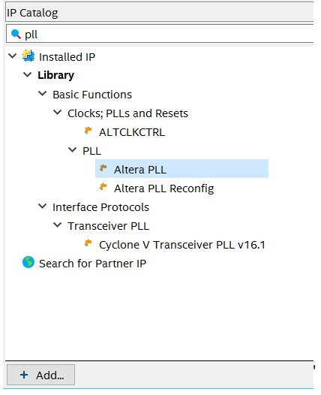
Figure 4-8 IP catalog
- In IP catalog, specify the following selections (see Figure 4-9):
- Choose PLL> Altera PLL.
- Under Which type of output file do you want to create? Choose Verilog HDL.
- Under What name do you want for the output file? Type pll.v at the end of the already created directory name.
- Click Next.
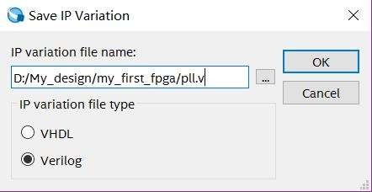
Figure 4-9 Save IP Variation

- In the MegaCore Manager window, make the following selections (see Figure 4- 10).
- The device speed grade choose 6 for DE10-Standard.
- Set the frequency of the refclk input 50 MHz.
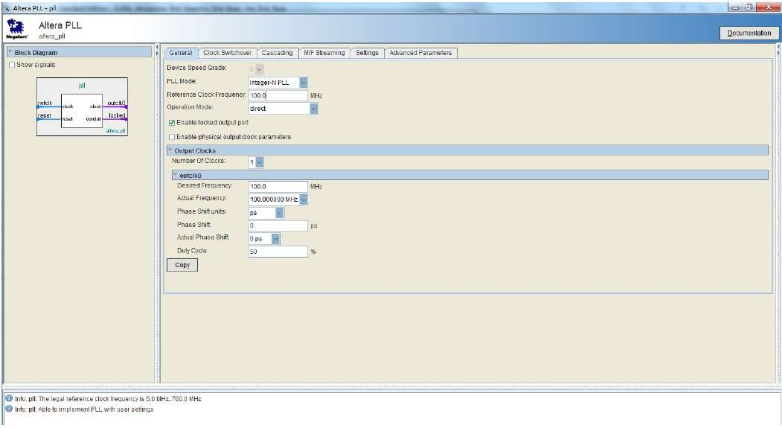
Figure 4-10 MegaWizard Plug-In Manager Selections

- Turn off the Enable locked output port option on MegaCore. As you turn it off, pin disappears from the PLL block’s graphical preview. See Figure 4-11 for an example.
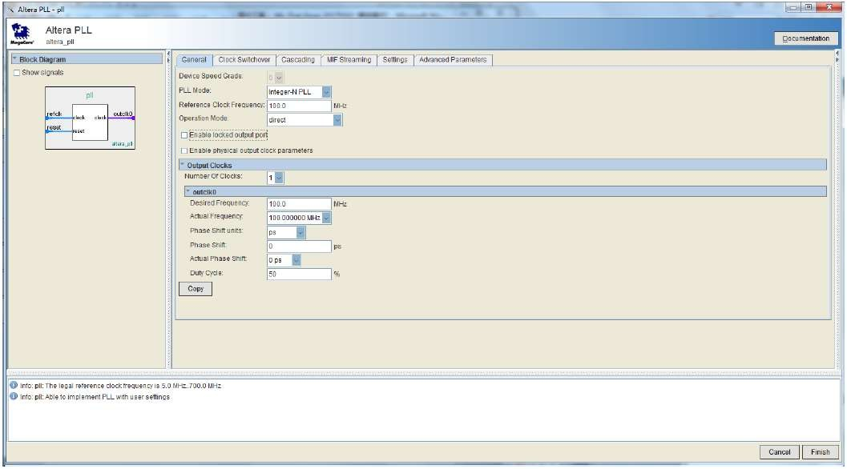
Figure 4-11 MegaWizard Plug-In Manager Selections
- Then, make the following selection (see Figure 4-12). (Desired Frequency input 5.0)

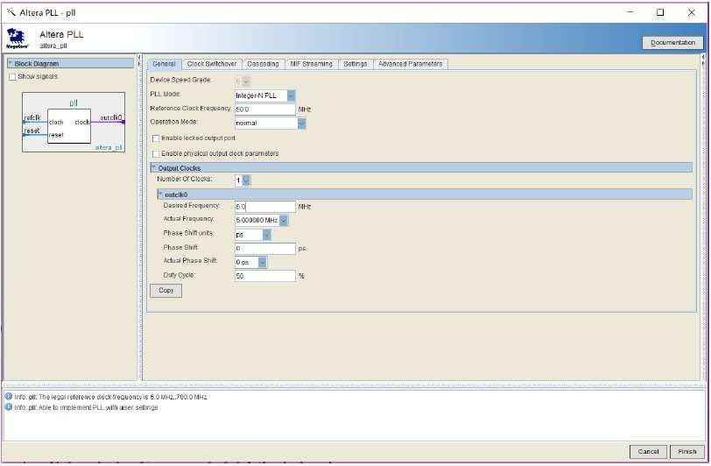
Figure 4-12 MegaWizard Plug-In Manager Selections
- Click Finish . It leads to Figure 4-13.Click Exit.
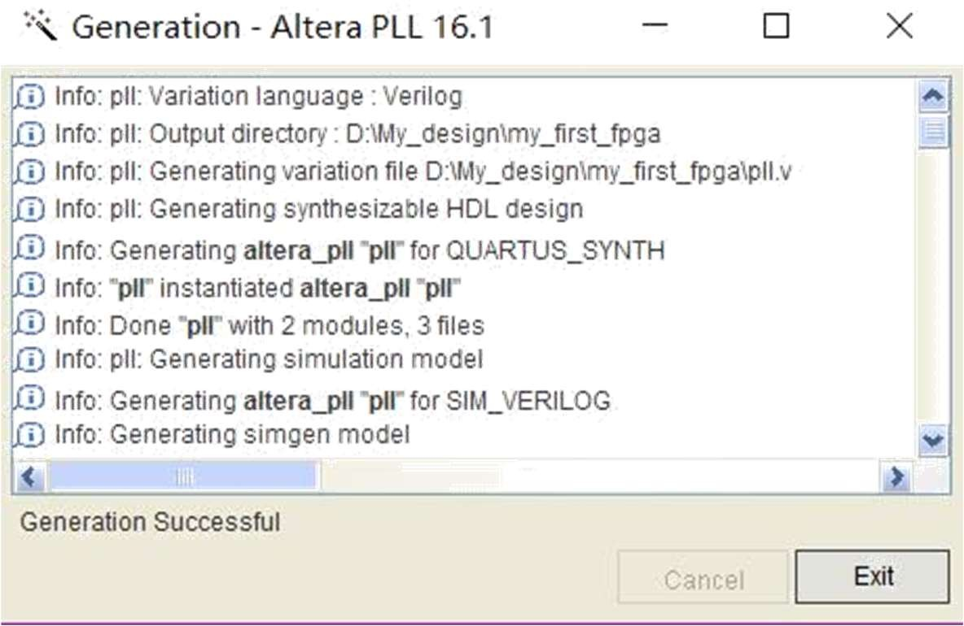
Figure 4-13 PLL Generation
- Right click> Insert >Symbol… or click Add Symbol on the toolbar.
- The Symbol window opens, showing the newly created PLL megafunction. See Figure 4-14.
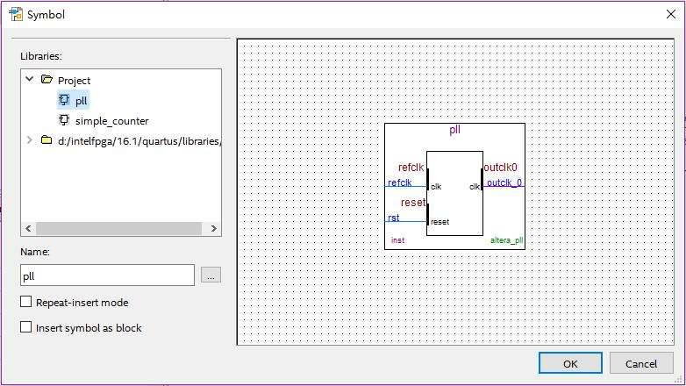
Figure 4-14 PLL Symbol

- OK and place the pll symbol onto the BDF to the left of the simple_counter symbol. You can move the symbols around by holding down the left mouse button, helping you ensure that they line up properly. See Figure 4-15.
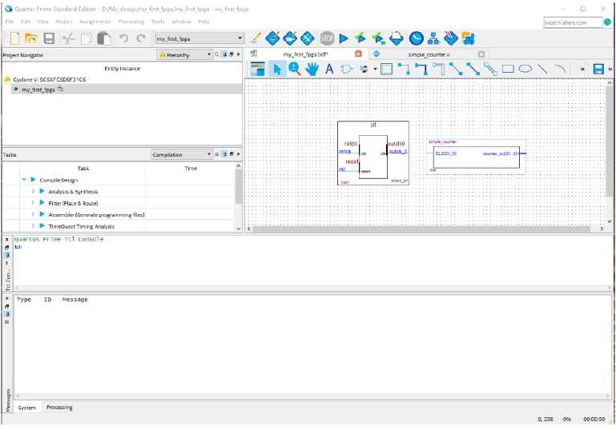
Figure 4-15 Place the PLL Symbol

- Move the mouse so that the cursor (also called the selection tool) is over the pll symbol’s outclk_0 output pin. The orthogonal node tool (cross-hair) icon appears.
- Click and drag a bus line from the outclk_0 output to the simple_counter clock input. This action ties the pll output to the simple_counter input (see Figure 4-16).

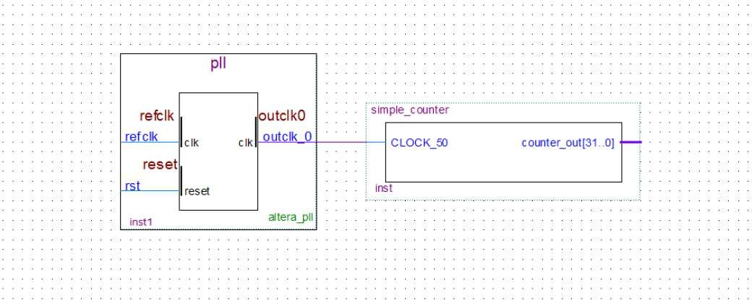
Figure 4-16 Draw a Bus Line connect pll outclk_0 port to simple_counter CLOCK_50 port
- Add an input pin and an output bus with the following steps:
- Right click> Insert >Symbol….
- Under Libraries, select quartus/libraries > primitives > pin >input. See Figure 4-17.
- Click OK
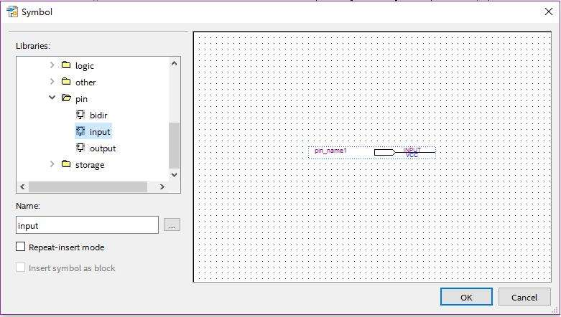
Figure 4-17 Input pin symbol
If you need more room to place symbols, you can use the vertical and horizontal scroll bars at the edges of the BDF window to view more drawing space.
- Place the new pin onto the BDF so that it is touching the input to the pll symbol.
- Use the mouse to click and drag the new input pin to the left; notice that the ports remain connected as shown in Figure 4-18.
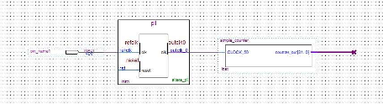
Figure 4-18 Connecting the PLL symbol and Input port

- Change the pin name by double-clicking pin_name and typing CLOCK_50 (see Figure 4-19). This name correlates to the oscillator clock that is connected to the FPGA.
- Using the Orthogonal Bus tool, draw a bus line connected on one side to the simple_counter output port, and leave the other end unconnected at about 4 to 8 grid spaces to the right of the simple_counter

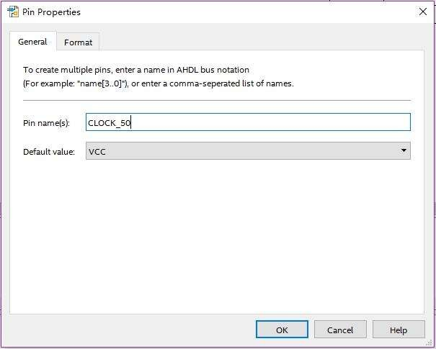
Figure 4-19 Change the input port name
- Right-click the new output bus line and choose Properties.
- Using the Orthogonal Bus tool, draw a bus line connected on one side to the simple_counter output port, and leave the other end unconnected at about 6 to 8 grid spaces to the right of the simple_counter.
- Type counter [31..0] as the bus name (see Figure 4-20). The notation [X ..Y] is the Quartus II method for specifying the bus width in BDF schematics, where X is the most significant bit (MSB) and Y is the least significant bit (LSB).
- Click OK. Figure 4-21 shows the BDF.
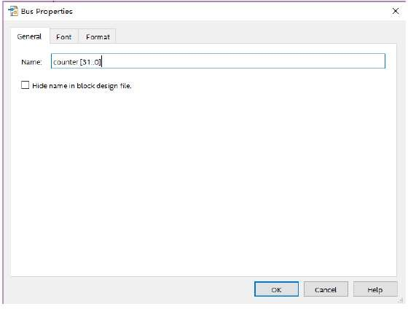
Figure 4-20 Change the output BUS name
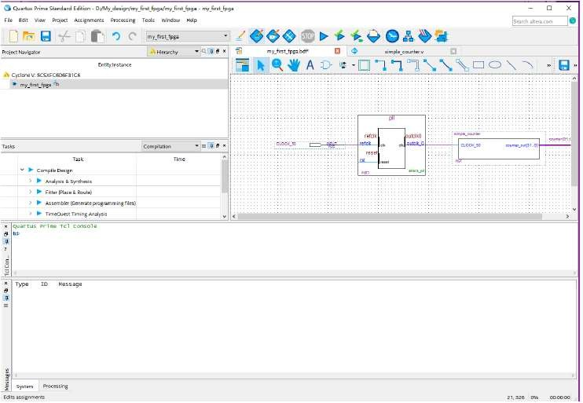
Figure 4-21 BDF
- Add a Multiplexer
This design uses a multiplexer to route the simple_counter output to the LED pins on the DE10-Standard development board. You will use the MegaWizard Plug-In Manager to add the multiplexer, lpm_mux. The design multiplexes two variations of the counter bus to four LEDs on the DE10-Standard development board.
- Choose IP catalog > Basic Functions > Misceelaneous >LPM_MUX
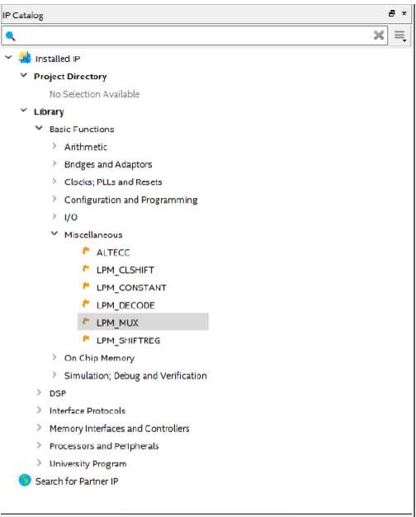

- Choose Verilog HDL as the output file type, and name the output file counter_bus_mux.v (see Figure 4-22).
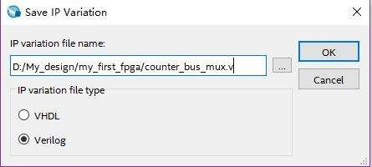

Figure 4-22 Save lpm_mux Variation
- Click OK. The MegaWizard Plug-in Manage window pops up.
- Under How many ‘data’ inputs do you want? Select 2 inputs (default).
- Under How ‘wide’ should the data input and result output be? Select 4 (see Figure 4-23).
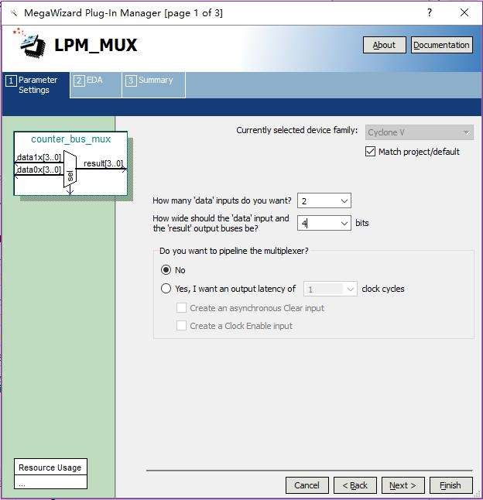
Figure 4-23 lpm_mux settings
- Click Next.
- Click Finish twice. The Symbol window appears (see Figure 4-24 for an example) when you right click and select Insert > Symbol.
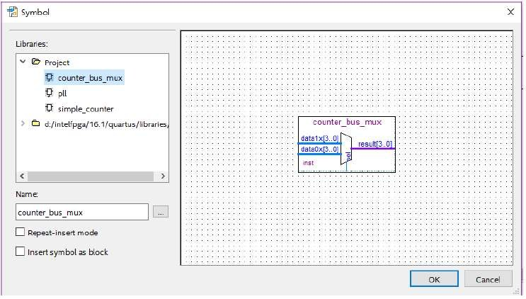

Figure 4-24 lpm_mux Symbol
- Click OK
- Place the counter_bus_mux symbol below the existing symbols on the BDF. See Figure 4-25.
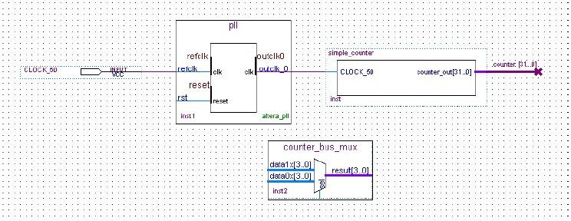
Figure 4-25 Place the lpm_mux symbol
- Add input buses and output pins to the counter_bus_mux symbol as follows:
- Using the Orthogonal Bus tool, draw bus lines from the data1x[3..0] and data0x[3..0]. Input ports to about 8 to 12 grid spaces to the left of counter_bus_mux.
- Draw a bus line from the result [3..0] output port to about 4 to 8 grid spaces to the right of counter_bus_mux.
- Right-click the bus line connected to data1x[3..0] and choose Properties.
- Name the bus counter[26..23], which selects only those counter output bits to connect to the four bits of the data1x input. Because the input busses to counter_bus_mux have the same names as the output bus from simple_counter, (counter[x .. y]) the Quartus II software knows to connect these busses.
- Click OK.
- Right-click the bus line connected to data0x[3..0] and choose Properties.
- Name the bus counter [24..21], which selects only those counter output bits to connect to the four bits of the data1x input.
- Click OK. Figure 4-26 shows the renamed buses.
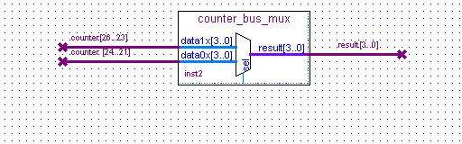
Figure 4-26 Renamed counter_bus_mux Bus Lines
If you have not done so already, save your project file before continuing.
- Right click on the mouse and select Insert > Symbol
- Under Libraries, double-click quartus/libraries/ > primitives > pin > output (see Figure 4-27).
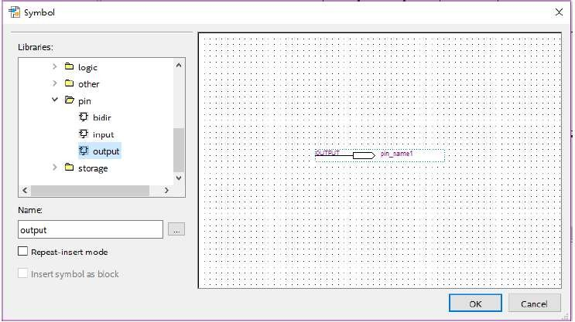
Figure 4-27 choose an output pin
- Click OK.
- Place this output pin so that it connects to the counter_bus_mux result [3..0] bus output line.
- Rename the output pin as LED [3..0] as described in steps 13 c and d. (see Figure 4-28).
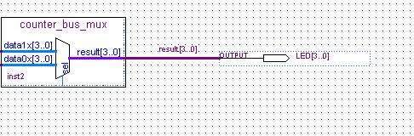
Figure 4-28 Rename the output pin
- Attach an input pin to the multiplexer select line using an input pin:
  - Right click on the mouse and select Insert > Symbol.
  - Under Libraries, double-click quartus/libraries/ > primitives > pin > input.
  - Click OK.
- Place this input pin below counter_bus_mux.
- Connect the input pin to the counter_bus_mux sel pin.
- Rename the input pin as KEY [0].
- Place another input pin at the left of the pll and rename it as KEY[1] (see Figure 4-29) .
- Right click on the mouse and select Insert > Symbol.
- Under Libraries, double-click quartus/libraries/ > primitives >logic > not (see Figure 4-30).
- Click OK.
- Place this not pin so that it connects to KEY[1] and the pll rst (see Figure 4-31).
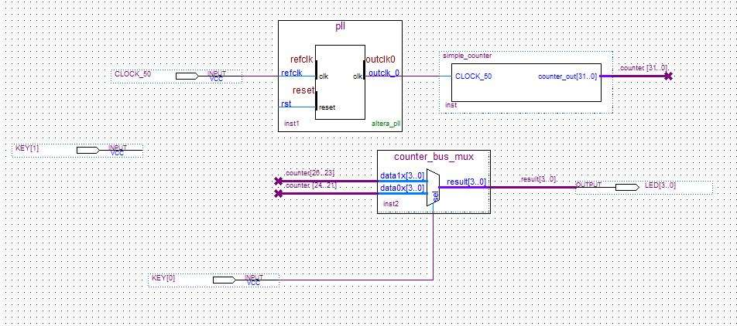

Figure 4-29 Adding the KEY [1:0] Input Pin
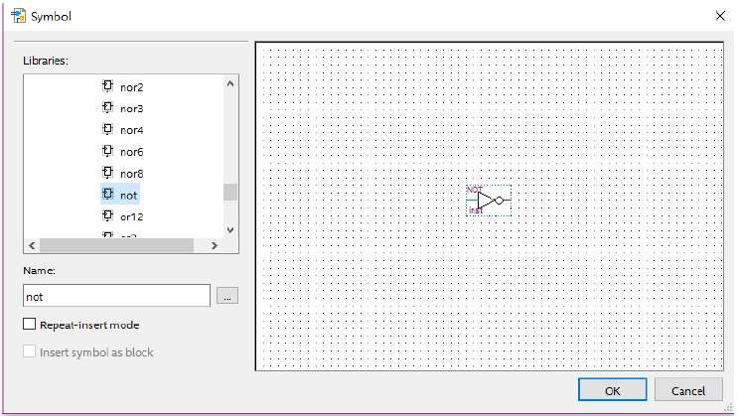
Figure 4-30 choose an not pin

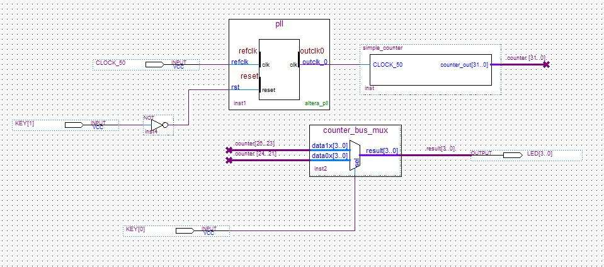
Figure 4-31 Place the not pin
You have finished adding symbols to your design. You can add notes or information to the project as text using the Text tool on the toolbar (indicated with the A symbol). For example, you can add the label “OFF = SLOW, ON = FAST” to the KEY [0] input pin and add a project description, such as “My First FPGA Project.”
- Assign the pins
In this section, you will make pin assignments. Before making pin assignments, perform the following steps:
- Choose Processing > Start > Start Analysis & Elaboration in preparation for assigning pin locations.
- Click OK in the message window that appears after analysis and elaboration completes.
To make pin assignments that correlate to the KEY[1:0] and CLOCK_50 input pins and LED[3..0] output pin, perform the following steps:
- Choose Assignments > Pin Planner, which opens the Pin Planner, a spreadsheet-like table of specific pin assignments. The Pin Planner shows the design’s six pins. See Figure 4-32.
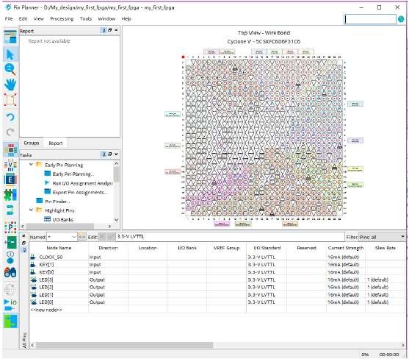
Figure 4-32 Pin Planner Example

- In the Location column next to each of the seven node names, add the coordinates (pin numbers) as shown in Table 4-1 for the actual values to use with your DE10-Standard board.
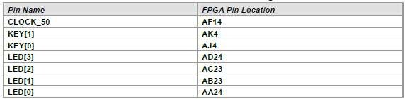
Table 4-1 Pin Information Setting
Double-click in the Location column for any of the seven pins to open a drop-down list and type the location shown in the table alternatively, you can select the pin from a drop-down list. For example, if you type F1 and press the Enter key, the Quartus II software fills in the full PIN_F1 location name for you. The software also keeps track of corresponding FPGA data such as the I/O bank and VREF Group. Each bank has a distinct color, which corresponds to the top-view wire bond drawing in the upper right window. See Figure 4-33.

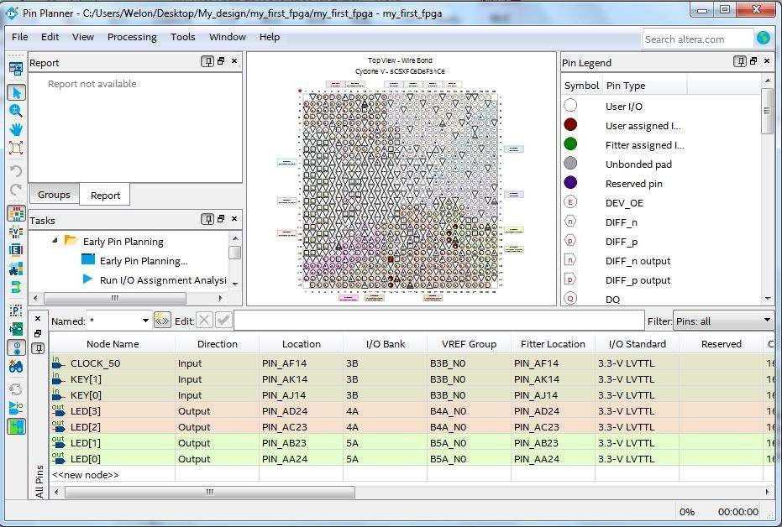
Figure 4-33 Completed Pin Planning Example
Now, you are finished creating your Quartus II design!
- Compile and Verify Your Design
- Compile your design
After creating your design you must compile it. Compilation converts the design into a bitstream that can be downloaded into the FPGA. The most important output of compilation is an SRAM Object File (.sof), which you use to program the device. The software also generates other report files that provide information about your code as it compiles.
If you want to store .SOF in memory device (such as flash or EEPROMs), you must first convert the SOF to a file type specifically for the targeted memory device.
Now that you have created a complete Quartus II project and entered all assignments, you can compile the design.
In the Processing menu, choose Start Compilation or click the Play button on the toolbar.
If you are asked to save changes to your BDF, click Yes.
While compiling your design, the Quartus II software provides useful information about the compilation (see Figure 5-1).
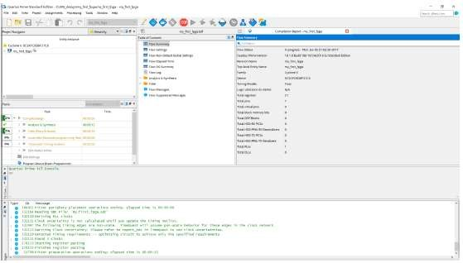
Figure 5-1 Compilation Message for project
When compilation is complete, the Quartus II software displays a message. Click OK to close the message box.
The Quartus II Messages window displays many messages during compilation. It should not display any critical warnings; it may display a few warnings that indicate that the device timing information is preliminary or that some parameters on the I/O pins used for the LEDs were not set. The software provides the compilation results in the Compilation Report tab as shown in Figure 4-2.
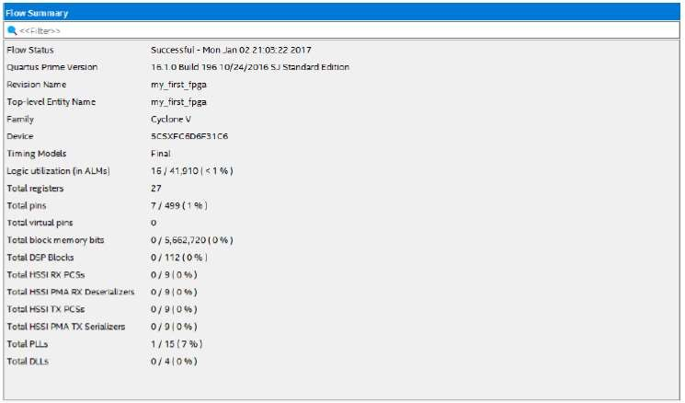

Figure 5-2 Compilation Report Example
- Program the FPGA device
After compiling and verifying your design you are ready to program the FPGA on the development board. You download the SOF you just created into the FPGA using the USB-BlasterII circuitry on the board. Set up your hardware for programming using the following steps:
- Connect the power supply cable to your board and to a power outlet.
- For the DE10-Standard board, connect the USB-BlasterII (included in your development kit) to J13 and the USB cable to the USB-BlasterII. Connect the other end of the USB cable to the host computer.Refer to the getting started user guide for detailed instructions on how to connect the cables.
- Turn the DE10-Standard board on using the on/off switch. Program the FPGA using the following steps.
- Choose Tools > Programmer.
- The Programmer window opens. See Figure 5- 3.
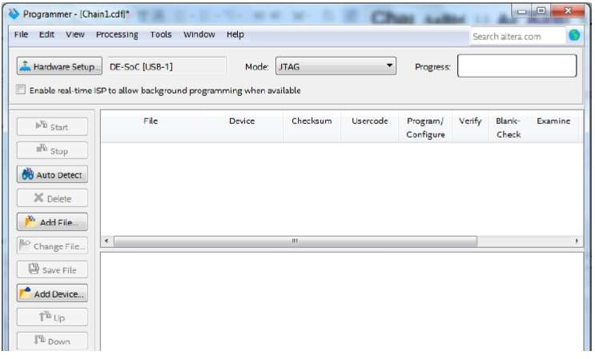

Figure 5-3 Programmer Window
- Click Hardware Setup.
- If it is not already turned on, turn on the DE10-Standard [USB-1] option under currently selected hardware. See Figure 5-4.
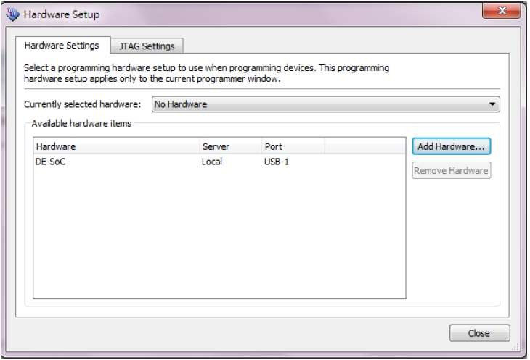

Figure 5-4 Hardware Setting
  - Click Close.
  - Click Auto Detect to detect all the devices on the JTAG chain.
  - Select 5CSXFC6D6 and click OK.
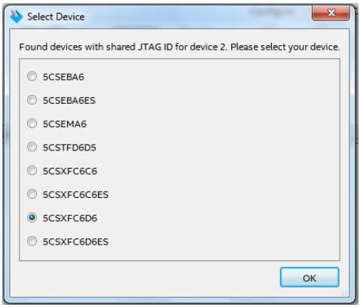

Figure 5-5 Select FPGA Device
  - Both HPS and FPGA will be list on the programmer. Select FPGA device and click Change File a .sof file.
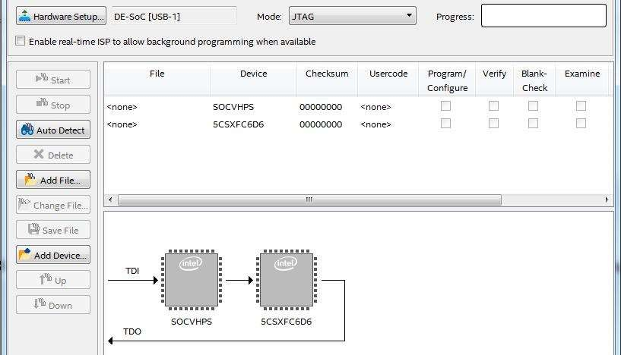

Figure 5-6 Programmer window
  - Select the my_first_fpga.sof file from the project directory (see Figure 5-7), select to Program/Configure and click Start to program .sof file into FPGA.
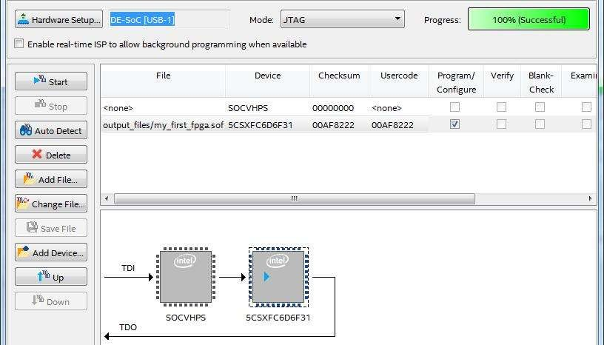

Figure 5-7 Downloading Complete
Congratulations, you have created, compiled, and programmed your first FPGA design! The compiled SRAM Object File (.sof) is loaded onto the FPGA on the development board and the design should be running.

