

QUARTERLY REPORT
Q2 2025

360 DIGITALY
CLOSED-END AND RESERVED ALTERNATIVE INVESTMENT FUND

The following regulations were approved by 360 Capital Partners after verifying its compliance with current applicable provisions. It should be noted that, since it is an alternative fund reserved under article 14 of the Decree of the Ministry of Economy and Finance on March 5th, 2015 no. 30 (Ministerial Decree 30/2015), the following regulations were not submitted for specific approval by the Banca d’Italia (Bank of Italy).

Page left blank intentionally

Table of Contents

1. Fund key figures as of Q2 2025 4
2. Management Company 5
3. Fund Status as of Q2 2025 6
3.1 Summary 6
3.2 Fund financial performance 8
3.3 Cash flow schedule and net IRR calculation 9
3.4 Net asset value accounting 10
4 Portfolio Reporting as of Q2 2025 11
4.1 Portfolio summary as of June 30, 2025 13
4.2 Full realised portfolio summary as of June 30, 2025 14
4.3 Current portfolio 15
TUNDR 16
MOVOPACK 18
GUIDOIO 20
SOOURCE 22
JAMPY 24
ZEFI 26
TALENTWARE 28
5 Capital account as of June 30, 2025 30
6 Glossary 31

Fund key figures as of Q2 2025

First closing date | August 16, 2024
Vintage year | 2024
Status | CLOSED-END AND RESERVED ALTERNATIVE INVESTMENT FUND
Management Company | 360 Capital Partners SAS
Investment policy | Seed and early stage investments, in companies operating in the venture capital market, highly innovative, with scalable business model, and active in the following focus areas: Artificial Intelligence, cloud computing, healthcare, Industry 4.0, cybersecurity, fintech, and blockchain, or in other areas of the digital transition
Fund currency  Total commitment | Euro  € 30.6M
Hurdle rate | 0.20x
Total drawdown to date | € 6.0M
Cumulative Drawdown A-Shares to date | 19.46%
Total distribution | € 0.00M
Fund net asset value | € 5.2M  A-share net value: € 171.432  B-share net value: € 0.171
Number of investee companies | 7
Total invested in portfolio companies | € 4.5M
Auditor | Deloitte, Italy
Custodian | CACEIS Bank, Italy Branch

Management Company

Company | 360 CAPITAL PARTNERS  138 Boulevard Haussmann  75008 Paris  Mail: info@360cap.vc,  jeanmarie@360cap.vc  SIREN: 498 943 471
AMF’s authorization | GP11000040
Partners | Lucrezia Lucotti  Alexandre Mordacq  Cesare Maifredi  Fausto Boni  François Tison  Nader Sabbaghian
Website | http://www.360cap.vc

Fund Status as of Q2 2025

Summary
In April, the Fund made its seventh investment by contributing € 1.8M to Tundr’s Seed round. The investment was made alongside 360 SICAF, which also contributed € 1.8M. The total funding round amounted to € 7.2M, based on a pre-money valuation of € 13.0M.
The company is a welfare fintech platform built to help companies efficiently manage and optimize employee benefits. It offers a comprehensive solution for both fringe and flexible benefits, giving employees seamless access to a wide network of services through the Tundr Card and App—usable both online and offline. For HR teams, Tundr delivers an intuitive management system that streamlines benefit administration, enhancing operational efficiency across the organization.

In May, the Fund participated in a € 0.27M follow-on SAFE in Guidoio, intended as advance funding ahead of the upcoming financing round. This was part of a € 0.54M bridge round completed alongside the SICAF. In addition, the transaction included the acquisition of € 0.2M in secondary shares from one of the co-founders, with 360 Digitaly and the SICAF each acquiring € 0.1M.

Separately, Emanuele Levi stepped down from his partner position at 360 Capital at the end of May to join CDP Venture Capital SGR as CEO.

Latest news of our portfolio:

Movopack:
The company continues to see a steady stream of incoming orders. Its recent partnership announcement with Decathlon has greatly boosted its visibility. Furthermore, Movopack has started working with initial clients on its new B2B packaging solution.

Zefi:
The company closed the second quarter with nearly € 300K in contracted ARR. On the hiring front, the sales team has been reinforced with the addition of two new professionals.

Recent developments

The net asset value as of June 30, 2025, was calculated with the information available at the date of this report.

Drawdown/distribution

In April 2025, to finance its follow-on investment in Guidoio, the Fund made its fourth drawdown. This brought the total capital called to 19.46%.

Subsequent event

None.

3.2 Fund financial performance

3.3 Cash flow schedule and net IRR calculation

3.4 Net asset value accounting

Portfolio Reporting as of Q2 2025

Key Portfolio Events are detailed below

- 1 new investment:

  - Tundr: € 1.8M investment as part of a € 7.2M Seed financing round, based on a pre-money valuation of € 13M. This investment is a co-investment with the SICAF, allowing each party to acquire a 9.60% ownership stake.

- 1 follow-on investment:

  - Guidoio: € 0.27M follow-on investment through a SAFE agreement and € 0.1M in secondary shares acquired from a co-founder. This investment has been made alongside the SICAF.

Investments valuation method
The valuation criteria for equity investments in closed-end funds in unlisted companies are described by the Regulation of Bank of Italy published on 2015, Title V, Chapter IV, Section II, Paragraph 2.4.

According to the provisions of paragraph 2.4.1, the valuation of equity investments in unlisted companies, in the absence of reference prices expressed by the market, requires estimation considering a lot of elements. These procedures significantly influence the determination of the value of the fund.

Consequentially in the valuation of the assets, the value of them should reflect the economic, equity and financial conditions of the investee companies, considering these are investments made on a long-term basis. These provisions do not impose rigid uniform criteria, but rather define, with the indication of a series of operational criteria, an area within which the method considered most appropriate is chosen, according to an independent assessment.

As regards to the general valuation criteria (par. 2.4.2), equity investments in unlisted companies are valued at purchase cost, but there are some exceptions described in the following paragraphs of the Regulation.

According to the provisions of paragraph 2.4.3 Investments in non-real estate companies, after a period which, as a rule, cannot be less than one year from the date of the investment, the securities of unlisted companies can be revalued based on the following criteria:
- Value resulting from one or more transactions, including capital increases, after the last valuation,
- Value resulting from the application of valuation methods based on economic-asset type indicators,
- Valuation, in the presence of companies that produce significant streams of income, from the methodologies of the price / earnings type, paying particular attention, however, that the ratio used is derived from a sufficiently large sample of companies like the one to be evaluated for type of production, economic and financial characteristics, development prospects and market positioning.

In addition, according to Bank of Italy regulations, in case of revaluation, a prudential measure due to illiquidity issues is to be considered, resulting in a 25% discount of the revaluation.

4.1 Portfolio summary as of June 30, 2025

4.2 Full realised portfolio summary as of June 30, 2025

4.3 Current portfolio
- TUNDR
- MOVOPACK
- GUIDOIO
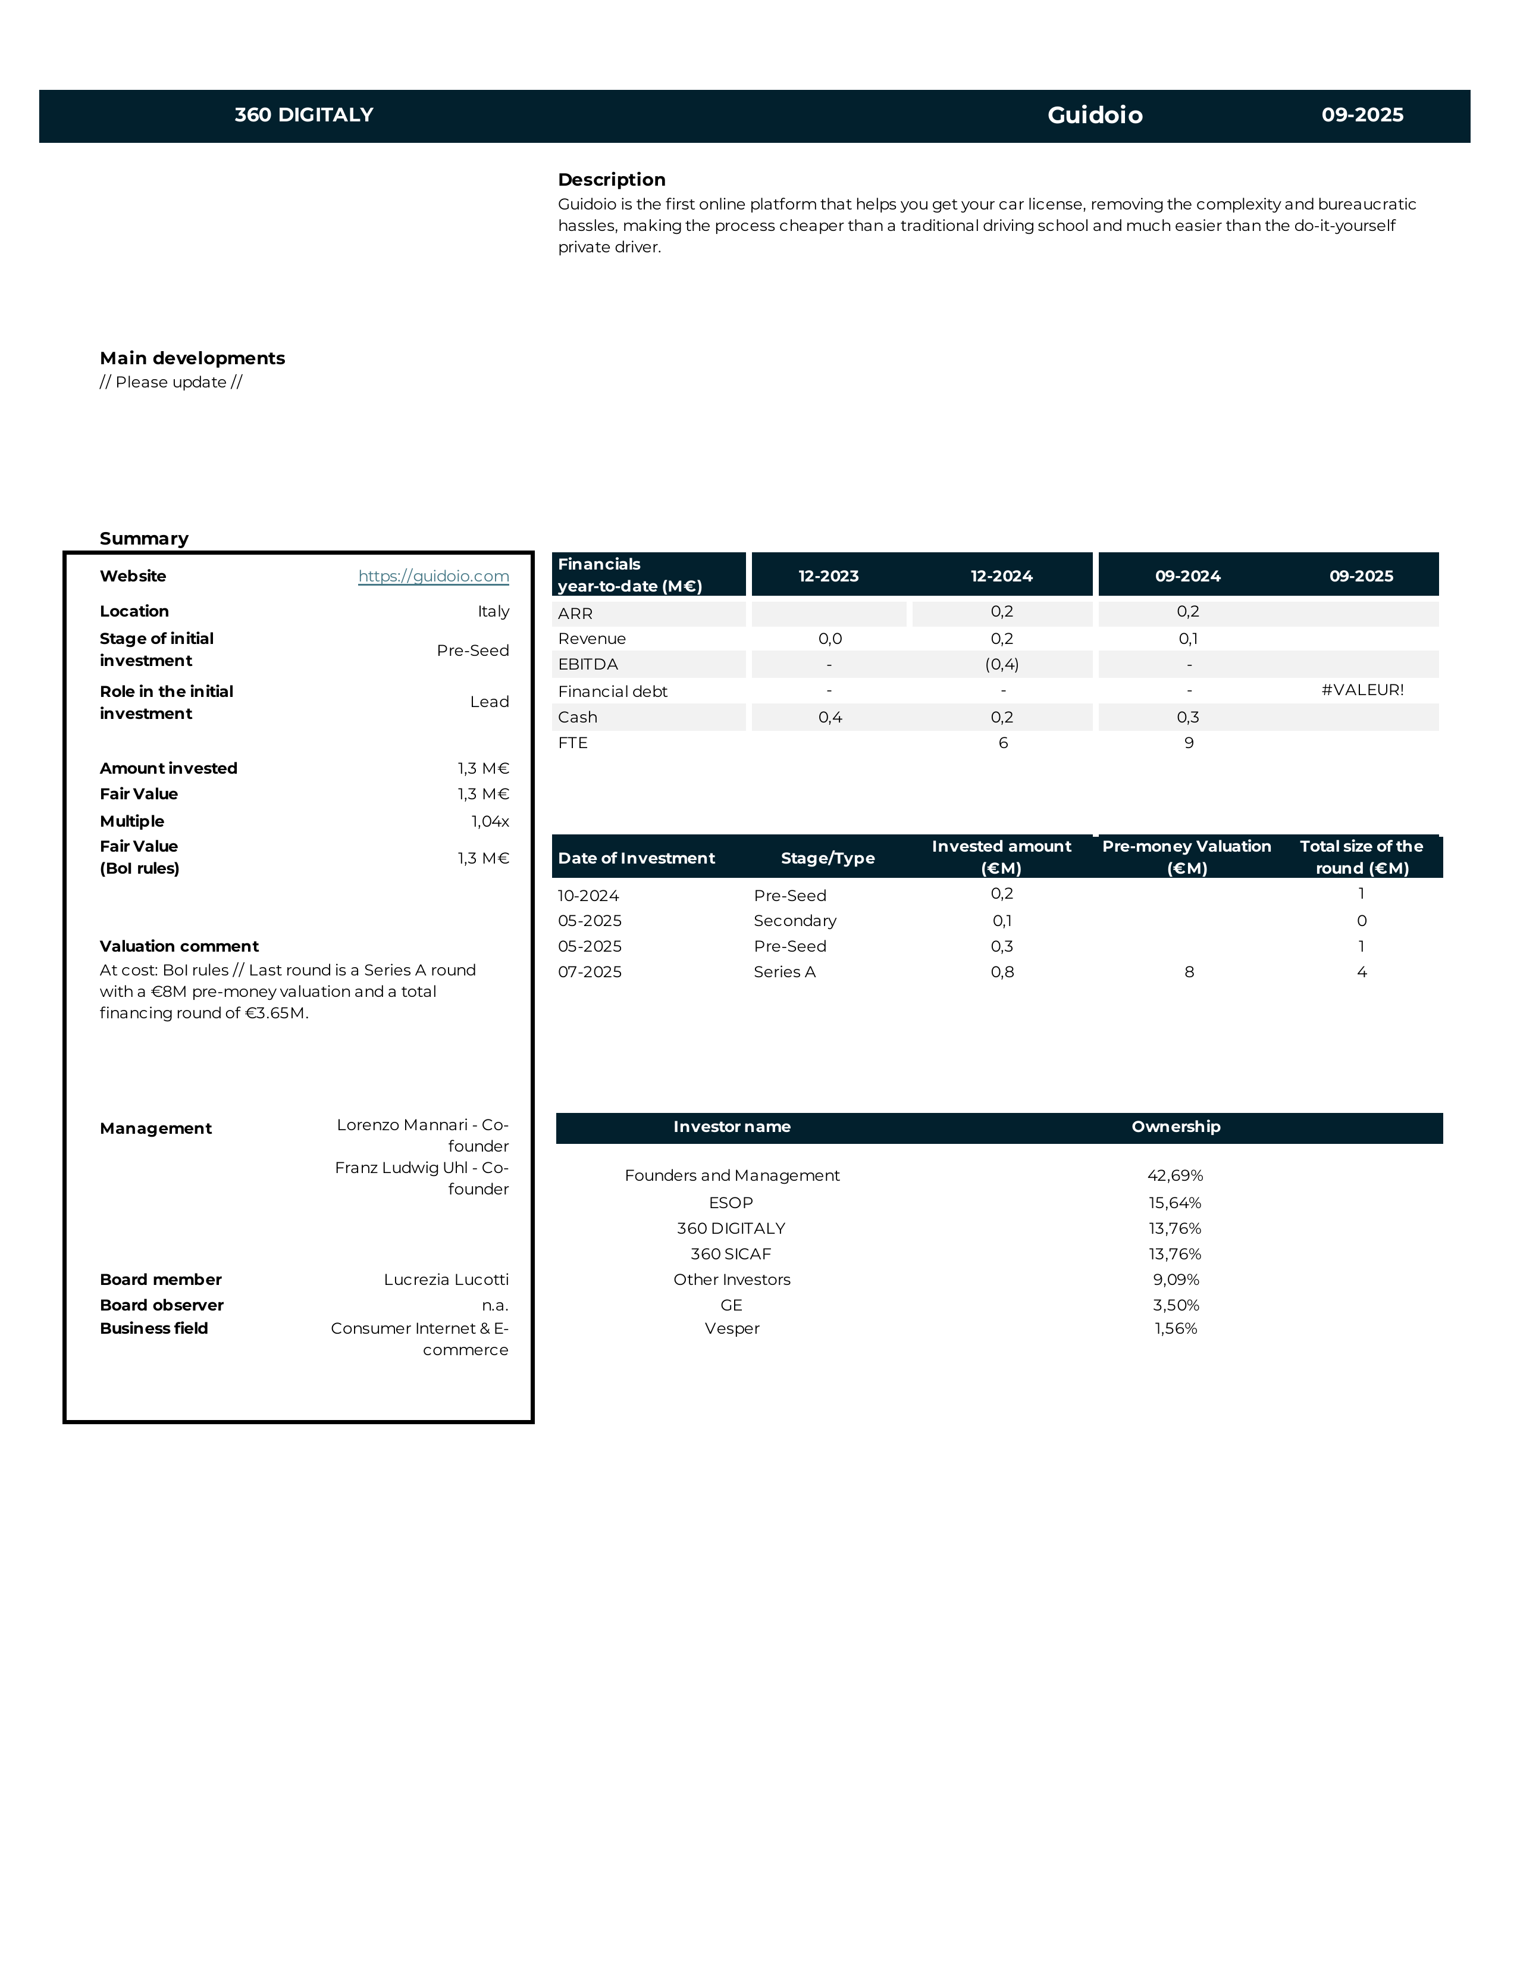
- SOOURCE
- JAMPY
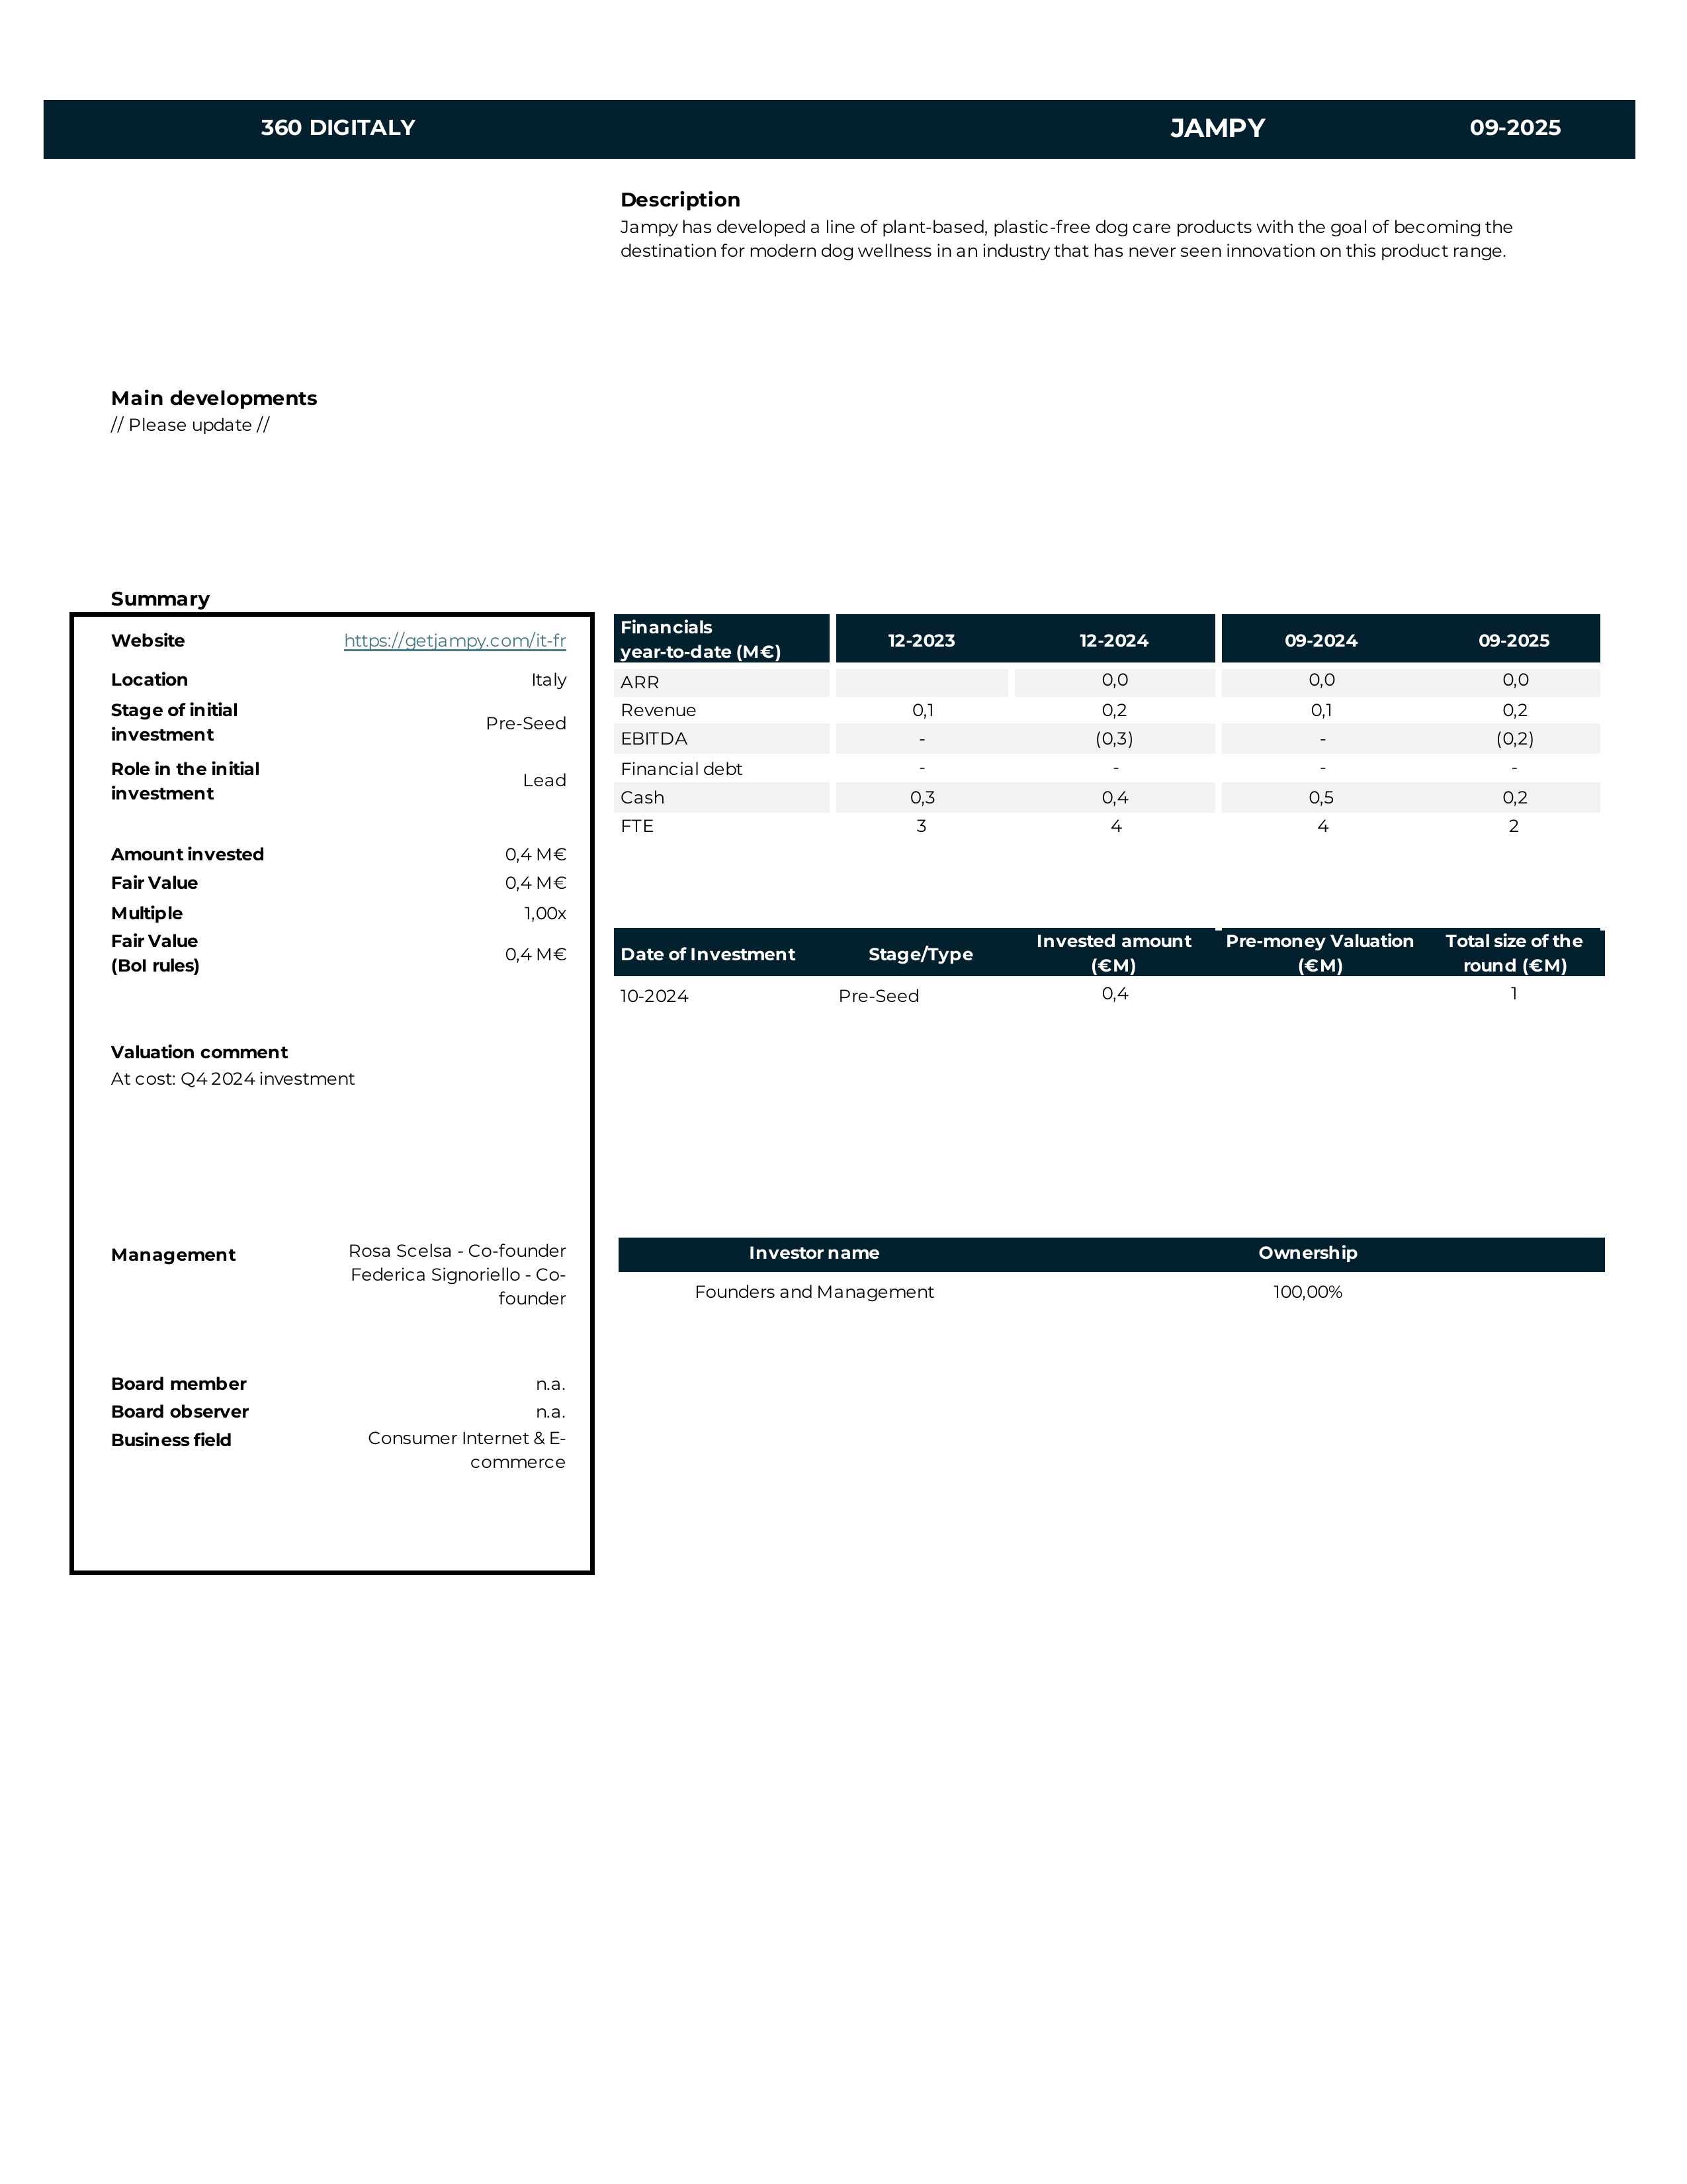
- ZEFI
- TALENTWARE
TUNDR
MOVOPACK

GUIDOIO

SOOURCE

JAMPY
ZEFI
TALENTWARE

Capital account as of June 30, 2025

Glossary

