AIE900A-AO DIO Quick User Guide
For customer testing on JetPack 6.2.1 with the AIE900A-AO test package.

1. Install and check the device
On the target, install the supplied package and reboot to load the updated Device Tree.
sudo apt install ./axio-dio-serial-test-jp6.2.1_arm64.deb
sudo reboot
After reboot, check the channels detected by the driver.
dioctl.sh status
The output groups channels by bank under CHANNEL, DIRECTION, and VALUE. Each bank uses channel numbers 0 through 7. Use dioctl.sh status 2 to show only dio_2 in each detected bank.

2. Set and save a channel
Use --bank 0 or --bank 1 before a command that targets a single bank when two banks are present. With one detected bank, you can omit the option.
# Set dio_2 on bank 0 to output High and check the readback
sudo dioctl.sh --bank 0 set 2 out 1
dioctl.sh --bank 0 get 2 value
# Configure dio_4 as an input
sudo dioctl.sh --bank 0 set 4 in
# Save the settings for all eight channels on bank 0
sudo dioctl.sh --bank 0 save
Changes take effect immediately. save persists the bank settings for the next load through modprobe. To clear saved settings while keeping the current GPIO state, run sudo dioctl.sh --bank 0 clear.

3. Use the desktop GUI
Open a terminal in the target's graphical desktop session.
dioctl.sh gui
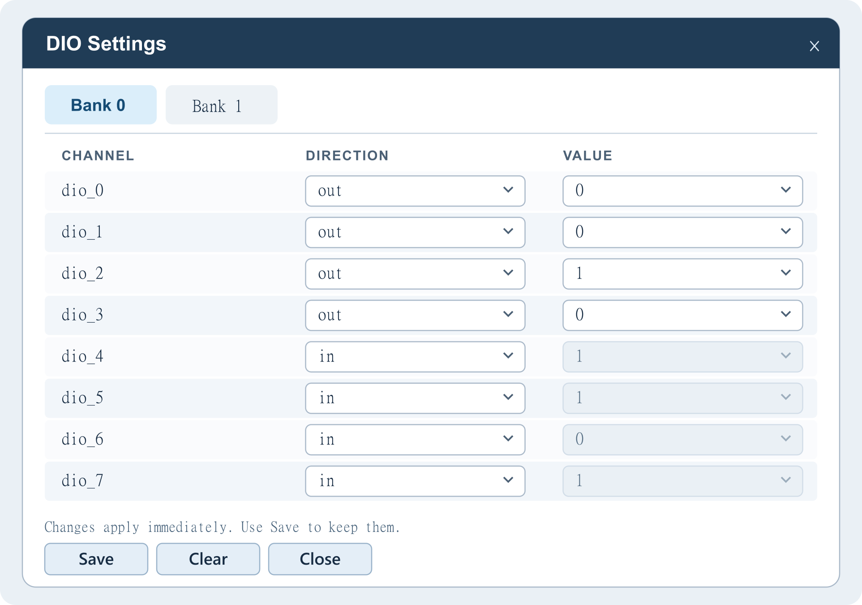
- Select the bank tab. A single bank opens directly.
- Choose in or out in DIRECTION. Switching to out starts at 0.
- Choose 0 or 1 in VALUE for an output. For an input, VALUE displays the readback.
- Select Save to keep the current bank's settings or Clear to erase its saved settings. If prompted by sudo, enter the password in the terminal.
If status reports no device, check the driver binding with ls -l /sys/bus/platform/drivers/dio-sysfs/. Run dioctl.sh --help for the full command list.
Full DIO README

