AIE900A-AO Serial Mode Control
Quick User Guide
Use serial_mode_ctl.sh to switch a configured COM port between RS-232, RS-422, and RS-485. This changes the transceiver mode; baud rate and framing are configured separately on the UART device.

Switch and save from the command line
sudo serial_mode_ctl.sh get
sudo serial_mode_ctl.sh set com1 rs422
sudo serial_mode_ctl.sh get com1
sudo serial_mode_ctl.sh save
The example sets COM1 to RS-422. Use rs232, rs422, or rs485 as needed. To change COM2, first check that it appears in get. Saving stores all configured ports for the next modprobe load; set alone does not save.
To delete saved settings and immediately restore Device Tree defaults:
sudo serial_mode_ctl.sh clear
If more than one device is detected, copy its reported sysfs directory and pass it before the command:
sudo serial_mode_ctl.sh --sysfs "$DEVICE_SYSFS" get
Set DEVICE_SYSFS to the selected device's actual directory.

Use the graphical interface
In a graphical desktop terminal, run:
sudo -v
serial_mode_ctl.sh gui
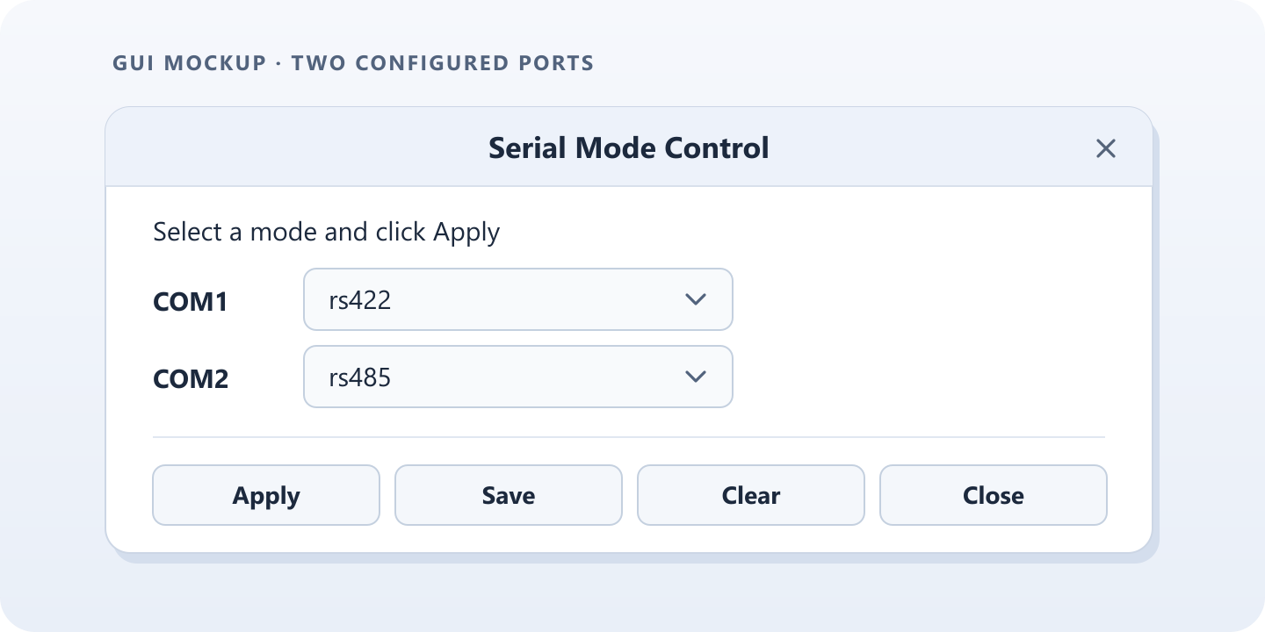
Example layout, not a screenshot. The window shows only configured ports.
Button | What it does
Apply | Switch to the selected modes for this session.
Save | Review the selected modes, then click OK to apply and save them in one step.
Clear | Review the current modes, then click OK to remove saved settings and restore the board defaults.
Close | Exit the window.
Choose Cancel in either confirmation dialog to make no change.

Quick checks
- No device or port appears: Check that the driver is bound and the port is configured. Review the driver messages in dmesg.
- GUI access fails: Run sudo -v again in the same terminal and retry.
- Saved settings do not return: Confirm that the module is loaded with modprobe; direct insmod does not read the saved configuration.
For command help, run serial_mode_ctl.sh --help.

