Ontology and Agent Harnesses from First Principles
  - Deriving the architecture from what a correct action requires
The core conclusion: a task needs meaningful distinctions and a process that applies them correctly. An explicit ontology is one way to define those distinctions. The harness is the machinery that runs the process. A separate ontology is not universally required.
To understand why, start before the words “agent,” “harness” and “ontology.” Suppose we want a system to check whether a particular software build can be deployed. What must be true for its answer to be correct?

Start with the conditions for correctness
Required condition | Why it matters in this task
A defined outcome | We must know whether success means advising, authorizing or actually deploying.
Reliable evidence | We need the requested build, relevant approval records and their current scope.
Consistent interpretation | An approval for a service and an approval for one build cannot be casually treated as equivalent.
A decision criterion | The policy must say which approvals are required and what to do when evidence is missing.
Controlled execution | If the system can deploy, it must act only with authority and report the actual result.

These requirements do not yet choose a graph database, ontology language, model provider or framework. They describe what would make the behavior correct. Some tasks can meet them with a small amount of ordinary software.

Two different problems emerge
There is an execution problem: how does the system obtain evidence, invoke computation, call tools and observe results? There is also a meaning problem: what do the records refer to, and which conclusions follow from their relationships? Solving one does not automatically solve the other.
A system can execute every step reliably and still apply an approval to the wrong build. It can also interpret the approval correctly but perform the deployment twice after a retry. The first failure concerns meaning or rule application; the second concerns execution and recovery.

Derive the harness from the work that must happen
Assume a language model can inspect supplied input and propose an answer or action. For an external action, a proposal alone is insufficient. Software must translate the request into an actual tool invocation and return the observation. Repeating that interaction gives us a minimal agent loop.
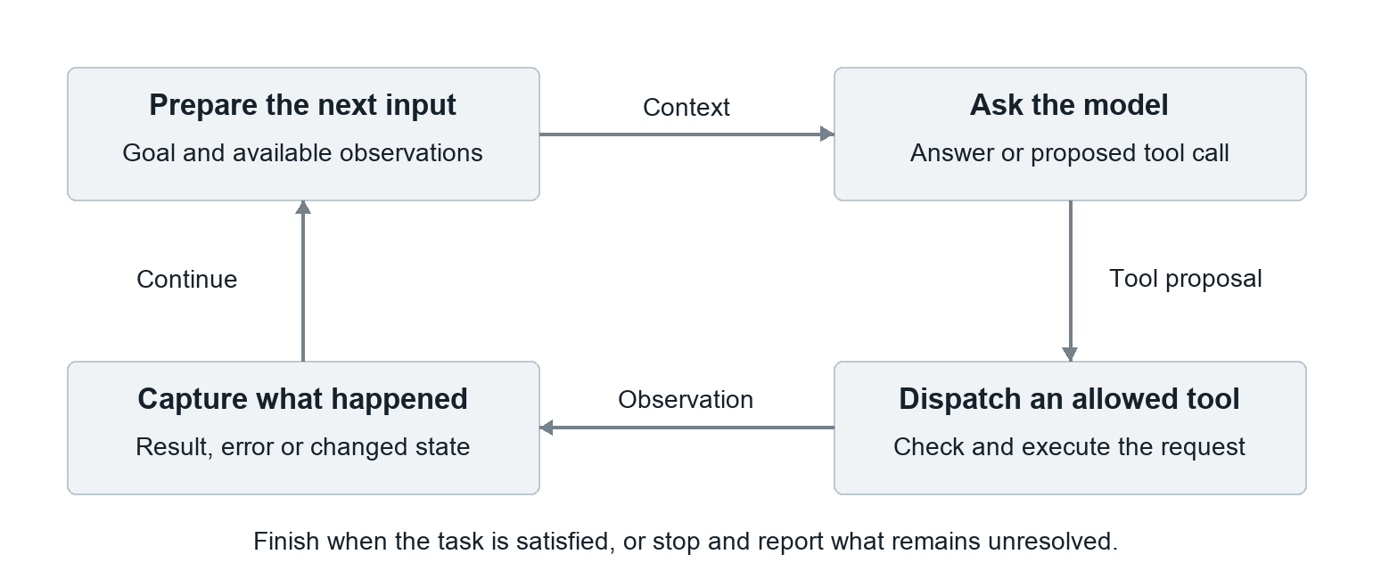
Figure 1 A minimal execution cycle. The model can finish with an answer instead of proposing another tool call. This diagram does not assume an ontology.

The missing machinery becomes the harness
The surrounding code prepares the model input, invokes the model, routes allowed tool requests and carries results into the next turn. That is the core execution responsibility we call the harness. Anthropic describes its harness as the model-calling and tool-routing loop; its durable session and sandbox are separate components. [1]
Additional requirements justify additional mechanisms. A run that must survive a crash needs durable state. A sensitive write needs authorization at execution. A non-idempotent external effect needs a recovery strategy that avoids duplicate effects. A need to explain failures justifies structured event records. These mechanisms follow from requirements, not from a universal checklist of agent components.
This also explains why “a prompt” is not the entire harness. Instructions may tell the model to check an approval, but they do not execute a query, establish permission, persist state or verify an external effect by themselves.

Nothing here forces an ontology
The loop can pass prose, database rows, files or formally structured knowledge. We have derived the need for execution machinery, but not the need for a separately maintained ontology. To decide about ontology, we must examine the meaning problem.

Derive ontology from the meaning problem
Suppose the evidence says that A9 approves Exporter. That sentence alone may not establish whether A9 covers every release, one build or a particular environment. A fluent interpretation is not enough when those alternatives lead to different actions.
Now make the relevant distinctions explicit: Exporter is a service; Build 41 and Build 42 are distinct builds of it; A9 covers only Build 41; the requested deployment targets Build 42. The policy requires approval for the exact target build.
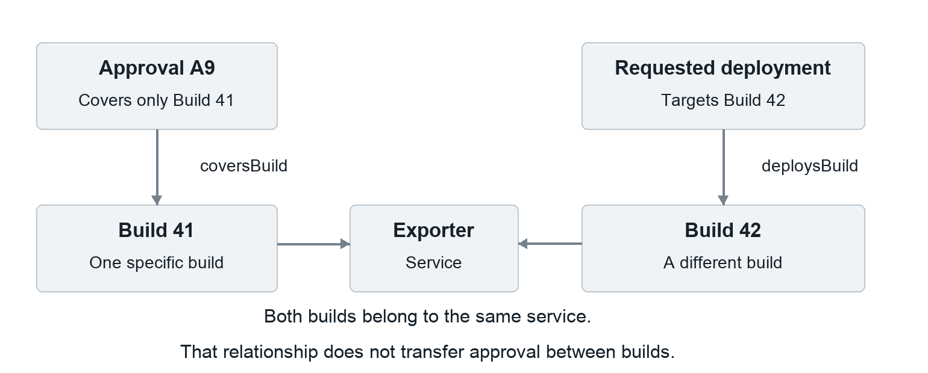
Figure 2 A relationship that is true does not justify every inference. Sharing a service does not imply sharing approval under the declared policy.

The building blocks follow from the questions
Question we must answer | Representation that answers it
What kind of thing is this? | Types such as Service, Build and Approval.
Which particular thing is this? | Stable identities for Exporter, Build 41 and A9.
How are these things connected? | Defined relationships such as coversBuild and buildOf.
What properties or logical commitments apply? | Attributes, category hierarchies and explicit axioms.

An ontology makes such conceptual commitments explicit. Gruber’s classic definition is “an explicit specification of a conceptualization.” Formal languages such as OWL give selected statements precise computational meaning. An ontology can also include particular assertions; it need not contain only category definitions. [2, 3]
The operational policy remains identifiable: requiring exact-build approval is a rule for this application. A chosen ontology language may represent some relevant logic, while time checks, permissions and exception handling may be implemented separately.

Test whether a separate ontology is necessary

Construct a system that does the task without one
An agent asks a tool for a deployment and its approval records. The records have documented build_id and environment fields. A checking function compares the exact identifiers and environment, verifies validity and returns the result. The harness supplies that result to the model, which reports it or asks for missing evidence.
This system can meet a narrowly specified approval-checking contract without a graph database, OWL document or separate ontology service. Its documented schema and checking code already embody a small domain model. This is a design example, not a claim that a particular implementation has been tested.
Therefore, meaningful interpretation is necessary for correct behavior, but a separately managed ontology artifact is not universally necessary. Schemas and code can express substantial meaning. “Without ontology” must not be used as shorthand for “without structure or definitions.”

Recognize when the argument becomes a naming exercise
If we call every conceptual assumption an ontology, then almost every software system has one. That broad usage does not prove we should build an additional component. For an engineering experiment, specify the actual intervention: explicit relationship definitions, a formal axiom set, common identifiers, a query interface or a reasoning service.

Now answer whether ontology is part of the harness
Responsibility | Example
Defining domain meaning | coversBuild identifies the build an approval covers.
Integrating that meaning | Load the definition, expose a query or pass its results to the model.
Computing a consequence | Compare approval scope, or invoke a reasoner with declared semantics.
Enforcing an action boundary | Reject deployment if current authorization is not established.

The ontology supplies the explicit domain model. The harness arranges for components to use it. The reasoner or checker performs its own computation; the executor applies the action boundary. These responsibilities can be in one program or several services.
Moving the ontology file into the harness repository does not, by itself, change any inference or permission. Packaging is not the source of the benefit. Under LangChain’s broad non-model definition, ontology configuration and integrations can count as harness components. Under a narrower execution-loop definition, the ontology is a dependency. [1, 4]
An application may require its own ontology to operate correctly. That local dependency does not make ontology a universal property of agent harnesses.

Derive when explicit ontology is worth the effort
The useful question is not whether ontology sounds advanced. It is which repeated failure becomes easier to prevent, detect or repair when domain meaning is explicitly modeled.

A plausible benefit comes from reducing disagreement
Suppose one tool uses “approved” to mean a reviewer agreed, another uses it for a currently valid permission, and a third attaches approval to a service rather than a build. A shared definition and verified mappings can expose these differences. The harness can then supply consistent records and meanings to downstream decisions.
This does not require a separate ontology in every case. A documented schema and well-tested adapters may solve the problem more simply. An ontology becomes a stronger candidate when relationships and category rules must remain consistent across many sources, tools or decisions.

Separate four mechanisms that can improve an answer
Intervention | What could actually produce the improvement
Clarify or add knowledge | The system now has a definition or fact it previously lacked.
Represent equivalent knowledge explicitly | The same information is easier for the model to bind and apply.
Compute with software | A query or reasoner performs work previously left to the model.
Enforce a check | Invalid proposals are blocked even if the model still makes them.

All four can be useful. They support different claims. Fewer unsafe actions after adding a validator does not demonstrate better model reasoning. A better answer after supplying a missing relationship does not isolate the value of representation.

An ontology cannot manufacture missing evidence
Imagine two possible worlds: in one, Build 42 has another valid approval; in the other, it does not. If the system sees only the same A9 record in both worlds, it cannot establish which world it is in from that record alone. Defining Approval more precisely does not create the missing observation.
We must obtain more evidence, rely on an explicit and justified completeness assumption, or report uncertainty. A formal derivation remains conditional on its premises. Consistency does not prove source truth. OWL itself treats absent information as potentially unknown rather than automatically false. [3]
The trade-off is concrete: possible gains in consistent interpretation and checking, against the work of defining, mapping, versioning and maintaining the model. A stale or incorrect ontology can spread the same mistake across many decisions.

Turn the argument into an isolating experiment
Hypothesis: on scope-sensitive approval cases, explicit ontology representation improves accuracy over equivalent prose. Test it with a read-only decision.

Hold knowledge and execution constant
Generate two packets from one reviewed source. A states every fact, relation meaning and policy in prose. B structures the same knowledge as types, relationships and axioms. Keep the harness, model, tools, instructions, output contract, settings, grading and context ceiling fixed. Supply no precomputed answers.
This tests representation. Giving only B additional definitions, better queries or a reasoner introduces another variable. Test those separately. A later study can separate graph formatting from formal semantics.

Choose cases that expose the proposed mechanism
Controlled case | What a correct system should preserve
Approval covers the requested build. | Recognize the match when all other requirements pass.
Approval covers a different build of the same service. | Do not transfer authorization between builds.
Rename the service without changing its identity or facts. | Keep the decision unchanged.
Remove all authoritative completeness and absence assertions. | Distinguish unresolved approval from established absence.
Add a waiver limited to a separate freeze restriction. | Do not treat it as waiving the approval requirement.

The smallest case may be too easy to measure a gain. Add representative combinations of identity, time and scope. Target specific semantic errors rather than difficulty for its own sake.

Measure the decision and the first broken boundary
Repeat live model runs; record provider, model, prompt, call identity and harness version. Check decisions, obligation status and cited support. Record source mappings, selected context, proposals and validation. Do not automatically blame reasoning for a faulty source mapping.
Independently verify expected answers. Preflight and warm local models; run measurements serially and record order. Separate model latency from other work. Report inconclusive and excluded cells, host load, residency, cold starts, missing cases, grader errors and instrumentation overhead. Do not selectively rerun conclusive failures.
Conclude only for the tested task and model. Better outcomes after adding deterministic computation support an architecture claim, not a representation-only claim.

The derived answer and supporting sources

The reasoning in one chain
1. A correct action requires both relevant evidence and a justified interpretation of that evidence.
2. An agent needs execution machinery to obtain observations, invoke computation, route tools and continue or stop. That motivates a harness.
3. The task also requires meaningful identities, categories and relationships. They can be expressed in prose, schemas, code or an ontology.
4. An ontology becomes a distinct engineering choice when making that domain model explicit and reusable addresses a real failure or coordination need.
5. The harness can integrate it. Whether it is packaged inside the harness does not determine whether it helps.
Answer: ontology is a possible semantic component of an agent system, not a universal requirement of an agent harness. Its value must come from a specified improvement in interpretation, computation or checking, and the experiment must distinguish those contributions.

Primary sources
1 Scaling Managed Agents
Anthropic, 8 April 2026. A concrete execution-loop definition of harness, distinct from session storage and sandbox.
2 A Translation Approach to Portable Ontology Specifications
Thomas R Gruber, 1993. The classic computing definition of ontology.
3 OWL 2 Web Ontology Language Primer
W3C Recommendation, 11 December 2012. Formal ontology constructs, reasoning and open-world semantics.
4 The Anatomy of an Agent Harness
LangChain, 10 March 2026. A broader definition covering non-model code, configuration and execution logic.
The release examples are illustrative. The argument and proposed experiment are an engineering synthesis, not reported benchmark results.

