Logos
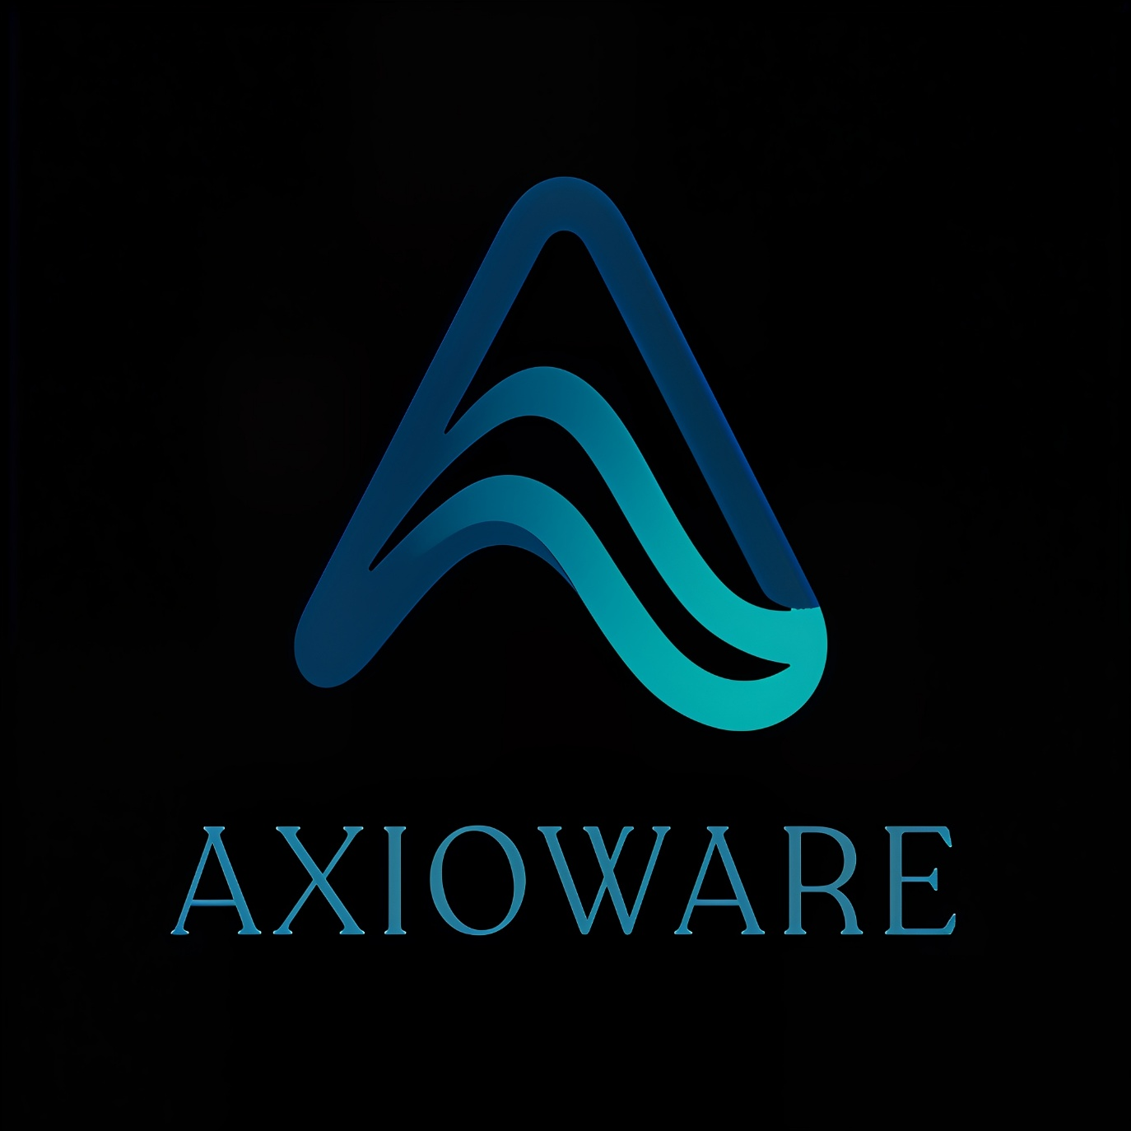


Some Decent References
Something like this but in light theme should also be good
https://v1.pinimg.com/videos/iht/expMp4/e2/be/c4/e2bec4e31f1885bd615d129cd7300065_720w.mp4
Orignal Website Link
https://axioware.tech

Contact Us info
