Databases Project – Spring 2021

Team No: 34

Members: Siran Li, Ke Wang, Ningwei Ma

Contents

Contents 1

Deliverable 1 2

Assumptions 2

Entity Relationship Schema 3

Schema 3

Description 4

Relational Schema 6

ER schema to Relational schema 6

DDL 7

General Comments 11

# Deliverable 1

## Assumptions

Each collision case has its unique case_id.

Each case has a primary collision factor (pcf); Different cases could have the same pcf.

Each case has several parties.

Each case collides in exactly one location; Different cases could collide in same location.

Each collision happened under exactly one condition, among which there could be several weather and road conditions; Different cases could collide under same condition.

Each party has a unique party_id.

Each party is involved in exactly one case; A case could involve several parties.

Each party may take a vehicle; Vehicles with same attributes are recognized as the same vehicle, and under this condition different parties can take the same vehicle.

“Party_number” refers to the specific party of a particular case, so “party_number + case_id” is unique for each party, playing the same role as party_id.

Each victim has a unique vic_id.

Each victim is associated with exactly a party in a case, by “party_number + case_id”. A party could be associated with 0 or several victims.

Each party of the case may have some other factors for the collision. Different parties may have same other factors.

Each party and victim may have their different safety_equipment. Different parties and victims may have same safety_equipment.

More detailed reasons will be given in the description.

## Entity Relationship Schema

### Schema

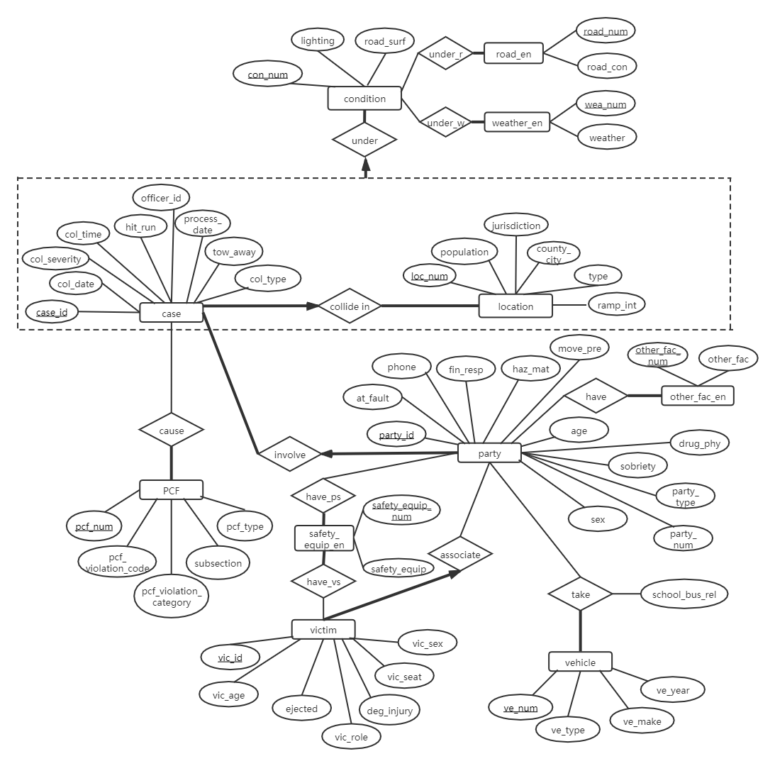

### Description

**Entities:** case (collision case), location, PCF (primary collision factor), party, victim, vehicle, condition, weather_en, road_en (road_condition), safety_equip_en (safety_equipment), other_fac_en (other_associated_factor)

Each case has some information: collision_date, collision_severity, collision_time, hit_and_run, officier_id, process_date, tow_away (if towed away or not) and col_type (type_of_collision). We set them as the attributes of the “case” entity, because they are some basic information miscellaneous of the case itself, which are easy to be analyzed as attributes. Each case has a unique case_id, so we set it as the primary key.

Each case collides in some location, including the following information: county_city (county_city_location), type (location_type), jurisdiction, population, ramp_int (ramp_intersection). We set these as the attributes of the entity “location”, because creating an entity to integrate them together, we may obtain clearer information about the “location information”. For each location, we add a primary key “loc_num”.

Each collision (a case collide in a location) happens under certain condition: lighting, road_surf (road_surface), different weather and different road_condition. For “weather” and “road_con”, we set them as another two entities and give them unique keys, because it is troublesome to have weather_1, weather_2 as different attributes of condition, and now we can easily add new instances of this kind of entities through a ‘one-to-many’ relationship. Then, “condition” keeps an “under_r” relationship with “road_en” and an “under_w” relationship with “weathe_enr”, “road_en” and “weather_en” have their own primary key “road_num” and “wea_num”. For each condition, we add a primary key “con_num”.

We use aggregation to aggregate case entity, collide_in relationship, location entity, so that we can treat the relationship as an entity and implement the constraint that “case collide in location” relationship is under exactly one “condition”.

Each case has a PCF (primary collision factor), which includes: pcf_type (primary_collision_factor), subsection (pcf_violation_subsection), pcf_violation_category, pcf_violation_code. For each PCF, we add a primary key “pcf_num”.

Each case involves parties. Party is an entity, with primary key “party_id”. Each party can only be involved with one case, because there are no unique person identifier, and so even though one person is involved in different cases, due to the different attributes of the party entity, he/she is regarded as different parties in the data. Each party has: at_fault, phone (cellphone_use), fin_resp (financial_responsibility), haz_mat (hazardous_materials), move_pre (movement_preceding_collision), age (party_age), drug_phy (party_drug_physical), sobriety, party_type, party_num (party_number), sex (party_sex) as its attributes. For “other_fac_en (other_associated_factor)”, we set it as an entity for the same reason with “weather_en” entity. “Party” and “other_fac_en” have a “have” relationship. For “party_safety_equipment”, we also set a “safety_equip_en” entity with primary key “safety_equip_num”, which has a “have_ps” relationship with “party”.

Each party may take a vehicle. Vehicle is an entity with a created primary key “ve_num”. Each vehicle has: ve_year (vehicle_year), ve_make (vehicle_make), ve_type (statewide_vehicle_type) as its attributes. “Party” and “vehicle” has a “take” relationship, which has an attribute “school_bus_rel”, indicating whether the vehicle is used as a school bus in this relationship. Vehicles with same “type, make and year” are recognized as a same vehicle in our assumption, so it is not an weak entity of party.

Each party may be associated with some victims. Victim is an entity, with primary key “vic_id”. As stated before, victim is associated with a party by “case_id + party_num” (which is the same as “party_id”), so we will use ‘party_id’ as a foreign key to reference party. Victim has: vic_age (victim_age), ejected (victim_ejected), vic_role (victim_role), deg_injury (victim_degree_of_injury), vic_seat (victim_seating_position), vic_sex (victim_sex) as its attributes. For “victim_safety_equipment”, we use “safety_equip_en” entity and give it a “have_vs” relationship with victim.

**Constraints:**

A case collides in exactly one location, and a collision happens under exactly one condition. So, “case – collide in” and “collide in – under” relationship both have a “exactly one” constraint. On the contrary, different cases can have same “location” and “condition”. And each instance of “location” and “condition” have to appear in one case, otherwise they won’t be recorded and appear in the entity set. Therefore, there is total participation but no “at most one” constraint for “condition – under” and “location – collide in”.

For the same reason, “road_con_en”, “weather_en”, “other_fac_en”, “vehicle”, “safety_equip_en” and “PCF” all have a total participation in the relationship, otherwise they won’t appear in the set. However, the entities that have such relationships with these entities may have “null” value in the raw data, so there is no constraint on the other side of the relationship.

A case at least involves one party. From the raw data we could find some case_ids in “collision.csv” that do not appear in the “parties.csv”, but we believe it is due to missing data but not the real situation, so we add this total participation constraint. Each party is involved in exactly one case. From the raw data, we could find that almost every party has its unique ‘case_id’, ‘party_num’ pair, and only 8 parties have duplicated data pairs. Compared to the large database,we think that these duplicates are due to error logging. The forum also tells us that there is no “person” entity to correspond to different cases. So “party” has exactly one corresponding case in this “involve” relationship.

For the same reason, a victim_id is generated if there are some victims associated with a party. We can also tell from the raw data that “case_id + party_num” of a victim is unique as “party_id”. So a victim is associated with exactly one party with “case_id + party_num” or “party_id”.

## Relational Schema

### ER schema to Relational schema

1. We start from the entity “case”. Create a table “Case”. It has primary key “case_id”. Domain of case_id, officer_id and tow_away is integer, domain of col_date is date, and for others is variable character string.

2. From the analysis above, we know a party is involved in exactly one case. So we merge the relationship “involve” with party to implement this constraint, and create a table “Party_involve”. “Party_id” is the primary key. Meanwhile, we need a foreign key to refer to the “case_id” of TABLE Case, and “case_id” cannot be null. Party_id, case_id, at_fault and party_num should be integer, and others are variable character string.

3. For the same reason, we also merge victim with “associate” relationship into one table. Create a table “Associate_victim”, with the primary key “vic_id” and foreign key “party_id”. By our assumption, party_id uniquely corresponds to “party_num+case_id”, so here we directly use party_id as foreign key, and “party_id” cannot be null.

4. For “other_fac_en” entity, we create an independent table “Other_fac_en” for it, with key “other_fac_num” and a description string. We also create table “Have” for “party have other_fac_en” relationship. It has unique (other_fac_num, party_id) pairs, and has two foreign keys that refers to “other_fac_num” of “Other_fac_en” table and “party_id” of “Party_involve”.

5. We also create an independent table for “Safety_equip_en” for safety equipment of parties and victims, with key “safety_equip_num” and a description string. We create table “Have_ps” and table “Have_vs” to demonstrate the relationship “party_have_safety_equip” and “victim_have_safety_equip”. They have integer party_id/vic_id and safety_equip_num as foreign key, the (party_id/vic_id, safety_equip_num) pairs as primary keys.

6. We create an independent table for “Vehicle”. With a primary key “ve_num” to denote vehicle with different “type, make, yead”. “Party take vehicle” relationship is signified by table “Take”. This table has “ve_num”, “party_id” as foreign keys and the tuples of these two are unique.

7. We create an independent table for “PCF”, which has the attributes of PCF entity, with a primary key “pcf_num”. “PCF causes case” relationship is signified by table “Cause”. Each entry has “pcf_num”, “case_id” as foreign keys. (pcf_num, case_id) pairs are unique.

.

8. Location is signified by the table “Location”. It has the attributes of location entity, and uses integer “loc_num” as its primary key.

9. Condition is signified by the table “Condition”. It has the attributes of condition entity, and uses integer “con_num” as its primary key.

10. Location, case and condition can be connected by a table “Under”. We use integer “case_id” as the primary key, to enforce the constraint that each case must collide in exactly one location, and meanwhile enforces that the “case collides in location” relationship is under exactly one condition (case_id is enough to uniquely identify the collide_in relationship). The table also has “loc_num” and “con_num” as its foreign key, which cannot be null because of the total participation of “case”.

11. We create an independent table “Road_en”, with a primary key “road_num” and “road_con” description. “condition under road_en” relationship is denoted by table “Under_r”. Each entry has “road_num”, “con_num” as foreign keys. (road_num, con_num) pairs are unique.

12. We create an independent table “Weather_en”, which has the attributes of “weather_en” entity, with a primary key “wea_num” and “weather” description. “condition under weather_en” relationship is denoted by table “Under_w”. Each entry has “wea_num”, “con_num” as foreign keys. (wea_num, con_num) pairs are unique.

### DDL

CREATE TABLE Case(

case_id INTEGER

loc_num INTEGER

col_date DATE

col_severity VARCHAR2(30)

col_time VARCHAR2(10)

hit_run VARCHAR2(30)

officer_id INTEGER

process_date DATE

tow_away INTEGER

col_type VARCHAR2(30)

PRIMARY KEY (case_id)

);

CREATE TABLE Party_involve(

party_id INTEGER

case_id INTEGER NOT NULL

at_fault INTEGER

phone VARCHAR2(3)

fin_resp VARCHAR2(3)

haz_mat VARCHAR2(3)

move_pre VARCHAR2(3)

age INTEGER

drug_phy VARCHAR2(3)

sobriety VARCHAR2(3)

party_type VARCHAR2(15)

party_num INTEGER

sex VARCHAR2(6)

PRIMARY KEY (party_id)

FOREIGN KEY (case_id) REFERENCES (Case)

);

CREATE TABLE Associate_victim(

vic_id INTEGER

party_id INTEGER NOT NULL

vic_age INTEGER

ejected INTEGER

vic_role INTEGER

deg_injury VARCHAR2(50)

vic_seat INTEGER

vic_sex VARCHAR2(6)

PRIMARY KEY (vic_id)

FOREIGN KEY (party_id) REFERENCES (Party_involve)

);

CREATE TABLE Other_fac_en(

other_fac_num INTEGER

other_fac VARCHAR2(3)

PRIMARY KEY (other_fac_num)

);

CREATE TABLE Have (

other_fac_num INTEGER

party_id INTEGER

PRIMARY KEY (other_fac_num, party_id)

FOREIGN KEY (party_id) REFERENCES (Party_involve)

FOREIGN KEY (other_fac_num) REFERENCES (Other_fac_en)

);

CREATE TABLE Safety_equip_en(

safety_equip_num INTEGER

safety_equip VARCHAR2(3)

PRIMARY KEY (safety_equip_num)

);

CREATE TABLE Have_ps(

party_id INTEGER

safety_equip_num INTEGER

PRIMARY KEY (party_id, safety_equip_num)

FOREIGN KEY (party_id) REFERENCES (Party_involve)

FOREIGN KEY (safety_equip_num) REFERENCES (Safety_equip_en)

);

CREATE TABLE Have_vs(

vic_id INTEGER

safety_equip_num INTEGER

PRIMARY KEY (vic_id, safety_equip_num)

FOREIGN KEY (vic_id) REFERENCES (Associate_victim)

FOREIGN KEY (safety_equip_num) REFERENCES (Safety_equip_en)

);

CREATE TABLE Vehicle(

ve_num INTEGER

ve_type VARCHAR2(50)

ve_make VARCHAR2(20)

ve_year INTEGER

PRIMARY KEY (ve_num)

);

CREATE TABLE Take(

ve_num INTEGER

party_id INTEGER

school_bus_rel VARCHAR2(5)

PRIMARY KEY (ve_num, party_id)

FOREIGN KEY (party_id) REFERENCES (Party_involve)

FOREIGN KEY (ve_num) REFERENCES (Vehicle)

);

CREATE TABLE PCF(

pcf_num INTEGER

pcf_violation_code INTEGER

pcf_violation_category VARCHAR2(50)

subsection VARCHAR2(3)

pcf_type VARCHAR2(50)

PRIMARY KEY (pcf_num)

);

CREATE TABLE Cause(

pcf_num INTEGER

case_id INTEGER

PRIMARY KEY (pcf_num, case_id)

FOREIGN KEY (pcf_num) REFERENCES (PCF)

FOREIGN KEY (case_id) REFERENCES (Case)

);

CREATE TABLE Location(

loc_num INTEGER

population INTEGER

jurisdiction INTEGER

county_city INTEGER

type VARCHAR2(20)

ramp_int VARCHAR2(10)

PRIMARY KEY (loc_num)

);

CREATE TABLE Condition(

con_num INTEGER

lighting VARCHAR2(50)

road_surf VARCHAR2(10)

PRIMARY KEY (con_num)

);

CREATE TABLE Under(

case_id INTEGER

loc_num INTEGER NOT NULL

con_num INTEGER NOT NULL

PRIMARY KEY (case_id)

FOREIGN KEY (case_id) REFERENCES Case

FOREIGN KEY(loc_num) REFERENCES Location

FOREIGN KEY(con_num) REFERENCES Condition

);

CREATE TABLE Road_en(

road_num INTEGER

road_con VARCHAR2(20)

PRIMARY KEY (road_num)

);

CREATE TABLE Under_r(

con_num INTEGER

road_num INTEGER

PRIMARY KEY (road_num, con_num)

FOREIGN KEY (road_num) REFERENCES (Road_en)

FOREIGN KEY (con_num) REFERENCES (Condition)

);

CREATE TABLE Weather_en(

wea_num INTEGER

weather_con VARCHAR2(20)

PRIMARY KEY (wea_num)

);

CREATE TABLE Under_w(

con_num INTEGER

wea_num INTEGER

PRIMARY KEY (wea_num, con_num)

FOREIGN KEY (wea_num) REFERENCES (Weather_en)

FOREIGN KEY (con_num) REFERENCES (Condition)

);

## General Comments

From the 3 raw tables, we derived 11 entities by learning the relationships between different fields, some of which are of the similar type and some are to deal with multiple values. We have tried our best to create a rigorous, elegant and efficient model, but we also have some confusion about some constraints and a better way to integrate attributes, entities and relationships.

Rough work allocation:

Siran Li: ER model

Ke Wang: Relation schema & DDL

Ningwei Ma: Report