Databases Project – Spring 2021

Team No:

Members:

Contents

Deliverable 1 2

Assumptions 2

Entity Relationship Schema 3

Schema 3

Description 3

Relational Schema 4

ER schema to Relational schema 4

DDL 4

General Comments 4

Deliverable 2 5

Entity Relationship Schema (updated) 5

Assumptions 6

Relational Schema 6

DDL (UPDATED) 6

Data Loading/Cleaning 10

Query Implementation 10

General Comments 17

# Deliverable 1

## Assumptions

Each collision case has its unique case_id.

Each case has a primary collision factor (pcf); Different cases could have the same pcf.

Each case has several parties.

Each case collides in exactly one location; Different cases could collide in same location.

Each collision happened under exactly one condition, among which there could be several weather and road conditions; Different cases could collide under same condition.

Each party has a unique party_id.

Each party is involved in exactly one case; A case could involve several parties.

Each party may take a vehicle; Vehicles with same attributes are recognized as the same vehicle, and under this condition different parties can take the same vehicle.

“Party_number” refers to the specific party of a particular case, so “party_number + case_id” is unique for each party, playing the same role as party_id.

Each victim has a unique vic_id.

Each victim is associated with exactly a party in a case, by “party_number + case_id”. A party could be associated with 0 or several victims.

Each party of the case may have some other factors for the collision. Different parties may have same other factors.

Each party and victim may have their different safety_equipment. Different parties and victims may have same safety_equipment.

## Entity Relationship Schema

### Schema

### Description

<Describe all the choices you made for Entities and Relationships>

## Relational Schema

### ER schema to Relational schema

<Describe the transition from ER schema to Relational schema>

### DDL

<Provide the DDL>

## General Comments

<In this section write general comments about your deliverable (comments and work allocation between team members>

# Deliverable 2

## Entity Relationship Schema (updated)

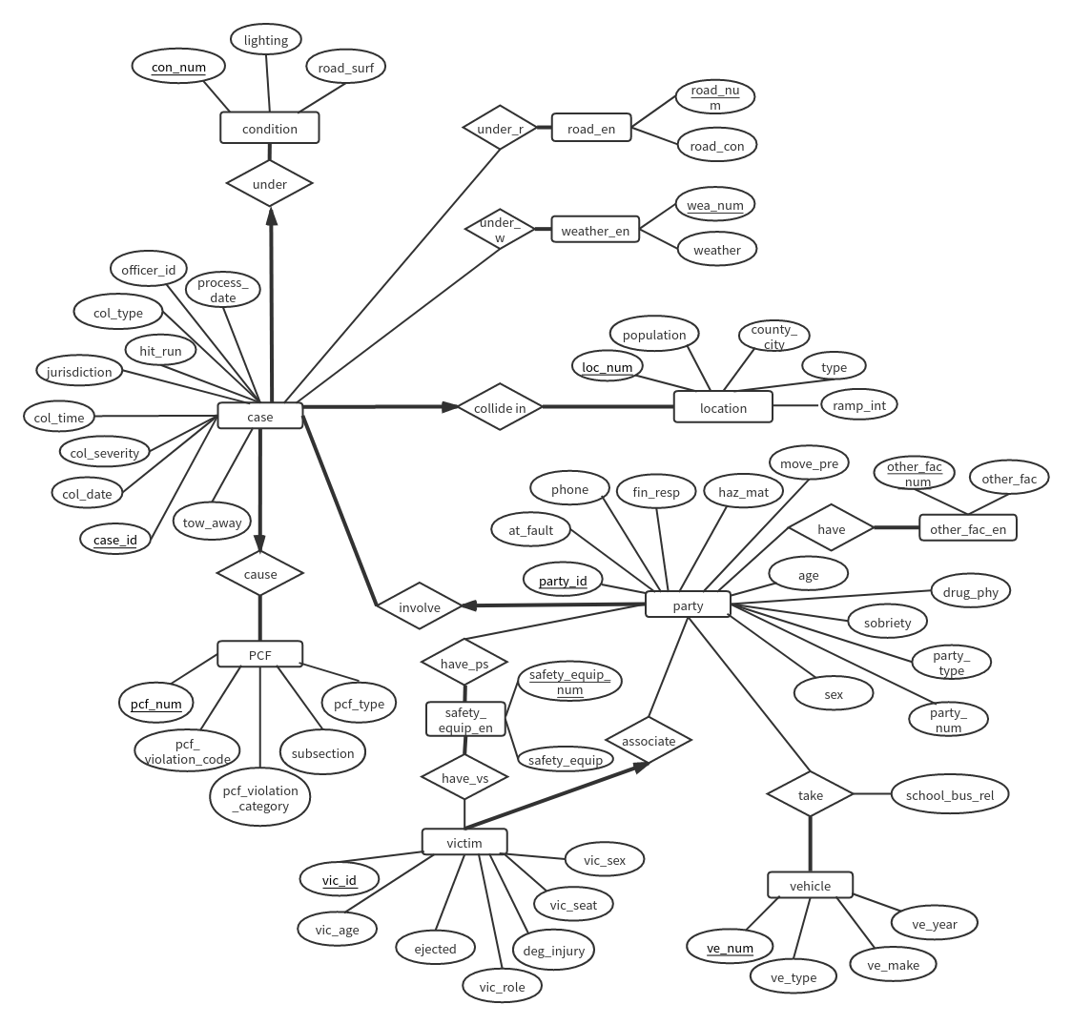

## Assumptions

Based on deliverable 1, we add these assumptions and explanations.

1. We have found that there are duplicates of case_id in the collision2018.csv (6 of them), and since their total number is small, we just removed them. After removing the duplicated terms in case, we have verified that in the parties2018.csv, each “party_num + case_id” corresponds to unique “party_id”. So we consider party as the weak entity of case. In the victims2018.csv, each victim is associated with the specific party by unique “partt_num +case_id”, and we also consider victim as the weak entity of party. Therefore, we merge the “victim-associated_with-party” and “party-involved_in-case” relationship into the tables of victim and party entity to illustrate these constraints.

2. For entities which may appear multiple times (weather, road_condition...), two identical value may appear in both con_1 and con_2 columns, when we encounter this situation, we only record once in the “under_condition”-like tables (relationship between party/case/victim and various condition).

3. We have found that PCF related attributes (pcf_violation, pcf_violation_category, pcf_violation_subsection, parimary_collision_factor) are quite similar and have close connection with each other, so we grouped them into one entity, and each case has exactly one collective PCF (entity) that cause it. To illustrate this total participation of the entity case, we merge the “PCF-cause-case” relationship into the case table.

4. Each case happens under exactly one condition and location, so we delete the “aggregation” in the previous ER model, and merge the “case-under-condition” and “case-collide_in-location” relationship into the case table, to illustrate the total participation.

5. We move the entity “road_en” and “weather_en” from connecting with the entity “condition” to the entity “case” because it is more concise and efficient.

6. We move the attribute “jurisdiction” from the entity “location” to entity ”case” because jurisdiction has little to do with the collision scene.

7. We didn’t change the value of “null”, just dropped them when needed. For example, we don’t consider cases without weather conditions when querying weather and corresponding count of cases.

## Relational Schema

### DDL (UPDATED)

ALTER SESSION SET nls_date_format = 'YYYY-MM-DD HH24:MI:SS'

CREATE TABLE Other_fac_en(

other_fac_num INTEGER,

other_fac VARCHAR2(3),

PRIMARY KEY (other_fac_num)

);

CREATE TABLE Safety_equip_en(

safety_equip_num INTEGER,

safety_equip VARCHAR2(3),

PRIMARY KEY (safety_equip_num)

);

CREATE TABLE Vehicle(

ve_num INTEGER,

ve_type VARCHAR2(50),

ve_make VARCHAR2(20),

ve_year INTEGER,

PRIMARY KEY (ve_num)

);

CREATE TABLE PCF(

pcf_num INTEGER,

pcf_violation_code INTEGER,

pcf_violation_category VARCHAR2(50),

subsection VARCHAR2(3),

pcf_type VARCHAR2(50),

PRIMARY KEY (pcf_num)

);

CREATE TABLE Location(

loc_num INTEGER,

population INTEGER,

county_city INTEGER,

loc_type VARCHAR2(20),

ramp_int VARCHAR2(10),

PRIMARY KEY (loc_num)

);

CREATE TABLE Condition(

con_num INTEGER,

lighting VARCHAR2(50),

road_surf VARCHAR2(10),

PRIMARY KEY (con_num)

);

CREATE TABLE Road_en(

road_num INTEGER,

road_con VARCHAR2(20),

PRIMARY KEY (road_num)

);

CREATE TABLE Weather_en(

wea_num INTEGER,

weather_con VARCHAR2(20),

PRIMARY KEY (wea_num)

);

CREATE TABLE Case(

case_id INTEGER,

loc_num INTEGER NOT NULL,

con_num INTEGER NOT NULL,

pcf_num INTEGER NOT NULL,

col_date DATE,

col_severity VARCHAR2(30),

col_time DATE,

hit_run VARCHAR2(30),

jurisdiction INTEGER,

officer_id VARCHAR2(10),

process_date DATE,

tow_away INTEGER,

col_type VARCHAR2(30),

PRIMARY KEY (case_id),

FOREIGN KEY (loc_num) REFERENCES Location(loc_num),

FOREIGN KEY(con_num) REFERENCES Condition(con_num),

FOREIGN KEY(pcf_num) REFERENCES PCF(pcf_num)

);

CREATE TABLE Party_involve(

party_id INTEGER,

case_id INTEGER NOT NULL,

at_fault INTEGER,

phone VARCHAR2(3),

fin_resp VARCHAR2(3),

haz_mat VARCHAR2(3),

move_pre VARCHAR2(3),

age INTEGER,

drug_phy VARCHAR2(3),

sobriety VARCHAR2(3),

party_type VARCHAR2(15),

party_num INTEGER,

sex VARCHAR2(6),

PRIMARY KEY (party_id),

FOREIGN KEY (case_id) REFERENCES Case(case_id)

);

CREATE TABLE Associate_victim(

vic_id INTEGER,

party_id INTEGER NOT NULL,

vic_age INTEGER,

ejected INTEGER,

vic_role INTEGER,

deg_injury VARCHAR2(50),

vic_seat INTEGER,

vic_sex VARCHAR2(6),

PRIMARY KEY (vic_id),

FOREIGN KEY (party_id) REFERENCES Party_involve(party_id)

);

CREATE TABLE Have (

other_fac_num INTEGER,

party_id INTEGER,

PRIMARY KEY (other_fac_num, party_id),

FOREIGN KEY (party_id) REFERENCES Party_involve(party_id),

FOREIGN KEY (other_fac_num) REFERENCES Other_fac_en(other_fac_num)

);

CREATE TABLE Have_ps(

party_id INTEGER,

safety_equip_num INTEGER,

PRIMARY KEY (party_id, safety_equip_num),

FOREIGN KEY (party_id) REFERENCES Party_involve(party_id),

FOREIGN KEY (safety_equip_num) REFERENCES Safety_equip_en(safety_equip_num)

);

CREATE TABLE Have_vs(

vic_id INTEGER,

safety_equip_num INTEGER,

PRIMARY KEY (vic_id, safety_equip_num),

FOREIGN KEY (vic_id) REFERENCES Associate_victim(vic_id),

FOREIGN KEY (safety_equip_num) REFERENCES Safety_equip_en(safety_equip_num)

);

CREATE TABLE Take(

ve_num INTEGER,

party_id INTEGER,

school_bus_rel VARCHAR2(5),

PRIMARY KEY (ve_num, party_id),

FOREIGN KEY (party_id) REFERENCES Party_involve(party_id),

FOREIGN KEY (ve_num) REFERENCES Vehicle(ve_num)

);

CREATE TABLE Under_r(

case_id INTEGER,

road_num INTEGER,

PRIMARY KEY (road_num, case_id),

FOREIGN KEY (road_num) REFERENCES Road_en(road_num),

FOREIGN KEY (case_id) REFERENCES Case(case_id)

);

CREATE TABLE Under_w(

case_id INTEGER,

wea_num INTEGER,

PRIMARY KEY (wea_num, case_id),

FOREIGN KEY (wea_num) REFERENCES Weather_en(wea_num),

FOREIGN KEY (case_id) REFERENCES Case(case_id)

);

## Data Loading/Cleaning

In “milestone2.ipynb”, we dropped the duplicates of cases and then combine “party_num” and “case_id” in the victims2018.csv to assign “party_id” to each victim. We extracted “road condition”, “weather condition”, “safety equipment”, “other associated factors” (which each case/party/victim may involves two values of them) to independent small tables and created the corresponding relationship tables. We concluded independent “location”, “PCF” and “condition” table from collisions2018.csv, added unique index to them and connected them with case by this index. We combine “collision_date” and “collsion_time” into one column to suit the DATE type in Oracle SQL. Finally we got 17 tables corresponding to the 17 tables of the DLL. We used Oracle EPFL to import our data.

## Query Implementation

**Query 1:**

***Description of logic:***

List the year-number of collisions per year. We use “group by” to group case by year (extracted from col_date) and count the number of cases of each year.

***SQL statement***

SELECT EXTRACT (YEAR FROM col_date) AS YEAR, count(*) AS N_collisions

FROM case

GROUP BY EXTRACT (YEAR FROM col_date)

ORDER BY YEAR ASC

***Query result (if the result is big, just a snippet)***

|  |  |
| --- | --- |
| YEAR | N_COLLISIONS |
| 2001 | 522562 |
| 2002 | 544739 |
| 2003 | 538952 |
| 2004 | 538294 |
| 2005 | 532724 |
| 2006 | 498850 |
| 2007 | 501908 |
| 2017 | 7 |
| 2018 | 21 |

**Query 2:**

***Description of logic:***

In the “take” table, group entries by “ve_make” and count the number of parties of each ve_make, then find the max count and the corresponding ve_make. Before that we need to use ve_number to know the ve_make, so we first join table vehicle and take. To illustrate the whole row of the most popular, we sort the table and take the first row.

***SQL statement***

SELECT *

FROM

(

(SELECT ve_make， COUNT(ve_make) AS N_VEHICLE

FROM (vehicle INNER JOIN take ON vehicle.ve_num = take.ve_num)

GROUP BY ve_make)

ORDER BY N_VEHICLE DESC

)

WHERE ROWNUM = 1

***Query result (if the result is big, just a snippet)***

|  |  |
| --- | --- |
| VE_MAKE | N_VEHICLE |
| FORD | 1129700 |

**Query 3:**

***Description of logic:***

In the lighting attribute of condition, find the description that contains “dark”, and count the fraction of cases that occur in such condition. We count the total number of cases and cases under “dark” lighting, then calculate the fraction.

***SQL statement***

SELECT DISTINCT

CONCAT(ROUND((SELECT COUNT(*) AS c

FROM case, condition

WHERE lighting LIKE '%dark%' AND case.con_num = condition.con_num)*100 /

(SELECT COUNT (*) FROM case), 2),'%') as fraction

FROM condition

***Query result (if the result is big, just a snippet)***

|  |
| --- |
| FRACTION |
| 27.98% |

**Query 4:**

***Description of logic:***

Find the number of collisions that have occurred under snowy weather. We count the number of entries that have weather_con = ‘snowing’ in the table “under_w”

***SQL statement***

SELECT count(*) AS N_collisions

FROM

(SELECT *

FROM under_w, weather_en

WHERE weather_en.wea_num = under_w.wea_num AND weather_en.weather_con = 'snowing')

***Query result (if the result is big, just a snippet)***

|  |
| --- |
| N_COLLISIONS |
| 8530 |

**Query 5:**

***Description of logic:***

Group by collisions by which day they are during a week, and count the total number of collisions of that day, then find the row of highest number of cases. We use TO_CHAR (COL_DATE, 'D') to extract the day of the week.

***SQL statement***

***(We consider grouping and finding the largest row as two tasks )***

***5.a***

SELECT TO_CHAR(COL_DATE, 'D') AS WEEK_DAY, COUNT(*) AS N_COLLISONS

FROM CASE

GROUP BY TO_CHAR(COL_DATE, 'D')

ORDER BY TO_CHAR(COL_DATE, 'D') ASC

***5.b***

SELECT *

FROM

(SELECT TO_CHAR(COL_DATE, 'D') AS WEEK_DAY, COUNT(*) AS N_COLLISONS

FROM CASE

GROUP BY TO_CHAR(COL_DATE, 'D')

ORDER BY COUNT(*) DESC)

WHERE ROWNUM = 1

***Query result (if the result is big, just a snippet)***

***5.a***

|  |  |
| --- | --- |
| WEEK_DAY | N_COLLISIONS |
| 1 | 428287 |
| 2 | 516798 |
| 3 | 535742 |
| 4 | 536068 |
| 5 | 536813 |
| 6 | 614852 |
| 7 | 509497 |

***5.b***

|  |  |
| --- | --- |
| WEEK_DAY | N_COLLISIONS |
| 6 | 614852 |

**Query 6:**

***Description of logic:***

List all weather types and their corresponding number of collisions in descending order of the collisions. We first join the weather_en table with the under_w table to know which case is under which weather condition, then we group cases by weather_con and list weather and the count number.

***SQL statement***

SELECT WEATHER_CON AS WEATHER, COUNT(*) AS COUNT

FROM WEATHER_EN

INNER JOIN UNDER_W

ON WEATHER_EN.wea_num = UNDER_W.wea_num

GROUP BY WEATHER_CON

ORDER BY COUNT(*) DESC

***Query result (if the result is big, just a snippet)***

|  |  |
| --- | --- |
| WEATHER | COUNT |
| clear | 2941037 |
| cloudy | 548249 |
| raining | 223752 |
| fog | 21259 |
| wind | 13952 |
| snowing | 8530 |
| other | 6960 |

**Query 7:**

***Description of logic:***

Count the number of parties that are at-fault, with financial responsibility and loose material. The attributes “at-fault” and “fin_resp” are in the table of party, we can filter them directly, but we need to find the road_num connected with the case from the case_id of party_involve table and the under_r table, then use road_en table to know if the road condition is “road_loose”.

We first extract the road_num of “road_loose”, then join it with the under_r table to find which cases are under such road condition. Then we filter the party_id with its case_id of party_involve table who is at fault and with financial responsibility. Finally we join the two table on the same case_id and count the number of distinct parties.

***SQL statement***

SELECT COUNT(DISTINCT PARTY_ID) AS N_PARTIES

FROM

(SELECT CASE_ID

FROM UNDER_R

INNER JOIN (SELECT ROAD_NUM

FROM ROAD_EN

WHERE ROAD_EN.ROAD_CON = 'loose material') road_loose

ON UNDER_R.ROAD_NUM = road_loose.ROAD_NUM) case_loose

INNER JOIN (SELECT PARTY_ID, CASE_ID

FROM PARTY_INVOLVE

WHERE AT_FAULT = 1 AND FIN_RESP = 'Y') party_atfault

ON case_loose.CASE_ID = party_atfault.CASE_ID

***Query result (if the result is big, just a snippet)***

|  |
| --- |
| N_PARTIES |
| 4803 |

**Query 8:**

***Description of logic:***

Find the median victim age: we directly use the “MEDIAN” function of SQL from the associate_victim table.

Find the most common victim seating position: we group the victims with seating position, and count the number of victims of each vic_seat, order them in the descending order of this number and find the max.

***SQL statement***

***8.a***

SELECT median(vic_age) AS MEDIAN_VIC_AGE

FROM associate_victim v2;

***8.b***

SELECT vic_seat AS MOST_COMMON_SEAT_POSITION

FROM

(SELECT COUNT(vic_seat) AS count, vic_seat

FROM associate_victim v2

GROUP BY vic_seat

ORDER BY count DESC)

WHERE rownum = 1;

***Query result (if the result is big, just a snippet)***

***8.a***

|  |
| --- |
| MEDIAN_VIC_AGE |
| 25 |

***8.b***

|  |
| --- |
| MOST_COMMON_SEAT_POSITION |
| 3 |

**Query 9:**

***Description of logic:***

Fraction of all participants (victims + parties) that have been victims using a belt. All participants refer to both parties and victims, so our denominator is the sum of number of all victims and parties. We first extract the vic_ids who use belt using table have_vs and safety_equip_en. Then we count the unique vic_ids and use this number as the numerator. Finally we get the fraction and format it to percentage.

***SQL statement***

SELECT CONCAT(ROUND(a.fraction*100.0,2),'%') AS fraction

FROM(SELECT DISTINCT

(SELECT COUNT(vic_id) AS count

FROM

(SELECT h1.vic_id as vic_id

FROM have_vs h1, safety_equip_en s1

WHERE h1.safety_equip_num = s1.safety_equip_num

AND s1.safety_equip like '%C%') v_belt)/

((SELECT COUNT(party_id) FROM party_involve)

+(SELECT COUNT(vic_id) FROM associate_victim)) as fraction

FROM party_involve) a

***Query result (if the result is big, just a snippet)***

|  |
| --- |
| FRACTION |
| 1.06% |

**Query 10:**

***Description of logic:***

Compute the fraction of collisions happening for each hour of the day, and display as ratio as percentage for all the hours of the day. We first use cast(col_time as timestamp) to extract the hour in which the case occurred. Then we group the cases by the specific hour and count the number of the cases, then order them by the number. We also calculate the total number of the cases. Then we divide the count number of each hour by the total number to get each percentage.

***SQL statement***

SELECT h_count.hour, CONCAT(ROUND((h_count.count/sum_count.sum*100.0),2),'%') AS fraction

FROM(SELECT

DISTINCT EXTRACT(hour from cast(col_time as timestamp)) as hour, count(*) as count

FROM case

GROUP BY EXTRACT(hour from cast(col_time as timestamp))

ORDER BY hour ASC) h_count,

(SELECT sum(h_count.count) AS sum

FROM

(SELECT

DISTINCT EXTRACT(hour from cast(col_time as timestamp)) as hour, count(*) as count

FROM case

GROUP BY EXTRACT(hour from cast(col_time as timestamp))

ORDER BY hour ASC) h_count) sum_count

***Query result (if the result is big, just a snippet)***

|  |  |
| --- | --- |
| HOUR | FRACTION |
| 0 | 1.91% |
| 1 | 1.83% |
| 2 | 1.81% |
| 3 | 1.15% |
| 4 | 0.98% |
| 5 | 1.45% |
| 6 | 2.62% |
| 7 | 5.17% |
| 8 | 5.23% |
| 9 | 4.09% |
| 10 | 4.23% |
| 11 | 4.89% |
| 12 | 5.78% |
| 13 | 5.78% |
| 14 | 6.55% |
| 15 | 7.75% |
| 16 | 7.33% |
| 17 | 7.91% |
| 18 | 6.30% |
| 19 | 4.43% |
| 20 | 3.49% |
| 21 | 3.28% |
| 22 | 2.86% |
| 23 | 2.38% |
| (null) | 0.81% |

## General Comments

Is it better to combine “condition” into the case? For it has only two attributes now. We found that we may need more join operations based on this design, is it normal?

We found that TIME type will lead to error in query (in Oracle SQL) so we use DATE type. There are also other types like timestamp/datetime and so on, so we don’t know if this type is the best choice.