Analysis protocol:

Measuring of Dia-GFP membrane to cytoplasm ratio

- Open the .czi image file (with high resolution XY=0.1 µm) z-stack; make “Composite” image by Channel tool, so that green and red channels are shown simultaneously.

- Draw line ROIs across single outer membranes of the macrophages using “Straight line” with width of 8 pixels and length about 7-9 µm (>=3 µm outside the cell and >=2 µm inside the cell). Drawing direction from outside the cell into the cell interior.
After drawing each ROI press “Ctrl+T” (or “Command+T” in MacOS) to add it to the ROI manager (there is also a button called “Add” in the ROI Manager).
All your line ROIs should be listed in the ROI Manager. Tick “Show all”.
Better to choose membranes which look thin but bright in red channel. Draw several (2-5) lines in one cell; analyze all slices of the z-stack, but not deep if green signal is low: ~ 10 slices (=up to 25 µm deep into the embryo)

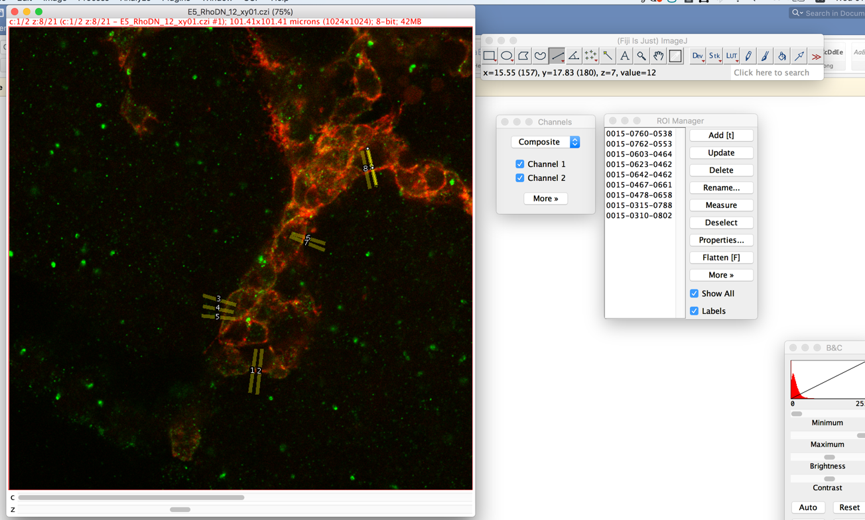

Save ROIs by clicking More>Save in ROI Manager. Save zip of all ROIs.
To open saved click “open” in ROI Manager, and choose ROIs.zip.

- Open macro “Macro_profiles_2_channels_to_txt.ijm” by clicking on it.
Press Run button in window containing macro. Press OK in “Please draw all ROIs” window or draw more ROI and click OK.
Macro will plot line profiles – first red channel 1, then green channel 2 – and save two columns (distance in µm, intensity) in a separate file named 1{ROInumber}.txt and put it in a new folder inside the folder with the source image file. It closes all profiles windows in the end.

- Open “Analyse_ratio_memb_cyto.m” script in Matlab and go inside MATLAB to the folder with .txt files you want to analyze. Run the script. Script finds membrane by a peak in the red channel, substracts extracellular background from the green profile and calculates GFP average intensity on the membrane divided by GFP average intensity in 2 µm of cytoplasm.
It will plot all profiles in magenta/green and display in red profiles, eliminated from analysis if they don’t satisfy quality conditions (green signal is too low or has too high peaks due to speckles, background is higher than cytoplasm levels, membrane signal is too wide).
Original GFP profile is plotted by dashed green line, with substructed background – by solid greed. Black line represents mean background level.
Mean GFP intensity inside membrane in a cytoplasm is plotted by blue line.

- Script produces 3 txt files in the same folder:
“Results_mem_to_cyto_ratio.txt” with the column of membraneGFP/cytoplasmicGFP ratios for each profile. For eliminated profiles value is NaN.
“Results_column.txt” which contains only number values (to copy to Prism, Excel),
and “Mean_SD.txt”

- Look through all profiles to check the profiles which were eliminated by the script. If needed, run the script again. To close all graphs type in Command Window: >>“Close all” and press Enter.

