Numero de parte | Nombre de parte | Descripcion del componente | Imagen del componente | Links de compra
#1 | 6x1F-H8.5 | PIN HEADER | 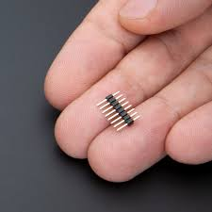 | 1-https://www.amazon.com/5-pin-header/s?k=5+pin+header  2-https://www.mikroe.com/1x8-male-header-15mm-pitch?srsltid=AfmBOoriKGQfYETwhXKCwRH28r2w9c_2XfeashXKEDHFpy14UOI0Nop_  3-https://www.jameco.com/shop/keyword=5-Pin-Header-Connector?srsltid=AfmBOori2xhgkPNE7EwdTvD539YYSUCYlE7kUmIJLQT4emHVRDbGKEk1
#2 | 100n | CAPACITOR, European symbol | 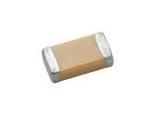 | 1-https://uelectronics.com/categoria-producto/smd/pasivos-smd/capacitores-smd/?srsltid=AfmBOorAuJ16S8VQNhQM4LAy4WW7zb5gqP2piLTz9hSYceqI5bEFl9dd  2-https://hetpro-store.com/capacitor-ceramico-0.1uf-1206-100nf-50v/?srsltid=AfmBOoog_zwHG6gOyuOoazeHilRsPgG17Topod6dymkDfUj4JfWSC35X  3-https://aelectronics.com.mx/home/2142-capacitor-ceramico-smd-1206-100nf-25v.html
#3 | 1u | CAPACITOR, European symbol | 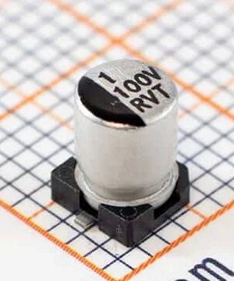 | 1-https://www.mouser.mx/c/passive-components/capacitors/ceramic-capacitors/mlccs-multilayer-ceramic-capacitors/multilayer-ceramic-capacitors-mlcc-smd-smt/?capacitance=1%20uF&case%20code%20-%20in=0201&dielectric=X5R&srsltid=AfmBOorYJgMUMYXni0_FHgC-6O6wEOfxU0JclRMOUV1GeMwxWAL6UBYG  2-https://uelectronics.com/producto/capacitor-electrolitico-1uf-100v-smd/?srsltid=AfmBOooLi6FWcHY7ay3G47nHZj5hYd4nQiIRmWogqzohBC43FpaFfhOx  3-https://syscom.mx/products/161742
#4 | Capacitor 100nF +/-20% 25V 0402 | Chip Capacitor, 100nF +/-20%, 25V, 0402, Thickness 0.6 mm | 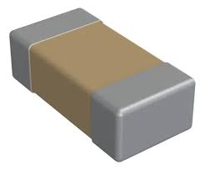 | 1-https://www.mouser.mx/c/passive-components/capacitors/ceramic-capacitors/mlccs-multilayer-ceramic-capacitors/multilayer-ceramic-capacitors-mlcc-smd-smt/?capacitance=0.1%20uF&case%20code%20-%20in=0402&voltage%20rating%20dc=25%20VDC&srsltid=AfmBOoqIywgLyIxWiSkNz3OKEEgP2BswhC9KIN78H7NDWrt3xYc86Y9L  2-https://www.amazon.com.mx/Condensador-chip-piezas-MLCC-100nf/dp/B09BFB2YLB  3-https://www.mouser.mx/c/passive-components/capacitors/ceramic-capacitors/mlccs-multilayer-ceramic-capacitors/multilayer-ceramic-capacitors-mlcc-smd-smt/?case%20code%20-%20in=0402&srsltid=AfmBOopga7kFsHwmHZ3geXCmMbAZbUEZLSSuI7UBKoWxmDOwqWK8B0M1
#5 | M7 | DIODE | 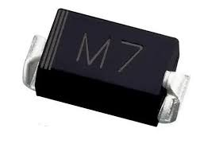 | 1- https://agelectronica.com/detalle?busca=1N%204007-M7  2- https://www.digikey.com.mx/es/products/detail/diotec-semiconductor/M7/13155808?srsltid=AfmBOoqxBDteIcsCt4dvtJwU2ZN7XCd2UBPGiQ8hZx_vQSm2nonLToQy  3- https://listado.mercadolibre.com.mx/diodo-m7
#6 | CD1206-S01575 | DIODE | 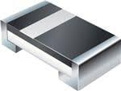 | 1- https://www.mouser.mx/ProductDetail/Bourns/CD1206-S01575?qs=FITO%2F%2FQgYDlGQsqciGRLTg%3D%3D&srsltid=AfmBOoq4eglvs0CvskeKI36s-mQv8exKVmlzXLpE_LQdccFpwyTEu0Cx  2- https://www.digikey.com/en/products/detail/bourns-inc/CD1206-S01575/3741981  3- https://docs.rs-online.com/7b0a/A700000006416241.pdf
#7 | MF-MSMF050-2 500mA | INDUCTOR, European symbol | 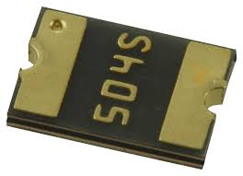 | 1- https://www.mouser.mx/ProductDetail/Bourns/MF-MSMF050-2?qs=t3shhpq1i1DZ7OBD5kLNoA%3D%3D&srsltid=AfmBOoqVRyrjp5kg-CmLw7pU-NxJ66vJypUCL2VmPUmO1THhheuN6wpM  2- https://www.digikey.com.mx/es/products/detail/bourns-inc/MF-MSMF050-2/662816?srsltid=AfmBOorjbgpsmrHH-4T0cmbAkyocKLFAfzvUk0z_f-A42yZlZviyNbVx  3- https://mexico.newark.com/bourns/mf-msmf050-2/fuse-ptc-reset-15v-500ma-1812/dp/02J2718?srsltid=AfmBOooJDjzThnU8t3EQ1SgSkbfAvk76E0ki6wYLY_s92929rj8Iqgnv
#8 | 3x2 M | PIN HEADER | 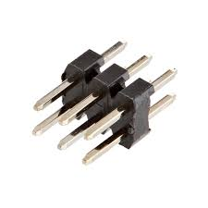 | 1-https://www.digikey.com/en/products/filter/rectangular-connectors/headers-male-pins/314  2-https://www.sparkfun.com/shrouded-header-pth-0-1in-2x3-pin.html
#9 | 10x1F-H8.5 | PIN HEADER | 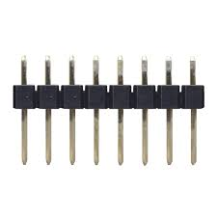 | 1-https://www.laserlance.com/wp-content/uploads/2018/11/Arduino_Mega_DAC_V1.0.4_BOM.pdf  2-https://www.mouser.mx/c/n/connectors/mil-spec-mil-type/rectangular-mil-spec-connectors/?contact%20gender=Pin%20%28Male%29&contact%20plating=Gold&mounting%20angle=Right%20Angle&product=Headers&srsltid=AfmBOop84QLDyydQ9rVb6ZlCg06wjCMnArNAxpAt7friA_5TbcguQMfY  3-
#10 | 8x1F-H8.5 | PIN HEADER | 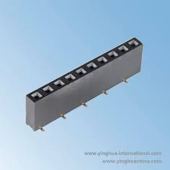 | 1-https://encrypted-tbn0.gstatic.com/shopping?q=tbn:ANd9GcQvgWA59tsNHLWRldwnuXoHdNpi3spRR1gnEK9EgPulOue74ItJa38KsGSqEaH6b5txMn68faAGN21jgroWizeChVdjFww2lNm_d6tELZT17aE6vIAjMZXc  2-https://www.laserlance.com/wp-content/uploads/2018/11/Arduino_Mega_DAC_V1.0.4_BOM.pdf
#11 | PJ-102A | PJ-102A 2.0 x 6.5 mm, 2.5 A, Horizontal, Through Hole, Tapered Pins, Dc Power Jack Connector | 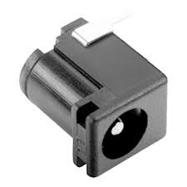 | 1-https://octopart.com/part/same-sky/PJ-102A  2-https://www.mouser.com/ProductDetail/Same-Sky/PJ-102A?qs=WyjlAZoYn50UKjtnxOz%252Bqg%3D%3D&srsltid=AfmBOopg1OazYWjpbiH265g9H3MhPdNdFzWkOXikG0Tkb990IUG6I4Yd  3-https://www.digikey.com/es/products/detail/same-sky-formerly-cui-devices/PJ-102A/275425
#12 | 897-43-004-90-000000 | CONN RCPT USB2.0 TYPEB 4POS R/A | 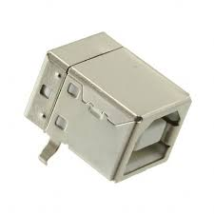 | 1-https://www.digikey.com.mx/es/products/detail/w%C3%BCrth-elektronik/61400416021/2060602?srsltid=AfmBOorrdnQ22CuuJaeIIDQTWgMzGib3tez0aHM-WioZPo3OqlVVR4Ns  2-https://www.digikey.com.mx/es/products/detail/te-connectivity-amp-connectors/292303-1/773786?srsltid=AfmBOoo2YAFZ07V64o2e9wygqVk6vSYS4CldX-uAMs8igM5aQlt7Z_lG  3-https://www.digikey.com.mx/es/products/detail/keystone-electronics/924/317303?srsltid=AfmBOorj_Dd1A3Kh-YXHLsW4grEwr9OL7pGE0xpGBiTsM_GxqA6nXHqz
#13 | BLM21 | SMD EMI Suppression Ferrite Beads - excellent anti-EMI properties - low DCR - impedances till 3000 ohms - rated current up to 6 A | 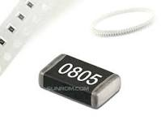 | 1-https://www.digikey.com/en/products/detail/kemet/L0805C100MDWLT/3674046  2-https://www.mouser.mx/c/passive-components/inductors-chokes-coils/power-inductors-smd/?inductance=10%20uH&termination%20style=SMD%2FSMT&srsltid=AfmBOor2l8tL7XdwBEm7lTbPsc5joY_t_0bE8Yd5roYGfT_ZyFFQHKDO  3-https://hetpro-store.com/cmi201209x100kt/?srsltid=AfmBOookySKLs4i5yWDiUjHq_Zx-QD1E-eaLXnqbuOOGXz7DIuGh-l_K
#14 | 10uH | 10uH 0805 |  | 1-  2-  3-
#15 | YELLOW | LED OSRAM | 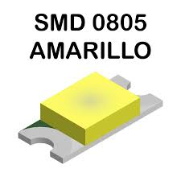 | 1-https://hetpro-store.com/led-smd-amarillo/?srsltid=AfmBOoqbAYCXkRr_9UmOF5sadWsNcRokdkiXuf0erOQSL3besk3weGCk  2-https://mvelectronica.com/producto/led-amarillo-smd-superficial-0805-2-1v-2-3v-de-20ma-a-590nm?srsltid=AfmBOord0QMuNl6WddTm60B7m2S2v9jVb3Ls5YJcLgLZQlNXfgxVMChr  3-https://uelectronics.com/producto/led-amarillo-smd-0805-ncd0805y1/?srsltid=AfmBOopFyt7UWP0N3r9mbXz5t5QvgKkWeof7iJi_USXLnS6i5Otn-sFz
#16 | GREEN | LED OSRAM | 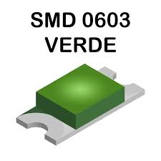 | 1-https://mexico.newark.com/multicomp-pro/mcl-s250gc/led-green-1-6mm-x-2mm-10mcd-570nm/dp/14N9349?srsltid=AfmBOorqk6AXZIHtFHvKCdj34CHHJgtNgrtyHXYGDgta8RbSfmlTABhB  2-https://mvelectronica.com/producto/led-verde-smd-superficial-1206-2-9v-3-0v-de-5ma-a-525nm?srsltid=AfmBOoofw39v5IMInuMFPF13y5P7-Y-VcbD_Y0zfYZIJCAtN6iXOuKUj  3-https://agelectronica.com/detalle?busca=LED-G5050-B-F120
#17 | 47u | POLARIZED CAPACITOR, European symbol | 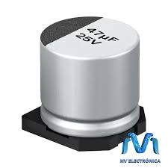 | 1-https://www.agelectronica.com/detalle.php?p=CEMS-47/16V  2-https://uelectronics.com/producto/capacitor-electrolitico-47uf-16v-smd/?srsltid=AfmBOoo5k_9B-EBvsb-bcvt3DrCVJLI2k4w9p5Ctrr3_OoNZ85-1iRMD  3-https://www.mouser.mx/c/passive-components/capacitors/aluminum-electrolytic-capacitors/aluminum-electrolytic-capacitors-smd/?capacitance=47%20uF&voltage%20rating%20dc=35%20VDC&srsltid=AfmBOooDjxAEkC4a8GPCAHC7kg5vdBanl4t2llQObpnPi3pDouZmvIHK
#18 | 1M | RESISTOR, European symbol | 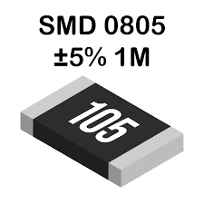 | 1-https://mvelectronica.com/producto/1m-ohms-resistencia-smd-0805-de-125mw?srsltid=AfmBOorynwKK724odeq53-AM6SVCSNw3SnkWpeN1pNuJSA_5j0W-QtCX  2-https://uelectronics.com/producto/resistor-1m-ohm-1-4w-smd-1206-rtt06105jtp/?srsltid=AfmBOorLtt5_NlDsSMiti8aJERTaqRl2BMIsQQR9AfhaFjU53XgUi55T  3-https://agelectronica.com/detalle?busca=RMS-1M
#19 | TS42031-160R-TR-7260 | TS42 Dongnan Electronics Tact switch VDC 12V - 50mA | 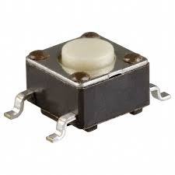 | 1-https://www.snapeda.com/parts/LX7188ILU-TR/Microchip%20Technology/view-part/  2-https://www.mouser.com/ProductDetail/Mountain-Switch/101-0164-EV?qs=MT0krMERVQ7Vi%2FwDih1Rbw%3D%3D&srsltid=AfmBOoqY0VJfWqp6_XTkl2TzfmrTdDP3e4GB9rhacVPh7ogA_rTdnYj8
#20 | SJ | SMD solder JUMPER | 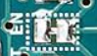 | 1-  2-  3-
#21 | 10K | Array Chip Resistor | 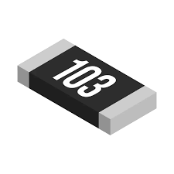 | 1-https://agelectronica.com/detalle?busca=RMS-10K  2-https://uelectronics.com/producto/resistor-10k-ohm-1-8w-smd-0805-0805w8f2202t5e/?srsltid=AfmBOorOzgzbW0gOR49gNZvE4jLj5Akw23ORUoJAsSh7qOUVEsF8r8dH  3-https://uelectronics.com/producto/resistor-10k-ohm-1-10w-smd-0603-rc0603fr-0710kl/?srsltid=AfmBOoqoWCrt4QrP5aADPiwZoGdOc_-BZsB7RpHG29qpw-8qxKzwJBmd
#22 | 1K | Array Chip Resistor | 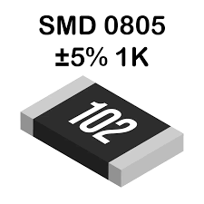 | 1- https://www.mouser.mx/c/passive-components/resistors/smd-resistors-chip-resistors/?q=1k%20ohm%20resistor&srsltid=AfmBOoojzgtA7Llo_7haIxbnCmMD4MWGZfNxDGK5PlFvjz7uRQLfwlj5  2- https://mvelectronica.com/producto/1k-ohms-resistencia-smd-0805-de-125mw?srsltid=AfmBOophiYhpGzgxIxIkp9MsL9qT27aisl6Rn1_hzm7IyNB6SQsUa3yz  3- https://uelectronics.com/producto/resistor-1k-ohm-1-8w-smd-0805-0805w8f4701t5e/?srsltid=AfmBOoo5so23JMbCx2qDD3CjKfQRidgxVu4TpCmPl596vT5OlRJwPQhl
#23 | 22R | Array Chip Resistor | 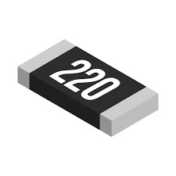 | 1- https://www.ideaelectronica.mx/1206-1-8w/8953-rms-22k-resistencia-smd-22-kohm-1-8w-1206.html  2- https://mvelectronica.com/producto/22-ohms-resistencia-smd-1206-de-250mw?srsltid=AfmBOoruvXgpqUJjbTPtjPJcvItbl7rTHcEr_ZUF_ZZ77hnNNnlNJeLj  3- https://www.mouser.mx/c/passive-components/resistors/?resistance=22%20Ohms&termination%20style=SMD%2FSMT&srsltid=AfmBOooQQ6IvyotUbTTk8RcN-BHjoJC32fkcb8pPp6k0QE1hYQYitmOd
#24 | FDN340P | MOS FET | 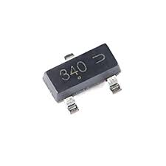 | 1- https://www.mouser.mx/ProductDetail/onsemi/FDN340P?qs=AMp2PTjoga9dhzFXRaqTZw%3D%3D&srsltid=AfmBOoqhKaOiGLlRmep23yuAASfmTwdBXj514mHot4GOZmFLEBhgSGPd  2- https://www.digikey.com.mx/es/products/detail/onsemi/FDN340P/965304?srsltid=AfmBOooTHrAPmGyWRay_U-t2gpQfnkoZmZ-8I4f2MSL9ZD_M8OkDEw1n  3- https://alltransistors.com/es/mosfet/transistor.php?transistor=1690
#25 | NCP1117ST50T3G | Adjustable Output Low Dropout Voltage Regulator 800 mA | 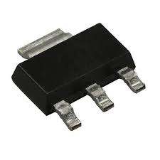 | 1- https://www.mouser.mx/ProductDetail/onsemi/NCP1117ST50T3G?qs=Gev%252BmEvV0ib6dijy6U0dhQ%3D%3D&srsltid=AfmBOopex-E12_88RPCUFRtBkumky9T3UBxTEl6WUzfQIGF1tbQ955oY  2- https://www.digikey.com.mx/es/products/detail/onsemi/NCP1117ST50T3G/921289?srsltid=AfmBOoo5z9_7J5yuTZ3EV7w8n8yVve-abODw8_8YTI27AYuWEpwjHMHd  3- https://www.onsemi.com/pdf/datasheet/ncp1117-d.pdf
#26 | LP2985-33DBVR | ULTRALOW-POWER 50-mA LOW-DROPOUT LINEAR REGULATORS 50-mA Low-Dropout Regulator | 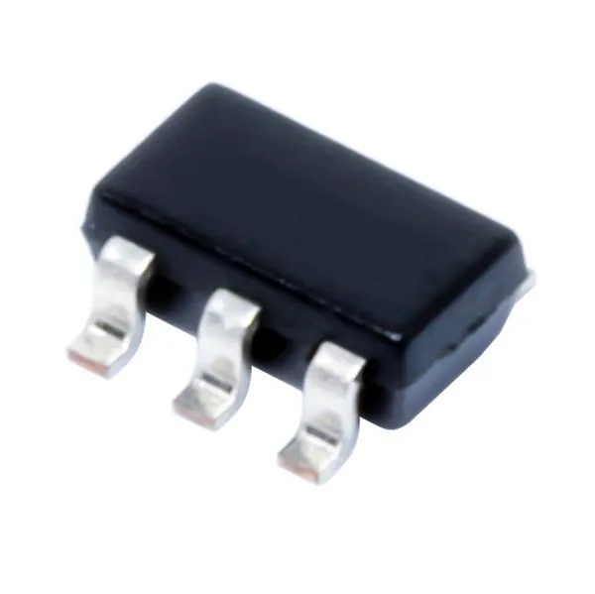 | 1- https://www.mouser.mx/ProductDetail/Texas-Instruments/LP2985-33DBVR?qs=paYhMW8qfiswyUdMjD%2FxlQ%3D%3D&srsltid=AfmBOoqZoP85R_PToHfr3E0J8HJOcvjTEwS5lQ_2Os1MMd5BVem93ZLJ  2- https://www.ti.com/product/es-mx/LP2985/part-details/LP2985-33DBVR  3- https://www.digikey.com.mx/es/products/detail/texas-instruments/LP2985-33DBVR/809759?srsltid=AfmBOorrbcouz7NfQ8lx5aHCb3IYs--YcO_IAhPr0KsGK28Lk5eIwAI4
#27 | LMV358IDGKR | Dual General Purpose, Low Voltage, Rail-to-Rail Output Operational.com/dt/lmv_qual.pdf | 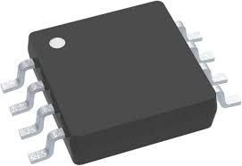 | 1- https://www.digikey.com.mx/es/products/detail/texas-instruments/LMV358IDGKR/486369?srsltid=AfmBOorNlZMg6P48uA59ogaO_ibiJQo80SofzRnHnNWlDrdnCV41fsqG  2- https://www.mouser.mx/ProductDetail/Texas-Instruments/LMV358IDGKR?qs=rgxfVHSNRPXxzk3brtXqQw%3D%3D&srsltid=AfmBOoqg5PQNOY3_ZDx8x5E2XlmWmcAQJrTwrG4090Z-YV9JvL6TqN0q  3- https://www.ti.com/product/es-mx/LMV358/part-details/LMV358IDGKR
#28 | CH340C | USB to serial chip CH340 | 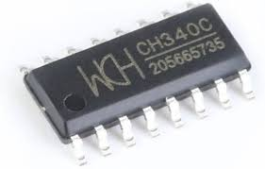 | 1- https://uelectronics.com/producto/ch340c-usb-a-serial-c84681/?srsltid=AfmBOopWahd-O9EJrRq2J6b2UvrqqrOUuolEFiAzyNroB1edntI6l7n6  2- https://hetpro-store.com/ch340c/?srsltid=AfmBOooC5Uo9w1iaKTa5cj6GrODDhe8zL9cjQqrXGn6oufw-mHgAvPTM  3- https://mvelectronica.com/producto/circuito-integrado-ch340c-usb-a-uart-c84681?srsltid=AfmBOookT7NwN8EV0HaR-BjLma3-hro1PQL0J13QenN7nfo3yXWFpKjn
#29 | CSTCE16M0V53-R0 16MHZ | Reloj de 16 Mhz con doble capacitor | 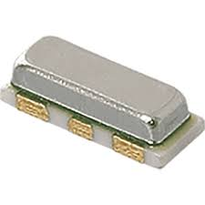 | 1- https://www.digikey.com.mx/es/products/detail/murata-electronics/CSTCE16M0V53-R0/584406?srsltid=AfmBOooQ6dn0lDRwgaM_VaeMKbyNAWYF2Mw43n37IHjljUKr5L0LJE7F  2- https://www.mouser.mx/ProductDetail/Murata-Electronics/CSTCE16M0V53-R0?qs=HPA2Xx%252BU0WhPWbRcNuzhZw%3D%3D&srsltid=AfmBOop1CS0Wu46lYnRqkSVqhFA22dmLC-setXdnVDO6WwBN9m8nkXDo  3- https://www.tme.com/mx/es/details/cstce16m0v53-r0/filtros-y-osciladores-ceramicos-smd/murata/
#30 | CG0603MLC-05E | VARISTOR | 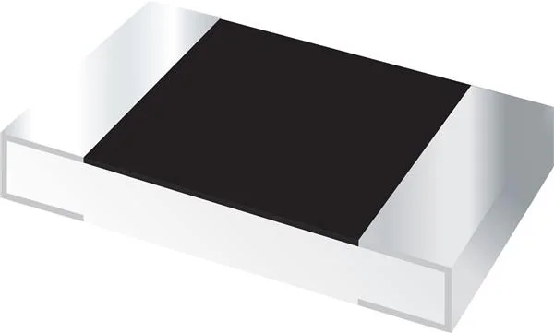 | 1- https://agelectronica.com/detalle?busca=CG0603MLC-05E%2A  2- https://www.mouser.mx/ProductDetail/Bourns/CG0603MLC-05E?qs=lDok7oSghXVLNKMK69q%252BFQ%3D%3D&srsltid=AfmBOorDajKoHqNXo80OtRLqLyxcXpIKca4GUlKPoK8pfHHyeA99mVbq  3- https://www.digikey.com.mx/es/products/detail/bourns-inc/CG0603MLC-05E/2538084?srsltid=AfmBOooQHOqJzKzgMr3GLS9AAlHYoBvHG_x8PjxhPfLn4LQMXxsG3vJB
#31 | ATMEGA328P-PU | MICROCONTROLLER 4 Kbytes FLASH 128 bytes SRAM 256 bytes EEPROM UART 6-channel 10 bit ADC | 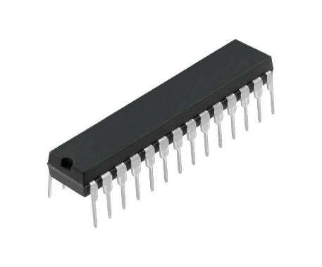 | 1- https://www.steren.com.mx/microcontrolador-atmega-328p-pu.html?srsltid=AfmBOoqWp0-u-u1CG4h3Xg0jYv-fB5SXbo3ZvJ-6ccdhkmqxlvkqkSIh  2- https://uelectronics.com/producto/atmega328p-pu-microcontrolador-8-bits-dip-28/?srsltid=AfmBOoqxdp4BAn6PUwvxB-8wLZlIQ8f4rNFqucHZNqa9qA8R2AbmLHzE  3- https://agelectronica.com/detalle?busca=ATMEGA328P-PU

