1. 答：

a) 任意多个a或b拼接ac的结构重复1次以上的串

b) 所有首尾符号相同的01串

1. 答：

a）/*([^*"]* | ".*" | *+[^/])****/

b) 即有偶数个1的01串 (0∗10∗1)∗0∗

1. 答：

a)

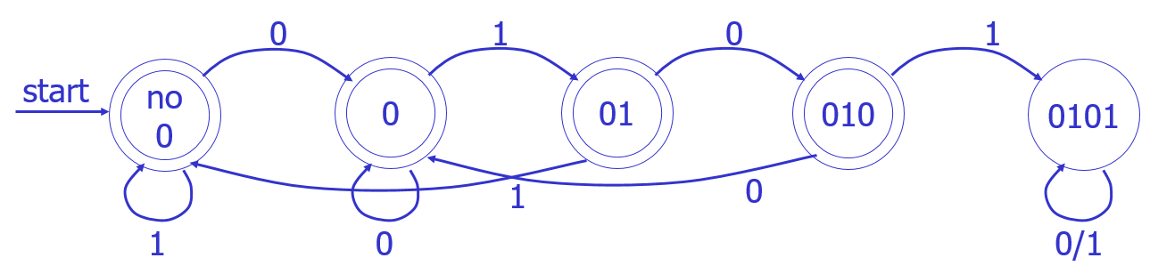

b)

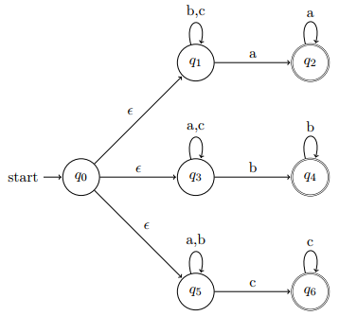

1. 答：

只需将文件名表达式允许的所有操作符用正规式表示出来即可

‘s’——“s”

\c——\c

*——.*

?——.

[s]——[s]

1. 答：



识别abbbaba过程：0🡪1🡪2🡪3🡪6🡪1🡪4🡪5🡪6🡪7🡪8🡪9🡪10🡪11🡪14🡪15🡪16🡪11

🡪12🡪13🡪16🡪17

1. 答：

_closure({0})={0, 1, 2, 4, 7}=A

A, a_closure(({0, 1, 2, 4, 7}, a))={1, 2, 3, 4, 6, 7}=B

A, b_closure(({0, 1, 2, 4, 7}, b))={1, 2, 4, 5, 6, 7, 8}=C

B, a_closure(({1, 2, 3, 4, 6, 7}, a))={1, 2, 3, 4, 6, 7}=B

B, b_closure(({1, 2, 3, 4, 6, 7}, b))={1, 2, 4, 5, 6, 7, 8}=C

C, a_closure(({1, 2, 4, 5, 6, 7, 8}, a))={1, 2, 3, 4, 6, 7}=B

C, b_closure(({1, 2, 4, 5, 6, 7, 8}, b))={1, 2, 4, 5, 6, 7, 8, 9}=D

D, a_closure(({1, 2, 4, 5, 6, 7, 8, 9}, a))={1, 2, 3, 4, 6, 7, 10, 11, 12, 14, 17}=E

D, b_closure(({1, 2, 4, 5, 6, 7, 8, 9}, b))={1, 2, 4, 5, 6, 7, 8, 9}=D

E, a_closure(({1, 2, 3, 4, 6, 7, 10, 11, 12, 14, 17}, a))={1, 2, 3, 4, 6, 7, 11, 12, 13, 14, 16, 17}=F

E, b_closure(({1, 2, 3, 4, 6, 7, 10, 11, 12, 14, 17}, b))={ 1, 2, 4, 5, 6, 7, 8, 11, 12, 14, 15, 16, 17}=G

F, a_closure(({1, 2, 3, 4, 6, 7, 11, 12, 13, 14, 16, 17}, a))=F

F, b_closure(({1, 2, 3, 4, 6, 7, 11, 12, 13, 14, 16, 17}, b))=G

G, a_closure(({1, 2, 4, 5, 6, 7, 8, 11, 12, 14, 15, 16, 17}, a))=F

G, b_closure(({1, 2, 4, 5, 6, 7, 8, 11, 12, 14, 15, 16, 17}, b))= { 1, 2, 4, 5, 6, 7, 8, 9, 11, 12, 14, 15, 16, 17}=H

H, a_closure(({1, 2, 4, 5, 6, 7, 8, 9, 11, 12, 14, 15, 16, 17}, a))={1, 2, 3, 4, 6, 7, 10, 11, 12, 13, 14, 16, 17}=I

H, b_closure(({1, 2, 4, 5, 6, 7, 8, 9, 11, 12, 14, 15, 16, 17}, b))=H

I, a_closure(({1, 2, 3, 4, 6, 7, 10, 11, 12, 13, 14, 16, 17}, a))=F

I, b_closure(({1, 2, 3, 4, 6, 7, 10, 11, 12, 13, 14, 16, 17}, a))=G



识别abbbaba过程：A🡪B🡪C🡪D🡪D🡪E🡪G🡪F

1. 答：

a将前者分裂为{A, B, C}和{D}，b将前者分裂为{A, B}和{C}，至此不可再分



1. 答：

M——人，W——狼，S——羊，C——白菜，

状态——哪些东西在原岸，如：MWS，表示人、狼、羊在原岸（白菜在目的岸）

动作——人将一样东西摆渡到对岸（原🡪目的——表示为🡪，也可能是目的🡪原——表示为🡨）

不满足要求的状态为死状态，如：WS、SC、…

初态：MWSC，终态：，初态到终态的一条路径——渡河方案。

(MWSC, 🡪MW) = SC （红色表示死状态）

(MWSC, 🡪MS) = WC

(MWSC, 🡪MC) = WS

(MWSC, 🡪M) = WSC

(WC, 🡨MW) = MWSC （蓝色表示出现过的状态）

(WC, 🡨M) = MWC

(WSC, 🡨M) = MWSC

(MWC, 🡪MW) = C

(MWC, 🡪MC) = W

(MWC, 🡪M) = WC

(C, 🡨MW) = MWC

(C, 🡨MS) = MSC

(C, 🡨M) = MC

(W, 🡨MS) = MWS

(W, 🡨MC) = MWC

(W, 🡨M) = MW

(MSC, 🡪MS) = C

(MSC, 🡪MC) = S

(MSC, 🡪M) = SC

(MWS, 🡪MW) = S

(MWS, 🡪MS) = W

(MWS, 🡪M) = WS

(S, 🡨MW) = MWS

(S, 🡨MC) = MSC

(S, 🡨M) = MS

(MS, 🡪MS) =  终态！

(MS, 🡪M) = S

状态转换序列：MWSC→WC→MWC→C→MSC→S→MS→

动作序列：🡪MS，🡨M，🡪MW，🡨MS，🡪MC，🡨M，🡪MS