Assignment #03

1. Consider the following network:



1. Show the distance tables at each node after the initialization phase of the distance vector (DV) algorithm, using the **poison reverse**.

Table X:

|  |  |  |  |
| --- | --- | --- | --- |
|  | x | y | z |
| x | 0 | 3 | 120 |
| y | ∞ | ∞ | ∞ |
| z | ∞ | ∞ | ∞ |

Table Y:

|  |  |  |  |
| --- | --- | --- | --- |
|  | x | y | z |
| x | ∞ | ∞ | ∞ |
| y | 3 | 0 | 2 |
| z | ∞ | ∞ | ∞ |

Table Z:

|  |  |  |  |
| --- | --- | --- | --- |
|  | x | y | z |
| x | ∞ | ∞ | ∞ |
| y | ∞ | ∞ | ∞ |
| z | 120 | 2 | 0 |

1. After initialization (but before *Y* and *Z* receive any further routing message), what routing message will *Y* and *Z* send to *X*? Show how the arrival of each of these messages will be used to update *X*’s distance table. Show the calculation process. (using the **poison reverse**)

Y send to X:

|  |  |  |  |
| --- | --- | --- | --- |
|  | x | y | z |
| y | 3 | 0 | 2 |

Z send to X:

|  |  |  |  |
| --- | --- | --- | --- |
|  | x | y | z |
| z | 120 | 2 | 0 |

Table X:

|  |  |  |  |
| --- | --- | --- | --- |
|  | x | y | z |
| x | 0 | 3 | 5 |
| y | 3 | 0 | 2 |
| z | 120 | 2 | 0 |

;

Dx(x)=0

Dx(y)=min{c(x,y)+Dy(y),c(x,z)+Dz(y)}=min{3+0,120+2}=3

Dx(z)=min{c(x,y)+Dy(z),c(x,z)+Dz(z)}=min{3+2,120+0}=5

1. After the DV algorithm has stabilized（稳定）(i.e., no more routing messages will be triggered（触发）), show the ***distance tables*** at each of the three nodes. (using the **poison reverse**)

Answer:

Table X:

|  |  |  |  |
| --- | --- | --- | --- |
|  | x | y | z |
| x | 0 | 3 | 5 |
| y | 3 | 0 | 2 |
| z | 5 | 2 | 0 |

Table Y:

|  |  |  |  |
| --- | --- | --- | --- |
|  | x | y | z |
| x | 0 | 3 | ∞ |
| y | 3 | 0 | 2 |
| z | ∞ | 2 | 0 |

Table Z:

|  |  |  |  |
| --- | --- | --- | --- |
|  | x | y | z |
| x | 0 | 3 | 5 |
| y | 3 | 0 | 2 |
| z | 5 | 2 | 0 |

The whole process is as listed:

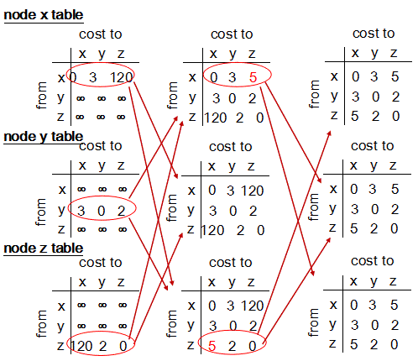 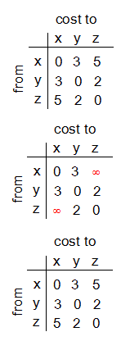

Using the position reverse,x arrive z through y,So,x tells y (x,z)=∞

z arrive x through y,so z tells y (z,x)=∞

1. After (3), assume that *Y* detects an increase in the link cost *c(X,Y)* from 3 to 100. As a result of the change, what initial routing message will *Y* send to *Z* to notify *Z* of the change? Show how this will affect *Z*’s distance table for ***destination X***. After *Z* has recomputed its distance table, what routing message will it send to *Y*? Show how the message will in turn affect *Y*’s distance table for ***destination X***.

Y tells Z:

|  |  |  |  |
| --- | --- | --- | --- |
|  | x | y | z |
| y | 100 | 0 | 2 |

Z changes his table:

Dz(z)=0

Dz(x)=min{c(z,x)+Dx(x),c(z,y)+Dy(x)}=min{120+0,2+100}=102

Dz(y)=min{c(z,x)+Dx(y),c(z,y)+Dy(y)}=min{120+3,2+0}=2

|  |  |  |  |
| --- | --- | --- | --- |
|  | x | y | z |
| z | 102 | 2 | 0 |

Z sends to Y:

|  |  |  |  |
| --- | --- | --- | --- |
|  | x | y | z |
| z | ∞ | 2 | 0 |

Before Y receive from X,Y needn’t change its table:

|  |  |  |  |
| --- | --- | --- | --- |
|  | x | y | z |
| x | 0 | 3 | ∞ |
| y | 100 | 0 | 2 |
| z | ∞ | 2 | 0 |

The process is as listed:

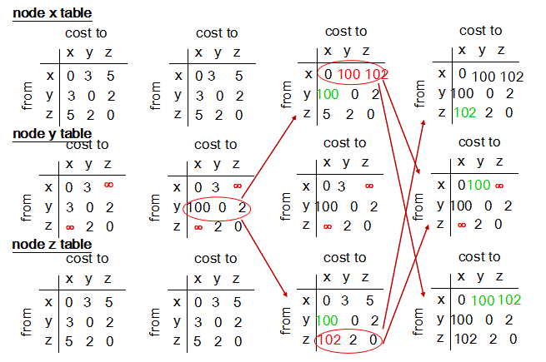

2. Suppose a router has built up the routing table shown below

|  |  |  |
| --- | --- | --- |
| Destination Network Address | Network Mask | Next Hop |
| 132.17.128.0  132.17.128.0  196.6.80.0  196.6.0.0  0.0.0.0 | 255.255.128.0  255.255.192.0  255.255.255.192  255.255.0.0  0.0.0.0 | R1  R2  R3  R4  R5 |

Where will the router send packets addressed to each of the following destinations? Why?

a) 132.17.97.1

b) 132.17.231.98

c) 196.6.80.10

d) 196.6.80.100

e) 132.17.135.47

Answer:

1. .Make 132.17.97.1 do and operation by bit with each Network Mask to see if it matches the destination Destination Network Address.

97---0110 0001

128-1000 0000

192-1100 0000

1. With Network Mask 255.255.128.0 ,we get 132.17.0.0 and it doesn’t match 132.127.128.0
2. With Network Mask 255.255.192.0,we get 132.17.64.0 and it doesn’t match 132.127.128.0
3. With Network Mask 255.255.255.192,we get 132.17.97.0 and it doesn’t match 196.6.80.0
4. With Network Mask 255.255.0.0,we get 132.17.0.0 and it doesn’t match 196.6.0.0
5. With Network Mask 0.0.0.0,we get 0.0.0.0 and it matches 0.0.0.0

**So next hop is R5 that’s default router**

1. Make 132.17.231.98 do and operation by bit with each Network Mask to see if it matches the destination Destination Network Address.

231-1110 0111

98--0110 0010

128-1000 0000

192-1100 0000

1. With Network Mask 255.255.128.0,we get 132.17.128.0 and it matches 132.17.128.0
2. With Network Mask 255.255.192.0,we get 132.17.192.0 and it doesn’t match 132.127.128.0
3. With Network Mask 255.255.255.192,we get 132.17.231.64 and it doesn’t match 196.6.80.0
4. With Network Mask 255.255.0.0,we get 132.17.0.0 and it doesn’t match 196.6.0.0
5. With Network Mask 0.0.0.0 we get 0.0.0.0 and it matches 0.0.0.0

The match follow the longest match principle.It choose 255.255.128.0 .It is 17 bits and matches 132.17.128.0.**So next hop is R1.**

1. Make 196.6.80.10 do and operation by bit with each Network Mask to see if it matches the destination Destination Network Address.

80--0101 0000

10--0000 1010

128-1000 0000

192-1100 0000

1. With Network Mask 255.255.128.0,we get 196.6.0.0.It doesn’t match 132.17.128.0
2. With Network Mask 255.255.192.0,we get 196.6.64.0.It doesn’t match 132.127.128.0
3. With Network Mask 255.255.255.192,we get 196.6.80.0.It matches196.6.80.0
4. With Network Mask 255.255.0.0,we get 192.6.0.0.It matches 196.6.0.0
5. With Network Mask 0.0.0.0,we get 0.0.0.0.It matches 0.0.0.0

The match follow the longest match principle.It choose Network Mask 255.255.255.192.It is 26 bits and matches 196.6.80.0.**So next hop is R3.**

1. Make 196.6.80.100 do and operation by bit with each Network Mask to see if it matches the destination Destination Network Address.

80--0101 0000

100-0110 0100

128-1000 0000

192-1100 0000

1. With Network Mask 255.255.128.0,we get 196.6.0.0.It doesn’t match 132.17.128.0
2. With Network Mask 255.255.192.0,we get 196.6.64.0.It doesn’t match 132.127.128.0
3. With Network Mask 255.255.255.192,we get 196.6.80.64.It doesn’t match 196.6.80.0
4. With Network Mask 255.255.0.0,we get 196.6.0.0.It matches 196.6.0.0
5. With Network Mask 0.0.0.0,we get 0.0.0.0.It matches 0.0.0.0

The match follow the longest match principle.It choose Network Mask 255.255.0.0.It is 16 bits and matches 196.6.0.0.**So next hop is R4.**

1. Make 132.17.135.47 do and operation by bit with each Network Mask to see if it matches the destination Destination Network Address.

135-1000 0111

47--0010 1111

128-1000 0000

192-1100 0000

1. With Network Mask 255.255.128.0,we get 132.17.128.0.It matches 132.17.128.0
2. With Network Mask 255.255.192.0,we get 132.17.128.0.It matches 132.17.128.0
3. With Network Mask 255.255.255.192,we get 132.17.135.0.It doesn’t match 196.6.80.0
4. With Network Mask 255.255.0.0,we get 132.17.0.0.It doesn’t match 196.6.0.0
5. With Network Mask 0.0.0.0,we get 0.0.0.0.It matches 0.0.0.0

The match follow the longest match principle.It matches 132.17.128.0.The Network Mask 255.255.192.0 is 18 bits and 255.255.128.0 is 17 bits.It matches 18 bits.**So next hop is R2.**

3. Consider the network shown below where the number on a link between two nodes is the distance between them.

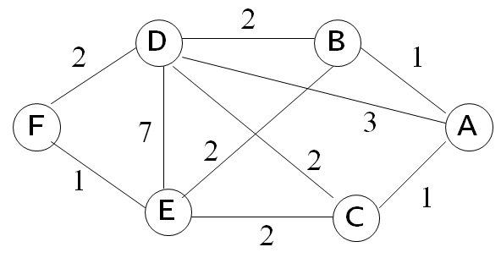

1. Use Dijkstra’s shortest path algorithm to find the shortest path from A to all other network nodes. Show how the algorithm works by completing the table below the figure.
2. What is the resulting shortest paths tree and **routing table**?

|  |  |  |  |  |  |  |
| --- | --- | --- | --- | --- | --- | --- |
| step | N | *D(B),p(B)* | *D(C),p(C)* | *D(D),p(D)* | *D(E),p(E)* | *D(F),p(F)* |
| 1 | A | 1，A | 1，A | 3，A | ∞ | ∞ |
| 2 | AB |  | 1，A | 3，A | 3，B | ∞ |
| 3 | ABC |  |  | 3，A | 3，B | ∞ |
| 4 | ABCD |  |  |  | 3，B | 5，D |
| 5 | ABCDE |  |  |  |  | 4，E |
| 6 | ABCDEF |  |  |  |  |  |

b)

Answer:

B

D

1

E

A

F

C

3

2

1 1

Router Table:

|  |  |
| --- | --- |
| 目的网络 | 下一跳 |
| B | B |
| C | C |
| D | D |
| E | B |
| F | B |