Proof of Concept — Ciel
Project: Ciel — AI-native Impact Operating System for the social sector
Event: Create & Conquer 2026 Hackathon · Theme #2
Date: 2026-06-26
Status: Elimination-round submission artifact

1. What this PoC demonstrates
Ciel closes the gap from need identified to solution scaled for NGOs, LGUs, and community organizations. This proof of concept shows:
- A plain-language social need becomes a grounded Theory of Change with cited evidence and “intelligent failure” prompts.
- A locked ToC becomes a funder-aligned grant proposal draft.
- Field indicators feed a predictive M&E loop that recommends scale, adapt, or stop.
The prototype runs as a Next.js web app (Vercel) backed by a Python AI service (Google Cloud Run) and Microsoft Foundry (GPT-only generation + RAG).

2. User flow
Primary path: sign-in → org onboarding → need intake → ToC Studio → grant workspace → project dashboard → field data → signals/reports.
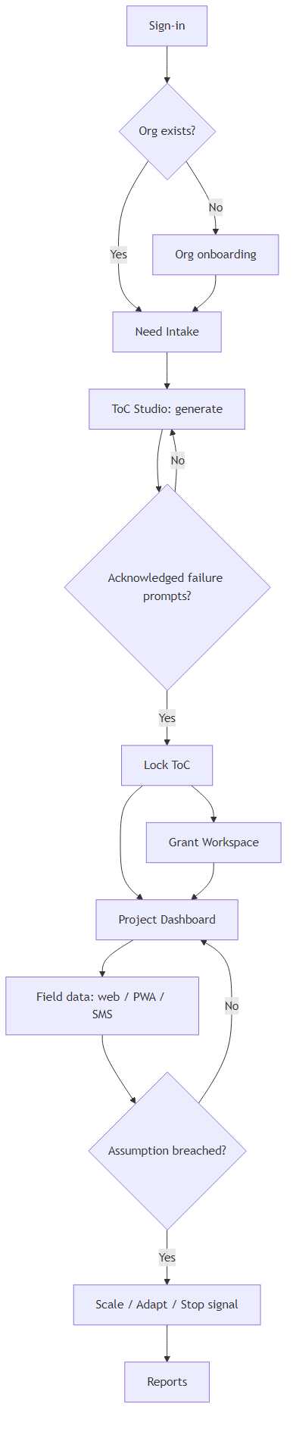
Diagram 1
Step | Actor | Outcome
Need Intake | Program manager | Plain-language need + context captured
ToC Studio | Program manager + AI | Structured ToC with citations; failure prompts acknowledged
Grant Workspace | Program manager + AI | Compliance-ready proposal draft aligned to funder KPIs
Project Dashboard | Program manager | Live indicators vs ToC assumptions
Field Capture | Field volunteer | Offline PWA or SMS entry synced to dashboard
Signal | System | Scale / adapt / stop recommendation with rationale
Full UX inventory: prd-ciel.md §5.

3. High-level architecture (SDD §2)
Two-tier application: Next.js product surface + Python AI service on Cloud Run, both fronting Microsoft Foundry and Supabase.
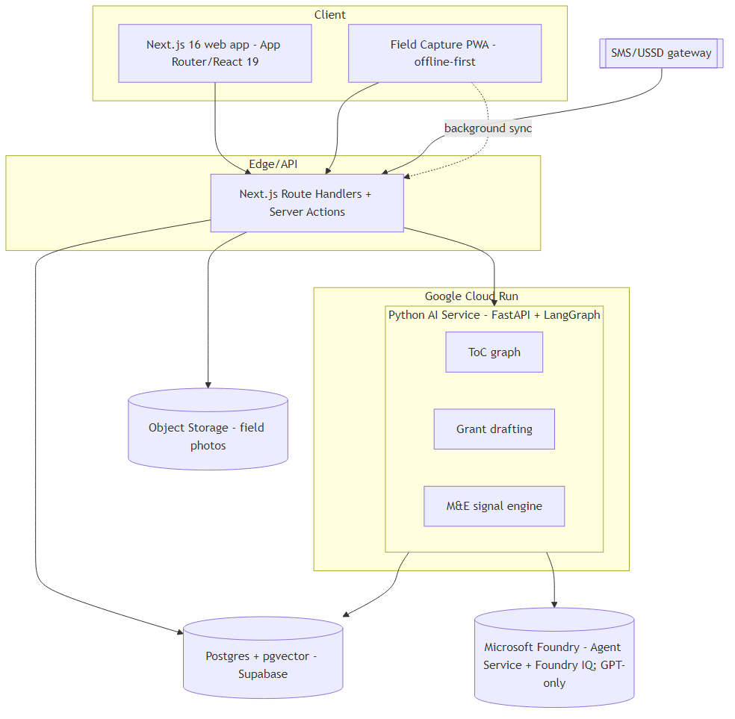
Diagram 2
Layer | Technology | Responsibility
Client | Next.js 16, React 19, Tailwind v4, PWA | Product UI, ToC Studio, offline field capture
API / Gateway | Next.js Route Handlers + Server Actions | Auth, CRUD, SMS ingest, AI proxy
Service / Compute | Python 3.12, FastAPI, LangGraph on Cloud Run | ToC, grant, M&E graphs
AI control plane | Microsoft Foundry (GPT-only) | Model hosting, agent runtime, RAG
Data | Supabase Postgres + pgvector, Object Storage | App data, embeddings, audit, media
Infrastructure | Vercel + Google Cloud Run | Hosting, scaling, secrets
Canonical architecture: sdd-ciel.md §2 · Hosting change: cr-ciel-005.md

4. Prototype scope (hackathon slice)
Module | PRD ID | PoC status
AI Theory-of-Change Generator | PRD-F1 | Demonstrated — generate, critique, lock
Grant Writing & Resource Alignment | PRD-F2 | Demonstrated — draft + edit + export
Predictive M&E + Field Ingestion | PRD-F3 | Demonstrated — dashboard signal (demo seed)
Org Workspace & Identity | PRD-F4 | Demonstrated — org bootstrap + roles
Trustworthy-AI Governance | PRD-F5 | Partial — citations, HITL lock gate, audit log
Ecosystem Integrations | PRD-F6 | Out of scope (v2)

5. How to run locally
# AI service
cd ai_service && pip install -r requirements.txt
uvicorn ai_service.main:app --reload --port 8000
# Frontend
cd client && pnpm install && pnpm dev
# Seed evidence corpus (optional, for grounded ToC)
python -m ai_service.scripts.seed_evidence
Set AI_SERVICE_URL and AI_SERVICE_API_KEY in the client environment per build-ciel.md.

6. References
- prd-ciel.md — product requirements and user stories
- sdd-ciel.md — system design
- hackathon-guide.md — submission requirements
- evidence-ciel.md — fact-check ledger

